Genesis-Dealers
Dealers User Manual

TABLE OF CONTENTS
1. Login & Logout 3
2. Home 7
GNB 8
Menu 19
Announcement 23
Quick Link 27
Board you’ve visited 32
Bulletin Highlight 33
Footer 34
3. Search Result 37
4. Bulletin Board 40
Post List 40
Post Detail 49
5. Email Notification 54
6. Dealer employee management 57
Dealer employee List 57
Create Dealer Employee 58
Edit Dealer Employee 70
7. HMG-Notification 72
Page Notification 72
Pop-up Notification 73
Consent Notification 74

Login & Logout
Login method
- Go to https://dealers.genesis-corp.io/ca/ to access the first screen.
- Select Corporation Code and enter hacc in the Corporate Code field.
- Log in using your HMG Partner ID and password.
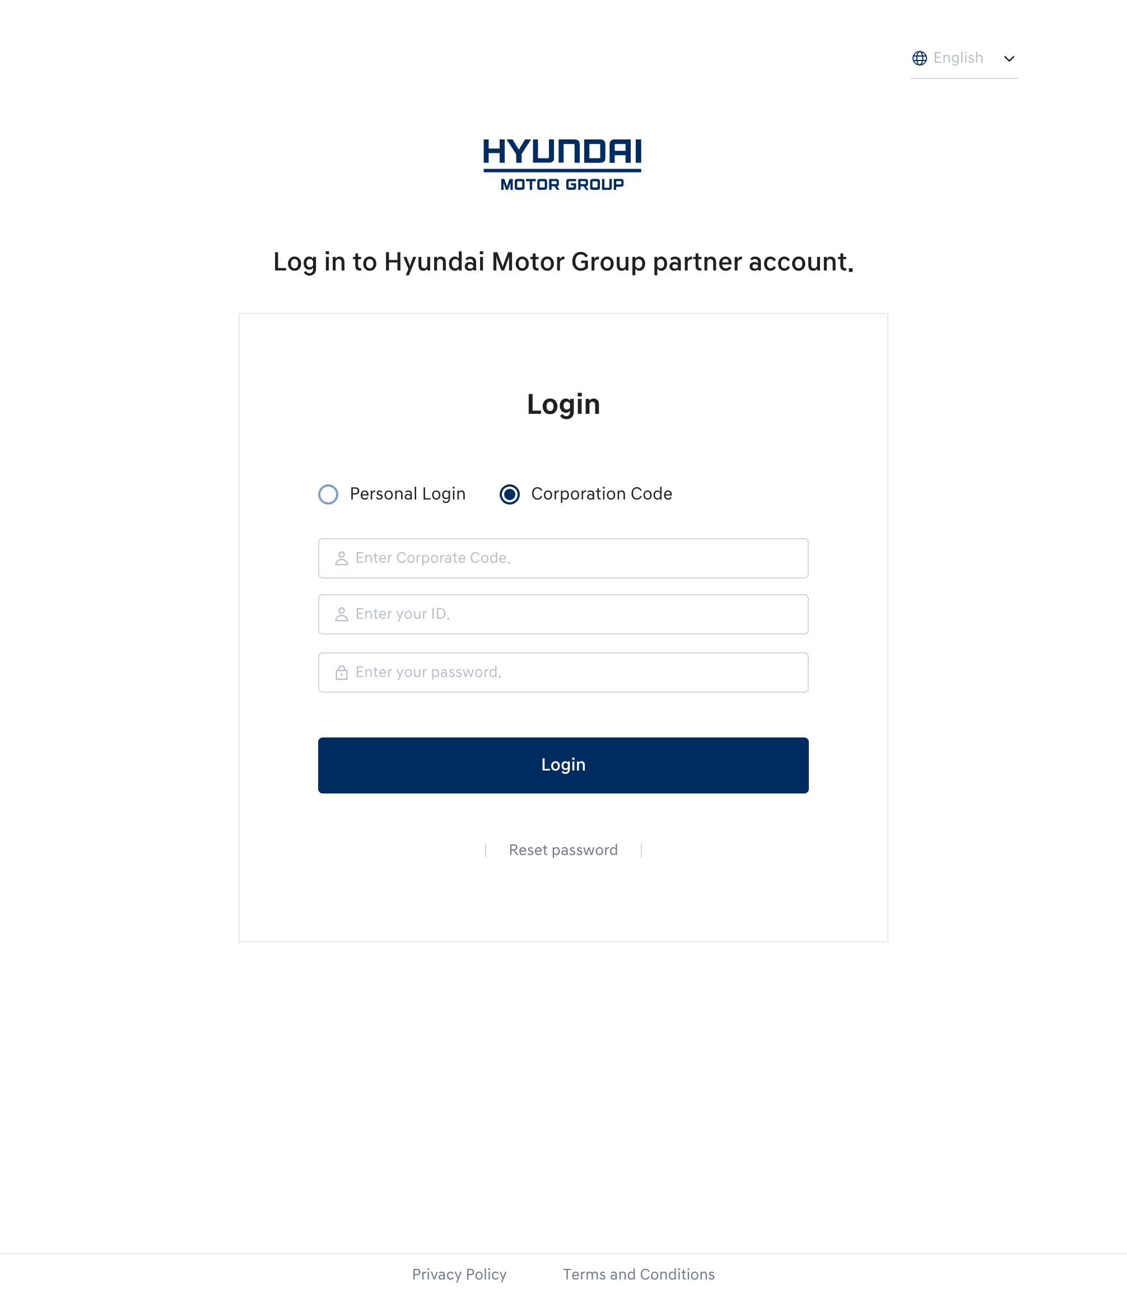
Login Screen
  - When accessing Dealers for the first time, you will be asked to agree to the HMG Partner ID service terms.
  - After that, you will be directed to the Dealers Service Terms and Personal Information Consent screen.
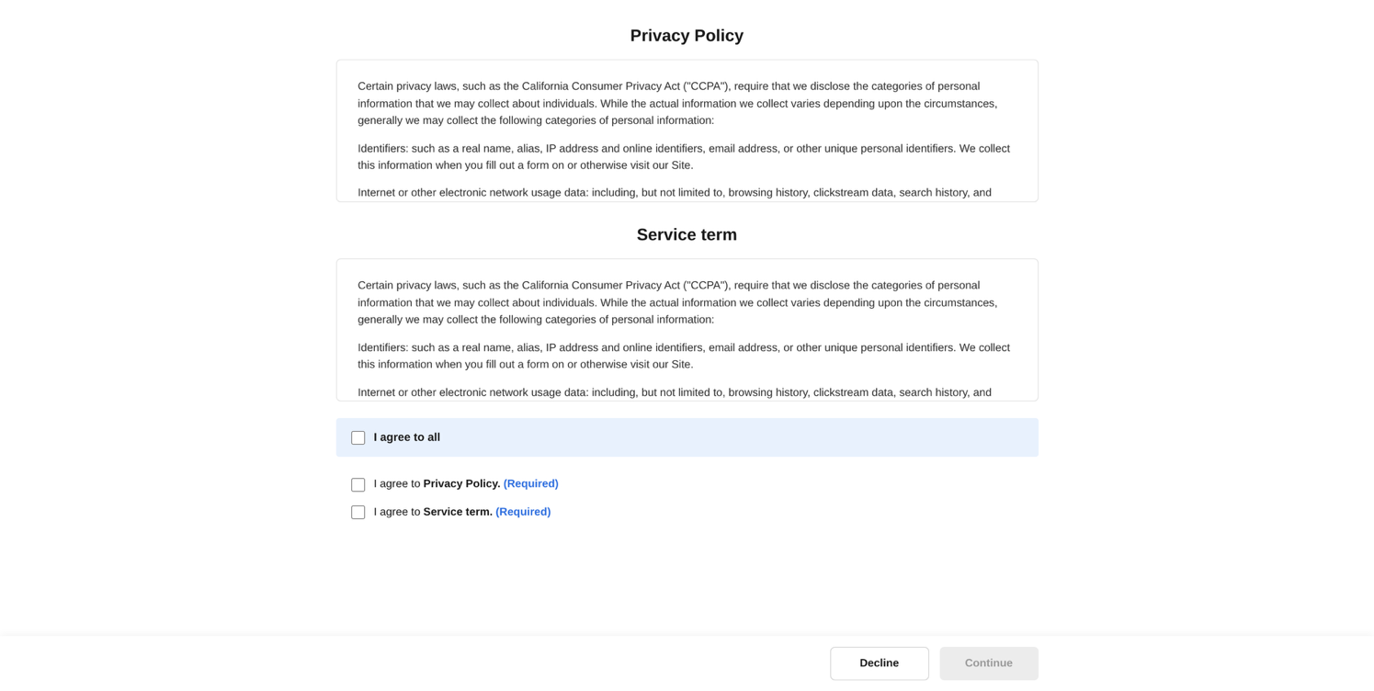
Service Agreement Screen
- You must agree to the required items and press the [Continue] button to use the service.
- If you belong to two or more dealerships, including Genesis/Hyundai brands, you will be directed to a screen where you can select which dealership to access.
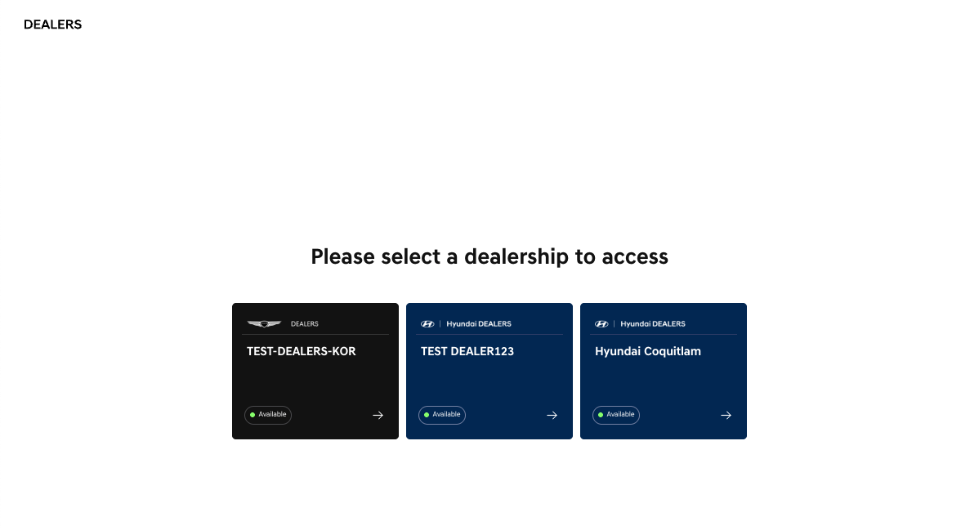
Dealer Selection Screen
- On the dealer selection screen, you can view both the brand and the dealer name for each affiliated dealership.
- If you can access a dealer, “Available” will appear. If access is not allowed, you will see “Access Denied” and cannot log in as a member of that dealer.
- When accessing a brand for the first time, you must agree to the service agreement on the agreement screen before using the service.
Logout Method
  - User logout instructions:
    - Click on the profile image area at the top left of the screen.
    - An Account sheet will appear.
    - Select Logout from this sheet.
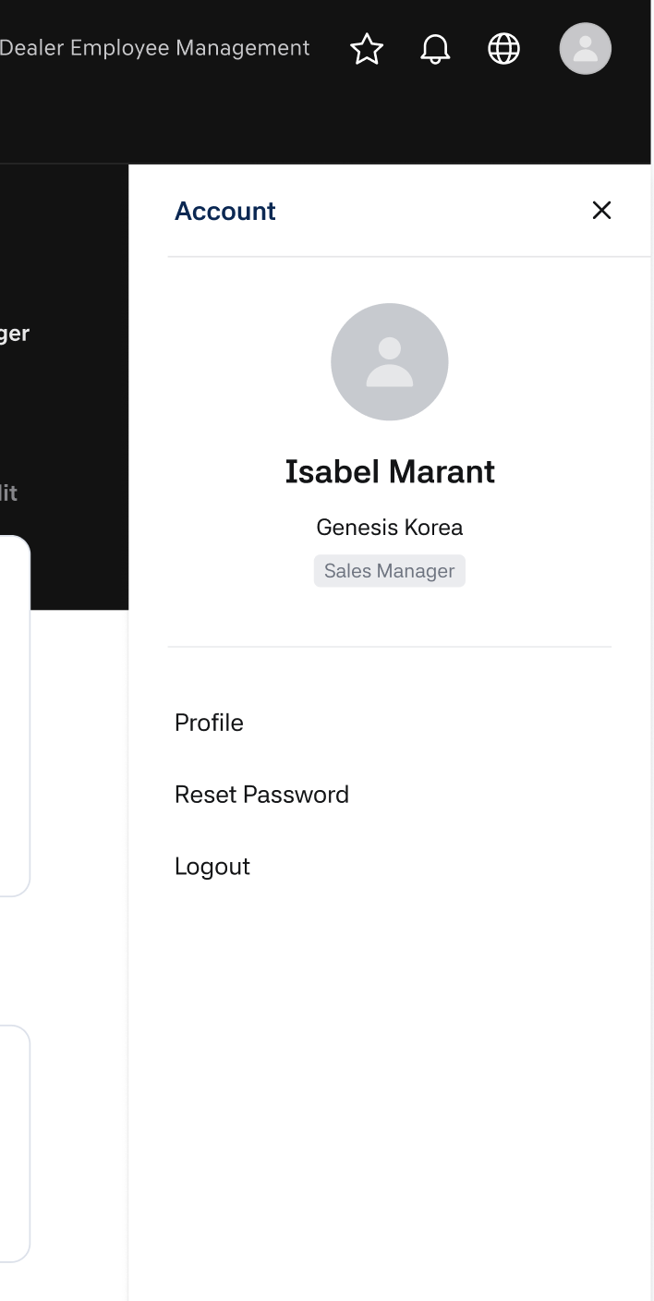
Logout button
- Automatic logout instructions:
    - In accordance with security policy, Dealers will automatically log you out if no activity is detected on the site for 60 minutes.
    - After 55 minutes of inactivity, a popup will appear notifying you that logout will occur in 5 minutes.
    - If inactivity is detected for 60 minutes, automatic logout will be initiated.
    - If a user returns to the Dealers screen after 60 minutes have passed, they will be automatically logged out.
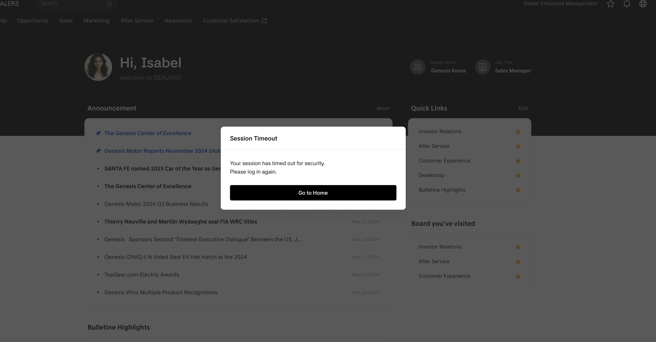
Session End Pop-up

Home
- The home screen is the main screen that is displayed first when a user connects. The home screen consists of GNB, Menu, Announcement, Quick Links, Board you've visited, Bulletin highlight, etc.
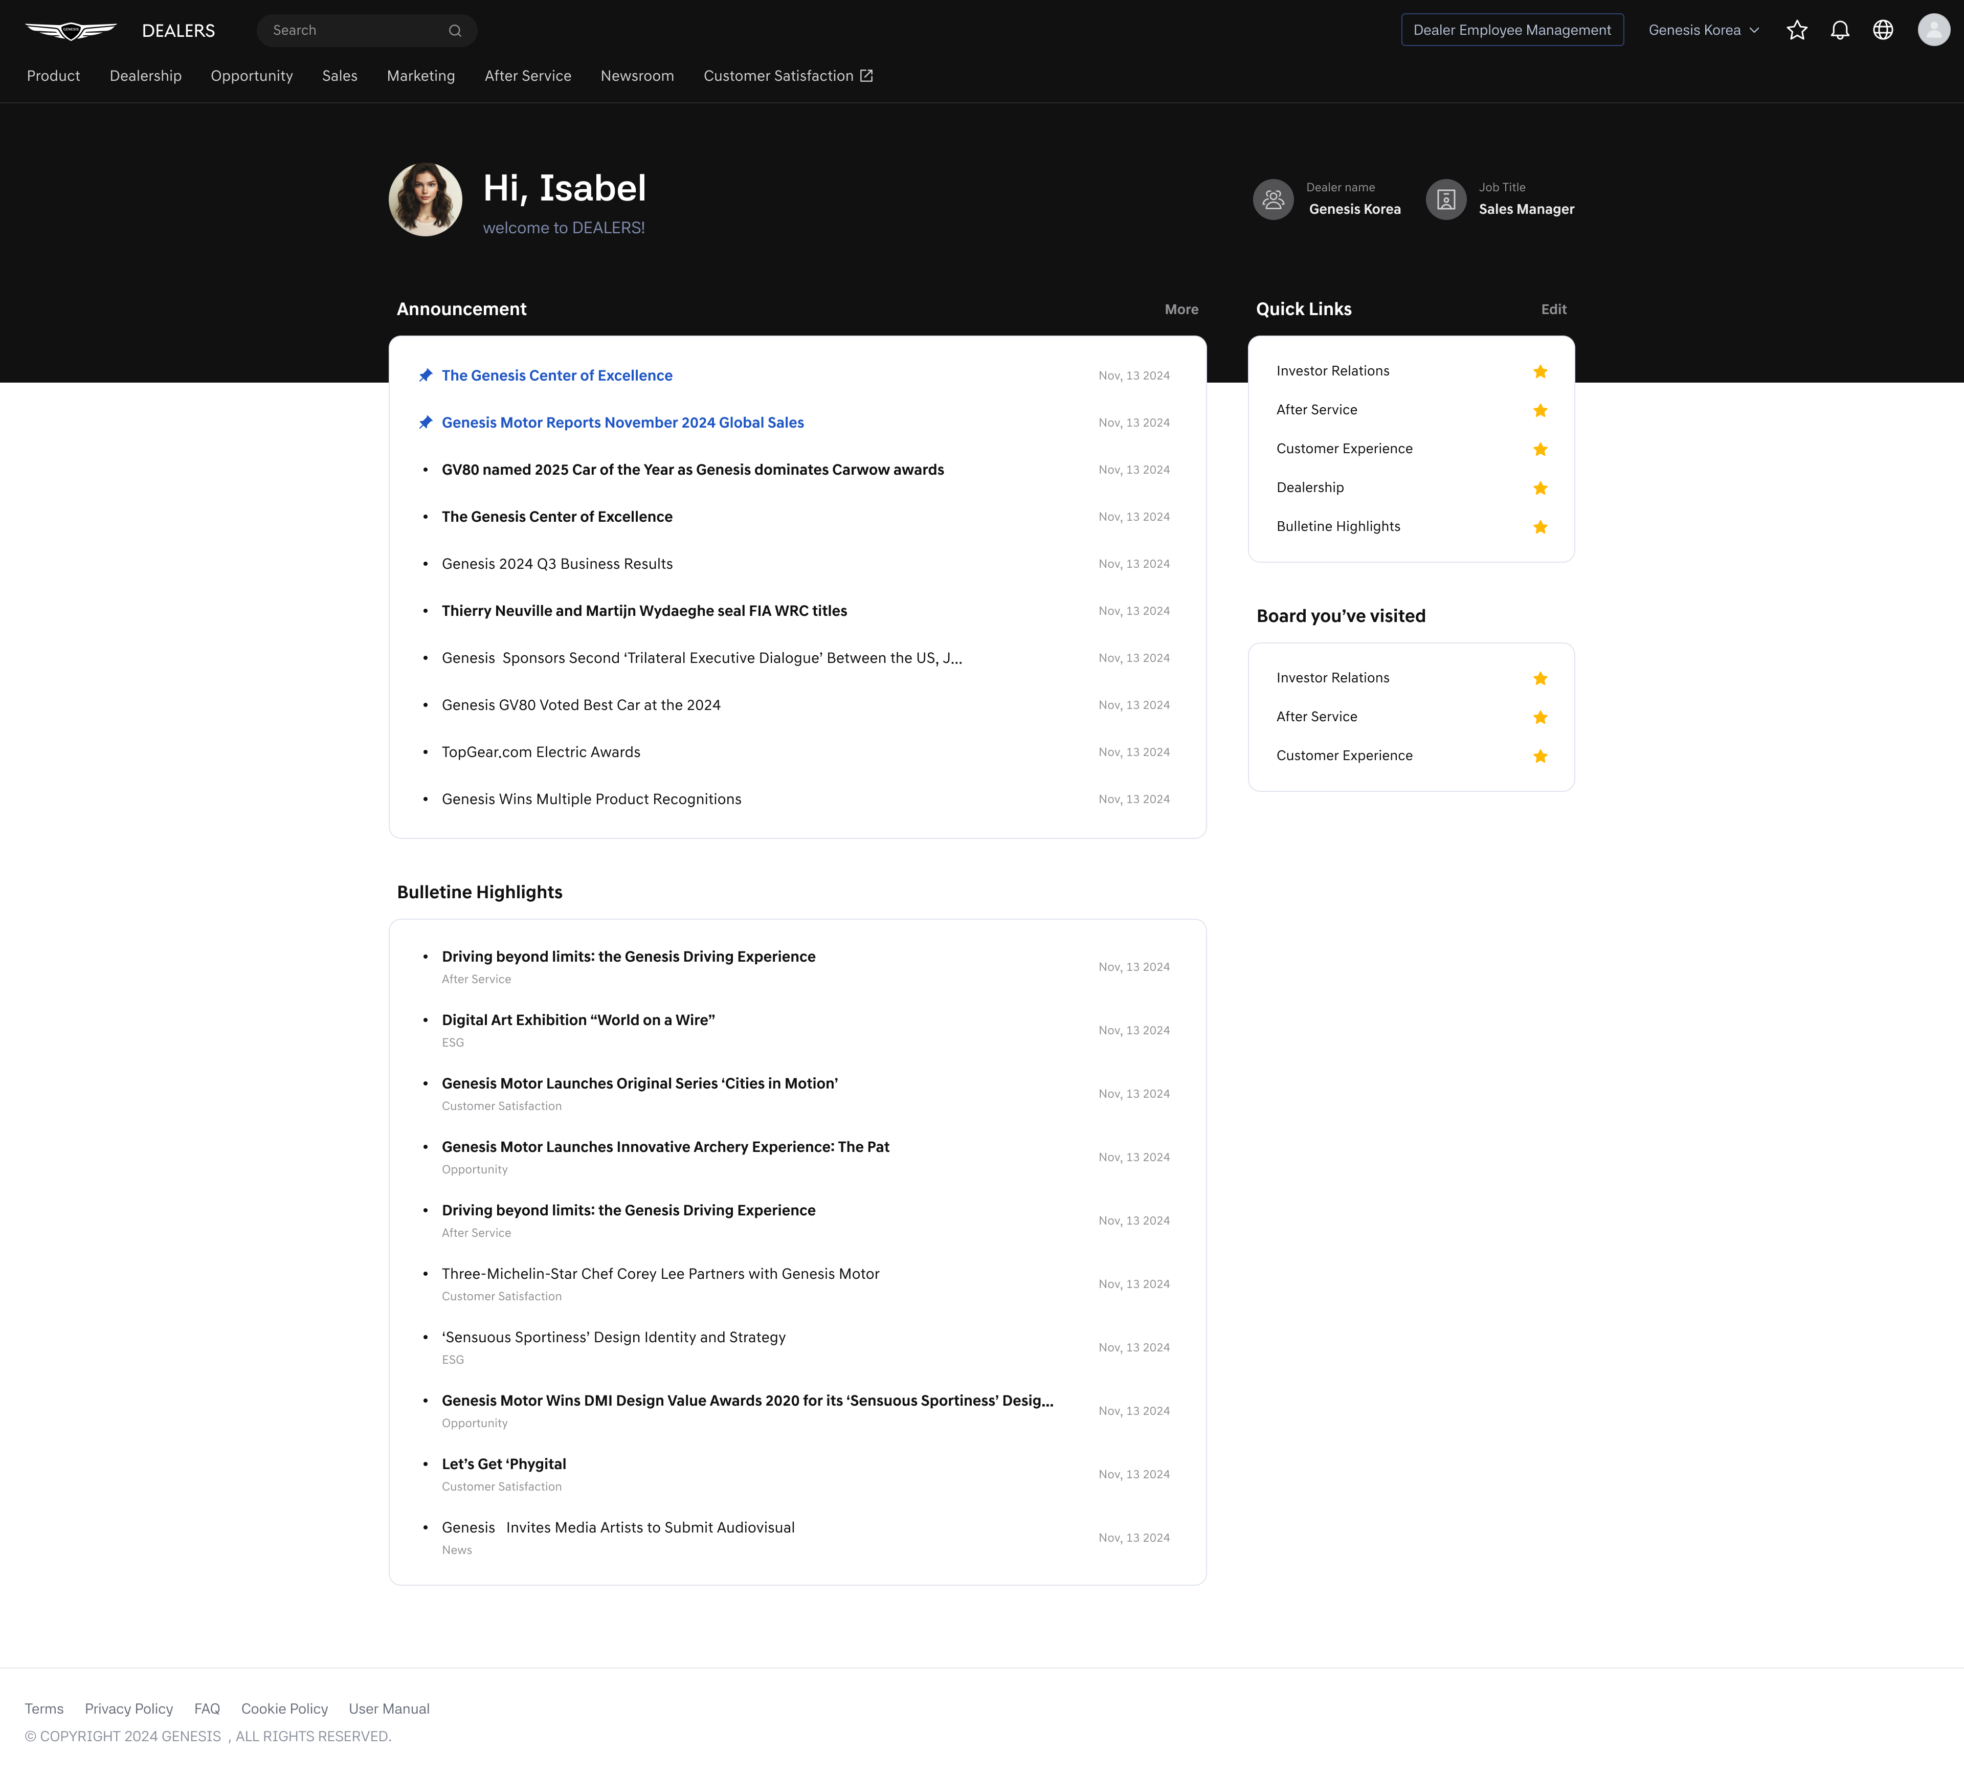
Home Screen

GNB
- GNB (Global Navigation Bar). Logo, search box, favorites, notifications, language settings, account information, and menu are displayed.
Figure 7 GNB(Global Navigation Bar)
- Logo
  - The service logo is displayed at the top left, and clicking on the logo will take you to the home screen.

Logo image
- Search Bar
  - A search box is displayed to the right of the logo.
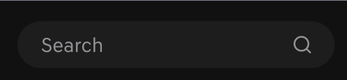
Search Bar
  - When clicking on the search box, keyboard input is activated and up to 10 recent searches are displayed. When hovering the mouse over a recent search term, a delete button appears, and clicking it immediately deletes that search history.
  - After entering a search term, pressing enter or selecting the search icon will execute the search with the entered term and take you to the integrated search results screen. (For integrated search results, see 3.Search Result below)
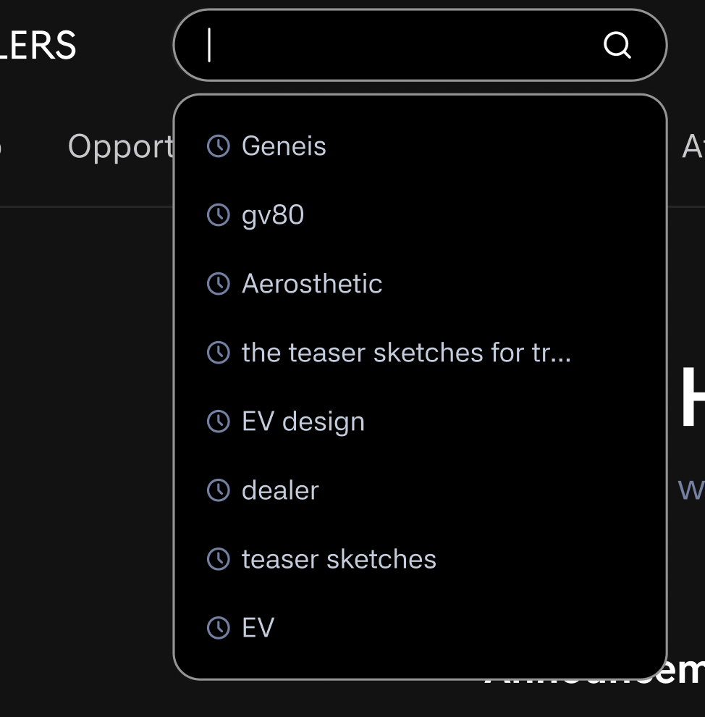
Recent searches
- Multi-Dealer Switch
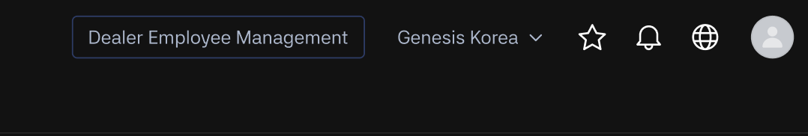
Multi dealer switch
  - The GNB displays the name of the currently active dealer.
  - Multi-dealer users: an arrow icon is displayed, and clicking the dealer name or icon opens a dealer selection box.
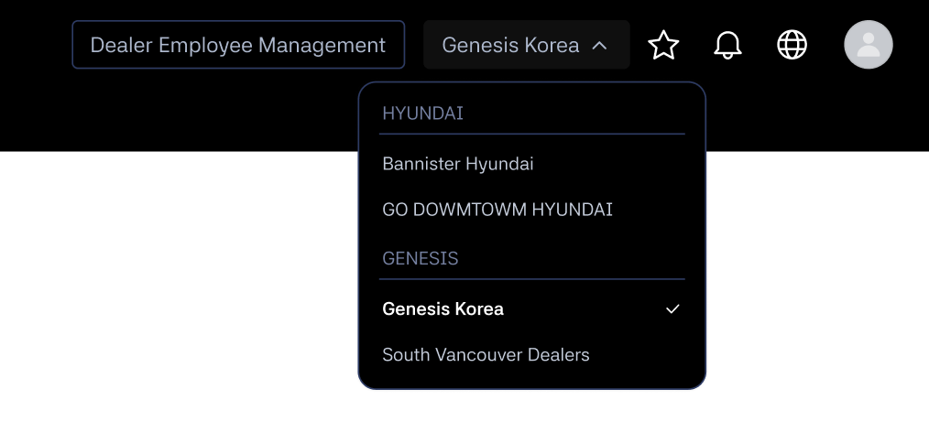
Multi dealer switch selection box
  - Dealers are grouped by brand: HYUNDAI (listed first) and GENESIS as separate sections. Only the brand section(s) applicable to the user are displayed.
  - Only dealers where the employee status is Active are listed, in alphabetical order (A–Z). The currently active dealer is shown in bold with a check icon.
  - A vertical scroll is provided if the list exceeds the maximum height of the selection box.
  - After switching, the user is redirected to the Home screen of the newly selected dealer.

- Quick Link
  - When Quick Link is clicked, the Quick Link screen is displayed. Please refer to the Quick Link description below.
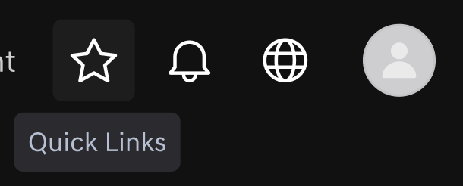
Quick Link
- Notification:
  - If there are notifications, the notification details will be displayed.
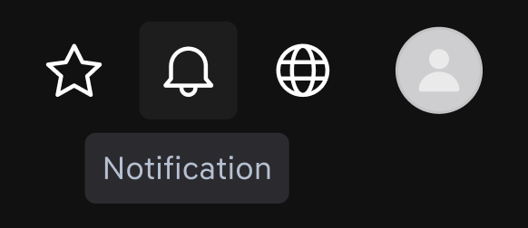
Notification
      - If there are new notifications, a number notification badge will be displayed, and after the layer screen is displayed, the number notification badge will be reset.

New notification
  - When the Notification button is clicked, the notification layer appears. In the Notification list, read and unread notifications are displayed separately.
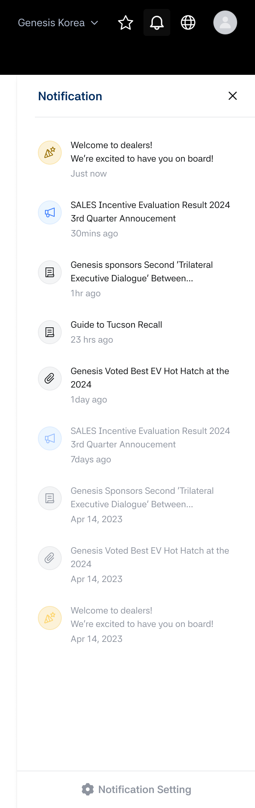
Notification layer
  - A Notification setting button is displayed at the bottom of the notification layer. When this button is clicked, a notification settings screen is opened where the user can configure their notification type for the currently active dealership only. Settings do not apply across multiple dealerships.
  - Notification receive type
        - Notification settings control both email notifications and FO (web) notifications in the same way.
      - Notification options:
        - All notifications (default): All posts where Notification = ON in Back Office, regardless of whether the post is marked as Important or Regular.
        - Important notices only: Only posts where Important Notice = ON, the Important period is active, and Notification = ON in Back Office.
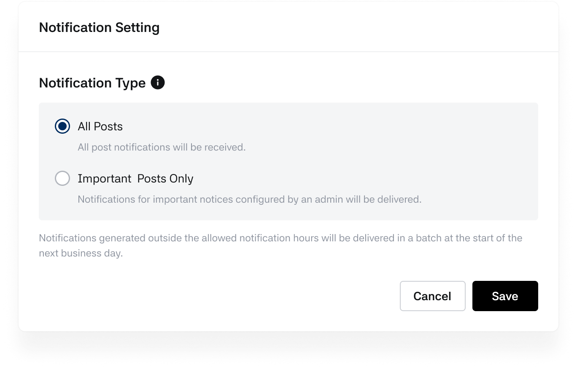
Notification setting

      - After Saving
        - Any change to the notification receive type is applied immediately and is used for the next notification sending decision.
        - For scheduled posts, if a post is changed to Important before it is sent, users who selected Important notices only will be included in the email/notification recipients at the time of sending.
        - When a post status is changed:
          - Regular → Important after sending:
No additional email or FO notification is sent.
          - Important → Regular after sending:
No additional email or FO notification is sent.
        - Already-sent notifications are not resent, even if the user changes their notification settings later. Changes affect only future sends.
      - Delivery rule by tenant business hours
        - Email and FO notifications are sent once at the posting start time (including the system’s delay rule).
        - If a notification is generated outside the tenant’s business hours, it is delivered in a batch at the start of the next business day based on the tenant’s timezone.

- Language setting:
  - The language setting button is displayed.
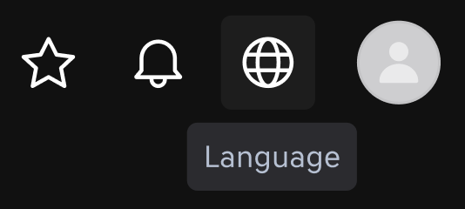
Language setting
  - When clicked, language information is displayed in the right layer, and you can select a language using radio buttons.
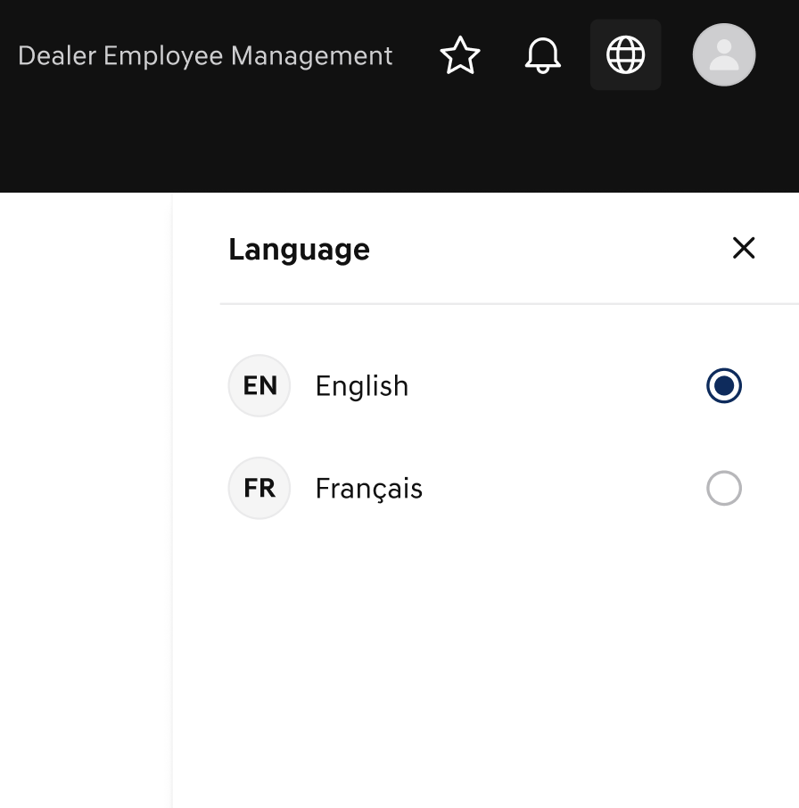
Language selection
- Account:
  - The user's account information is displayed.

Account
  - If the user has registered a profile picture, the profile image is displayed. If an image has not been registered, a default image is displayed.
  - When account information is clicked, the user's profile image, name, Dealer Name, and Job title are displayed in the right Layer, and it's possible to view Profile, Reset password, and logout.
Account layer

Profile Screen View:
- When Profile is clicked, users can view their registered profile information.
- On this screen, users can only view the registered profile information; modification or deletion is not possible.
- If a photo is registered to the account, the registered photo will be displayed.
- Name information and the user's email are displayed.
- If the user is a dealer principal, that badge will be displayed on the left.
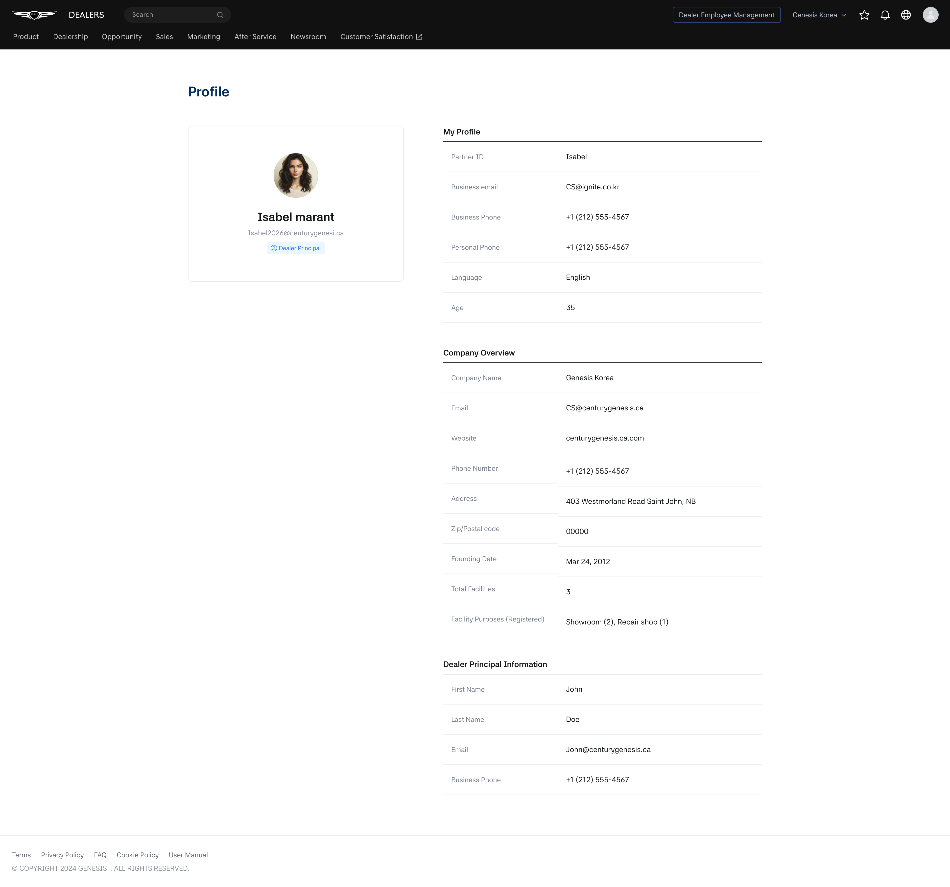
Profile
- User information, information about the dealer company the user belongs to, and information about the dealer representative are displayed in the right area.

- Profile area
    - Picture
    - Name
    - Account Email: Account email information.
      - Account-related emails will be sent to this address. If a password reset is requested, an email with instructions will be sent to this address.
- My profile area
    - Partner id: The user's account ID
    - Business Email: The business email address.
      - Notification emails for new posts published on Dealers will be sent to this address.
    - Business phone: The registered user's business phone number
    - Personal phone: The registered user's personal phone number. If this information is not registered, it is marked with '-'
    - Language: Displays the default language value
    - Age: Calculates and displays the age based on the registered birth date information. If this information is not registered, it is marked with '-'
- Company overview
    - Company name: The name of the dealer company to which the user belongs
    - Email: The email information of the affiliated dealer company
    - Website: The website address of the affiliated dealer company
    - Phone number: The phone number of the affiliated dealer company
    - Address: The address information of the affiliated dealer company
    - Zip/postal code: The postal code of the affiliated dealer company's address
    - Founding date: The establishment date of the affiliated dealer company
    - Total facilities: The number of assets registered to the affiliated dealer company
    - Facility purposes(registered): The number of assets according to the purpose of the registered assets
  - Dealer principal information
    - First name: The dealer representative's name information, surname
    - Last name: The dealer representative's name information, first name
    - Email: The dealer representative's email information
    - Business phone: The dealer representative's phone number
Reset Password
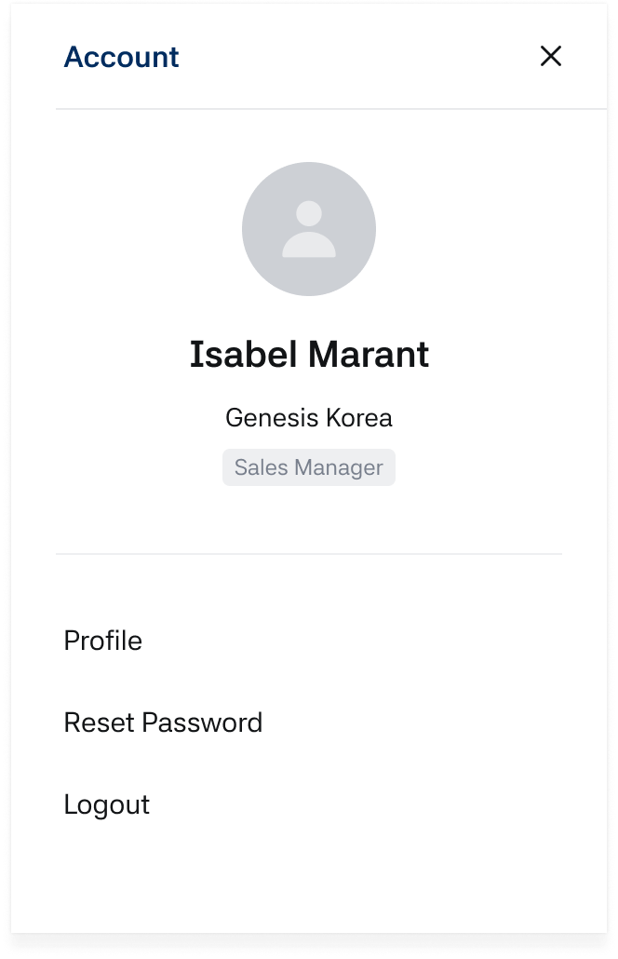
Reset Password
    - When you click Reset Password, a URL to reset your password will be sent to your registered account email address.
    - Once you complete the password change through the provided URL, the new password will be applied.

Menu
GNB Menu
  - The menu configured in BO > Menu Management will be displayed.
  - The way each menu is shown depends on the menu type selected in BO.
  - If the menu type is General, the user will be redirected directly to the entered URL.
    - If the menu type is General and the Domain is set as Directory, clicking the GNB (Global Navigation Bar) menu will not redirect the user; instead, it will serve as a directory menu, displaying its 2nd to 4th depth sub-menus.
  - If the menu type is Bulletin Board, the user will be redirected to the linked bulletin board screen.
    - If the menu type is Outlink, an icon indicating a new tab will appear next to the menu name. Clicking the menu will open the outlink URL entered in the Domain field in a new browser tab.
  - The menu is only visible to users with the appropriate access permissions configured in BO > Menu Management and for those whose Job Title or Username has been granted access in BO > Job Management.
  - GNB menu displays only 1depth menu, and when a menu is selected, you will be directed to the detailed screen of that menu.
GNB Menu
  - When hovering the mouse over a 1depth menu, the entire 2 ~ 4depth menu layer of that menu is displayed, and when a menu is selected, you will be directed to the detailed screen of that menu.
  - Menu dropdown: When hovering the mouse over a 1depth menu, you can check the lower 2 ~4 depth menus through the menu dropdown.
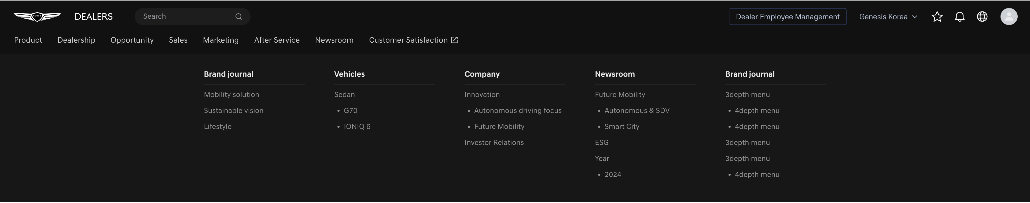
Menu dropdown
SNB Menu
- Displays the menu set in BO > Menu management.
- The menu is displayed only to users whose Job Title or Username has been granted access in BO > Job Management, and who have menu access permissions configured in BO > Menu Management.
- This is the SNB(Side Navigation Bar) menu that appears when selecting a 1~4depth menu.
- The 1depth menu of the selected menu is marked as selected in the GNB, and the corresponding 2~4depth menus are displayed in a tree structure.
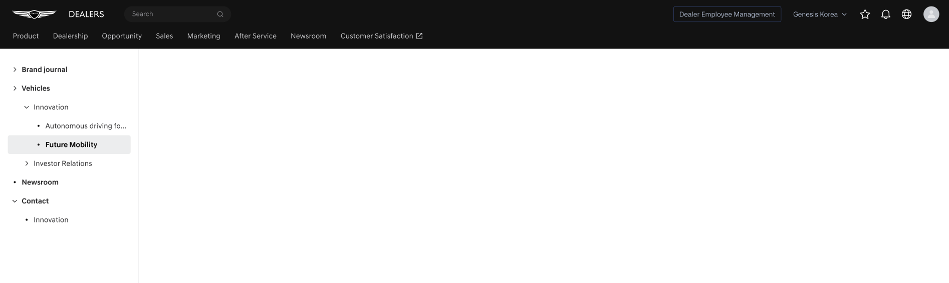
SNB (Side Navigation Bar) Menu
- When a menu is selected, you will be directed to the detailed screen of that menu, and the selected menu name is displayed on the right page.
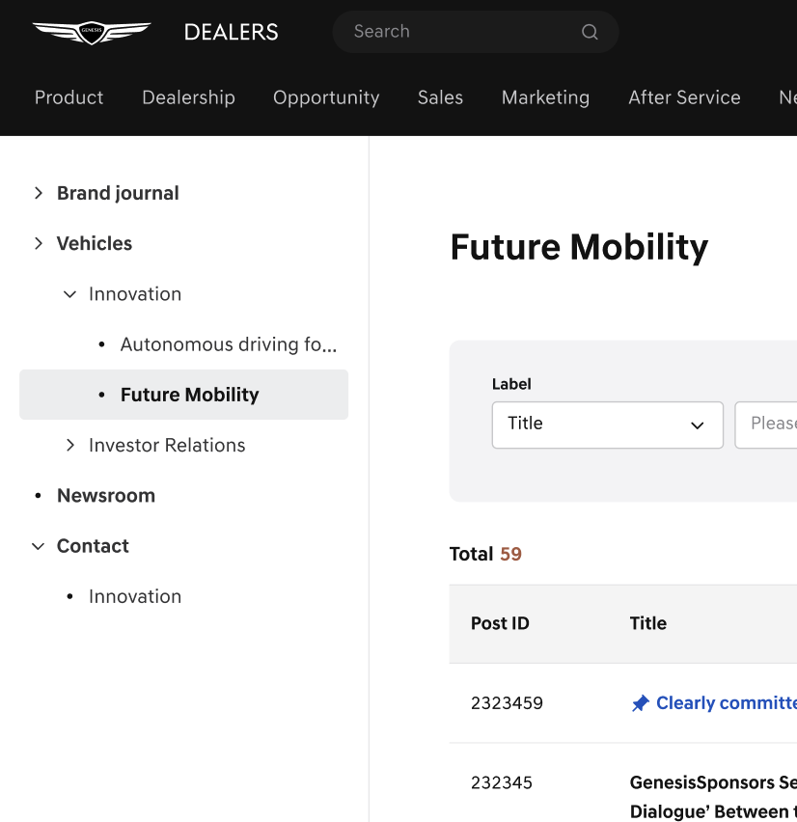
Selected Menu
Click on SNB Menu
- Initial Entry
  - When initially entering by clicking on a 1depth menu, the 2depth menus are displayed in a collapsed state.
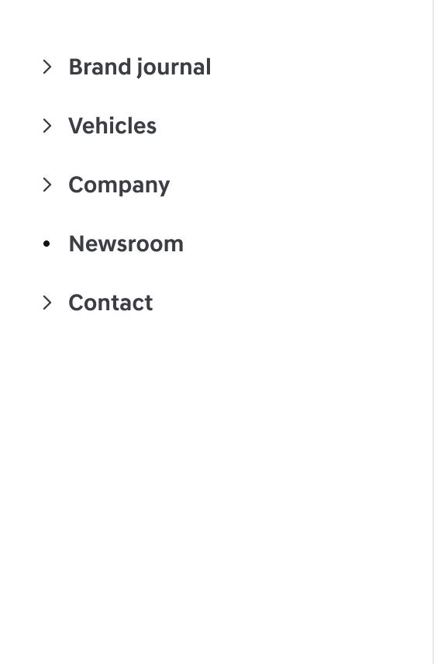
2depth menus
- Expand and Collapse
  - Menus with an 'arrow' icon can be expanded and collapsed.
  - When clicking on an SNB menu of 2depth or higher, the menus below the 2depth are displayed.
  - If the menu name exceeds the allocated display width, it is truncated with an ellipsis (…).
  - When the user hovers the mouse over the truncated menu name, a tooltip is displayed showing the full menu name.
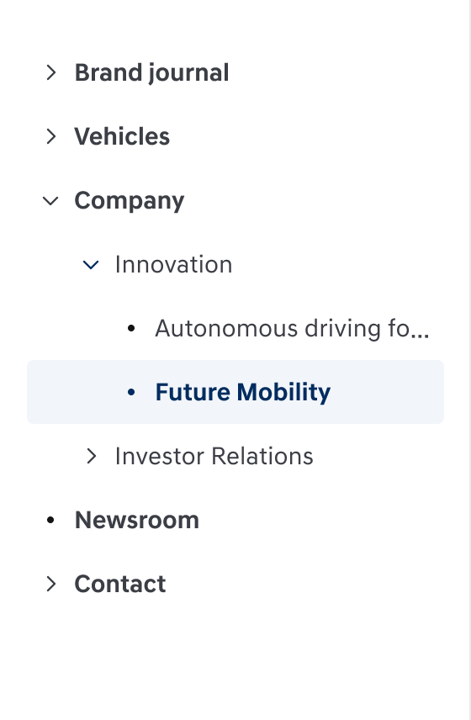
Expanded menu1
- Accessing Other Menus
  - You can expand other menus even if there are already expanded menus.
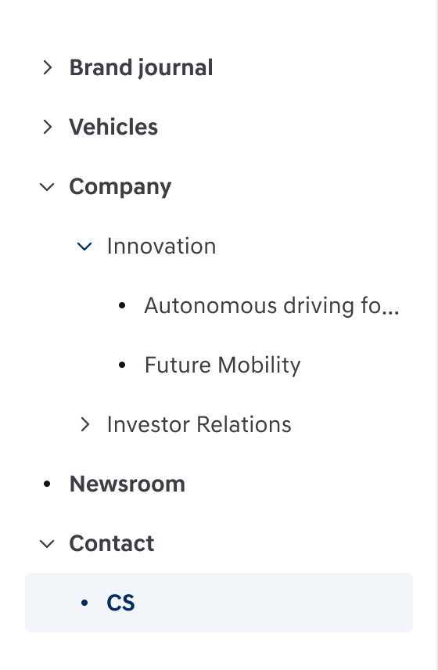
Expanded menu2

Announcement
- This is an area where bulletin boards registered as announcements among hmg admin > Dealers bulletin boards are displayed, and a maximum of 10 posts are shown.
- Posts set as important notices can be viewed fixed at the top for a specific period.
- Posts are displayed in order of most recently registered important notice posts, followed by most recently registered general posts.
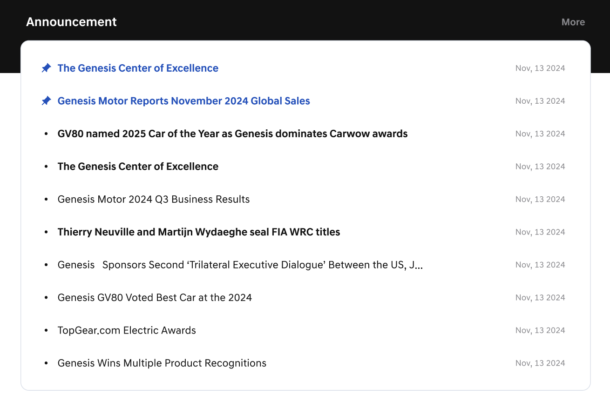
Announcement
    - Important icon: If a post is set as a pinned/important post, it is fixed at the top of the list during the configured period.
    - Title: When selected, you will be directed to the detailed screen of that post.
    - Date: The date when the post was published is displayed.
    - New flag: The New flag is automatically applied to new posts according to the tenant configuration.
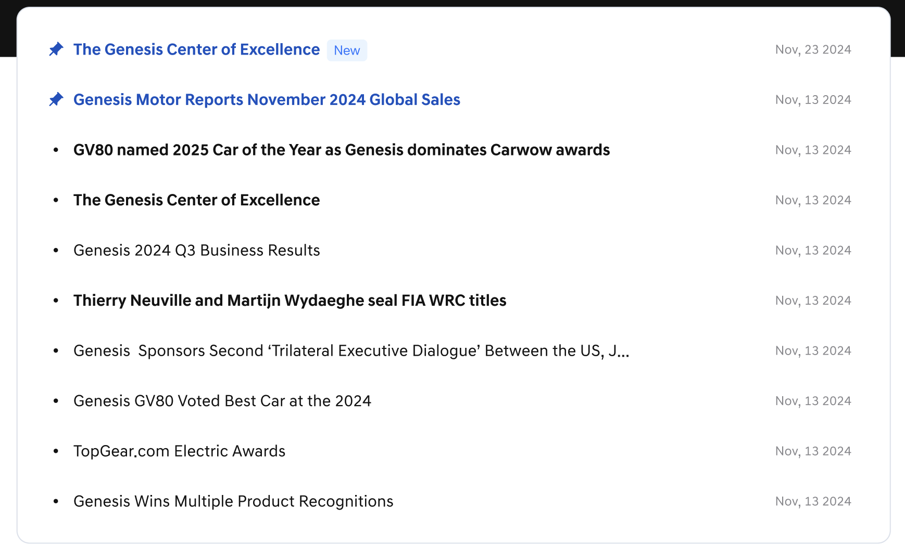
Announcement – Icon/Title/Date/Flag
    - [More]: When clicked, you will be directed to the Announcement bulletin board screen, taking you to the page where you can view the entire list of Announcement posts.
View Announcement Post List
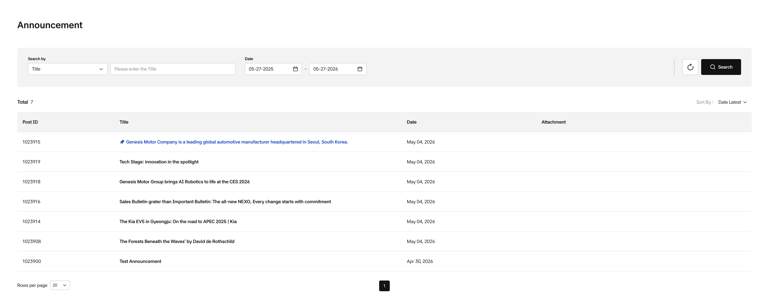
Announcement List
- The post list screen consists of a title, search area, and search results display area.
- Search filter: You can search for posts according to specific conditions in the search area.
- Date:

Announcement - Search Filter
- You can select Title(default), key word, or Post ID fields to search for posts that match the search criteria.
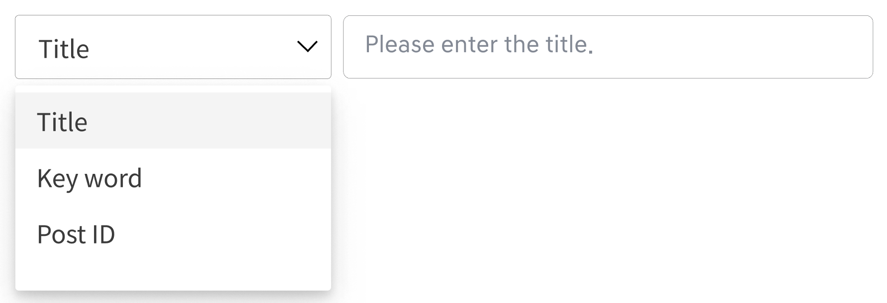
Search filter - Search criteria
- The post search area shows the total number of posts, and the list displays Title, Attachment, and Date information.
- Clicking on the Attachment filename allows you to preview it. (For Attachment preview details, refer to 4. Bulletin board > Attachment area)
- [reset]: When clicked, resets the filter conditions and search results.
- [search]: When clicked, displays the search results for posts that match the set conditions.

Quick Link
- This is a feature that allows users to quickly access frequently visited menus.
- Users can add and delete desired menus individually.
- Clicking on a registered menu in the list will take you to that menu screen.
- Quick Links may be preconfigured according to the user’s job.
Using Quick Link on the Home Screen
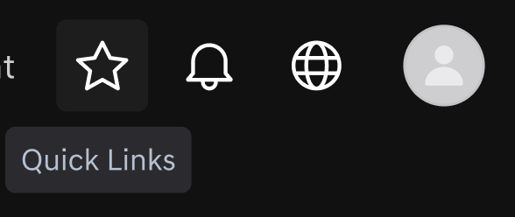
Quick Link
- Quick links are provided on the right side of the home screen.
- All registered Quick link lists are displayed on the screen, and up to 20 can be registered and checked. If a menu name is long, it is displayed with line breaks so the full name is visible.
- Hovering over a menu name displays the full menu path.
- Clicking the star icon to the right of the menu name removes it from the quick link list.
    -  : Status of being added to quick link
    -  : Status of not being added to quick link
- Pressing the [edit] button next to the quick link menu creates a popup that manages the entire quick link list. (description below)
- Board you've visited below Quick link displays recently visited menus.
- Clicking the star icon in that list immediately adds it to quick links.
- If the menu is already added to quick links, clicking the icon will remove it from quick links.
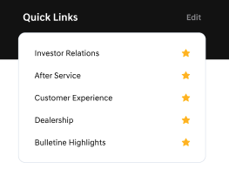
Quick Links on Home Screen
Using Quick Link from Other Screens
- Clicking the star icon in the upper right area of the Dealers screen creates a Quick links list on the right.
- This list can be accessed from any screen within Dealers by clicking the star icon at the top.
- Clicking a menu name in the list takes you to that menu.
- Clicking the star icon removes it from Quick link.
- Clicking the [Add Quick Links] button at the bottom creates a popup that manages the entire quick link list (description below)
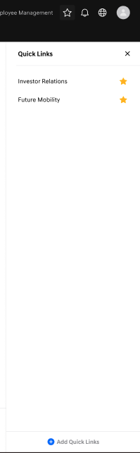
Quick Link Panel
Quick Link Settings
- This is a popup that appears when you click edit next to Quick link on the home screen, or click [Add Quick links] at the bottom of the Quick link sheet. 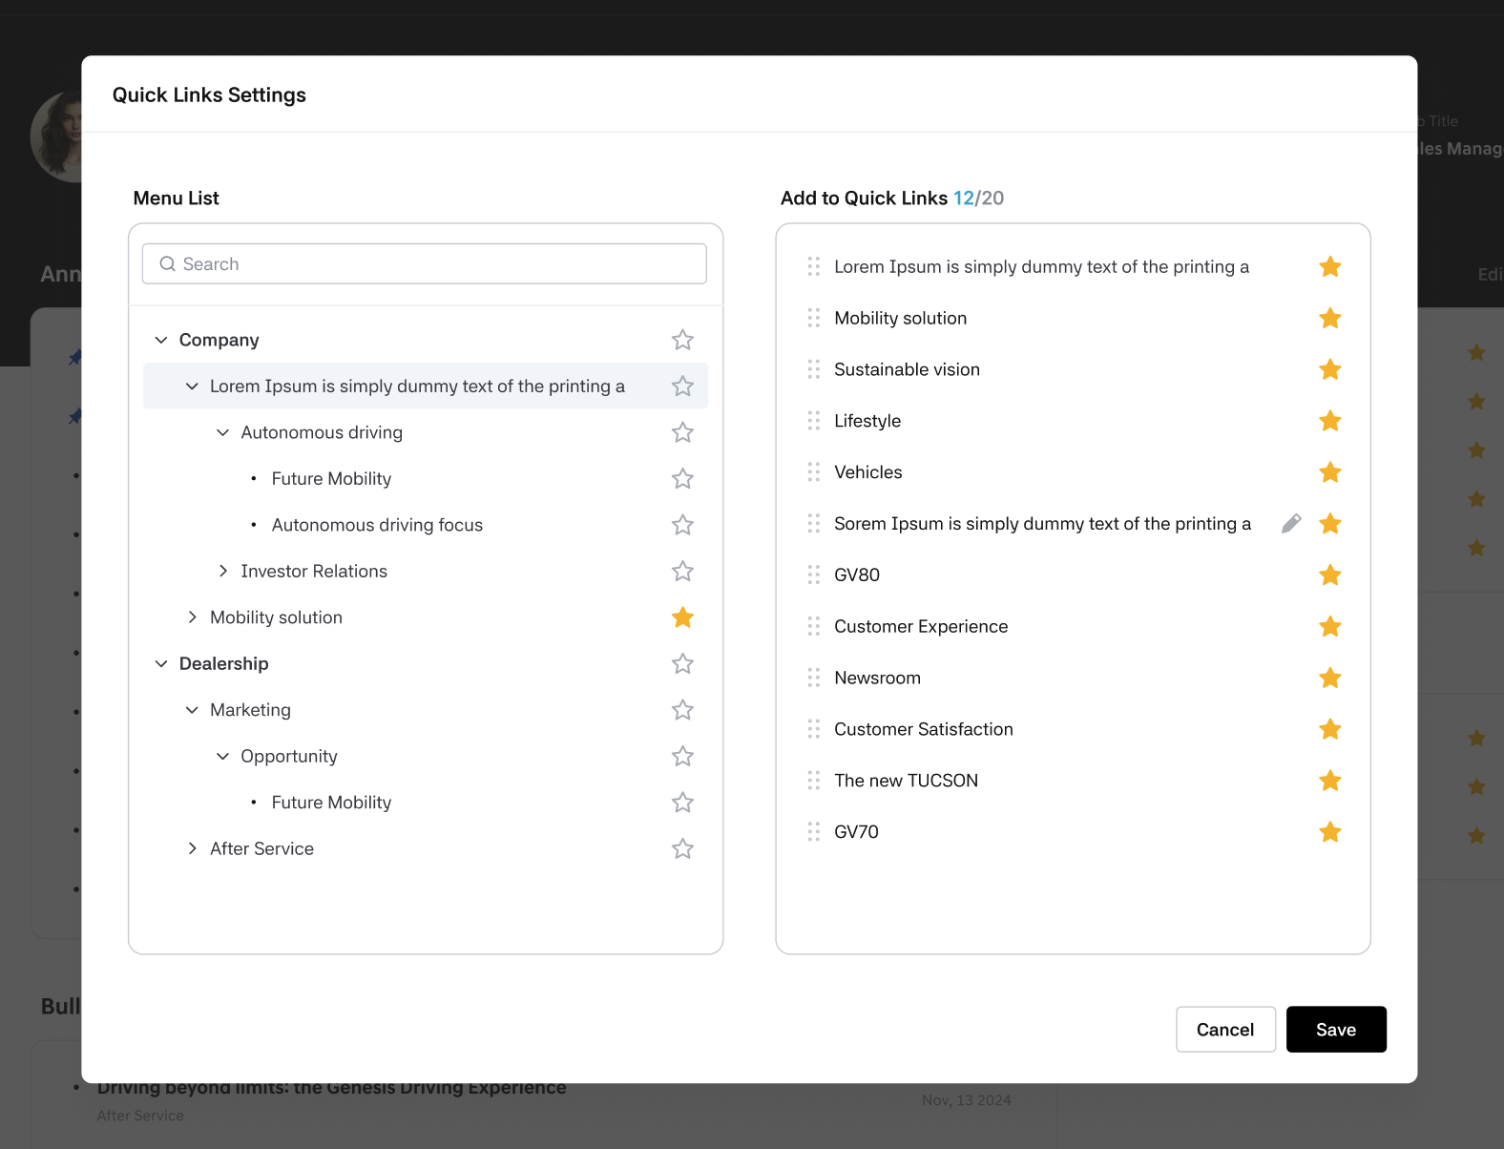
Quick Link Setting Popup
- Menu List shows the list of menus displayed on the Dealers screen according to the user's permissions.
- Using the search box at the top, you can quickly find a menu by searching for its name.
- Add to Quick Links is a list of menus added by the user. The first added menu is at the top, and clicking the six-dot drag handle icon on the left allows you to change the order as desired.
- Up to 20 can be added to quick links.
- Pressing the [cancel] button closes the window without saving the changes made so far. Pressing the [save] button saves the changes and the new quick link list is reflected in all quick link lists.
Rename Quick Link
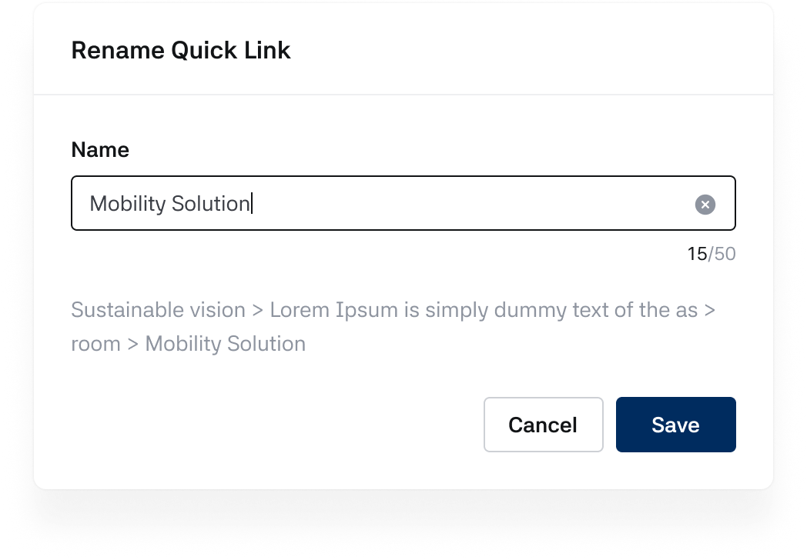
Rename Quick Link

- Hovering over a Quick Link item displays a pencil icon. Clicking it opens the Rename Quick Link modal.
- If no custom name has been saved, the field placeholder displays the original menu name. If a custom name exists, it is pre-filled.
- Maximum 50 characters. Numbers and special characters are allowed. A character counter is provided.
- Clearing the field via the X button and losing focus restores the original menu name as text.
- The full menu path is displayed below the text field.
- Cancel closes the modal without saving. Save is always enabled.

After Saving
- The custom name is reflected in the Quick Links area, Quick Links slide panel, and "Board you've visited" (for menus added to Quick Links).
- Not reflected in the Menu List within Quick Link Settings, GNB/SNB, or "Board you've visited" for menus not added to Quick Links.
- Duplicate custom names are allowed across different menus.
- Custom names are applied per dealer and are not synced across dealers for multi-dealer users.
- If a menu is removed from Quick Links and re-added, the custom name is reset.

Board you’ve visited
- This is a feature that allows users to quickly access recently visited menus.
- The list displays up to five.
- Clicking on a registered menu in the list will take you to that menu screen.
- Pressing the star icon registers or removes it from the Quick-Links list above.
- If 20 Quick-Links are already registered, new ones cannot be added.
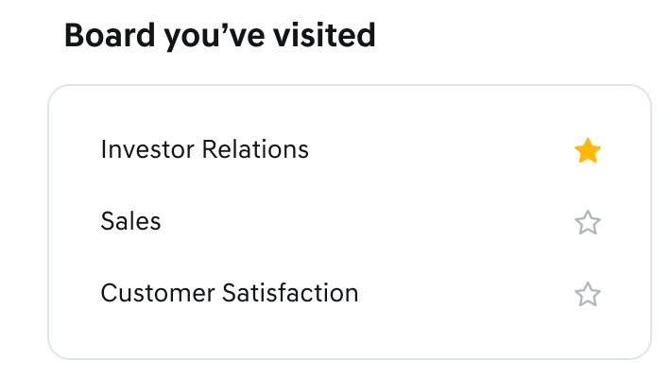
Board you've visited on Home Screen

Bulletin Highlight
- The post collection feature is an area where posts registered as Important notices in general bulletin boards are collected and displayed, and only posts from bulletin boards with permissions are shown.
- A maximum of 10 posts are sorted by the most recent registration order.
- Title and date information are displayed.
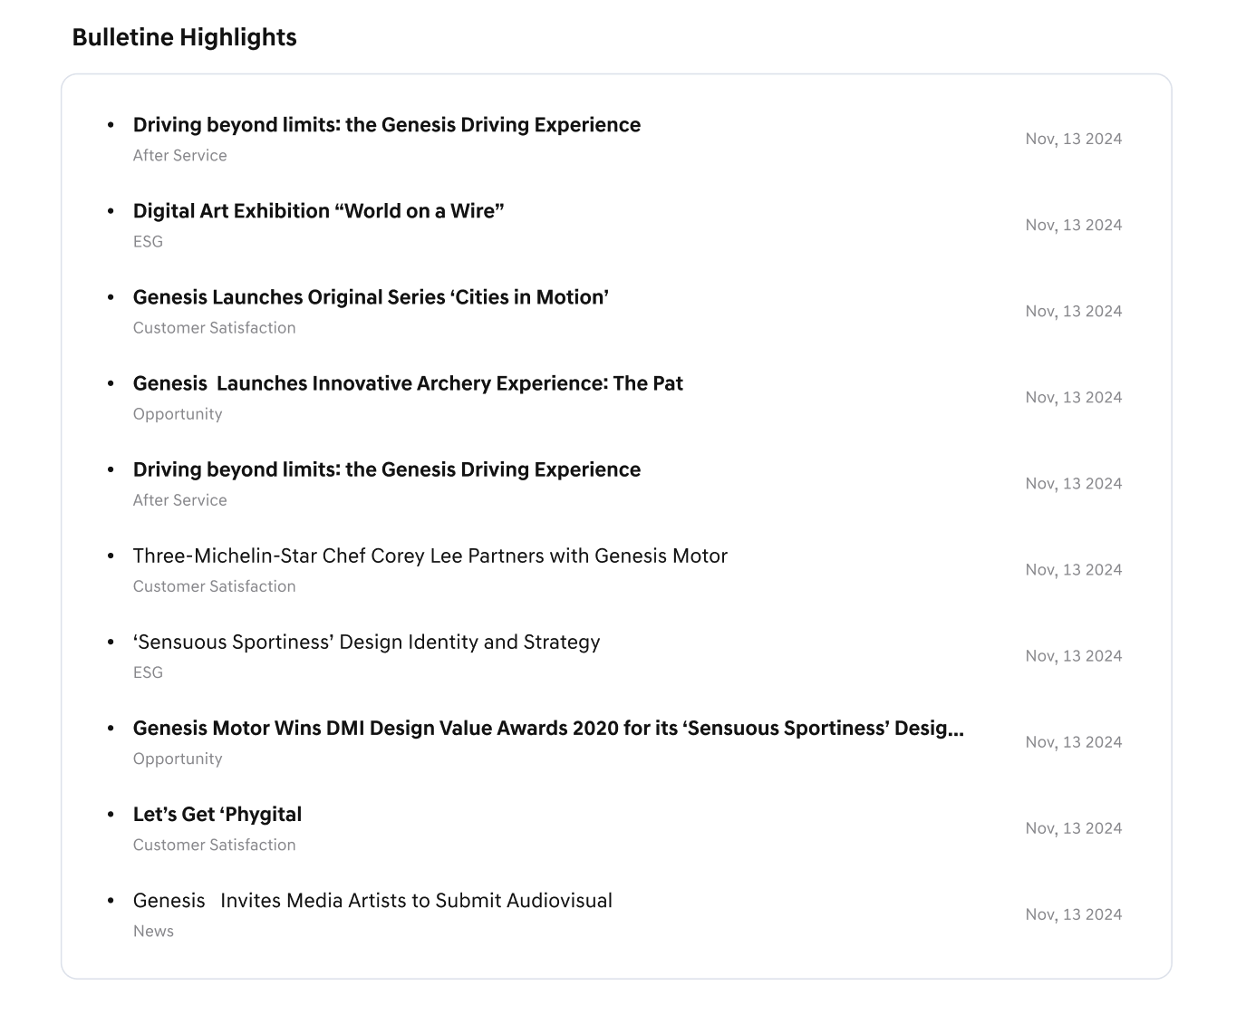
Bulletin Highlights on Home Screen
    - Title: When selected, you will be directed to the detailed screen of that post.
    - Date: The date when the post was published is displayed.
    - New flag: The New flag is automatically applied to new posts according to the tenant configuration.
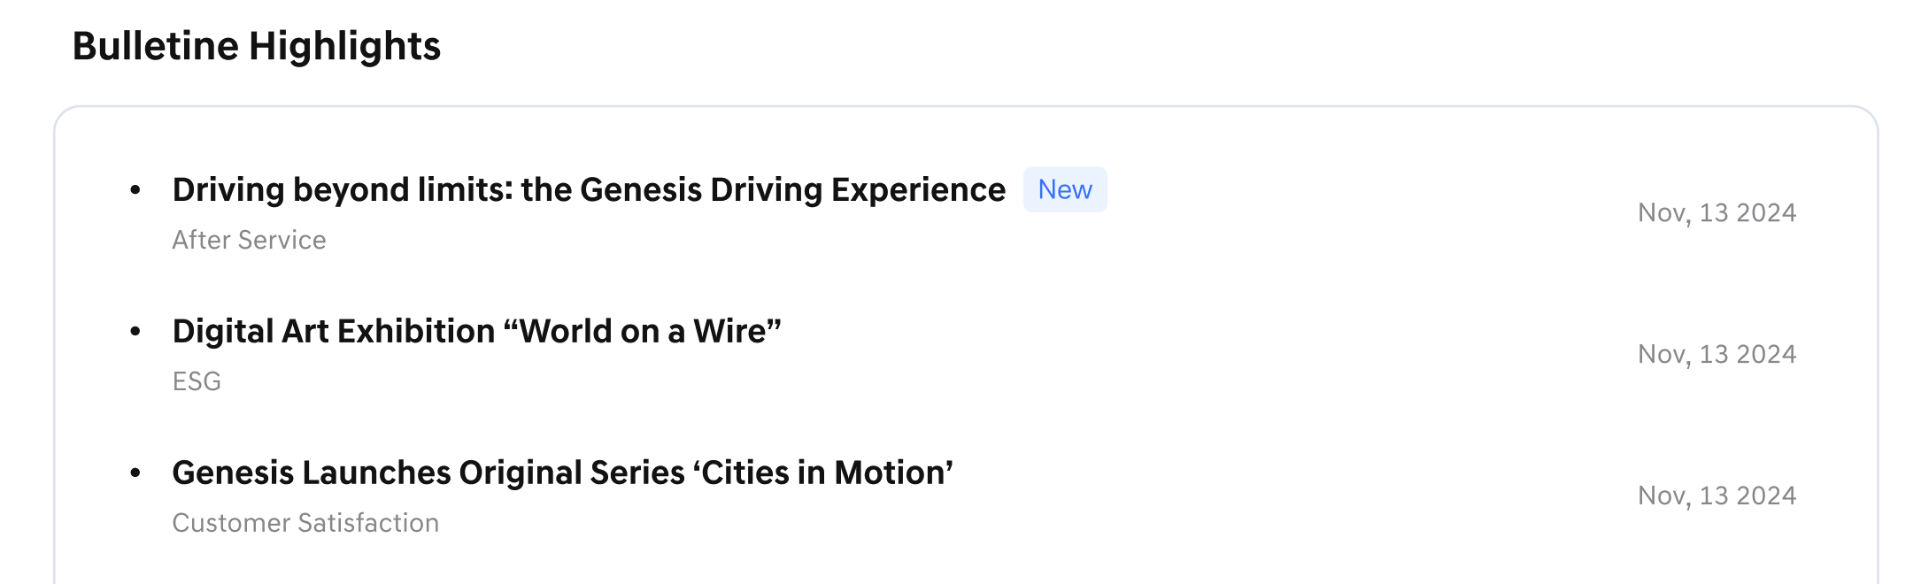
Bulletin Highlight – Icon/Title/Date/Flag

Footer
- In the footer area at the very bottom of the Dealers homepage, you can check the Terms, privacy policy, FAQ, Cookie policy and User Manual content.

Service Term
- Clicking on Service Term allows you to check the latest service terms.
- When you click Service Term, the Service Term page will open in a new tab.
- Clicking on the select box in the upper right provides previous versions of the service terms.
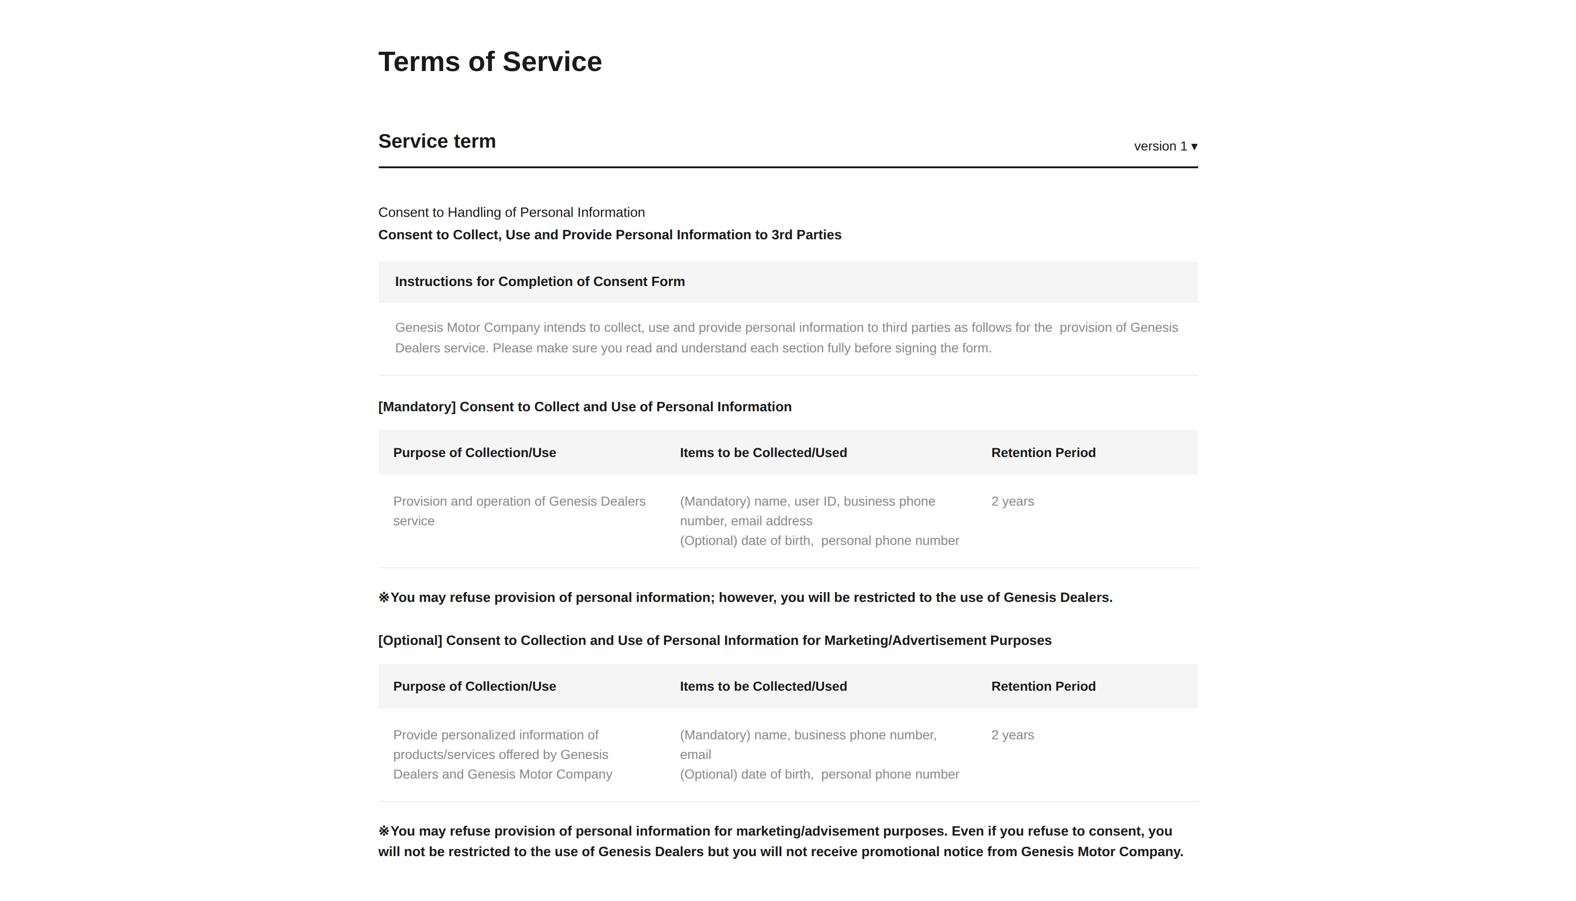
Service Term

Privacy Policy
- Clicking on Privacy policy allows you to check the latest personal information policy.
- When you click Privacy Policy, the Privacy Policy page will open in a new tab.
- Clicking on the select box in the upper right provides previous versions of the personal information policy.
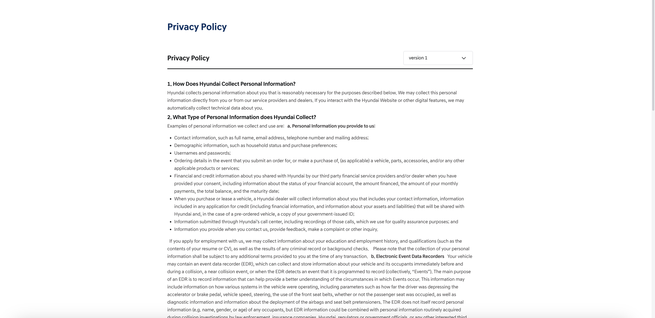
Privacy policy

FAQ
- Clicking on FAQ allows you to check frequently asked questions.
- When you click FAQ, the FAQ page will open in a new tab.
- The left area provides the major categories of questions.
- When you select a category, appropriate questions are displayed in the right area.
- You can select a second category in the filter at the top.
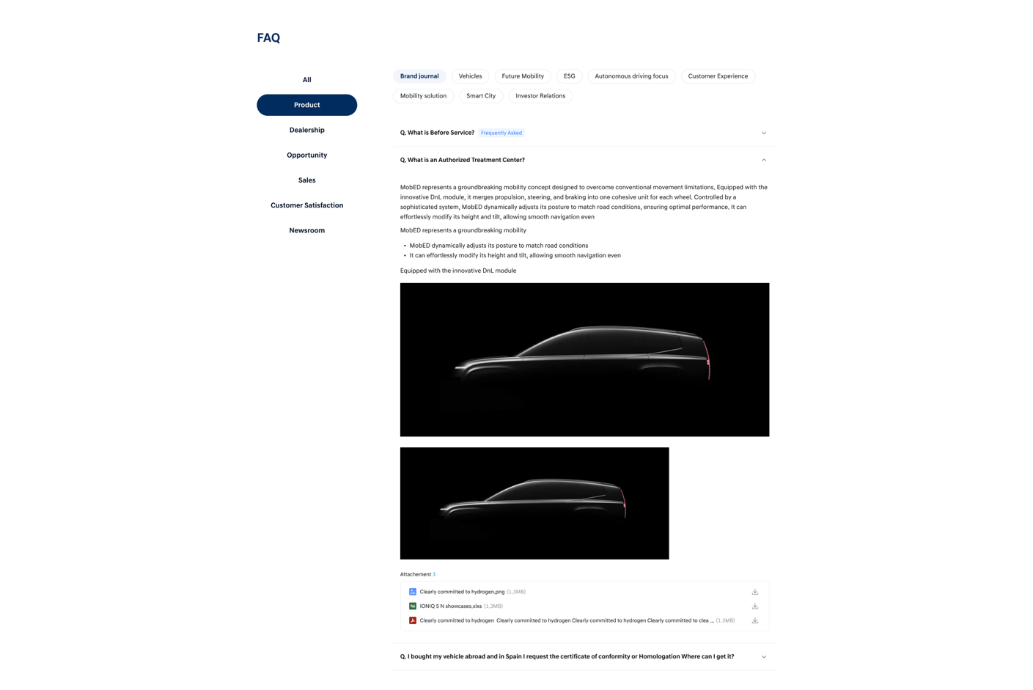
FAQ
- FAQ categories are displayed up to a maximum of 3.
- If there is no relevant content, it will not be displayed.
- Clicking on a question title allows you to check the detailed content.
- Clicking an attached file opens a preview, and the download icon allows you to save the file.
- A "Frequently asked" badge is provided for frequently asked questions. 

Cookie policy
- Clicking on Cookie policy allows you to check the cookie policy content.
- When you click Cookie Policy, the Cookie Policy page will open in a new tab.
- Clicking on the select box in the upper right allows you to check the content of previous versions of the policy.
- Clicking the [cookie settings] button at the top creates a cookie settings popup.
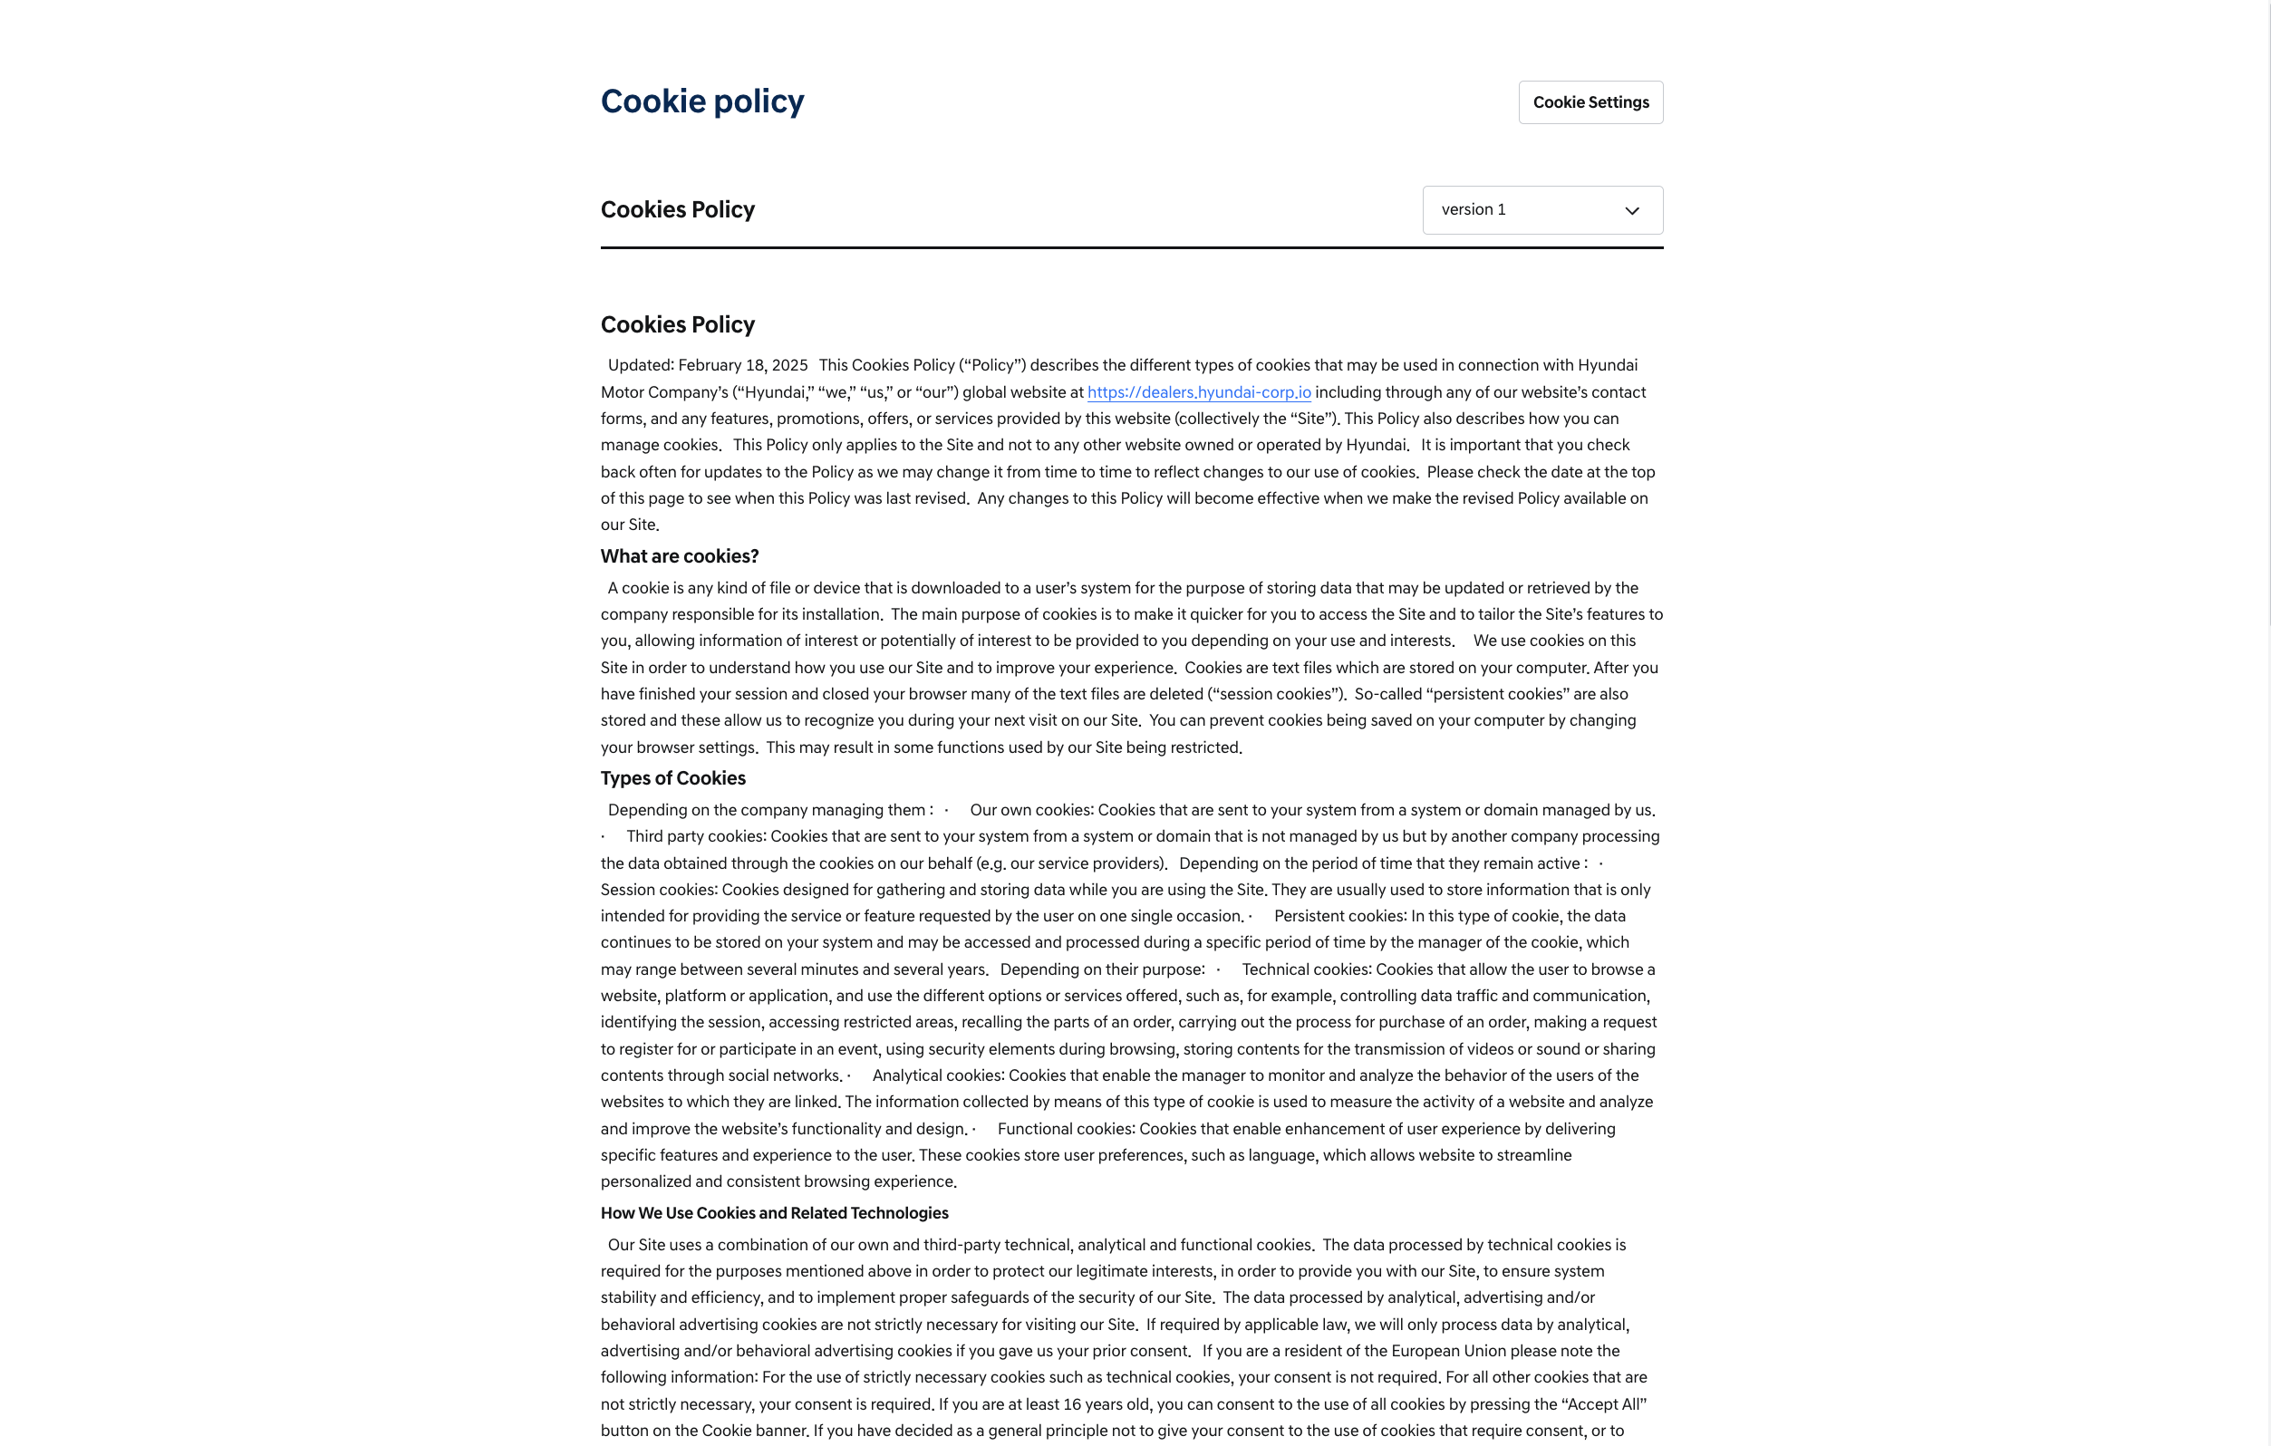
Cookie Policy

- In the popup, you can reset and save the cookie values that you individually consent to.
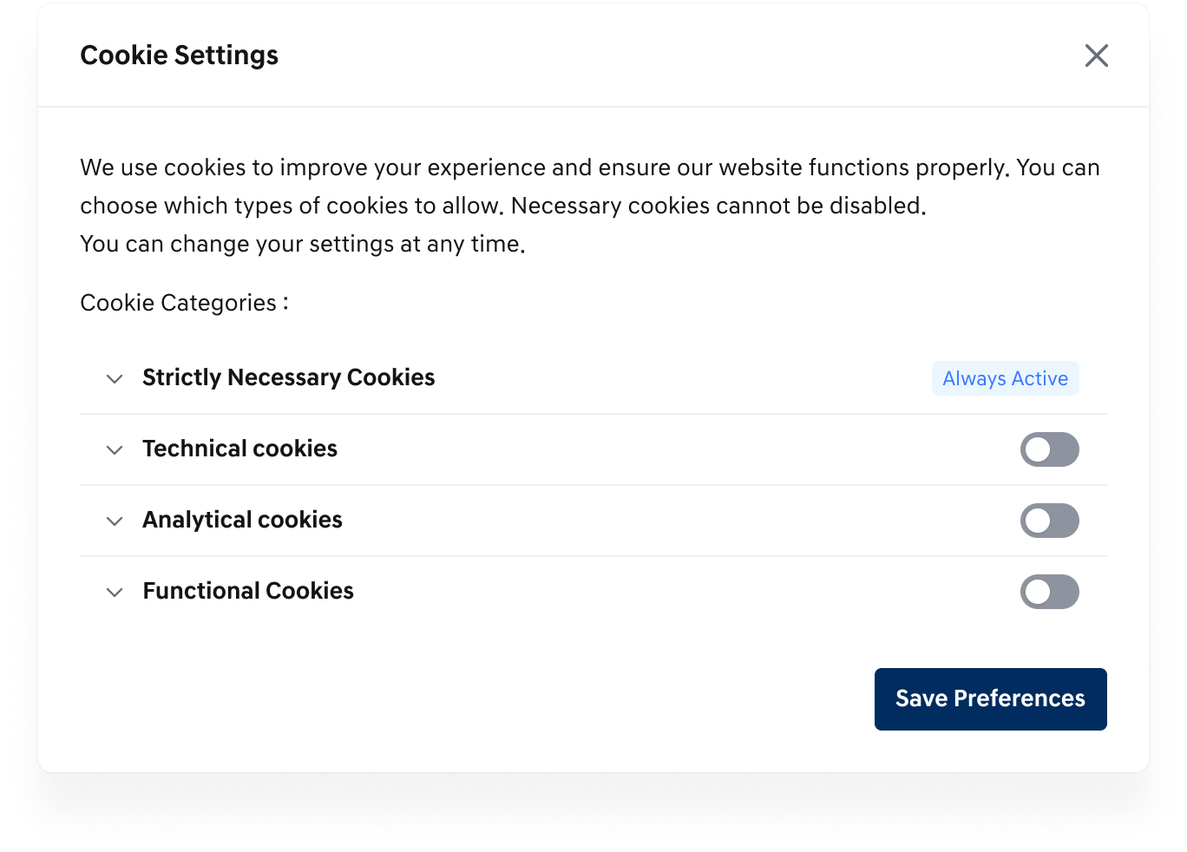
Cookie Settings
User Manual
- Clicking on User Manual allows you to check the user manual content.
- When you click User Manual, the FAQ screen with user manual-related content will open in a new tab.

Search Result
- Keyword Search
- Search results matching the entered search keywords are displayed. If there are attachments, they are also displayed.
- Clicking on a post takes you to the post detail screen.
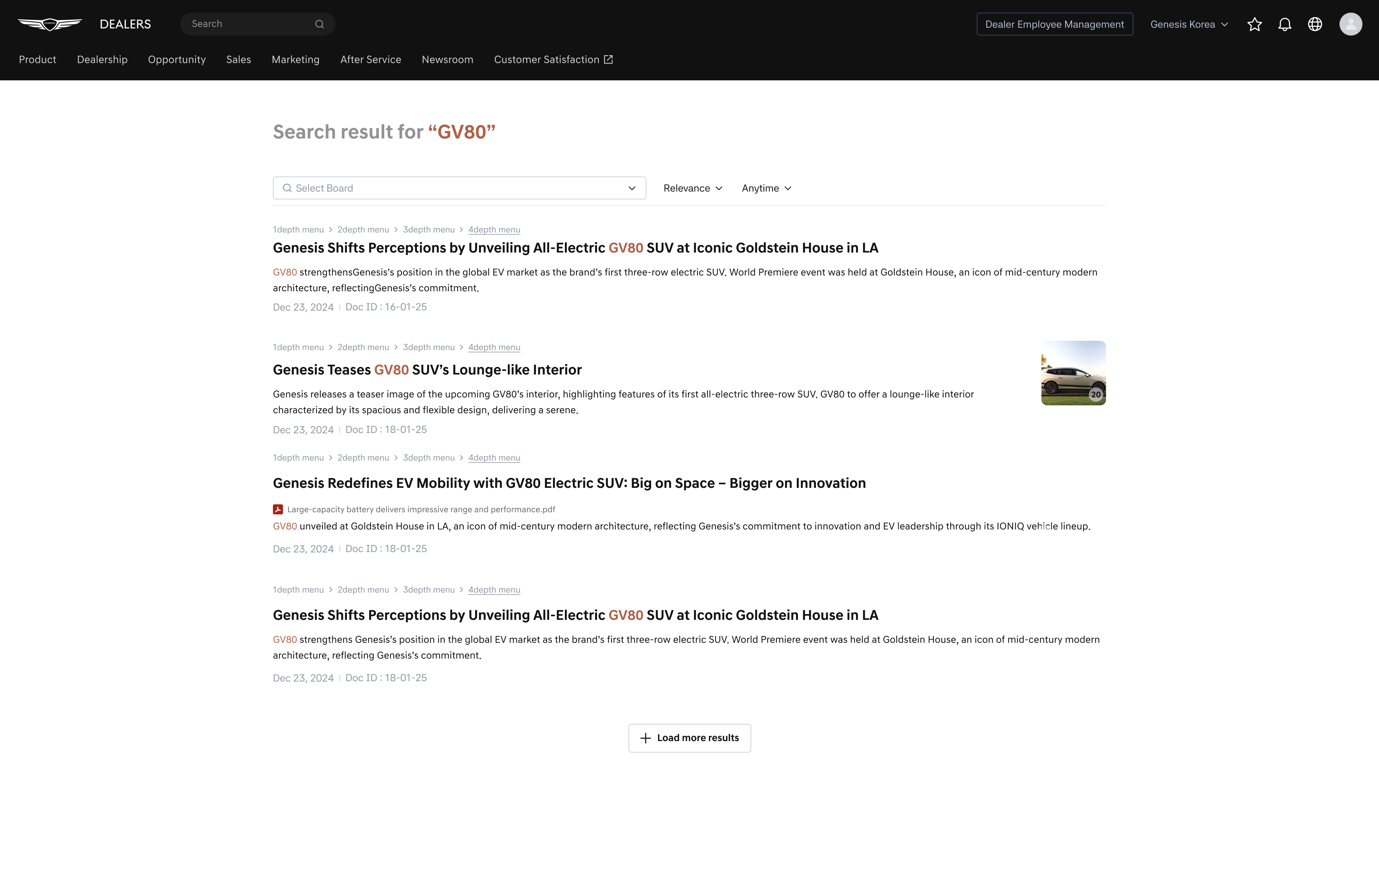
Keyword Search Result
- Sort Search Results
- Search results can be sorted by specific conditions.
  - Relevant: By keyword accuracy
  - Most recent: By latest
  - 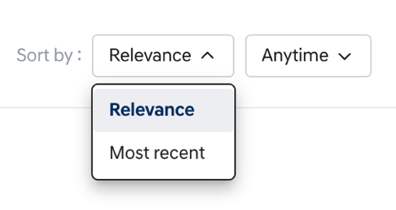
Sort Search Result by condition1
  - 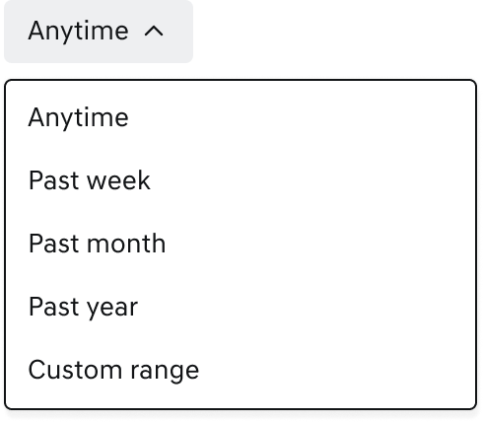
Sort Search Result by condition2
  - anytime: Entire period
  - past week: Past 1 week
  - past month: Past 1 month
  - past year: Past 1 year
  - custom range: When clicked, the date range function is displayed, allowing you to search by entering a desired period
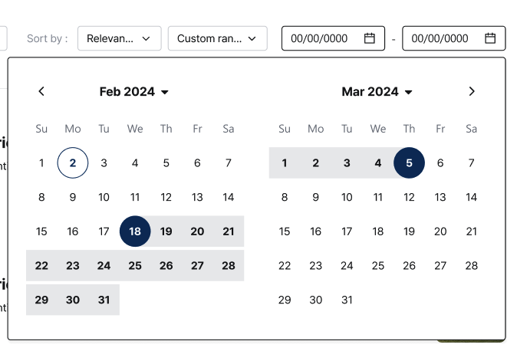
Search Result by date range
- Once you have searched, you can filter the results by selecting one or more boards. Only posts within the selected boards are displayed. If no board is selected, all board results are shown by default.
- 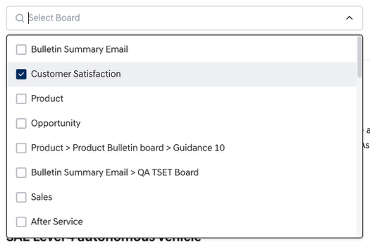
Select Board
- Search results for posts with attachments or thumbnails are displayed as follows.
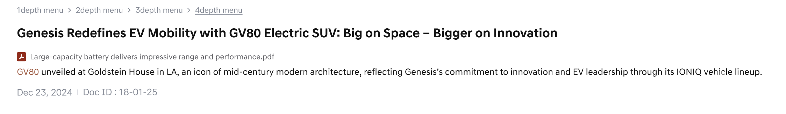
Search Result with attachments
- Clicking on an attachment allows you to view a preview.
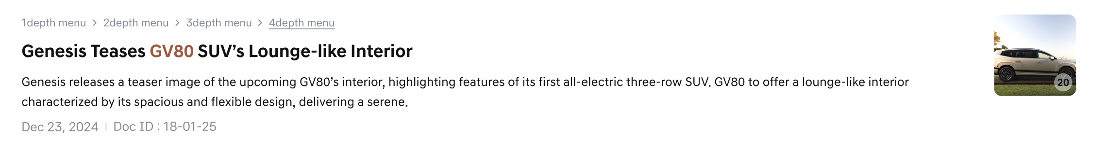
Search Result with a preview
- Clicking on the post title, body, thumbnail, etc. takes you to the post detail screen.
- Clicking the [Load more result] button at the bottom of the search results loads 20 more search results at a time, and the button is not displayed if there are no more search results.

Bulletin Board
- When a menu is clicked, the bulletin board screen connected to the menu is displayed.
- The selected menu name, menu description is displayed at the top, and the post search area and post search results area are displayed.
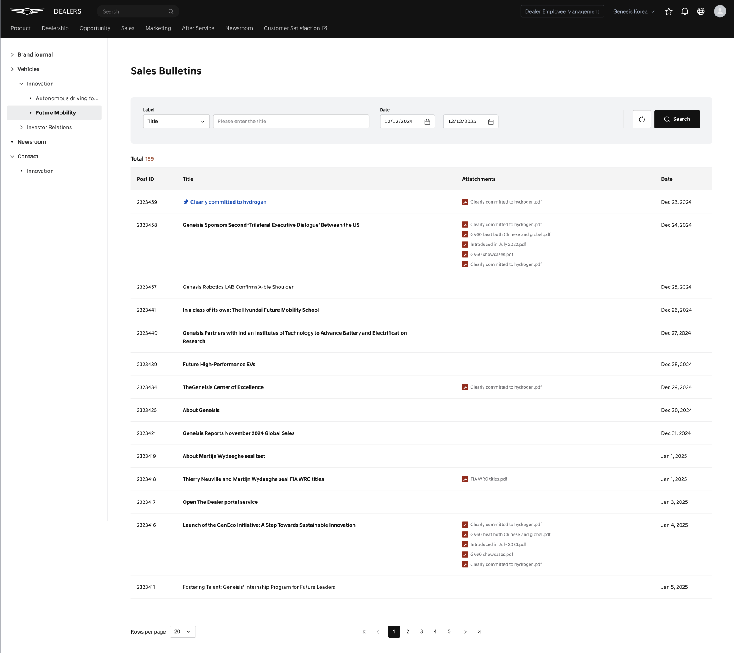
Bulletin board

Post List
- Posts in the Post List are only displayed if the user has the appropriate access permissions for each post.
If a post without access permission is clicked, a "No Permission" pop-up will appear and the content will not be viewable.
- For dealer-affiliated employee profiles, unread posts are displayed in bold, while read posts appear in regular font, allowing users to distinguish between read and unread posts.
- The post list displays the following required fields: Post ID, Title, and Date.
- Depending on the Attachments and Additional Attribute settings, list items may also appear in the search area and results.
- Posts may be displayed in the order they were updated in the BO, and any Field Name included in the search criteria will also be shown as a column in the list.
- Sorting options are available to organize posts by Date (latest to oldest) or Title (alphabetical ascending or descending).
- Default Default search period (auto setting): On the post list screen, the Date search condition is automatically initialized when the user enters the screen.
    - The End date is automatically set to today’s date (current date).
    - The Start date is automatically set to 1 year before today’s date.
      - Example) If today is 2026-04-20:
        - Start date: 2025-04-20
        - End date: 2026-04-20
- By default, 20 posts are displayed, and you can select up to 50 posts to display from the bottom left.
- The post list includes a pagination feature that allows you to navigate between page groups using the < and > buttons, move to the first page using <<, and move to the last page using >>.
- Example screen when additional attributes are displayed:
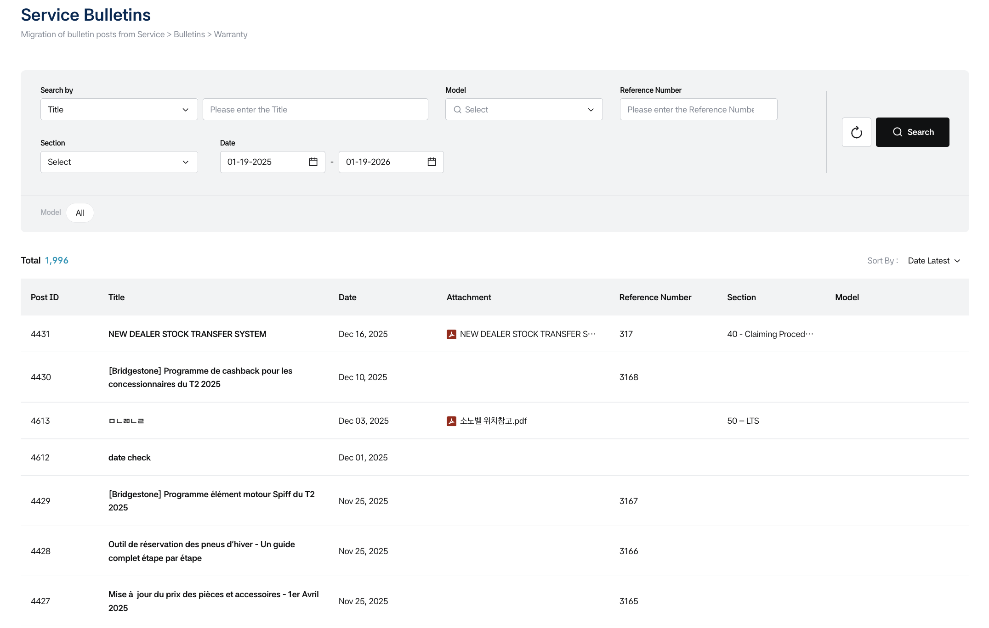
Bulletin boards with additional attributes
Search with Additional Attributes
- An example of a search area with additional attributes is as follows:
    - For the radio button format, it appears in the search area as shown below, and the initial setting is provided with All selected.
    - You can search by selecting one value with the radio button.
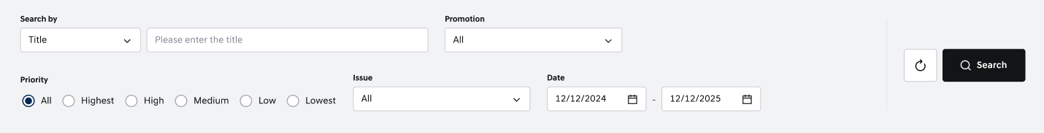
Search - Radio button
- For single/multiple selection dropdown formats, they appear in the search area like the Tag example below, and the initial setting is provided with All selected.
- When multiple selection dropdown items are selected, the selected chip filters are displayed below.
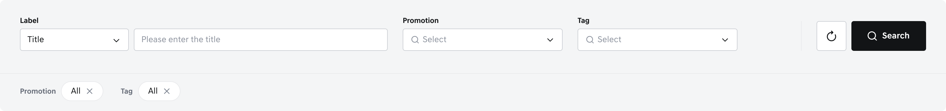
Search – Single/Multi selection
    - When selecting an item within a single selection dropdown, you can select one value.
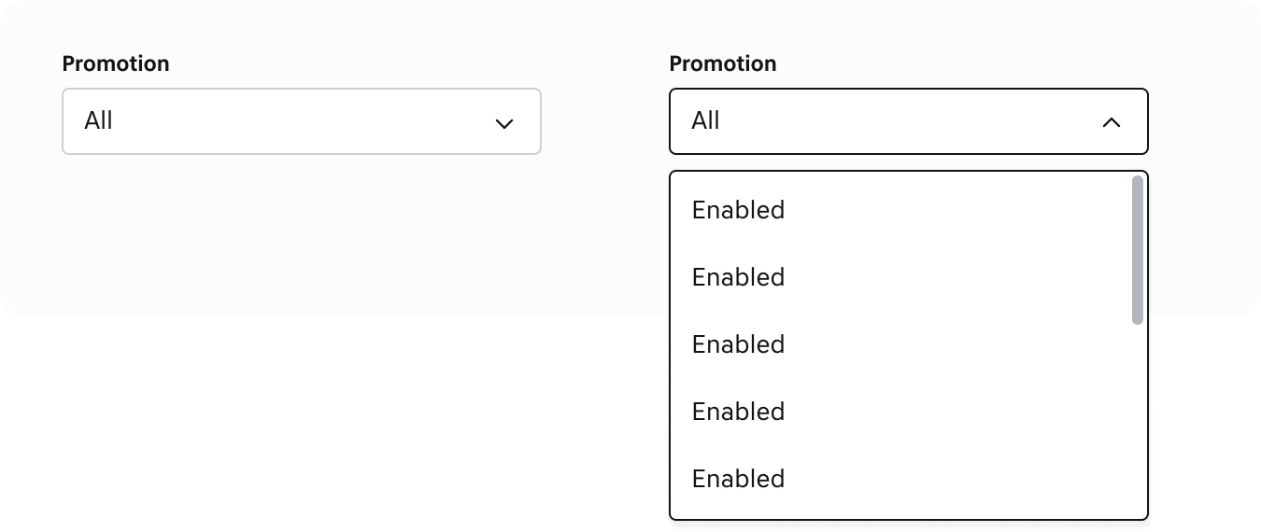
Search – Single selection dropdown
    - When selecting items within a multiple selection dropdown, you can select multiple values, and the selected values are displayed in the bottom area of the search filter.
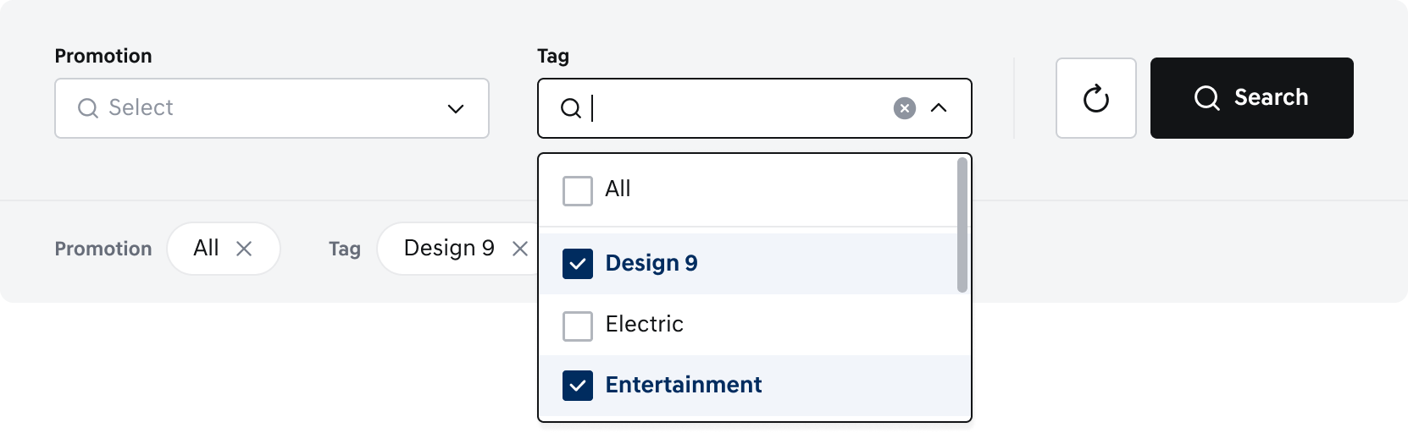
Search – Multiple selection dropdown
    - For Input box (text) type, users can directly enter text to search for values that match the data entered in the corresponding additional attribute Field Name.
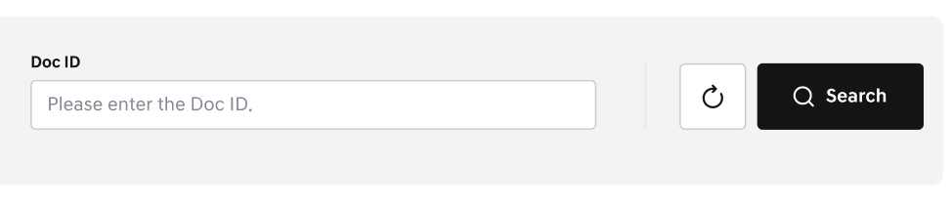
Search - Input box(text)
    - When a specific field is selected in the dropdown, the selected value is displayed as a chip filter at the bottom of the search area, and when [Search] is clicked with that condition, search results matching the condition are displayed.
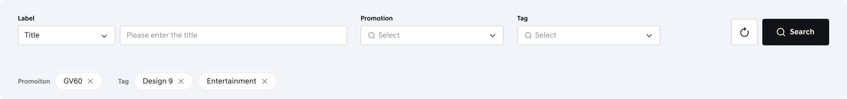
Search - Chip filters

Post Search Results Area
- Total: The total number of posts displayed reflects the user's access permissions.
- Sort by: Date sorting is based on the post’s publication start date — you can sort from latest to oldest or oldest to latest. Title sorting arranges posts in alphabetical order — ascending (A, B, C ~) or descending (Z, Y, X ~).
  - Important Notice posts are always displayed at the top of the list above regular posts, followed by the selected sorting order.
  - New flag: The New flag is automatically applied to new posts according to the tenant configuration.
- Post ID: The post ID is displayed.
- Title: Clicking on the title takes you to the post detail screen.
  - For important notice posts, they are fixed at the top and a fixed icon is displayed to the left of the title.
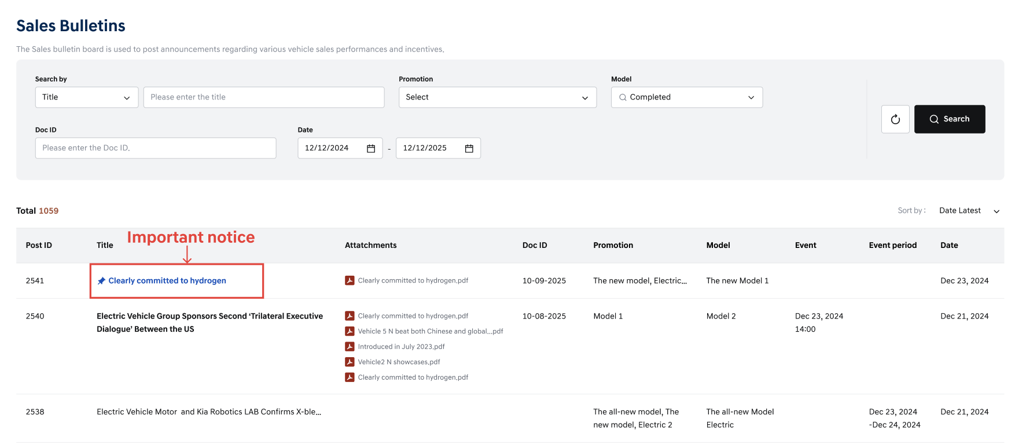
Post Search Results Area
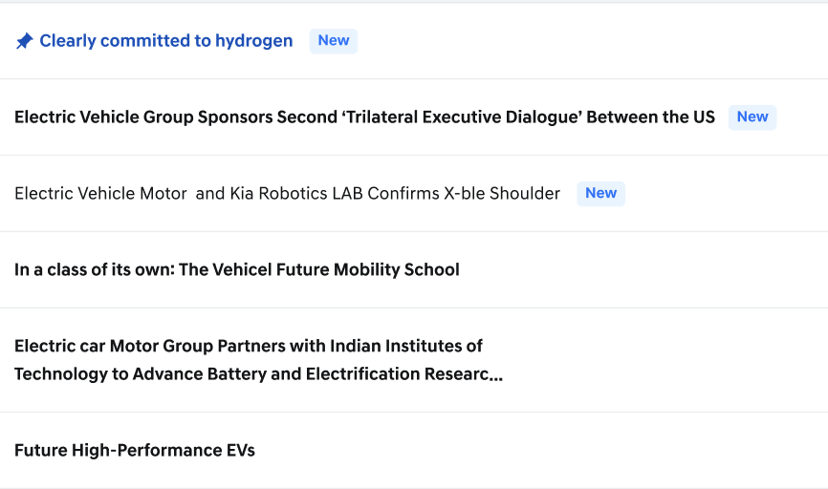
Post – Icon/Title/Date/Flag
- Attachments: Up to 5 attachments can be displayed.
  - If the attachment filename exceeds the area, you can see the full filename in a tooltip when hovering over the filename.
  - Clicking on the attachment icon and filename displays a preview popup, and watermarks are displayed on each page of PDF files.
  - The watermark text is displayed according to the following format and rules:
    - Format: Dealer No - User ID (nickname) - Date – Time
      - Example: 1000-sujee-12/18/2024 9:40:16 AM
    - Dealer No: A value assigned when the dealer is created.
    - User ID: A value used like the dealer employee’s nickname.
    - Date: Displayed in MM/DD/YYYY format, based on the local time zone.
    - Time: Displayed in HH:MM:SS AM/PM format, based on the local time zone.
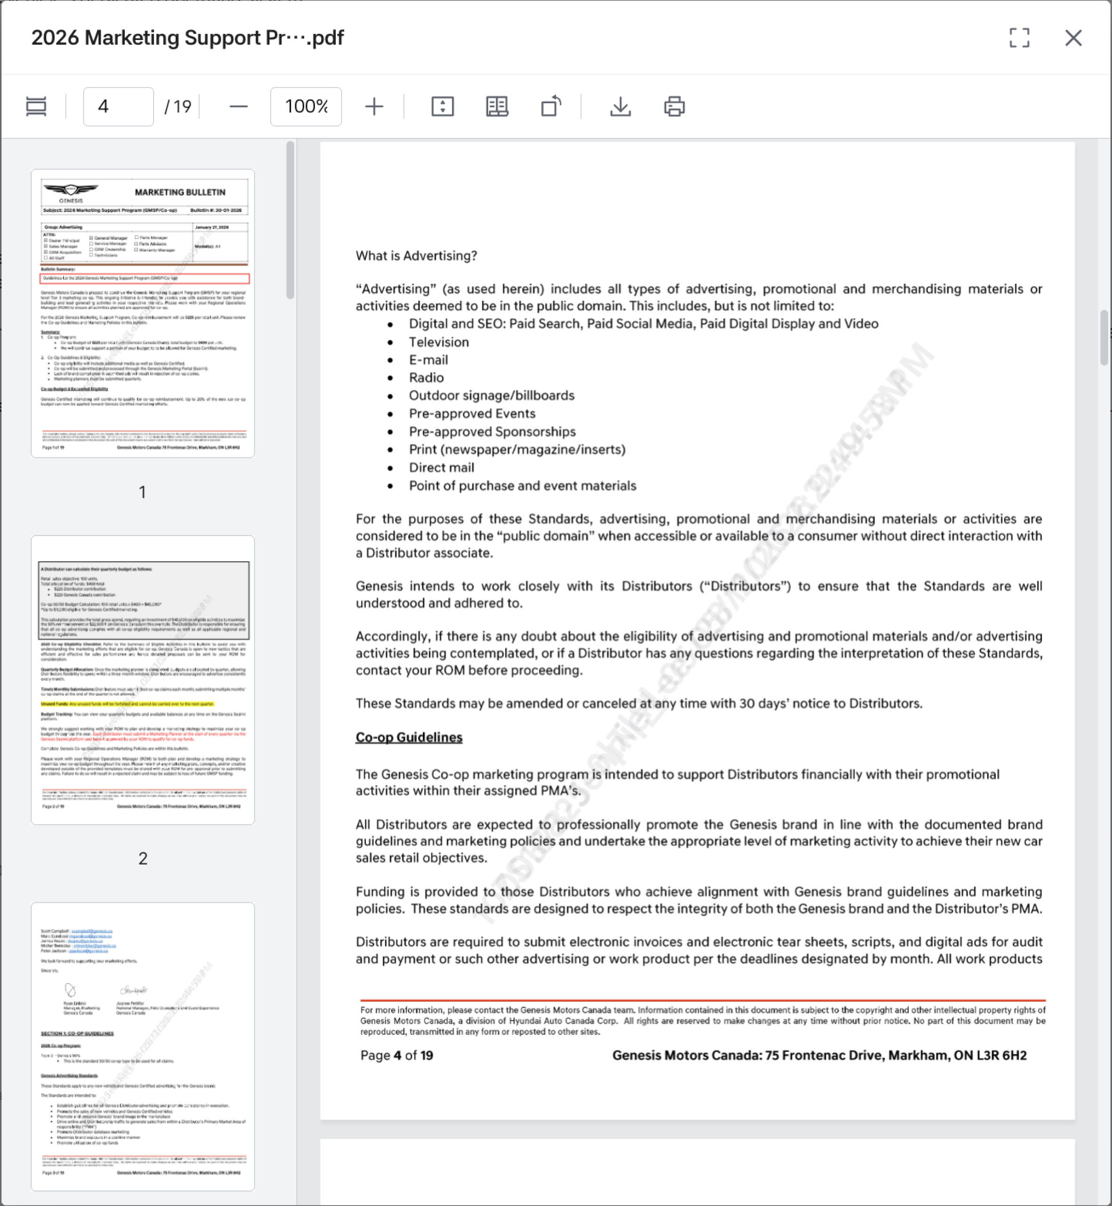
PDF preview
  - The top left of the popup window displays the filename and extension, and the top right has buttons for full view and close. 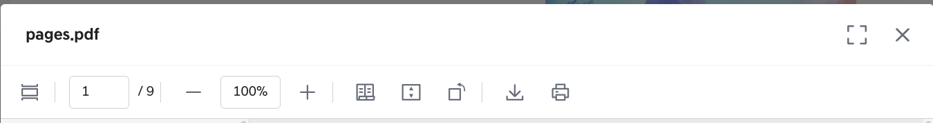
PDF Header Area
  - Clicking on icons from the left performs the following actions:
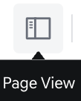
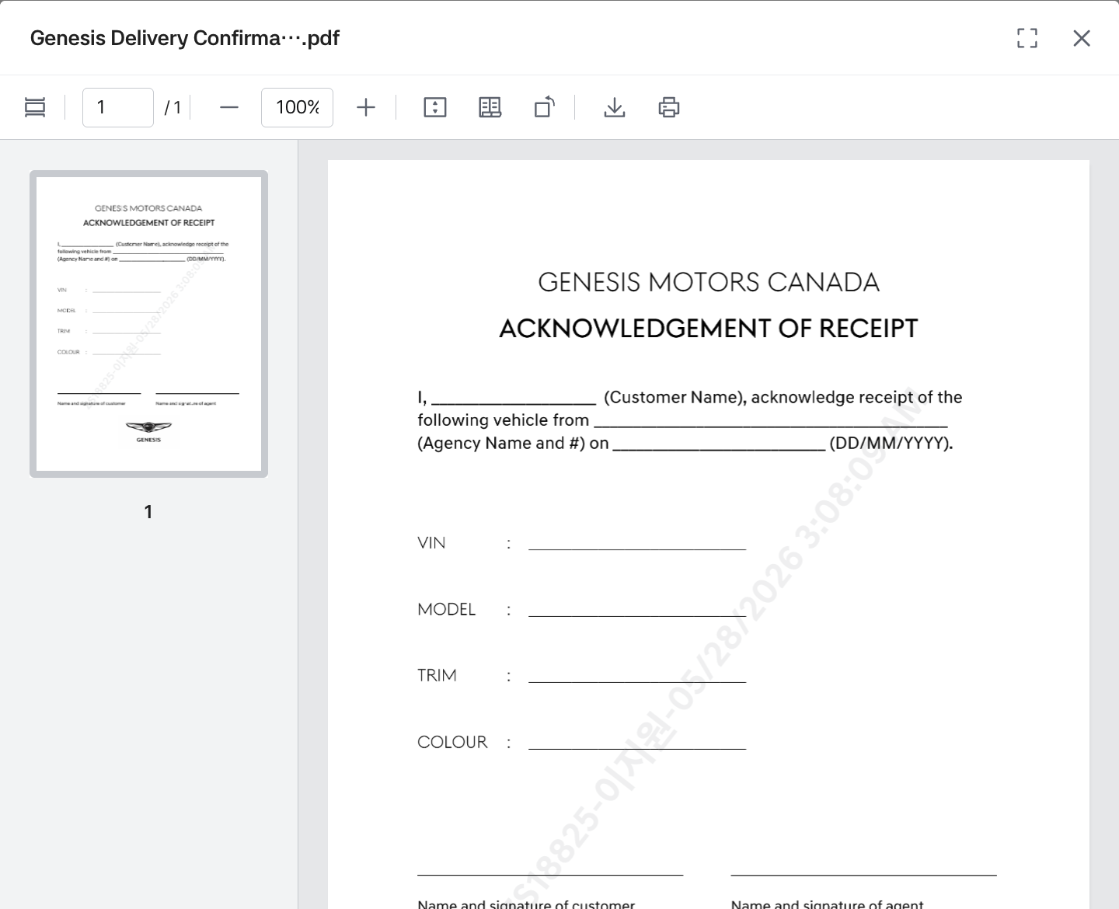 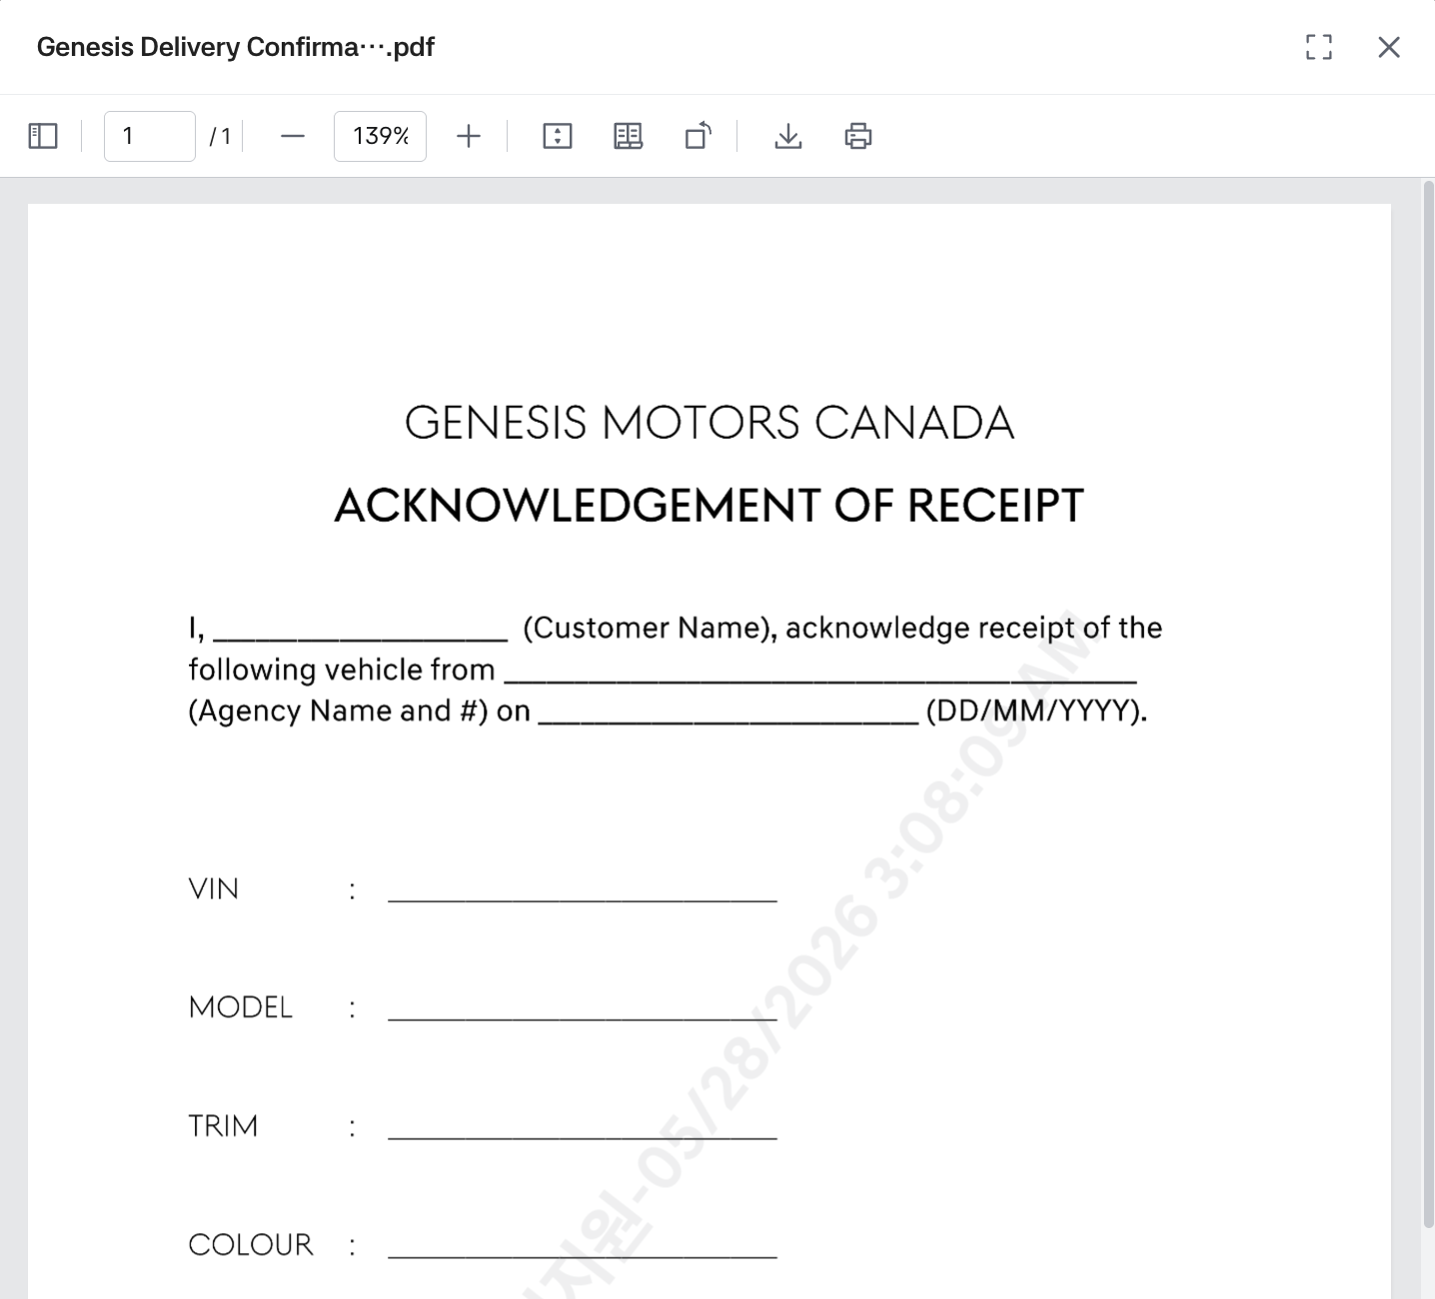
- View settings: You can set thumbnail preview view/normal page view.
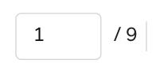
- View current page number/total page number, and view a page by entering the desired page number.

- Enlarge/Reduce: You can enlarge or reduce the file by entering the file ratio and clicking the -/+ buttons (minimum 50%, maximum 150%).
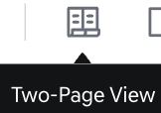 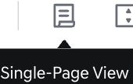
- Two/Single Page: You can set two-page view/one-page view.
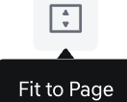 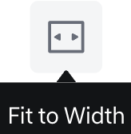
- View: You can set page height fit/page width fit view.

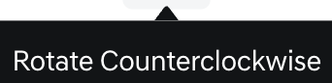
- Page rotation: You can rotate 90 degrees to the left.
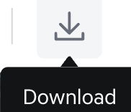
- Download: Clicking the download button takes you to the PDF file download page, where you can download the file with watermarks.
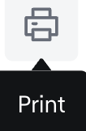
- Print: Clicking the print button displays the print settings page, allowing you to print the file with watermarks.
- Additional Attribute:
  - Additional attribute values set in the BO are displayed, and values are displayed according to five display formats.
  - Single selection: When selecting only one value, one value is shown as below, and it can be displayed by categories such as vehicle model names or engine types.
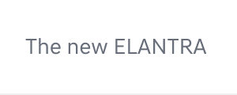 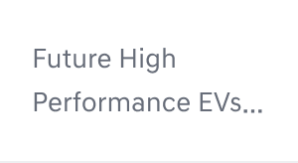
  - Multiple selection: When selecting multiple values, multiple values are shown as below, and various characteristics can be listed and displayed.
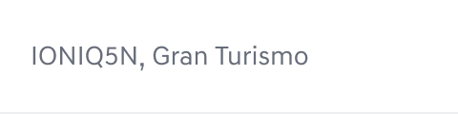 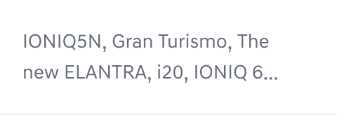
  - Input box (text): Displays a single text value entered for the corresponding Field Name. It is mainly used to show the official document number or document ID associated with the post’s attachment.
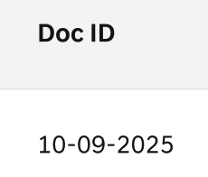 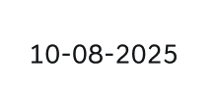
  - Date selection: Specific date or date + time data can be displayed. This can be used when certain events or notices occur.
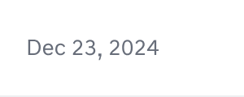 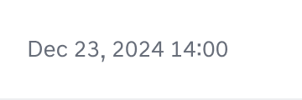
  - Period selection: Period or period + time data can be displayed, and this can be used to inform about specific event periods.
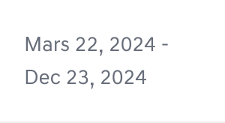 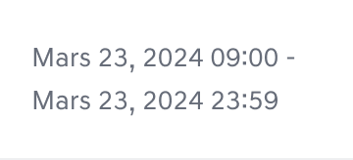
- Date: The date when the post was published is displayed, following the American date format.

Post Detail
- You can view posts registered in the BO.
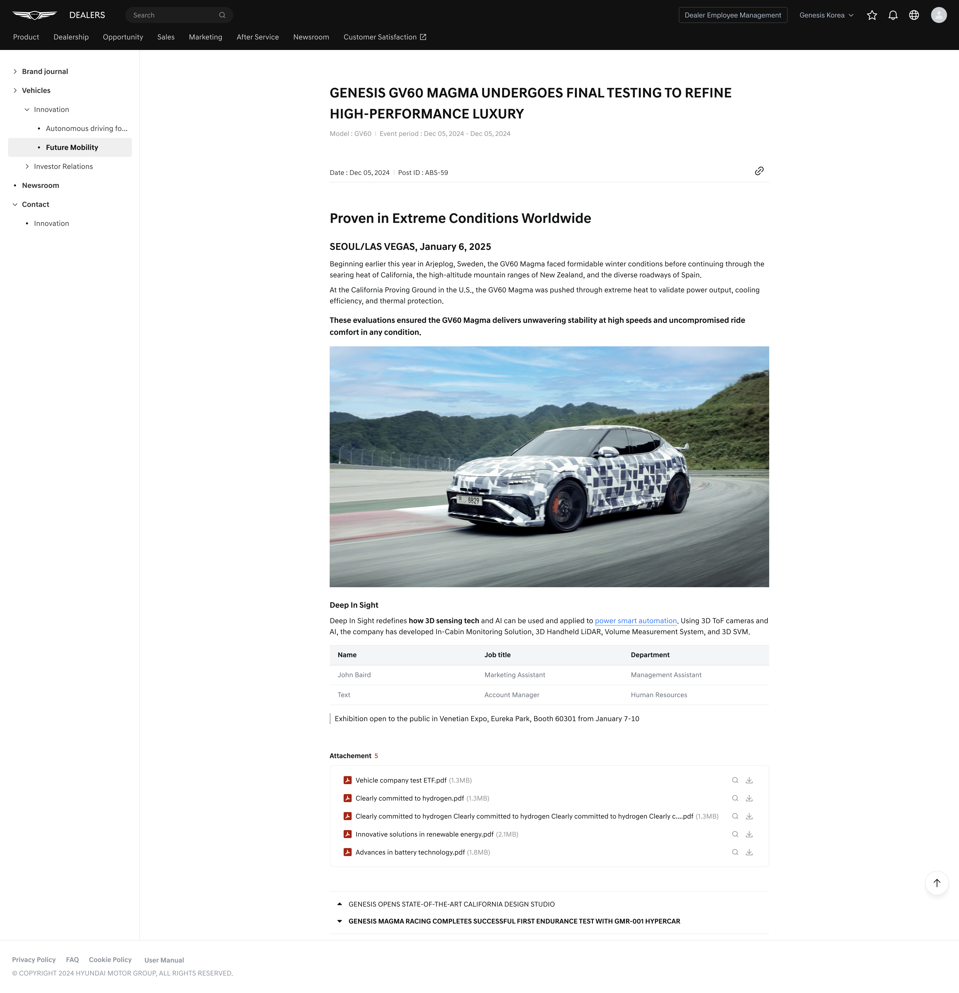
Post Detail
- Header: An example of post header information is as follows.
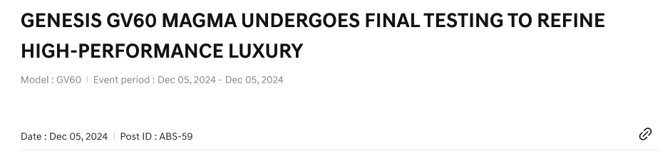
Post - Header Area
    - Title: The post title is displayed up to 200 characters.
    - Additional Attribute: Depending on the use of Additional attributes entered in the BO, they may be displayed/not displayed.
    - Date: The date when the post was registered is displayed, following the American date format.
    - Content: The Content entered in the BO post is displayed. It is displayed according to the styles added in the editor tool, such as text formats, lists, tables, images, icons, etc. entered in the Content.
    - Copy Link: This is a function to copy the link to the post. It can be used when you need to share the post.
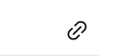

- Body: An example of post body information is as follows.
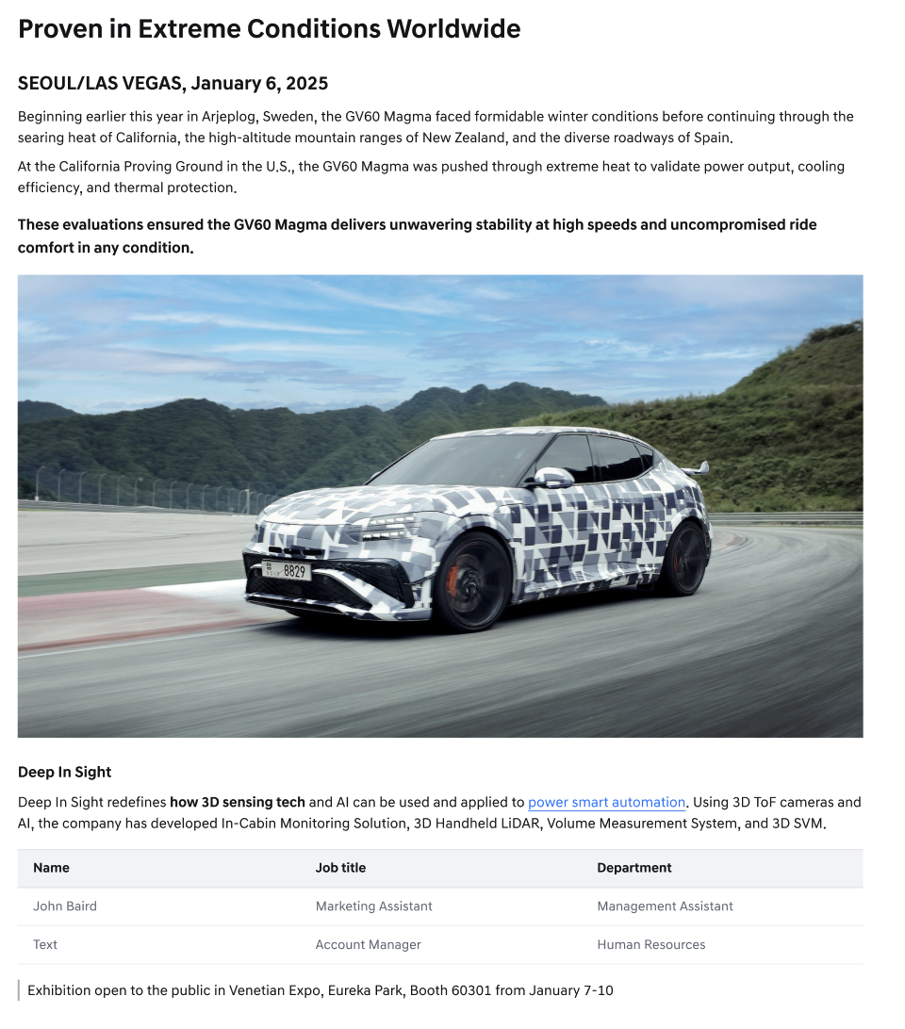
Post - Body
  - Image Gallery
      - When an image in the Content is clicked, it is displayed in Image gallery view.
      - The image filename is displayed on the top left, and download and close buttons are displayed on the top right.
      - When hovering over the image filename, the full filename is displayed as a tooltip.
      - When there are 15 or more thumbnails, previous and next buttons appear on both sides of the bottom image thumbnails.
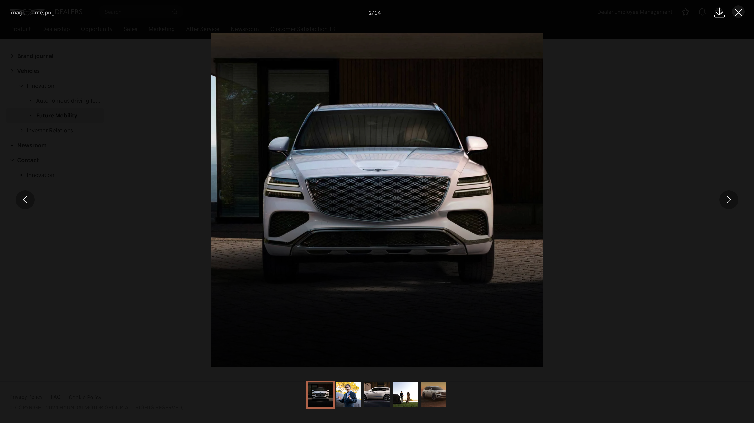
Image Gallery
  - Attachment: Up to 5 attachments can be displayed, and the number of attached files is displayed at the top. File preview and download are available.
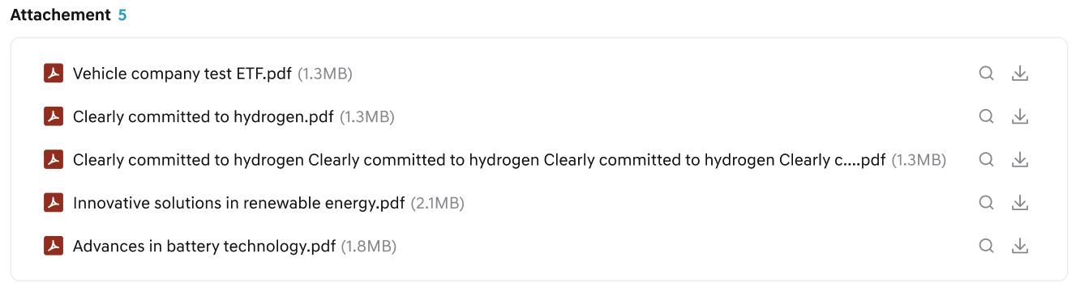
Post - Attachment
  - Preview, Next: Clicking allows you to see the previous or next post.
Post - Preview/Next
  - View List: Clicking takes you to the post list screen.
  - Top: Clicking takes you to the very top of the post. When scrolling down the post, the Top button appears in the bottom right.

Email Notification
- When a post with email notification set in the BO is registered, an email is sent.
- For posts in general boards, the email is sent only when the post belongs to a board that is currently exposed on the front end through a linked menu.
- For posts in the Announcement board, the email is sent as long as the board is exposed on the front end, regardless of whether it is linked to a menu or not.
- Email notifications are sent to the target audience 1 hour after the post is published on the front end.
    - This is the general post email screen:
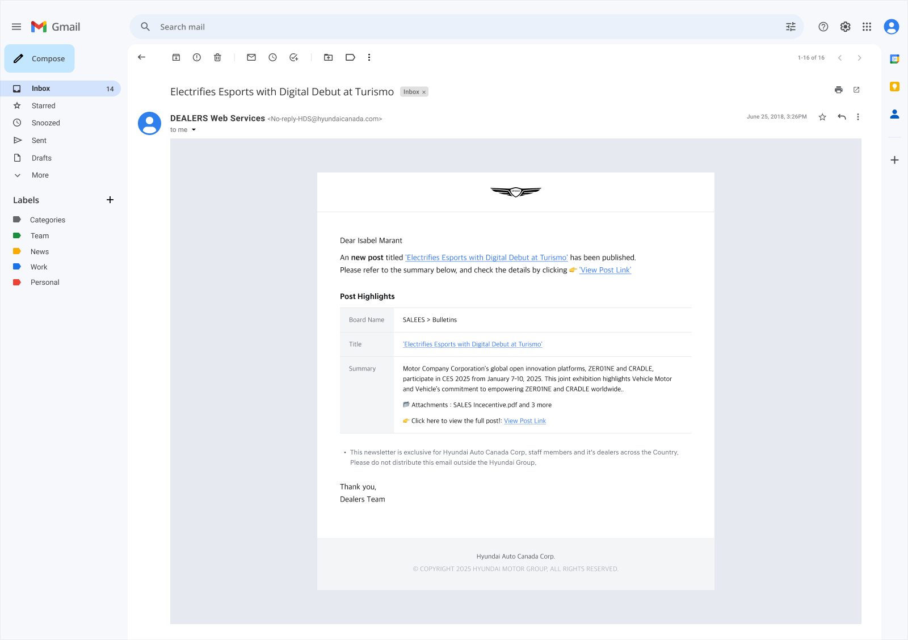
General Post Email Notification
    - Important notice post email screen:
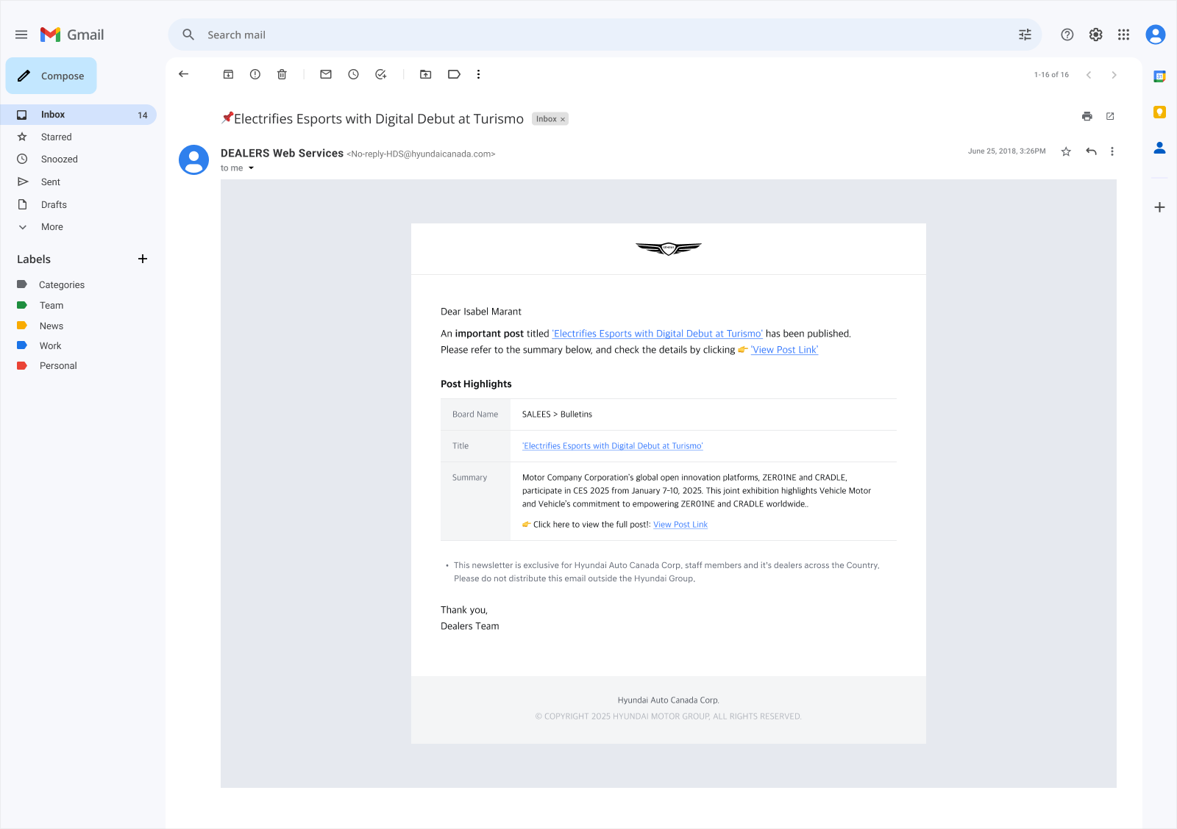
Important Post Email Notification
- The email is composed of Introduction, Body(Board Name, Title, Summary), and Footer.
- The Intro displays a greeting and a simple title about the post with a detailed link.
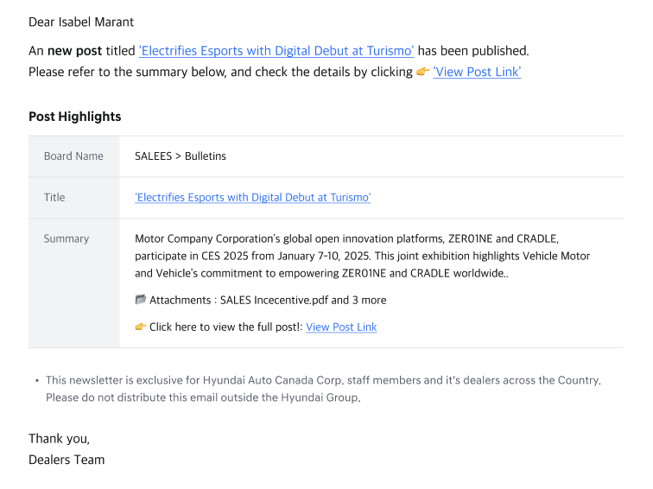
Email Body
- The Body area displays the Title and Summary up to 500 characters, and shows information such as whether there are attachments in the post.
- The Footer area displays guidance text such as the source of the email and contact information.

Dealer employee management
- This is a screen where you can manage dealer employees who belong to the same dealer company as the user.
- You can view the information of dealer employees. Depending on your permissions, you can create new employees or modify employee information.
- You can access this screen through dealer employee management in the upper right. The dealer employee management menu name is displayed to users
- Only users with the Dealer Principal or Super Admin job roles can access and view this screen.

Dealer employee List
- This is a screen where you can view dealer employee information.
- Clicking [create new] at the top will take you to a screen to create new employee information. 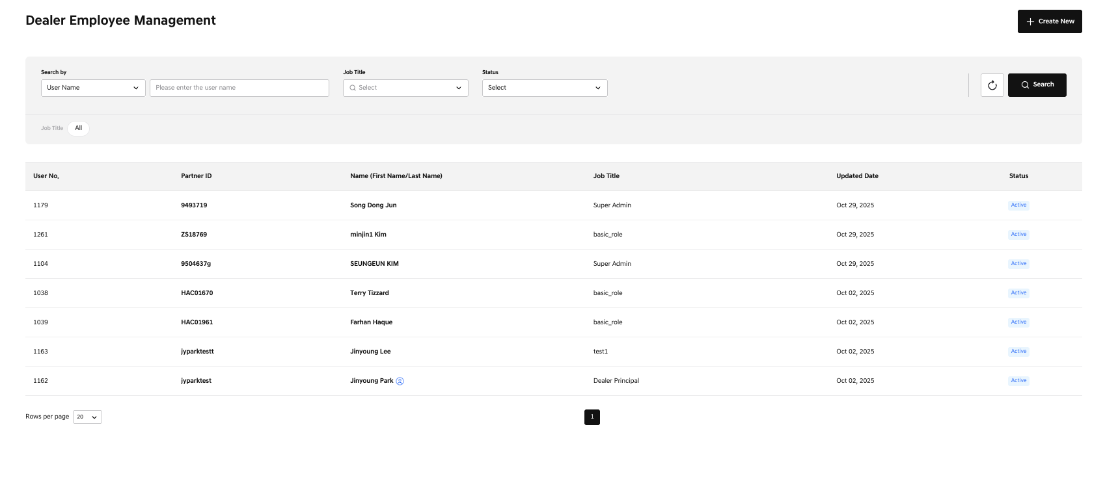
Employee List
- You can view the dealer employee list according to employee conditions.
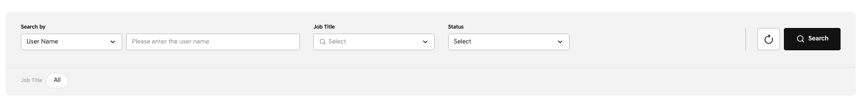
Employee List - Search Filter
    - User Name: You can search by the user's name.
    - User No.: You can search by the user's User No.
    - Partner id: You can search by the user's HMG Partner id.
    - Job title: Select the job title assigned to the user. You can select more than one, and the selected items appear in the job title area below.
    - Status: You can view according to the status of the user account.
    - Active: Account activated status
    - Inactive: Account deactivated status
    - Clicking the [search] button displays the results of the set conditions.
    - Clicking the [reset] icon button resets everything.
- The dealer employee list provides the following information:
    - User No.: A unique user number generated by the Dealers system.
    - Partner ID: The user's Partner ID.
    - Name: Provides first name and last name combined
    - If designated as the dealer principal of the dealership, a badge is displayed in the list.

    - Job title: The user's permission
    - Updated date: The date when the user's account was created or modified
    - Status: The status of the account
    - Clicking on the Partner ID or name area allows you to check the detailed information of that user.

Create Dealer Employee
- Clicking [create new] at the top of the dealer employee list takes you to a screen to create a dealer employee.
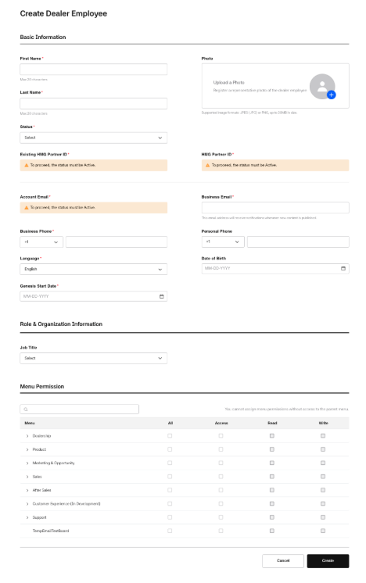
Create Dealer Employee
- In the Basic information area, enter the user's basic information:
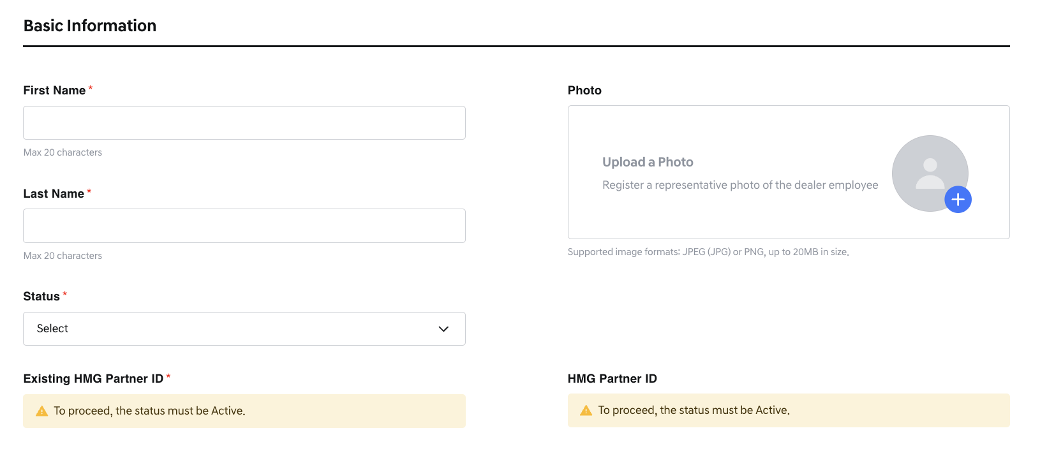
Employee - Basic information1
- First name(Required): Maximum 20 characters can be entered.
- Last name(Required): Maximum 20 characters can be entered.
- Picture: Optional. One image representing the user can be registered.
- Status(Required): Select the status of the dealer employee account.
    - Inactive: Indicates a deactivated status where the user cannot access the service. If the initial account is created with Inactive status, an HMG Partner ID cannot be created. The Account Email also cannot be entered.
- 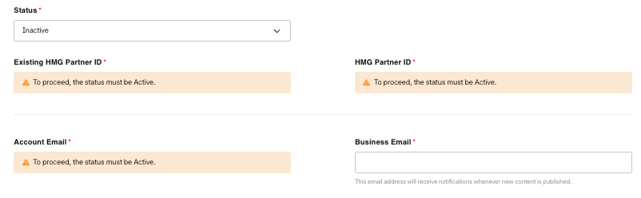
Status – Inactive
    - Active: Indicates an activated status where the user can access the service. If the initial account status is set to Active, an HMG Partner ID can be created.
      - When active, the Existing HMG Partner ID field is enabled.
        - Existing HMG Partner ID
          - No, Create a new account: Proceeds with creating a new HMG Partner ID.
          - Yes, Use existing account: Links to an existing HMG Partner ID.
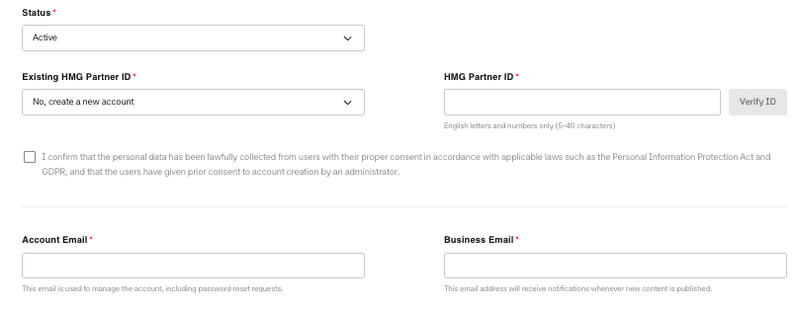
Status – Active: Create New HMG Partner ID
- HMG Partner ID : This is the ID used to log in to the Dealers system.
  - An HMG Partner ID can only be created when the account is initially in an Active status, and creation is mandatory in this case.
    - Create a new account Case
    - Once created, the ID remains valid even if the account status is later changed to Inactive.
    - The ID must be between 5 to 10 characters, using a combination of letters and numbers.
    - A duplicate check is required. After entering your desired ID, click [Verify ID] to check for duplicates.
    - Consent to create the HMG Partner ID is mandatory.

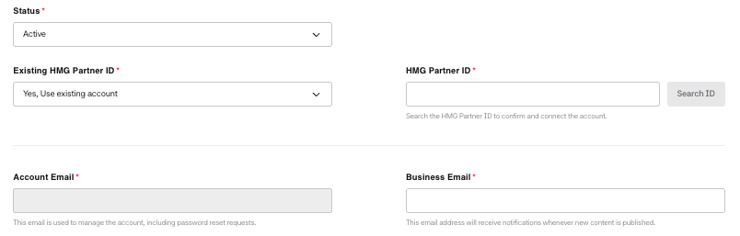
Status – Active: Search existing HMG Partner ID
    - Use existing account Case
  - When registering an account with an existing HMG Partner ID as a dealer employee, enter the HMG Partner ID and click the [Search ID] button.
  - If the account exists, some user information will be displayed in the search results so you can verify the user.
  - If the information is correct, click the [Save] button to add the employee details.
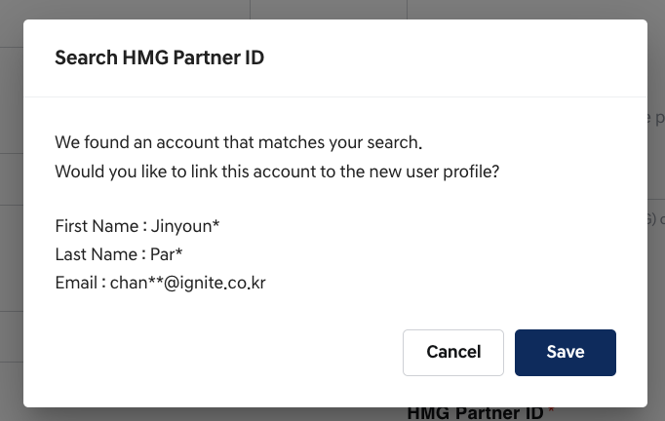
Verifying user popup
- If existing HMG Partner ID information is mapped and imported, the following fields cannot be edited
  - Name / Account Email / Language
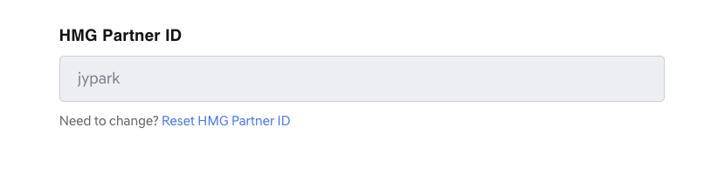
Reset HMG Partner ID
- If the information is incorrect, click [Reset HMG Partner ID] below the HMG Partner ID field to reset and re-enter the information.
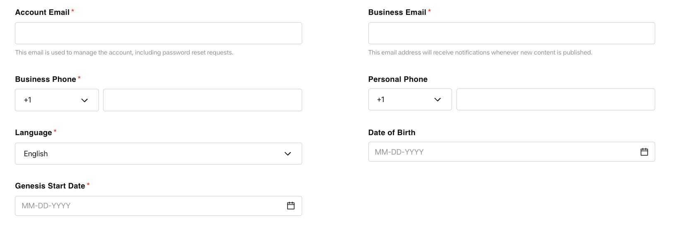
Employee - Basic information2
- Account email(required): The email address linked to the HMG Partner ID. Account-related notifications, such as password resets, will be sent to this address.
- Business Email(Required): The business email address. If a domain is registered for the dealership, the domain must be selected from the registered domains.
- 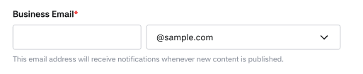
When domain information is present
- Business Phone(Required): Enter the user's business phone number.
    - Select international number from 1 or 82. 1 is provided as default.
- Personal Phone: Optional. Enter the user's personal phone number.
    - Select international number from 1 or 82. 1 is provided as default.
- Language(Required): This is a value that sets the language of the dealer employee.
    - It determines the language displayed on the user's login screen and the emails sent.
    - English is selected by default. Choose between English and French.
- Date of Birth: Optional. Enter the user's birthday.
- Genesis Start date(Required): Enter the date when the user started working at Genesis.
- In the Role & Organization Information section, you can configure the user's permissions.
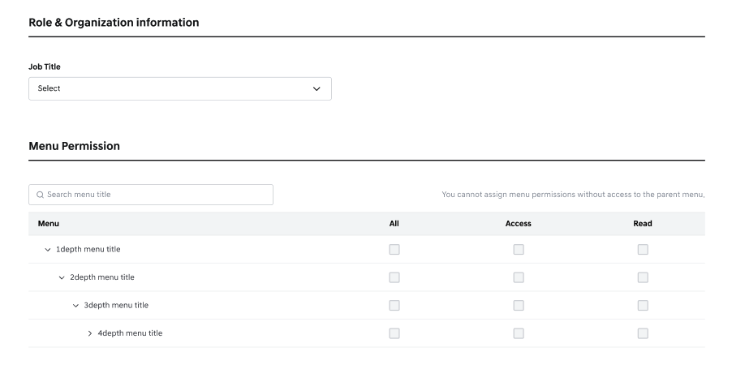
Employee - Role
- Job Title: User permissions can be assigned through the selected job title.
Once a job is selected for a user, the corresponding menu permissions mapped to that job can be viewed in the Menu Permission section.
- If the dealer employee's status is set to Active, selecting a job is mandatory.
If the status is Inactive, assigning a job is optional.
- Users with access to the Dealer Employee Management screen and the ability to create new employees must be granted the Super Admin job title.
A maximum of three Super Admins can be assigned per dealer.
- The Dealer Principal cannot be assigned through this screen, and the job title of a Dealer Principal cannot be modified.

- Menu Permission: This section displays the menu-level permissions mapped to the selected job.
- In addition to the permissions granted via the job, individual permissions can also be added manually if necessary.
- Permission Descriptions:
  - All: Grants all available permissions for the selected menu at once.
  - Access: Makes the menu visible to the employee.
  - Read: Allows the user to view the bulletin board and read the details within the menu area.
Employee - Role setting
- How to Grant Permissions
- You must have at least Access permission for a 1st-level menu in order to assign permissions to its 2nd-level menus.
- If a 2nd-level menu has existing permissions, you cannot remove all permissions from its parent 1st-level menu.
- Access permission is required before Read permission can be granted.
Similarly, Read permission is required before Write permission can be granted.
- If both Access and Read permissions are granted, you cannot uncheck only Access.
- Unchecking Access will also remove Read permission.

- : Indicates a permission defined by the job. It cannot be modified.
- : Indicates that additional permissions can be assigned.
- : Indicates that a lower-level permission is required before this can be added.
- : Indicates a permission that was manually granted to the individual. This can be unchecked to remove it.
Bottom Button & Account Creation Process
- Clicking the [cancel] button returns to the previous screen without saving the entered content. Clicking the [create] button creates a new dealer employee account with the entered content.
- If an HMG Partner ID is newly created, an email will be sent to the registered email address containing a link to create the account and set a password through the HMG Partner system. Using this link, the employee can complete the password setup.
- When a dealer employee account is created with an HMG Partner ID, a welcome invitation email is automatically sent to the registered Account Email.
Welcome invitation email

View Dealer Employee
- You can view the detailed information of an employee by clicking the Partner ID or name area in the dealer employee list.
- If the employee is a dealer principal, a badge saying dealer principal is displayed.
- If an HMG Partner ID has not been created, an "HMG Partner ID Required" badge will be displayed.
- Clicking [Reset Password] in the upper right will send a link to the registered email address to set a new password.
Once the password is changed through the link, the new password will be applied.
- Clicking the [Edit] button in the upper right navigates to the screen where employee information can be modified.
- Clicking the [View List] button at the bottom takes you to the Dealer Employee List screen.
View Employee details

- The dealer employee detail screen provides the following information:
Employee details1
  - If a dealer employee photo is registered, it provides the photo.
    - User No.: Once the dealer employee information is registered, a unique employee number is automatically generated and displayed by the Dealers system.
    - First name
    - Last name
    - Status
    - HMG Partner ID: If the HMG Partner ID has not been created, a message indicating that creation is required will be displayed.
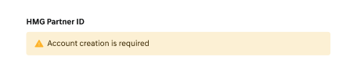
HMG Partner ID Not existed
Employee details2
- Account Email
- Business Email
- Business Phone
- Personal Phone: If not registered, it is provided as a blank.
- Language
- Age: Based on the dealer employee's birthday information, the age is calculated and displayed on the screen.
- Genesis Start Date: Based on the date when Genesis work started, the period worked at Genesis as of today is calculated and displayed.
      - The working period is calculated and displayed with only year and month information.
      - It is calculated as 1 month from the month when work started.

- Role & Organization information
Employee details3
  - Job title: Displays the job title assigned to the account.
  - Menu Permission
        - Displays all menus and permissions assigned to the employee.

Edit Dealer Employee
- Pressing the [edit] button on the dealer employee view screen takes you to a screen to view the employee information.
Edit Employee
- The dealer employee information edit screen is mostly identical to the dealer creation screen.
- The parts that do not match the dealer creation screen are as follows:
- HMG Partner id:
    - If HMG Partner ID has already been created:
The HMG Partner ID cannot be modified or deleted.
    - If the user is a multi-dealer user, some information cannot be modified.
      - Name(First, Last Name)/Account email/Language
    - If HMG Partner ID has not been created:
A message will appear indicating that the status must be set to Active before creating the ID.
HMG Partner ID Not existed
    - When the Status is updated to Active, the Existing HMG Partner ID field is enabled.
    - You can then choose to create a new HMG Partner ID or link an existing one just like in the initial creation screen.
    - If you are creating a new HMG Partner ID, consent for account creation is required to proceed with generating the HMG Partner ID.
  - Account email: Cannot be modified on this screen once registered.
- Password: The password item is newly viewed. A [reset password] button is provided, which can reset the account's password.
      - Clicking the Change Password button will send a URL link to the registered email address, allowing the user to set a new password.
      - Once the password is successfully updated through the link, the new password will take effect.
- Pressing the [cancel] button does not save the changes, and pressing the [save] button applies the changes.

HMG-Notification
- HMG-notice is a system used for the purpose of providing a platform-based function for managing announcement content through the "Common Notice System (hmg-Admin)"
- It provides APIs to manage content such as FAQs, terms and conditions, notices, and notifications (pop-ups, etc.) so that they can be used appropriately for the Dealers service.

Page Notification
- Notifications registered in HMG-notice are displayed. They can be displayed based on buttons added in HMG-notice, and clicking the button allows navigation to specific pages
Notification with buttons
Notification without buttons

Pop-up Notification
- HMG Pop-up notifications registered in HMG-notice are displayed.
- They can be displayed based on buttons added in HMG-notice, and clicking the button allows navigation to specific pages.
- It is possible to set pop-up notifications to be displayed for a specific period (3 days, 7 days), and it is also possible to set them to always be displayed.
Notification popup
Popup with one button
Popup with 2buttons

Consent Notification
- In the case of customer consent notifications, these are used when customer consent is needed due to policy changes, etc. 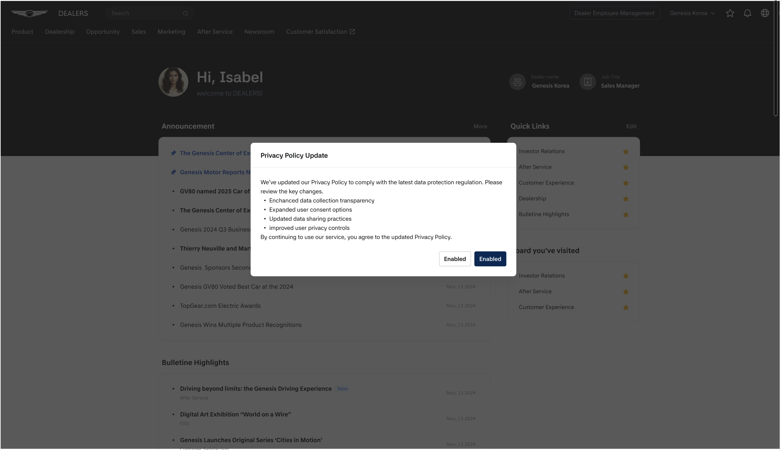
Consent notification

- By clicking the button, you can agree or refuse terms and conditions, and navigate to the terms screen.
- In case there is only one button, the button name is provided as "Accepted".
Consent notification with one button

