**Git Tutorial**

**1.What is Git ?**

**2.Why Git ?**

**3.How to use Git ?**

**4.Download and Installation of Git.**

**5.Git Bash(Terminal)**

**5.Basic commands of Git.**

**1. Git version**

**$ git** --**version**

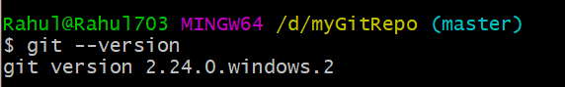

**Or in Command Prompt**

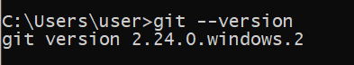

**2. Creating a folder (GitRepo) in D drive**

Rahul@Rahul703 MINGW64 ~

**Getting into D drive**

**$ cd d:**

Rahul@Rahul703 MINGW64 /d

**Creating a directory**

**$ mkdir myGitRepo**

Rahul@Rahul703 MINGW64 /d

**Getting into folder**

**$ cd myGitRepo**

Rahul@Rahul703 MINGW64 /d/myGitRepo

**3. Checking status of the folder**

**$ git status**

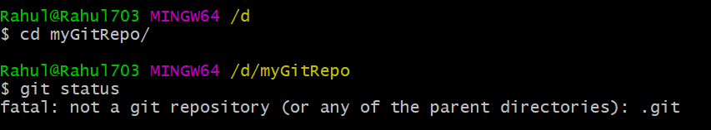

**4. Initializing the folder as repository**

**$ git init**

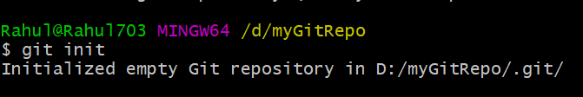

**5. Now checking status again**

**$ git status**

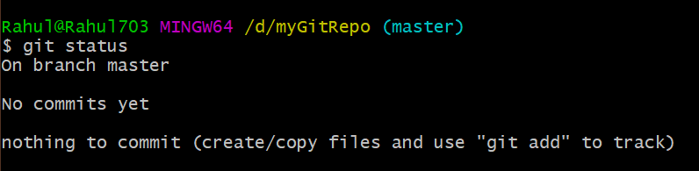

**6.a) Checking Global Username**

**$ git config --global user.name**

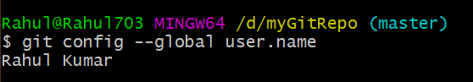

**b) Setting or Changing the Global Username**

**$ git config --global user.name "Mohit Sharma"**

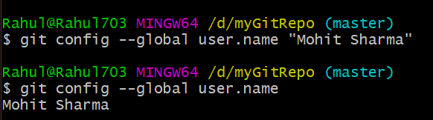

**7.a) Checking Global User email**

**$ git config --global user.email**

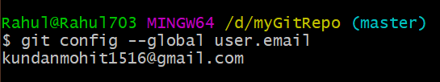

**b) Setting or Changing Global User email**

**$ git config --global user.email "rk7870382701@gmail.com"**

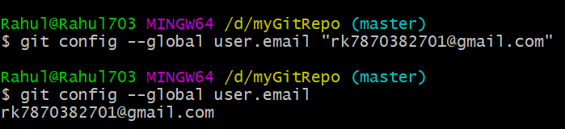

**Note : There are two types of Users as well as Email**

1. **Global User/Email**
2. **Local User/Email**

**If there is no local defined, the Global is used in local as well**.

**8.a) Checking Local and Global Username**

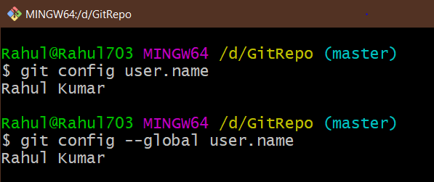

**b.) Setting or Changing Local Username**

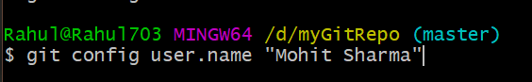

**11.a) Checking Local and Global User Email**

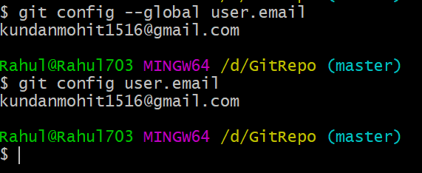

Use of GIT

Rahul@Rahul703 MINGW64 ~

$ cd d:

Rahul@Rahul703 MINGW64 /d

$ cd myGitRepo/

Rahul@Rahul703 MINGW64 /d/myGitRepo (master)

$ dir

index.html

Rahul@Rahul703 MINGW64 /d/myGitRepo (master)

$ git status

On branch master

No commits yet

Changes to be committed:

(use "git rm --cached <file>..." to unstage)

new file: index.html

Changes not staged for commit:

(use "git add <file>..." to update what will be committed)

(use "git restore <file>..." to discard changes in working directory)

modified: index.html

Rahul@Rahul703 MINGW64 /d/myGitRepo (master)

$ git add .

Rahul@Rahul703 MINGW64 /d/myGitRepo (master)

$ git status

On branch master

No commits yet

Changes to be committed:

(use "git rm --cached <file>..." to unstage)

new file: index.html

Rahul@Rahul703 MINGW64 /d/myGitRepo (master)

$ git commit -m "first commit,index.html added"

[master (root-commit) b2a14ab] first commit,index.html added

1 file changed, 2 insertions(+)

create mode 100644 index.html

Rahul@Rahul703 MINGW64 /d/myGitRepo (master)

$ git status

On branch master

nothing to commit, working tree clean

Rahul@Rahul703 MINGW64 /d/myGitRepo (master)

$ git log

commit b2a14ab089914e40ade2b566e47eb3e3947bbe4f (HEAD -> master)

Author: Rahul Kumar <rk7870382701@gmail.com>

Date: Wed May 27 02:47:27 2020 +0530

first commit,index.html added

Rahul@Rahul703 MINGW64 /d/myGitRepo (master)

$ git log --oneline

b2a14ab (HEAD -> master) first commit,index.html added

Rahul@Rahul703 MINGW64 /d/myGitRepo (master)

$ git log --oneline -3

b2a14ab (HEAD -> master) first commit,index.html added

Rahul@Rahul703 MINGW64 /d/myGitRepo (master)

$