Final Project Assignment — Pharmacy Claims
Junhui Hu
Northeastern University
ALY6030 Data Warehousing & SQL
Prof. Chandrasekaran
Feb 14, 2026

Part 1
Question 1
In my fact table, copay and insurancepaid are considered additive because they can be summed across all dimensions, including patient, drug, and fill date, without violating any business logic.
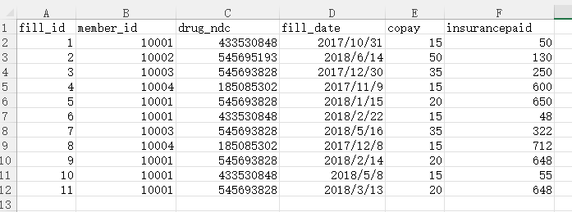
Question 2
Each row represents one prescription fill event for one patient and one drug on one specific fill date.

Part 2
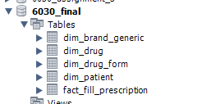
Question 1
For table dim_patient I used member_id as PK, dim_drug I used drug_ndc as PK, dim_drug_form used drug_form_code as PK, dim_brand_generic I used drug_brand_generic_code as PK and for fact table fact_fill_prescription I used fill_id as PK. member_id, drug_ndc, drug_form_code, drug_brand_generic_code are natural key but fill_id is a surrogate key, From a schema design perspective , I created when I separated the data in excel and added an auto-increment fill_id mainly for future maintainability. Although the combination of business fields could uniquely identify each record, using a surrogate key makes the table easier to manage and more aligned with an OLTP design approach.

Question 2
I created 4 FK, in fact_fill_prescription I set member_id and drug_ndc as FK, referencing the PK member_id and drug_ndc in table dim_patient and dim_drug.
In dim_drug table I set drug_form_code and drug_brand_generic_code as FK, referencing the PK drug_form_code and drug_brand_generic_code in table dim_drug_form and dim_brand_generic.

Question 3
For all FK I selected ON UPDATE and ON DELETE. Because prescription fill data is essentially historical transaction data. After a fill event is recorded, it shouldn’t be automatically changed or deleted just because something in a related dimension table is updated. As a result, I think the fact table should preserve the original event as it happened.

Part 3
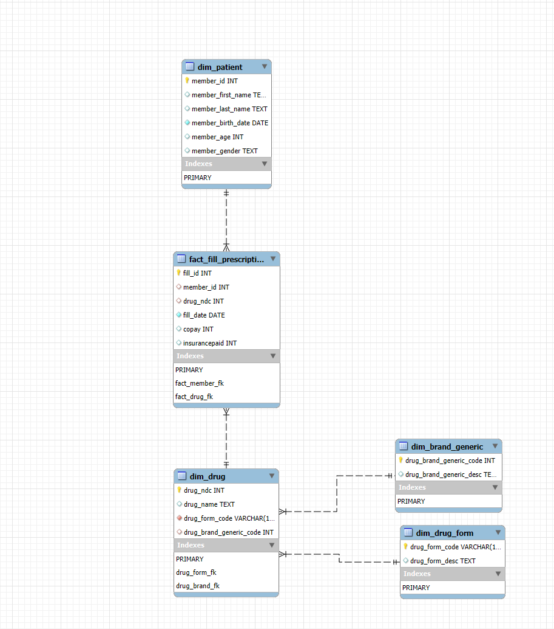
After reviewing part 3 requirement, I realized that my schema is structured more like a snowflake schema rather than a star schema because some dimension tables are normalized into separate sub-dimensions. I understand that in a true star schema, all descriptive attributes should be flattened into single dimension tables directly connected to the fact table. If I were to revise it, I would merge those related dimension tables back into dim_drug to create a fully denormalized star structure.
I apologize for not strictly following the star schema requirement, but since the tables and relationships are already established, I decided not to restructure everything at this stage.

Part 4
Task 1
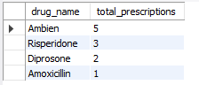
There are 5 prescriptions were filled for the drug Ambien.

Task 2
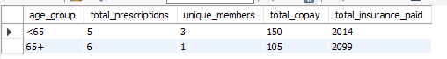
There is only one member that over 65 years of age and he filled out 6 prescriptions.

Task 3
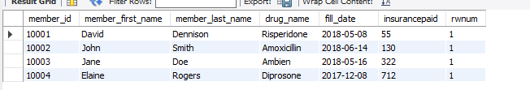
For member ID 10003, the drug name listed on their most recent fill date is Ambien, and the insurance paid for that medication is 322(There is no unit, so probably USD).

