Message Blast Quick Start Guide


The Message Blast Interface

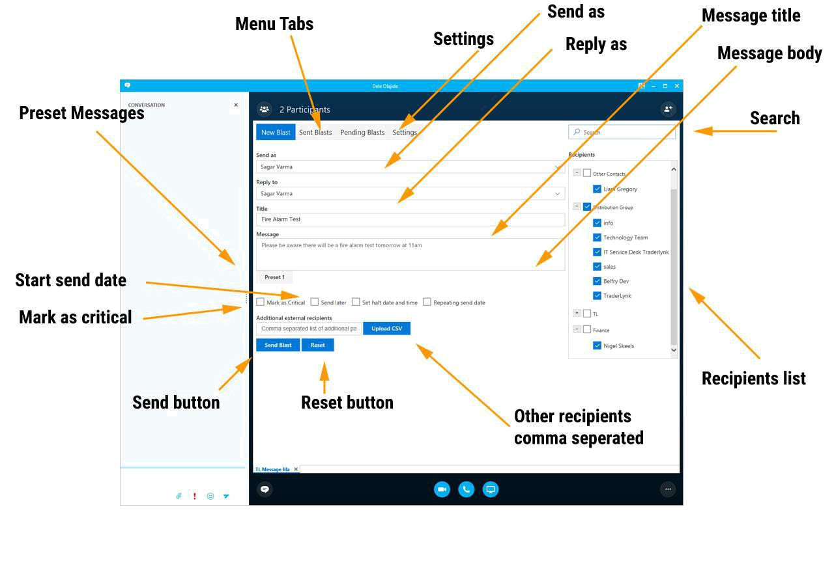

 | The Fundamentals |  |  |  | Glossary
 | • To Start the Application: Open Microsoft Skype for |  |  | Message Blast | A message sent to multiple recipients over
 | Business and sign in. Open a chat window. A pop-up |  |  |  | Skype for Business
 | window will appear in the bottom right corner,. Click on
 | the three dots in the bottom right corner of the window |  |  | Reply to | The SFB address that we receive any
 | and select TL Message Blast. The application will open. |  |  |  | replies (if any).
 | • To Change view: Click on the tabs at the top of the
 | application (Inbox, NewBlast, SentBlasts) |  |  | Title | Title for the Blast.
 | • Inbox: Incoming reply messages to blasts are listed here
 | • New Blast: This is where outgoing Blasts are composed |  |  | Message | Message body for the blast. Highlighting
 | • Sent Blasts: This view lists all the Blasts that have been |  |  |  | text brings up the HTML Styling menu for
 | sent since the server was last started |  |  |  | bold, underline and adding url links
 | • To Close the Application: click the close button on the |  |  | Mark as critical | Adds a red priority! To the received
 | top right corner of the window. The application will |  |  | Mark as critical | Adds a red priority! To the received
 | top right corner of the window. The application will |  |  |  | message.
 | continue to run in the background |  |  |  | message.
 | • To Shut Down the Application: close the application and |  |  | Start send date | Set a date in the future that the message
 | log out of Microsoft Skype for Business. |  |  | Start send date | Set a date in the future that the message
 | log out of Microsoft Skype for Business. |  |  |  | will be sent.
 | • Search: Enter a user name to search for and press enter. |  |  |  | will be sent.
 | Search will return one or many users with new |  |  | Other recipients | Manually add additional recipients in
 | checkboxes at the top of the Recipients list. Tick a |  |  | Other recipients | Manually add additional recipients in
 | checkboxes at the top of the Recipients list. Tick a |  |  |  | comma separated format or upload a csv
 | checkbox to select the user. |  |  |  | comma separated format or upload a csv
 | checkbox to select the user. |  |  |  | file.

Pressing the “X” button to the left of the search field: | Send button | Send the blast after a check dialogue
This will reload the recipients with only the selected | Preset Buttons | Inserts a preset title and message that can
search items and the previously returned list. |  | be edited from the settings tab.
 | Search | Enter a username and press the enter key
 |  | to search.


The Message Blast Sent Blasts

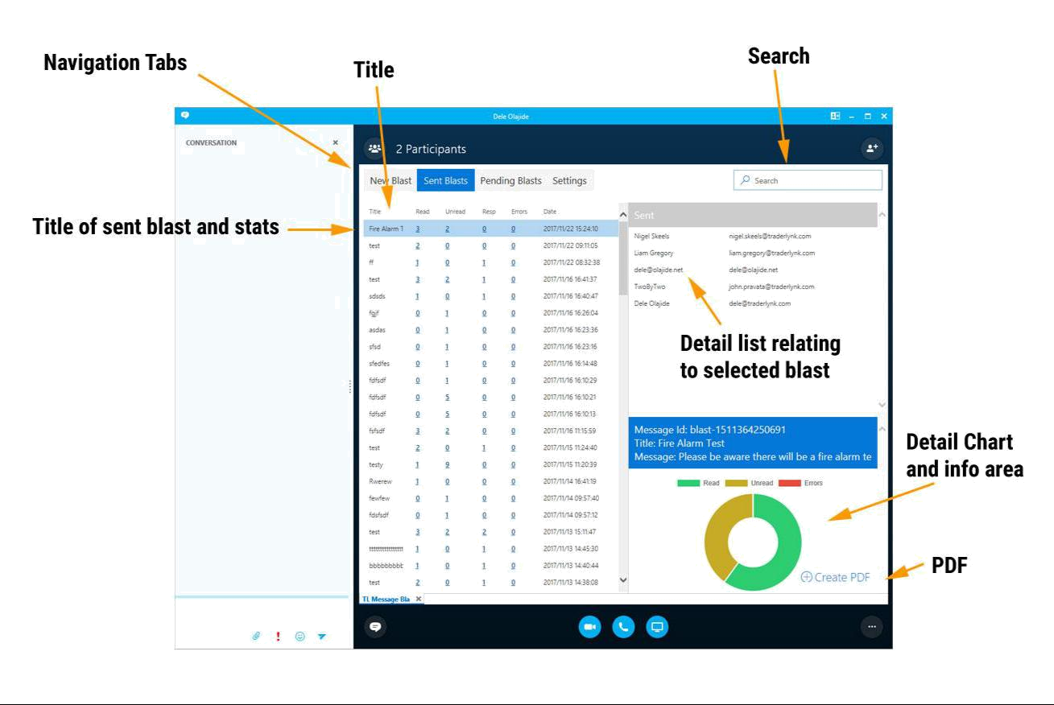

The Fundamentals | Glossary

• Sent blasts view: Shows all the blasts that have been | Title
sent, Status, Statistics and date for each message.
• Right hand panels show contextual detail | Status

- Search: Live search updates filter on left panel and search
query on to left panel concurrently | Statistics

- Right hand top panel: Lazy loads 100 items at a time.
Scrolling to the bottom loads the next 100. | Date

The Title of the sent Blast

How many blasts have been delivered Received, Read and Responded Date the blast was sent


The Message Blast Pending Blasts
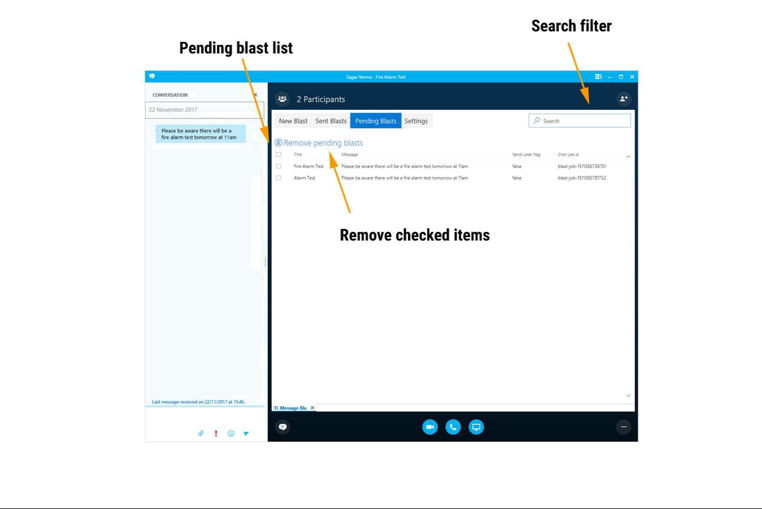

The Fundamentals |  | Glossary
• Pending view: Shows all pending blasts that are queued | Title | The Title of the pending Blast
and waiting to be sent.
• Check boxes: Use the check boxes to select Blasts to be | Message | The blast message content
cancelled and removed from the pending list. Press the
“Remove pending blasts” to clear the selected pending | Cron job id | The id of the blast to send
blasts.


The Message Blast Settings
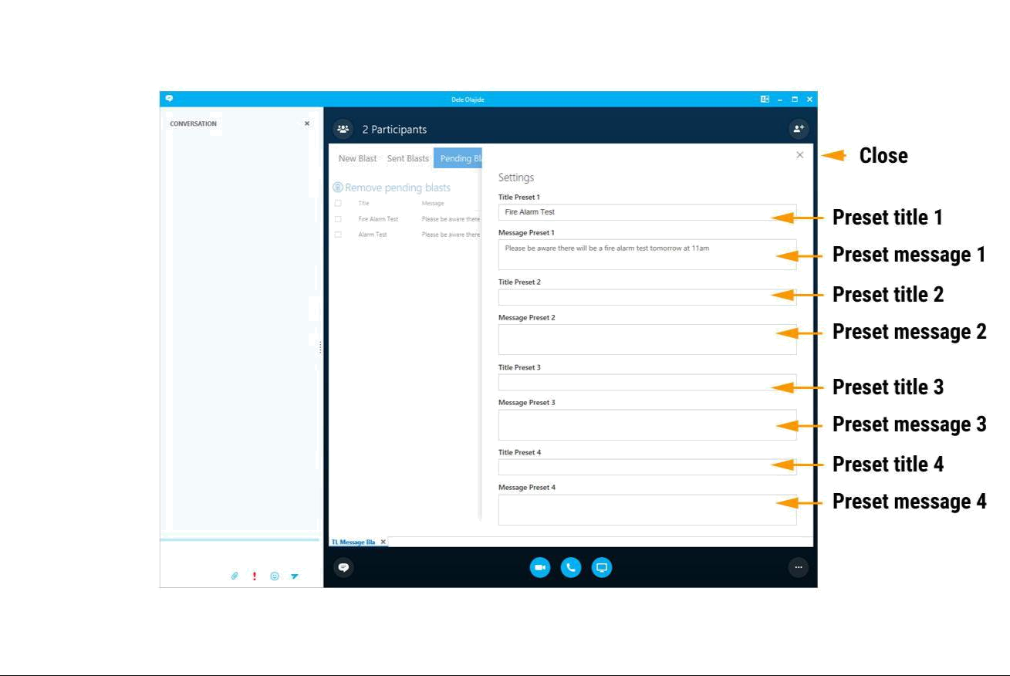

The Fundamentals |  | Glossary
• Presets: Presets allow blast message content to be saved | Title Preset x | Field for adding a preset Title
and used multiple times. 4 presets are available
• Close: Clicking the close button stores the presets | Message Preset x | Field for adding a preset Message
• Accessing presets: Once a preset has been stored by
closing the panel, a Preset button will be displayed on the | Close | Close button to save
New Blast view. Clicking the preset button populates the
title and message fields accordingly

