**AEM Task**

**1. Apply Styling**

* Style the **header** and **footer** using the **AEM Style System**.
* Update CSS in the **ui.frontend** module.

Header:

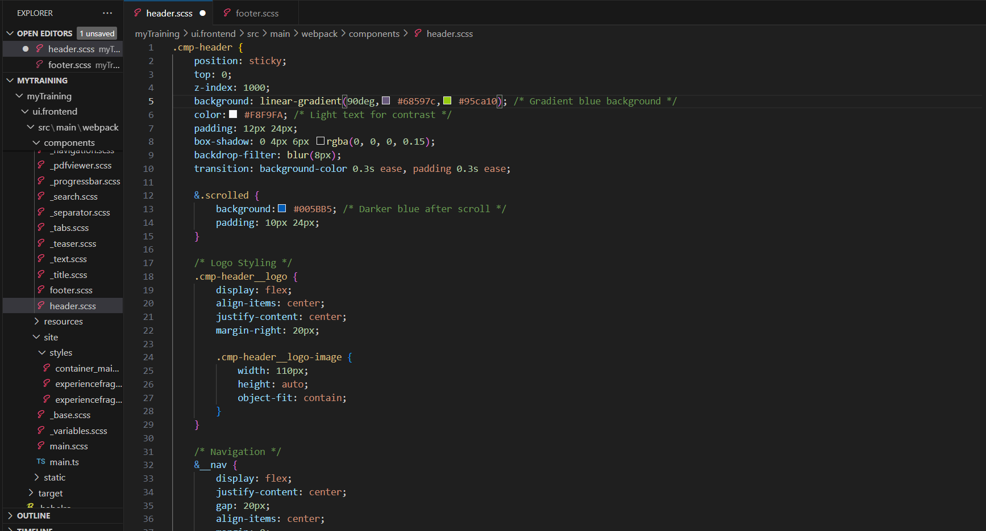

Footer:

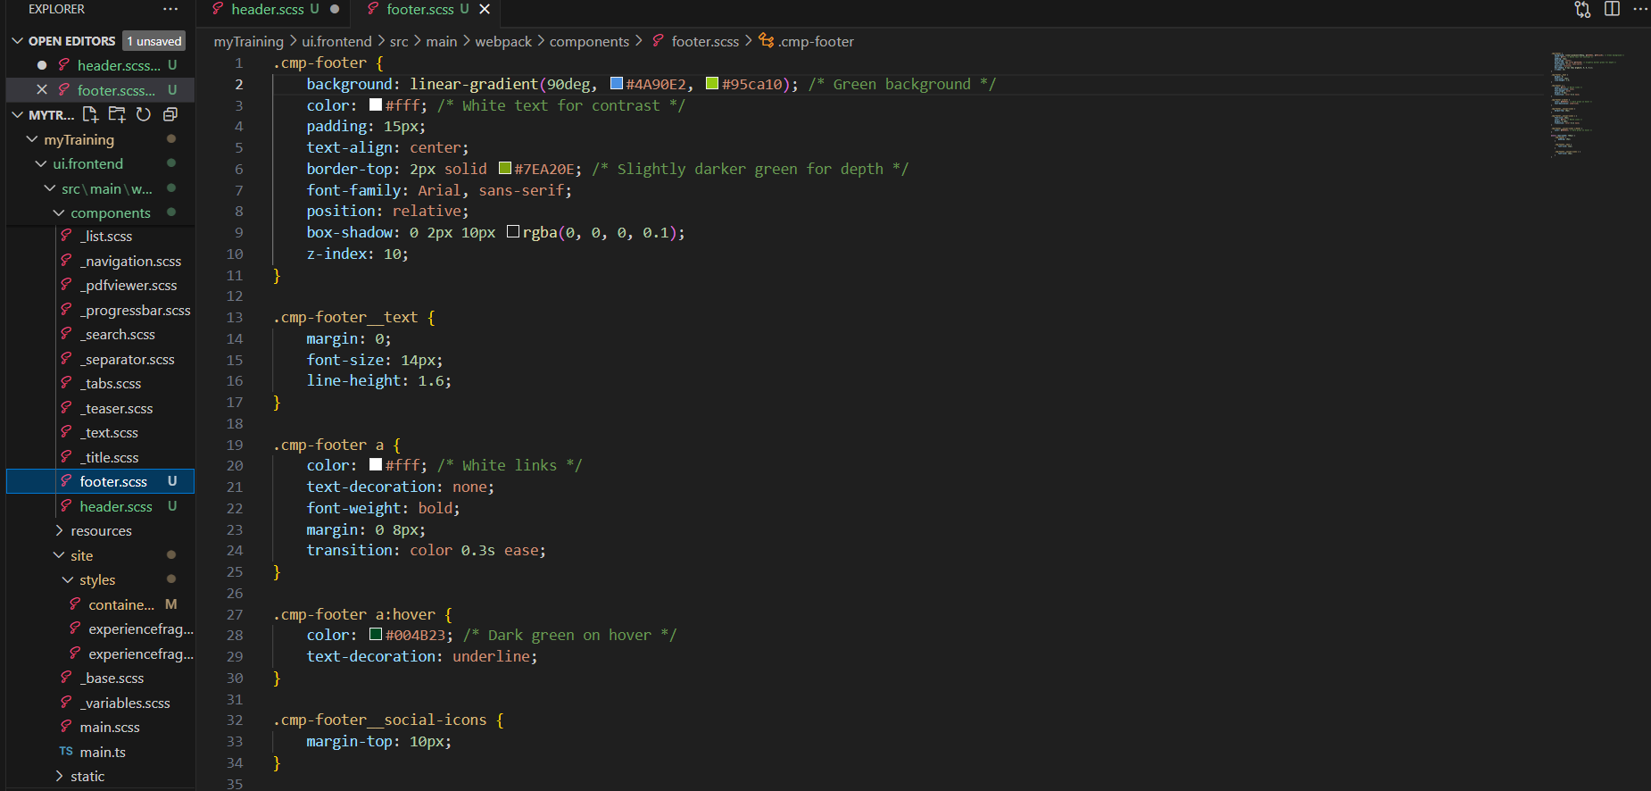

**Header of the page:**

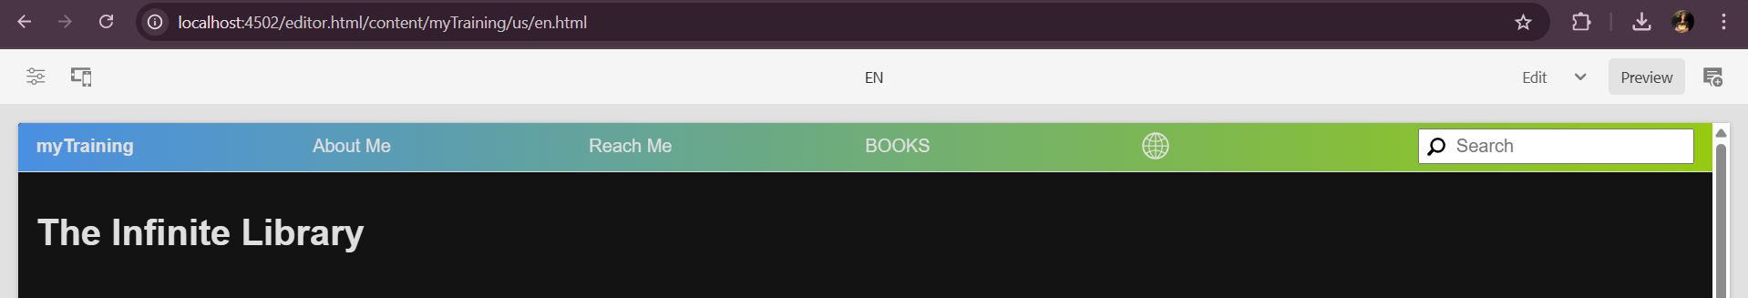

**Footer of the page:**



**2. Add Custom Page Property**

* Add a **textarea property (addScript)** in the **Book Page Component** for injecting scripts.

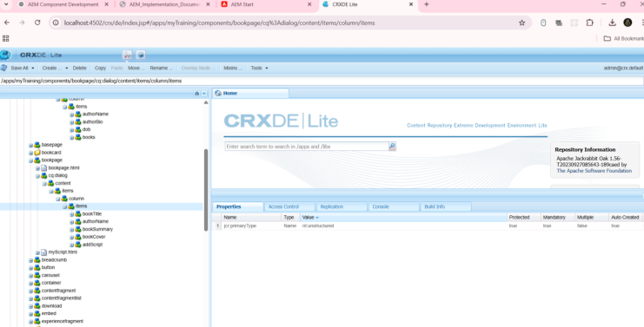

**3. Update Author Component**

* Add a **multi-field for books** and a **new text property**.
* Implement a **Sling Model** to fetch values.

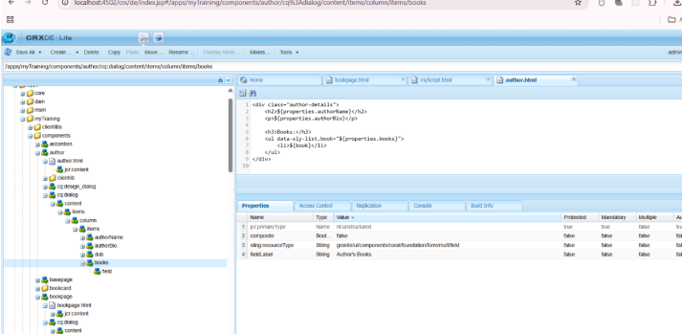

Author Details Component implemented by multifield

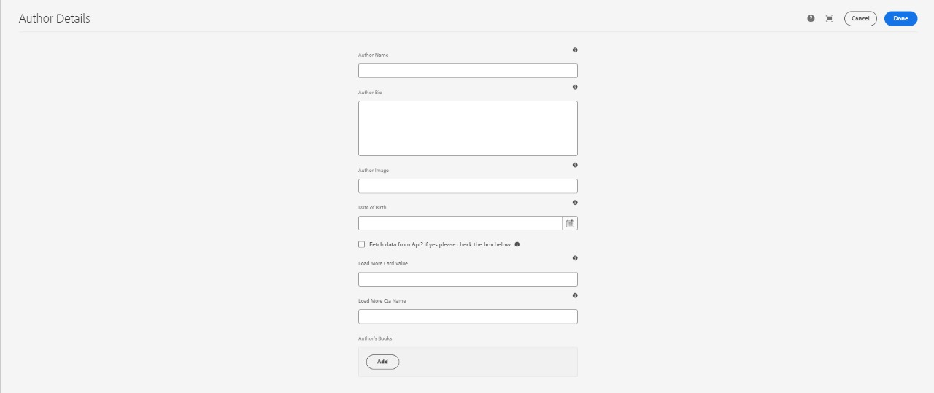

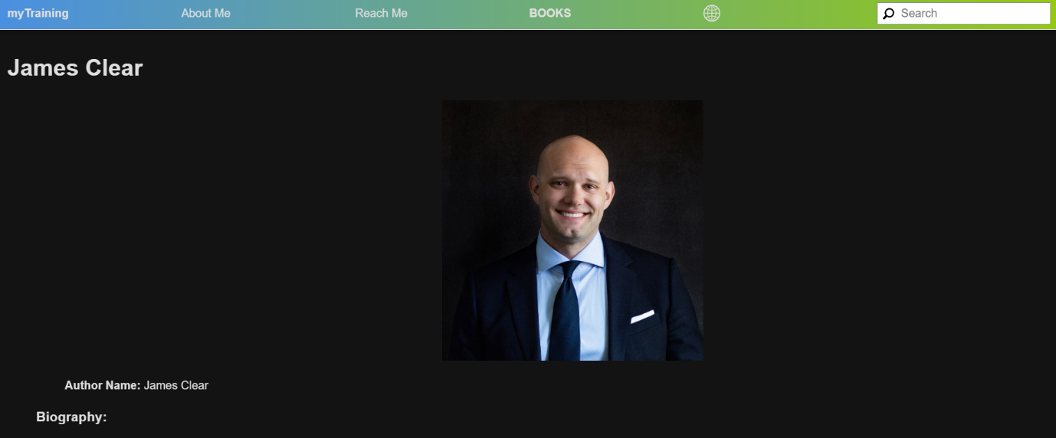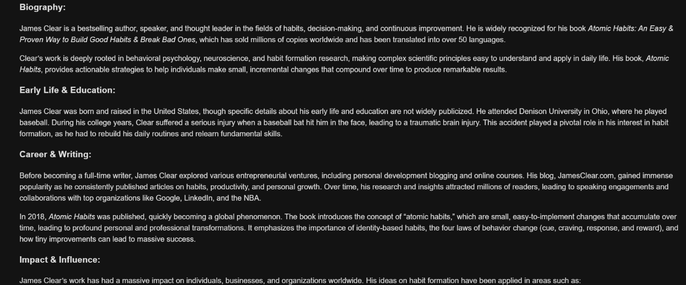

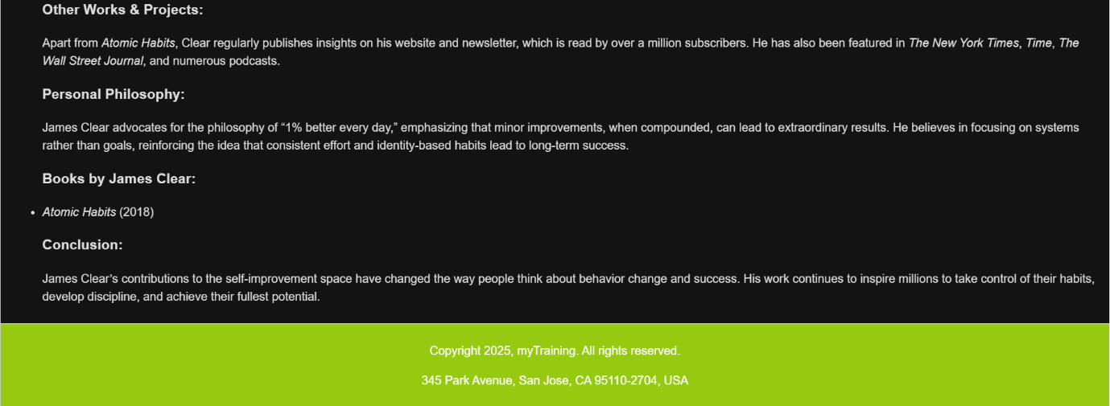

**4. Create "About Book" Template**

* Use **Base Page Template** to generate book-related pages.

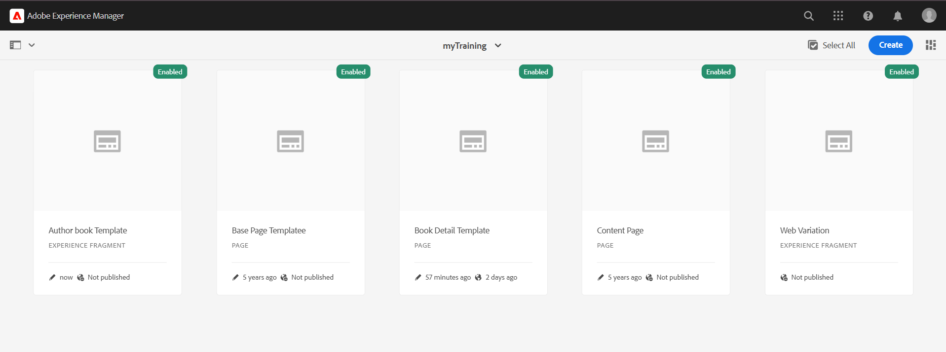

Book component template: It contains the details of authors.

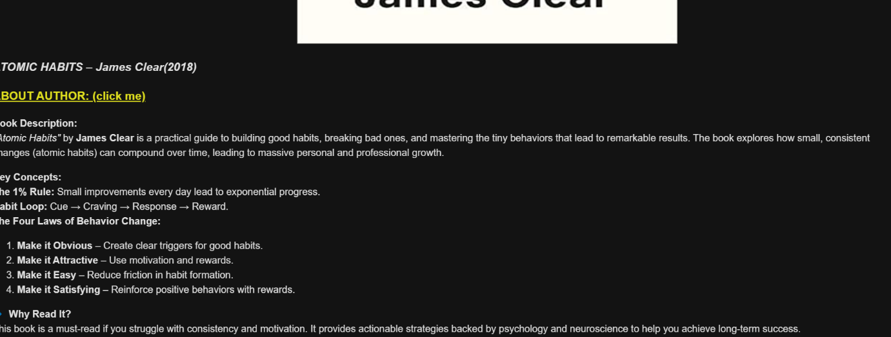



**5. Develop Book Page Component**

* Extend from **Base Page Template** and allow dynamic content addition.

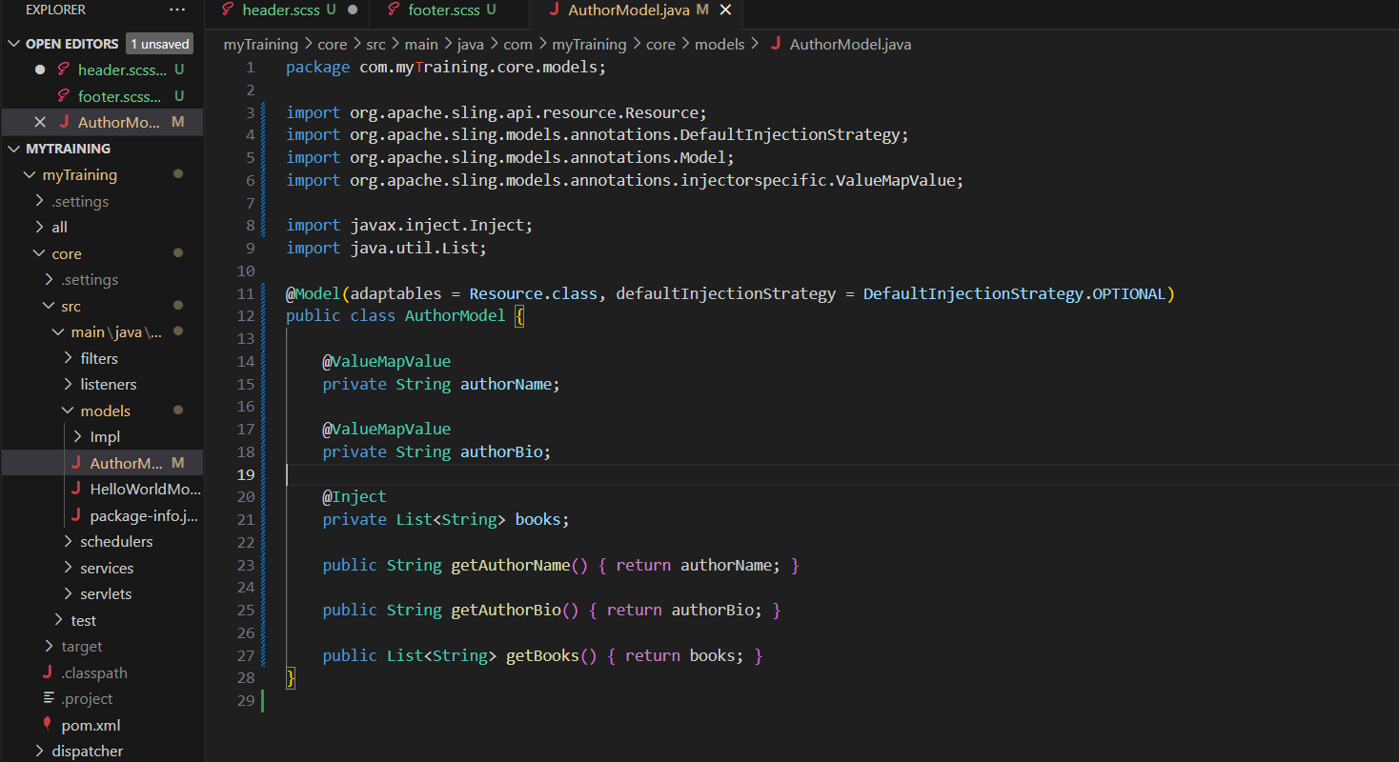

Home page:

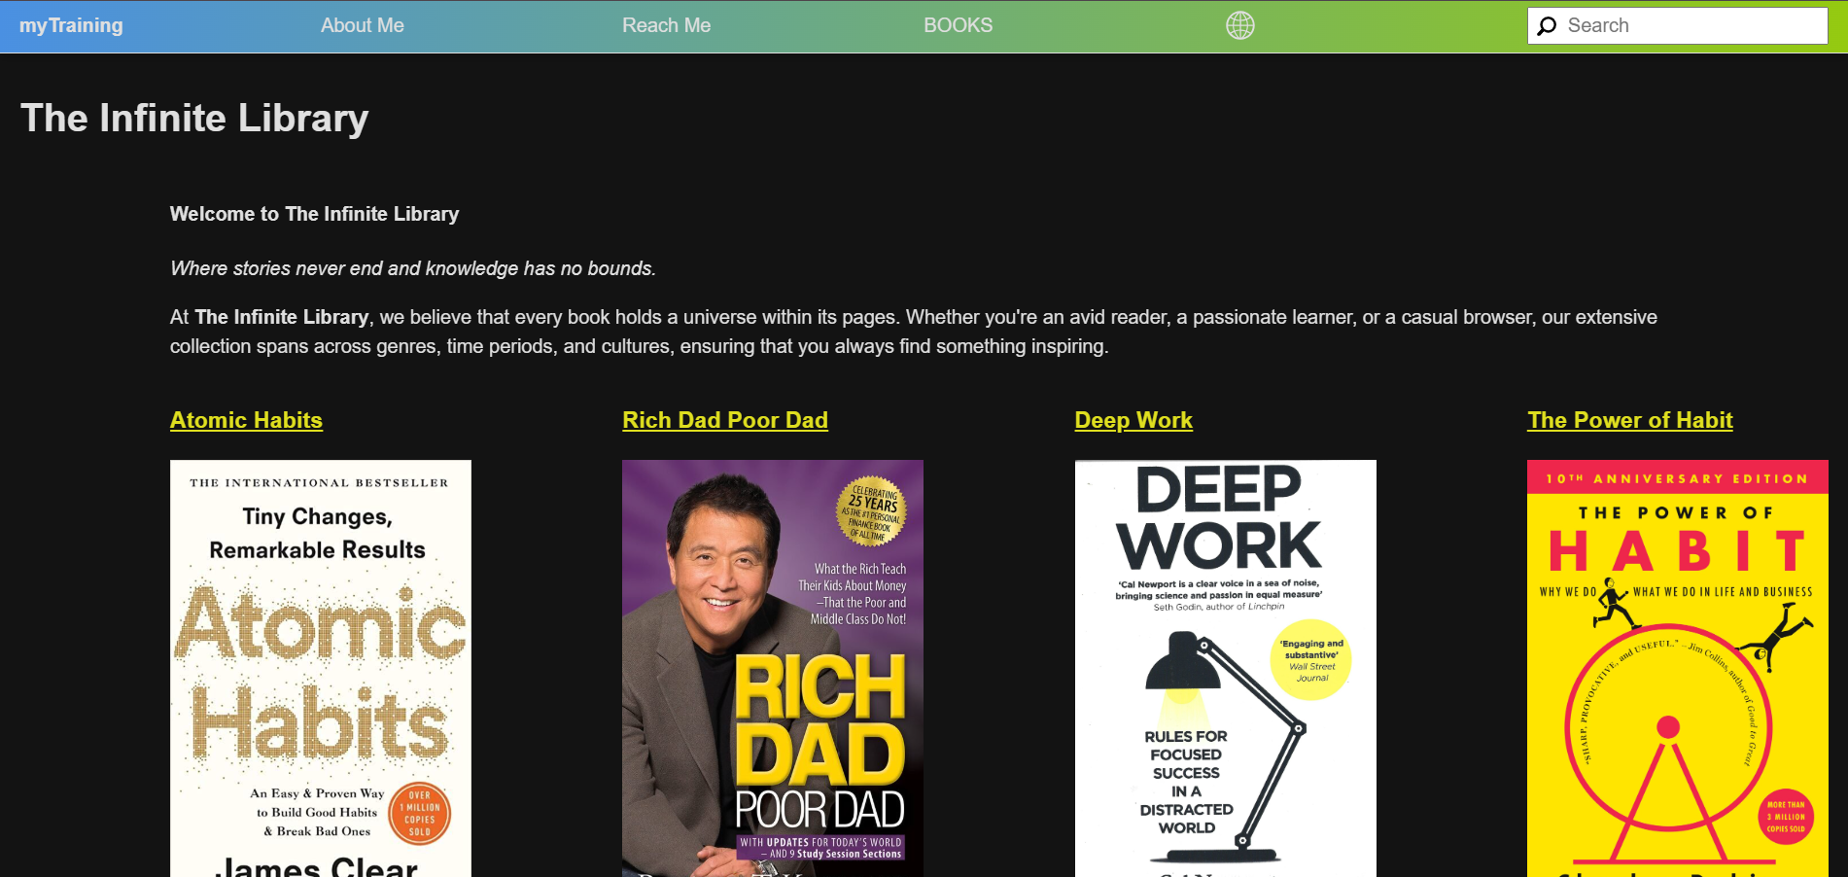

Inside Atomic Habits book:

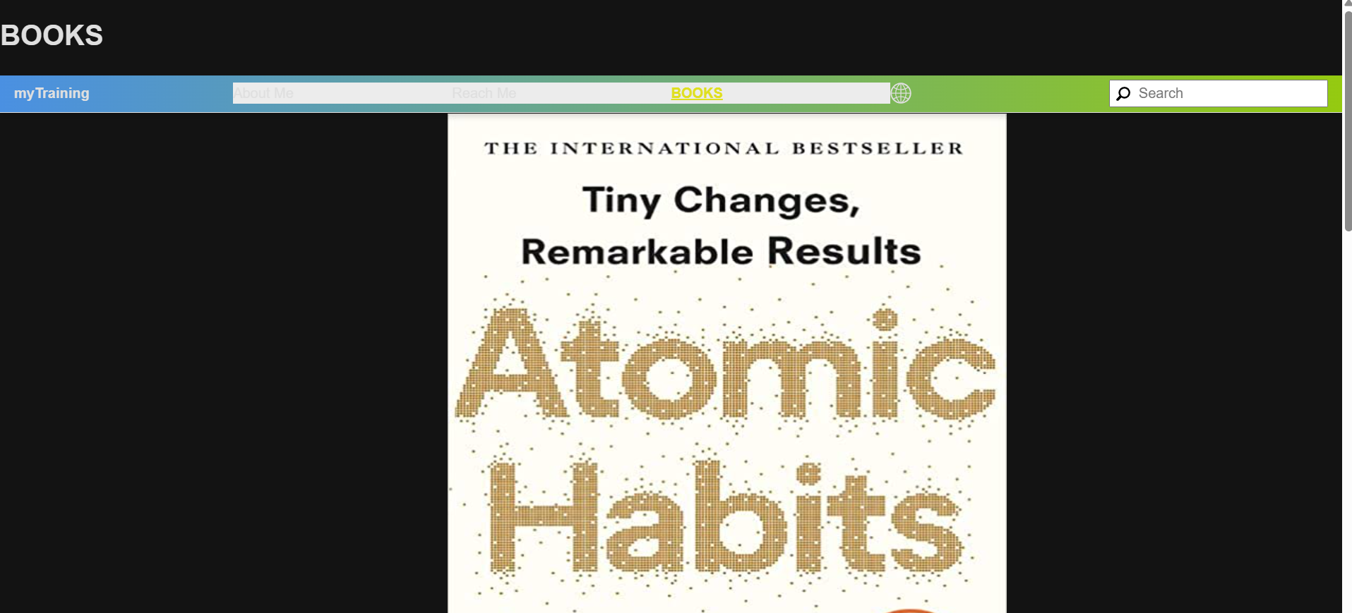

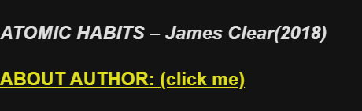

About author page:

