
Source Code
state = "q0"
count = 0

string = input("Enter the input string: ")

for symbol in string:
match state:
case "q0":
match symbol:
case "a":
state = "q1"
case "b":
state = "q0"

case "q1":
match symbol:
case "a":
state = "q2"
case "b":
state = "q0"

case "q2":
match symbol:
case "a":
state = "q2"
case "b":
state = "q3"

case "q3":
count += 1
match symbol:

case "a":
state = "q1"
case "b":
state = "q0"

if state == "q3":
count += 1

print("Occurrences of 'aab' =", count)


Output
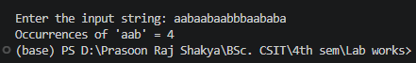
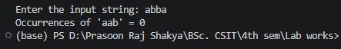

Conclusion
The Moore Machine was successfully implemented using Python with the match-case statement to recognize and count occurrences of the substring "aab". The program correctly transitions between states based on the input characters and accurately counts each occurrence of the specified pattern, demonstrating the practical application of Moore Machines in pattern recognition and string processing.

