2.2) DHCP Server Configuration and Dynamic IP Address Allocation
Objective: To configure a DHCP server and verify automatic IP address allocation to network devices using Cisco Packet Tracer

Theory
Dynamic Host Configuration Protocol (DHCP) is a network management protocol used to automatically assign IP addresses and other network configuration parameters to devices connected to a network. Instead of manually configuring each device with a static IP address, a DHCP server dynamically provides the required settings, reducing administrative effort and minimizing configuration errors.
A DHCP server assigns an IP address from a predefined DHCP pool (scope), which contains a range of available IP addresses along with network parameters such as the subnet mask, default gateway, and DNS server. When a client device joins the network, it requests an IP address from the DHCP server through the DHCP process. The server then leases an available IP address to the client for a specified period.
The DHCP address allocation process consists of four steps, commonly known as the DORA process:
- Discover – The client broadcasts a request to locate a DHCP server.
- Offer – The DHCP server responds with an available IP address and network configuration.
- Request – The client requests the offered IP address from the server.
- Acknowledge (ACK) – The DHCP server confirms the lease and assigns the IP address to the client.

Components Required
- Router 2901
- Switch 2960
- Server
- PCs/Laptops
- Copper Straight-Through Cable
1. Creating the Network Topology
i) Open Cisco Packet Tracer.
ii) Drag and place the following devices into the workspace:
- 1 Router
- 1 Switch
- 1 Server
- 2 PCs
iii) Connect the devices using Copper Straight-Through cables:
- Router GigabitEthernet0/0 → Switch FastEthernet0/1
- Server FastEthernet0 → Switch
- PC0 FastEthernet0 → Switch
- PC1 FastEthernet0 → Switch
iv) Verify that all devices are properly connected.
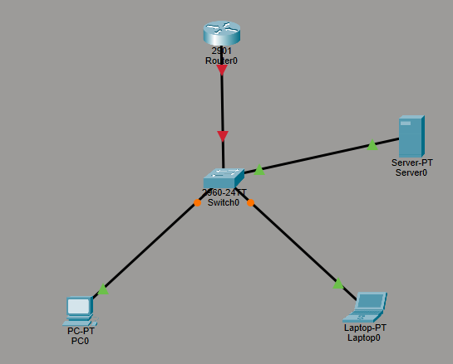

2. Configuring the Router
i) Click Router0 and select the CLI tab.
ii) Enter privileged EXEC mode.
Router> enable
iii) Enter global configuration mode.
Router# configure terminal
iv) Configure the interface connected to the switch.
Router(config)# interface gigabitEthernet0/0
Router(config-if)# ip address 192.168.1.1 255.255.255.0
Router(config-if)# no shutdown
Router(config-if)# exit
v) Exit configuration mode and save the configuration.
Router(config)# end
Router# copy running-config startup-config
vi) Verify that the interface is active.
Router# show ip interface brief
The GigabitEthernet0/0 interface should display Status: up and Protocol: up.
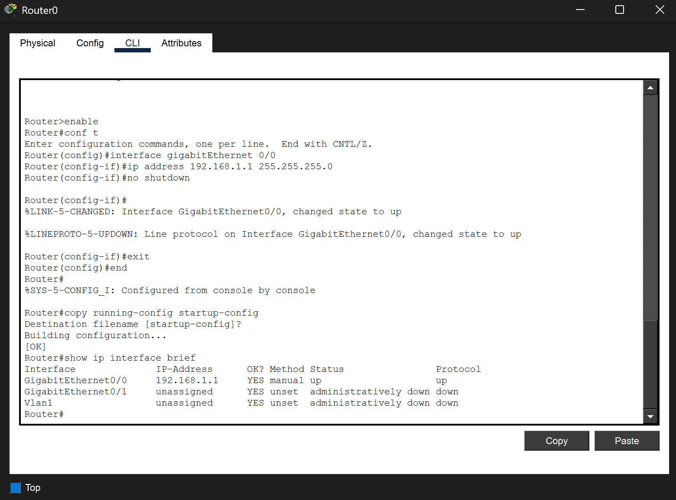
3. Configuring the DHCP Server
i) Click the Server.
ii) Select the Desktop tab.
iii) Open IP Configuration.
iv) Assign a static IP address.
- IP Address: 192.168.10.2
- Subnet Mask: 255.255.255.0
- Default Gateway: 192.168.10.1
v) Select the Services tab.
vi) Click DHCP.
vii) Turn the DHCP service On.
viii) Configure the DHCP pool.
ix) Click Add to create the DHCP pool.
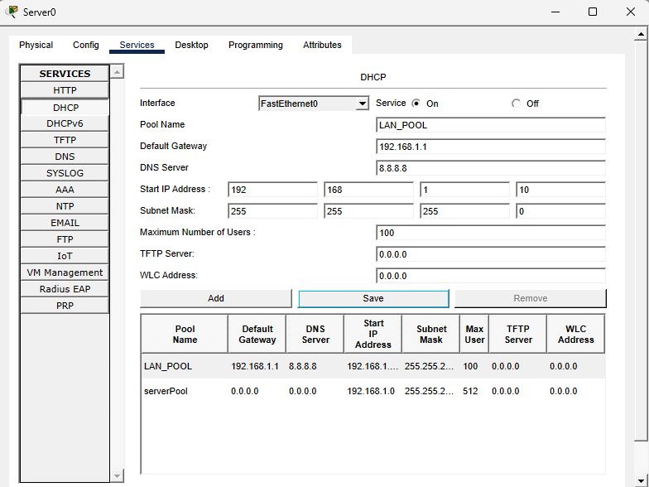

4. Configuring Client PCs
i) Click PC0.
ii) Open Desktop → IP Configuration.
iii) Select DHCP.
iv) Wait until the PC automatically receives an IP address.
v) Repeat the same procedure for Laptop0.

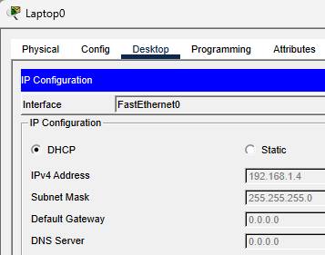
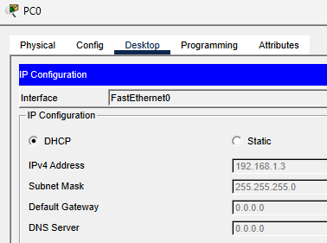
5. Testing Connectivity
i) Open Command Prompt on PC0.
ii) Execute:
ping 192.168.10.1
iii) Verify that replies are received.
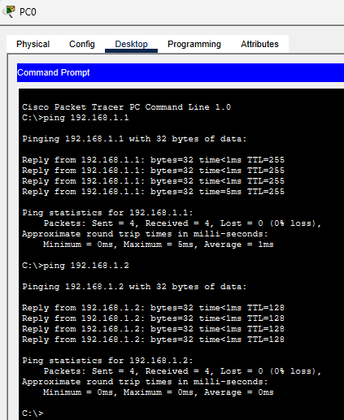
7. Simulation Verification
i) Switch Packet Tracer to Simulation Mode.
ii) Generate network traffic using the ping command (pinging PC0 to Laptop1).
iii) Observe packet exchange between the DHCP server and clients.
iv) Verify successful network communication.
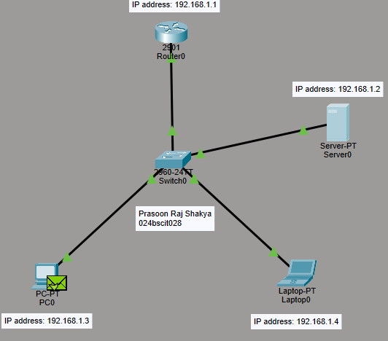
Conclusion
In this laboratory exercise, different Windows networking commands were explored and performed to gain a better understanding of network setup, troubleshooting, monitoring, and administration. Tools such as ipconfig, ping, tracert, nslookup, netstat, and arp helped demonstrate practical methods for analyzing network connectivity and diagnosing communication issues.
Additionally, a DHCP-based network was created and configured using Cisco Packet Tracer. Compared to the static IP addressing approach used in Lab 1, DHCP allowed automatic assignment of IP addresses and other network configuration details to client devices. The successful distribution of IP addresses and verification of connectivity highlighted the importance and efficiency of dynamic host configuration in modern networking environments.

