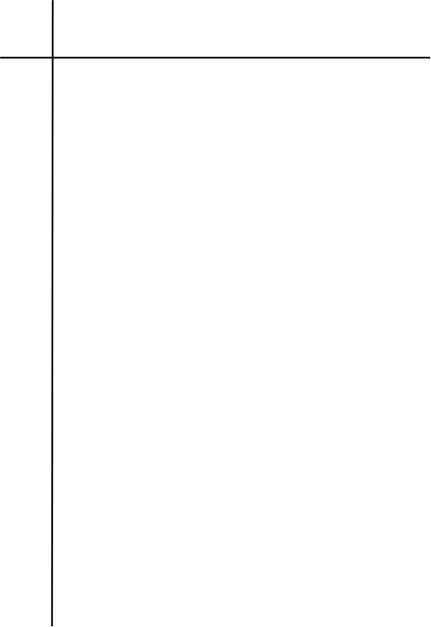
Source Code
alphabet = {"a", "b"}
s = input("Enter a string sequence: ")
state = "A"

for ch in s:
if ch not in alphabet:
state = "dead"
break
match state:
case "A":
state = "B" if ch == "a" else "E"
case "B":
if ch == "a":
state = "C"
else:
state = "dead"
break
case "C":
if ch == "a":
state = "D"
else:
state = "dead"
break
case "D":
state = "B" if ch == "a" else "E"
case "E":
if ch == "b":
state = "F"
else:
state = "dead"
break
case "F":

if ch == "b":
state = "D"
else:
state = "dead"
break

if state == "D":
print("Valid")
else:
print("Invalid")


Output/Observations
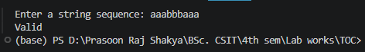
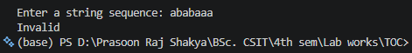


Source Code
alphabet = {"0", "1"}
s = input("Enter a string sequence: ")

state = "A"

for ch in s:
if ch not in alphabet:
state = "Invalid"
break

match state:
case "A":
state = "B" if ch == "0" else "D"

case "B":
state = "C" if ch == "0" else "E"

case "C":
state = "A" if ch == "0" else "F"

case "D":
state = "E" if ch == "0" else "G"

case "E":
state = "F" if ch == "0" else "H"

case "F":
state = "D" if ch == "0" else "I"

case "G":
state = "H" if ch == "0" else "A"


case "H":
state = "I" if ch == "0" else "B"

case "I":
state = "G" if ch == "0" else "C"

if state in ('ABCDG'):
print("Valid")
else:
print("Invalid")


Output/Observations
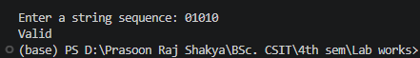
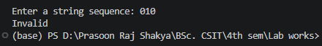

Conclusion
This lab demonstrated the practical implementation of Deterministic Finite Automata (DFA) to validate strings based on specific language constraints. By designing state transitions and testing different input strings, the experiments reinforced the concepts of finite-state machines, transition functions, and acceptance criteria, highlighting how DFAs efficiently recognize patterns defined by formal languages.

