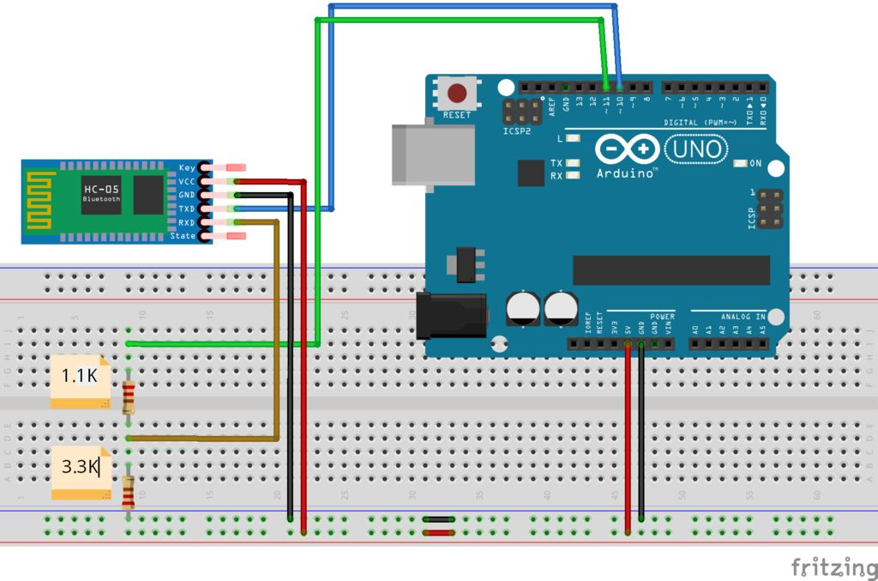

1. Unplug power from HC-05
2. Upload sketch (HC_05.ino)
3. Hold down the ‘EN’ button on the HC-05 module
4. Reconnect power to HC-05 (wait until LED blinks slowly)
5. Press Arduino reset button
6. Open Serial Monitor
7. Make sure "Both NL & CR" is selected and set baudrate to 38400
8. Type AT commands

First type AT? to see if it’s responding. It should answer ‘OK’.

- Change HC-05 baud rate from default 9600 to 115200, 0 stop bit, 0 parity. Type: AT+UART=115200,0,0. To check new baud rate type: AT+UART?
- To change between slave/master: To ask: AT+ROLE? To configure: AT+ROLE=X (X=0 =Slave; 1=Master). Make one master (receiver) and the other slave (emitter).
- Set connection mode: Ask first: AT+CMODE? (0=connect to specific address; 1=connect to any address; 2=Loop (slave)). Leave at ‘1’. If it’s not 1, type AT+CMODE=1.
- Type AT+RESET when finished.
You can also use a FTDI adapter to program the module, which is simpler. Just make sure you use a voltage divider for the Rx pin, like above.

