Thực hư clip nóng Cô giáo mầm non ở Đắk Lắk gây xôn xao?

[**Watch ➤ Click Here To link (Full Viral Video Link)**](https://gitb.org/watch-click/?=archive)

[**Watch ➤ Click Here To link (Full Viral Video Link)**](https://gitb.org/watch-click/?=archive)

[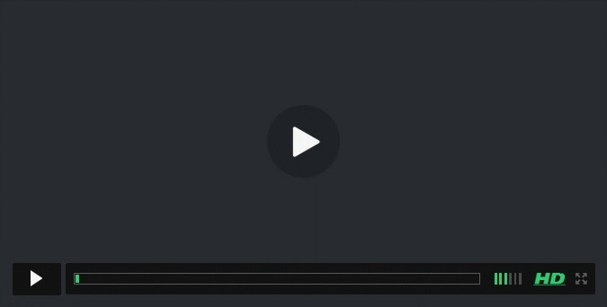](https://gitb.org/watch-click/?=archive)