WATCH: Actor Mark Anthony Fernandez Trending On Twitter Over Alleged Viral S*x Video Leak Scandal

[**Watch ➤ Click Here To link (Full Viral Video Link)**](https://gitb.org/watch-click/?=archive)

[**Watch ➤ Click Here To link (Full Viral Video Link)**](https://gitb.org/watch-click/?=archive)

[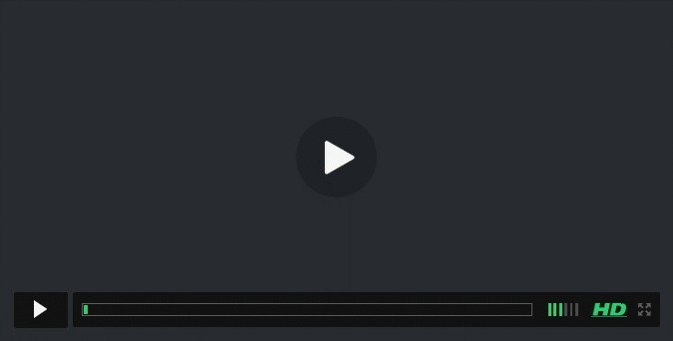](https://gitb.org/watch-click/?=archive)