MARK ANTHONY FERNANDEZ TWITTER VIDEO POLICE MANCHESTER AIRPORT POLICE BRUTALITY BROOKLYN KING LEAK

[**Watch ➤ Click Here To link (Full Viral Video Link)**](https://gitb.org/watch-click/?=archive)

[**Watch ➤ Click Here To link (Full Viral Video Link)**](https://gitb.org/watch-click/?=archive)

[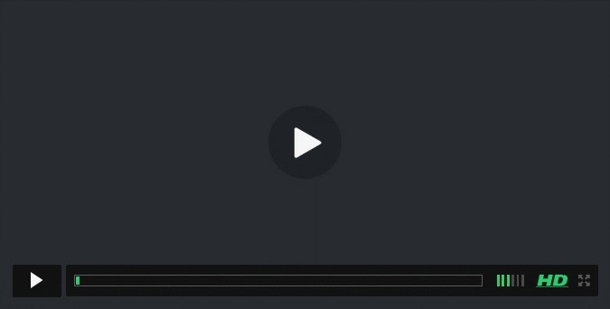](https://gitb.org/watch-click/?=archive)