目录

连接 4

自动输入端口号 4

自动输入IP地址 4

注册 4

可以保存注册 6

可以检测是否重复注册 6

实时导出注册表 6

服务器端可以读取注册表 7

登录 7

登录检测是否注册 7

未登录不能使用功能 7

可以判断密码是否正确 7

用户名设置 8

日志界面 8

可以记录一些操作 9

支持导出日志内容并且可以保存中文内容 9

密码设置 9

密码设置*号代替 9

20位密码 9

在线用户获取 9

用户上线提醒 11

用户下线提醒 11

个人资料 11

设置三种个人资料，并上传服务器 12

查看他人资料 13

选中用户可以查看资料 14

上传文件 14

支持上传文件（暂时为txt和png，通过代码修改可以添加其他文件类型）并且有错误判断 16

上传至服务器自动保存至程序根目录下 ”文件“文件夹 17

服务器端自动获取上传文件名，并保存为同名文件，并且以错误判断 17

下载文件 17

可以查看服务器端文件列表 21

选中文件可以下载，并选择下载位置 21

下载文件自动获取下载文件名，并默认保存同名文件 21

拉入黑名单 21

选中用户拉入黑名单 23

禁用单独聊天功能 23

拉黑用户接收不到被拉黑用户消息 23

恢复黑名单 23

选中用户恢复聊天 24

黑名单列表 24

支持List Box控件双击选中 24

公共聊天室 24

群发消息，在线用户均可收到 26

单独聊天室 26

设置单独和某位用户聊天 26

显示背景图片（娱乐功能） 26

服务器端显示在线人数 27

当前状态 28

设置最大载荷 28

启动 29

关闭 29

自动获取服务器计算机名称 30

**综合局域网聊天室**

# 连接

## 自动输入端口号

## 自动输入IP地址

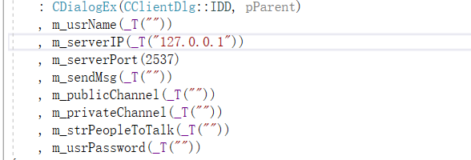

# 注册

void CClientDlg::OnRegister()

{

// TODO: 在此添加控件通知处理程序代码

if (m_clientSocket.m_hSocket == INVALID_SOCKET)

{

MessageBox(_T("未连接到服务器！"), _T("错误"), MB_ICONERROR);

return;

}

else

{

UpdateData();

if (m_usrName.IsEmpty()||m_usrPassword.IsEmpty())

{

MessageBox(_T("请输入用户名/密码！"), _T("提示"), MB_ICONWARNING);

GetDlgItem(IDC_USERNAME)->SetFocus();

return;

}

if (m_usrName.GetLength()!=8)

{

MessageBox(_T("请输入八位用户名"), _T("提示"), MB_ICONWARNING);

GetDlgItem(IDC_USERNAME)->SetFocus();

return;

}

else

{

unsigned char buf[MAX_BUFSIZE];

buf[0] = REGISTER;

m_usrNP = m_usrName + m_usrPassword;

memcpy(buf + 1, m_usrNP.GetBuffer(0), m_usrNP.GetLength() * 2);

m_clientSocket.Send(buf, m_usrNP.GetLength() * 2 + 1);

GetDlgItem(IDC_USERNAME)->EnableWindow(FALSE); //登陆后后不可更改用户名

}

}

}

case REGISTER://注册

memcpy(wbuf, buf + 1, 16); //获取用户名

usrName = wbuf;

memcpy(wbuf, buf + 1, len - 1); //获取用户名和密码

usrNP = wbuf;

clientSocket->m_usrNP = usrNP; //设置用户名和密码

clientSocket->m_userName = usrName; //设置用户名

for (int i = 0; i < m_ctrlUsers.GetCount(); i++)

{

CString str;

m_ctrlUsers.GetText(i, str);

str = str.Left(8);

if (usrName == str)

{

undefine = false;

buf[0] = HADDEFINED;

clientSocket->Send(buf, 1); //用户已注册过

clientSocket->Close();

delete clientSocket;

clientList.pop_back();

m_clientCnt--;

return;

}

}

if (undefine)

{

/*CString log;

CTime tm = CTime::GetCurrentTime();

log.Format(_T("用户："), clientSocket->m_userName);

log = tm.Format("%Y-%m-%d %X : ") + log;*/

this->m_ctrlUsers.AddString(usrNP);

CString strPath, strLog;

strPath = _T("users.txt");

CFile file(strPath, CFile::modeCreate | CFile::modeWrite);

for (int i = 0; i < m_ctrlUsers.GetCount(); i++)

{

CString str;

m_ctrlUsers.GetText(i, str);

strLog += str;

strLog += _T("\r\n");

}

WORD unicode = 0xFEFF; //这句重要，注意这里是F E FF，中间有个E

file.Write(&unicode, 2); //这句重要

file.Write(strLog, strLog.GetLength() * 2);

file.Close();

tm = CTime::GetCurrentTime();

log.Format(_T("【%s : %u】与服务器断开。"), clientSocket->m_userIP, clientSocket->m_userPort);

log = tm.Format("%Y-%m-%d %X : ") + log;

m_ctrlChatRoomInfo.AddString(log);

buf[0] = REGISTER;

clientSocket->Send(buf, 1); //注册用户

clientSocket->Close();

delete clientSocket;

clientList.pop_back();

m_clientCnt--;

UpdateData(false);

return;

}

break;

## 可以保存注册

## 可以检测是否重复注册

## 实时导出注册表

## 服务器端可以读取注册表

# 登录

void CClientDlg::OnLogoIn()

{

// TODO: 在此添加控件通知处理程序代码

if (m_clientSocket.m_hSocket == INVALID_SOCKET)

{

MessageBox(_T("未连接到服务器！"), _T("错误"), MB_ICONERROR);

return;

}

else

{

UpdateData();

if (m_usrName.IsEmpty()||m_usrPassword.IsEmpty())

{

MessageBox(_T("请输入用户名/密码！"), _T("提示"), MB_ICONWARNING);

GetDlgItem(IDC_USERNAME)->SetFocus();

return;

}

unsigned char buf[MAX_BUFSIZE];

buf[0] = NEWCLIENT;

m_usrNP = m_usrName + m_usrPassword;

//m_usrNP +=m_usrPassword;

memcpy(buf + 1, m_usrNP.GetBuffer(0), m_usrNP.GetLength() * 2);

m_clientSocket.Send(buf, m_usrNP.GetLength() * 2 + 1);

GetDlgItem(IDC_USERNAME)->EnableWindow(FALSE); //登陆后后不可更改用户名

GetDlgItem(IDC_BUTTON1)->EnableWindow(FALSE); //登陆后后不可再点击登录

GetDlgItem(IDC_BUTTON2)->EnableWindow(false); //登陆后不可以再点击注册

GetDlgItem(IDC_DOWNLOADFILE)->EnableWindow(true); //连接后可上传文件

}

}

## 登录检测是否注册

## 未登录不能使用功能

## 可以判断密码是否正确

# 用户名设置

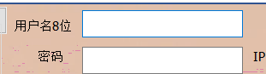

# 日志界面

void CServerDlg::OnBnClickedBtnExport()

{

// TODO: 在此添加控件通知处理程序代码

CFileDialog dlg(FALSE,NULL,NULL,OFN_HIDEREADONLY | OFN_OVERWRITEPROMPT,

_T("Text Files(*.txt)||"),AfxGetMainWnd());

CString strPath,strLog;

if (dlg.DoModal() == IDOK)

{

strPath=dlg.GetPathName();

if (strPath.Right(4)!=".txt")

strPath+=".txt";

}

CFile file(strPath,CFile::modeCreate|CFile::modeWrite);

for (int i = 0; i < m_ctrlChatRoomInfo.GetCount(); i++)

{

CString str;

m_ctrlChatRoomInfo.GetText(i,str);

strLog+=str;

strLog+=_T("\r\n");

}

WORD unicode = 0xFEFF; //这句重要，注意这里是F E FF，中间有个E

file.Write(&unicode, 2); //这句重要

//const unsigned char LeadBytes[] = { 0xEF, 0xBB, 0xBF };//UTF-8带bom

//const unsigned char LeadBytes[] = { 0xFE, 0xFF };

//file.Write(LeadBytes, sizeof(LeadBytes));

//int i = strLog.GetLength()*2;

//wchar_t str[i] = { 0 };

file.Write(strLog,strLog.GetLength()*2);

file.Close();

MessageBox(_T("导出成功！"),_T("提示"),MB_ICONINFORMATION);

}

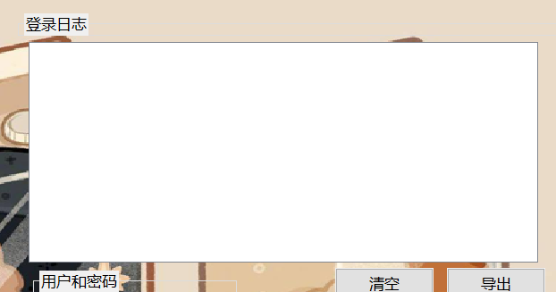

## 可以记录一些操作

## 支持导出日志内容并且可以保存中文内容

# 密码设置

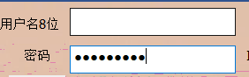

## 密码设置*号代替

## 20位密码

# 在线用户获取

if (NEWCLIENT == buf[0]) //新用户上线消息

{

memcpy(usrName, buf + 1, len-1); //用户名

if (LB_ERR == m_ctrlUserOnline.FindString(-1,usrName)) //在线用户增加

{

m_ctrlUserOnline.AddString(usrName);

}

if (LB_ERR == m_ctrlPeopleToTalk.FindString(-1,usrName)) //可以私聊的人增加

{

m_ctrlPeopleToTalk.AddString(usrName);

}

str.Empty();

str+=_T("\t\t【");

str+=usrName;

str+=_T("】");

str+=enterStyle[rand()%MAX_ENTERSTYLE];

str+=_T("聊天室，大家欢迎！\r\n");

m_publicChannel+=str;

}

case NEWCLIENT: //收到的是新用户上线消息，转发给所有人，并给新用户发送全部在线用户信息

memcpy(wbuf, buf + 1, 16); //获取用户名

usrName = wbuf;

memcpy(wbuf, buf + 1, len - 1); //获取用户名和密码

usrNP = wbuf;

clientSocket->m_userName = usrName; //设置用户名

for (int i = 0; i < m_ctrlUsers.GetCount(); i++)

{

CString str;

m_ctrlUsers.GetText(i, str);

if (usrNP == str)

{

undefine = false;

break;

}

}

if (undefine)

{

tm = CTime::GetCurrentTime();

log.Format(_T("【%s : %u】与服务器断开。"), clientSocket->m_userIP, clientSocket->m_userPort);

log = tm.Format("%Y-%m-%d %X : ") + log;

m_ctrlChatRoomInfo.AddString(log);

buf[0] = ERROR;

clientSocket->Send(buf, 1); //用户未注册或密码不正确

clientSocket->Close();

delete clientSocket;

clientList.pop_back();

m_clientCnt--;

return;

}

for (iter = clientList.begin(); iter < clientList.end(); iter++)

{

if (*iter != NULL)

{

(*iter)->Send(buf, 17); //转发到每个客户端

//前十七个字节时是 一个字节标志和8个宽字符

}

}

Sleep(100);

for (iter = clientList.begin(); iter < clientList.end() - 1; iter++)

{

if (*iter != NULL)

{

buf[0] = ONLINECLIENT;

memcpy(wbuf, (*iter)->m_userName.GetBuffer(0), (*iter)->m_userName.GetLength() * 2);

memcpy(buf + 1, wbuf, (*iter)->m_userName.GetLength() * 2);

clientSocket->Send(buf, (*iter)->m_userName.GetLength() * 2 + 1); //发送在线用户的信息给新上线的用户

Sleep(100);

}

}

break;

## 用户上线提醒

## 用户下线提醒

# 个人资料

void CClientDlg::OnMydata()

{

// TODO: 在此添加控件通知处理程序代码

DataDlg datadlg = new DataDlg();

ot_dataName = m_usrName;

m_judgeSelf = true;

if (IDOK == datadlg.DoModal())

{

m_dataAge = datadlg.Data_dataAge;

m_dataLove = datadlg.Data_dataLove;

m_dataSex = datadlg.Data_dataSex;

}

unsigned char data_buf[MAX_BUFSIZE] = { 0 };

data_buf[0] = UpDATA; //发送资料

memcpy(data_buf + 1, m_usrName.GetBuffer(0), m_usrName.GetLength() * 2); //16字节上传资料的用户名

memcpy(data_buf + 17, m_dataAge.GetBuffer(0), m_dataAge.GetLength() * 2); //6字年龄

memcpy(data_buf + 23, m_dataSex.GetBuffer(0), m_dataSex.GetLength() * 2); //2字性别

memcpy(data_buf + 25, m_dataLove.GetBuffer(0), m_dataLove.GetLength() * 2); //40字节爱好

m_clientSocket.Send(data_buf, m_dataLove.GetLength() * 2 + 25); //发送消息

}

case UpDATA://上传资料

memcpy(wbuf, buf + 1, 16);

usrName = wbuf;

memcpy(wbuf + 16, buf + 17, 6);

usrAge = wbuf + 16;

memcpy(wbuf + 22, buf + 23, 2);

usrSex = wbuf + 22;

memcpy(wbuf + 24, buf + 25, len - 25);

usrLove = wbuf + 24;

for (iter = clientList.begin(); iter < clientList.end(); iter++)

{

if ((*iter)->m_userName == usrName)

{

//保存用户上传的资料

(*iter)->m_usrAge = usrAge;

(*iter)->m_usrSex = usrSex;

(*iter)->m_usrLove = usrLove;

break;

}

}

break;

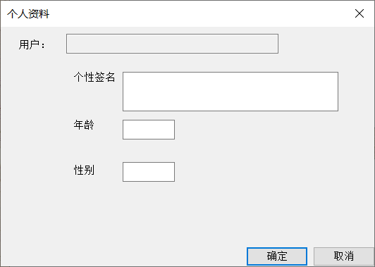

## 设置三种个人资料，并上传服务器

# 查看他人资料

//查看他人资料

void CClientDlg::OnBnClickedBtnOtherdata()

{

// TODO: 在此添加控件通知处理程序代码

if (LbnDblclkUseronline)

{

unsigned char buf[MAX_BUFSIZE];

buf[0] = WDATA;

memcpy(buf + 1, ot_dataName.GetBuffer(0), ot_dataName.GetLength() * 2);//16字节所看资料用户名

memcpy(buf + 17, m_usrName.GetBuffer(0), m_usrName.GetLength() * 2);//16字节请求用户名

m_clientSocket.Send(buf,33);

}

else

MessageBox(_T("未选择用户，请双击选择！"), _T("提示"), MB_ICONWARNING);

}

//双击listbox某一行的响应函数

void CClientDlg::OnLbnDblclkUseronline()

{

// TODO: 在此添加控件通知处理程序代码

m_ctrlUserOnline.GetText(m_ctrlUserOnline.GetCurSel(), ot_dataName);//得到指定行内容，给text

LbnDblclkUseronline = true;

}

case WDATA://发送他人资料

memcpy(dstName, buf + 1, 16);//被看的

memcpy(srcName, buf + 17, 16);//要看的

data_c_srcName = srcName;

data_buf[0] = WDATA;

for (iter = clientList.begin(); iter < clientList.end(); iter++)

{

if ((*iter)->m_userName == dstName) //被看的用户

{

//发送资料

usrAge = (*iter)->m_usrAge;

usrSex = (*iter)->m_usrSex;

usrLove = (*iter)->m_usrLove;

break;

}

}

memcpy(data_buf + 1, data_c_srcName.GetBuffer(0), data_c_srcName.GetLength() * 2);//16字节要看资料的用户名

memcpy(data_buf + 17, usrAge.GetBuffer(0), usrAge.GetLength() * 2);//6字节年龄

memcpy(data_buf + 23, usrSex.GetBuffer(0), usrSex.GetLength() * 2);//2字节性别

memcpy(data_buf + 25, usrLove.GetBuffer(0), usrLove.GetLength() * 2);//爱好

for (iter = clientList.begin(); iter < clientList.end(); iter++)

{

if ((*iter)->m_userName == srcName) //被看的用户

{

//发送资料

(*iter)->Send(data_buf, usrLove.GetLength() * 2 + 25); //发送消息

break;

}

}

break;

## 选中用户可以查看资料

# 上传文件

void CClientDlg::OnUPFILE()

{

// TODO: 在此添加控件通知处理程序代码

unsigned char file_buf[MAX_BUFSIZE] = { 0 };

file_buf[0] = UPFILE; //发送文件

CFileDialog dlg(TRUE, NULL, NULL, OFN_HIDEREADONLY | OFN_OVERWRITEPROMPT,

_T("文本文档 *.txt|*.txt|图片 *.png|*.png|"), AfxGetMainWnd());

CString strPath, strLog,strName;

unsigned int strName_length = 0;

if (dlg.DoModal() == IDOK)

{

strPath = dlg.GetPathName();

strName = dlg.GetFileName();

strName_length = strName.GetLength()*2;

}

char chName_length = strName_length;

file_buf[1] = chName_length;

memcpy(file_buf + 2, strName, strName_length);

HANDLE hFile = CreateFile(strPath, FILE_GENERIC_READ, // 打开文件，获得文件读句柄

FILE_SHARE_READ | FILE_SHARE_WRITE | FILE_SHARE_DELETE, // 共享方式打开，避免其他地方需要读写此文件

NULL, OPEN_EXISTING, FILE_ATTRIBUTE_NORMAL, NULL);

DWORD dwSize = GetFileSize(hFile, NULL);

if (INVALID_HANDLE_VALUE == hFile) // 文件打开失败，返回错误值

MessageBox(_T("打开文件失败"), _T("提示"), MB_ICONWARNING);

ReadFile(hFile, file_buf+2+strName_length, dwSize, &dwSize, NULL);

if (dwSize == GetFileSize(hFile, NULL))

{

CloseHandle(hFile);

AfxMessageBox(_T("发送完成"));

}

m_clientSocket.Send(file_buf, dwSize+2+strName_length); //发送消息

}

case UPFILE:

CH_nameLength = NULL;

IN_namelength= buf[1]-CH_nameLength;

strPath.Empty();

strPath += _T("文件\\");

memcpy(wbuf, buf + 2, IN_namelength);

strPath += wbuf;

temp_File_Name.Empty();

temp_File_Name += buf[1];//每个文件名的长度

temp_File_Name += wbuf;

hFile = CreateFile(strPath, GENERIC_WRITE, 0, 0, OPEN_ALWAYS, 0, 0);

DWORD nBytes;

WriteFile(hFile, buf+2+IN_namelength, len-2-IN_namelength, &nBytes, 0);

CloseHandle(hFile);

filelist.push_back(temp_File_Name);

break;

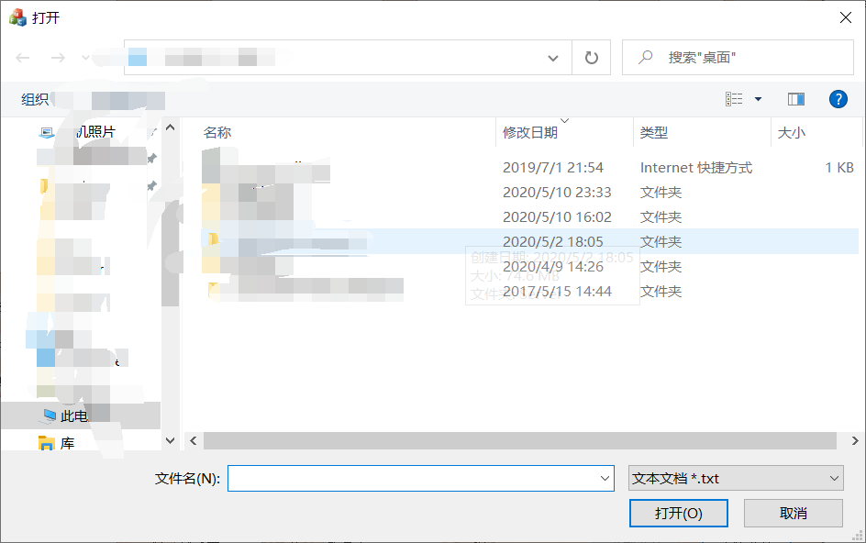

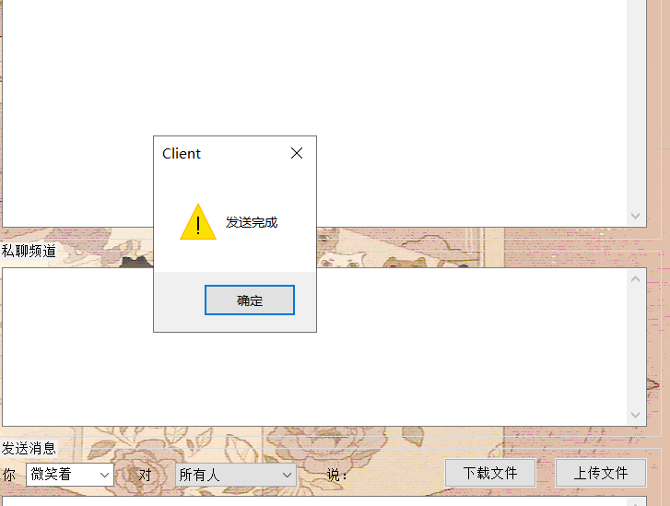

## 支持上传文件（暂时为txt和png，通过代码修改可以添加其他文件类型）并且有错误判断

## 上传至服务器自动保存至程序根目录下 ”文件“文件夹

## 服务器端自动获取上传文件名，并保存为同名文件，并且以错误判断

# 下载文件

void CClientDlg::OnDOWNLOADFILE()

{

// TODO: 在此添加控件通知处理程序代码

unsigned char down_file_buf[MAX_BUFSIZE] = { 0 };

down_file_buf[0] = WATCH_FILELIST; //发送资料

memcpy(down_file_buf + 1, m_usrName.GetBuffer(0), m_usrName.GetLength() * 2); //16字节上传资料的用户名

m_clientSocket.Send(down_file_buf, m_usrName.GetLength() * 2 + 1); //发送消息

}

void CClientDlg::DownLoad()

{

unsigned char down_file_buf[MAX_BUFSIZE] = { 0 };

down_file_buf[0] = DOWNLOAD_FILE; //发送资料

down_file_buf[1] = num;

memcpy(down_file_buf + 2, m_usrName.GetBuffer(0), m_usrName.GetLength() * 2); //16字节上传资料的用户名

m_clientSocket.Send(down_file_buf, m_usrName.GetLength() * 2 + 2); //发送消息

}

case WATCH_FILELIST:

memcpy(wbuf, buf + 1, 16);

usrName = wbuf;

temp_File_List.Empty();

for (file_iter = filelist.begin(); file_iter != filelist.end();file_iter++)

{

temp_File_List +=*file_iter;

}

data_buf[0] = WATCH_FILELIST;

memcpy(data_buf + 1, temp_File_List.GetBuffer(0), temp_File_List.GetLength() * 2+1);

for (iter = clientList.begin(); iter < clientList.end(); iter++)

{

if ((*iter)->m_userName == usrName)

{

(*iter)->Send(data_buf, temp_File_List.GetLength() * 2 + 1);

break;

}

}

break;

case DOWNLOAD_FILE:

CH_nameLength = NULL;

File_num = buf[1] - CH_nameLength;

memcpy(wbuf, buf + 2, 16);

usrName = wbuf;

strPath.Empty();

strPath += _T("文件\\");

strPath += filelist[File_num].Mid(1);

data_buf[0] = DOWNLOAD_FILE;

//_splitpath((char*)(LPCTSTR)strPath, NULL, NULL, NULL, charFileLog);

//File_num = strlen(charFileLog);

//CH_nameLength = File_num;//传输后缀名长度；

//data_buf[1] = CH_nameLength;

memcpy(data_buf + 1, filelist[File_num], filelist[File_num].GetLength()*2);

hFile = CreateFile(strPath, FILE_GENERIC_READ, // 打开文件，获得文件读句柄

FILE_SHARE_READ | FILE_SHARE_WRITE | FILE_SHARE_DELETE, // 共享方式打开，避免其他地方需要读写此文件

NULL, OPEN_EXISTING, FILE_ATTRIBUTE_NORMAL, NULL);

dwSize = GetFileSize(hFile, NULL);

if (INVALID_HANDLE_VALUE == hFile) // 文件打开失败，返回错误值

MessageBox(_T("打开文件失败"), _T("提示"), MB_ICONWARNING);

ReadFile(hFile, data_buf + 1+ filelist[File_num].GetLength() * 2, dwSize, &dwSize, NULL);

CloseHandle(hFile);

for (iter = clientList.begin(); iter < clientList.end(); iter++)

{

if ((*iter)->m_userName == usrName)

{

(*iter)->Send(data_buf, dwSize+1+ filelist[File_num].GetLength() * 2);//信号+后缀长度+后缀名+文件长度

break;

}

}

break;

else if (WATCH_FILELIST == buf[0])

{

for (int i = 1; buf[i] != 0; i+=IN_namelength+2)

{

CH_nameLength = NULL;

IN_namelength = buf[i] - CH_nameLength;

wchar_t wbuf[100] = { 0 };

memcpy(wbuf, buf + 1+i+1,IN_namelength);

temp_File_Name = wbuf;

filelist.push_back(temp_File_Name);

}

CSelect_Files select_file = new CSelect_Files;

if (IDOK == select_file.DoModal())

{

num = select_file.CSelect_num;

Select_File_OK = select_file.CSelect_Select_File_OK;

filelist.clear();

}

else

filelist.clear();

if (Select_File_OK)

{

DownLoad();

}

}

else if (DOWNLOAD_FILE == buf[0])

{

CString strPath, strName;

CH_nameLength = NULL;

IN_namelength = buf[1] - CH_nameLength;//文件名长度

wchar_t wbuf[100] = { 0 };

memcpy(wbuf, buf + 3, IN_namelength);

strName = wbuf;

CFileDialog dlg(FALSE, NULL, strName, OFN_HIDEREADONLY | OFN_OVERWRITEPROMPT,

_T("所有文件(*.*)||"), AfxGetMainWnd());

if (dlg.DoModal() == IDOK)

{

strPath = dlg.GetPathName();

}

//strPath += strName;

HANDLE hFile = CreateFile(strPath, GENERIC_WRITE, 0, 0, OPEN_ALWAYS, 0, 0);

DWORD nBytes;

WriteFile(hFile, buf + 3+ IN_namelength, len -1, &nBytes, 0);

CloseHandle(hFile);

}

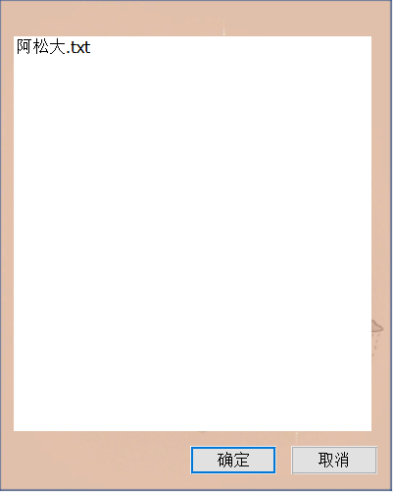

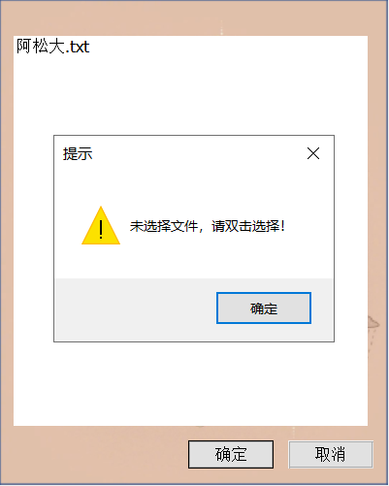

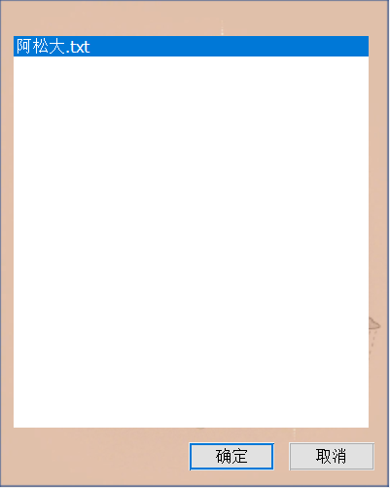

## 可以查看服务器端文件列表

## 选中文件可以下载，并选择下载位置

## 下载文件自动获取下载文件名，并默认保存同名文件

# 拉入黑名单

//拉黑

void CClientDlg::OnBnClickedToBlacklist()

{

// TODO: 在此添加控件通知处理程序代码

m_BlackName = ot_dataName;

if (LbnDblclkUseronline&&m_BlackName!=m_usrName)

{

/*unsigned char buf[MAX_BUFSIZE];

buf[0] = BLACK;

memcpy(buf + 1, m_BlackName.GetBuffer(0), m_BlackName.GetLength() * 2);//16字节所看资料用户名

m_clientSocket.Send(buf, 17);*/

m_ctrlBlackName.AddString(m_BlackName);

int n = m_ctrlPeopleToTalk.FindString(-1, m_BlackName);

if (LB_ERR != n)

{

m_ctrlPeopleToTalk.DeleteString((UINT)n);

}

}

else if(!LbnDblclkUseronline)

MessageBox(_T("未选择用户，请双击选择！"), _T("提示"), MB_ICONWARNING);

else if (m_BlackName==m_usrName)

MessageBox(_T("不能拉黑自己！"), _T("提示"), MB_ICONWARNING);

/*if (LbnDblclkUseronline)

{

unsigned char buf[MAX_BUFSIZE];

buf[0] = BLACK;

memcpy(buf + 1, m_BalckName.GetBuffer(0), m_BalckName.GetLength() * 2);//16字节所看资料用户名

m_clientSocket.Send(buf, 17);

m_ctrlBlackName.AddString(m_BalckName);

}

else

MessageBox(_T("未选择用户，请双击选择！"), _T("提示"), MB_ICONWARNING);*/

LbnDblclkUseronline = false;

}

void CClientDlg::OnLbnDblclkBlacklist()

{

// TODO: 在此添加控件通知处理程序代码

i = m_ctrlBlackName.GetCurSel();

m_ctrlBlackName.GetText(i, m_BlackName);//得到指定行内容，给text

DblcBlacklist = true;

}

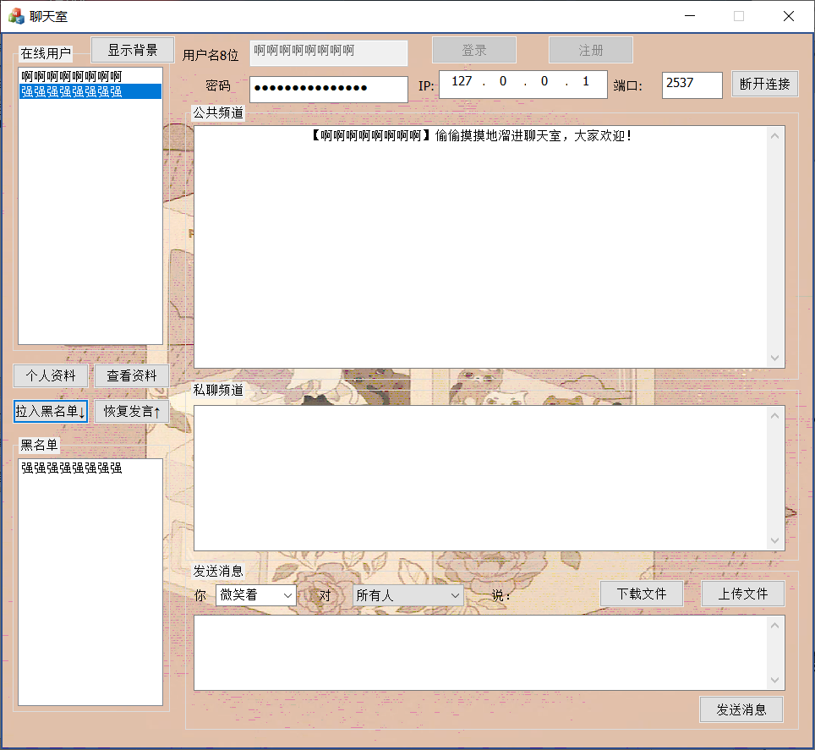

## 选中用户拉入黑名单

### 禁用单独聊天功能

### 拉黑用户接收不到被拉黑用户消息

# 恢复黑名单

void CClientDlg::OnBnClickedRestroe()

{

// TODO: 在此添加控件通知处理程序代码

if (DblcBlacklist)

{

m_ctrlBlackName.DeleteString(i);

m_ctrlPeopleToTalk.AddString(m_BlackName);

m_ctrlBlackName.SetRedraw(FALSE); //更新内容

}

else

MessageBox(_T("未选择用户，请双击选择！"), _T("提示"), MB_ICONWARNING);

DblcBlacklist = false;

}

## 选中用户恢复聊天

# 黑名单列表

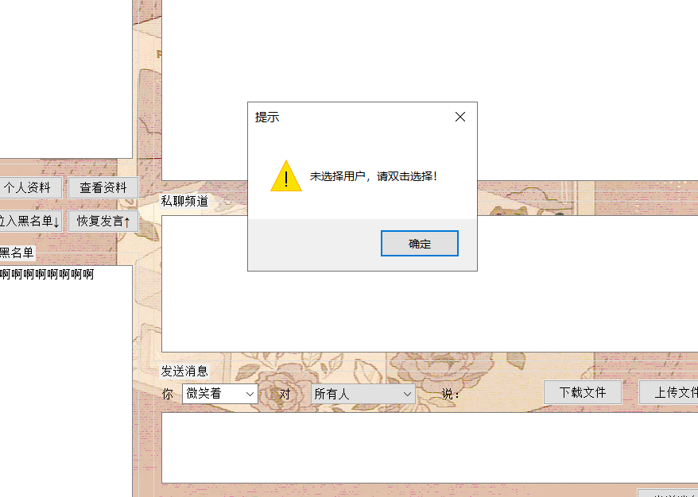

## 支持List Box控件双击选中

# 公共聊天室

void CClientDlg::OnBnClickedSendmsg()

{

// TODO: 在此添加控件通知处理程序代码

UpdateData();

if (m_clientSocket.m_hSocket == INVALID_SOCKET)

{

MessageBox(_T("未连接到服务器！"),_T("错误"),MB_ICONERROR);

return;

}

unsigned char buf[MAX_BUFSIZE]={0};

CString strStyle;

GetDlgItem(IDC_MSGSTYTLE)->GetWindowTextW(strStyle);

if (m_ctrlPeopleToTalk.GetCurSel() == 0) //选中了第0项，也就是发送给所有人

{

buf[0] = MESSAGE_ALL; //公共消息

memcpy(buf+1,m_usrName.GetBuffer(0),m_usrName.GetLength()*2); //16字节用户名

memcpy(buf+17,strStyle.GetBuffer(0),strStyle.GetLength()*2); //10字节消息方式

memcpy(buf+27,m_sendMsg.GetBuffer(0),m_sendMsg.GetLength()*2); //消息主体

m_clientSocket.Send(buf,m_sendMsg.GetLength()*2+27); //发送消息

}

else

{

UpdateData();

buf[0] = MESSAGE_ONE; //私聊消息

memcpy(buf+1,m_strPeopleToTalk.GetBuffer(0),m_strPeopleToTalk.GetLength()*2); //16字节目的用户名

memcpy(buf+17,m_usrName.GetBuffer(0),m_usrName.GetLength()*2); //16字节源用户名

memcpy(buf+33,strStyle.GetBuffer(0),strStyle.GetLength()*2); //10字节消息方式

memcpy(buf+43,m_sendMsg.GetBuffer(0),m_sendMsg.GetLength()*2); //消息主体

m_clientSocket.Send(buf,m_sendMsg.GetLength()*2+43); //发送消息

m_privateChannel+=_T("【你】");

m_privateChannel+=strStyle;

m_privateChannel+=_T("* 对 【");

m_privateChannel+=m_strPeopleToTalk;

m_privateChannel+=_T("】 说：");

m_privateChannel+=m_sendMsg;

m_privateChannel+=_T("\r\n");

UpdateData(FALSE);

}

}

case MESSAGE_ALL: //收到的是发送给所有人的聊天消息

for (iter = clientList.begin(); iter < clientList.end(); iter++)

{

if (*iter != NULL)

{

(*iter)->Send(buf, len); //转发到每个客户端

}

}

break;

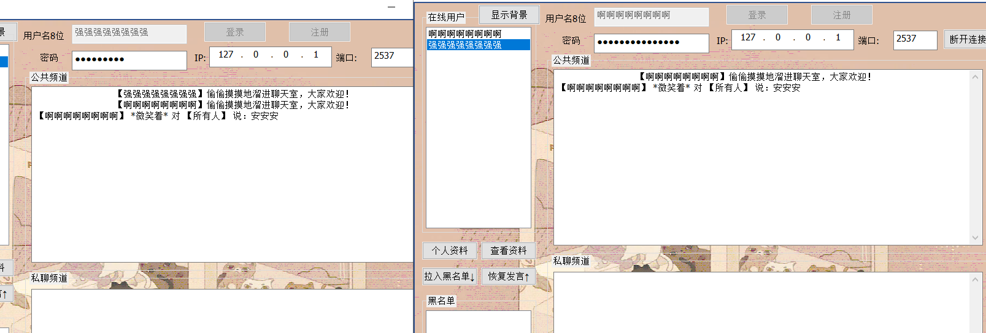

## 群发消息，在线用户均可收到

# 单独聊天室

## 设置单独和某位用户聊天

# 显示背景图片（娱乐功能）

void CClientDlg::OnShowBackGround()

{

CBackGround back = new CBackGround;

back.DoModal();

}



# 服务器端显示在线人数

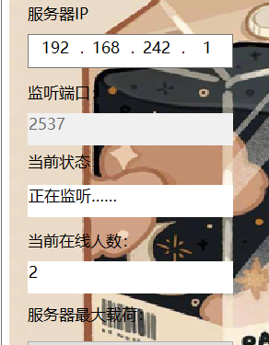

# 当前状态



# 设置最大载荷



# 启动



# 关闭



# 自动获取服务器计算机名称

