DB Experiment 6——Second-Hand book Platform
单人一组：71122133 唐珉
目录
DB Experiment 6——Second-Hand book Platform 1
1.Project Overview 2
1.1 Background and significance of the project 2
1.2 Project tasks 2
1.3 Report structure 3
2.Requirements analysis 3
2.1 Target clients 3
2.2 System function requirements 4
3.Second-hand Book Platform System Design 7
3.1 Overall system functional design 8
3.2 Architecture Design 9
3.3 Interface Design 9
3.4 DataBase Design 10
3.5 User interface Design 13
4.Software implementation 17
4.1 SEU detailed class design of second-hand book platform system 17
4.2 User management module class design and important function implementation 20
4.3 Book management module class design and important function implementation 27
4.4 Book searching module class design and important function implementation 33
4.5 Trading Management module class design and important function implementation 35
4.6 user appeal module class design and important function implementation 41
4.7 user communicate module class design and important function implementation 44
4.8 summery 47
5 result display 48
5.1 login 48
5.2 book managing 50
5.3 searching book 57
5.4 book trading 58
5.5 real time user communicate 63
5.6 manager adding users in batches 64
5.7 User Complaints 66
6.experiments summery 68

1.Project Overview

1.1 Background and significance of the project
In universities, both faculty and students often have textbooks and professional books that are left unused or sold at low prices after courses end. This creates significant demand in the second-hand book market. For students, buying new books can be expensive, while second-hand books offer an affordable option and a chance to earn extra income by selling unused books. This reduces financial pressure, promotes book recycling, and supports environmental sustainability.
Second-hand book trading platforms are not only marketplaces but also spaces for exchanging information. Students can buy and sell books, share learning experiences, and enhance interaction between faculty and students, fostering a stronger academic atmosphere and mutual support.
Building such a platform offers economic benefits for students, supports environmental sustainability by reducing resource waste, and improves campus communication. It also makes transactions more convenient compared to traditional offline methods.

1.2 Project tasks
The development of software generally goes through several stages: (initial) requirement analysis, (detailed) system design (data, functionality, behavior, interface, architecture, detailed design), construction (implementation, integration, testing), and deployment. Our experiment mainly focuses on these stages.
Requirement Analysis: Analyzing from the perspectives of administrators and regular users in a university setting.
System Design: Includes architecture design, module functionality and interface design, database design, etc.
Platform Implementation: Frontend pages are developed using HTML, CSS, and JavaScript, while the backend is built using the popular Spring Boot framework.
Platform Deployment: The project is deployed on a server to ensure the platform runs smoothly.

1.3 Report structure
This report is divided into the following sections:
Chapter 1 is the introduction, which outlines the background, significance, main work, and structure of the East China University second-hand book platform project.
Chapter 2 is the requirement analysis of the project, presented in a top-down structure to introduce the system’s requirements.
Chapter 3 is the system design of the project, focusing on the analysis of the design of each module.
Chapter 4 is the implementation of the project, starting with the database design, followed by the implementation of each module, including class design and key technologies used. It also discusses the features that have not been implemented and the reasons.
Chapter 5 is system testing, demonstrating the entire process and the execution results of the East China University second-hand book platform project.

2.Requirements analysis

2.1 Target clients
The system’s target users are divided into two categories: regular users and special users.
Regular users refer to students, faculty, and staff of Southeast University. These users mainly include those with idle books and those in need of books. They can buy and sell books on the platform to meet their needs for obtaining or disposing of books.
Special users include the platform administrators. Administrators are responsible for maintaining the platform and ensuring its normal operation. Their duties include reviewing book information, handling user feedback, and managing users to ensure the platform runs efficiently and provides a good user experience.
By clearly defining the types and roles of target users, we can better understand user needs and design and implement the system accordingly.

2.2 System function requirements

1.System overall use case diagram
First, we model the system based on scenarios. There are two main types of participants: ordinary users and administrator users. Ordinary users can be both buyers and sellers. Therefore, ordinary users are not divided into sellers and buyers here, but directly regarded as a participant.
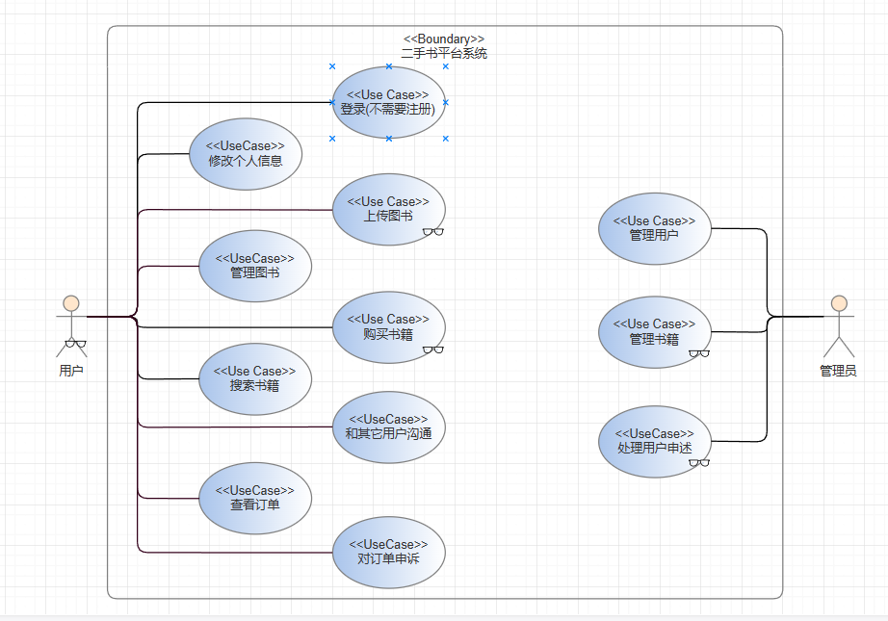

2.Functional requirements of ordinary users
Ordinary users include students and faculty members of Southeast University. They can log in to the platform to publish and purchase books, modify personal information, search and browse books, view book details, upload and manage book information, view sales records, view and manage orders, communicate with other users, handle complaints, and receive message notifications. The specific functions are as follows:
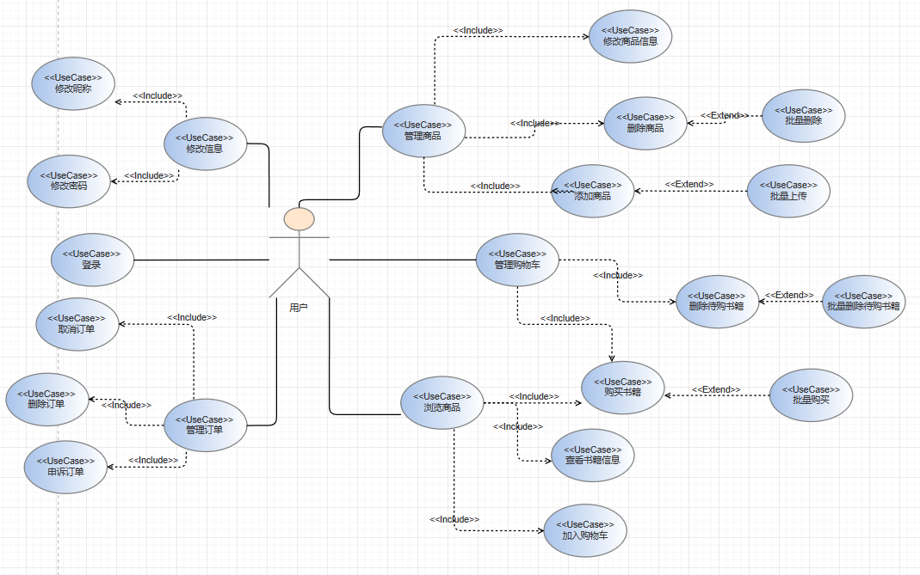
Ordinary user use case diagram
role | Use case | function
ordinary users | Log in | Users must log in to post book information or make purchases.
 | Edit user own info | Modify login password or username.
 | Book searching | · Search books by title, author, publisher, subject, or category.  · Support advanced search with multiple criteria.
 | Browse Book Categories | Browse books by subject category.
 | View book details | View detailed book information, including description, images, and price
 | Upload book info | 1. Basic information such as book title, author, publisher, etc.  2. Book description, including detailed information of the book (newness, whether there are notes, etc.).  3. Book classification: Sellers can classify books into different subject categories, such as computer, mathematics, physics, etc.  4. Book pictures: Support uploading photos of book covers.  Price setting: Sellers set a price for the book
 | Manage their own book info | Sellers can modify or delete published book information.
 | View sale record | Users can view the records of books they have sold.
 | Buy book | Buyers can choose the books they like and place an order.
 | User communicate | Buyers and sellers can communicate and exchange ideas through the real-time chat system built into the real-time platform
 | User appeal | If you are not satisfied with the quality of the book you purchased, you can file a complaint.
 | View orders | 1. Check the book orders you have purchased and track the order status.  2.Check the book orders you have sold and track the order status
 | Receiving Messages | When there is a new message, display a prompt

3.Administrator Function Requirements
Administrators are managers in the platform. Their needs include book category management, user management, and complaint handling. The specific use cases are as follows: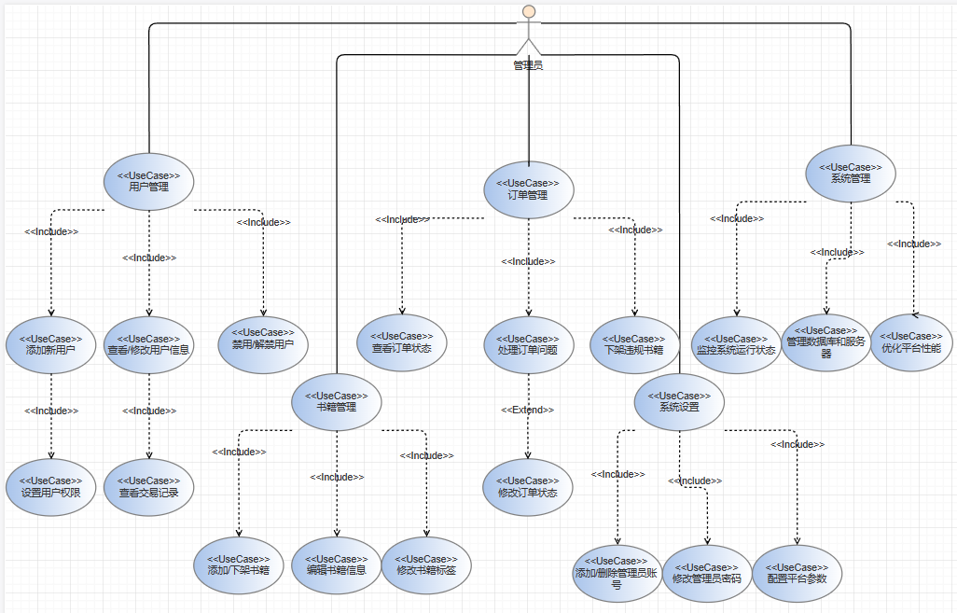
role | Use case | function
manager | Book category management | Add or modify book categories
 | User manager | - 1. View user information.  - 2. Modify user information.  - 3. Add users.  - 4. Add users in batches.  - 5. Delete users.  - Delete users in batches
 | Appeal handling | Check the complaints raised by buyers, handle them and give the results.

3.Second-hand Book Platform System Design
The system design will adopt a front-end and back-end separation architecture, with HTML, CSS, and JavaScript used on the front end. The back end will adopt a microservice architecture based on RESTful API, implemented using the popular programming language and framework Spring Boot to ensure the high availability, scalability, and performance of the system.
The system will use modern database technology for data storage and management, and the relational database MySQL will be selected to meet the needs. At the same time, the system will implement a good user interface and user experience to ensure that users can easily use the platform to trade second-hand books.

3.1 Overall system functional design
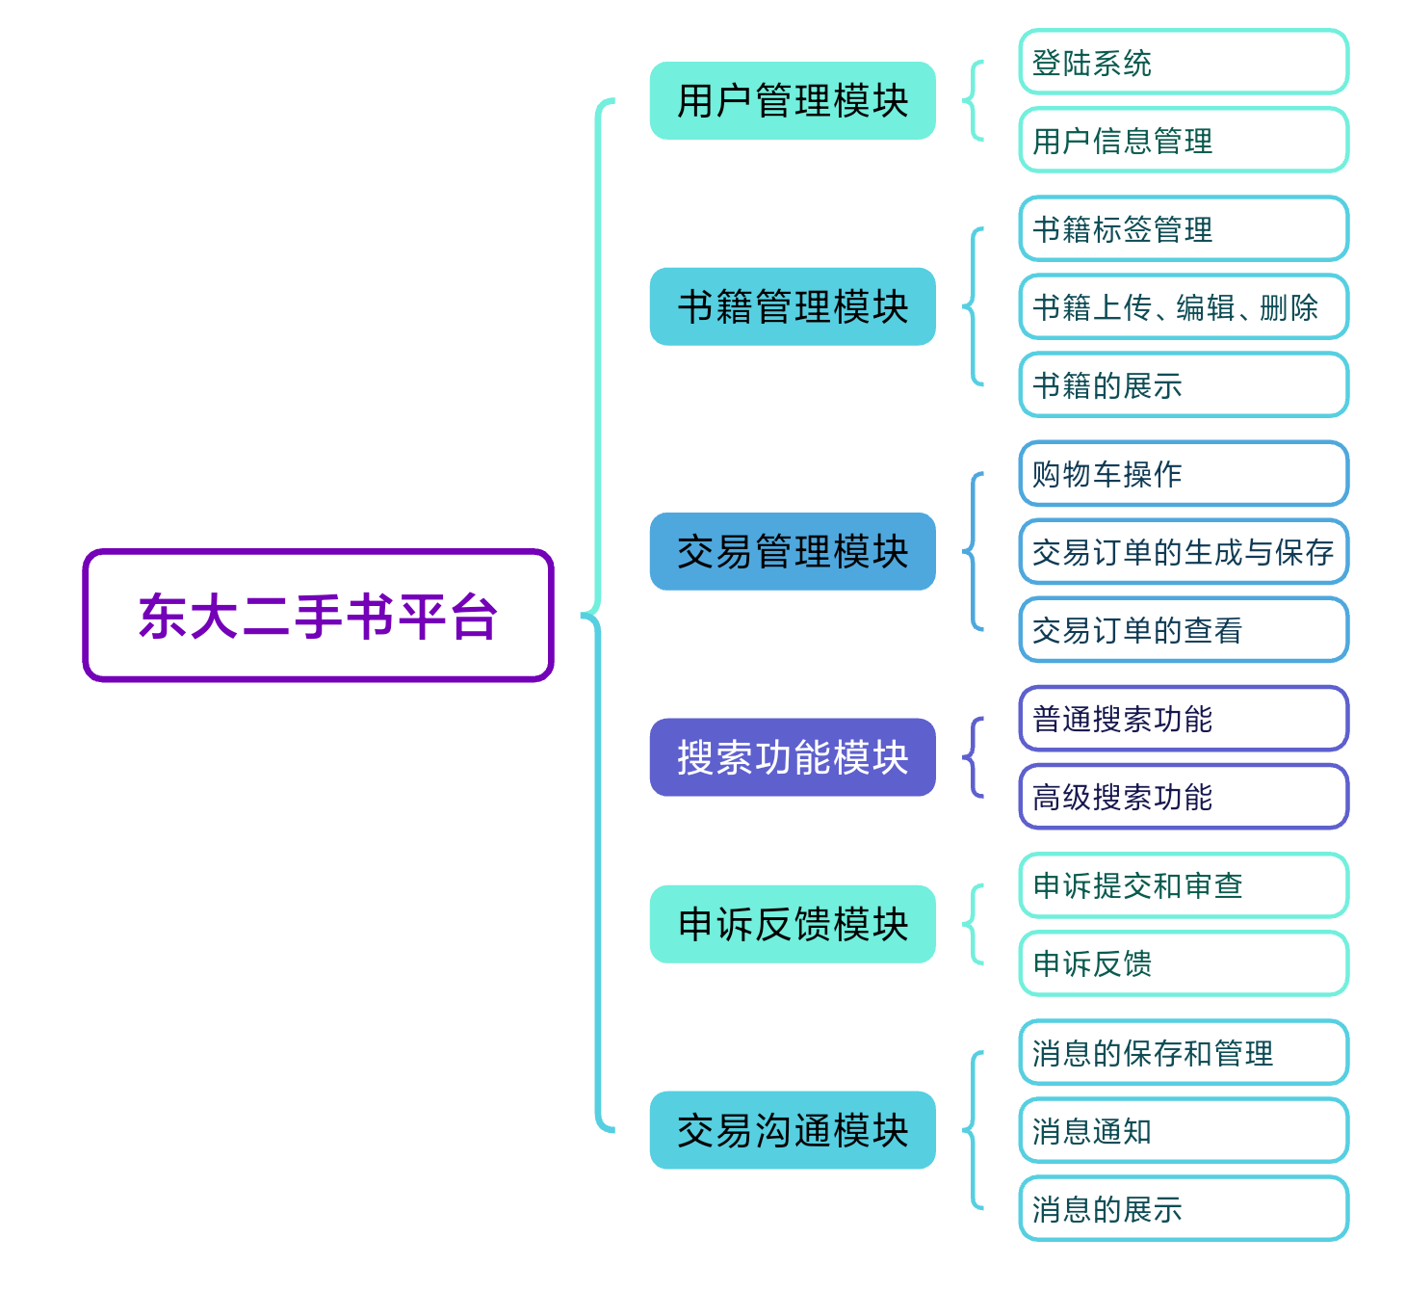
The overall system function design of SEU second-hand book platform covers the following main modules:
User management module, including login system: realizing user registration, login, password retrieval and other functions; user information management function: users can view and update personal information.
Book management module, including book management functions: such as book upload, editing, deletion, supporting users to upload, edit and delete book information; book display: display all book information, users can browse and search books.
Transaction management module, including the generation and preservation of transaction orders; after the user initiates a purchase request, an order is generated and the order information is saved; shopping cart addition and deletion functions: users can operate the shopping cart; transaction order viewing: users can view specific order details and transaction status.
Search function module, including: general search function: basic search of books based on keywords; advanced search function: precise search based on multiple attributes of books (such as classification, author, etc.).
Appeal feedback module, including: appeal submission and review: users can submit appeals, and administrators review them; appeal feedback: administrators handle appeals and feedback to users.
The transaction communication module includes: message storage and management: message communication records between users are stored and managed; message display: communication messages between users are displayed.

3.2 Architecture Design
This system will adopt the B/S architecture and a layered design, with the server side divided into the following layers:
Configuration Layer: Includes platform security configuration (SecurityConfig), cross-origin resource sharing configuration (CORSConfig), and message communication configuration (WebSocketConfig). These configurations ensure platform security, communication, user authorization, and resource protection.
Controller Layer: Includes various controller classes such as MainPageController, PcController (Personal Center), ManagerController (Admin Center), and BookInfoController (Book Actions). They handle user requests for different pages or modules, passing data to the service layer, and receiving data from the service layer to send back to the frontend.
Service Layer: Contains service classes for each object, such as UserLibraryServer (user management), BookLibraryServer (book-related services), OrderLibraryServer, MessageLibraryServer, ShoppingCarServer, and LabelServer. These services interact with the corresponding repository layer to access data and handle complex logic, forming the core of system operations.
Repository Layer: Uses the Spring Data JPA framework (e.g., UserLibrarySql, BookLibrarySql) for direct interaction with the database, performing search, save, update, and delete operations.
Entity Layer: Contains the core data models of the application, mapped to database tables using an ORM framework like Hibernate. Examples include entities such as User, Book, Order, and Label, typically defined with JPA’s @Entity annotation.

3.3 Interface Design
The interface design mainly includes the front-end and back-end interaction interfaces and internal service interfaces. The design is as follows:
Front-End and Back-End Interaction Interfaces: Based on RESTful API, these interfaces facilitate data exchange between the front-end and back-end. The interfaces cover modules such as user registration, login, book information management, and transaction management. Both the request and response formats use JSON.
Specifically:
/common/: Interfaces accessible to both regular users and administrators, such as /common/bookinfo/ for viewing book details and /common/search/ for searching books.
/user/: Interfaces restricted to regular users, such as /user/submitbook/ for uploading books, /user/shoppinglist/delete/{bookid} for deleting items from the shopping cart, and /user/orderappeal/{orderid} for filing a complaint about an order.
/manager/: Interfaces accessible only to administrators, such as /manager/addlable for adding book tags, /manager/handleappeal/{orderid}/{outcome} for handling user appeals, and /manager/addALotsOfUser for batch adding users via file.

3.4 DataBase Design

3.4.1 ER design
The atrributes’ datatype of entity is not correct in this diagram, please watch the detail table design for exact datatype.
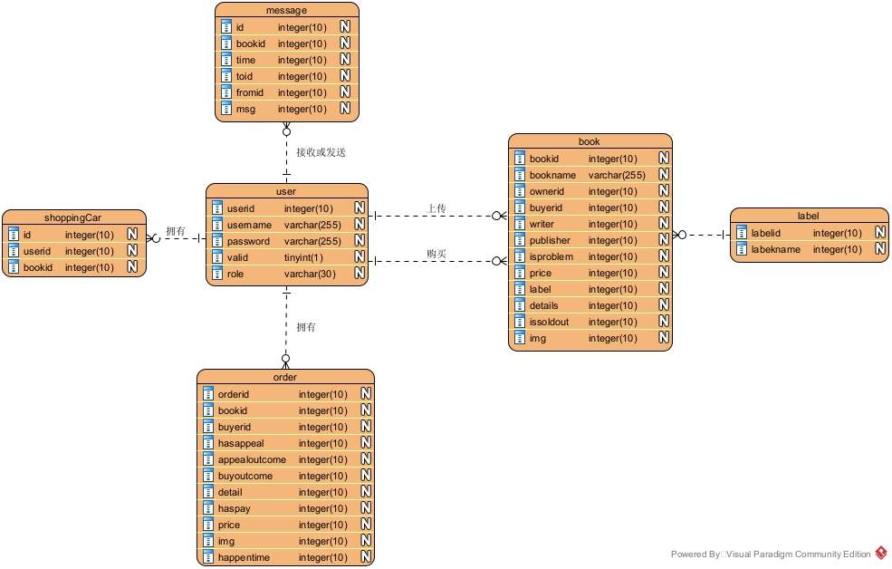

3.4.2 Data Schema design
The platform incorporates multiple tables to store and manage various types of data. These include the user table (user), book table (book), label table (label), shopping cart table (shoppingcar), orders table (orders), and message table (message). Each table is designed based on specific functional requirements.
Relation Name | Data Schema
users | Users(id, username, password, valid, role)
books | Books(id, bookname, ownerid, buyerid, writer, publisher, isproblem, issoldout, price, label, details, img)
labels | Labels(id, label)
shoppingCart | ShoppingCart(id, userid, bookid)
orders | Orders(id, bookid, bookname, buyerid, sellerid, happendedtime, hasappeal, appealoutcome, buyoutcome, detail, haspay, price, img)
messages | Messages(id, bookid, time, tousername, fromusername, msg)

3.4.3 Detail table design
1. User Table (user)
Stores basic user information, including user ID, username, encrypted password, account status, and user roles.
Field Name | Data Type | Length | Nullable | Description
id | int | Default | No | Primary key
username | varchar | 30 | No | Unique login name for the user
password | varchar | 255 | No | Encrypted user password
valid | tinyint | 1 | No | Indicates if the user account is active
role | varchar | 30 | No | User role for access control
2. Book Table (book)
Records basic book information and status, including title, author, owner, buyer, and more.
Field Name | Data Type | Length | Nullable | Description
id | int | Default | No | Primary key
bookname | varchar | 100 | No | Book title
ownerid | int | Default | No | Owner's user ID
buyerid | int | Default | Yes | Buyer's user ID (default is 0)
writer | varchar | 30 | No | Author's name
publisher | varchar | 30 | No | Publisher name
isproblem | int | 1 | No | Indicates if the book has issues (default: 0)
issoldout | int | 1 | No | Indicates if the book is sold (default: 0)
price | float | Default | No | Price of the book
lable | varchar | 10 | No | Book tags
details | text | Default | Yes | Description of the book
img | varchar | 100 | Yes | Unique filename for the book image
3.Label Table (label)
Stores book tag information.
Field Name | Data Type | Length | Nullable | Description
id | int | 10 | No | Primary key
lable | varchar | 30 | No | Book tag
4. Shopping Cart Table (shoppingcar)
Records information about books in a user's shopping cart.
Field Name | Data Type | Length | Nullable | Description
id | int | Default | No | Primary key
userid | int | Default | No | User's ID
bookid | int | Default | No | Book's ID
5. Orders Table (orders)
Tracks order details, including books, buyers, sellers, and status.
Field Name | Data Type | Length | Nullable | Description
id | int | Default | No | Primary key
bookid | int | Default | No | Book's ID
bookname | varchar | 100 | No | Book's name
buyerid | int | Default | No | Buyer's ID
sellerid | int | Default | No | Seller's ID
happendedtime | datetime | Default | No | Order creation time
hasappeal | int | 1 | No | Indicates if there is an appeal (default: 0)
appealoutcome | int | 1 | No | Appeal outcome (0: Pending, 1: Success, -1: Fail)
buyoutcome | int | 1 | No | Indicates if the purchase is confirmed (default: 0)
detail | text | Default | Yes | Appeal details
haspay | varchar | 1 | No | Indicates if the order is paid
price | float | Default | No | Price of the book
img | varchar | 100 | Yes | Filename of the book's image
6. Message Table (message)
Records messages exchanged between users.
Field Name | Data Type | Length | Nullable | Description
id | int | Default | No | Primary key
bookid | int | Default | No | Book associated with the message
time | datetime | Default | No | Time when the message was sent
tousername | varchar | 30 | No | Recipient's username
fromusername | varchar | 30 | No | Sender's username
msg | text | Default | No | Message content

3.5 User interface Design
1.Log in and sign up page
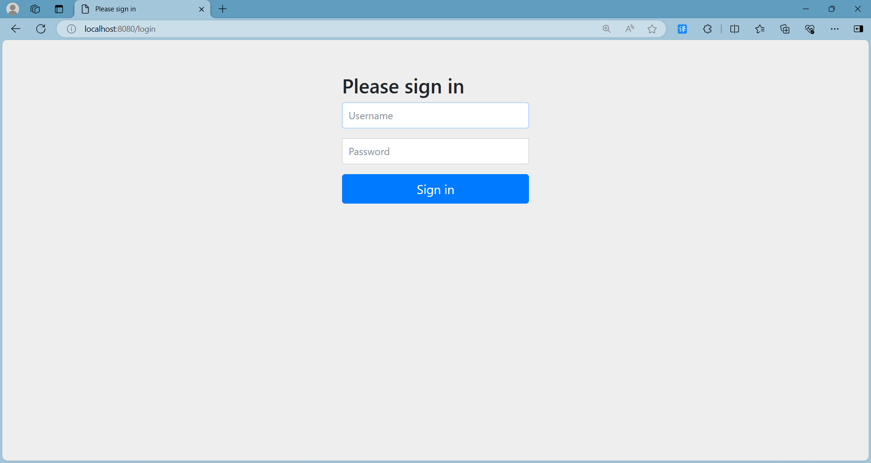

- main page
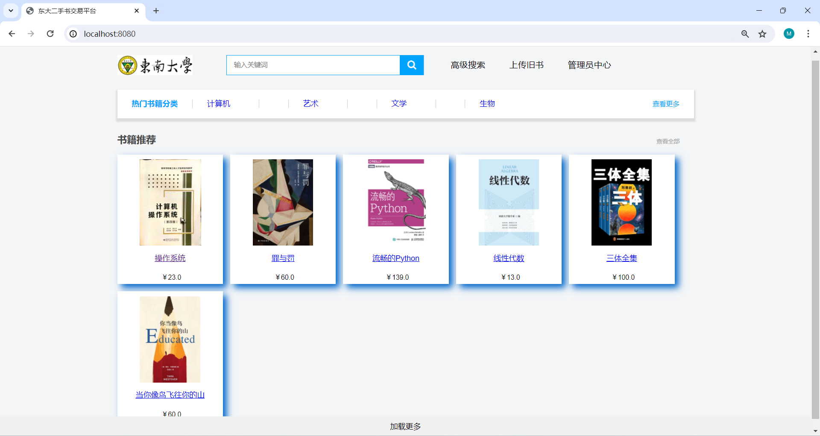
- Book detail page
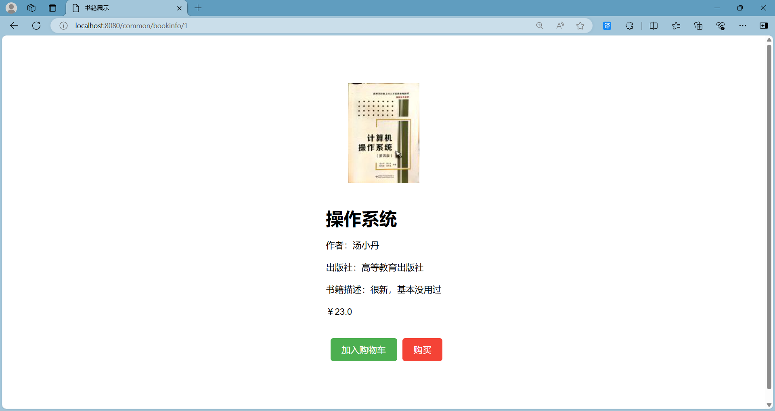
- user upload book page
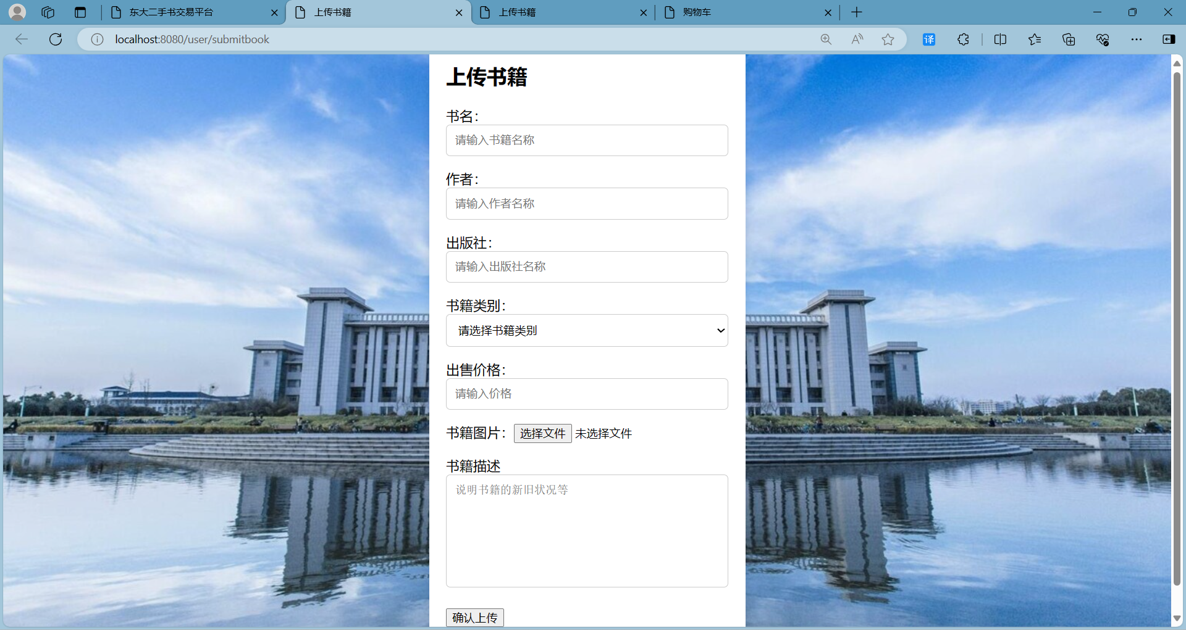
- user click buy button to buy book page
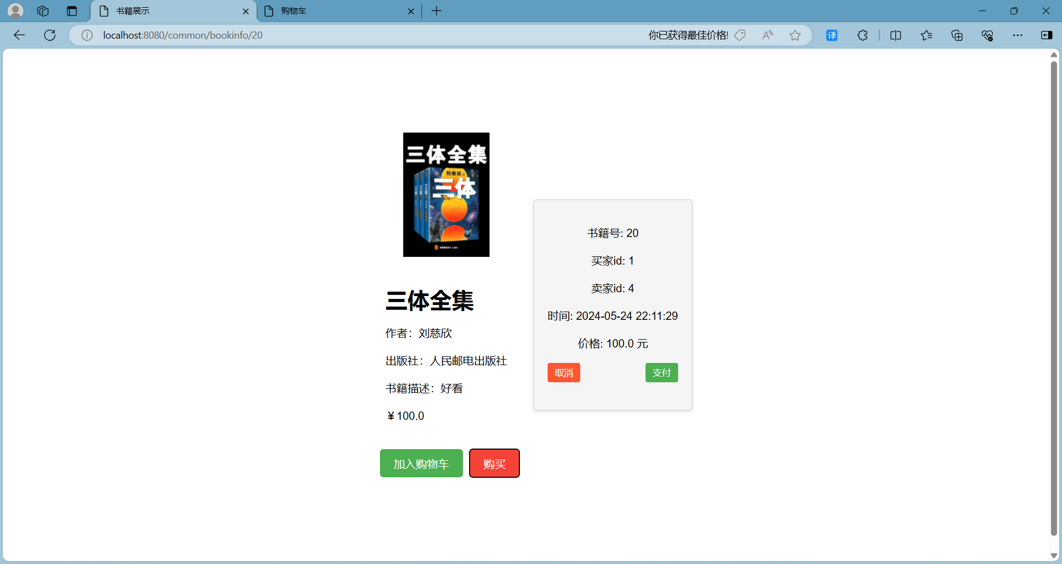
- User chatting page

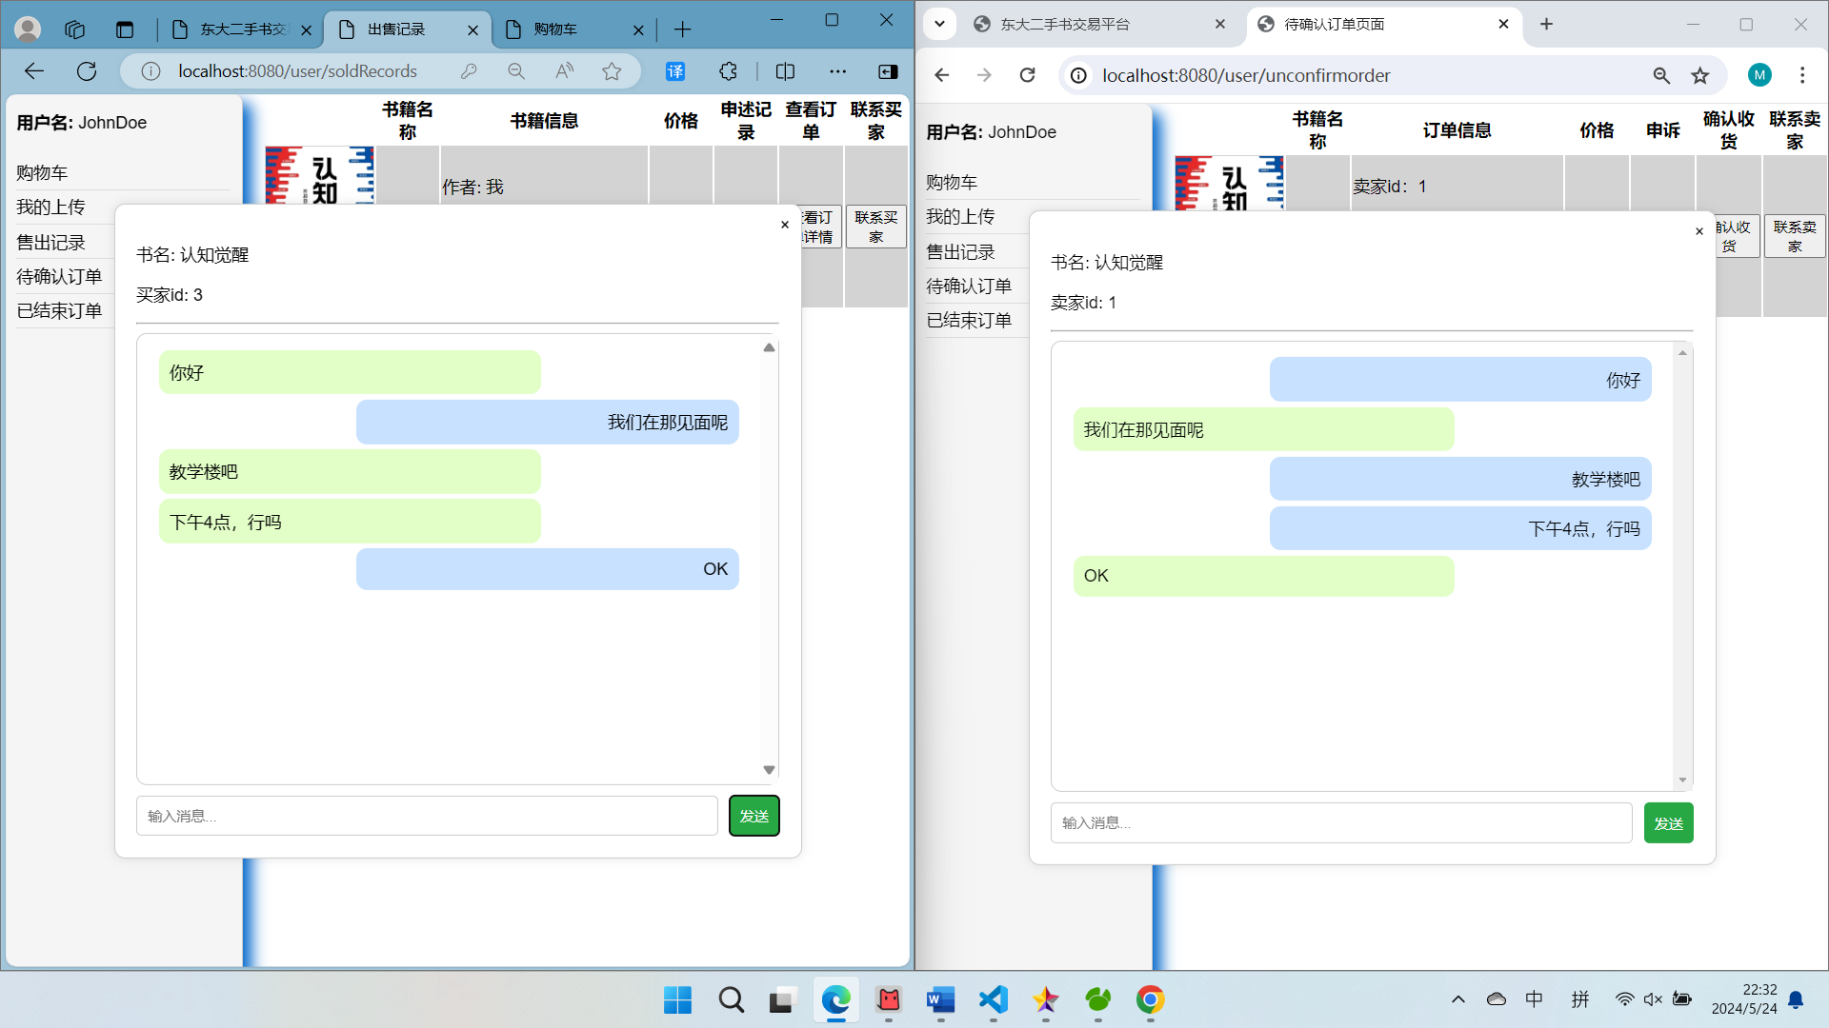
- Order detail page
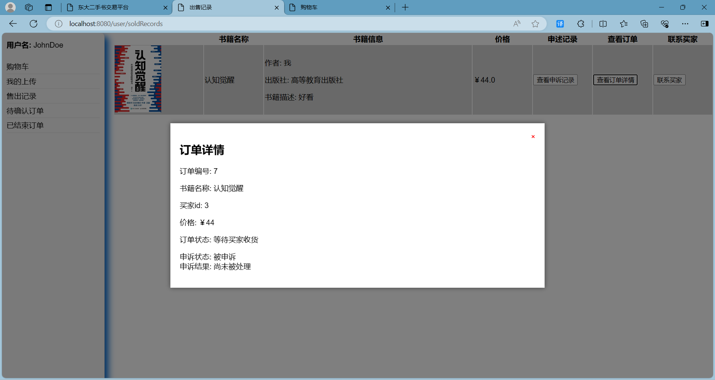

- User center page
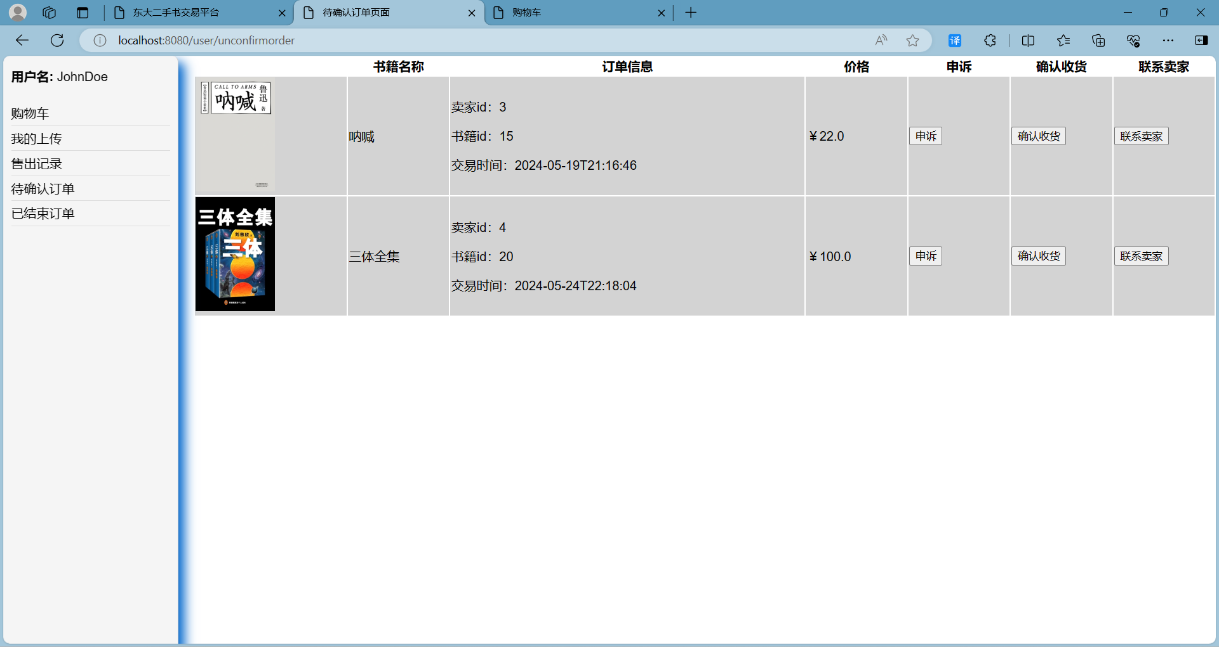
- Book searching page
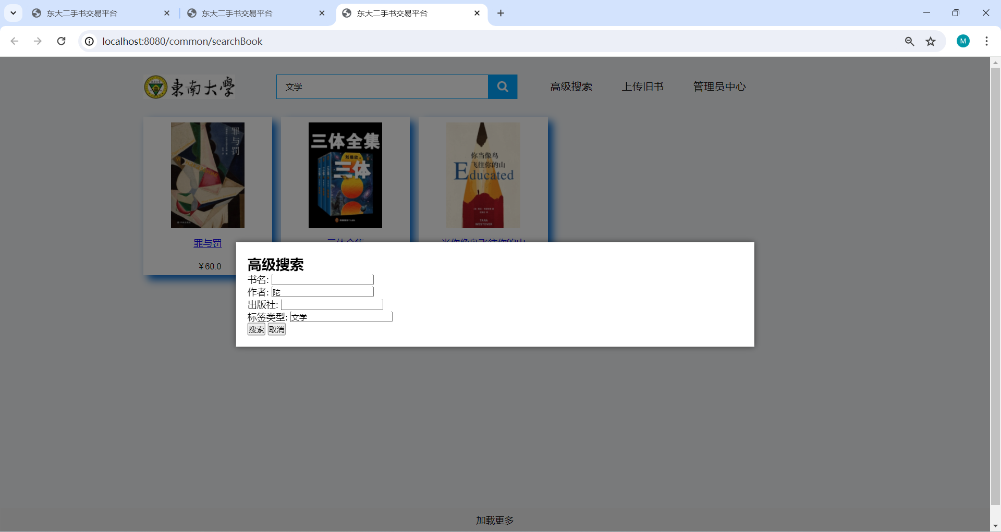
- Manager handle user appeal page
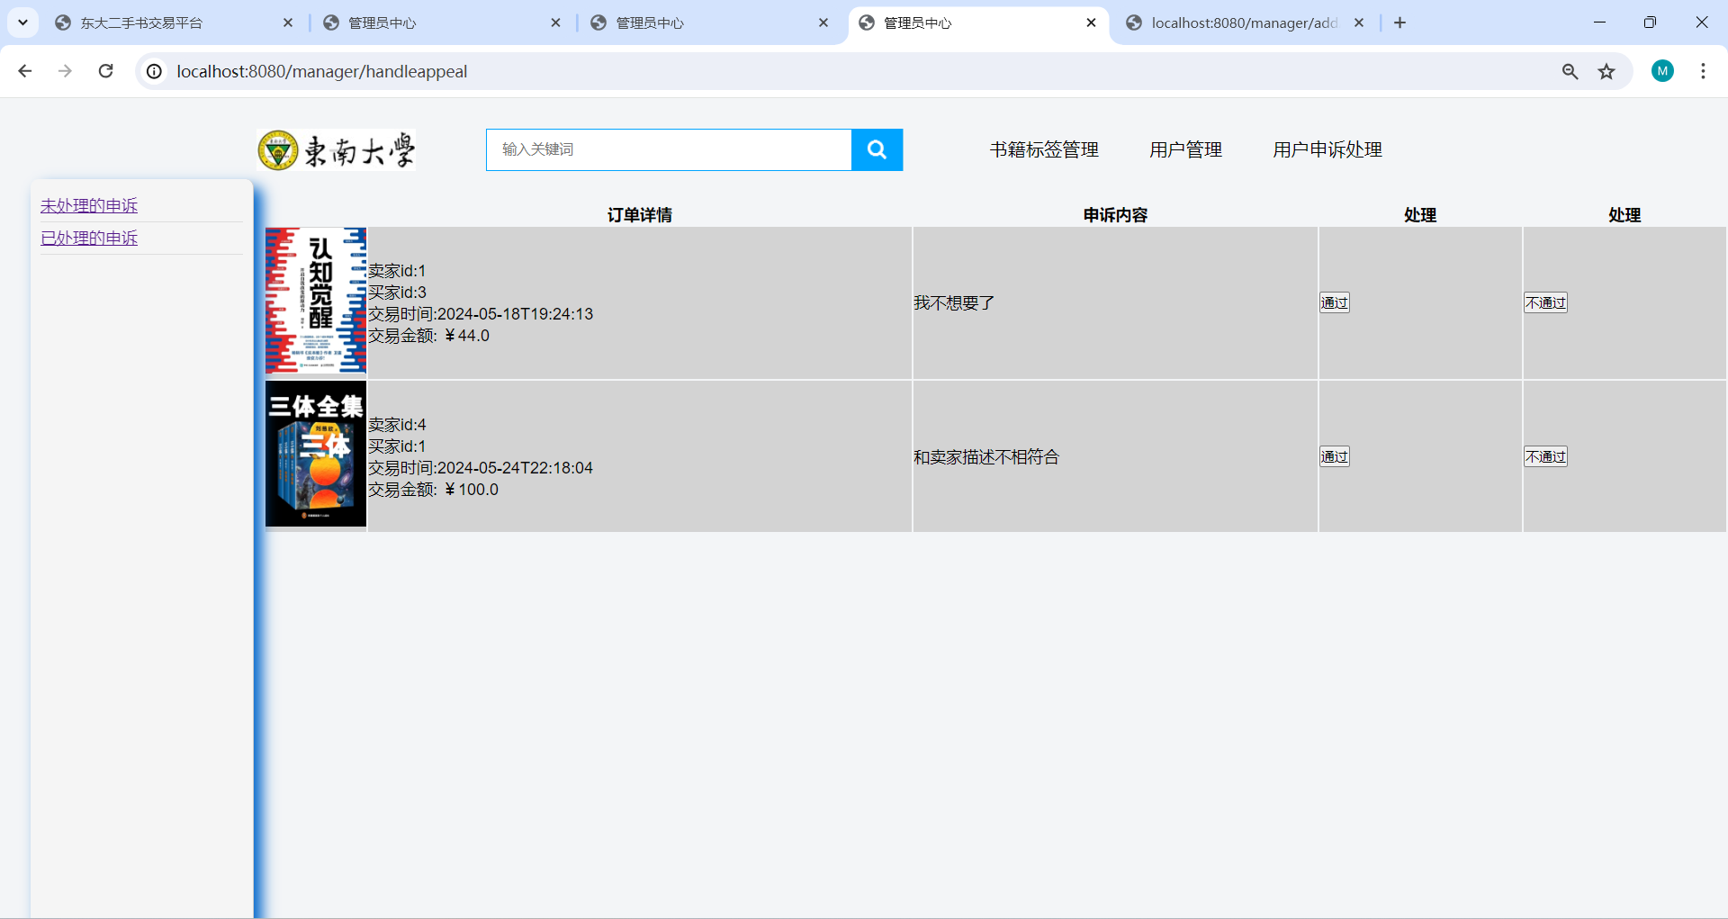

- Manager manage user account page
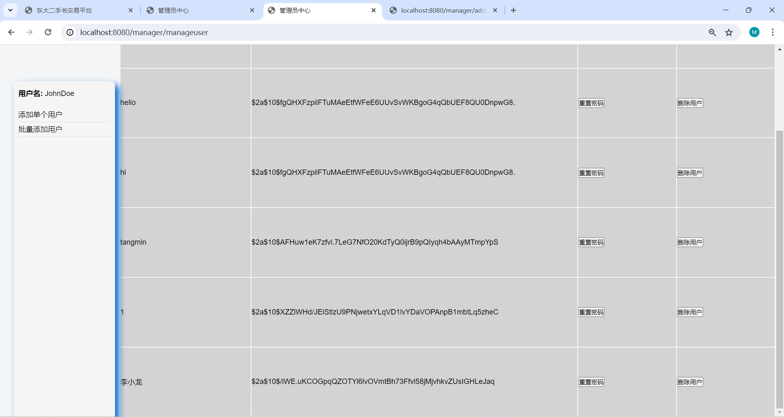

4.Software implementation
Technology Stack: spring boot, java, HTML+CSS+JS+Thymeleaf, mysql

4.1 SEU detailed class design of second-hand book platform system
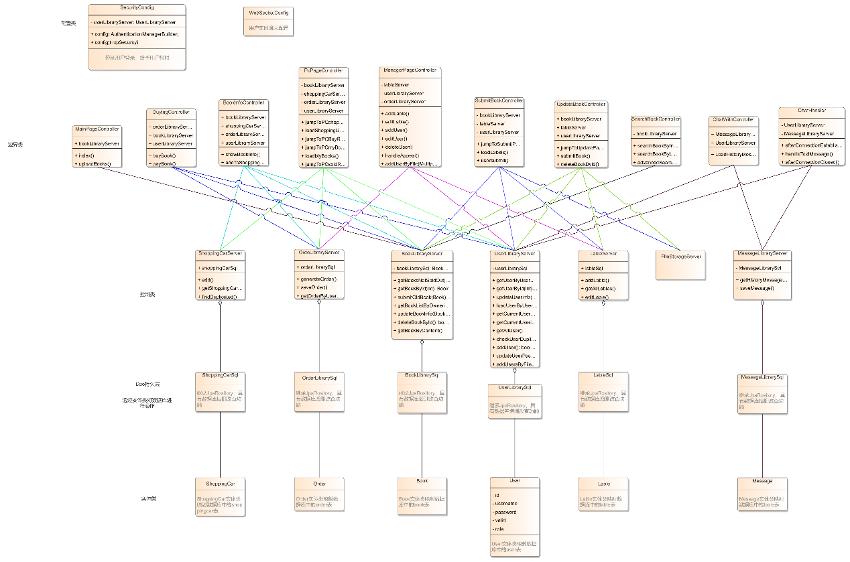
The SEU Second-Hand Book Platform adopts a multi-layer architecture to ensure both functionality and maintainability. The system is designed with distinct layers, each serving a specific purpose, and the following sections describe the key components of the system.
Configuration Layer
The configuration layer manages the platform's fundamental settings to ensure security and efficient communication:
- SecurityConfig: Handles platform security by implementing user permission control and resource protection mechanisms.
- CORSConfig: Configures Cross-Origin Resource Sharing (CORS) to facilitate secure and seamless communication between the frontend and backend.
- WebSocketConfig: Sets up WebSocket communication to enable real-time user-to-user chat functionality.
Controller Layer
The controller layer serves as the entry point for the system, processing client requests and generating appropriate responses. Controllers are implemented using Spring annotations, such as @Controller and @RestController, with a clear division of responsibilities:
- UserController: Manages user-related operations, including login, registration, and profile updates.
- BookController: Handles book-related tasks, such as posting, searching, and viewing details of books.
- ShoppingCartController: Oversees shopping cart operations, including adding, removing, and viewing books in the cart.
- OrderController: Processes order-related functionalities, such as order creation, status updates, and appeals.
- MessageController: Supports real-time messaging by managing user communication operations.
Service Layer
The service layer encapsulates the core business logic of the platform, ensuring a clean separation from data persistence. Each service is annotated with @Service and coordinates with the repository layer for database interactions:
- UserService: Implements user-related logic, including login validation and profile management.
- BookService: Handles book-related functionalities, such as posting, updating, and deleting books.
- ShoppingCartService: Manages shopping cart operations, including content modification and retrieval.
- OrderService: Facilitates order lifecycle management, including creation, status tracking, and updates.
- MessageService: Oversees messaging functionalities, such as sending, receiving, and organizing messages.
Repository Layer
The repository layer interacts with the underlying database using Spring Data JPA to perform persistence operations. It provides efficient and structured access to the data:
- UserRepository: Supports database operations related to user information.
- BookRepository: Manages book data in the database.
- ShoppingCartRepository: Handles the persistence of shopping cart contents.
- OrderRepository: Manages the storage and retrieval of order-related data.
- MessageRepository: Handles message-related database operations.
Entity Layer
The entity layer defines the data models of the platform, mapping them to relational database tables using JPA annotations. The key entities include:
- User: Represents user data, including username, password, and roles.
- Book: Captures details about books, such as title, author, publisher, and price.
- ShoppingCart: Represents the contents of a user's shopping cart.
- Order: Details order information, including buyer, seller, associated books, and order status.
- Message: Records messages exchanged between users, including content and sender/receiver details.
This multi-layer architecture design enables the Tongda Second-Hand Book Platform to effectively support core functionalities, including user management, book transactions, shopping cart management, order processing, and messaging. The modular structure ensures a clear separation of concerns, promotes scalability, and simplifies system maintenance, making the platform well-suited for future extensions and enhancements.

4.2 User management module class design and important function implementation
The main functions of the user management module are: 1. User login; 2. (Batch) adding users; 3. (Batch) deleting users; 4. Modifying user information; here we select the two main functions of user login and batch adding users for implementation demonstration.

4.3.1User login function implementation
This platform is a second-hand book trading platform designed for teachers and students of this school. User names must use the student ID or faculty ID of teachers and students of this school. This requirement not only ensures the uniqueness of the user group, but also facilitates the verification and management of user identities. During the user login process, all transmitted sensitive information (such as usernames and passwords) must be encrypted via HTTPS. In addition, user passwords should be encrypted and stored using a strong hashing algorithm (such as bcrypt) to ensure that user privacy can be protected to the greatest extent even if the database is leaked.
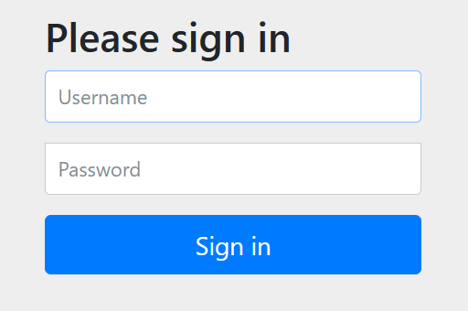
1. User login core class SecurityConfig algorithm
The user first needs to enter his account and password on the login interface. This operation is the first step to verify the user's identity and ensure that only teachers and students of the school can access the platform. After the input is completed, the system will encrypt the password entered by the user. The encryption operation converts the plaintext password into ciphertext to ensure the security of the password, which is difficult to crack even if it is intercepted during transmission. Next, the system will determine whether the password entered by the user is correct. This step is completed by comparing the encrypted input password with the encrypted password stored in the database. If the passwords match, the system will jump to the main page of the platform and the user will log in successfully. At this point, the user can start using various functions of the platform, including browsing and trading second-hand books.
If the passwords do not match, the system will prompt the user that the input is wrong and ask to re-enter the account and password. This cyclic operation ensures that the user can correct the input error in time instead of directly rejecting their access request, thereby improving the user experience
流程图展示
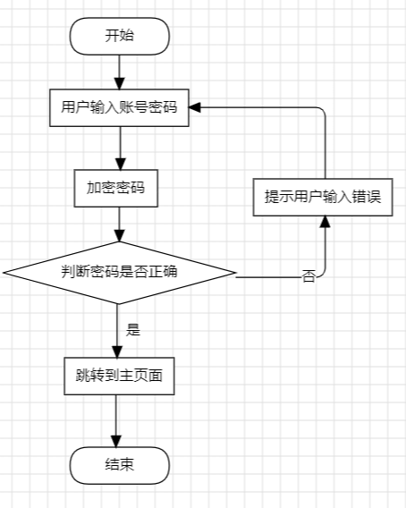
- User login function
Message transmission between classes, represented by a detailed sequence diagram;
SecurityConfig is the system's security configuration, responsible for encrypting user information and user rights, and UserLibraryServer obtains user information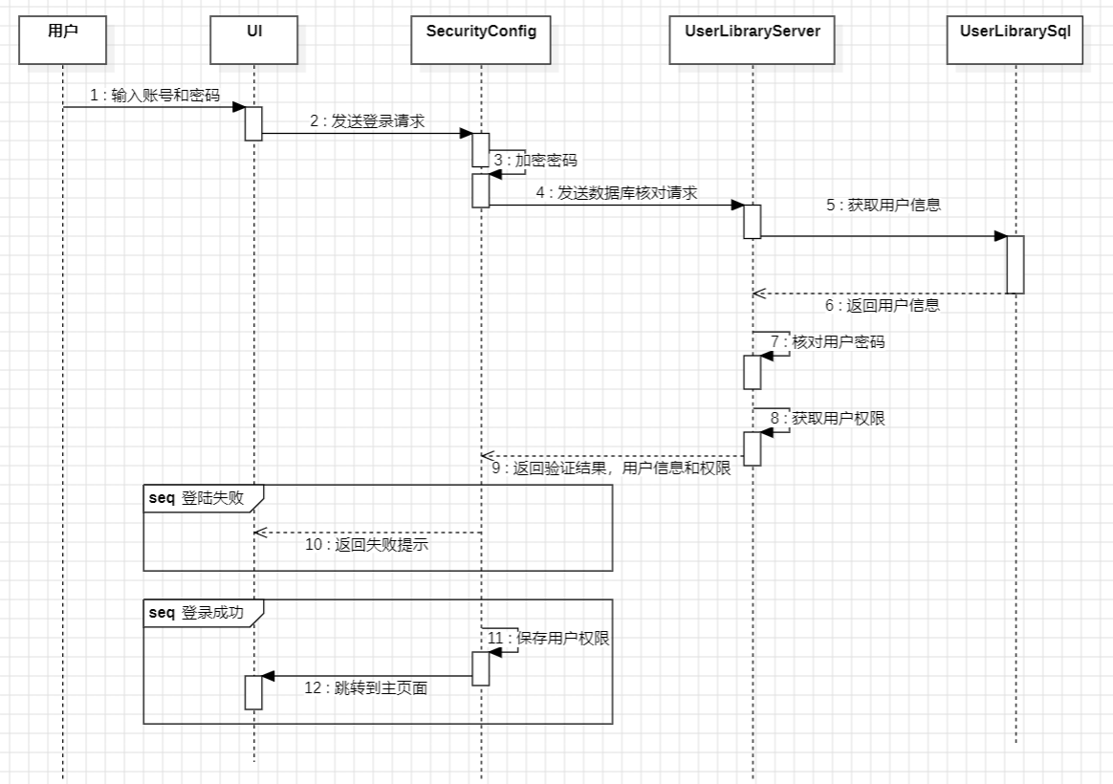
- Core code
SecurityConfig类
- @EnableWebSecurity//开启mvc security安全支持
- public class SecurityConfig extends WebSecurityConfigurerAdapter{
- //使用JDBC进行身份验证
- @Autowired
- private UserLibraryServer userLibraryServer;

- @Override//重写AuthenticationManagerBuilder auth
- protected void configure(AuthenticationManagerBuilder auth) throws Exception
- {
- //密码需要设置编码器
- BCryptPasswordEncoder encoder = new BCryptPasswordEncoder();//必须要使用encoder，不然报错
- auth.userDetailsService(userLibraryServer)
- .passwordEncoder(encoder);
- }

- @Value("${COOKIE.VALIDITY}")
- private Integer COOKIE_VALIDITY;
- @Override
- protected void configure(HttpSecurity http) throws Exception
- {
- http.authorizeRequests()
- .antMatchers("/css/**", "/js/**").permitAll()//当启用security后，
- //Spring Security默认会保护所有的URL路径，包括那些指向静态资源的路径（如CSS、JavaScript和图片文件）
- //.antMatchers("/","/user/**", "/manager/**","/common/**").permitAll()
- //--------------
- .antMatchers("/common/**","/","/chat/**").authenticated()//登录后才能访问
- .antMatchers("/user/**","/user/orderappeal/**").hasRole("user")//上传书籍需要有user角色
- .antMatchers("/manager/**").hasRole("manager")//尚未实现
- //--------------
- .anyRequest().authenticated()//对于除了上面指定的路径之外的所有其他请求，都需要用户进行认证。
- .and()//这个方法表示结束当前的配置链，并开始一个新的配置链。

- .formLogin()
- .usernameParameter("username").passwordParameter("password")
- .defaultSuccessUrl("/")
- ;
- }
- }

UserLibraryServer类
@Autowired
private JdbcTemplate jdbcTemplate;

@Override
public UserDetails loadUserByUsername(String username) throws UsernameNotFoundException {
System.out.println("进入service,用户名为 : " + username);
if(username == null || username.isEmpty()){
throw new UsernameNotFoundException("请输入用户名!");
}
List<SimpleGrantedAuthority>list = new ArrayList<>();
User user = jdbcTemplate.queryForObject("select * from user where username = " + "\"" + username + "\"", new BeanPropertyRowMapper<>(User.class));
list.add(new SimpleGrantedAuthority(user.getRole()));//用户权限
return new org.springframework.security.core.userdetails.User(user.getUsername(), user.getPassword(), list);
}

4.3.2Batch add user function implementation
In actual application scenarios, in order to meet the needs of adding a large number of new users at one time, we must provide a method to add new user information in batches. We can upload new user information in batches by uploading files, thereby creating new users in batches.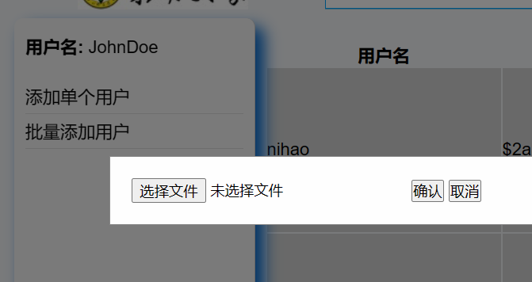
1. Add users in batches, core algorithm flow chart
First, select the file to upload in the system, and then the system will determine whether the file is in the appropriate format. This step is to accurately obtain the new user information. When the system detects that the file format is wrong, the system will return to the step of uploading the file and prompt the message "File format error"; if the file format is correct, the file will be backed up. After that, the system will start to add new users in batches according to the content of the file, and will record the users who have not been successfully generated. After the batch addition is completed, the system will generate a list of unsuccessful additions and display it.
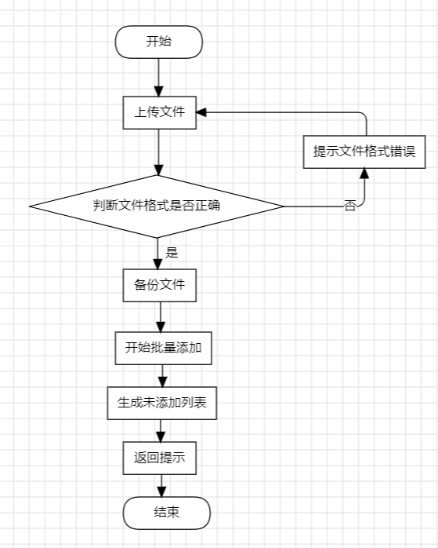
2. Sequence diagram of batch adding user functions
MangerController is used to receive the front-end file input and return the response, UserLibraryServer accesses the data by calling the persistence layer UserLibrarySql to implement batch adding, and UserLibrarySql is used to directly interact with the database user table to add new users.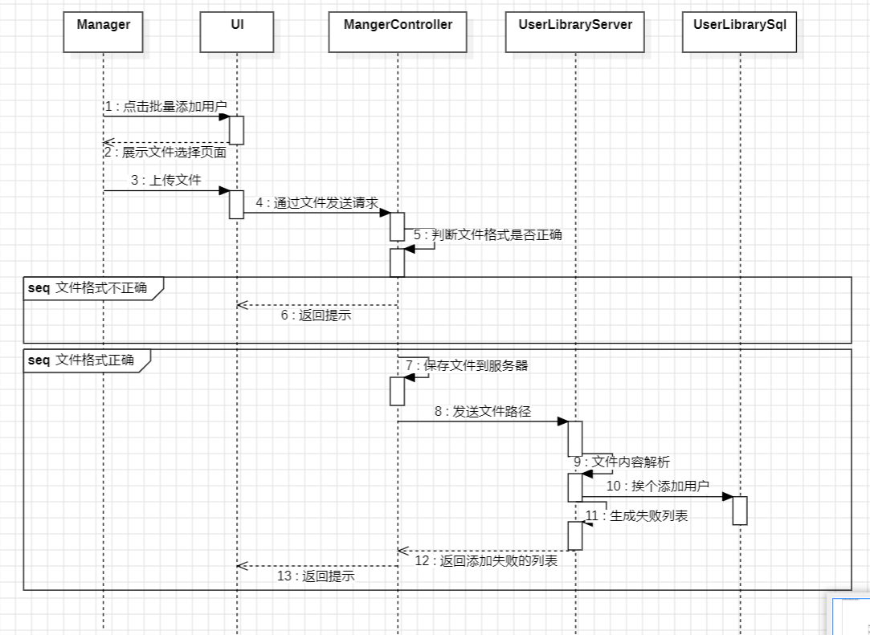

3.Batch add user code implementation：
ManagerController
ManagerController类中的函数
//批量通过txt文件批量添加用户
@RequestMapping("/manager/addALotsOfUser")
public ResponseEntity<?> addALotsOfUser(@RequestParam("file") MultipartFile file)
{
if (file.isEmpty()) {
return ResponseEntity.status(HttpStatus.BAD_REQUEST).body("File is empty");
}

try {
//使用ResourceUtils保存位置未知避免找不到路径报错
//于是将文件保存到外部目录中
String uploadDir = "D:\\F盘\\Desktop\\软件工程导论\\项目实验\\OuterProjectFileSaving\\manager";
File directory = new File(uploadDir);
if (!directory.exists()) {
directory.mkdirs();
}

// 保存文件到指定路径
// 保存文件到外部目录
Path uploadPath = Paths.get(uploadDir, file.getOriginalFilename());
file.transferTo(uploadPath.toFile());

List<String> unputList = userLibraryServer.addUsersByFile(uploadPath.toString());

//期望告知管理员，哪些学生未添加成功

return ResponseEntity.ok("File uploaded and processed successfully: " + uploadPath.toString());
} catch (IOException e) {
e.printStackTrace();
return ResponseEntity.status(HttpStatus.INTERNAL_SERVER_ERROR).body("File upload failed");
}
}

UserLIbraryServer
UserLibraryServer类中的一个函数
//通过txt文件批量添加用户
public List<String> addUsersByFile(String filePath) {
List<String> unputList = new ArrayList<>();
try (BufferedReader br = new BufferedReader(new FileReader(filePath))) {
String username;
while ((username = br.readLine()) != null)
{
// 处理读取到的每一行here
if (!this.addUser(username))
unputList.add(username);
}
} catch (IOException e) {
e.printStackTrace();
}
return unputList;
}

4.3.3 Batch delete user function implementation
The batch deletion function is expected to enable administrators to perform batch deletion by specifying class numbers, major numbers, grade numbers, etc.
1. The batch deletion function flow chart is expected to be as follows:
First, the administrator specifies the classification information such as class numbers, major numbers, grade numbers, etc. that need to be deleted, and then prompts the administrator to confirm the deletion and confirm the deletion information before deletion. If the administrator chooses no, the deletion operation is canceled and ends directly; if the administrator confirms the deletion, the system starts the process of batch deleting users, and ends the program after the batch deletion is completed.
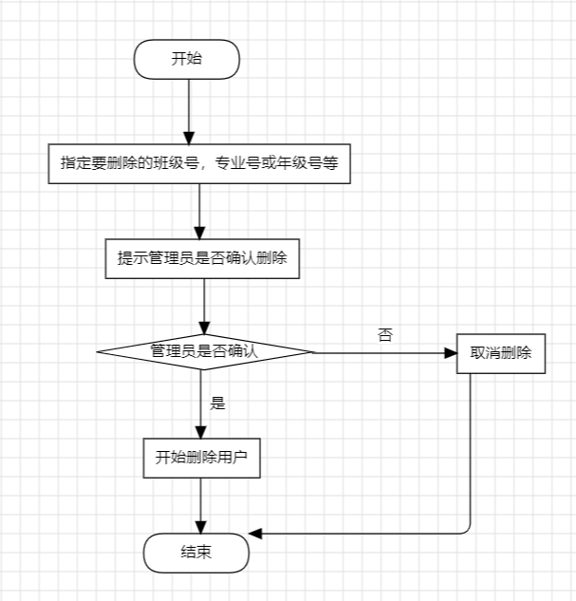

4.3 Book management module class design and important function implementation
The main functions of the book management module are: 1. Upload books; 2. Update book information; 3. Add and modify book tags; 4. Delete books; 5. Display books; 6. Add books to or remove them from the shopping cart;
Since there are many functions and most of them have the same principles, we choose to update book information and modify book tags as representative functions.

4.4.1user updating book information function
In actual use, we hope to be able to modify the book information saved in the system at any time, that is, the book information update function. First, select the book to be modified, and we can modify the book's name, author, publisher, category, price and other information at one time.
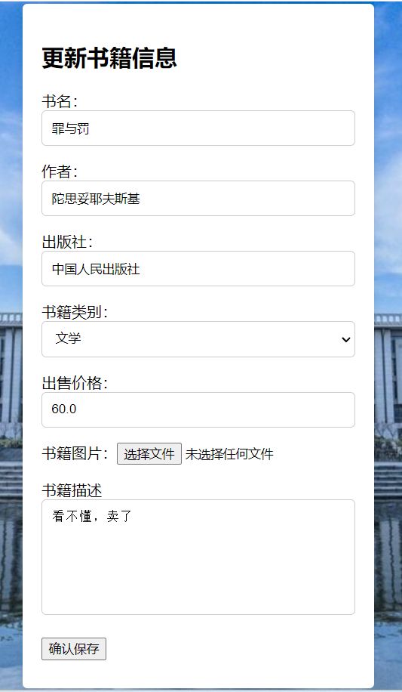
1. Flowchart for updating book information
First, the user needs to select the book whose information needs to be updated, and then the system will jump to the modification page and display the original book information for the user to modify. Then the system will determine whether there is a new book image. If there is a new image, the system will delete the original image and save the new image, and then update the book information; if there is no new image, the system will directly update the book. After the update is completed, the system will return the update result and display it to the user.
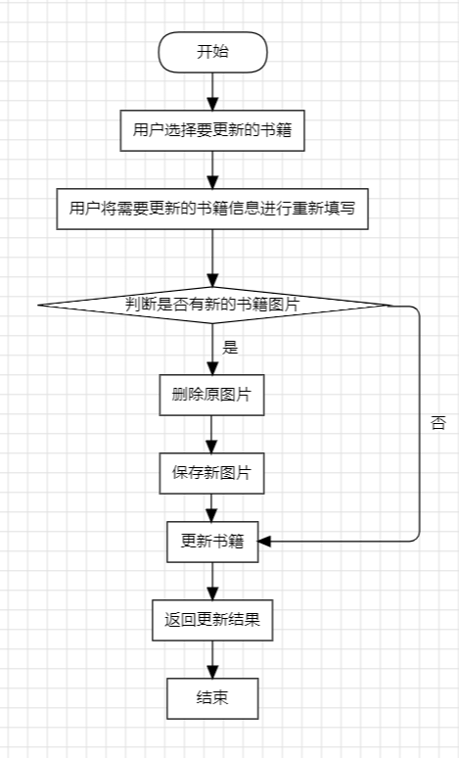
2. Update book information sequence diagram
The UpdateBookController class is responsible for responding to requests to modify book information; the FileStorageServer class is responsible for implementing the image storage and deletion part; the BookLibraryServer class is responsible for accessing data by calling the BookLibrarySql class to implement book information modification.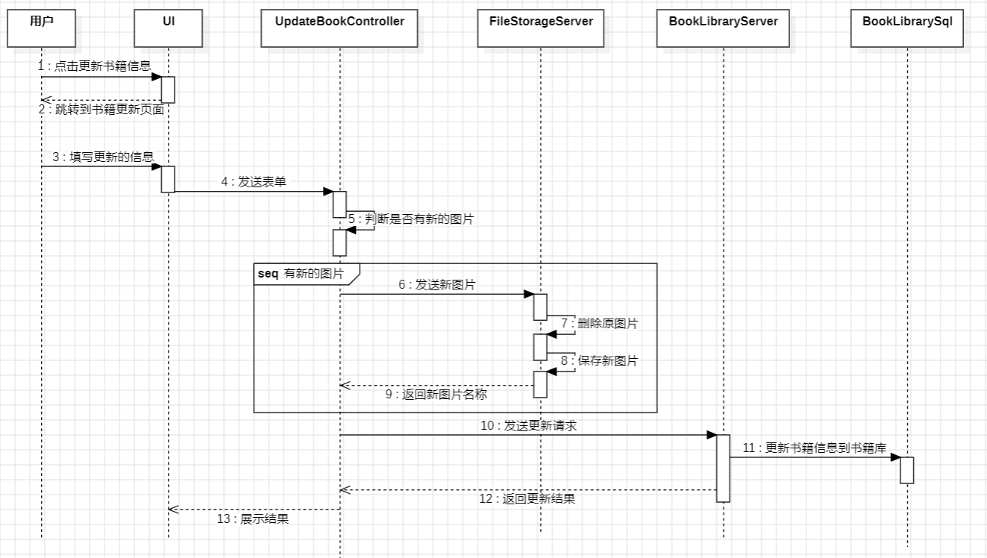
3.code
1.UpdateBookController
UpdateBookController类中的函数
@RequestMapping("/user/updateBook/{id}/onsubmit")
public ResponseEntity<?> onSubmit(@PathVariable("id") Integer id,
@RequestParam("bookName") String bookName,
@RequestParam("author") String author,
@RequestParam("publisher") String publisher,
@RequestParam("bookLable") String bookLabel,
@RequestParam("price") float price,
@RequestParam("details") String details,
@RequestParam("img") MultipartFile file
)//@RequestParam("img") MultipartFile file,
{
//获取用户信息
String userName = SecurityContextHolder.getContext().getAuthentication().getName();
User user = null; // 初始化为null
try {
user = userLibraryServer.getUserByUsername(userName);
System.out.println(user);
} catch (Exception e) {
e.printStackTrace();
}

Book oldBook = bookLibraryServer.getBookById(id);
Book book = new Book();
book.setId(id);
book.setBookname(bookName);
book.setWriter(author);
book.setPublisher(publisher);
book.setDetails(details);
book.setPrice(price);
book.setLable(bookLabel);
book.setBuyerid(0);
book.setOwnerid(user.getId());
book.setImg(oldBook.getImg());

if (!file.isEmpty()) {
// 删除旧图片
if (oldBook != null && oldBook.getImg() != null) {
fileStorageServer.deleteFile(oldBook.getImg());
}

String fileName = fileStorageServer.storeFile(file);
book.setImg(fileName); // 保存文件名到数据库
}

//flag判断书籍是否上传成功
boolean flag = bookLibraryServer.submitOldBook(book);
if (flag) {
return new ResponseEntity<>("书籍更新成功", HttpStatus.OK);
} else {
return new ResponseEntity<>("书籍更新失败", HttpStatus.INTERNAL_SERVER_ERROR);
}
}

2.FileStorageController
public String storeFile(MultipartFile file) {
String fileName = StringUtils.cleanPath(file.getOriginalFilename());
String uniqueFileName = UUID.randomUUID().toString() + "-" + fileName;

try {
if (fileName.contains("..")) {
throw new RuntimeException("Sorry! Filename contains invalid path sequence " + fileName);
}

// 缩放图像并保存
Path targetLocation = this.fileStorageLocation.resolve(uniqueFileName);
logger.info("Storing file at: " + targetLocation.toString());
Thumbnails.of(file.getInputStream())
.size(150, 180) // 这里指定目标宽度和高度
.toFile(targetLocation.toFile());

return uniqueFileName;
} catch (IOException ex) {
throw new RuntimeException("Could not store file " + uniqueFileName + ". Please try again!", ex);
}
}

4.4.2 Modify book label function
In actual needs, we may need to modify the saved book tags. It should be noted that this operation is not for modifying a specific book, but for modifying the book category. When modifying the tag, all book information with this tag in the database needs to be updated.
1. Flowchart of modifying book tags
First, the administrator clicks on the book tag to be modified and enters the new book tag. Here, it is necessary to ensure that the new tag is different from the existing tag, otherwise an error may occur. After that, the system will change the old tag to the new tag, and then the system will find all books with old tags and update their old tags to new tags.
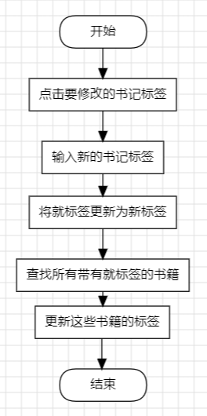
2. Sequence diagram for modifying book labels
The ManagerController class is responsible for responding to administrators' needs to update book labels; the LabelServer class is responsible for calling the LabelSql class to access label data and modify labels; the BookLibraryServer class is responsible for calling the BookLibrarySql class to obtain books with old labels, update book information, and save them.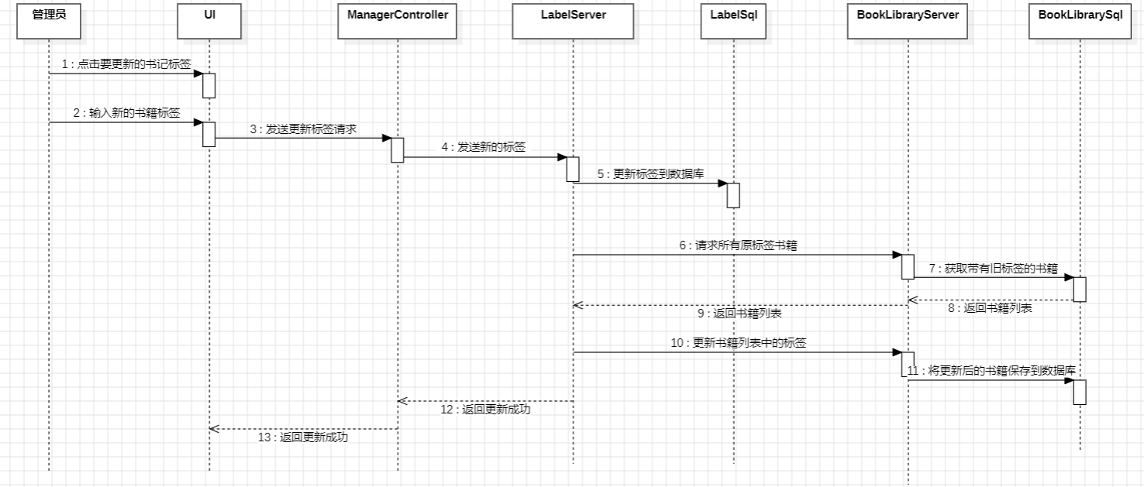
3.code
1.LableServer class’s main functional function
public boolean editLable(String oldlable, String newlable)
{
//更新lable表
List<Lable> lablelist = lableSql.findByLable(oldlable);
Lable lable = lablelist.get(0);
if (lable != null)
{
lable.setLable(newlable);
lableSql.save(lable);
List<Lable> list = lableSql.findByLable(newlable);
if (list.size() == 0)
return false;

//更新所有为oldlable的书籍的lable
List<Book> booklist = bookLibraryServer.getBooksByLable(oldlable);
for(int i = 0; i < booklist.size();i++)
{
Book book = booklist.get(i);
book.setLable(newlable);
bookLibraryServer.updateBookInfo(book);
}
return true;
}
return false;
}

4.4 Book searching module class design and important function implementation
The book search module has two functions: normal search and advanced search
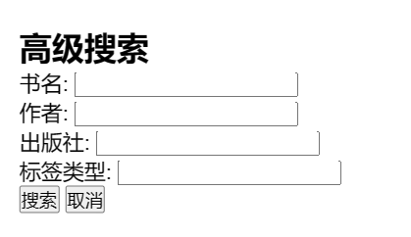

4.4.1Advanced search function implementation
In actual use, in addition to searching by single keywords, we also provide advanced search. Users can search for books by choosing to enter all or several pieces of information including book title, author, publisher, etc., to achieve more accurate and efficient search.
1. Advanced search function flow chart
First, the user jumps to the advanced search page, and the user fills in part of the information of the book he wants to find as needed. Then the system will perform an advanced search based on the information the user has filled in, and finally display the searched book list to the user.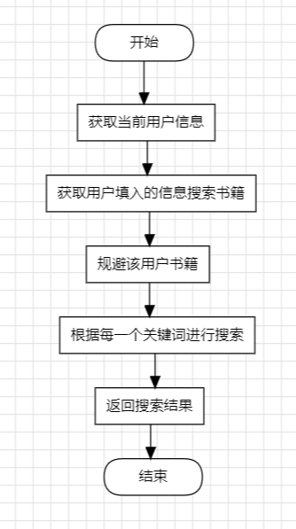
2.Advanced search function sequence diagram
The SearchBookController class is responsible for responding to advanced search requests from users; the BookLibraryServer class is responsible for access screening of books by calling the BookLibrarySql class and based on the existing advanced search information, obtaining a list of all possible books and returning it to the control layer.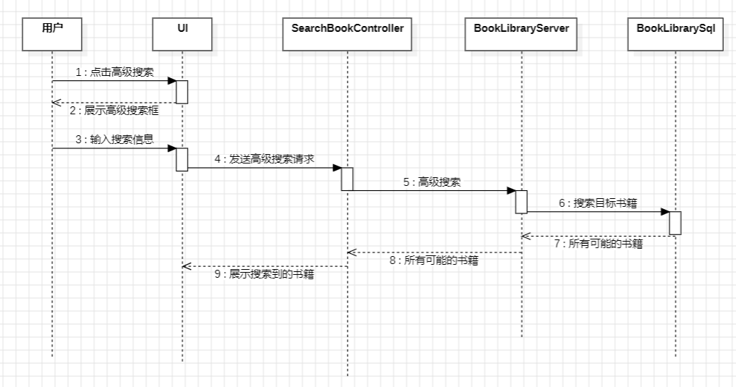

3.code
LableSql类中一个函数
//高级搜索
@Query("SELECT b FROM Book b " +
"WHERE b.issoldout = 0 AND b.ownerid != :userid AND " +
"(:bookName IS NULL OR b.bookname LIKE %:bookName%) AND " +
"(:author IS NULL OR b.writer LIKE %:author%) AND " +
"(:publisher IS NULL OR b.publisher LIKE %:publisher%) AND " +
"(:label IS NULL OR b.lable LIKE %:label%)")
List<Book> advanceSearch(@Param("bookName") String bookName,
@Param("author") String author,
@Param("publisher") String publisher,
@Param("label") String label,
@Param("userid") Integer userid);

4.5 Trading Management module class design and important function implementation
Southeast University Second-hand Book Trading Platform is a platform that provides students with convenient and fast second-hand book trading services, aiming to improve the circulation efficiency of second-hand books and reduce resource waste. The platform mainly includes the following functions: 1. Generate orders; 2. User payment; 3. View orders. 4. Add and remove shopping carts
Generate orders: After users select and purchase second-hand books on the platform, the system will generate corresponding order information.
User payment: After the order is generated, users can pay through the payment methods provided by the platform.
Order viewing: Users can view their historical orders at any time to understand the order status and details.
Add and remove shopping carts: Users can add their favorite books to the shopping cart, or remove books that are no longer needed from the shopping cart.

4.5.1User adds books to the shopping cart
1.flowchart
The user starts browsing the book details page on the platform. After the user clicks the "Add to Cart" button, the system checks whether the book already exists in the shopping cart. The system returns a prompt "Yes" to inform the user that the book is already in the shopping cart; otherwise, the system adds the book to the shopping cart. End: Operation completed.
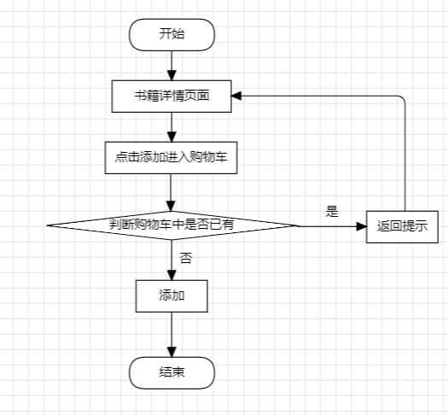

2.Add shopping cart sequence diagram
BookInfoController is responsible for responding to requests and returning prompt messages, while ShoppingCarServer is responsible for checking duplicate shopping carts and calling ShoppingCarSql to update the database.
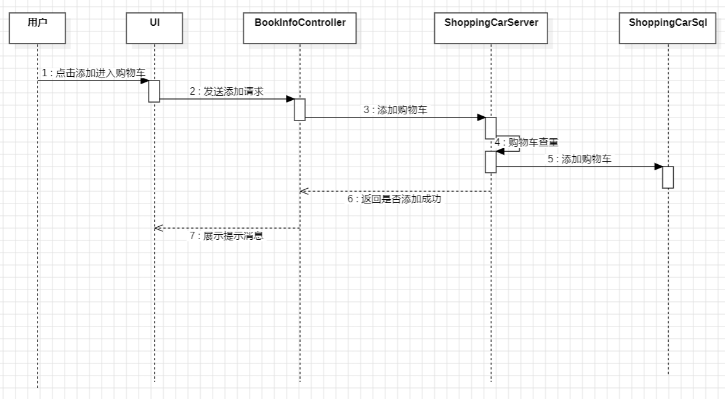
3.code
//添加到购物车
@RequestMapping("/user/bookinfo/{id}/addToShoppingCar")
@ResponseBody
public boolean addToShoppingCar(@PathVariable("id") Integer bookid, HttpServletRequest request)
{
//获取用户信息
String userName = SecurityContextHolder.getContext().getAuthentication().getName();
User user = null; // 初始化为null
try {
user = userLibraryServer.getUserByUsername(userName);
System.out.println(user);
if (user == null) {
// 处理找不到用户的情况
// 这里可以返回false或抛出异常等
return false;
}
} catch (Exception e) {
e.printStackTrace();
return false;
}

ShoppingCar shoppingCar = new ShoppingCar();
shoppingCar.setUserid(user.getId());
shoppingCar.setBookid(bookid);

//避免重复加入购物车
boolean flag =true;
if (!shoppingCarServer.findDuplicated(user.getId(), bookid))
flag = shoppingCarServer.add(shoppingCar);
//判断flag，看是否加入购物车成功
return flag;
}

4.5.2User purchase book function
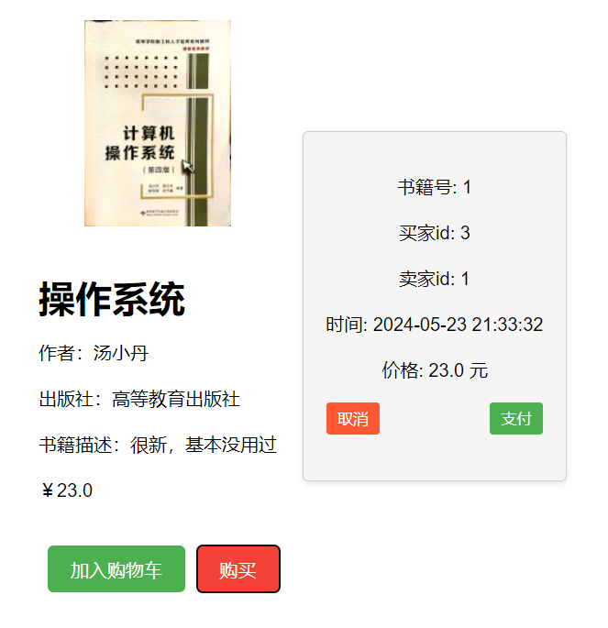
1.User purchase book flow chart
The user enters the book details interface. After the user clicks the purchase function, the system will generate a prepaid order, then lock the book, wait for the user to pay, and determine whether the payment is successful. If it returns no, it will prompt that the book payment failed, unlock the book and return to the book details interface; if the payment is successful, the order will be saved and the operation will end.
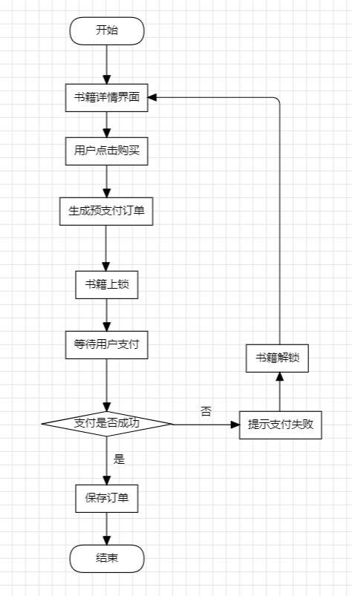

2.User purchase sequence diagram
The main steps are generating a prepaid order, waiting for the user to pay, and returning the payment status. When the user clicks to buy, BookLibraryServer is responsible for locking the book, and OrderLibraryServer is responsible for saving the order and returning the result.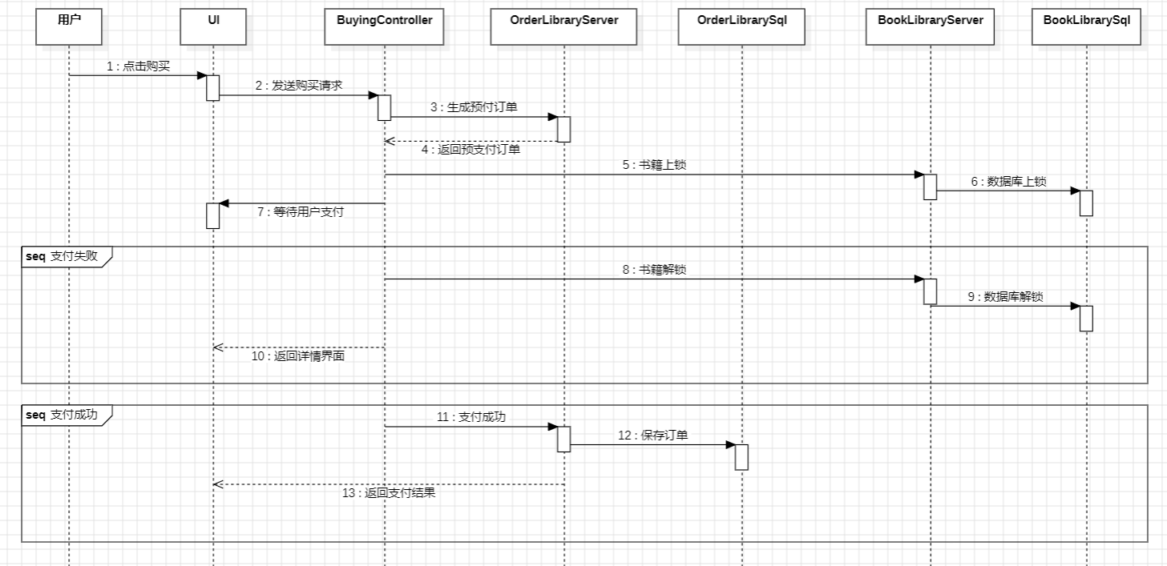

3.code
The payment is not really implemented here, but is equivalent to a simple setting of 1. We originally considered using Alipay's sandbox payment as the payment process, but due to time and manpower issues, it was not implemented.
BuyingController函数
@RequestMapping("/user/buying/{id}/paying")
public boolean payBook(@PathVariable("id") Integer bookid, HttpServletRequest request)
{
//获取用户信息
String userName = SecurityContextHolder.getContext().getAuthentication().getName();
User user = null; // 初始化为null
try {
user = userLibraryServer.getUserByUsername(userName);
System.out.println(user);
if (user == null) {
// 处理找不到用户的情况
// 这里可以返回false或抛出异常等
}
} catch (Exception e) {
e.printStackTrace();
// 在这里你可以选择记录日志、返回false或抛出异常等
}
Book book = bookLibraryServer.getBookById(bookid);
//生成订单
Order order = orderLibraryServer.generateOrder(user.getId(), book);

//考虑并发,isSoldOut相当于锁
if(book.getIssoldout()== 0)
{
book.setIssoldout(1);
bookLibraryServer.updateBookInfo(book);
}
else
return false;

//检查支付是否成功
boolean flag = true;//checkpayment()

if (flag)
{
//假设支付成功立马更新
order.setHaspay(1);
book.setBuyerid(order.getBuyerid());
//book.setIssoldout(1);
bookLibraryServer.updateBookInfo(book);//更新数据库

//保存订单
orderLibraryServer.saveOrder(order);
}
else
{
//支付失败
book.setIssoldout(0);
bookLibraryServer.updateBookInfo(book);
return false;
}
return flag;
}

4.6 user appeal module class design and important function implementation
The user complaint module is an important part of the Southeast University second-hand book trading platform. Its main functions include
1. User initiates or withdraws complaints
2. Administrator handles complaints
3. Real-time chat function (including viewing historical messages).
1. OrderLibraryServer
2. MyOrderController
3. OrderLibraryServer
4. OrderLibrarySql

4.6.1user appeal function
The core process of user appeal and the operation of withdrawing appeal are basically the same and will not be repeated.
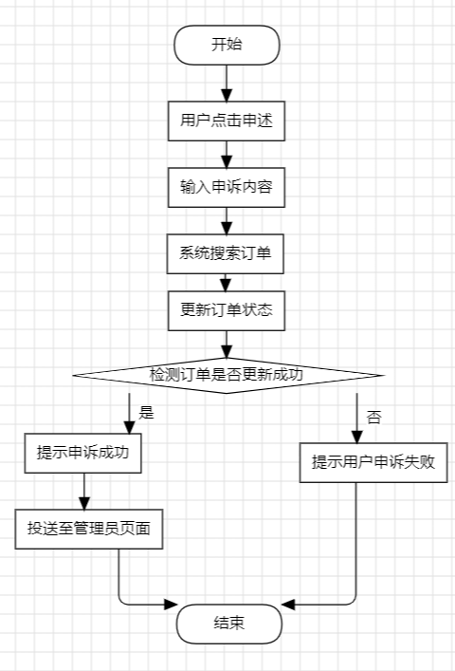
2.sequence diagram
Among them, PcMyOrderController handles order-related operations of PC users, mainly requests from users to initiate or withdraw appeals, and forwards them to OrderLibraryServer to update the order status.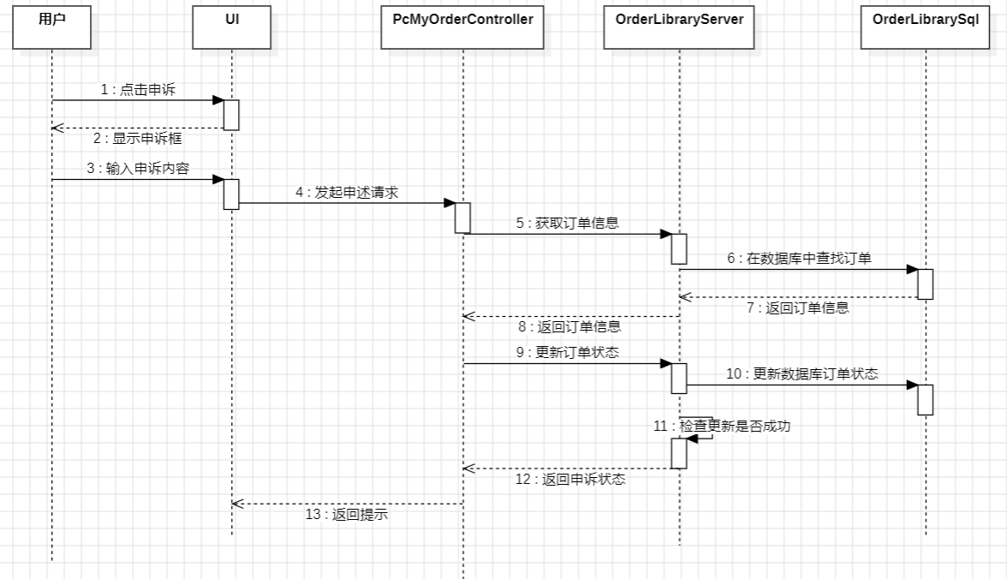
3.code
MyOrderController类函数
MyOrderController中一个函数
//申诉
@PostMapping("/user/orderappeal/{orderid}")
@ResponseBody
public boolean appealOrder(@PathVariable("orderid") Integer orderid, @RequestBody String detail)
{
System.out.println("detail");
Order order = orderLibraryServer.getOrderById(orderid);
boolean flag = false;
if (order != null)
flag = orderLibraryServer.orderAppeal(order,detail);
return flag;
}

OrderLibraryServer
//申诉
public boolean orderAppeal(Order order, String detail)
{
order.setHasappeal(1);
order.setDetail(detail);
orderLibrarySql.save(order);
Order orderChecker = (Order)orderLibrarySql.getById(order.getId());
if (orderChecker.getHasappeal() == 1)
return true;
return false;
}

4.6.2 Administrator complaint handling function
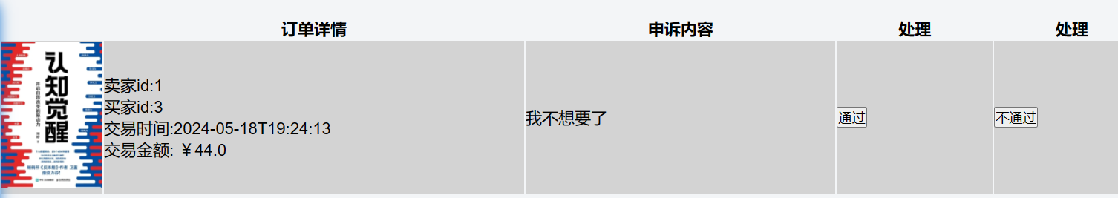
1.flowchart
After starting the operation, the administrator clicks "Process Appeal", after which the system displays the order being appealed and enters the waiting stage. After completion, the appeal result is updated and the operation ends.
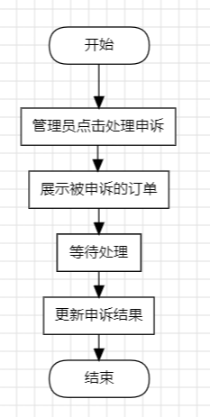
2.code
//处理申述
@RequestMapping("/manager/handleappeal/{orderid}/{outcome}")
@ResponseBody
public boolean handleAppeal(@PathVariable("orderid") Integer orderid, @PathVariable("outcome") int outcome)
{
Order order = orderLibraryServer.getOrderById(orderid);
if(order == null)
return false;
order.setAppealoutcome(outcome);
boolean flag = orderLibraryServer.saveOrder(order);
return flag;
}

4.7 user communicate module class design and important function implementation
Real-time chat implementation.The real-time chat function includes the ability to view historical messages
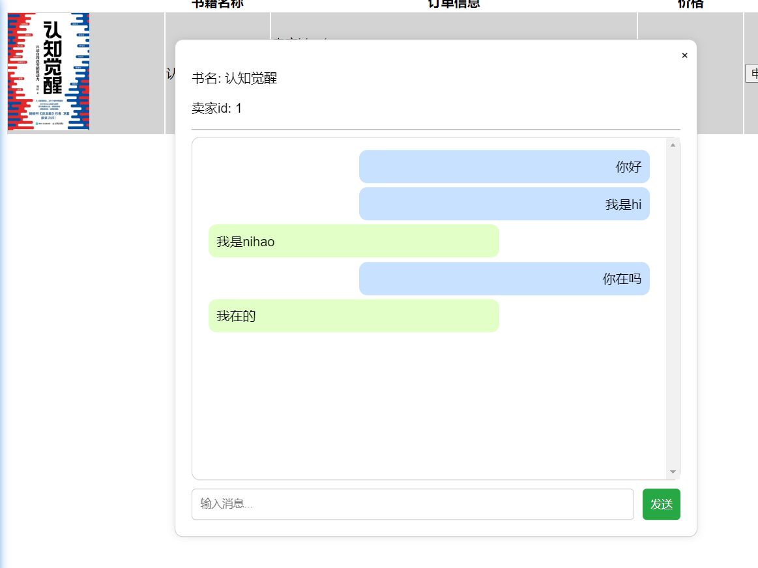
1.flowchart
After the start, the user clicks to contact the buyer or seller, and then loads the historical messages. After the user sends a message, the system checks whether the target contact is online. If so, it sends the message to the target contact and saves it to the database; otherwise, it directly saves it to the database. After judging whether the user clicks "End Chat", if yes, the operation ends directly; otherwise, it returns to the stage where the user sends a message.
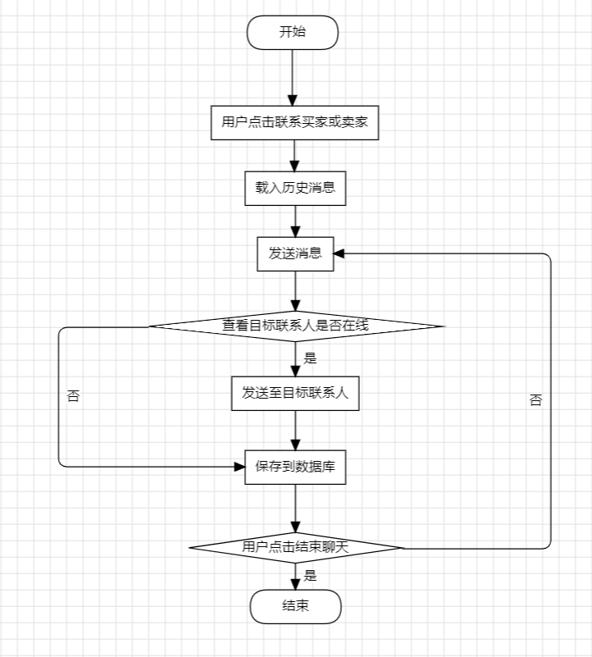
After receiving the user request, WebSocketConfig intercepts and updates the user agreement, and then ChatWithController requests to load historical information. ChatHandler sends and receives messages. MessageLibraryServer handles the business logic related to messages, including the acquisition and return of historical messages. MessageLibrarySql is responsible for interacting with the database, storing and retrieving chat messages.
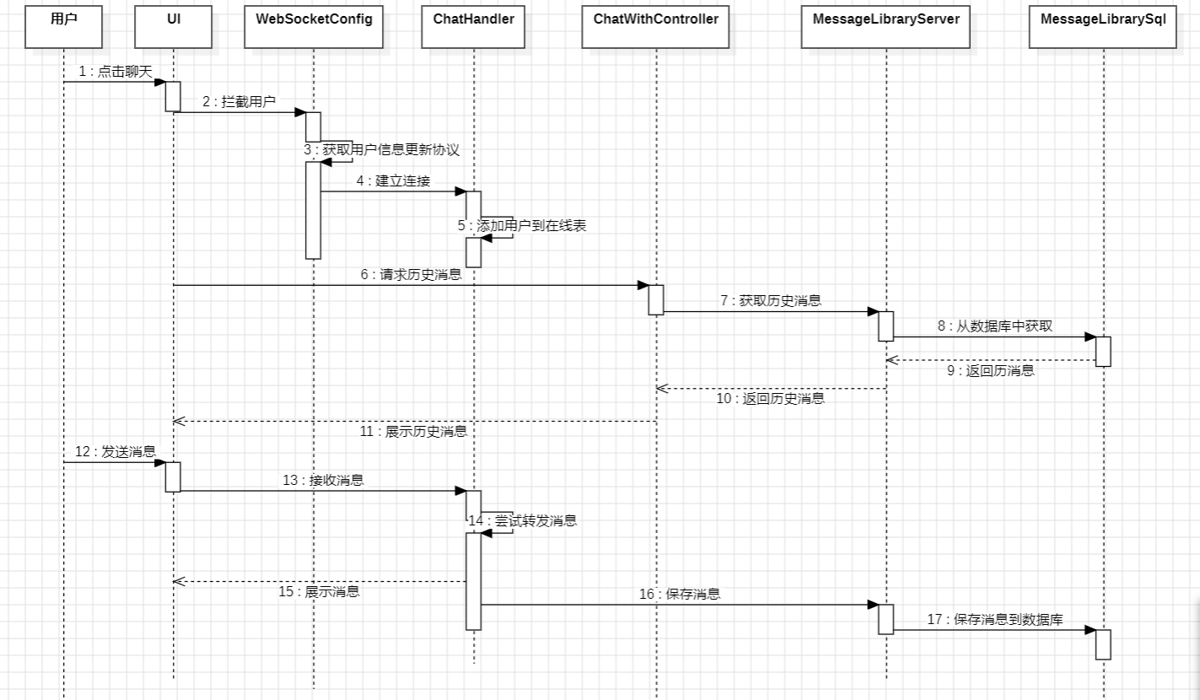
2.code
public class ChatHandler extends TextWebSocketHandler {
private static final Logger logger = Logger.getLogger(ChatHandler.class.getName());

@Autowired
private UserLibraryServer userLibraryServer;

@Autowired
private MessageLibraryServer messageLibraryServer;

private Map<String, WebSocketSession> sessions = new ConcurrentHashMap<>();
private Map<String, String> userSessions = new ConcurrentHashMap<>(); // user -> sessionId, 没有使用static final但是依然只是一个，疑问？？
@Override
public void afterConnectionEstablished(WebSocketSession session) throws Exception {
String userName = (String) session.getAttributes().get("user");
System.out.println("username: " + userName);
//username映射session的id，session的id映射session
sessions.put(session.getId(), session);
userSessions.put(userName, session.getId());

System.out.println("usersessionsize: "+userSessions.size());

// 发送历史消息给用户
//通过chatwithController发送
}

@Override
protected void handleTextMessage(WebSocketSession session, TextMessage message) throws Exception {
String[] payload = message.getPayload().split(":", 3);
if (payload.length < 2) {
// 消息格式不正确
return;
}

//发过来的是用户主键，而不是用户名，需要的是用户名，所以通过用户主键寻找用户名
String toUserId = payload[0];
Integer touserid = Integer.parseInt(toUserId);
User user = userLibraryServer.getUserById(touserid);
if(user == null)
{
logger.warning("找不到用户id"+touserid);
return;
}
String BookId = payload[1];
Integer bookid = Integer.parseInt(BookId);

String msg = payload[2];

String toSessionId = userSessions.get(user.getUsername());
if (toSessionId != null) {
WebSocketSession toSession = sessions.get(toSessionId);
if (toSession != null && toSession.isOpen()) {
toSession.sendMessage(new TextMessage(bookid+":"+msg));
}
}

// 保存消息到历史记录, 支持发向离线id
messageLibraryServer.saveMessage(bookid, user.getUsername(), (String)session.getAttributes().get("user"), msg);
}
}

4.8 summery
This chapter mainly introduces the implementation of the system. It introduces the key technologies used in the implementation and posts some codes for easy understanding. When introducing the implementation, it is accompanied by a completed page, which is easier to understand when combined with the completed page.

5 result display

5.1 login
1.登录页面

2.输入错误的用户名或密码时，给出提示
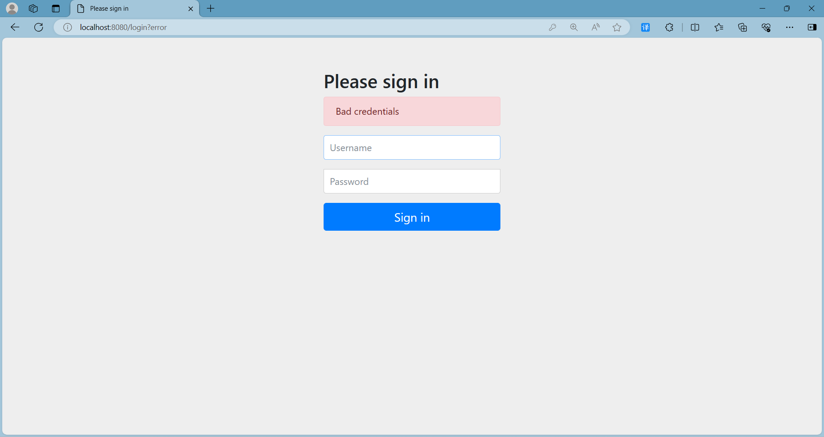

3.登录成功，跳转主页
普通用户登录，上方显示个人中心
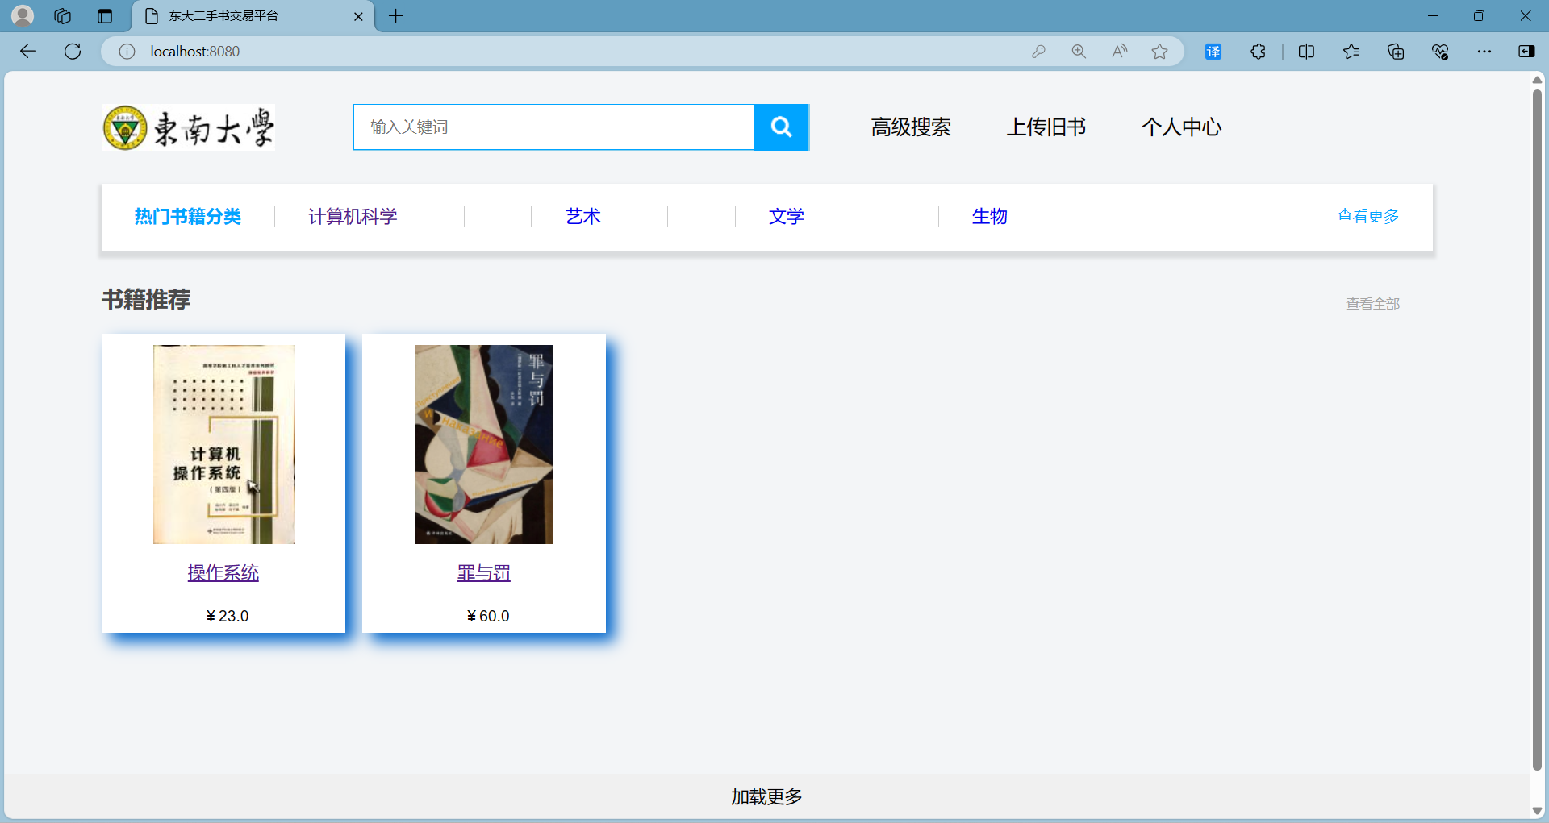
管理员用户登录，上方显示管理员中心
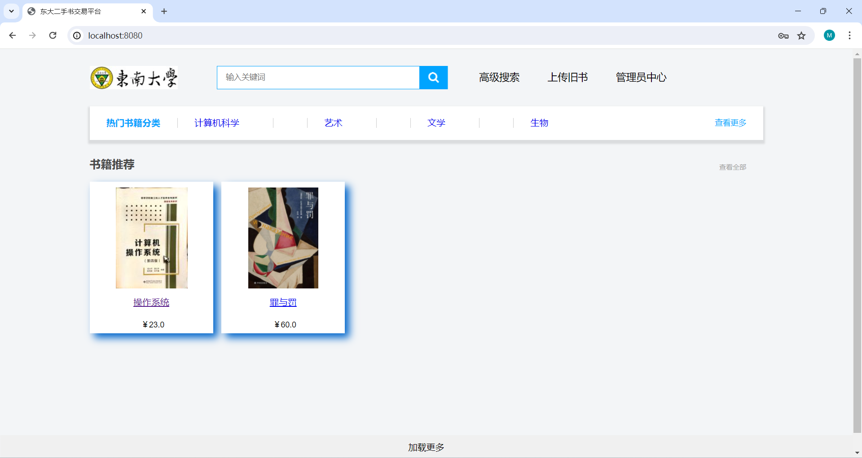

5.2 book managing

5.2.1 Book details display
Click on the book image or title to enter the book details page


5.2.2 Book upload function
Click Upload Books on the homepage to jump to the book upload interface


After filling in the book information, click Submit
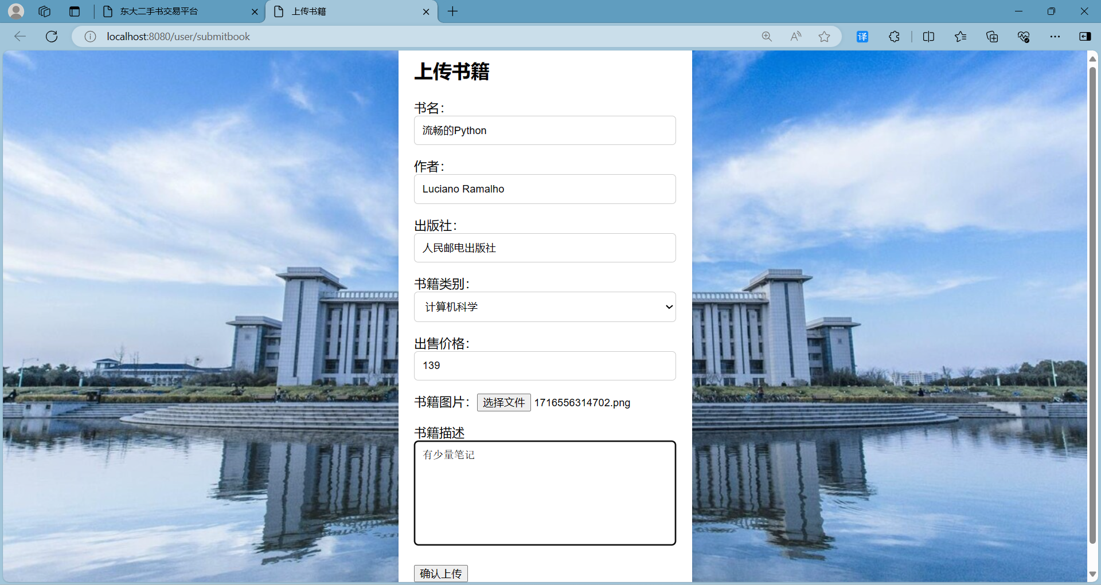
Submitters cannot see or search their own books on the public page, but other users can see them.
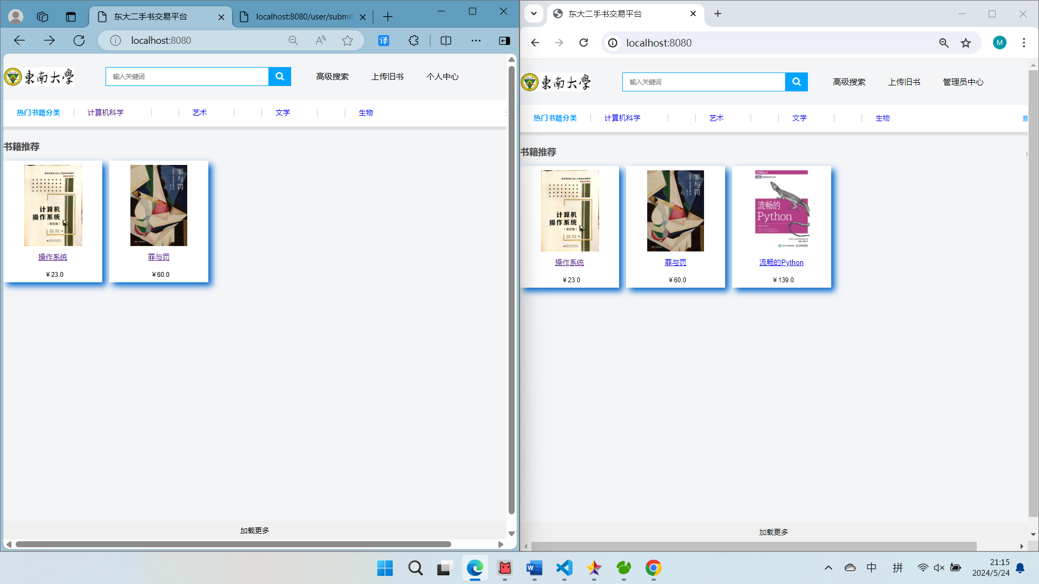
The two pages here are for two different users, and they show different content after users upload books.

5.2.3Book information update
Click Personal Center-My Uploads to see the books you uploaded and click to modify the book information.
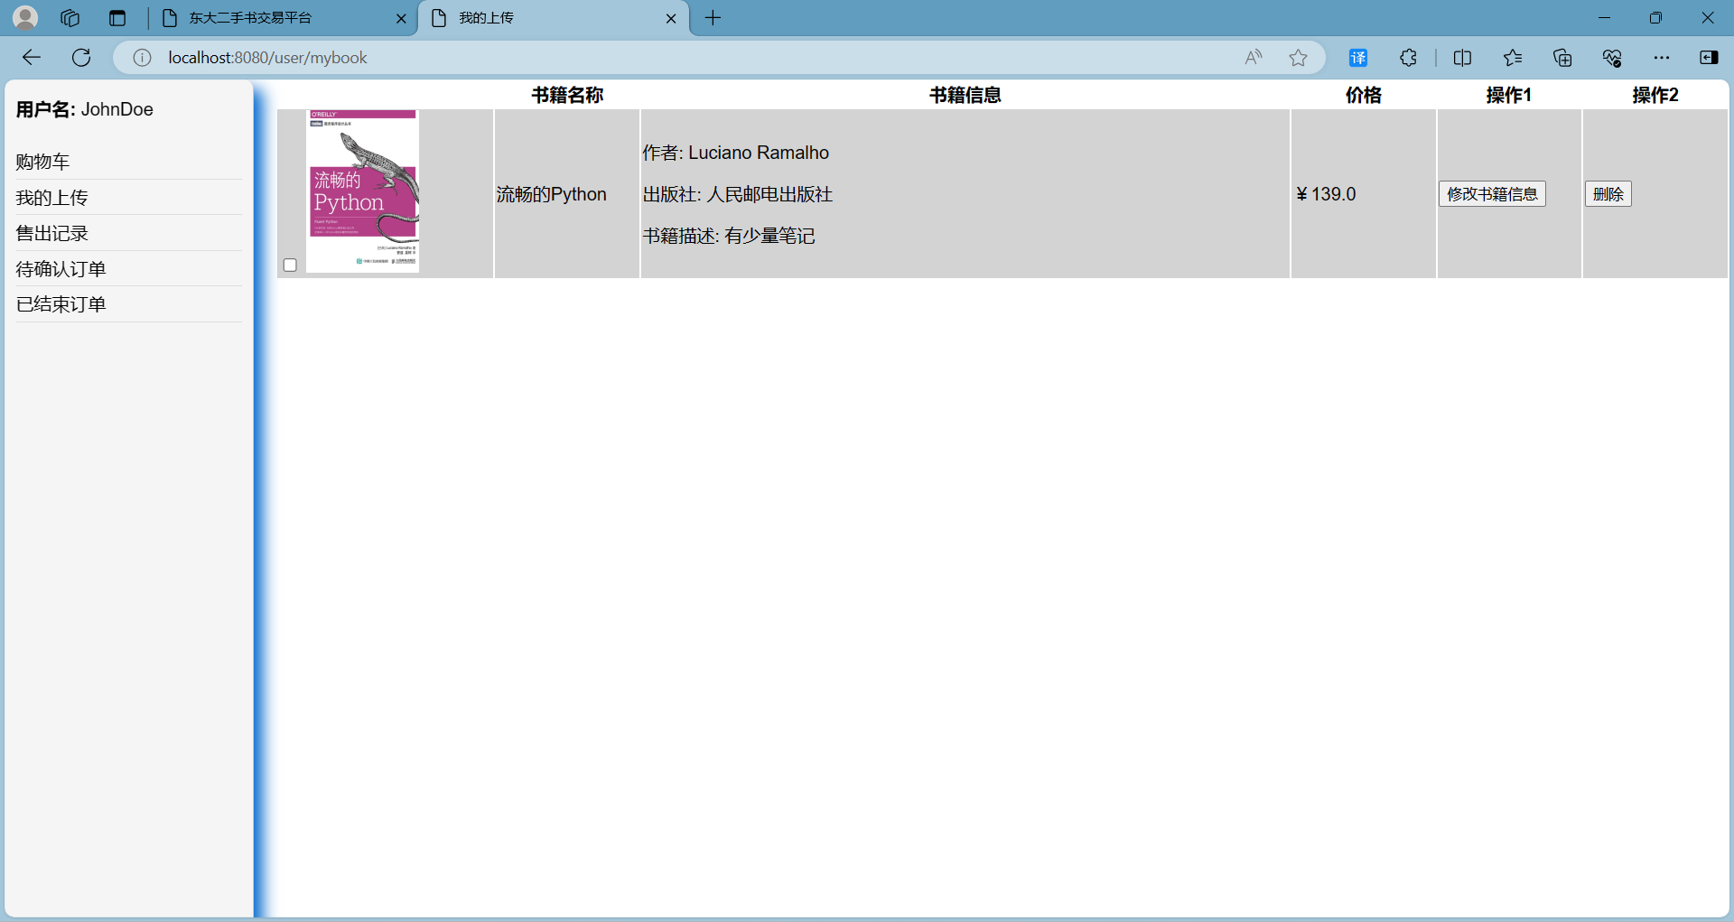
Jump to the book update page, the page retains the original information of the book, the user only needs to enter the information to be updated
Here, choose the most troublesome book image to update

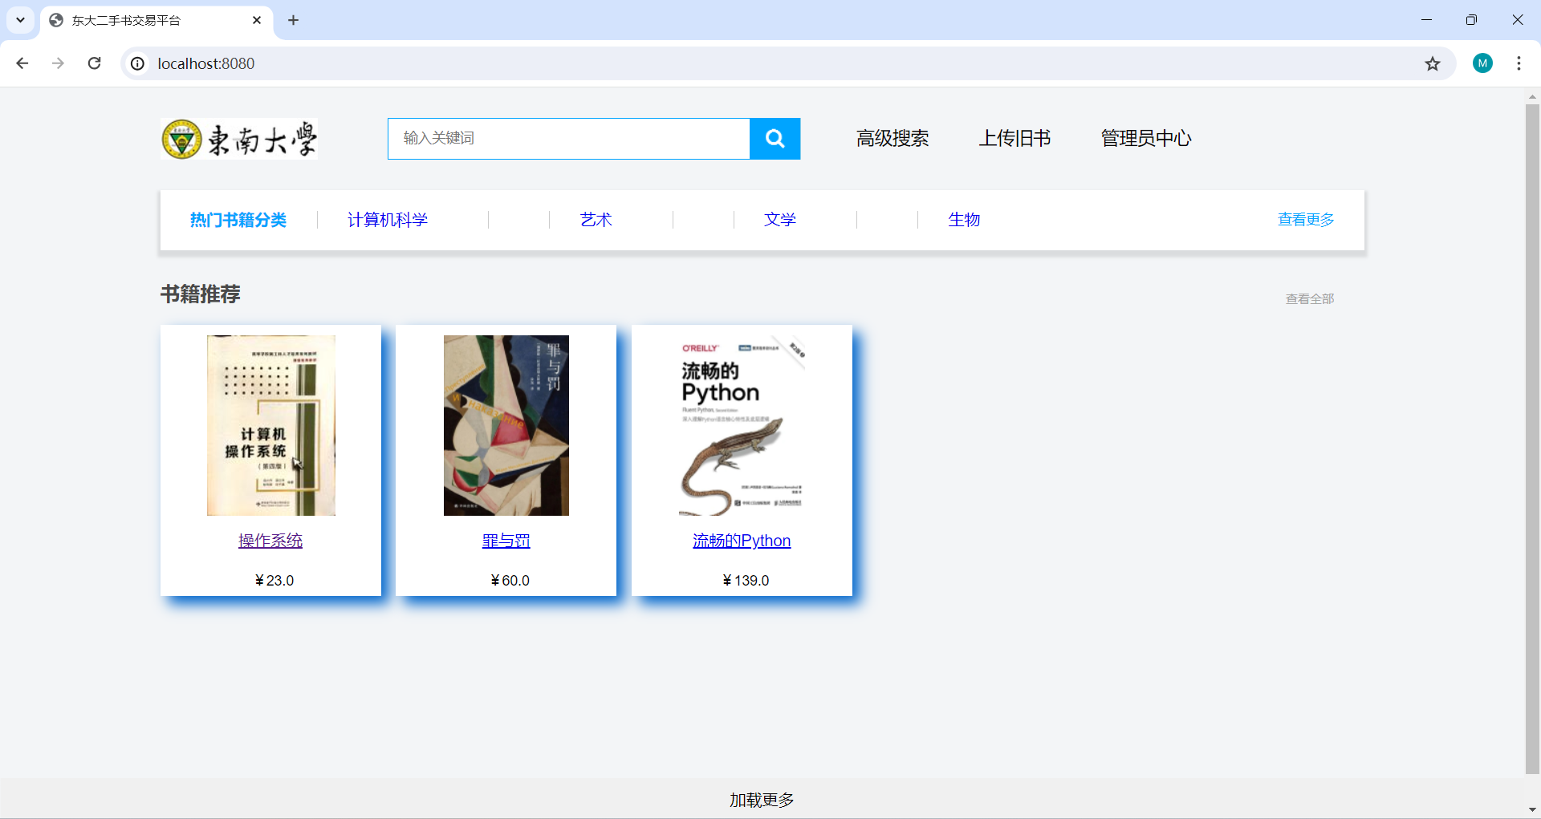

5.2.4book delete
Users can delete books through the Personal Center - My Uploads.
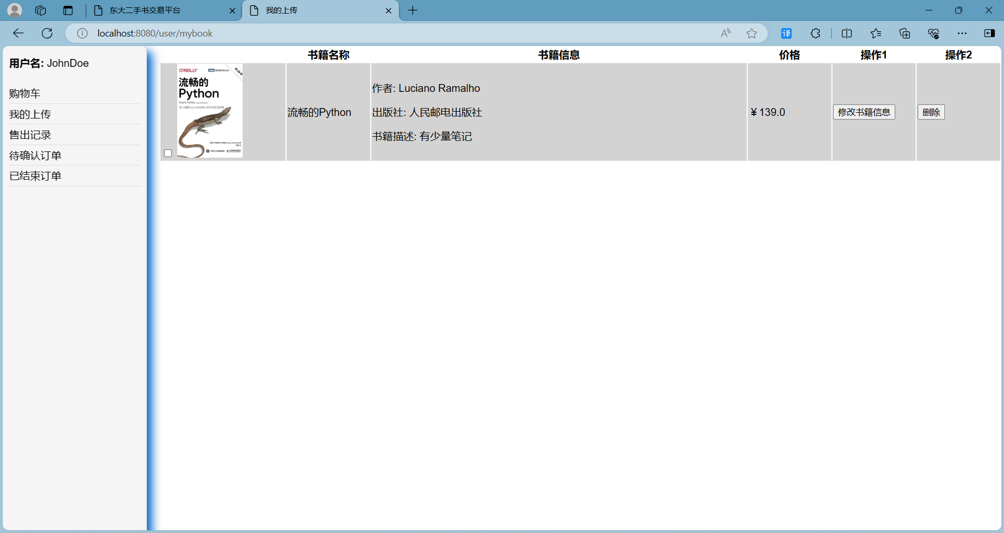
The system prompts whether to confirm the deletion
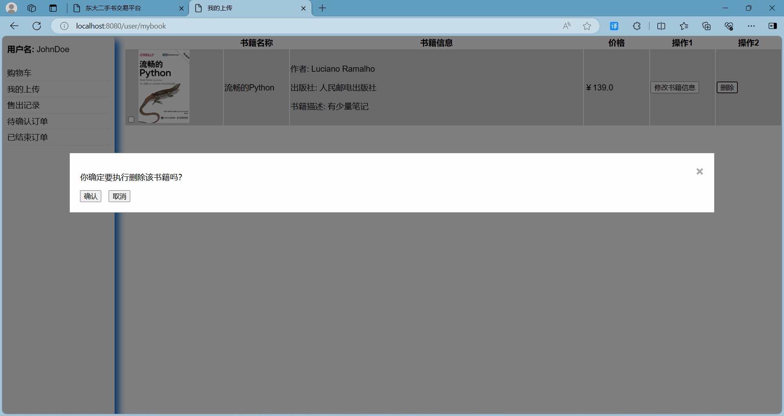
Click Confirm Deletion, the book will be completely deleted, and the system will prompt the deletion result
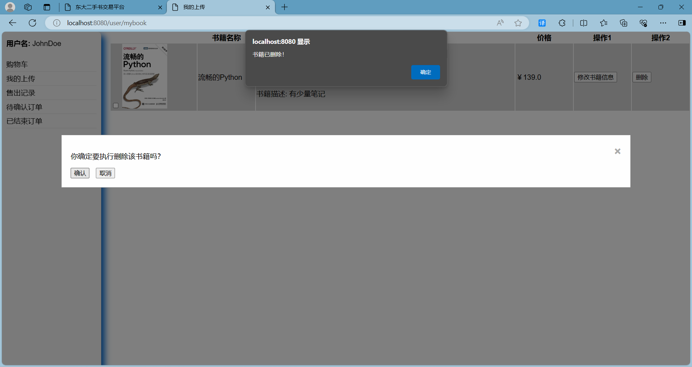
"Smooth Python" no longer exists in the database and the main page is no longer displayed. The deletion was successful.
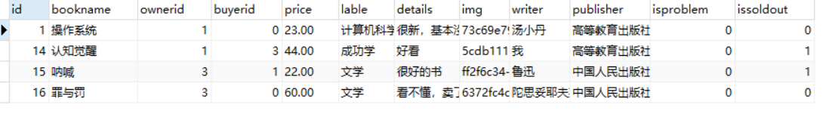

5.2.5Admin adds book tags
The administrator clicks "Book Tag Management" to jump to the tag management page
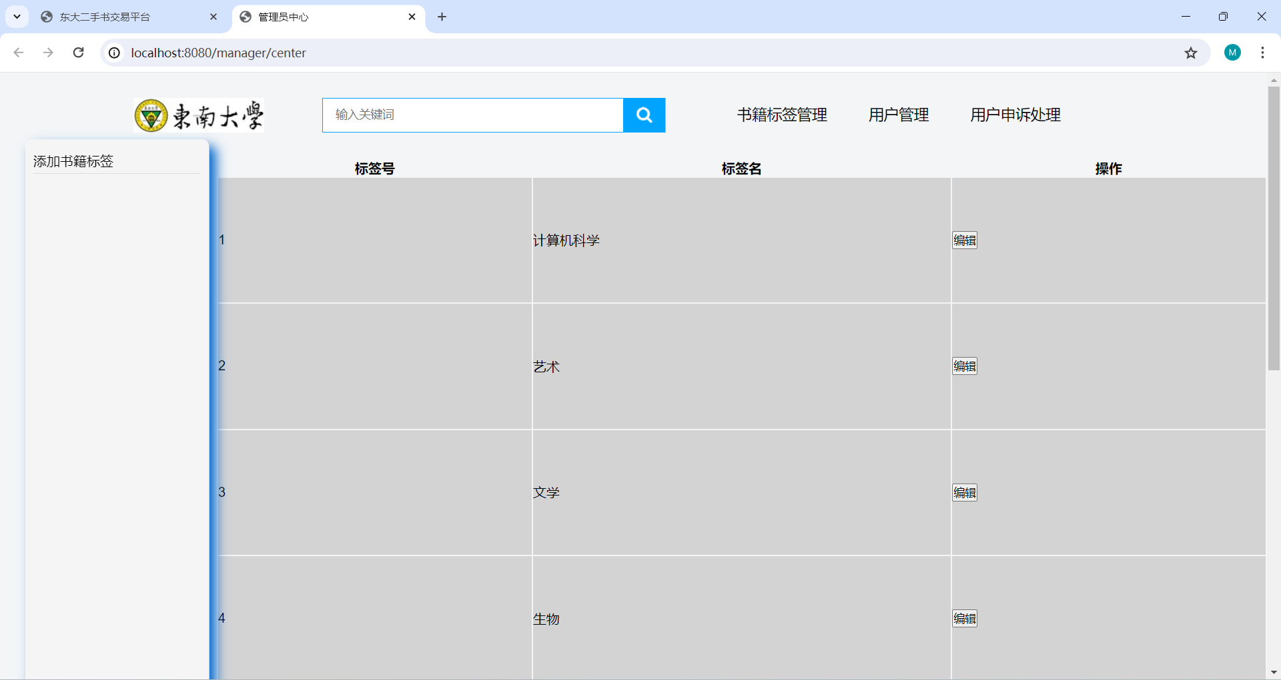
Click to add book tags

Add Advanced Engineering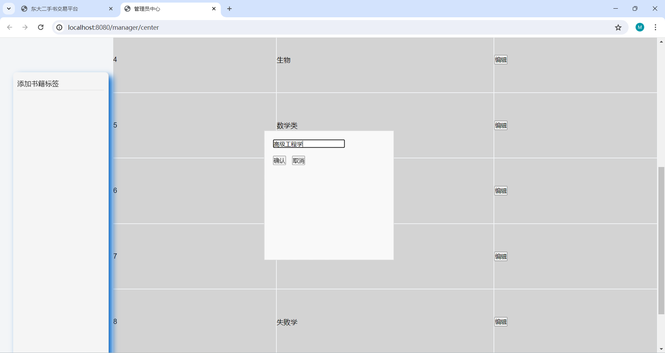
success
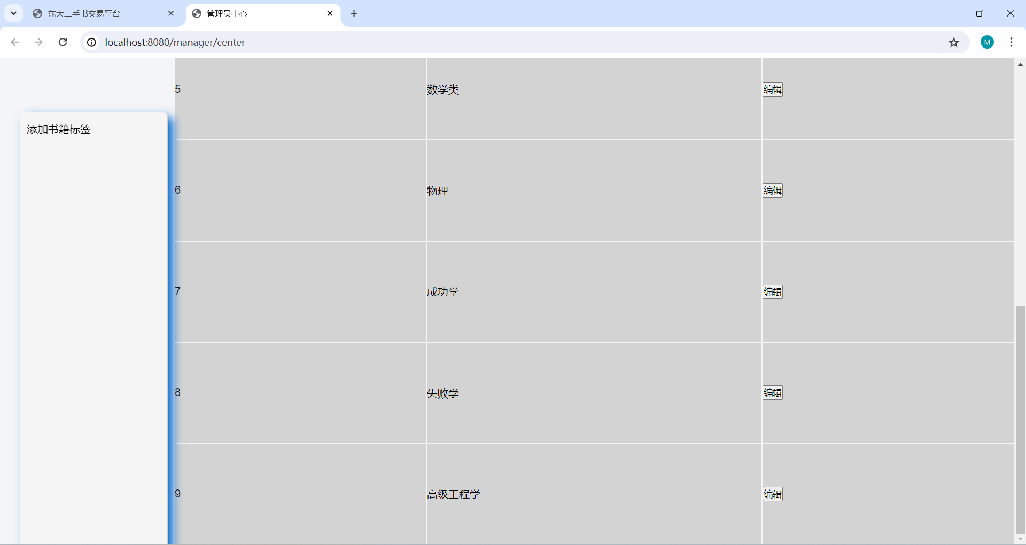

5.2.4 manager modify book label
1.Modify Computer Science to Computers
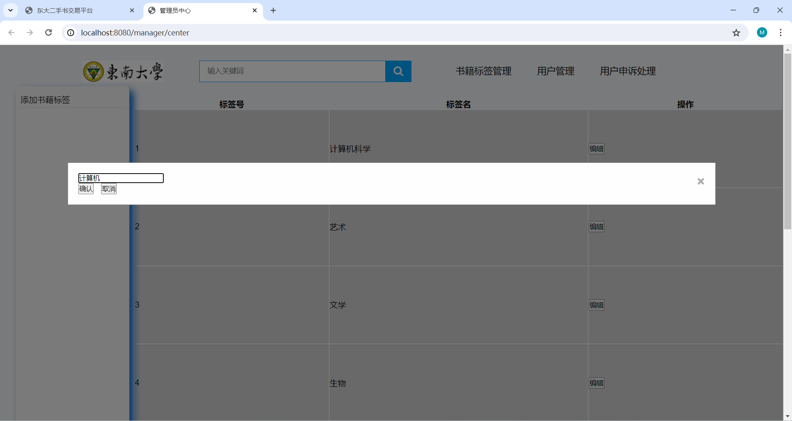
2.System prompt for successful modification
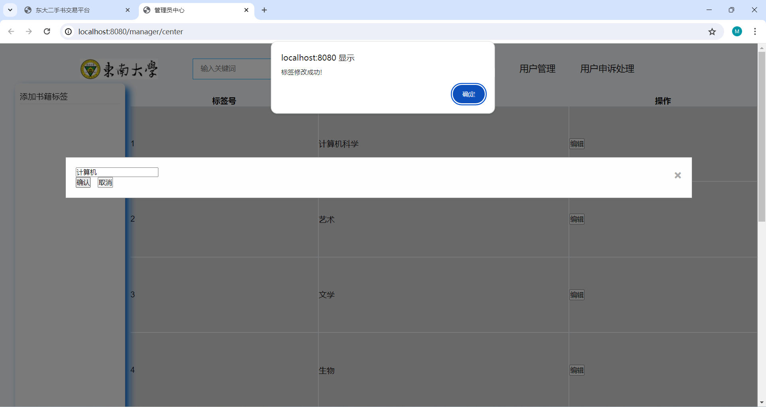
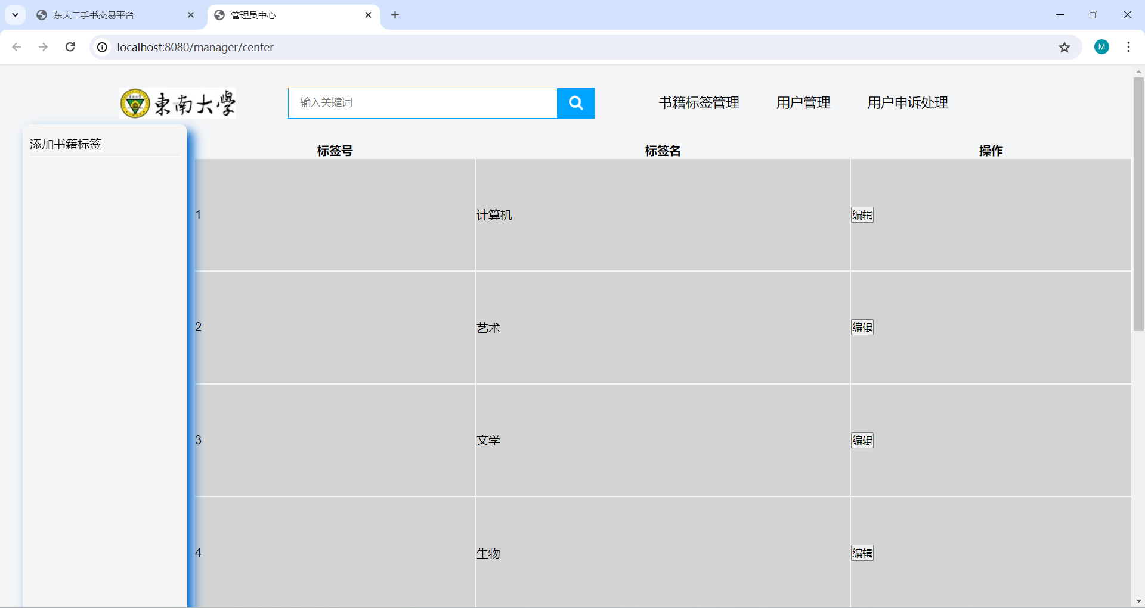

5.3 searching book

5.3.1 General search function, single keyword fuzzy search

2.Search for "literature"
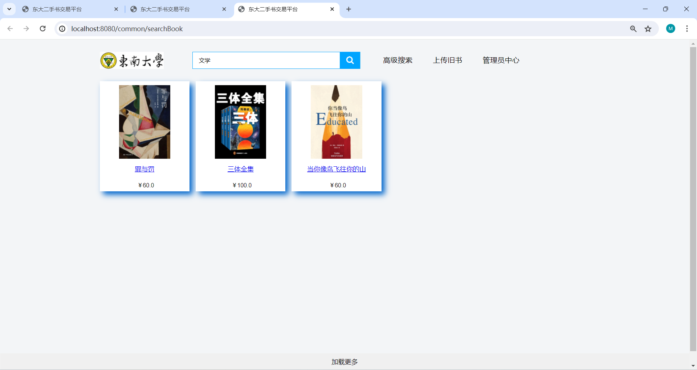

5.3.2 Advanced search function
1.Click Advanced search, the system displays the input box


2.Do not know the information can be empty, the input of multiple keywords for fuzzy search, display the search results
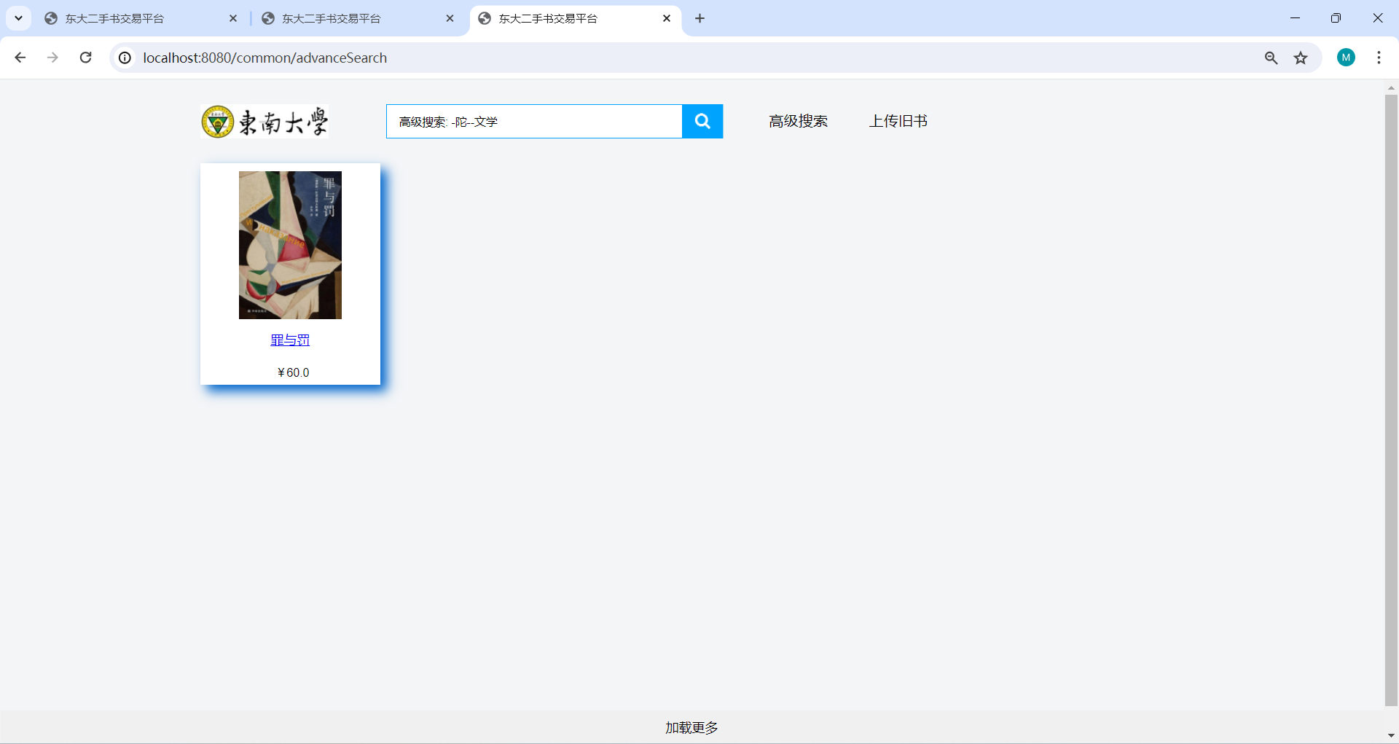

5.4 book trading

5.4.1 Add and remove shopping cart features
1.Users click to enter the book details page, click to join the shopping cart
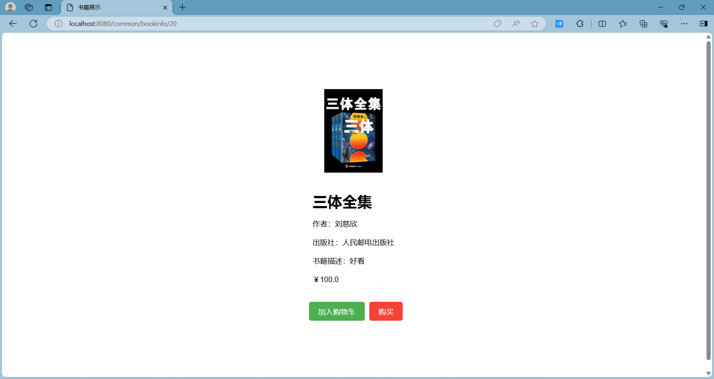
2.Are prompted to add the results
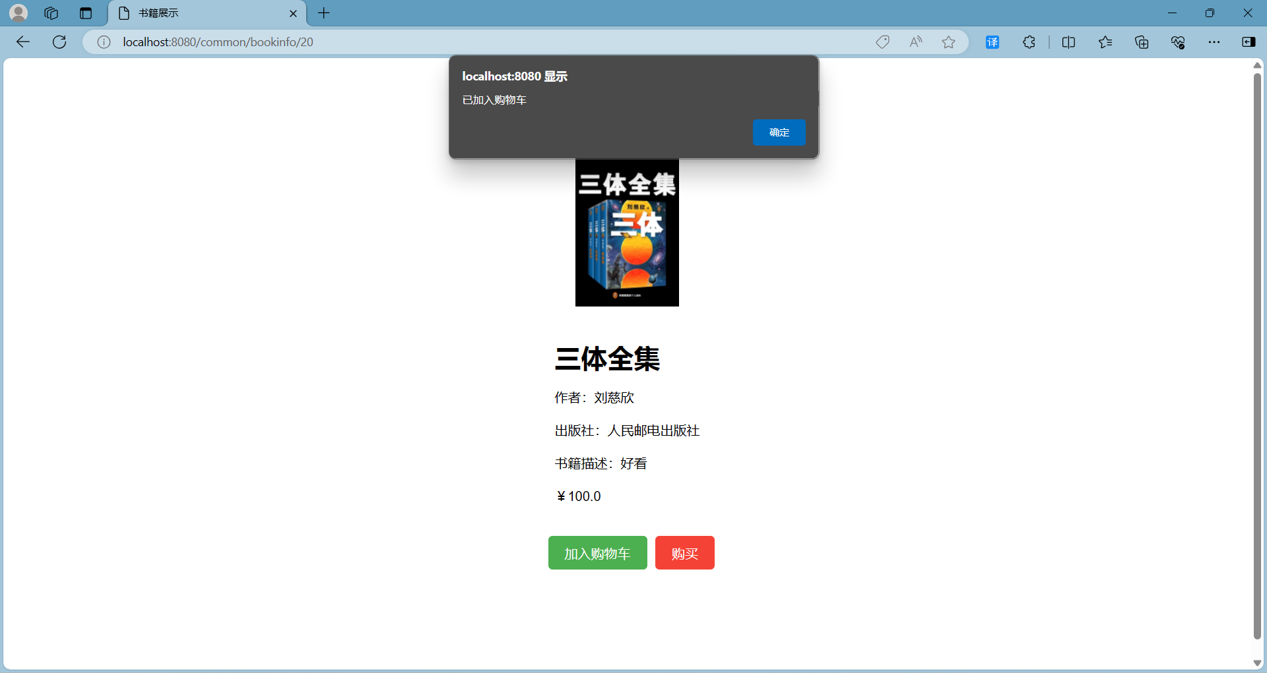

3.Go to the personal center-shopping cart view, add success If the book added to the cart has been sold, indicate book status
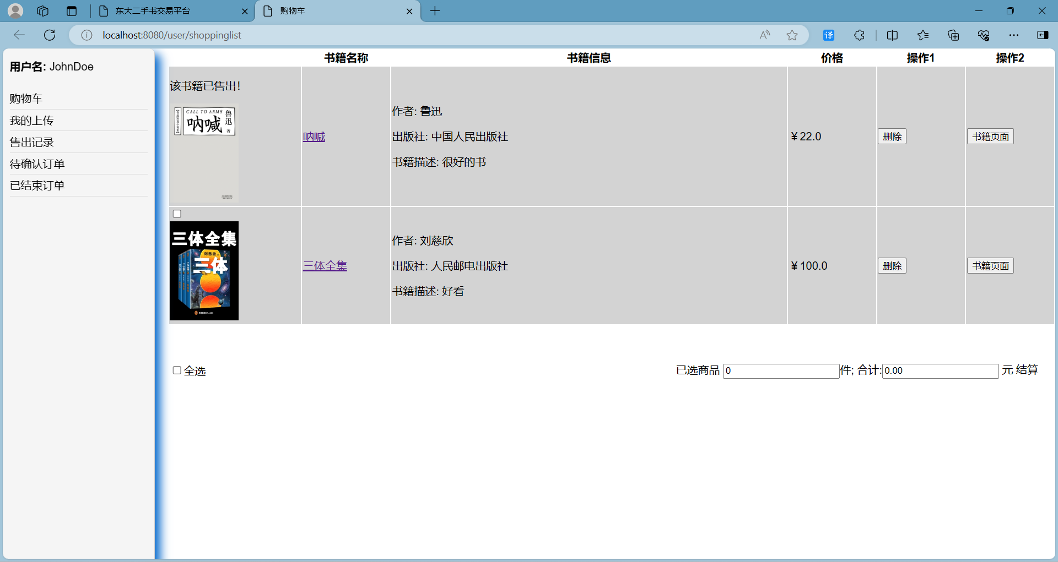
4.Remove the shopping cart, click delete, the system prompt has been deleted
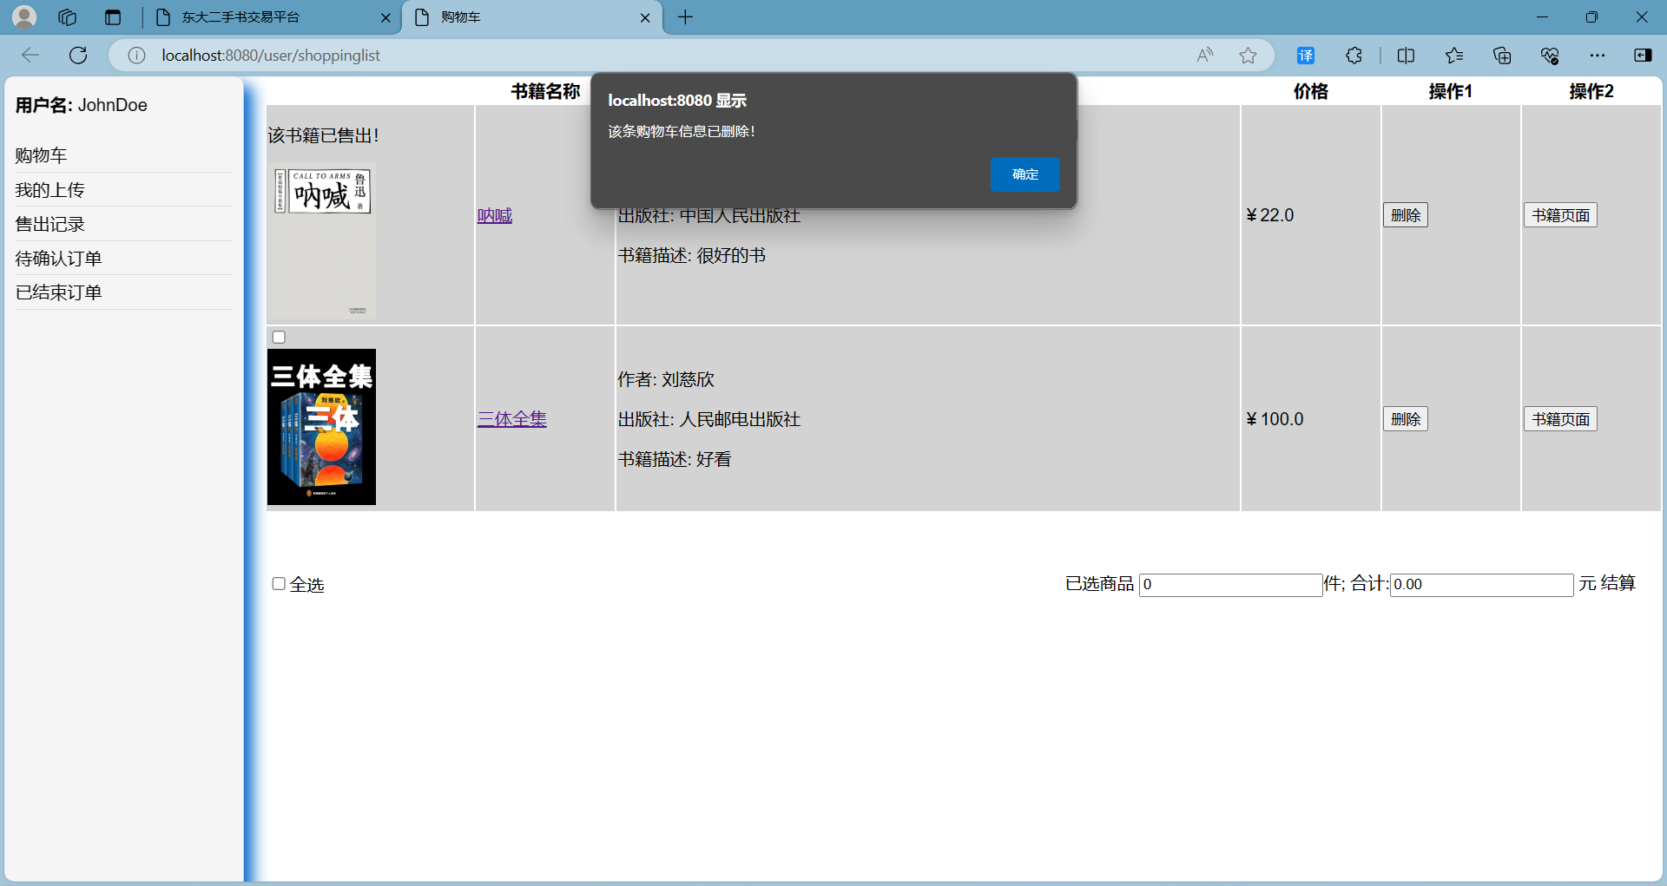
5.delete success
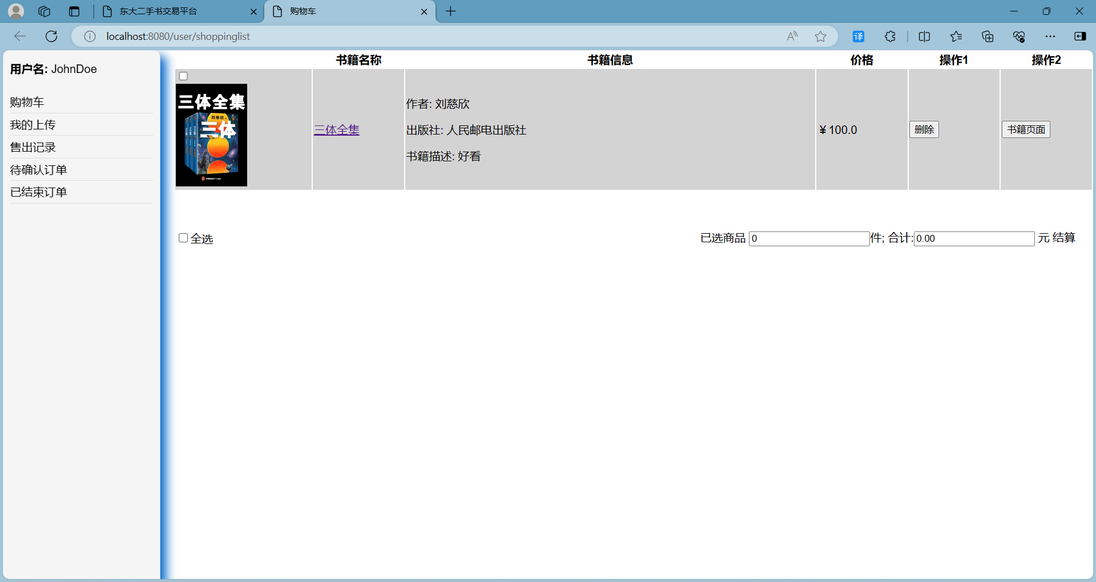

5.5.2Users buy books
1.Users click on the secretary details page to click to buy, to generate the pre-payment order

2.The user clicks to pay, (no real process, equivalent to placing 1)
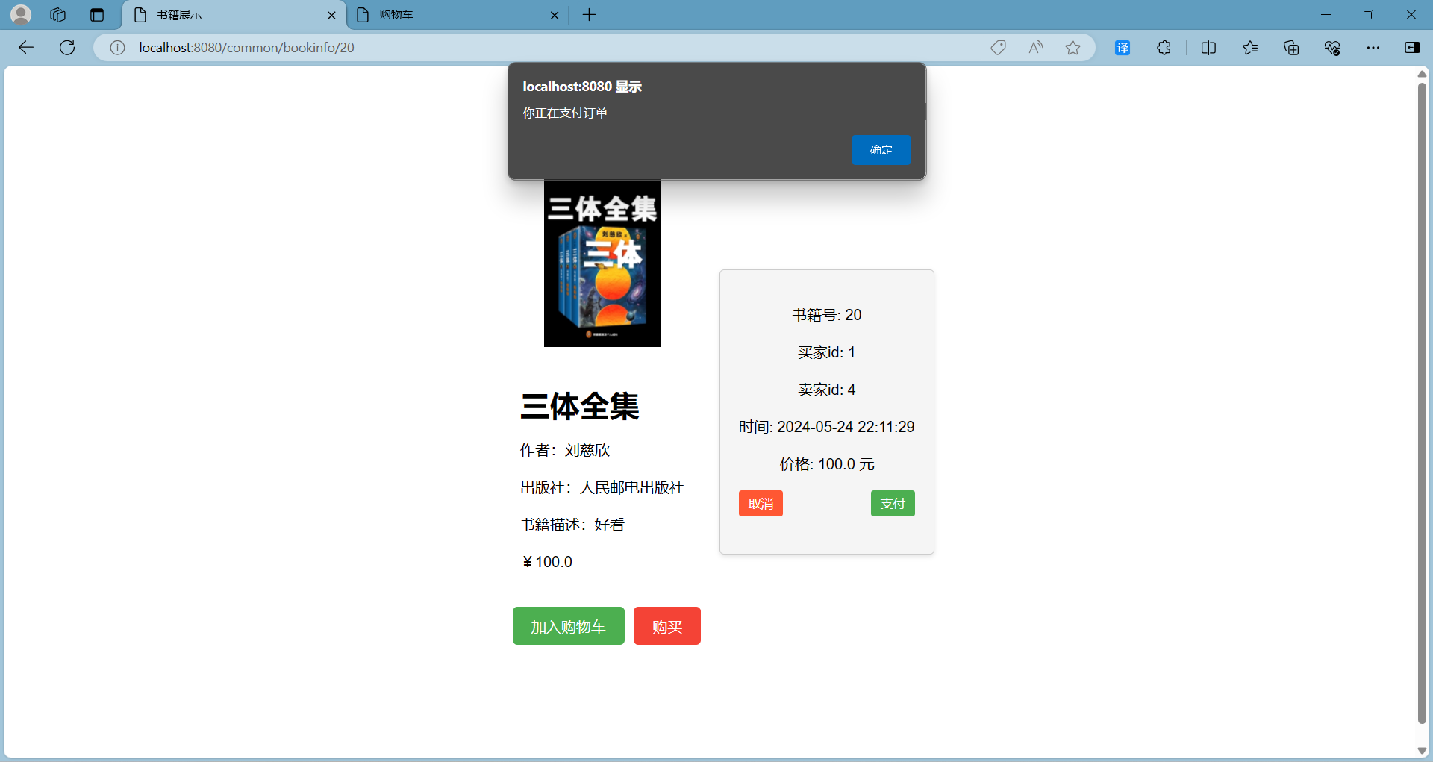
3.After the successful payment, the personal Center-to confirm the order page can view the order


4.Click on the sell record to view the books you have sold
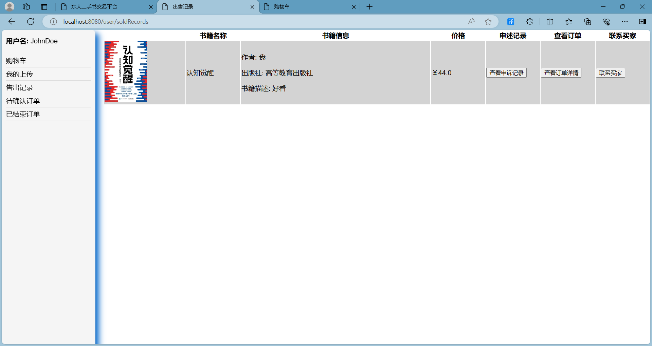
5.Click to view the order details to view the order status

6.Click to confirm receipt, and display in the closed order
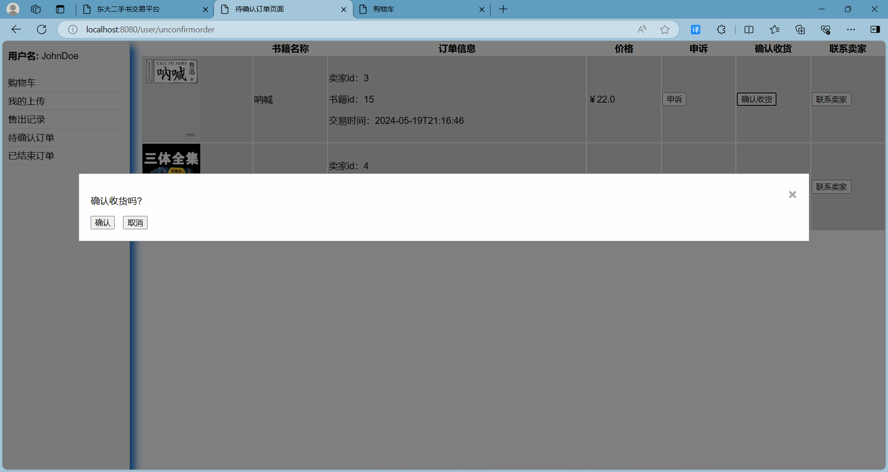

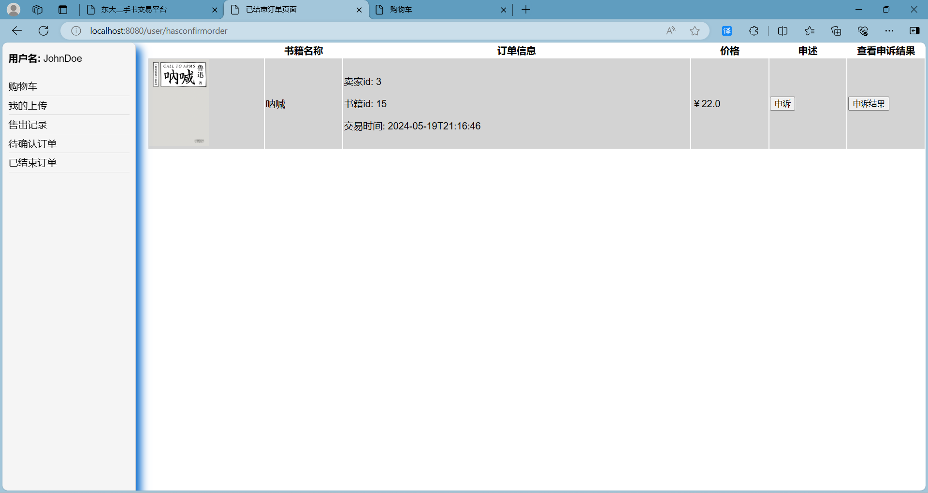

5.5 real time user communicate
1.Users click to contact the seller or contact the buyer, the system displays the chat box, and display the historical message
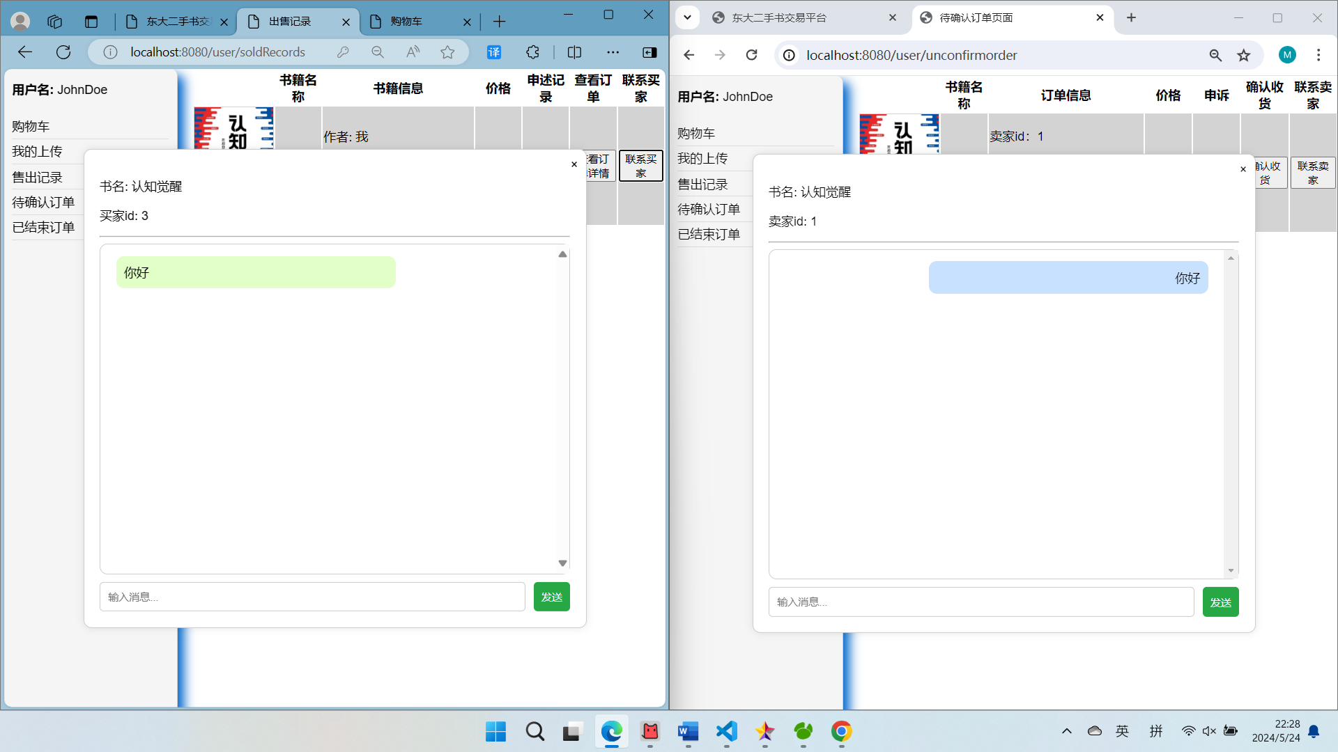

2.Live chat, messages appearing on the right, messages appearing on the left


5.6 manager adding users in batches
1.Select the file " User table. Txt ", the table includes Bruce Lee, Guan Yu, Zhang Fei
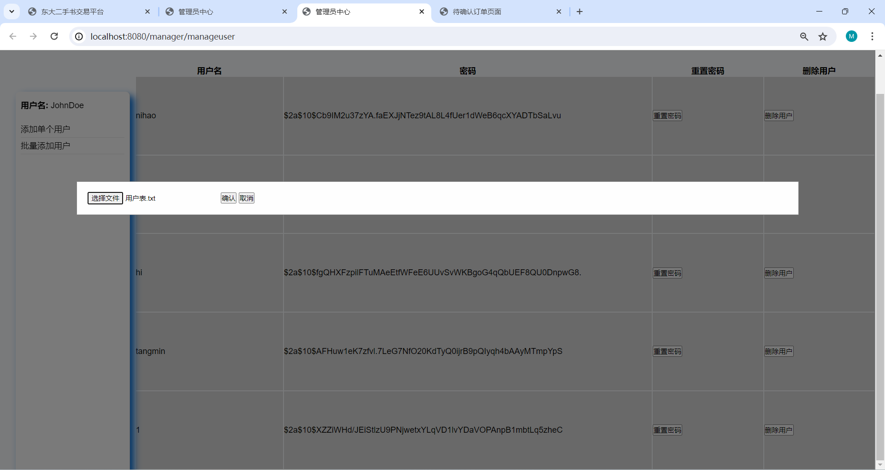
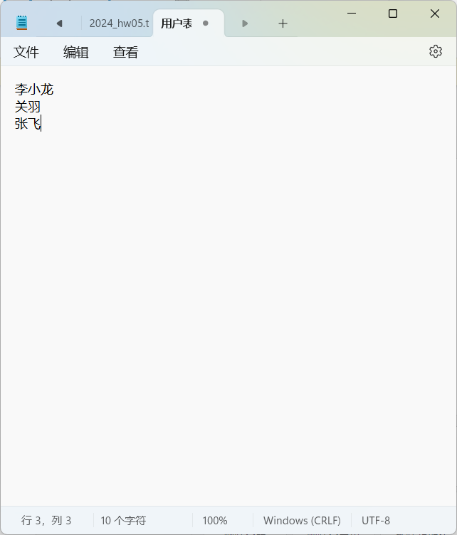
2.Click confirm batch add, the user added successfully
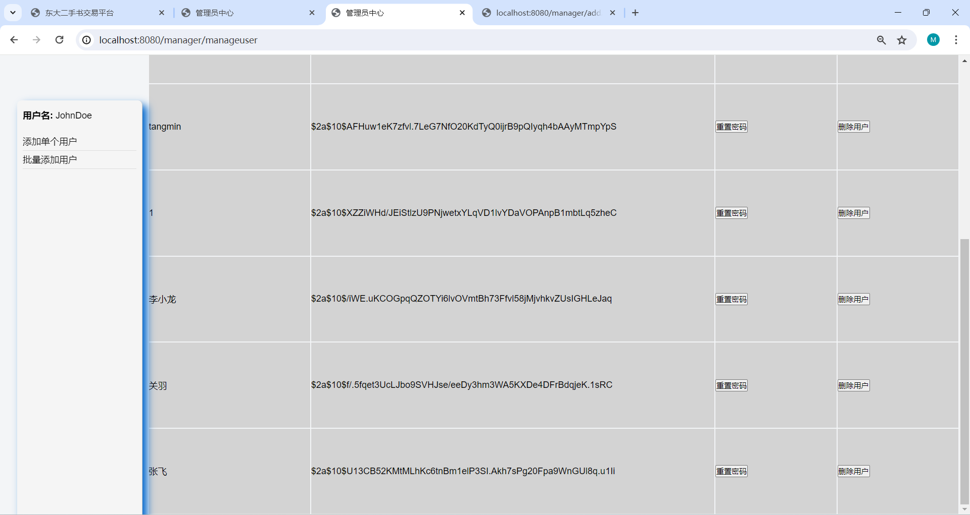
3.Delete the user, click Delete user, prompt whether to confirm the deletion
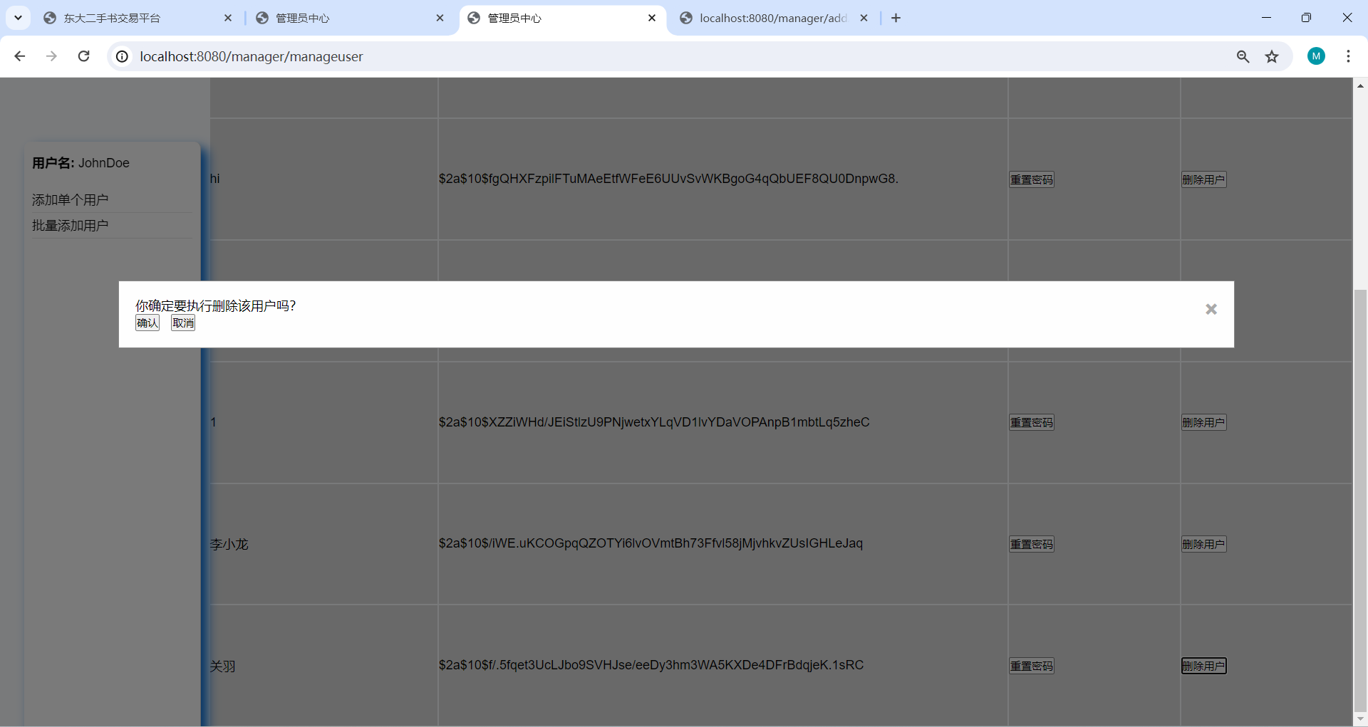
4.After the confirmation, the deletion was successful, and Guan Yu was deleted


5.7 User Complaints
1.Users on the order page, click to describe
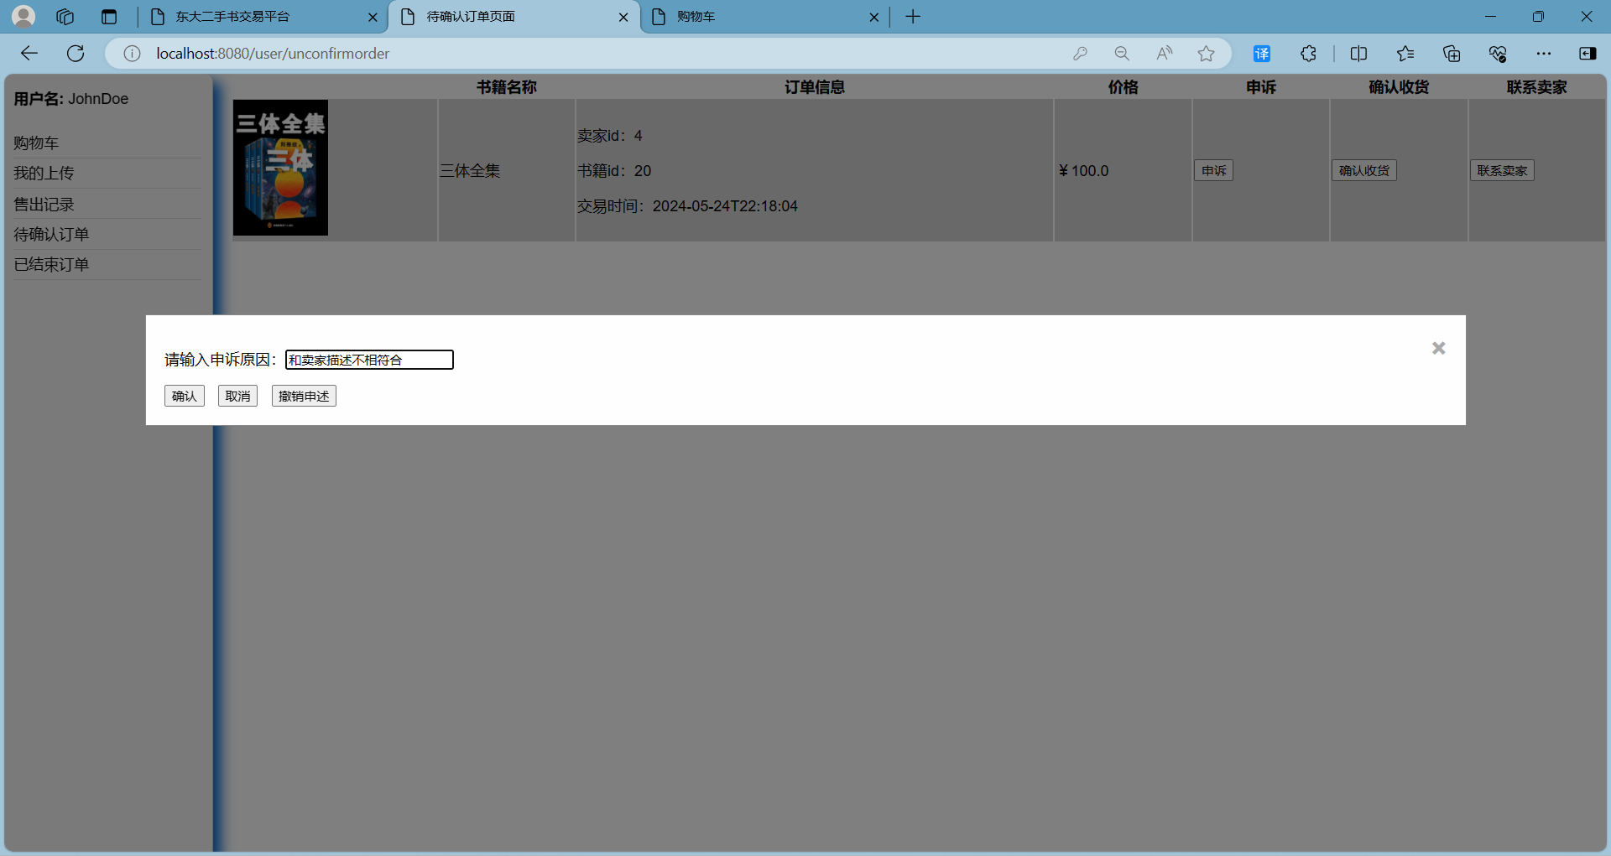
2.Click to describe the results, the system prompt
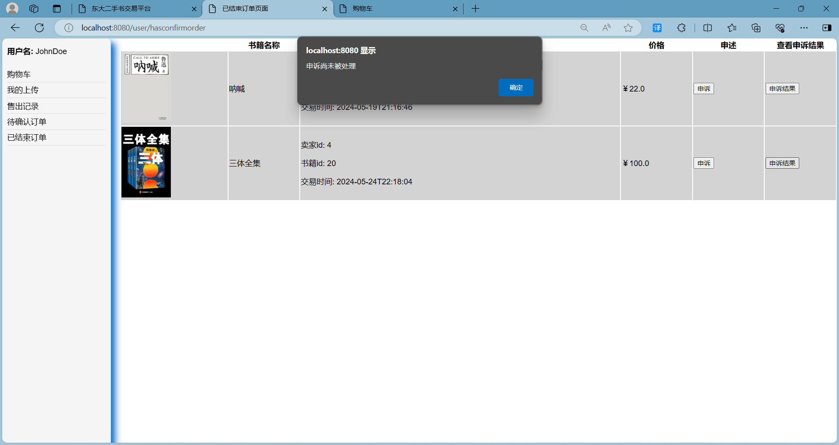
3.The seller can see the complaint，
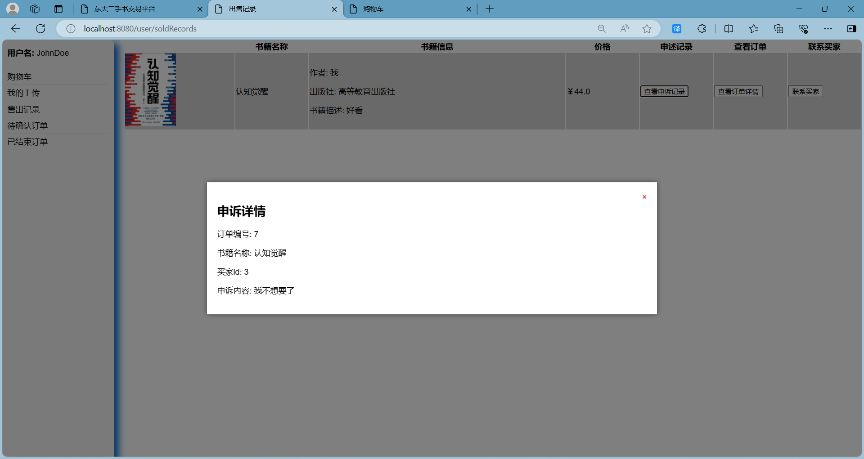
4.The administrator page handles statements, with two statements to be processed


5.press ‘yes’
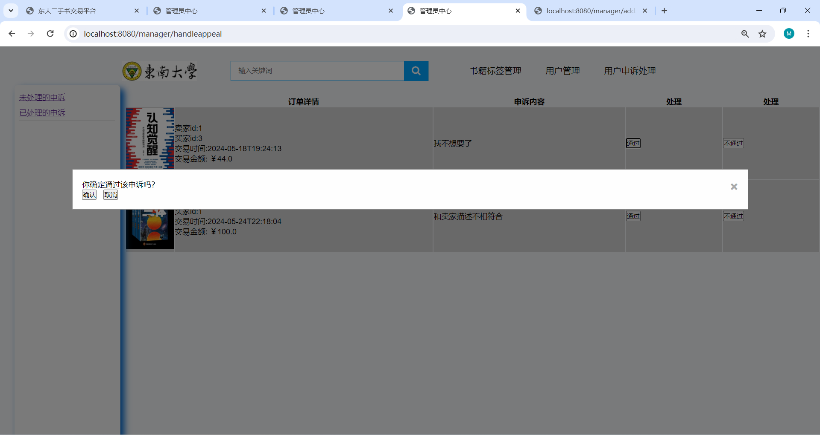
6.The administrator has processed the appeal page presentation
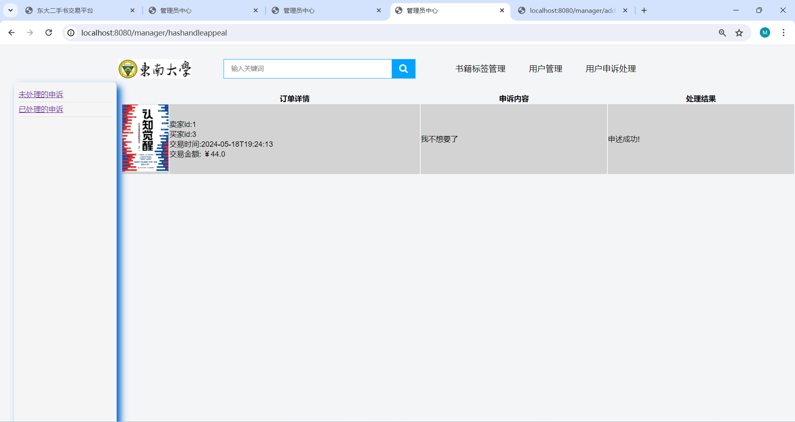
7.user checking appeal result
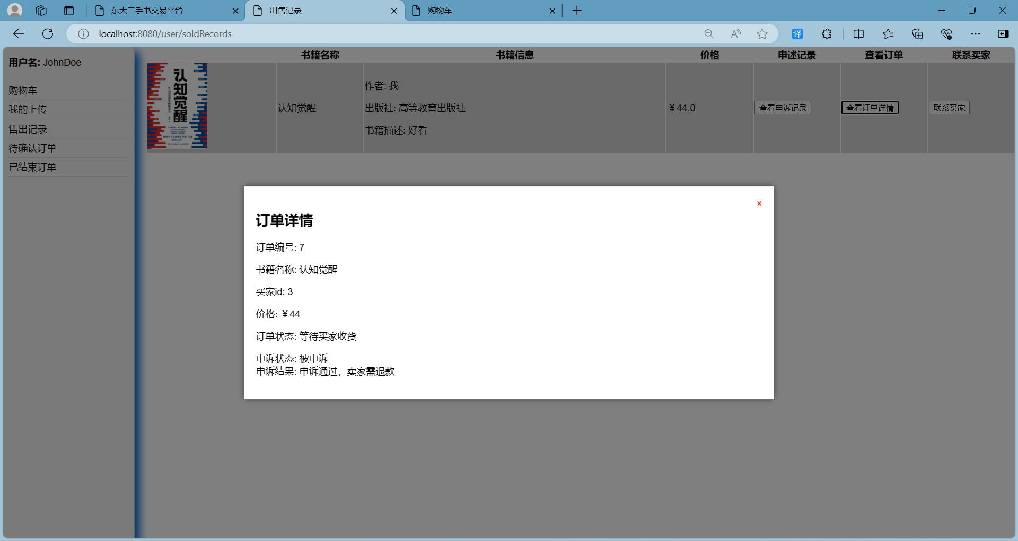

6.experiments summery
From the perspective of project development, I truly understand the importance of demand analysis and object-oriented to web projects. This process seems simple, but it is actually full of challenges. How to investigate and how to analyze. Wrong decisions made in the demand analysis phase are likely to lead to big mistakes in the implementation or even testing phase.
When designing the platform, I was busy coding when I didn't understand the existing technology and framework, which made many things complicated and took a lot of time to make changes. Therefore, it is also necessary to investigate the selection of the early technology stack to avoid modifications caused by inappropriate frameworks.
In terms of ability, I have been greatly trained. In order to realize the front-end interface, I taught myself html, css, and js. Although I am not good at it and the things I made are not very beautiful, it can be regarded as expanding my horizons, understanding some of the working principles of the front end, and solving previous confusions. Since the srtp project has been exposed to the front end before, it is actually okay. The most headache for me is SpringBoot. Since I have already written part of the code before and I have no idea about SpringBoot, I spent a whole week to build and learn how to use SpringBoot. I made a lot of mistakes and bought a lot of related books. Finally, I learned how to use the SpringBoot framework to build a Web project through step-by-step error correction and imitation. After understanding how to use it, the object-oriented thinking in it greatly helped me speed up the implementation of the code, and submitting it once a day became my task. The next step is database design. I studied the book Database Principles and Applications, which is relatively easy.
In summary, from the beginning of the semester when I knew about Experiment 6 to the completion of the project now, I chose to complete this project by myself. I was confused and painful in the first month of learning, and gradually became proficient in the second month. Basically, most of my spare time was invested in it. Although the things I made were not satisfactory, they also brought me great growth. It turns out that building a website by myself is not a crazy idea.

