

**DIGITAL RADIO**

**LABORATORY**

**PROJECT REPORT ON**

Pluto SDR Demonstration of Signal

Classiﬁcation in Real-Time using

Deep Learning

**SUBMITTED BY**:

Gopala krishna Abba-120ec1071

**Abstract:** We present a prototype of a software-defined radio (SDR) capable of real-time signal classification. The ability to detect, classify, and characterize wireless signals is crucial for the efficient use and shared access of the spectrum in SDR-based cognitive and intelligent radio systems. We employ a convolutional neural network (CNN), a type of deep learning algorithm, to classify the modulation of wireless signals. Our demonstration utilizes two different types of radio frequency (RF) front ends for transmitting and receiving signals over the air: the ADALM-PLUTO and the Universal Software Radio Peripheral (USRP) equipped with an SBX daughterboard. We achieved a classification accuracy of 95.5% with the ADALM-PLUTO setup and 96.25% accuracy using the USRP N210.

**I. INTRODUCTION**

Identifying, classifying, and understanding wireless signals are crucial steps in efficiently managing and sharing the electromagnetic spectrum, enabling the advancement of software-defined radio (SDR)-based cognitive and intelligent radio systems. Traditional machine learning techniques rely on manually defined features to train models for signal classification. However, the advent of deep learning (DL), which learns features directly from data, has opened new avenues for signal classification. Deep learning algorithms like deep belief networks (DBN), convolutional neural networks (CNN), and recurrent neural networks (RNN) have been explored, with each offering distinct advantages and limitations outlined in Table I.

CNNs, in particular, have been extensively researched for their effectiveness in various signal processing and classification challenges, achieving notable success. One application has involved deploying CNNs for the classification of jamming signals in telecommunications links, where simulations at low jamming noise rates have shown a minimum classification accuracy of 92%. CNNs have also demonstrated significant potential in waveform modulation recognition. An in-depth evaluation of DL algorithms for this purpose highlighted CNNs' ability to achieve comparable classification accuracy with both real over-the-air transmitted signals and synthetically generated data, reinforcing the viability of CNNs for signal modulation classification tasks.

This illustrates the practical application of CNNs for classifying over-the-air signals via an SDR system built with two USRP N210 radios, programmed using MATLAB. We detail the CNN training process and the testing methodologies employed to ensure the model's effectiveness for real-time demonstration. The demonstration's conceptual and procedural aspects are then elaborated upon. In Section IV, we discuss the outcomes and broader implications of implementing this SDR system for signal classification, along with considerations for future research in this domain.

TABLE I

ADVANTAGES AND LIMITATIONS OF THE MAIN DL MODELS

|  |  |  |
| --- | --- | --- |
| DL Method | Advantages | Limitations |
| DBN | * Establish a joint distribution between   observation data and labels   * Restore the conditional probability distribution | * Lower accuracy than conventional   discriminant model   * Higher complexity * Translation invariant of input data |
| CNN | * Weight sharing strategy * Reducing the spatial resolution of the Network * Low translation invariance requirement of input data | * Vanishing gradient is prone to occur * Preset the length of input vector |
| RNN (LSTM) | * Depth model in time dimension * No need to preset the length of input vector * Solving time series problems and extracting time series information | * No characteristic learning ability |

**II. RF FRONT-END OF THE SDR PROTOTYPE**

The initial phase of the proposed demonstration involved an experiment utilizing an RF front-end consisting of two ADALM-PLUTO radio modules, with one serving as a transmitter (TX) and the other as a receiver (RX). As the experimentation progressed and the understanding of the convolutional neural network (CNN) deepened, there arose a desire to employ an alternative RF front-end with enhanced TX/RX capabilities to further investigate the system's performance in a dynamically changing environment. This led to the implementation of a similar system using two USRP N210s, with one acting as the TX and the second as the RX.

ADALM-PLUTO radios were chosen initially for their suitability in SDR applications, serving as a rapid solution for RF design verification, educational purposes, or as an introductory tool for radio. The ADALM-PLUTO was utilized as an I/O peripheral device with configurable parameters such as center frequency and sampling rate.

While the USRP involves a steeper learning curve, MATLAB provides a comparable hardware and software support system, simplifying interaction with the device. The USRP is also treated as an I/O peripheral, similar to the ADALM-PLUTO, but with additional configurable parameters like interpolation factor and oscillator offset.

Although the ADALM-PLUTO serves as a suitable starting point for initial exploration, the USRP N210, with its SBX daughterboard, is more desirable for ongoing project development due to its superior specifications, as summarized in Table II. The limitations of transmission power on Pluto radios result in a much shorter ideal physical distance between two PLUTO radios compared to USRPs. These characteristics are advantageous for future exploration into the automated classification of high-frequency communication protocols such as Wi-Fi or 5G, as well as orthogonal frequency-division multiplexing (OFDM) waveforms.

TABLE II

ADALM-PLUTO VS. USRP N210 WITH SBX DAUGHTERBOARD SPECIFICATIONS

|  |  |  |
| --- | --- | --- |
|  | ADALM-PLUTO | USRP N210 +SBX |
| ADC Resolution | 12 bits | 14 bits |
| DAC Resolution | 12 bits | 16 bits |
| Frequency Range | 325 MHz - 3.8 GHz | 400 - 4400 MHz |
| Max Instantaneous BW | 20 MHz | 56 MHz |
| ADC Sample Rate | Flexible Rate | 100 MS/s |
| DAC Sample Rate | Flexible Rate | 400 MS/s |

**III. DEMONSTRATION OF MODULATION**

**CLASSIFICATION**

**A. Training and Testing CNN**

In our prior analysis, we delved into the performance of the CNN employed in the ongoing demonstration. Initially, we scrutinized the architecture of this specific deep learning model by experimenting with the addition and removal of hidden layers within its internal structure. The impact of these structural manipulations was then observed in terms of the training duration for the CNN, as well as the resulting accuracy during testing and validation, as depicted in Fig. 1 and Fig. 2.

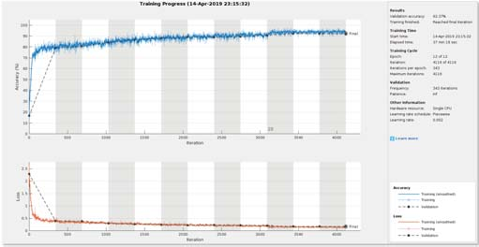

Fig. 1. Training Progress with 4 Hidden Layers Removed from the Baseline

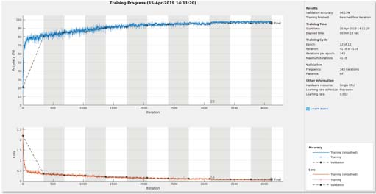

Fig. 2. Training Progress with 4 Hidden Layers Added Back to the Baseline

Apart from architectural adjustments, we also examined the CNN's performance when training and testing the network with waveforms at a signal-to-noise ratio (SNR) lower than 30dB. This SNR value aligns with the conditions encountered when subjecting software-generated waveforms to both additive white Gaussian noise (AWGN) channels and Rician multipath fading channels. These evaluations were conducted through simulations, and the outcome is illustrated in Fig. 3, showcasing the confusion matrix generated by the default CNN with simulated waveforms as input.

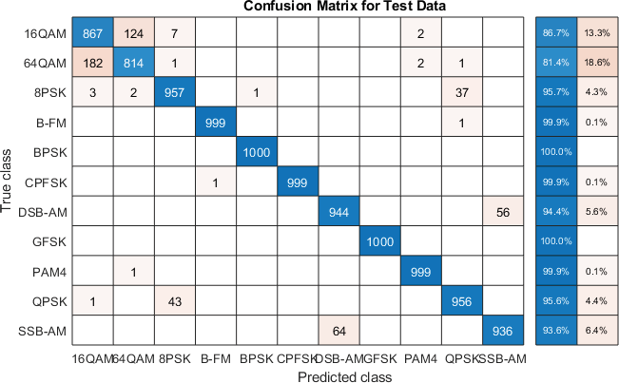

Fig.3.Confusion Matrix of Simulated Waveforms with Pre-Trained CNN

The outcomes of the architectural adjustments suggested that, for the current task of classifying baseband signals with different modulation types, the number and arrangement of hidden layers are optimized in the pre-trained default CNN. The training time experienced an increase when hidden layers were either added or removed. Furthermore, the addition of hidden layers to the existing model only resulted in a slight increase in overall validation/test accuracy. The final validation accuracy reached 96.15%, with the loss graph indicating a noticeable approach towards zero over the 12-epoch training/validation cycle.

Subsequently, we conducted tests by inputting waveforms generated with SNR values of 15 dB and 5 dB for classification. This led to a decrease in validation/test accuracy, demonstrating a correlation between decreased SNR values and lower accuracy. Following this, we retrained the CNN using waveforms with a 15 dB SNR and tested it with waveforms at 30 dB, 15 dB, and 5 dB SNR values, revealing a consistent pattern. These results suggest the need to introduce some form of resilience to the CNN for future exploration into dynamic environment classification problems. However, for laboratory experimentation purposes, the current model proves sufficient.

**B. Testing CNN with SDR Radios**

Moving on to testing the CNN with SDR radios, a demonstration was devised to showcase the feasibility of an SDR system implementing a CNN-based recognition model for receiving and classifying over-the-air signals with a high degree of reliability and accuracy. Eight digital modulation types, including 8PSK, 16QAM, 64QAM, BPSK, CPFSK, GFSK, PAM4, and QPSK, were utilized for this demonstration. The subsequent tests involved the use of over-the-air signals to validate the CNN as a solid foundation for real-time signal classification. Initially, ADALM-PLUTO radios were employed as depicted in Fig. 4. Two ADALM-PLUTO radios were positioned 2 feet apart, featuring a 900 MHz center frequency and a 200 kHz sampling rate. This setup achieved a classification accuracy of 95.5%, and the corresponding confusion matrix is illustrated in Fig. 5.

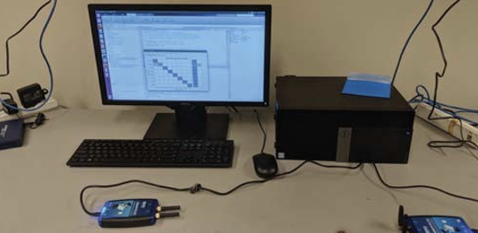

Fig. 4. Physical System for Demonstration – PLUTO

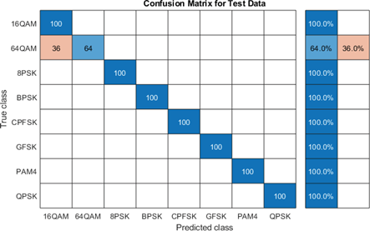

Fig. 5. Confusion Matrix of Testing CNN using ADALM-PLUTO

Building upon this example, a similar system was implemented using USRPs as the RF front-end, as outlined in Section II. The physical system setup is illustrated in Fig. 6. The development of the USRP classification system required a distinct software implementation compared to the ADALM-PLUTO example. The method for the transmission process needed reevaluation. Unlike the ADALM-PLUTOs, executing both transmission (TX) and reception (RX) functionality in a single script was not feasible with the USRP at the time. Additionally, the hardware distinctions between the USRP and ADALM-PLUTO necessitated fine-tuning of the USRP system to identify the optimal values for parameters such as center frequency, sampling rate, and channel gain.

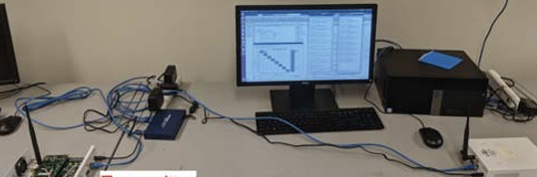 Fig. 6. Physical System for Demonstration – USRP

Fig. 7. Testing

The physical system employed for the demonstration features two USRP N210 devices, as detailed in Section II. Positioned on a level surface approximately 6 feet apart, with no obstruction between them, the devices operate in a relatively low-noise environment. One USRP serves as the transmitter (TX), while the other serves as the receiver (RX). They are programmed to operate at a center frequency of 2.48 GHz, with a 400 KHz sampling rate and a channel gain set to 15 dB.

During the over-the-air test, a classification accuracy of 96.25% was achieved using the USRP, surpassing the 95.5% accuracy achieved with the ADALM-PLUTO. The testing process and classification accuracy details are depicted in the command window, as illustrated in Fig. 7. Additionally, the confusion matrix corresponding to the USRP implementation is provided in Fig. 8.

The obtained result reinforces the notion that the CNN serves as a reliable foundation upon which to construct a model for signal recognition. It consistently, reliably, and accurately classifies signals. Therefore, the current demonstration, focused on the real-time classification of over-the-air signals using the CNN, is designed and executed with these objectives in mind.

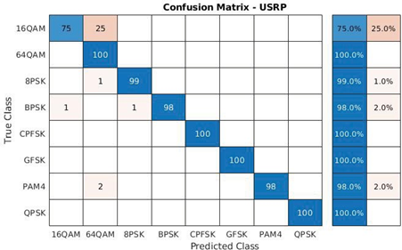

Fig. 8. Confusion Matrix of Testing CNN using USRP N210 with SBX

A. Modulation Classiﬁcation using USRP in Real-Time

The signals undergo modulation, adopting one of the described 8 modulation types, and are generated on the transmitter (TX) end. The TX USRP transmits the signal for a predefined period (25 seconds in this instance) and then automatically proceeds to transmit the next signal. Consequently, all 8 modulated signals are sequentially transmitted. The command window on the left side of Fig. 9 presents the transmitting signals. On the receiver (RX) end, the USRP receives the signal, down-converts it to baseband, and forwards the digitized complex samples to the CNN for classification. The command window on the right side of Fig. 9 displays the classified signal in real-time.

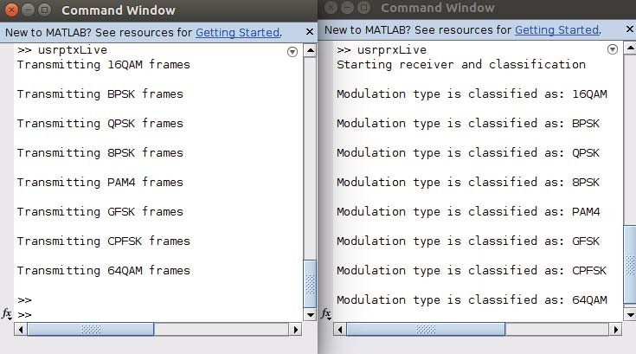

Fig. 9. View of Real-Time Classiﬁcation

**CONCLUSION**

In summary, the demonstration provides strong evidence that a system is feasible in which real-time communications are classiﬁed with a measure of reliability and accuracy. It supports the efﬁcacy of CNN as a strong candidate for the purpose of modulation recognition problems. A strong foundation is provided for further development of a SDR real- time signal classiﬁcation system.

A CNN architecture will be pursued which has a higher tolerance for signals transmitted in environments with a low SDR value in order to explore the deployment of such a system in a dynamic environment. Additionally, more modulation types including OFDM as well as MIMO communications will be added to the CNN training regime to allow for greater classiﬁcation capabilities.