NO112219C_Camui_305A/306A_CalBryte630AM_10Ca_2Ca 25nM Calyc

cells are~ 90% confluency, 1DAT,

Laser Calibration 930 nm (1850mW at the laser screen, software) not calibrated

7%=0.8mW

8%=0.97mW

9%=1.1mw

10%=1.2mW

11%=1.32mW

12%=1.45mW

13%=1.6mW

14%=1.7mW

15%=1.86mW

Laser Calibration 1010 nm (920mW at the laser screen, software)-

9% = .9mW

10% = 1.02mW

12% = 1.26mW

13% = 1.6mW

14% = 1.7mW

15% = 1.6mW

16% = 2.0mW

17% = 1.8 mW

18% = 1.9 mW

19%= 2.0mW

20%=2.2mW

**Laser 1010 20 %**

HBSS 0Ca,

1uL aliquots of 8 mM conc were prepared by Nick on Nov 14th, by adding 20ul of DMSO to 50uL dye. Then 1ul of this dye stock was added to 500ul of (DMEM+FBS) /0.02% pluronic PF-127. The latter was prepared by adding 3.5 ul of 10%pluronic (in DW prepared 11.14.19) to 10 ml of DMEM.

get a final dye conc of about 4uM.

2 mM and 10 mM solutions contained 1uMlatrunculin A (5uL volume from aliquots) and **25nM Caliculin** A. (0.5uL volume from -80 eppendorf containing the stock) (Caliculin prepared from old stock and Latrunculin prepared from stock 11.14.19)

128x128; Aver =20, 10x1um stack

Loc1- 2m-b, 1m lt 1.74 

Loc 2-2m

Loc 3- 2m-b

Loc 4-2m

Loc 5-5m, 1b lt 1.74 

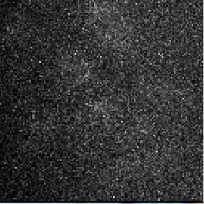

Loc 6-3m lt 1.8 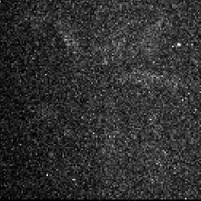

Loc 7-2m

Loc 8-2m

Loc 9 – 3m, 2d lt 1.8 

Loc 10-2m

Loc 11-2m

Loc 12-

Loc13-

Loc14-

Loc15-

Loc16-

Loc17-

Loc18-

Loc19-

Loc20 -

Loc21 –

Loc22-

Loc23-

Loc24-

Loc25-

Loc26-

Loc27

AI pos 20 (position – 12- dendritic imaging)

10 im stack 20 aver (77 sec total)

Start with HBSS/0Ca (25mMHEPES) (prepared from HBSS/0Ca (Nick 11.08.19)

After img5 start HBSS/10Calcium 100uM ATP

After 12 Start with HBSS/2Ca

After 19, start recirculating HBSS/2Ca

Img 46 end (was recorded for 60 minutes0



