07.12.19 NO071219A mlsn2b-ires-mChCamK calyculin and lacrunculin

cells are~ 30% confluency, 1DAT

Laser Calibration 930 nm (2012mW at the laser screen, software)-

4%=0.38mW

5%=0.51mW

6%=0.63mW

7%=0.76mW

8%=0.88mW

9%=1.0mw

10%=1.13mW

11%=1.27mW

12%=1.38mW

13%=1.50mW

14%=1.62mW

15%=1.74mW

16%=1.86mW

17%=2.0mW

18%=2.13mW

19%=2.22mW

Laser Calibration 1010 nm (1005mW at the laser screen, software)-

15% = 0.84mW

16% = 0.88mW

17% = 0.93mW

18% = 0.98mW

19% = 1.05mW

20% = 1.14mW

21% = 1.16mW

22% = 1.23mW

23% = 1.27mW

24% = 1.35mW

25% = 1.42mW

Laser 1010 25%

(lp10%) 128x128; Aver =20, 10x1um stack

Loc1- 1mid

Loc2- 1mid translocated?

Loc3- 1dim

Loc4- 1mid good

Loc5- 1mid good, lt=2.88

Loc6- 1bright

Loc7- 1bright good, z3, lt=3

Loc8- 1mid/bright good, z3, lt=3,13

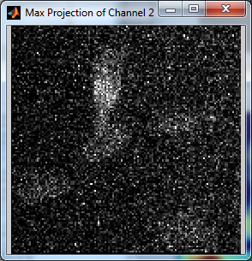

Loc9-

Loc10-

Loc11

Loc12-

Loc13-

Loc14-

Loc15-

Loc16-

Loc17-

Loc18-

Loc19-

Loc20-

B

AI pos 1

Start with HBSS/2mMCalcium (25mMHEPES) (prepaired from HBSS/0Ca (Nick 6..19) by addition of 100uM of 1 M Ca in 50 ml of HBSS/0Ca

After img5 start HBSS /2mMCa with ionomycin ( fresh 10uM) w/ caly/lacr. The solution was washing out (no recirc)

After img11 start 1mMEGTA/3.57mMCa+ w/ caly/lacr. The solution was washing out ;

After img19 the solution started circulation

Im 35 - end

