Quarto Document

Igor Dimitrov

2023-10-27

Table of contents

## 1 Colors

* Red
* Green
* Blue

## 2 Shapes

* Square
* Circle
* Triangle

## 3 Textures

* Smooth
* Bumpy
* Fuzzy

Einsteins’s theory of of special relativity that expresses the equivalence of mass and energy:

$E=mc^{2}$

## 4 Overview

See Figure 1 in Section 5 for a demo of a simple plot

## 5 Plot

import matplotlib.pyplot as plt  
plt.plot([1, 23, 2, 4])  
plt.show()

|  |
| --- |
| Figure 1: Simple Plot |

## 6 Equation

$$s=\sqrt{\frac{1}{N−1}\sum_{i=1}^{N}{\left(x_{i}−{\overline{x}}^{2}\right)}} \left(1\right)$$

|  |
| --- |
| Note |
| Note that ther are five types of callouts, including: note, tip, warning, caution, and important. |

## 7 Placing Colorbars

Colorbars indicate the quantitative extent of image data. Placing in a figure is non-trivial because room needs to be made for them. The simplest case is just attaching a colorbar to each axes:[1].

import matplotlib.pyplot as plt  
import numpy as np  
  
fig, axs = plt.subplots(2, 2)  
fig.set_size_inches(20, 8)  
cmaps = ['RdBu_r', 'viridis']  
for col in range(2):  
 for row in range(2):  
 ax = axs[row, col]  
 pcm = ax.pcolormesh(  
 np.random.random((20, 20)) * (col + 1),  
 cmap=cmaps[col]  
 )  
 fig.colorbar(pcm, ax=ax)  
plt.show()

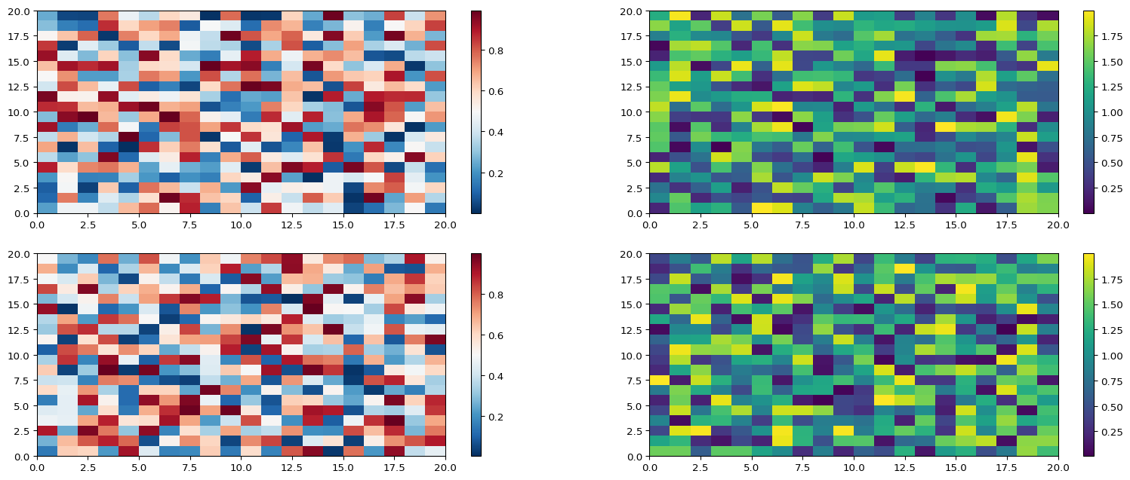

1. See the [Matplotlib Gallery](https://matplotlib.org/stable/gallery/subplots_axes_and_figures/colorbar_placement.html) to explore colorbars further