**Homework** 1:

Find the minimized value of the following function:

$$f\left(x\right)=\sin{(2πx)}+\frac{1}{2}\sin{(6πx)}+\frac{1}{2}cos{(10πx)}, x∈[0,1]$$

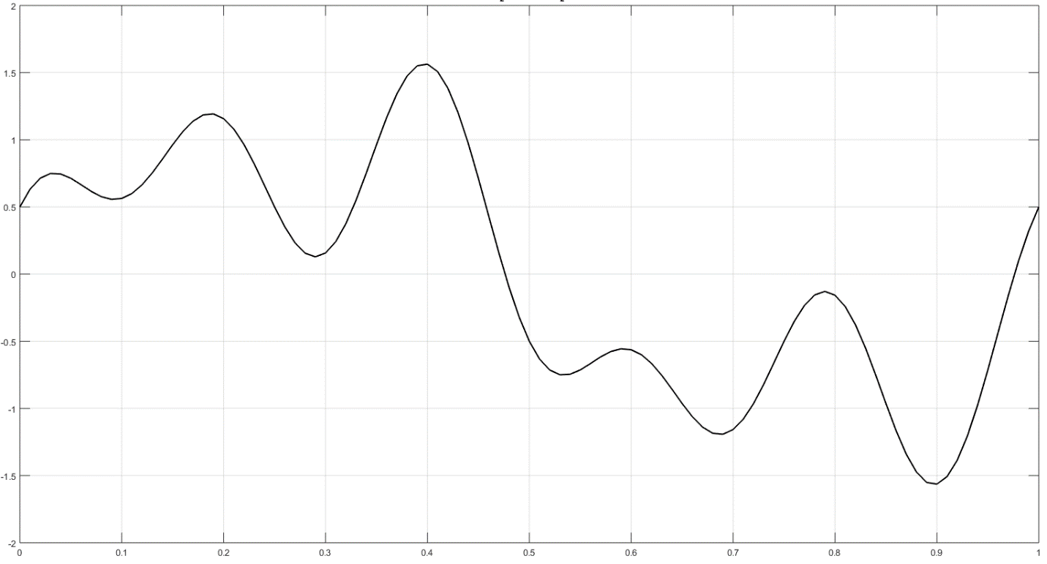

**Solution I** ($∇descent$):

$$dy(i)=∇f\left(x_{i}\right)=-5π\sin\left(10πx_{i}\right)+3π\cos\left(6πx_{i}\right)+2π\cos{(2πx_{i})}$$

|  |  |
| --- | --- |
| $$x_{i+1}=x_{i}+Δx_{i}=x_{i}-α∇f\left(x_{i}\right),$$ | $$α∈\left\{0.001, 0.01, 0.1, 1\right\}$$ |
|  | $$x_{0}=\{0.1, 0.5, 0.9\}$$ |

**Code** in Matlab:

% plot y=f(x)

x=0:0.01:1;

y=sin(2*pi()*x)+0.5*sin(6*pi()*x)+0.5*cos(10*pi()*x);

plot(x,y,'k','LineWidth',1.5)

xlabel('x')

ylabel('y')

title('sin(2\pix)+^{1}/_{2}sin(6\pix)+^{1}/_{2}cos(10\pix)')

grid on

clear x y

%solve

learning_rate_Array = [0.001, 0.01, 0.1, 1];

x0_Array = [0.1, 0.4, 0.9]

iterations = 1000

for i_x0 = 1:numel(x0_Array)

for i_alpha = 1:numel(learning_rate_Array)

learning_rate = learning_rate_Array(i_alpha);

x(1)=x0_Array(i_x0);

epsilon = 0.0001;

for i=1:iterations

dy(i)=-5*pi()*sin(10*pi()*x(i))+3*pi()*cos(6*pi()*x(i))+2*pi()*cos(2*pi()*x(i));

if abs(dy(i)) <= epsilon

y(i)=sin(2*pi()*x(i))+0.5*sin(6*pi()*x(i))+0.5*cos(10*pi()*x(i));

[n,xx,yy,dyy] = deal(i,x(i),y(i),dy(i));

disp(['Results for x0 = ', num2str(x(1)), ', alpha = ', num2str(learning_rate) ...

': n = ', num2str(n), ', ', 'xx = ', num2str(xx), ...

', ', 'yy = ', num2str(yy), ', ', 'dyy = ', num2str(dyy)])

break

else

x(i+1)=x(i)-learning_rate*dy(i);

y(i)=sin(2*pi()*x(i))+0.5*sin(6*pi()*x(i))+0.5*cos(10*pi()*x(i));

end

if x(i+1) < 0 || x(i+1) > 1 %range of function

y(i)=sin(2*pi()*x(i))+0.5*sin(6*pi()*x(i))+0.5*cos(10*pi()*x(i));

[n,xx,yy,dyy] = deal(i,x(i),y(i),dy(i));

Disp(…)

break

end

if i == iterations

disp(…)

end

end

end

end

**Output**:

Results for x0 = 0.1, alpha = 0.001: n = 31, xx = 0.092627, yy = 0.55539, dyy = 8.8748e-05

Results for x0 = 0.1, alpha = 0.01: no results found in 1000 iterations

Results for x0 = 0.1, alpha = 0.1: n = 1, xx = 0.1, yy = 0.56331, dyy = 2.1708

Results for x0 = 0.1, alpha = 1: n = 1, xx = 0.1, yy = 0.56331, dyy = 2.1708

Results for x0 = 0.4, alpha = 0.001: n = 34, xx = 0.5338, yy = -0.75184, dyy = -9.5392e-05

Results for x0 = 0.4, alpha = 0.01: no results found in 1000 iterations

Results for x0 = 0.4, alpha = 0.1: n = 2, xx = 0.61708, yy = -0.64353, dyy = -7.089

Results for x0 = 0.4, alpha = 1: n = 1, xx = 0.4, yy = 1.5633, dyy = -2.1708

Results for x0 = 0.9, alpha = 0.001: n = 10, **xx = 0.89682, yy = -1.5668**, dyy = 7.4361e-05

Results for x0 = 0.9, alpha = 0.01: no results found in 1000 iterations

Results for x0 = 0.9, alpha = 0.1: n = 3, xx = 0.84432, yy = -0.84361, dyy = -21.1726

Results for x0 = 0.9, alpha = 1: n = 1, **xx = 0.9, yy = -1.5633**, dyy = 2.1708

When $x∈ R$ instead of $x∈[0,1]$ gradient descent converged only in case of learning rate value $α=0.001$ depending on initial point in 31, 34 and 10 iterations pointing to local minima $f\left(0.09\right)=0.55$, $f\left(0.53\right)=-0.75$, $f\left(0.90\right)=-1.56$. **Other than that gradient descend did not converge**.

* Gradient descent method does not guarantee global minimum of function**,** only **local minimum** in case of convergence.

**Solution II** ($GA (fitness evaluation only)$):

Code is roughly the same as in the slides, only fitness function is slightly different:

function PI = GA_fitfun(chro)

global MIN_offset

MIN_offset = 10;

x = chro(1);

y = sin(2*pi()*x)+0.5*sin(6*pi()*x)+0.5*cos(10*pi()*x);

PI = MIN_offset - y;

Because GA doesn’t generate new population by crossover, GA is initialized with a rich set of solutions (initial population is 1000)

**Result**:

Real value of chromosome with the highest fitness value is **0.8980** which is indeed close to **global minimum** of function ($x_{min}=0.8968$)