# Homework 4 <GRAY CODE>

Find the decimal value of the gray code:

**Answer**:

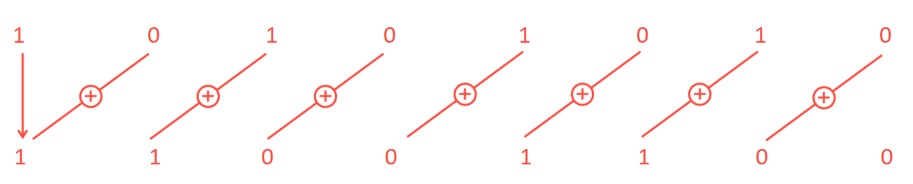

**Matlab implementation**:

gray_code=[1 0 1 0 1 0 1 0];

binary_code=zeros(size(gray_code));

binary_code(1) = gray_code(1);

decimal = binary_code(1) * 2^(length(binary_code)-1);

for i=2:length(gray_code)

binary_code(i) = xor(gray_code(i),binary_code(i-1)) ;

decimal = decimal + binary_code(i) * 2^(length(binary_code)-i);

end