**Homework 5**:

(1) If the Temperature is 78 for the fuzzy heating machine, then Gas?

(2) Determine the washing time by means of the degree of dirty and the power of flow. (D=60. F=35. T=?)

For the homework I used mam21 program:



Under Edit tab I entered all the FIS Properties, Membership Functions and Rules required by the two models of the homework.

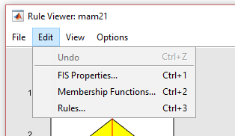

I used the following methods for fuzzy reasoning and deffuzification:

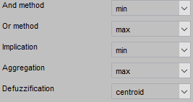

For membership functions I used trapmf and trimf shapes depending on the membership.



Setting up the rules using Rule Editor in mam21 program was easy and very intuitional because of using the linguistic values and variables:

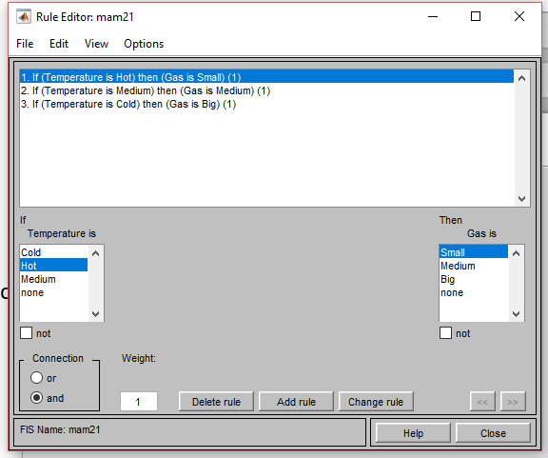

Using this procedure I derived two models in mam21 program to obtain the results:

1)

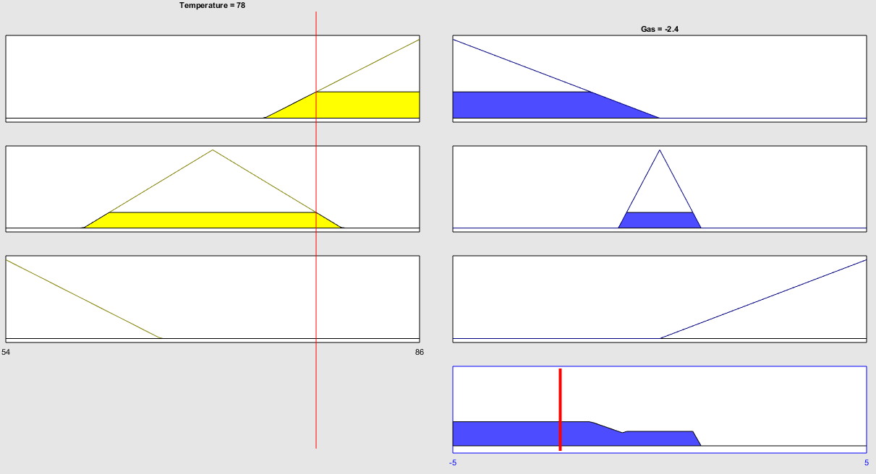

Gas = -2.4

2)

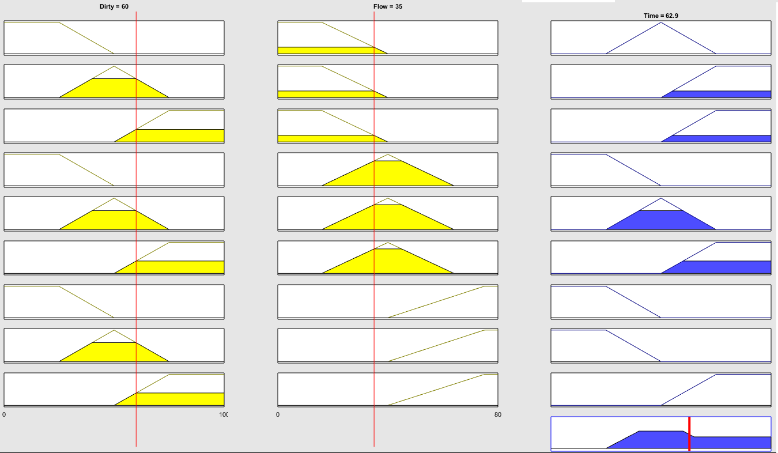

T = 62.9