# Project 3

Find the optimal PID controller for the system $G\left(s\right)=\frac{5}{s^{2}+s-6}$ with step input such that the following specs are satisfied:

1. Maximum overshoot < 20%
2. Settling time < 2 s
3. Steady-state error = 0
4. Maximum u < 20

**Answer**:

Best parameters found:

**Kp**=19.6436

**Ki**=19.0953

**Kd**=3.2558

**Results**:

Method A

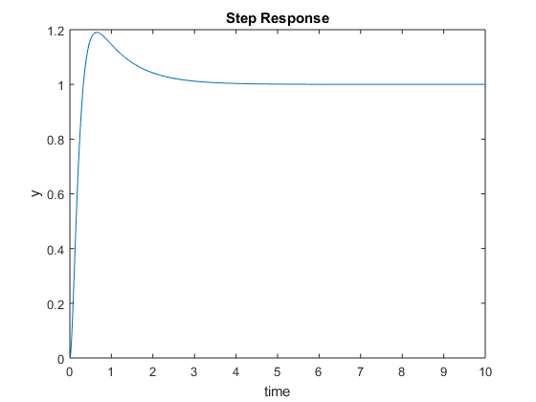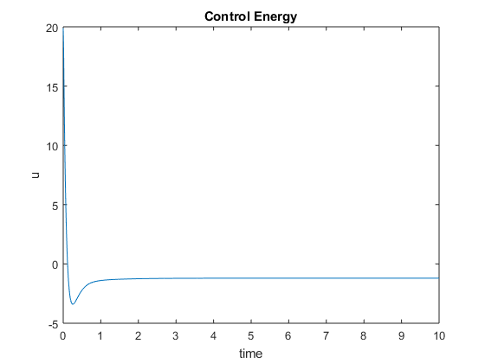

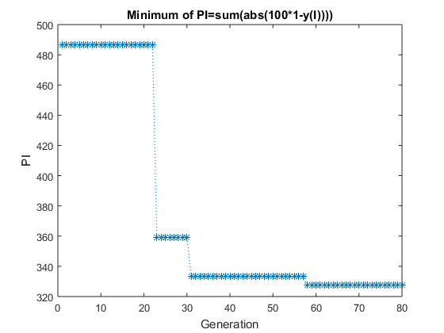

Results for:

popu_size=400;

bit_length=40;

gene_no=3;

range=[0 0 0; 20 20 20];

fitfcn='GA_fitfun_P3PID';

generation_no=100;

crossover_rate=0.4;

mutate_rate=0.08;

elite=1;

The settling time exceeded 2 s for all the Kp, Ki, Kd found in extensive search for optimal parameters. During the search various combinations of initial parameters of genetic algorithm were tried but none of the result satisfied settling time requirement. Results presented in the answer were the best found Kp, Ki, Kd.

Kp=19.8950

Ki=18.2856

Kd=3.4478

Method B:

For another method I changed initial population in the following manner:

* Generate initial population of size *popu_size_init*
* Set initial population to *popu_size* best genes of initial population (popu=initpopu(1:popu_size,:))
* Start genetic algorithm as in GA_genetic.m

So the change in GA_genetic.m was:

initpopu=GA_initpopu(popu_size_init, bit_length, gene_no);

[fitness, popu_real, initpopu] = GA_fitpopu(initpopu, bit_length, range, fitfcn);

popu=initpopu(1:popu_size,:);

Initial parameters:

popu_size_init=3000;

popu_size=50;

bit_length=60;

gene_no=3;

range=[0 0 0; 20 20 20];

fitfcn='GA_fitfun_P3PID';

generation_no=100;

crossover_rate=0.8;

mutate_rate=0.25;

elite=1;

While this change in genetic algorithm did not make computation time much longer (because fitness for the large initial population of 3000 was calculated only once, later population size was only 50), it provided much better results:

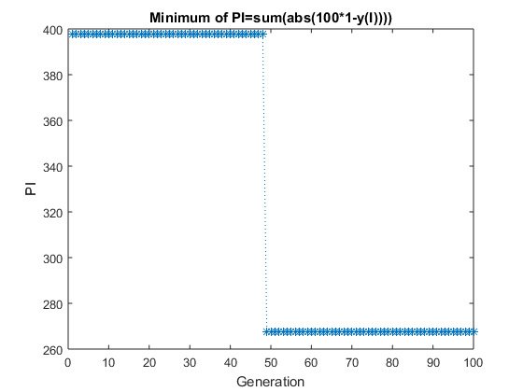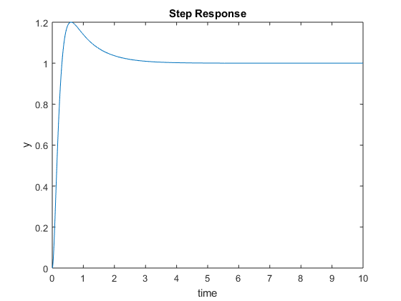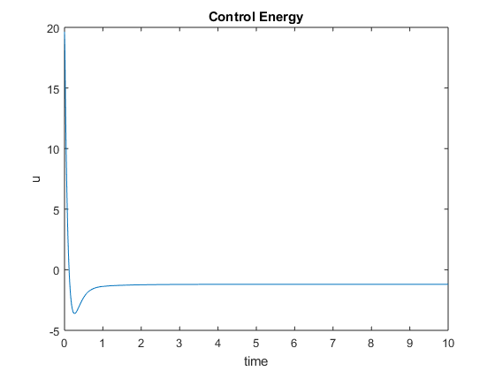

Kp=19.6436

Ki=19.0953

Kd=3.2558

Changing range of Kp, Ki, Kd to larger made settling time better, however because large Kp, Ki, Kd were found, maximum control energy exceeded the limit of 20 a lot.

**Simulink Model:**

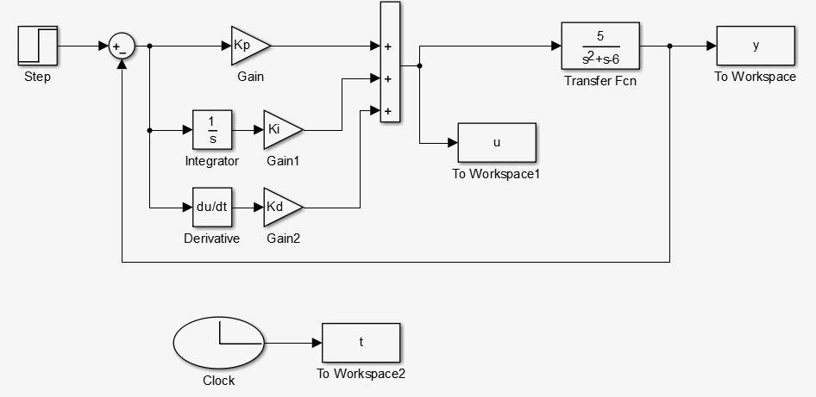

**Fitting Function:**

function PI = GA_fitfun_P3PID(chro)

global MIN_offset Kp Ki Kd t y

MIN_offset = 10000;

Kp = chro(1);

Ki = chro(2);

Kd = chro(3);

sim('P3GPID');

I=find(t>2);

z=sum(abs(100*(1-y(I))));

if max(y)>1.20

z=z+1000;

end

if max(u)>20

z=z+1000;

end

PI=MIN_offset-z;