# Project 3

Find the optimal PID controller for the system $G\left(s\right)=\frac{5}{s^{2}+s-6}$ with step input such that the following specs are satisfied:

1. Maximum overshoot < 20%
2. Settling time < 2 s
3. Steady-state error = 0
4. Maximum u < 20

**Answer**:

Best parameters found:

Kp = 310.5358 Ki = 494.0308 Kd = 14.0728

(least steady-state error, maximum |u| exceeding 8

**Simulink Model:**

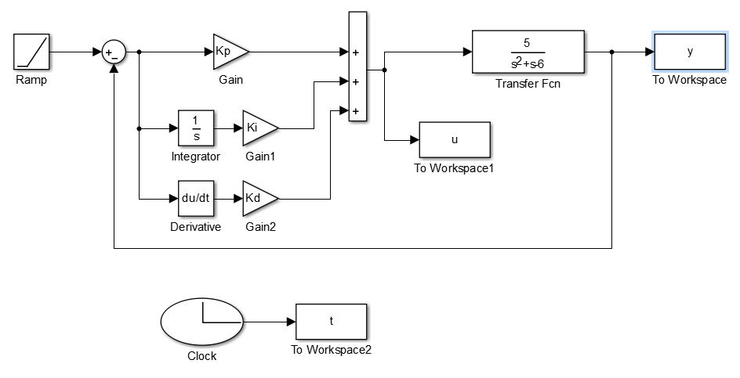

**Fitting Function:**

function PI = GA_fitfun_P4PID(chro)

global MIN_offset Kp Ki Kd

MIN_offset = 100000;

Kp = chro(1);

Ki = chro(2);

Kd = chro(3);

sim('P4GPID');

error_ss=-6/(5*Ki);

z = 100*max(abs(u));

if abs(error_ss) > 0.1

z=z+1000;

end

PI=MIN_offset-z;

I decided to assess the results according to the maximum energy they have and only penalize for exceeding steady-state error. Because of the dynamics of the system, it was easy not to exceed steady-state error, but I could not find parameters for which maximum control energy wasn’t exceeded.

To solve this problem, I tried different methods: at first I minimized with respect to error_ss, then I varied penalty values, assessed according to sum(abs(u)), etc. but none of the methods gave significantly better results.

**Steady-state error:**

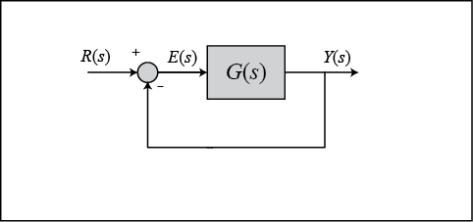

For the given system G(s) is:

$$G\left(s\right)=(K_{p}+K_{i}s^{-1}+K_{d}s)(\frac{5}{s^{2}+s-6})$$

For the system as shown in the figure above, steady-state error for unit-ramp input is given as:

$$e_{ss}=\lim_{s→0}{\frac{s}{1+G\left(s\right)}\frac{1}{s^{2}} }=\lim_{s→0}{\frac{1}{sG\left(s\right)} }$$

For the given system steady-state error will be:

$$e_{ss}=\lim_{s→0}{\frac{1}{sG\left(s\right)}}=\lim_{s→0}{\frac{s^{2}+s-6}{5s(K_{p}+K_{i}s^{-1}+K_{d}s)}=-\frac{6}{5K_{i}}}$$

**Results**:

PI=100*max(abs(u))

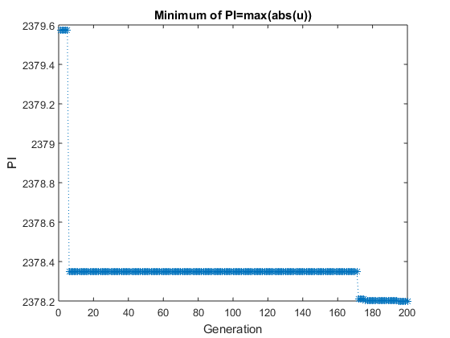

Even for big number of iterations 100*maximum of |u| hardly decreased at all.

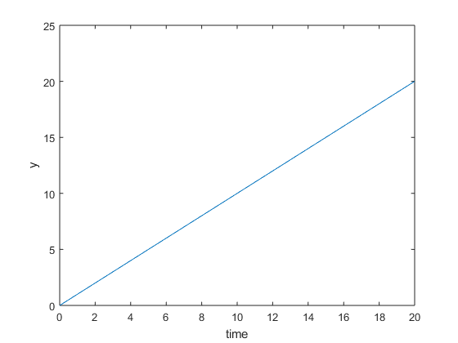

For most of results I got when varying initial parameters of Genetic Algorithm, error_ss was 0.

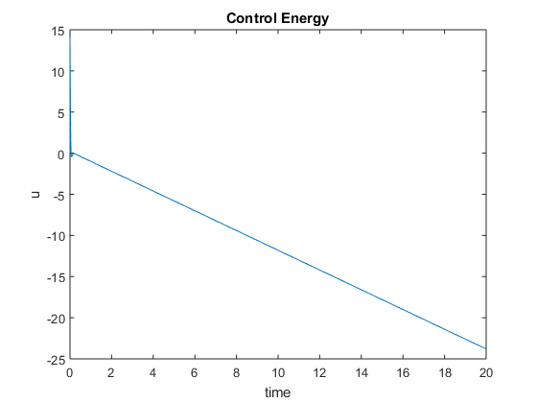

However, I could not achieve max(abs(u)) smaller than 8. In fact, control energy grew proportionally to the ramp input.

To be sure, that there are no parameters that satisfy the control energy requirement, I sampled the solution space densely by initializing and assessing population of 100000 for which the result also did not satisfy control energy requirement.