# Project 3

Find the optimally robust PID controller for the system $G\left(s\right)=\frac{aa}{s^{2}+bbs-cc}$ with step input such that the following specs are satisfied:

1. Maximum overshoot < 25%
2. Settling time < 2.5 s
3. Steady-state error = 0
4. Maximum u < 30

**Answer**:

Best parameters found:

**Kp =** 20.2184

**Ki =** 19.7948

**Kd =** 7.3131

**Results**:

For this task I initialized GA with the following parameters:

popu_size=30;

bit_length=40;

gene_no=3;

range=[0 0 0; 30 30 30];

fitfcn='GA_fitfun_P5PID';

generation_no=50;

crossover_rate=0.8;

mutate_rate=0.02;

elite=1;

Optimal Kp, Ki, Kd were found in 46th generation.

Fitness across generations:

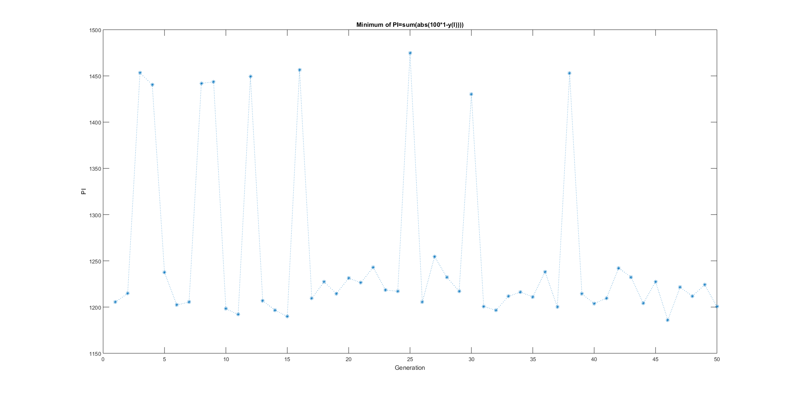

The graph above resembles graph of fitness for GA without elitism. This is because fitness function is calculated for random aa, bb, cc, so for the fittest gene fitness value will be different in two evaluations:

aa=5+2*(rand-0.5)*2;

bb=1+1*(rand-0.5)*2;

cc=6+2*(rand-0.5)*2;

Variation of fitness value is very visible in comparison to example in 3-3 because I did not assign different weights for different cases of a, b, c (in example 3-3 for a=400, b=300, c=200 there was weight of 20 assigned in line 40: z=z+20*sum(abs(100*(1-y(I))))). Assigning different weights yielded worse results.

Step response:

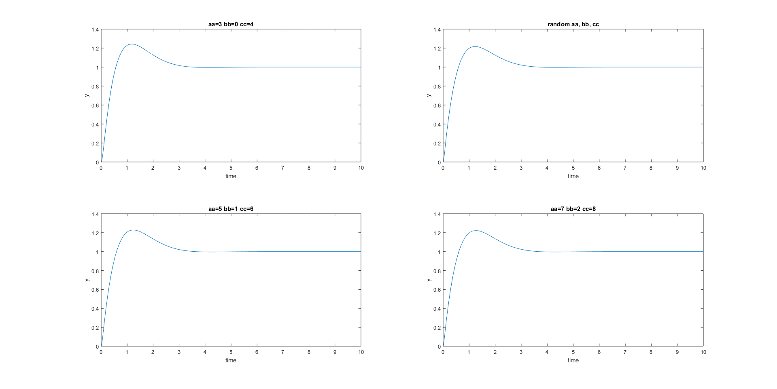

Control energy:

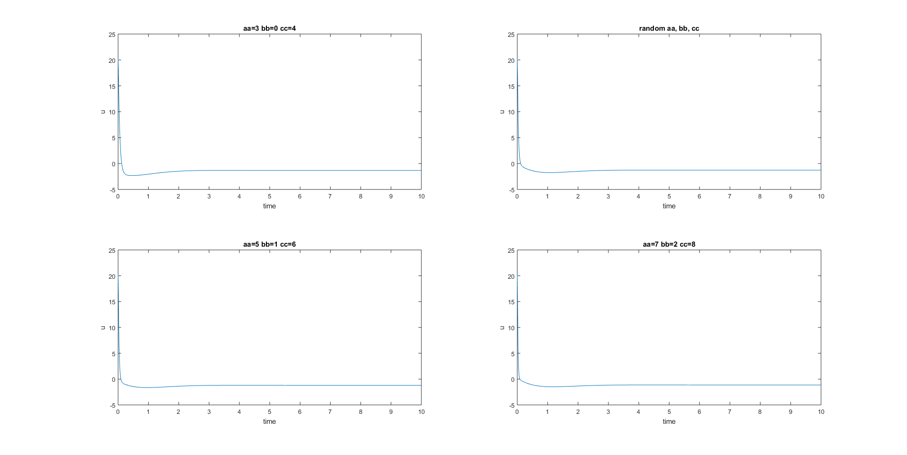

**Simulink Model:**

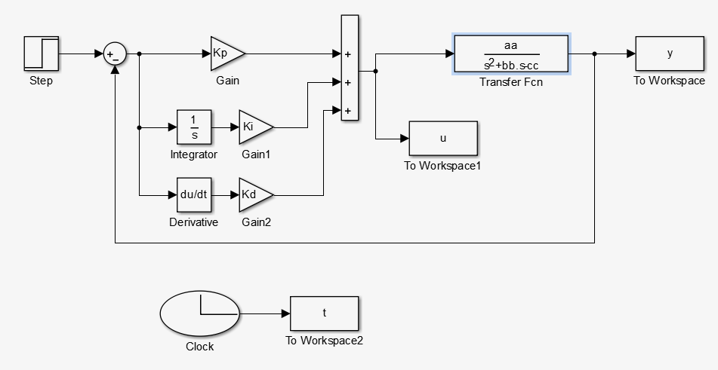

**Fitting Function:**

Analogically to examples 3-3 (summing up z for different a, b, c) and 3-2 (penalizing for exceeding max u and overshoot):

function PI = GA_fitfun_P5PID(chro)

global MIN_offset Kp Ki Kd t y aa bb cc

MIN_offset = 20000;

Kp = chro(1);

Ki = chro(2);

Kd = chro(3);

aa=3;

bb=0;

cc=4;

sim('P5GPID');

I=find(t>2.5);

z=sum(abs(100*(1-y(I))));

if max(y)>1.25

z=z+1000;

end

if max(u)>30

z=z+1000;

end

aa=5+2*(rand-0.5)*2;

bb=1+1*(rand-0.5)*2;

cc=6+2*(rand-0.5)*2;

sim('P5GPID');

I=find(t>2.5);

z=z+sum(abs(100*(1-y(I))));

if max(y)>1.25

z=z+1000;

end

if max(u)>30

z=z+1000;

end

aa=5;

bb=1;

cc=6;

sim('P5GPID');

I=find(t>2.5);

z=z+sum(abs(100*(1-y(I))));

if max(y)>1.25

z=z+1000;

end

if max(u)>30

z=z+1000;

end

aa=7;

bb=2;

cc=8;

sim('P5GPID');

I=find(t>2.5);

z=z+sum(abs(100*(1-y(I))));

if max(y)>1.25

z=z+1000;

end

if max(u)>30

z=z+1000;

end

PI=MIN_offset-z;