Problema 1.
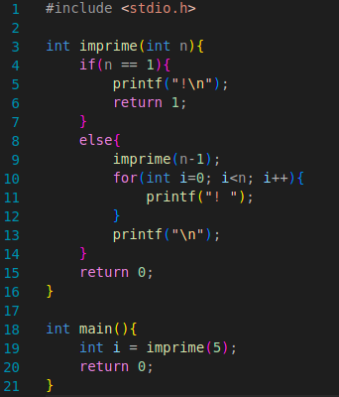

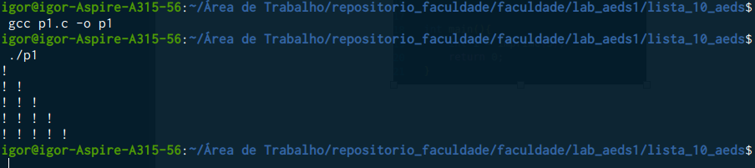
Problema 2.

Problema 3.
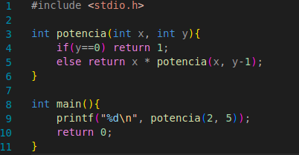

Problema 4.

a)

a se b = 0
MDC(b, a%b) se b > 0

b)
MDC(4032, 1272) = MDC(1272, 216)
MDC(1272, 216) = MDC(216, 192)
MDC(216, 192) = MDC(192, 24)
MDC(192, 24) = MDC(24, 0)
MDC(24, 0) = 24

c)
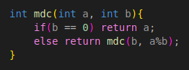

d)

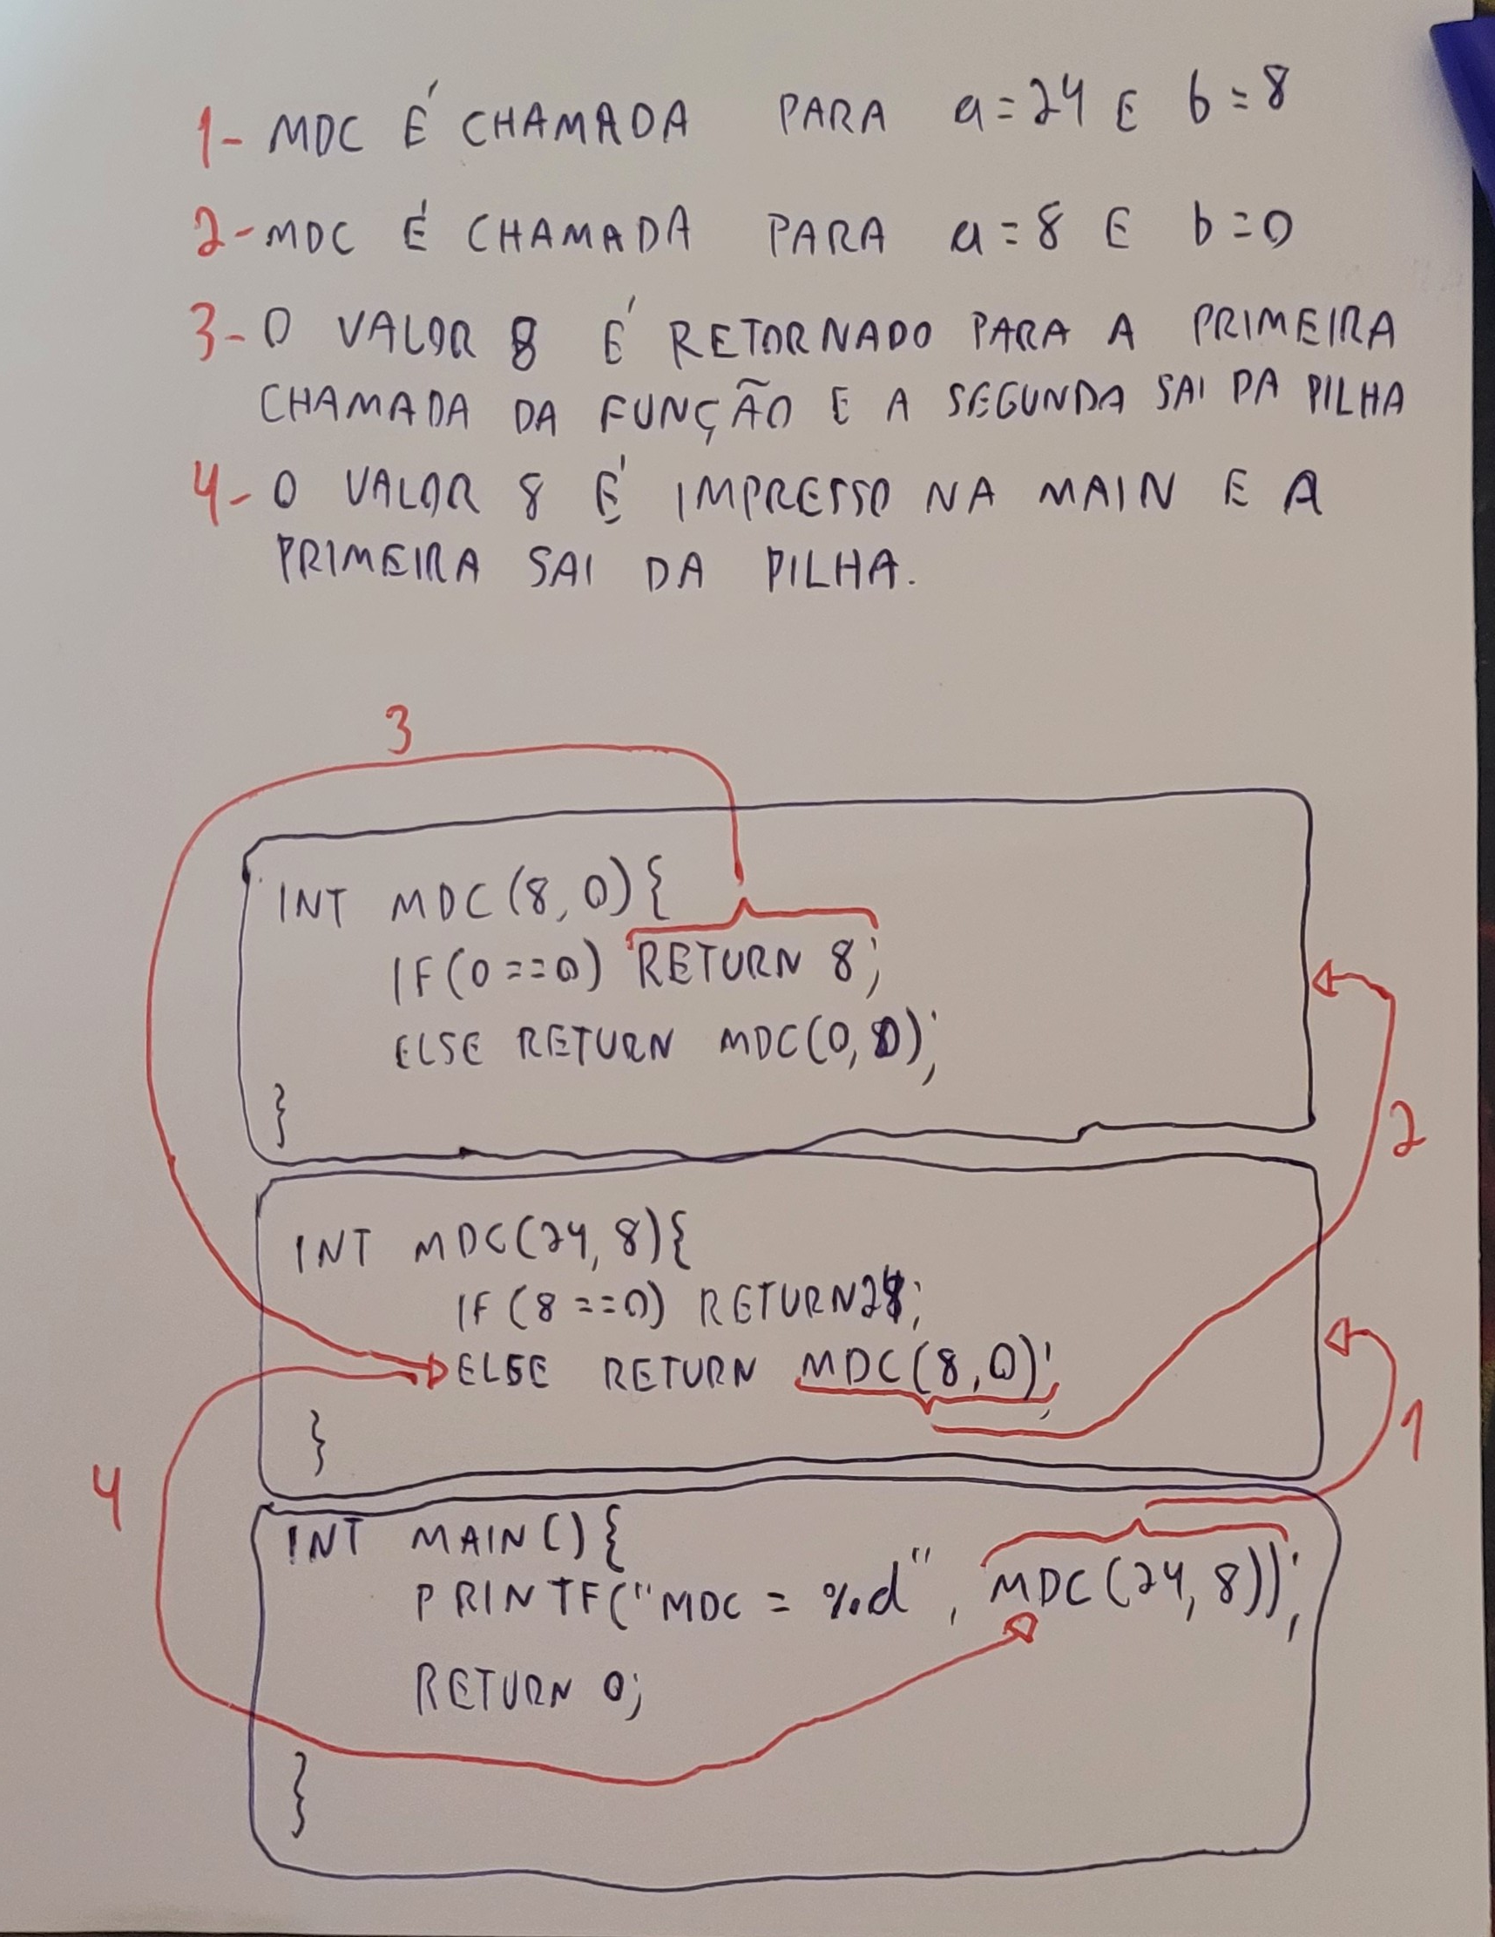

Problema 5.
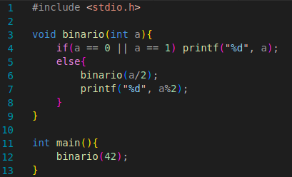

Problema 6.
