Table of Contents

MKD Slidea — User Manual
Interactive live presentations, polls, quizzes & word clouds — for teachers, trainers and event hosts. Platform: slidea.mismath.net · Version: July 2026
Welcome to MKD Slidea, the platform that turns any classroom, training or event into a two-way conversation. This manual walks you through everything — from your first login to running a live session with hundreds of participants responding from their phones.
How to read this manual: Sections 2–6 are for hosts (the person running the session). Section 7 is for participants (the audience). Section 8 covers templates & pricing, and Section 9 gives teaching tips to get the most out of every session.

1. What is MKD Slidea?
MKD Slidea is a real-time audience-engagement platform. As a host, you project a presentation on a screen; your audience joins from any phone or laptop using a short code, and answers polls, quizzes, word clouds, ratings and open questions live. Their responses appear instantly on your screen as animated charts, leaderboards and word clouds.
What you can do with it: - Run 8 types of activities: multiple-choice poll, quiz (with leaderboard), word cloud, open text, star rating, ranking, 1–10 scale, and multi-question surveys. - See live results projected to the room, with a real-time participant counter. - Use your phone as a remote control while the presentation runs on the projector. - Generate questions with AI, aligned to your curriculum. - Reuse and share ready-made templates. - Brand your sessions with your own colors and logo.
No app to install — participants just open a link or scan a QR code.

2. Getting Started

2.1 The landing page
The home page explains the platform and lets participants jump straight into a session by entering a code.
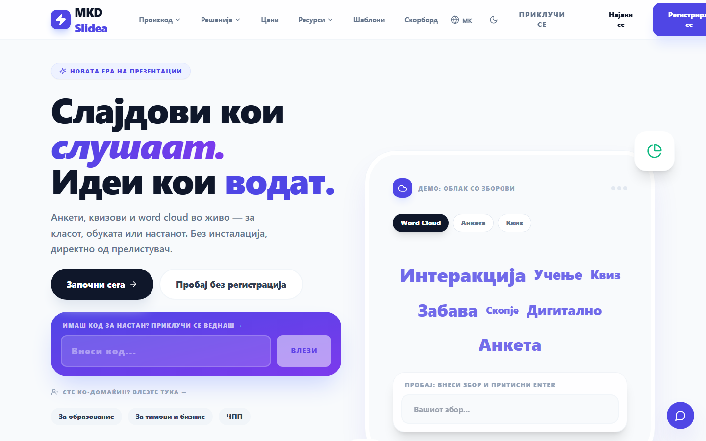
Landing page hero
The landing page. The gradient card on the left lets a participant enter a session code directly; the host signs in from the top-right.

2.2 Signing in
Click Sign in (top-right) to open the login dialog. Enter your email and password, or continue with Google.
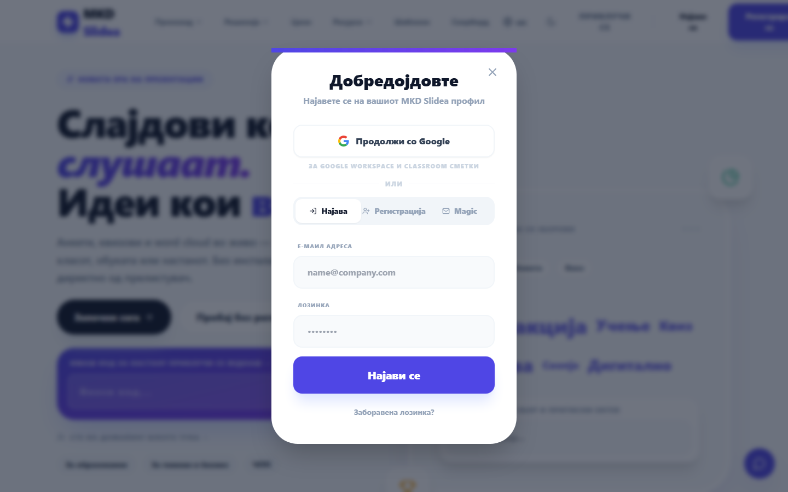
Login dialog
The sign-in dialog supports email/password, Google, and a passwordless Magic Link.
If you don’t have an account yet, switch to the Register tab — it takes a few seconds.

3. Your Dashboard
After signing in you land on the Dashboard, your control center. The left sidebar holds every section.
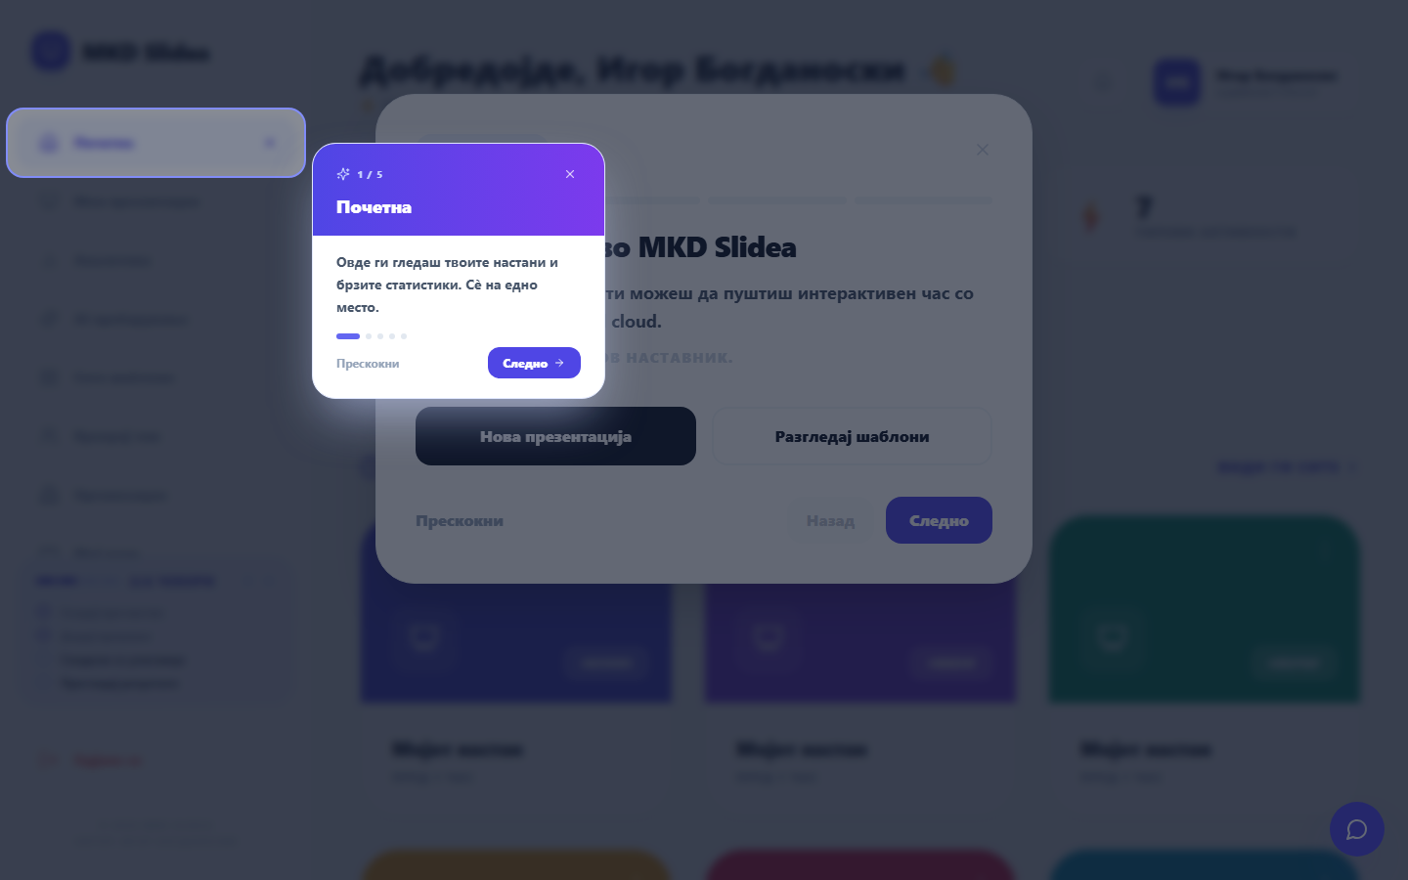
Dashboard home
The Dashboard home shows your recent events, quick actions, and a usage meter for your plan.

3.1 My Presentations
All your events live here. Open any event to manage it, duplicate it, or launch the presenter.
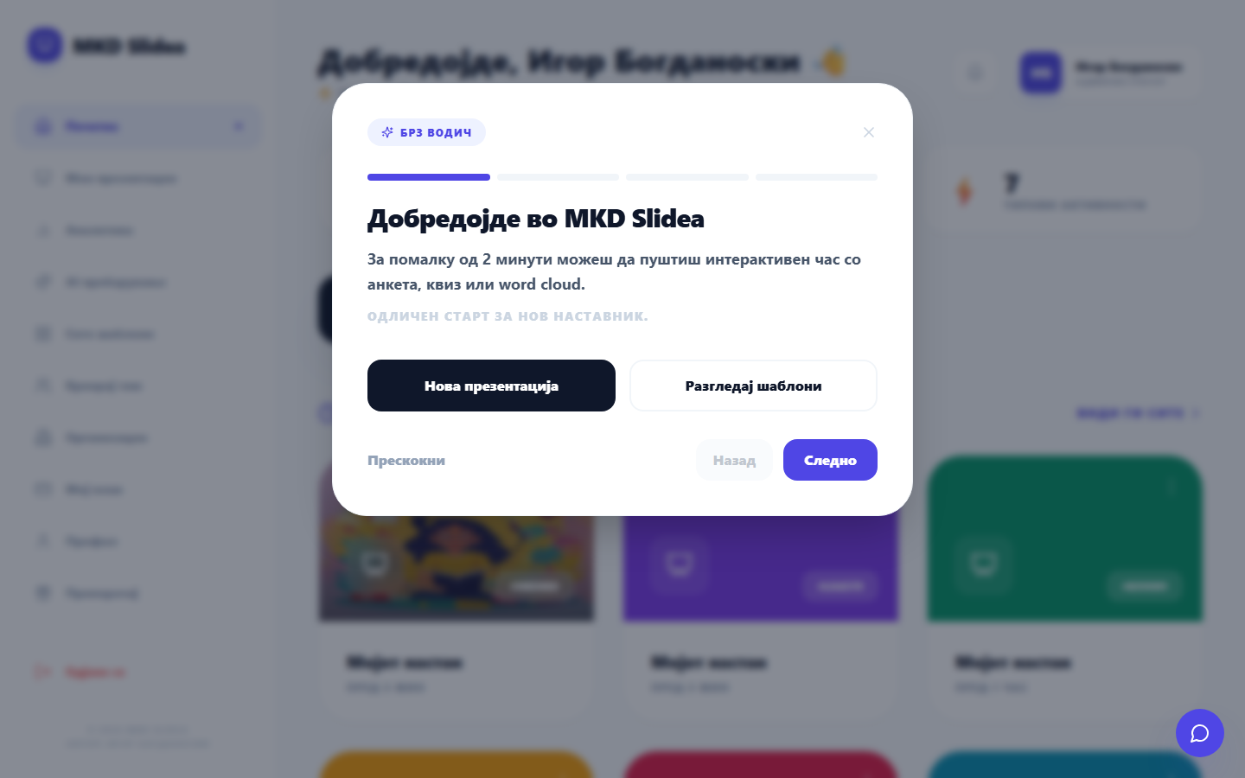
My Presentations

3.2 Analytics
Review how your sessions performed — participation, response rates and trends over time. (Pro feature.)
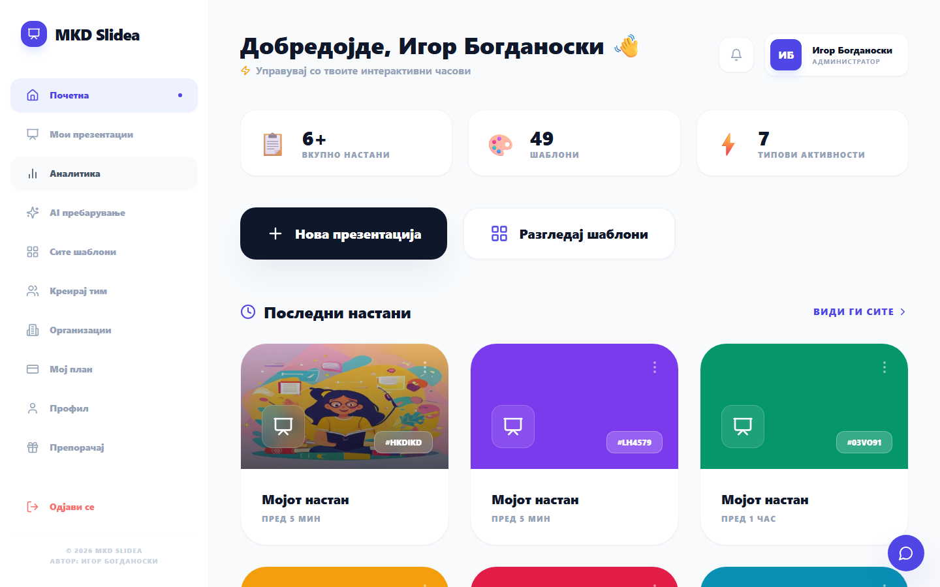
Analytics

3.3 AI Search
Ask a question in plain language and search your curriculum and past content semantically — powered by AI embeddings.
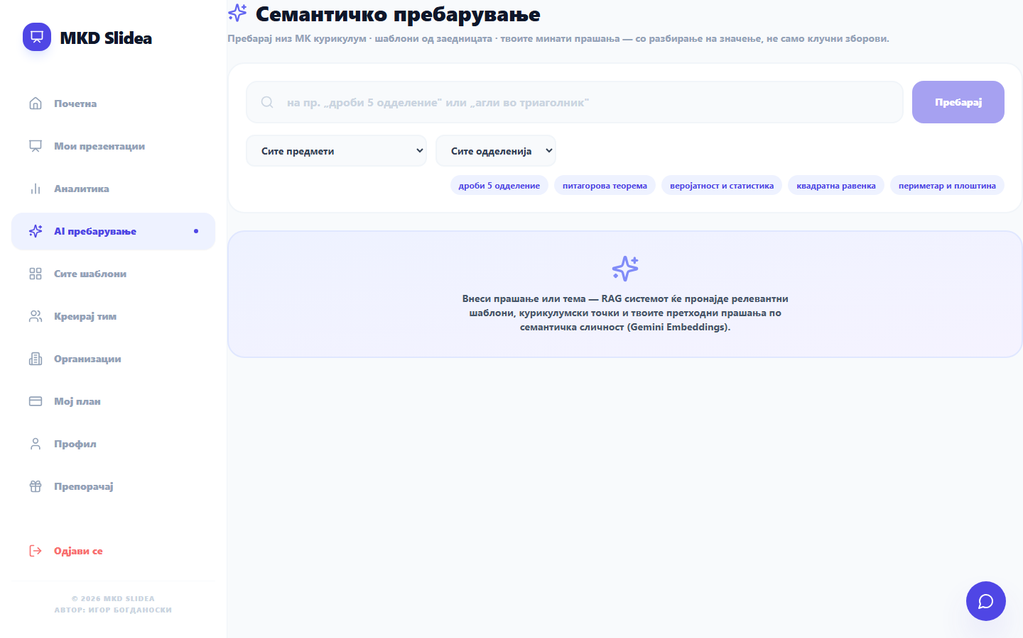
AI Search

3.4 Templates
Browse and apply ready-made templates, or publish your own to the community gallery.
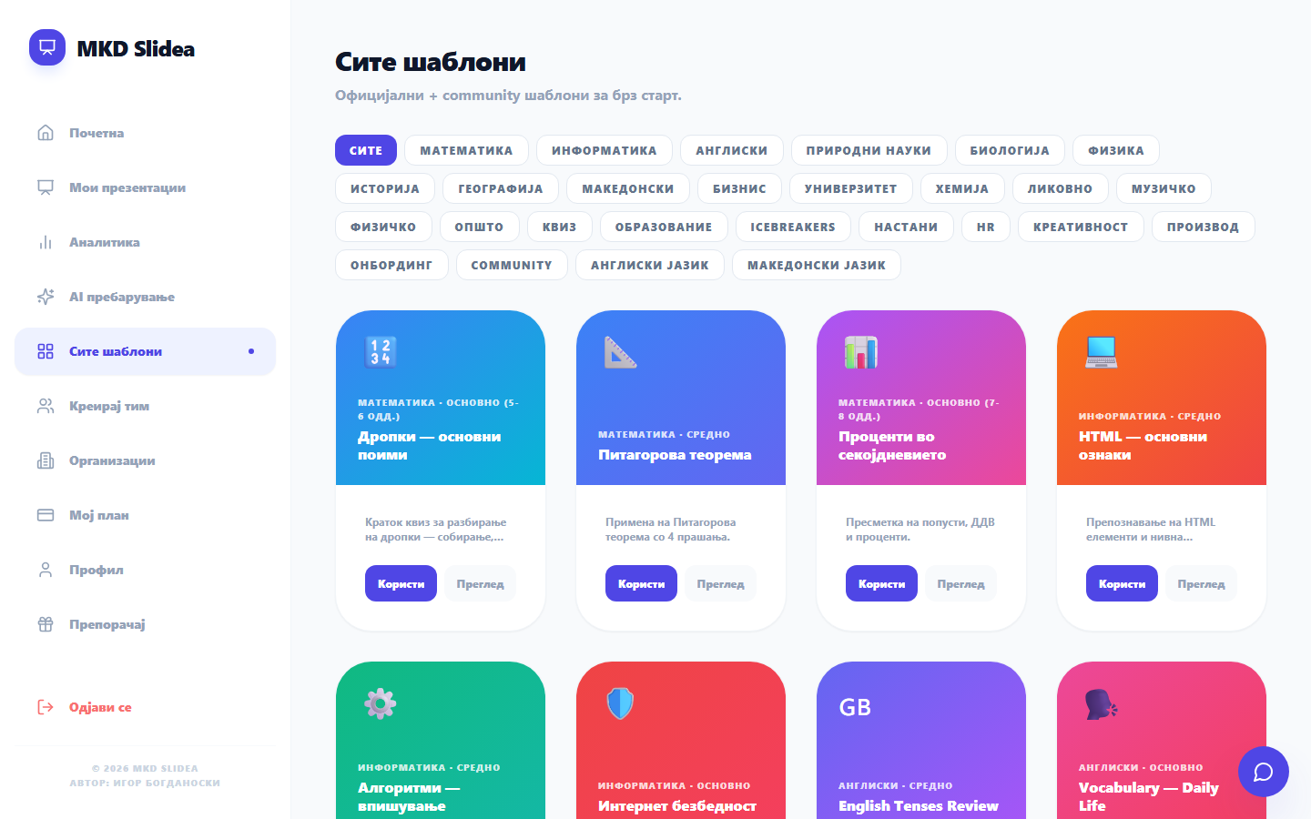
Templates tab

3.5 Organizations & Profile
Organizations lets a school or company connect multiple hosts under one account with shared billing and branding. Profile holds your account details.
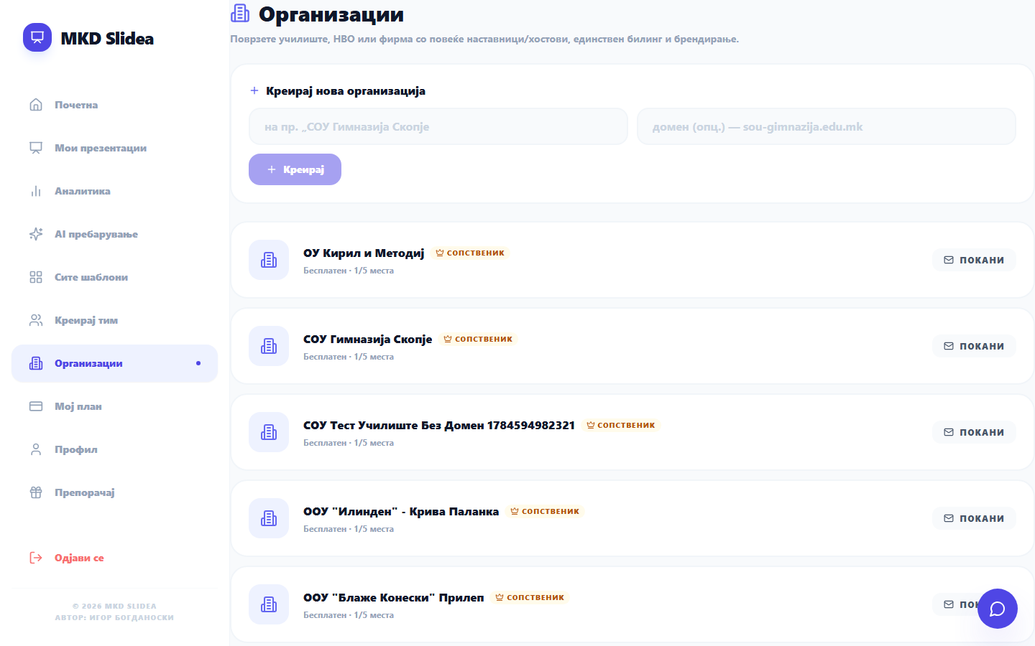
Organizations
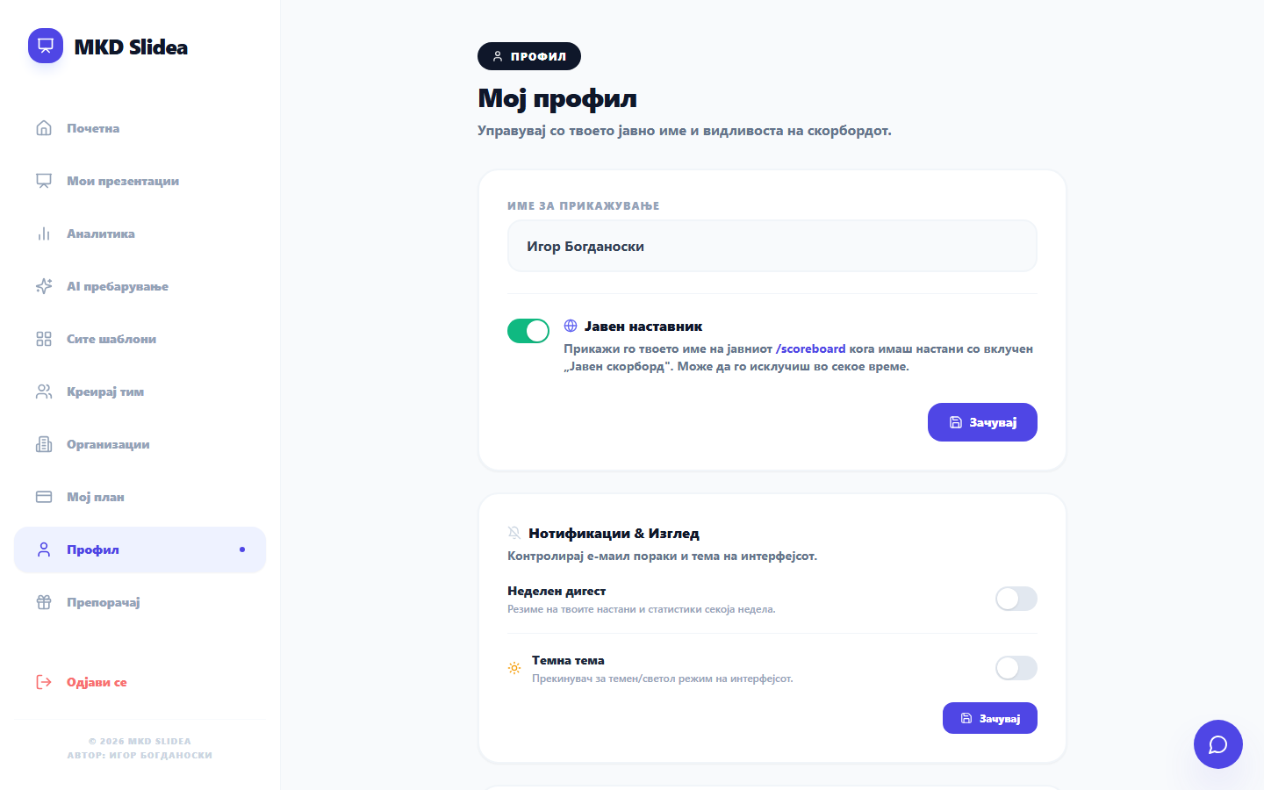
Profile

4. Creating Your First Event
From the Dashboard, click New presentation (or open an existing event). You enter the Host view, where you build and run your session.

4.1 The activity list
Every activity (question) you add appears as a card. Click a card to make it active — that’s what your audience sees and responds to right now.
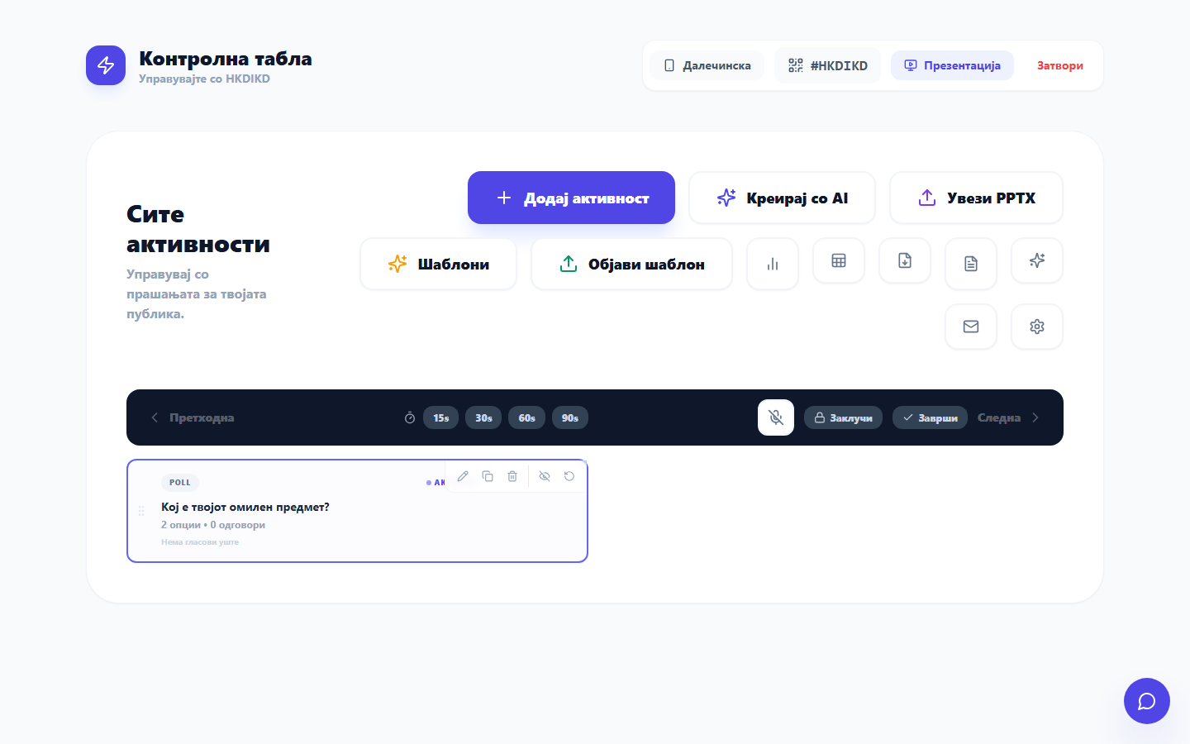
Host activity list
Each card is one activity. The active one is highlighted; click any card to put it on screen.

4.2 Choosing an activity type
Click Add activity to see all 8 activity types. Pick the one that fits your goal.
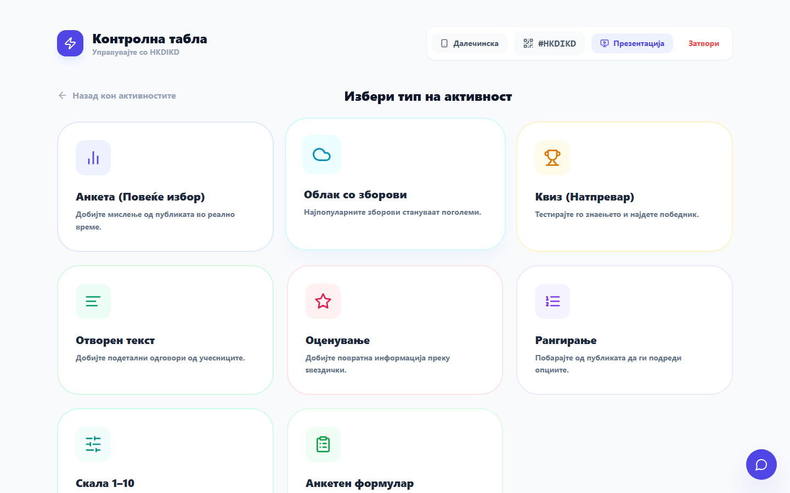
Activity type picker
The eight activity types: poll, word cloud, quiz, open text, rating, ranking, 1–10 scale, and survey form.

5. Adding Activities

5.1 A poll (multiple choice)
Type your question and the answer options, then Save activity.
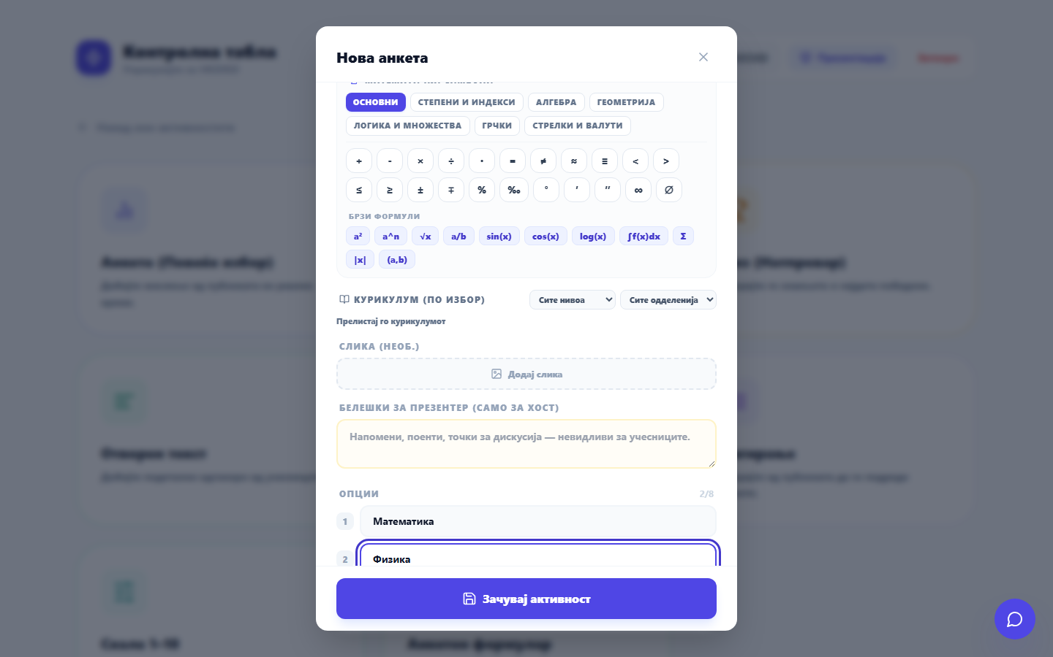
Create a poll

5.2 A quiz (with a correct answer)
Same as a poll, but mark the correct option with the ✓ button. Quizzes give participants instant feedback and build a leaderboard.
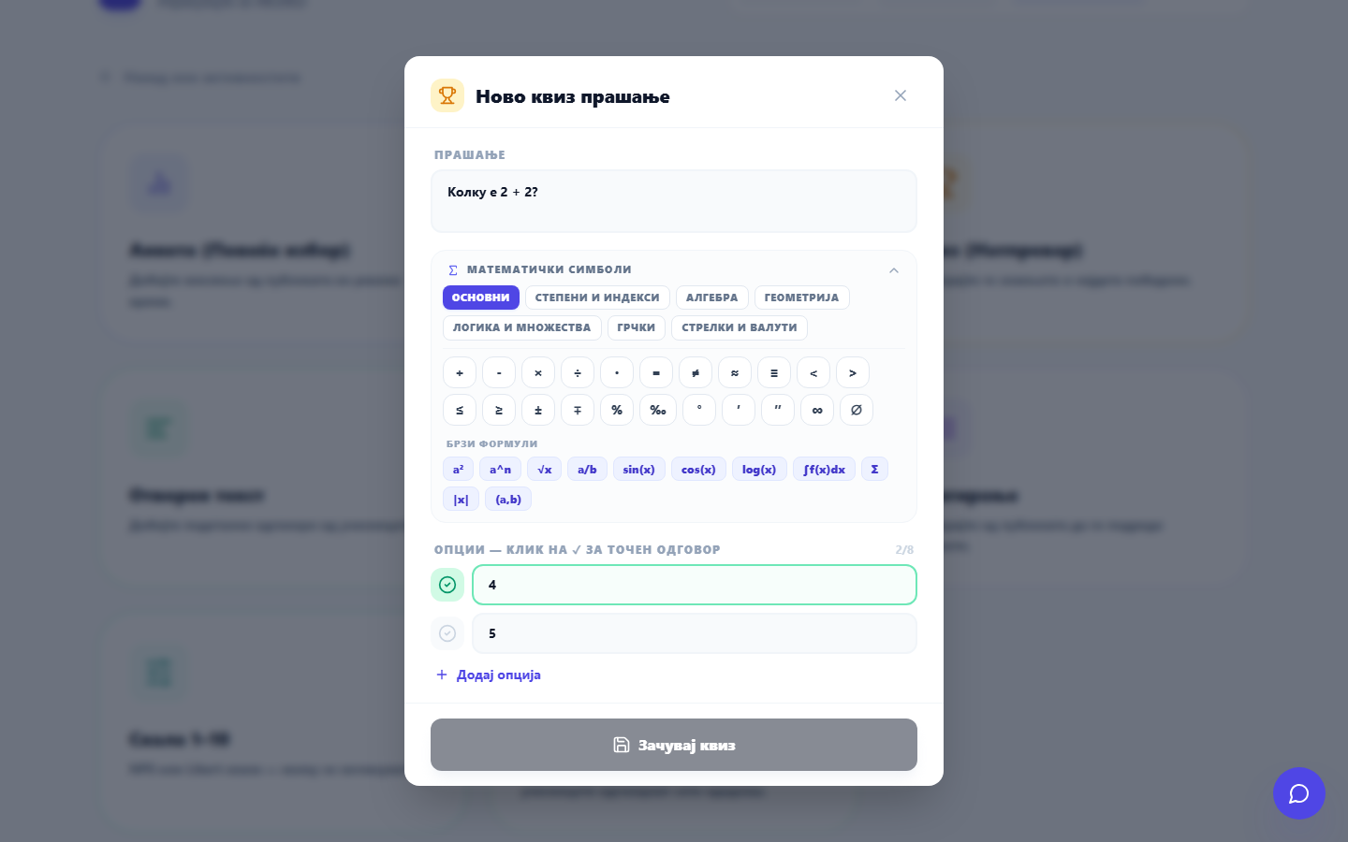
Create a quiz

5.3 Other types
- Word cloud — participants submit single words; the most common grow largest on screen. Great for warm-ups and brainstorming.
- Open text — free-form answers shown as sticky notes.
- Rating — a 1–5 star rating for quick pulse checks.
- Ranking — participants order items by importance (the whole order counts, not just the top pick).
- Scale 1–10 — a slider-style agreement scale.
- Survey — several sub-questions at once (open, scale, or choice).
Tip: You can attach an image to any activity, and let AI suggest or generate the question for you.

6. Event Settings & Branding
Open Settings (gear icon) to control your session: schedule it for later, set a cover image, choose your brand color and font, upload a logo, enable a password, or allow multiple votes per participant.
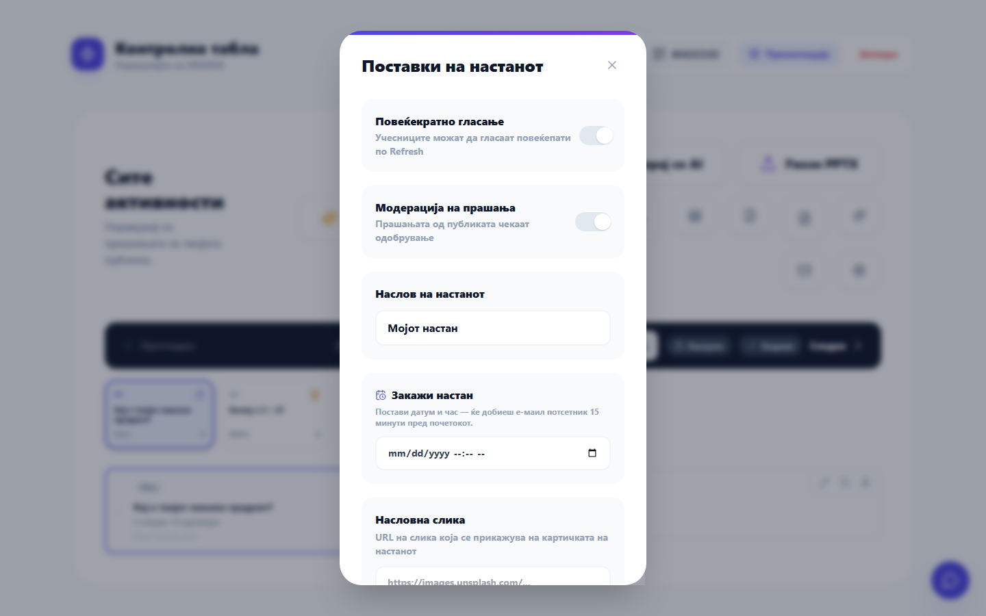
Event settings

7. Going Live — The Presenter View
Click Presentation (or open /event/<code>/present) to show your session on the big screen. As people respond, the results animate live.
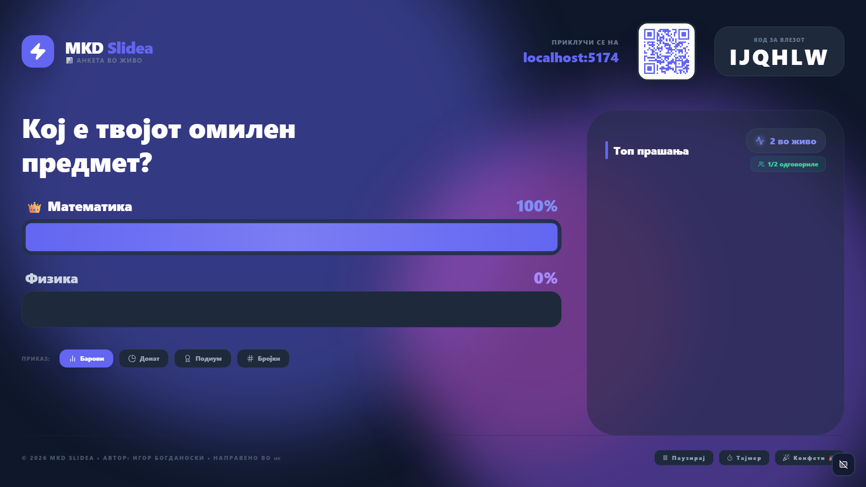
Presenter with live results
The presenter view: the live question, an animated bar chart of responses (the leading option wears a 👑), the participant counter (“2 live”, “1/2 answered”), and a chart-mode switcher (Bars / Donut / Podium / Numbers). A QR code and the join code are always visible.
You can switch chart styles, pause voting, run a timer, or fire confetti to celebrate a result. For quizzes, a leaderboard appears on the right.

7.1 The Remote Control
While the presentation runs on the projector, open the host page on your phone and tap Remote. Your phone becomes a clicker — advance questions, lock voting and reset with big, one-tap buttons.
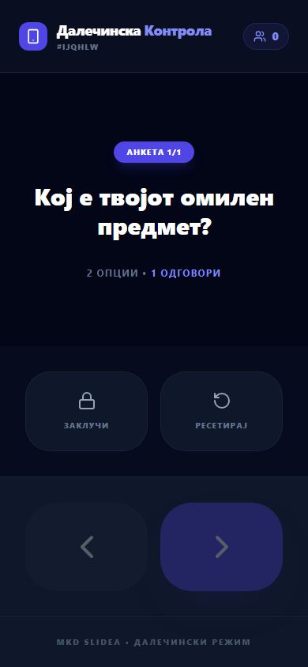
Remote control on phone
The phone remote: the active question, response progress, and large previous/next, lock and reset controls.

8. For Participants — Joining & Responding

8.1 Joining
Participants go to the join page and enter the code shown on the presenter’s screen (or scan the QR code).
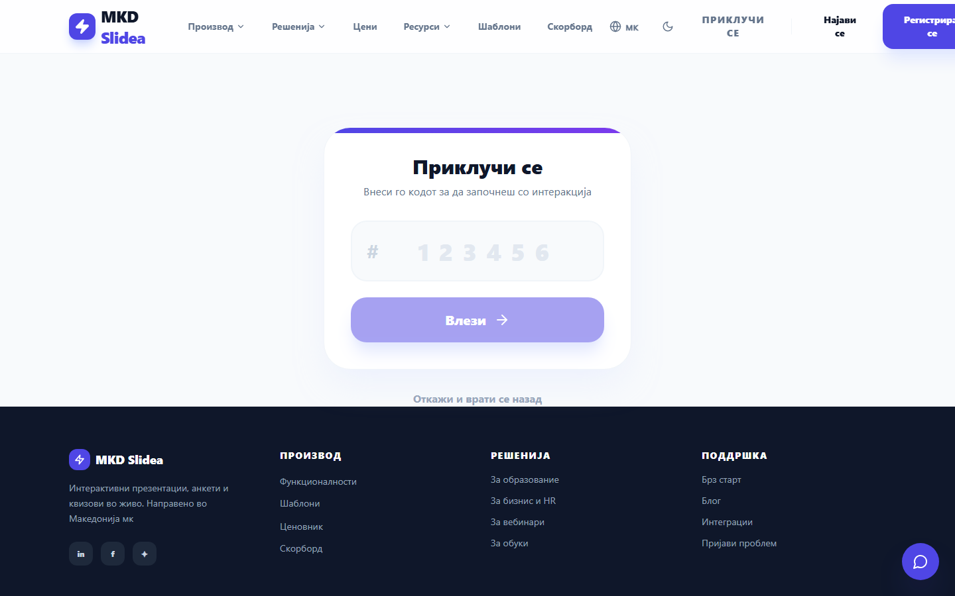
Join page

8.2 Entering a name
A friendly prompt asks how to call them — this name shows on leaderboards and in Q&A. They can also continue anonymously.
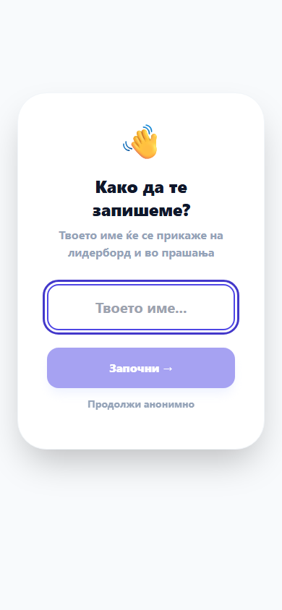
Enter your name

8.3 Answering
The active question appears on their phone. For a poll or quiz, they tap an option; for a word cloud or open question, they type and send.
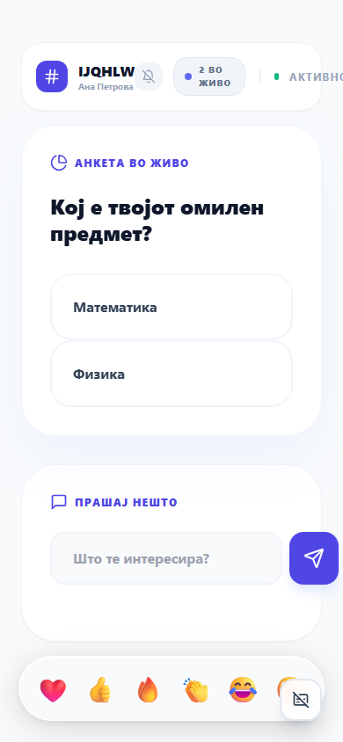
A poll on the participant’s phone
After answering, they see a confirmation (and, for quizzes, whether they were correct).
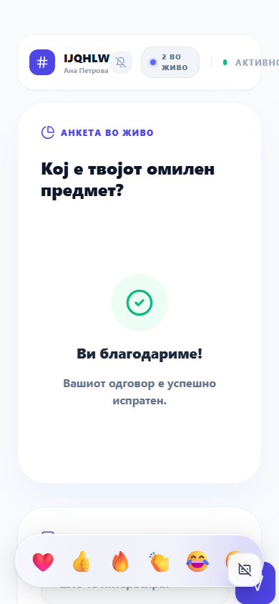
Vote confirmed

9. Templates & Pricing

9.1 Templates gallery
The public gallery offers dozens of curriculum-aligned templates you can apply in one click — or contribute your own.
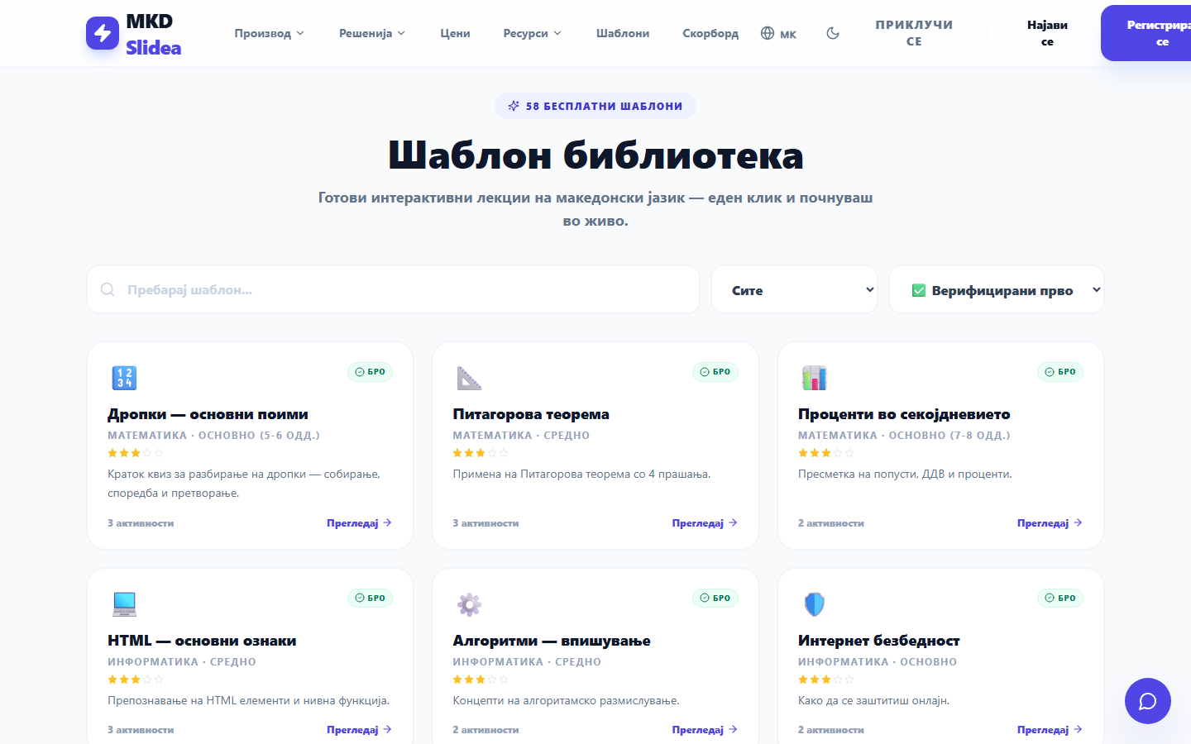
Templates gallery

9.2 Plans
The Free plan covers most needs (up to 200 participants). Pro unlocks unlimited participants, branding, exports and AI insights. Schools and organizations can get institutional licenses.
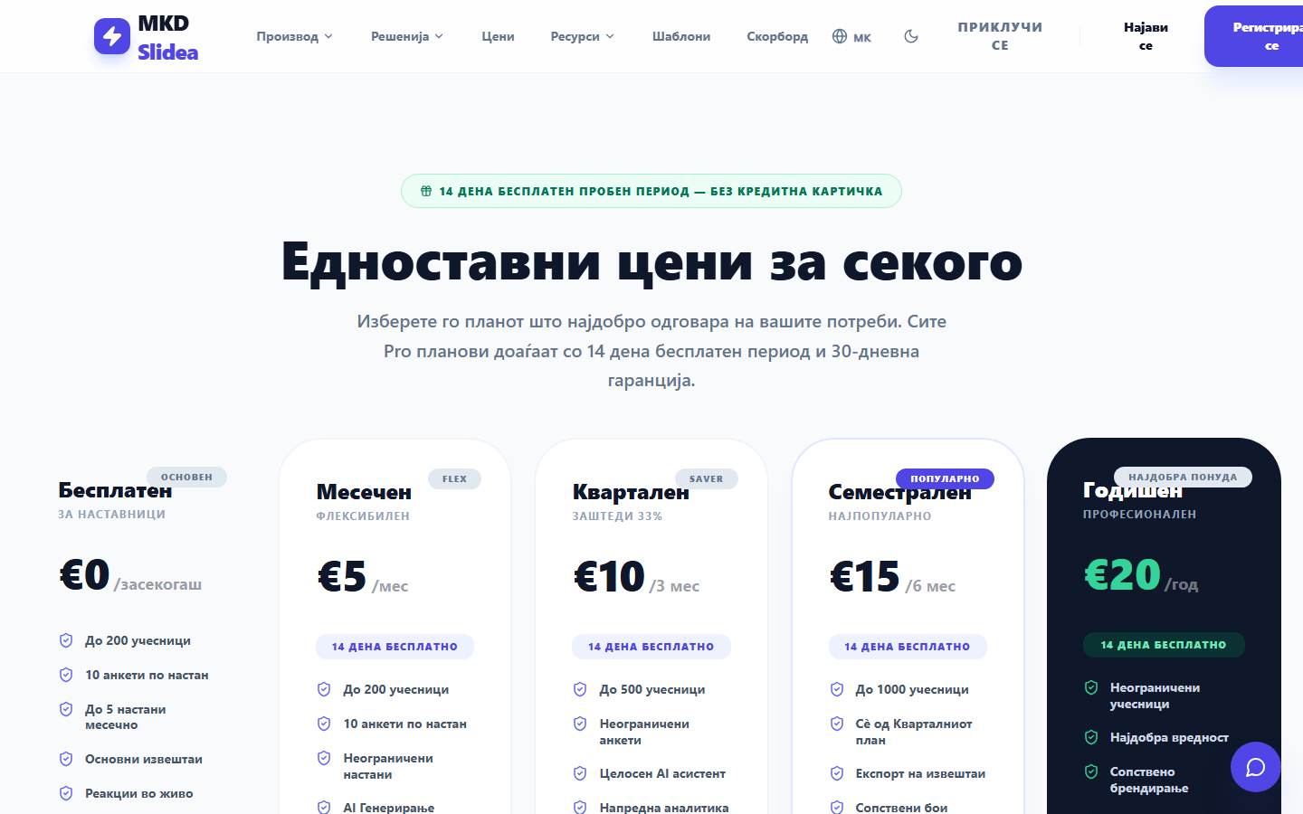
Pricing

10. Teaching Tips — Getting the Most Out of a Session
These practices come from classroom and training experience:
- Start with a low-stakes warm-up. A word cloud or a fun poll in the first 60 seconds gets everyone to join and tap — once they’ve interacted once, they keep engaging.
- One question, one idea. Keep each activity focused on a single concept so the results are easy to read and discuss.
- Use the result as a teaching moment. Pause on a surprising chart and ask “Why do you think most of you chose this?” — the data becomes a discussion starter.
- Mix activity types. Alternate quick polls with a quiz (energy + competition) and an open question (depth + reflection) to keep the rhythm varied.
- Ranking reveals priorities. When you want to know what matters most, ranking gives a richer picture than a single-choice poll.
- Lock before you discuss. Lock voting before revealing the “right” answer in a quiz so late votes don’t skew the result.
- Project the word cloud. Watching their words grow on screen is highly motivating for shy participants.
- Use the timer for timed challenges and to keep the session on schedule.
- End with a rating or open reflection — “One thing I learned today…” — to close the loop and capture feedback.
- Save as a template. A session that worked well is worth reusing; publish it so colleagues benefit too.

11. Troubleshooting & FAQ
- Participants can’t join? Check the code on the presenter screen matches what they typed; make sure the session isn’t paused or ended.
- No results appearing? Confirm the activity is active (highlighted in the host list) and that the presenter tab is open.
- Forgot your password? Use Forgot password? on the sign-in dialog.
- Need more than 200 participants? Upgrade to Pro or an institutional plan.
- Data & privacy: MKD Slidea is GDPR-compliant; see the Privacy Policy and Terms of Service in the footer.

MKD Slidea — made in 🇲🇰 for classrooms, trainings and events worldwide. Need help? igorbogdanoski@mismath.net · +389 70 246 814

