Inversion is geophysical inversion software for magnetic and gravity profile data. It is using Werner deconvolution to compute approximate position of singularities of anomalous bodies. For detailed description see Werner deconvolution.

Werner Deconvolution
Werner (1953), analysing the magnetic field of arbitrary dikes, proposed a method for it’s interpretation. This method deals with 2-D problems. By solving the systems of linear equations we can find, either, under assumption of a thin dike object from ΔT curve it’s upper edge, or under assumption of a thick dike, from ∂(ΔT)/∂x curve its upper edges. Although the simplification seems to be a limitation, the method does provide a wide range of applications. Advantages and limitations of the process of inversion will be discussed in this chapter.

Theory

Thin dike in magnetic
Assuming the well-known formulae for magnetic scalar potential (1.1) we can derive an equation for arbitrary 2-D body (e.g. Talwani & Heirtzer, 1964; Ku & Sharp, 1983). We choose the x-axis perpendicular to the strike of the dike, the y-axis parallel to the strike, and the z-axis vertical. Equations for vertical, horizontal and total magnetic anomalies are
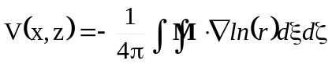, (1.0)
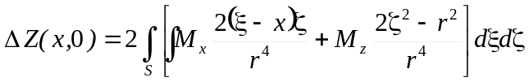, (1.1)
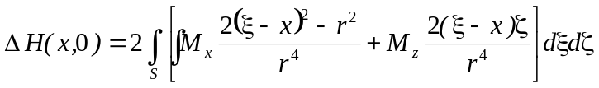, (1.2)

where
M = (M_{x}, M_{z}) is the magnetisation vector M = M_{Remanent} + M_{Induced,}
r=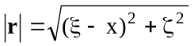.
Let h be depth of a dike, and 2b be width of a dike, and the centre of a dike (location) is located at (0, h). Under the assumption that b<<h, we can write

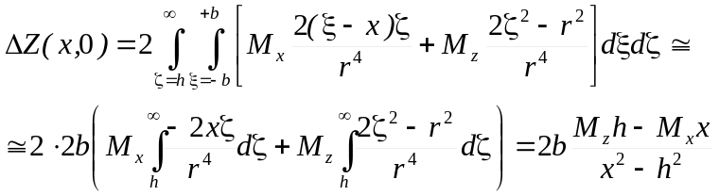, (1.3)

similarly

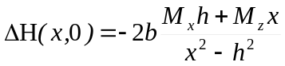, (1.4)

and

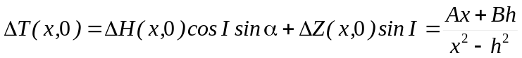, (1.5)

where

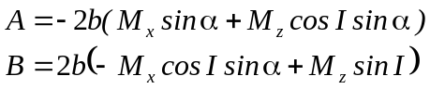. (1.6)

Then from above equations we can write

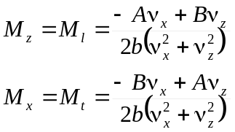, (1.7)

where

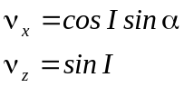, (1.8)

I is a magnetic inclination of the main field T; α is a strike of the dike measured from the magnetic north, positive clockwise.
For an arbitrary location of the dike (x₀, h₀) on a profile (x, 0), equation (4.5) becomes

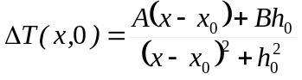, (1.9)

or

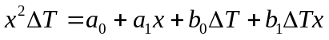. (1.10)

This equation is referred to be a Werner four-point operator, and its properties will be discussed in chapter 4.1.3.

Generalisation of Werner deconvolution

In this chapter brief generalisation of the Werner deconvolution is given. Only equations are to be written. For further reading see original papers.
- Magnetic
Thin dike (Werner, 1953)

.

For a thick dike edge we can write (Ku & Sharp, 1983):

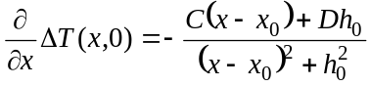.

- Gravity
2-D cylinder (Dobrin, 1976, in Kilty, 1983):

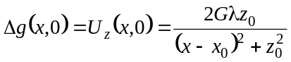.

Vertical thin dike, depth unlimited (Klingelé et al. 1991):

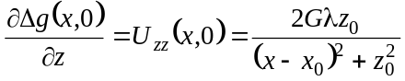.

Laterally infinite step (Klingelé et al. 1991):

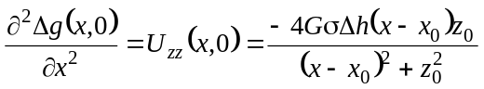.

The goal is that all above equations can be rewritten in the form of equation (4.10) and they can be solved similarly as in classical Werner deconvolution for unknown parameters x₀, z₀.

Properties of the Werner n-point operator

In this chapter we are going to discuss the properties of the Werner n-point operator from the point of view of theory, where n-point operator means that we are solving n equations of either n or more unknowns.
Let us rewrite the interpretation equation (4.9) in the form

, (1.11)

or in the form

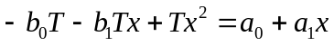. (1.12)

I prefer to write the interpretation equation in the form written above, because of clarity of the following discussion.
Now let us assume Werner’s interference polynomial in the form

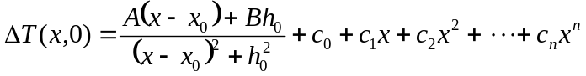, (1.13)

or

, (1.14)

where

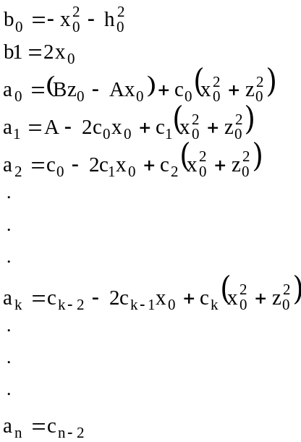. (1.15)

From the equations (4.15) we have

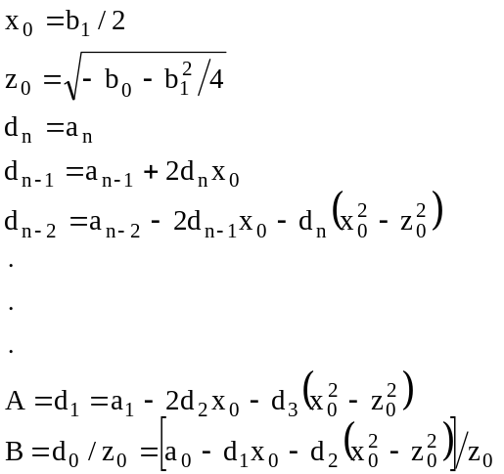, (4.16)

where d, d = (d₀ d₁ d₂ . . . d_{n}) is “solution” vector, n+1 is the number of terms on the right-hand side of the equation (4.14). The equation (4.16) gives solution for depth and location of the dike; from parameters A and B we can compute dip and susceptibility, and parameters of the interference polynomial c₀, c₁, c₂, …, c_{n-2}.

As long as we have computed parameters A, B we can derive susceptibility contrast and the dip of the dike. Recalling the equations (4.7) we have

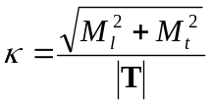, (1.17)
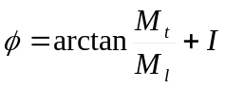, (1.18)

where I is magnetic inclination.

Now look closer at the equations, and try to examine, how computed parameters affect a solution. The right-hand side of the equation (4.15) contains all pieces of information about the magnetic inclination, declination, strike, dip and susceptibility of the dike (parameters a_{i}). We can see, that changes in the parameters a_{i} of a dike, related with the right-hand side of the equation (4.15), do not in fact affect a solution for depth and position of a dike. It happens rarely, that we can find the exact position of a geological body, although we do not know any other parameters of a body. On the other hand, parameters b_{i} affects the solution of the inclination, strike … see equations (4.16).
- The remnant magnetisation does not affect the solution for depth and position of the dike.
Proof: Due to the superposition principle we can write

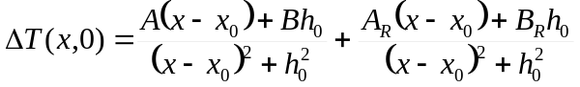, (1.20)

where coefficients A_{R} and B_{R} are for the remnant magnetisation.
Then

, (1.21)

and finally

. (4.22)

The equation (4.22) equals to (4.12). q.e.d.

If the induced magnetisation is known (what is true), we can compute remnant magnetisation.
Assume an interference of more dikes. If we want to get some meaningful solution, we need to add to the interpretation equation a function that approximates the field of the “interfered” dike within the k-point operator window. What kind of function are we to use? Probably it can be only a polynomial function suggested by Werner, because the rational function affects the left-hand side of the equation (4.14) (isn’t there plenty of choices?). The second question is: what kind of the polynomial degree are we going to pick? Polynomials of the second, third degree can good approximate an interfered curve only in surrounding parts of an anomaly. Hence, we had better seek for a solution, which gives a better approximation, what is the higher order polynomial. One could bother, that such an approximation can have large amplitudes between the data points, but we need a good approximation in data points. Unfortunately there will be numerical problems in practical computing. The system of linear equations will be ill conditioned; its condition number will be very high (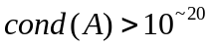). Such a systems of linear equations do not have solutions in a sense of classical numerical analysis. One possible way is to use regularisation.
Sensitivity to the noise: Recall the equation (3.48) of the condition number and the chapter about SVD. From discussion about SVD we can see that small error either in measured data b or coefficients of the matrix A can cause unacceptable error in the solution. The condition numbers of the systems of linear equations solved in Werner deconvolution are ~10⁴ – 10³⁰ (ideal is 1), what means that the systems are ill conditioned. For this reason small perturbations may cause that the solution fails.

