**МИНОБРНАУКИ РОССИИ**

**САНКТ-ПЕТЕРБУРГСКИЙ ГОСУДАРСТВЕННЫЙ**

**ЭЛЕКТРОТЕХНИЧЕСКИЙ УНИВЕРСИТЕТ**

**«ЛЭТИ» ИМ. В.И. УЛЬЯНОВА (ЛЕНИНА)**

**Кафедра автоматики и процессов управления**

**Практическая работа**

**по дисциплине «Технологии XML»**

**Тема: Разработка системы для хранения данных о юнитах в настольной игре**

|  |  |  |
| --- | --- | --- |
| Студент гр. 9370 |  | Чепков И. В. |
| Преподаватель |  | Кондратьева Н. Ю. |

Санкт-Петербург

2019

Имеется модель данных описываемая карточкой

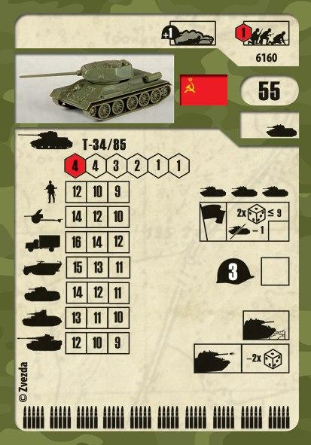 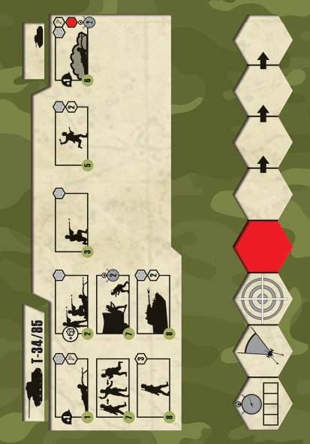

1.  - наименование отряда
2.  - тип отряда
3.  - сторона
4.  - цена отряда
5.  - числинность
6.  - Защита (броня)
7.  - боеприпасы
8. 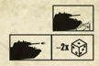 - Специальные свойства отряда
9.  - возможные свойства
10. 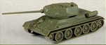 - Изображение отряда
11.  - меткость отряда
12. 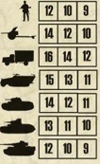 - интенсивность огня
13. 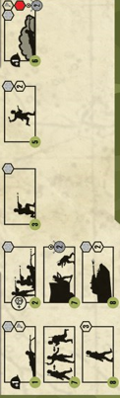 - возможные приказы

Представим эту модель в формате xml

<?xml version="1.0" encoding="utf-8"?>

<!DOCTYPE rules SYSTEM "DTD.dtd">

<?xml-stylesheet type='text/xsl' href='XSL.xsl'?>

<rules name="Standart">

<Units>

<Unit>

<Name>T-34 mod. 1940</Name>

<Side>1</Side>

<Type>F</Type>

<Price>35</Price>

<Count>3</Count>

<Defence>3</Defence>

<Ammunition>

<Ammo>10</Ammo>

</Ammunition>

<SpecialProperty>A B</SpecialProperty>

<Status>1(1) 2(1)</Status>

<Image>1.jpg</Image>

<Accuracy>2 2 2 1 1</Accuracy>

<FireIntensity>

<A>11 9 7</A>

<B>12 10 8</B>

<C>14 13 12</C>

<D>13 12 11</D>

<E>11 10 9</E>

<F>10 9 8</F>

<G>9 8 7</G>

</FireIntensity>

<Order>A B C P R V AE AO AQ AP</Order>

</Unit>

<Unit>

<Name>Zis-5 3 t.</Name>

<Side>1</Side>

<Type>C</Type>

<Price>15</Price>

<Count>6</Count>

<Defence>0</Defence>

<Ammunition>

<Ammo>30</Ammo>

<Mine>3</Mine>

</Ammunition>

<SpecialProperty></SpecialProperty>

<Status>1(0) 3 4 5</Status>

<Image>2.jpg</Image>

<Accuracy></Accuracy>

<FireIntensity></FireIntensity>

<Order>AL AM AE AF AB AN AO AP</Order>

</Unit>

<Unit>

<Name>53-K 45mm</Name>

<Side>1</Side>

<Type>B</Type>

<Price>17</Price>

<Count>3</Count>

<Defence>1</Defence>

<Ammunition>

<Ammo>10</Ammo>

</Ammunition>

<SpecialProperty>C D</SpecialProperty>

<Status>1(1) 2(1) 3 6(2)</Status>

<Image>3.jpg</Image>

<Accuracy>2 2 2 1 1</Accuracy>

<FireIntensity>

<A>10 8 6</A>

<B>9 8 7</B>

<C>10 9 18</C>

<D>8 7 6</D>

<E>7 6 5</E>

<F>5 4 3</F>

<G>3 2 1</G>

</FireIntensity>

<Order>A B C R S T AB AE U AN</Order>

</Unit>

<Unit>

<Name>Maxim</Name>

<Side>1</Side>

<Type>A</Type>

<Price>12</Price>

<Count>2</Count>

<Defence>1</Defence>

<Ammunition>

<Ammo>10</Ammo>

</Ammunition>

<SpecialProperty>C D</SpecialProperty>

<Status>1(2) 2(1) 7 6(2)</Status>

<Image>4.jpg</Image>

<Accuracy>3 3 2 1 </Accuracy>

<FireIntensity>

<A>10 6</A>

<B>10 5</B>

<C>9 5</C>

<D>2 1</D>

<E>2 1</E>

<F>1 1</F>

</FireIntensity>

<Order>A B C R V AL AM AE S T U AN AO</Order>

</Unit>

<Unit>

<Name>Solders</Name>

<Side>1</Side>

<Type>A</Type>

<Price>10</Price>

<Count>5</Count>

<Defence>1</Defence>

<Ammunition>

<Ammo>10</Ammo>

</Ammunition>

<SpecialProperty>D</SpecialProperty>

<Status>1(1) 2(1) 7 6(2)</Status>

<Image>5.jpg</Image>

<Accuracy>2 2 1 1 </Accuracy>

<FireIntensity>

<A>8 6 4 3 2</A>

<B>8 6 4 2 1</B>

<C>7 5 4 3 2</C>

<D>6 4 3 2 1</D>

<E>5 4 3 2 1</E>

<F>4 3 2 1 1</F>

<H>2 2 1 1 1</H>

</FireIntensity>

<Order>A B C P R V AL AM AE AG AN AO</Order>

</Unit>

<Unit>

<Name>Pz.Kpfw. III ausf. G</Name>

<Side>2</Side>

<Type>F</Type>

<Price>28</Price>

<Count>3</Count>

<Defence>2</Defence>

<Ammunition>

<Ammo>10</Ammo>

</Ammunition>

<SpecialProperty>A B</SpecialProperty>

<Status>1(1) 2(1)</Status>

<Image>6.jpg</Image>

<Accuracy>2 2 2 1 1 </Accuracy>

<FireIntensity>

<A>10 8 6</A>

<B>11 9 7</B>

<C>12 11 10</C>

<D>11 10 9</D>

<E>9 8 7</E>

<F>6 5 4</F>

<G>4 3 2</G>

</FireIntensity>

<Order>A B C P R V AE AO AQ</Order>

</Unit>

<Unit>

<Name>Pz.Kpfw. II</Name>

<Side>2</Side>

<Type>E</Type>

<Price>22</Price>

<Count>3</Count>

<Defence>2</Defence>

<Ammunition>

<Ammo>10</Ammo>

</Ammunition>

<SpecialProperty>A B</SpecialProperty>

<Status>1(2) 2(1)</Status>

<Image>7.jpg</Image>

<Accuracy>3 2 2 1</Accuracy>

<FireIntensity>

<A>11 10 9</A>

<B>11 10 9</B>

<C>12 11 10</C>

<D>8 7 6</D>

<E>7 6 5</E>

<F>4 3 2</F>

<G>3 2 1</G>

</FireIntensity>

<Order>A B C P R V AE AO AQ</Order>

</Unit>

<Unit>

<Name>MG-40</Name>

<Side>2</Side>

<Type>A</Type>

<Price>13</Price>

<Count>2</Count>

<Defence>1</Defence>

<Ammunition>

<Ammo>10</Ammo>

</Ammunition>

<SpecialProperty>C D</SpecialProperty>

<Status>1(2) 2(1) 7 6(2)</Status>

<Image>8.jpg</Image>

<Accuracy>3 3 2 1</Accuracy>

<FireIntensity>

<A>9 5</A>

<B>9 4</B>

<C>8 4</C>

<D>2 1</D>

<E>2 1</E>

<F>1 1</F>

<H>3 2</H>

</FireIntensity>

<Order>A B C R V AE AO AN AL AM S T U</Order>

</Unit>

<Unit>

<Name>Miners</Name>

<Side>2</Side>

<Type>A</Type>

<Price>22</Price>

<Count>4</Count>

<Defence>1</Defence>

<Ammunition>

<Ammo>8</Ammo>

<Mine>1</Mine>

</Ammunition>

<SpecialProperty>D E</SpecialProperty>

<Status>1(2) 2(1) 7 6(2)</Status>

<Image>9.jpg</Image>

<Accuracy>3 2 1 1</Accuracy>

<FireIntensity>

<A>8 5 3 2</A>

<B>6 5 3 1</B>

<C>5 4 3 1</C>

<D>7 6 4 3</D>

<E>7 5 4 3</E>

<F>6 5 4 2</F>

<G>5 4 3 2</G>

<H>2 2 1 1</H>

</FireIntensity>

<Order>A B C P R V AL AM AE AG AK AC Z W X AN AO AA AD</Order>

</Unit>

<Unit>

<Name>Solders</Name>

<Side>2</Side>

<Type>A</Type>

<Price>12</Price>

<Count>5</Count>

<Defence>1</Defence>

<Ammunition>

<Ammo>10</Ammo>

</Ammunition>

<SpecialProperty>E</SpecialProperty>

<Status>1(1) 2(1) 7 6(2)</Status>

<Image>10.jpg</Image>

<Accuracy>2 2 1 1</Accuracy>

<FireIntensity>

<A>8 7 5 3 2</A>

<B>6 7 4 2 1</B>

<C>8 6 4 3 2</C>

<D>6 4 3 2 1</D>

<E>5 4 3 2 1</E>

<F>4 3 2 1 1</F>

<H>2 2 1 1 1</H>

</FireIntensity>

<Order>A B C P R V AL AM AE AG AN AO</Order>

</Unit>

</Units>

<Typies>

<Solders id ="A">Unit</Solders>

<Artilery id ="B">Unit</Artilery>

<Cars id ="C">Car</Cars>

<DefencedCars id ="D">Unit</DefencedCars>

<LightTank id ="E">Tank</LightTank>

<MidleTank id ="F">Tank</MidleTank>

<HeavyTank id ="G">Tank</HeavyTank>

<LightPlane id ="H">Plane</LightPlane>

<HeavyPlane id ="I">Plane</HeavyPlane>

</Typies>

<Statuses>

<UnderFire id ="1">int</UnderFire>

<InAmbush id="2">int</InAmbush>

<Towing id="3"></Towing>

<GetAmmo id="4"></GetAmmo>

<SetAmmo id="5"></SetAmmo>

<InDefence id="6">int</InDefence>

<InCar id="7"></InCar>

</Statuses>

<SpecialProperties>

<DestroyWall id ="A"></DestroyWall>

<FireInAction id ="B"></FireInAction>

<SectorFire id="C"></SectorFire>

<TankScream id="D"></TankScream>

<MineFinder id="E"></MineFinder>

</SpecialProperties>

<Orders>

<Defence id="A" time ="1"></Defence>

<StrongFire id="B" time ="2"></StrongFire>

<Fire id="C" time="3"></Fire>

<Smoke id="D" time="3"></Smoke>

<HelpToArtilery id="E" time="3"></HelpToArtilery>

<EndFly id="F" time="4"></EndFly>

<ReadyToFly id="G" time="4"></ReadyToFly>

<StartFly id="H" time="4"></StartFly>

<PlaneFire id ="I" time="4"></PlaneFire>

<PlaneAtack id="J" time="4"></PlaneAtack>

<FlyResearch id="K" time="4"></FlyResearch>

<Patrol id ="L" time="4"></Patrol>

<FlySupport id="M" time="4"></FlySupport>

<Landing id="N" time="4"></Landing>

<Supply id="O" time="4"></Supply>

<Atack id="P" time="5"></Atack>

<StrongAtck id="Q" time="5"></StrongAtck>

<Ambush id="R" time="6"></Ambush>

<ReadyToGo id="S" time="7"></ReadyToGo>

<ReadyToFire id="T" time="7"></ReadyToFire>

<ChangeFireSide id="U" time="7"></ChangeFireSide>

<Union id="V" time="7"></Union>

<SetMine id="W" time="7"></SetMine>

<GetMine id="X" time="7"></GetMine>

<DestroyObject id="Y" time ="7"></DestroyObject>

<DestroyTankDefence id="Z" time="7"></DestroyTankDefence>

<SetFire id="AA" time="7"></SetFire>

<Towing id="AB" time="7"></Towing>

<CreateBrige id="AC" time="7"></CreateBrige>

<DestroyForest id="AD" time="7"></DestroyForest>

<GetAmmo id="AE" time="7"></GetAmmo>

<SetAmmo id="AF" time="7"></SetAmmo>

<CreateDefence id="AG" time="7"></CreateDefence>

<Research id="AH" time="7"></Research>

<Repairs id="AI" time="7"></Repairs>

<Heal id="AJ" time="7"></Heal>

<DestroySolderDefence id="AK" time="7"></DestroySolderDefence>

<GetFromCar id="AL" time="7"></GetFromCar>

<SetInCar id="AM" time="7"></SetInCar>

<FightAction id="AN" time="8"></FightAction>

<Action id="AO" time ="8"></Action>

<Wait id="AP" time="8"></Wait>

<ActionWithFire id="AQ" time="8"></ActionWithFire>

<SetToPlatform id="AR" time="8"></SetToPlatform>

<GetFromPlatform id="AS" time="8"></GetFromPlatform>

</Orders>

</rules>

Опищем DTD

<!ELEMENT Units (Unit)>

<!ELEMENT Unit (Name, Side, Type, Price, Count, Defence, Ammunition, SpecialProperty, Status, Image, Accuracy, FireIntensity, Orders)>

<!ELEMENT Name (#PCDATA)>

<!ELEMENT Side (#PCDATA)>

<!ELEMENT Type (#PCDATA)>

<!ELEMENT Price (#PCDATA)>

<!ELEMENT Count (#PCDATA)>

<!ELEMENT Defence (#PCDATA)>

<!ELEMENT Ammunition (Ammo, Mine)>

<!ELEMENT Ammo (#PCDATA)>

<!ELEMENT Mine (#PCDATA)>

<!ELEMENT SpecialProperty (#PCDATA)>

<!ELEMENT Status (#PCDATA)>

<!ELEMENT Image (#PCDATA)>

<!ELEMENT Accuracy (#PCDATA)>

<!ELEMENT FireIntensity (#PCDATA)>

<!ELEMENT Order (#PCDATA)>

<!ELEMENT Typies (#PCDATA)>

<!ELEMENT Statuses (#PCDATA)>

<!ELEMENT SpecialProperties (#PCDATA)>

<!ELEMENT Orders (#PCDATA)>

<!ATTLIST rules name CDATA #REQUIRED>

Опишем XSL

<?xml version="1.0" encoding="utf-8"?>

<xsl:stylesheet version="1.0" xmlns:xsl="http://www.w3.org/1999/XSL/Transform"

xmlns:msxsl="urn:schemas-microsoft-com:xslt" exclude-result-prefixes="msxsl"

>

<xsl:template match="/">

<html>

<body>

<h1>

<xsl:value-of select="rules/@name"/>

</h1>

<h2>

Юниты

</h2>

<xsl:for-each select="rules/Units/Unit">

<xsl:choose>

<xsl:when test="Side &gt; 1">

<font color="Blue">

<h3>

<xsl:value-of select="Name"/>

</h3>

</font>

</xsl:when>

<xsl:otherwise>

<font color="Red">

<h3>

<xsl:value-of select="Name"/>

</h3>

</font>

</xsl:otherwise>

</xsl:choose>

<i>

<br/>

<img>

<xsl:attribute name="src">

<xsl:value-of select='Image'/>

</xsl:attribute>

</img>

<br/>

Тип: <xsl:value-of select="Type"/>

<br/>

Цена: <xsl:value-of select="Price"/>

<br/>

Численность: <xsl:value-of select="Count"/>

<br/>

Защита: <xsl:value-of select="Defence"/>

<br/>

Патроны: <xsl:value-of select="Ammunition/Ammo"/>

Мины: <xsl:value-of select="Ammunition/Mine"/>

<br/>

Специальные свойства: <xsl:value-of select="SpecialProperty"/>

<br/>

Допустимые статусы: <xsl:value-of select="Status"/>

<br/>

Меткость: <xsl:value-of select="Accuracy"/>

<br/>

Интенсивность огня: <xsl:value-of select="FireIntensity"/>

<br/>

Приказы: <xsl:value-of select="Order"/>

</i>

</xsl:for-each>

</body></html> </xsl:template></xsl:stylesheet>

Преобразование в HTML  
