

|  |
| --- |
| architecture overview |
| ClientID-ProductIDOTP |

| Related Artifacts | |
| --- | --- |
| Ref. | Name |
|  |  |
|  |  |

|  |  |
| --- | --- |
| Abbreviations and Acronyms | |
|  |  |
|  |  |

Contents

1 Medtronic AWS IoT Baseline Solution overview 4

1.1 AWS IoT device software 4

1.2 AWS IoT control services 5

1.3 AWS IoT data services 5

1.4 Reporting service 6

1.5 Administrator and reserve user web interface 6

2 6

3 6

4 Example of a 1st lvl heading 6

4.1 Example of a 2nd lvl heading 7

4.1.1 Example of a 3rd lvl heading 7

Appendix A. Example of 1st lvl appendix 9

Appendix A.1. example of 2nd lvl appendix 9

Appendix A.1.1. Example of 3rd lvl Appendix 9

# Medtronic AWS IoT Baseline Solution overview

The highlighted path is a first straightforward iteration for the system implementation.

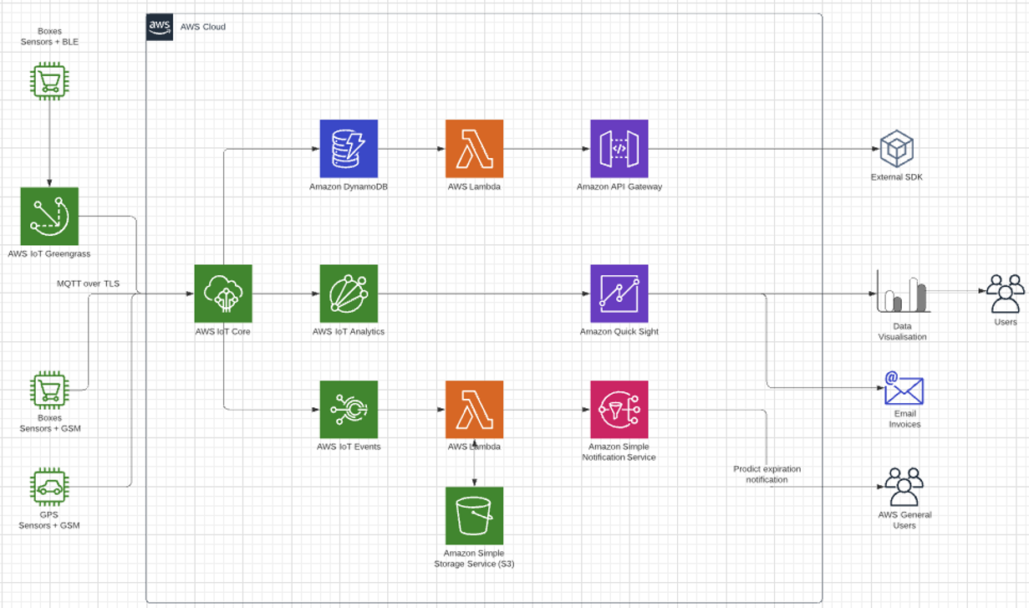

## AWS IoT device software

AWS IoT provides this software to support your IoT devices.

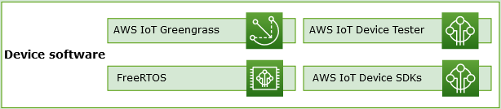

**FreeRTOS**

Amazon release FreeRTOS code under the MIT open source license. GitHub site at <https://github.com/aws/amazon-freertos>. FreeRTOS documentation is available at <https://github.com/awsdocs/aws-freertos-docs>

**AWS IoT Device Tester**

[AWS IoT Device Tester](https://docs.aws.amazon.com/freertos/latest/userguide/device-tester-for-freertos-ug.html) for FreeRTOS and AWS IoT Greengrass is a test automation tool for microcontrollers. AWS IoT Device Tester test your device to determine if it will run FreeRTOS or AWS IoT Greengrass and interoperate with AWS IoT services.

**AWS IoT Device SDKs**

The [AWS IoT Device and Mobile SDKs](https://docs.aws.amazon.com/iot/latest/developerguide/iot-sdks.html) help you efficiently connect your devices to AWS IoT. The AWS IoT Device and Mobile SDKs include open-source libraries, developer guides with samples, and porting guides so that you can build innovative IoT products or solutions on your choice of hardware platforms.

**AWS IoT Greengrass**

[AWS IoT Greengrass](https://docs.aws.amazon.com/greengrass/) extends AWS to edge devices so they can act locally on the data they generate and use the cloud for management, analytics, and durable storage. With AWS IoT Greengrass, connected devices can run [AWS Lambda](https://docs.aws.amazon.com/lambda/) functions, Docker containers, or both, execute predictions based on machine learning models, keep device data in sync, and communicate with other devices securely – even when they are not connected to the Internet.

## AWS IoT control services

Connect to the following AWS IoT services to manage the devices in your IoT solution.

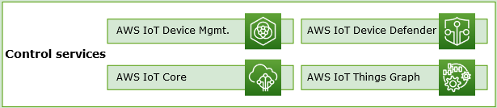

**AWS IoT Core**

[AWS IoT Core](https://docs.aws.amazon.com/iot/) is a managed cloud service that enables connected devices to securely interact with cloud applications and other devices. AWS IoT Core can support many devices and messages, and it can process and route those messages to AWS endpoints and other devices. With AWS IoT Core, your applications can interact with all of your devices even when they aren’t connected.

**AWS IoT Device Management**

[AWS IoT Device Management](https://docs.aws.amazon.com/iot-device-management/) services help you track, monitor, and manage the plethora of connected devices that make up your devices fleets. AWS IoT Device Management services help you ensure that your IoT devices work properly and securely after they have been deployed. They also provide secure tunneling to access your devices, monitor their health, detect and remotely troubleshoot problems, as well as services to manage device software and firmware updates.

**AWS IoT Device Defender**

[AWS IoT Device Defender](https://docs.aws.amazon.com/iot-device-defender/) helps you secure your fleet of IoT devices. AWS IoT Device Defender continuously audits your IoT configurations to make sure that they aren’t deviating from security best practices. AWS IoT Device Defender sends an alert when it detects any gaps in your IoT configuration that might create a security risk, such as identity certificates being shared across multiple devices or a device with a revoked identity certificate trying to connect to [AWS IoT Core](https://aws.amazon.com/iot-core/).

**AWS IoT Things Graph**

[AWS IoT Things Graph](https://docs.aws.amazon.com/thingsgraph/) is a service that lets you visually connect different devices and web services to build IoT applications. AWS IoT Things Graph provides a visual drag-and-drop interface for connecting and coordinating interactions between devices and web services, so that you can build IoT applications efficiently.

## AWS IoT data services

Analyze the data from the devices in your IoT solution and take appropriate action by using the following AWS IoT services.

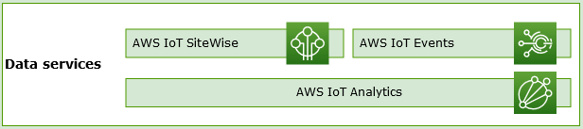

**AWS IoT Analytics**

[AWS IoT Analytics](https://docs.aws.amazon.com/iotanalytics/) lets you efficiently run and operationalize sophisticated analytics on massive volumes unstructured IoT data. AWS IoT Analytics automates each difficult step that is required to analyze data from IoT devices. AWS IoT Analytics filters, transforms, and enriches IoT data before storing it in a time-series data store for analysis. You can analyze your data by running one-time or scheduled queries using the built-in SQL query engine or machine learning.

**AWS IoT SiteWise**

[AWS IoT SiteWise](https://docs.aws.amazon.com/iot-sitewise/) collects, stores, organizes, and monitors data passed from industrial equipment by MQTT messages or APIs at scale by providing software that runs on a gateway in your facilities. The gateway securely connects to your on-premises data servers and automates the process of collecting and organizing the data and sending it to the AWS Cloud.

**AWS IoT Events**

[AWS IoT Events](https://docs.aws.amazon.com/iotevents/) detects and responds to events from IoT sensors and applications. Events are patterns of data that identify more complicated circumstances than expected, such as motion detectors using movement signals to activate lights and security cameras. AWS IoT Events continuously monitors data from multiple IoT sensors and applications, and integrates with other services, such as AWS IoT Core, IoT SiteWise, DynamoDB, and others to enable early detection and unique insights.

## Reporting service

**Amazon QuickSight** is a business analytics service you can use to build visualizations, perform ad hoc analysis, and get business insights from your data. In Enterprise edition, you can send a dashboard in report form either once or on a schedule (daily, weekly, or monthly). You can email the reports to users or groups who share your Amazon QuickSight subscription.

## Administrator and reserve user web interface

Cases:

1. Add new device to a control interface
2. Get information about existing devices
3. Delete device from a control interface
4. Show history of any device movements
5. Show low-level log from connected devices in real time perspective

# 

# 

# Example of a 1st lvl heading

Body text

Use **Body Text** style. Always use Trebuchet MS, size 10. Style is Body (not Normal).

Lorem ipsum dolor sit amet, consectetur adipiscing elit, sed do eiusmod tempor incididunt ut labore et dolore magna aliqua. Ut enim ad minim veniam, quis nostrud exercitation ullamco laboris nisi ut aliquip ex ea commodo consequat.

Table 1 Table name

| Table heading | |
| --- | --- |
| Column name1 | Column name2 |
| Table text. No special text style formatting is needed. It’s already modified in **Table_EPAM** table style.  Example of table numbered list:   1. This is the first item in a 1st level numbered list. Use **Table Numbered List** style. 2. This is the second item in a 1st level numbered list.    1. 1st item in a 2nd level numbered list.    2. 2nd item in a 2nd level numbered list.       1. 1st item in a 3rd level numbered list.       2. 2nd item in a 3rd level numbered list. | Table text  Example of table bulleted list:   * This is the first item in a 1st level bulleted list. Use **Table Bullet List** style; * This is the second item in a 1st level bulleted list.   + 1st item in a 2nd level bulleted list;   + 2nd item in a 2nd level bulleted list.     - 1st item in a 3rd level bulleted list;     - 2nd item in a 3rd level bulleted list. |

## Example of a 2nd lvl heading

Use **Body Text** style adding text information to document’s sections.

This is an example of picture inserted



Figure 1 Figure name

### Example of a 3rd lvl heading

Body text

#### Example of a 4th lvl heading

Body text

1. This is the first item in a 1st level numbered list. Use List Number style.
2. This is the second item in a 1st level numbered list.
   1. This is the first item in a 2nd level numbered list. To move to 2nd level list press **Tab** after pressing **Enter**.
   2. This is the second item in a 2nd level numbered list.
      1. This is the first item in a 3rd level numbered list. To move to 3rd level list press **Tab** after pressing **Enter**.
      2. This is the second item in a 3rd level numbered list.
3. This is the third item in a 1st level numbered list.
4. This is the fourth item in a 1st level numbered list.

[Hyperlink](http://elements.epam.com/)

* This is the 1st level bulleted list. Use **List Bullet** style;
  + This is the 2nd level bulleted list. Use **List Bullet 2** style;
    - This is the 3rd level bulleted list. Use **List Bullet 3** style.

1. This is the style of Note – a modified numbering style linked to **Note Style** paragraph.
2. This is the style of Warning that will look exactly like Note Style except for the caption

Code example. Courier new.

1. Example of 1st lvl appendix

This is Appendix A.

* 1. example of 2nd lvl appendix

This is Appendix A.1.

* + 1. Example of 3rd lvl Appendix

This is Appendix A.1.1.

| REVISION HISTORY | | | | | |
| --- | --- | --- | --- | --- | --- |
| Ver. | Description of Change | Author | Date | Approved | |
| Name | Effective Date |
| n.n |  |  | dd-Mmm-yyyy |  | dd-Mmm-yyyy |
|  |  |  |  |  |  |
|  |  |  |  |  |  |