**TH_Java_SDK 3.5 Configuration File**

1. This demo base SSM framework,and the device use websocket as it’s

communication protocal,this sdk use java.org_websocket jar,implement websocket interface

1. The main class is WSSServe.
2. Development environment:

JDK 1.8, ecplise_J2EE, Maven 3.5 and above,Tomcat 9 and above,mysql 5.7.

Setting maven and tomcat in ecplise.

1. Import fingerprint.sql into mysql database;
2. Import project into ecplise
3. open windows firewall port 7788.
4. setting the server ip your computer local ip,and setting network and server port 7788.
5. Config image setting.tomcat/conf/server.xml

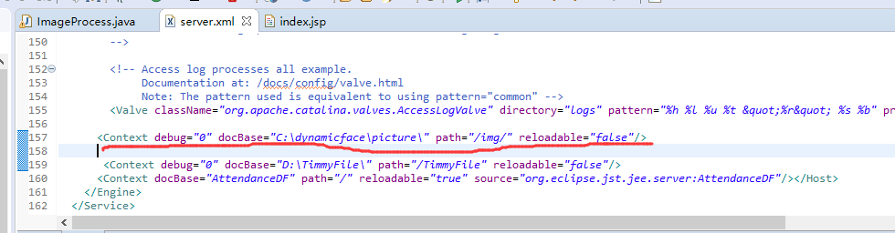

9.run the project, and operate

[backupnum 0-9 is fingerprint，backupnum 20-27 is face（20-23 is first face，24-27 is another face），backupnum 30-37 is palm，50 is photo