Has NHS England’s announcement on direct access investigations led to increased use of radiology tests?
Igor Francetic^{1,2}, Sam WD Merriel¹, Stephen Bradley³
¹ Centre for Primary Care and Health Services Research, The University of Manchester, Oxford Road, M13 9PL, Manchester, UK
² Competence Centre for Healthcare Practices and Policies, University of Applied Sciences and Arts of Southern Switzerland, Via Violino 11, 6928 Manno, Switzerland
³ University of Sheffield, Western Bank, S10 2TN, Sheffield, UK

Abstract
The NHS Long Term Plan set an aim to diagnose 75% of all new cancer cases in England at an early stage by 2028. The GP Direct Access policy, announced in November 2022, was intended to contribute to that goal by speeding up cancer diagnosis for patients who do not meet National Institute for Health and Care Excellence (NICE) criteria for an urgent suspected cancer referral. It allows GPs in England to order CT scans, ultrasounds or brain MRIs directly for patients with concerning symptoms who fall below that threshold.
Using monthly counts of CT, MRI and ultrasound investigations requested by every general practice in England, we compared direct access activity in the 13 months before the announcement with the 16 months after it. Adjusted activity was on average 2.7 referrals per practice–trust pair per month higher after the announcement (95% CI 1.6 to 3.8), equivalent to 5.2% of the pre-announcement mean of 51.7. The increase was concentrated in trusts with the most imaging staff per scanner (+9.5 referrals per month, +19.5%) and in three regions: North East and Yorkshire (+24.8%), North West (+12.3%) and South West (+11.7%). Changes in London, the Midlands, the South East and the East of England were not statistically distinguishable from zero.
GPs appear to be referring more patients directly to NHS trusts for cancer investigations since the policy was introduced, but uptake varies widely across England in a pattern that tracks the resources available at the receiving trust. Because this is a before-and-after comparison without a control group, and because diagnostic services were recovering from the pandemic throughout the study period, these differences should be read as trends consistent with a policy response rather than as proof of one. Capacity bottlenecks are likely to keep limiting the gains from the policy, unevenly across regions.
Keywords: diagnostic imaging, early cancer detection, direct access, general practice
Funding: Igor Francetic was supported by the National Institute for Health and Care Research, School for Primary Care Research (grant nr. 610).
Data availability statement: All data and code used to obtain the tables and figures, alongside information on how we sourced publicly available data and obtained adjusted changes in GP direct access, are available at https://github.com/igorfrancetic/gpda.
Competing interests: None declared.

Background
The NHS Long Term Plan included an aim to diagnose 75% of all new cancer cases in England at an early stage by 2028 (1). The GP Direct Access policy announced in November 2022 was intended to contribute to this goal, speeding up cancer diagnosis by reducing waiting times for diagnostic imaging in cases that do not meet National Institute for Health and Care Excellence (NICE) criteria for an urgent suspected cancer referral (2,3). The policy allows GPs in England to order CT scans, ultrasounds or brain MRIs directly for patients with concerning symptoms who fall outside the NICE guideline threshold for an urgent suspected cancer referral (3). NHS England subsequently issued guidance on which patients should be considered for direct access tests (4).
The announcement was not accompanied by dedicated additional workforce or equipment funding, which limits its potential impact given the pressures diagnostic services already face. The UK has a limited stock of imaging equipment compared with other OECD countries (5), and the average age and state of maintenance of imaging equipment across the NHS is suboptimal (6). The Royal College of Radiologists has estimated that delivering and interpreting the diagnostic imaging needed to meet the NHS Long Term Plan goals would require the radiologist workforce to expand by as much as 30% (7). The Society of Radiographers has reported similarly concerning figures for its own workforce in the English NHS (8).
Our analysis explores the extent to which GPs increased their use of direct access tests after the policy was announced, and examines the geographical differences in that response alongside potential facilitators and barriers to uptake.

What we did
We obtained data from NHS England, by email request to the Diagnostic Imaging Dataset Publication Team, on counts of CT, MRI and ultrasound investigations requested by all English general practices. The estimation sample covers October 2021 to February 2024, giving 13 months before the announcement and 16 months after it; February 2024 was the last month supplied and is only partially complete, so estimates for the final month should be treated with caution. The unit of observation is the practice–trust–month: 356,563 observations covering 7,819 practices referring to 133 NHS trusts.
We estimated adjusted differences in monthly direct access activity after the announcement using linear regression with practice-specific intercepts, which hold constant time-invariant differences in list size, case mix and referral style between practices, and integrated care board (ICB) intercepts. We adjusted for calendar month to account for seasonality, and for the receiving trust’s counts of MRI, CT and ultrasound scanners and its staffing in clinical radiology and medical oncology roles, both fixed at pre-policy levels. Standard errors are clustered at practice level. Small counts of one to three referrals per month are masked by NHS England; rather than drop these cells, which are missing systematically rather than at random, we imputed a value drawn from a uniform distribution between 1 and 3. Full details are in the online appendix.

How have GPs responded so far? Some trends
In the 13 months before the announcement, the average practice sent 51.7 direct access referrals per month to each NHS trust it used, and about 97 direct access referrals per month in total across all the trusts it referred to. As at 31 March 2023, the receiving NHS trusts had on average 4.34 (SD 3.06) MRI scanners, 4.99 (2.94) CT scanners and 25.2 (21.4) ultrasound scanners. The staff-to-scanner ratio (Box 1) at the receiving trusts averaged 1.48 (1.20), ranging from 0.20 to 9.24.
Box 1: The staff-to-scanner ratio explained
The staff-to-scanner ratio is a crude measure of how much specialist medical staffing is available for each imaging scanner at an NHS trust. It is obtained by dividing the number of doctors (full-time equivalents in clinical radiology or medical oncology roles, all grades, as at October 2022) by the combined count of MRI, CT and ultrasound scanners the trust reported owning across all its sites as at 31 March 2023.
Higher values indicate more staff available to operate scanners and report the results, and so a greater capacity to absorb increased volumes of GP direct access referrals than at trusts with a very low ratio. The measure has two important limitations. First, a high ratio can arise either from generous staffing or from a small scanner fleet; because our models also control separately for the counts of MRI, CT and ultrasound scanners and for total staffing, the tertile comparisons hold both components fixed and do not simply reflect trust size. Second, the numerator counts medical staff only. Diagnostic radiographers, who operate most scanners and whose workforce shortfall has been documented separately, are not captured in the NHS Workforce Statistics medical staff file and are therefore absent from the measure.

Table 1 reports the main trends in GP direct access activity since the announcement. After adjustment for seasonal effects and for pre-existing differences between practices, receiving trusts and ICBs, we found a mean increase of about 2.7 additional direct access referrals per month for each practice–trust pair, around 5.2% more than the pre-announcement average.
Table 1: Adjusted changes in GP direct access activity after the policy announcement
 | Adjusted mean change in monthly direct access referrals per GP–trust pair | 95% confidence interval | GP–trust–month observations | Pre-announcement mean | % change vs pre-announcement mean
Overall difference | 2.71*** | 1.64 to 3.78 | 356,563 | 51.7 | +5.2%
By tertile of imaging staff-to-scanner ratio at the receiving NHS trust
1st tertile (fewest staff per scanner) | 2.18** | 0.74 to 3.62 | 114,903 | 52.7 | +4.1%
2nd tertile | 0.06 | −2.66 to 2.78 | 107,701 | 54.4 | +0.1%
3rd tertile (most staff per scanner) | 9.52*** | 7.62 to 11.42 | 133,959 | 48.7 | +19.5%
Note: Adjusted for calendar month, ICB, and the receiving trust’s scanner counts and staffing. Standard errors clustered at practice level. * p < 0.05, ** p < 0.01, *** p < 0.001.
The relationship with trust capacity is not a smooth gradient. Practices served by trusts in the top tertile of the staff-to-scanner ratio increased their direct access referrals by 9.5 per month, close to 20% above their pre-announcement average and more than three times the national figure. Practices served by bottom-tertile trusts recorded a smaller but still clear increase of 2.2 referrals per month (+4.1%), while the middle tertile showed no change at all. The concentration of the response in the best-resourced trusts suggests that those areas were better able to accommodate additional investigations from GPs, or were more likely to commit to implementing the policy, or both.
Figure 1 shows the adjusted difference for each month before and after the announcement, relative to the reference month of October 2022. Activity rose in the months immediately following the announcement, peaking around two to four months in, and settled at roughly the average effect thereafter. The estimates for the final three months are imprecise and are affected by incomplete reporting at the end of the data series.
Figure 1: Month-by-month adjusted changes in GP direct access activity after the policy announcement
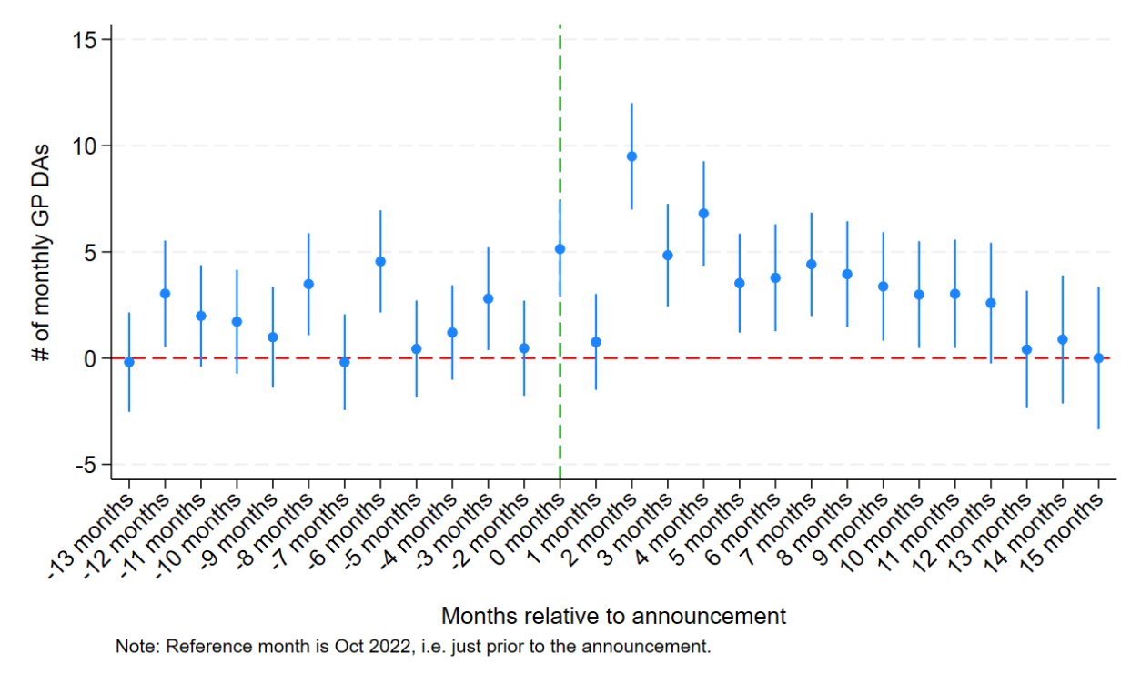
Note: Reference month is October 2022, i.e. just prior to the announcement. Vertical bars are 95% confidence intervals.
There is also substantial variation across regions in how direct access activity changed (Table 2 and Figure 2). Activity increased most sharply in the North East and Yorkshire, the North West and the South West. Changes in London, the South East, the East of England and the Midlands were smaller and not statistically distinguishable from zero, although the confidence intervals in some of these regions are wide enough to be consistent with meaningful increases.
Table 2: Adjusted change in GP direct access activity after the policy announcement, by NHS England region
NHS England region | Adjusted % change vs pre-announcement regional mean | Statistical significance
North East and Yorkshire | +24.8% | p < 0.001
North West | +12.3% | p < 0.001
South West | +11.7% | p < 0.01
South East | +6.4% | not significant
East of England | +5.8% | not significant
London | +1.1% | not significant
Midlands | −0.9% | not significant
Note: Each region is estimated with the same specification as the overall model in Table 1. Percentages are expressed relative to the region’s own pre-announcement mean.
Figure 2: Differences in response to the GP direct access policy by region
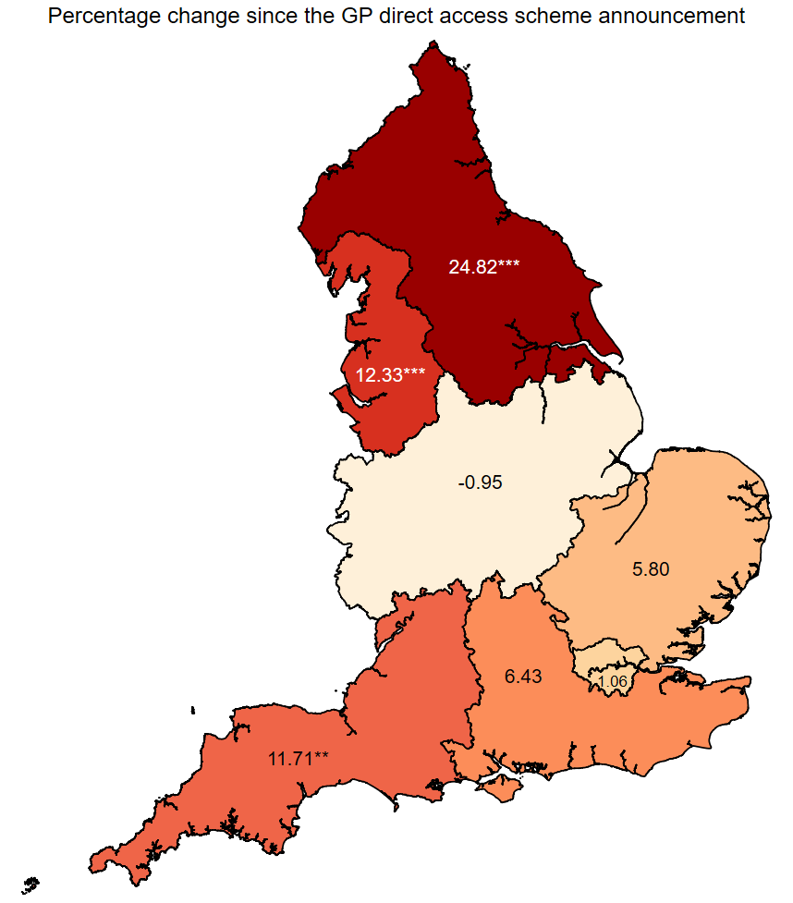
Note: Values are adjusted percentage changes relative to each region’s pre-announcement mean. Stars indicate differences that are statistically significant at the 99% (**) and 99.9% (***) confidence level; regions without stars are not statistically distinguishable from zero.

Strengths and limitations
The main strength of this analysis is its coverage: it uses every direct access request recorded for every general practice in England over 29 months, which allows adjusted comparisons at a level of geographical detail that national aggregate statistics cannot support.
The principal limitation is that this is a before-and-after comparison without a control group. No group of English practices was left unexposed to the announcement, so we cannot separate the policy from anything else that changed at the same time — most importantly the continuing recovery of diagnostic services from the pandemic. Direct access activity was already growing before November 2022, and the estimates above attribute all of the post-announcement difference to a step change at that date. When we instead allow for a common underlying upward trend across the whole period, the discontinuity at the announcement falls to 0.3 referrals per month (95% CI −0.9 to 1.5) and is no longer statistically distinguishable from zero, while the fitted trend of roughly 0.16 additional referrals per month absorbs the difference. Placebo tests that assign a fictitious announcement date within the pre-policy period produce no comparable jump, so the data are not simply generating spurious discontinuities; but the headline estimate should still be read as the difference in activity before and after the announcement rather than as an isolated causal effect of it.
Three further caveats apply. First, small counts of one to three referrals are masked in the source data and account for 38% of practice–trust–month cells, though only 1.4% of total referral volume; results are insensitive to how these cells are filled, and dropping them instead would substantially overstate the change by selecting on high-volume practice–trust pairs. Second, scanner counts and staffing are each measured at a single point in time and cannot capture changes in capacity during the study period, and the staffing measure omits diagnostic radiographers. Third, the models absorb practice-level rather than practice–trust-level intercepts, so shifts in which trust a practice refers to are not fully separated from changes in its overall volume.

What can we learn?
The NHS GP Direct Access policy has coincided with increased referrals for imaging from general practice since its launch in November 2022, with significant geographical variation in the response. The stronger responses in the North of England, alongside the stability of direct access activity in London, may suggest that the policy has helped address a previously unmet demand for cancer investigations. Resource allocation can have important implications for cancer inequalities, which in some cases are exacerbated by new policies when these do not take into account capacity to deliver. In settings other than GP cancer diagnostic referrals, examples of this phenomenon have recently been highlighted in work published in the BJGP (9).
One element that these early trends highlight is how the continued lack of investment in capital and maintenance in the NHS limits the ability of the health system to respond to the intentions of policy makers. Trusts with fewer resources appear less able to deliver the increased direct access to imaging that the policy aimed to achieve, although other factors may contribute to this difference — for example cultural factors amongst clinicians related to association with major teaching centres. These issues were widely acknowledged prior to the pandemic (10) and have recently been restated by the Royal College of Radiologists (11), alongside an action plan to speed up treatments (12), and addressed by the manifesto of the present UK government (13).
The capacity of diagnostic services to receive GP direct access referrals may help explain an apparent ambiguity in recent academic evidence on how GPs respond to waiting times for cancer diagnostic services. On the one hand, GPs exposed to pilots of new waiting time standards in selected areas appear to respond to shorter waits by increasing their volume of referrals, offsetting potential waiting time gains through increased demand for services (14). On the other hand, over longer time horizons and across all GP practices and NHS trusts between 2012 and 2018, referral volumes did not appear to respond to waiting times for diagnostic imaging scans (15). The explanation may lie in the fact that some NHS trusts are better equipped to accommodate additional referral volumes, whilst others are not.

Conclusion
Overall, GPs appear to be referring more patients directly to NHS trusts for cancer investigations since the GP Direct Access policy was introduced. The resulting uptake of direct access investigations varies widely across regions, and this may be related in part to resourcing as well as to how actively regional health organisations have implemented the policy. In some regions, given the overall state of waiting times in the NHS, the increase may reflect real unmet demand for more timely diagnosis on the part of both patients and GPs. However, bottlenecks in the system are likely to continue to limit the potential gains from the policy, in a scattered and unequal way across regions in England.

References
1. National Health Service. The NHS Long Term Plan [Internet]. London: NHS; 2019. Available from: https://www.longtermplan.nhs.uk/publication/nhs-long-term-plan/
2. Merriel SWD, Francetic I, Buttle P. Direct access to imaging for cancer from primary care. BMJ. 2023 Feb 9;380:e074766.
3. NHS England. NHS gives GP teams direct access to tests to speed up cancer diagnosis [Internet]. 2022 [cited 2024 Jul 31]. Available from: https://www.england.nhs.uk/2022/11/nhs-gives-gp-teams-direct-access-to-tests-to-speed-up-cancer-diagnosis/
4. NHS England. Urgent GP direct access to diagnostic services for people with symptoms not meeting the threshold for an urgent suspected cancer referral [Internet]. 2023 [cited 2024 Oct 17]. Available from: https://www.england.nhs.uk/long-read/urgent-gp-direct-access-to-diagnostic-services-for-people-with-symptoms-not-meeting-the-threshold-for-an-urgent-suspected-cancer-referral/
5. OECD. Computed tomography (CT) scanners [Internet]. OECD; 2021 [cited 2021 Aug 2]. Available from: https://www.oecd.org/en/data/indicators/computed-tomography-ct-scanners.html
6. NHS Improvement, NHS England. Transforming imaging services in England: a national strategy for imaging networks. 2019. Report No.: CG 51/19.
7. The Royal College of Radiologists. Clinical Radiology Workforce Census 2023 [Internet]. London, UK: The Royal College of Radiologists; 2023. Available from: https://www.rcr.ac.uk/news-policy/policy-reports-initiatives/clinical-radiology-census-reports/
8. College of Radiographers. Diagnostic radiography workforce 2021 UK census [Internet]. London, UK: Society of Radiographers; 2022. Available from: https://www.sor.org/learning-advice/professional-body-guidance-and-publications/documents-and-publications/reports-and-surveys/cor-diagnostic-radiography-workforce-census-2021
9. Wilding A, Sutton M, Agboraw E, Munford L, Wilson P. Geographic inequalities in need and provision of social prescribing link workers: a retrospective study in primary care. Br J Gen Pract. 2024 Feb 15. Available from: https://bjgp.org/content/early/2024/07/08/BJGP.2023.0602
10. Kraindler J, Gershlick B, Charlesworth A. Failing to capitalise: capital spending in the NHS [Internet]. London: Health Foundation; 2019. Available from: https://www.health.org.uk/publications/reports/failing-to-capitalise
11. Royal College of Radiologists. Equipped for the Future: Diagnostics equipment in NHS England – the case for investment [Internet]. 2024. Available from: https://www.rcr.ac.uk/news-policy/policy-reports-initiatives/equipped-for-the-future-diagnostics-equipment-in-nhs-england-the-case-for-investment/
12. Royal College of Radiologists. Recovering radiotherapy services in England [Internet]. 2024. Available from: https://www.rcr.ac.uk/news-policy/policy-reports-initiatives/recovering-radiotherapy-services-in-england/
13. The Labour Party. Labour’s Manifesto: Build an NHS fit for the future [Internet]. 2024 [cited 2024 Oct 17]. Available from: https://labour.org.uk/change/build-an-nhs-fit-for-the-future/
14. Hayes H, Meacock R, Stokes J, Sutton M. How do family doctors respond to reduced waiting times for cancer diagnosis in secondary care? Eur J Health Econ. 2024 Jul 1;25(5):813–28.
15. Hayes H, Meacock R, Stokes J, Sutton M. The effect of local hospital waiting times on GP referrals for suspected cancer. PLOS ONE. 2024 May 8;19(5):e0294061.

