What to do:  
  
Liquid AI:  
1) Get the models  
Download the models we are going to use:  
<https://huggingface.co/HuggingFaceTB/SmolVLM2-500M-Video-Instruct>  
and  
[https://huggingface.co/LiquidAI/LFM2-VL-450M](https://huggingface.co/LiquidAI/LFM2-VL-450M?clone=true)  
you can download using git:  
-git lfs install

-git clone <https://huggingface.co/HuggingFaceTB/SmolVLM2-500M-Video-Instruct>  
  
and

-git lfs install

-git clone <https://huggingface.co/LiquidAI/LFM2-VL-450M>

The models are big so it can take some time.  
  
2) Get the files to execute  
Download file and extract they were you want:  
- liquid.zip

3) Move the whole directories downloaded with the model form huggingface to the liquid folder extracted on the previous steps. Image to be more clear where they should be:

4) Install python libs to run the models

Double click on the .bat file “install_requirements.bat”  
If you have python and pip installed this will install all the requirements to run the model

5) run the models

Once the pip install is over, you can run the models.

Double click on the .bat file “run_lfm_model_original.bat” to use the original liquid mode. This will run and open the browser to use the model.

e.g.:

To run the other model to the test, Double click on the .bat file “run_smol_model_original.bat” to use the original liquid mode. This will run and open the browser to use the model.  
  
Now you should have two browsers windows open, one with the lfmv2-vl model and smolvlm2 model.  
  
5) Code carbon:

Download file and extract they were you want:  
- CarbonMonitor-2.0-win64.zip

6) Go to CarbonMonitor-2.0-win64/ CarbonMonitor-2.0-win64.zip/bin and double click on the .start_monitor.bat file. This should open a browser window with the CapGreen code carbon.  
  
7) Monitoring the process to compare the models.  
First we need to find which models are the python process. For now we use the Task Manager on windows.  
Press the windows button and type “Task Manager”, on the Left click on Details, and on the search bar type python

You would be able to see the python process corresponding to the running AI models. You need this information to seach on capgreen code carbon the application to monitor.  
  
Now that you have the PID of each process lets monitor it.  
In your browser, duplicate the tab of capgreen code carbon. Two tabs will be helpful to monitor at the same time the two process.  
  
In Capgreen carbon monitor, click in “Start Monitoring a Tool” .

As “tool name”, lets call it lfm2_vl.  
In “select processes to monitor type the pid of the process for example, 24364 (change for the PID you find at the task manager)  
Press Create Tool Monitoring  
  
In the other tab do the same for the other running process, call it smolvlm2 for example:

Press Create Tool Monitoring  
  
You now must have two tabs of the Capgreen, two monitoring tools, one for each process, and the two model windows open to be used  
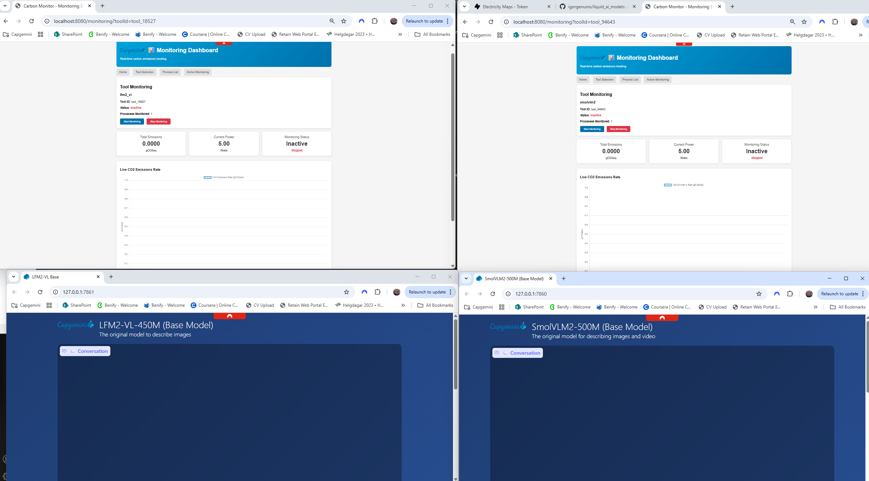

Press Start Monitoring on both. The chart should start to be populated. Try to start both at the same time to more accurately comparison.  
Now in the Models, you can upload a image and ask the same inference in both model for example:  
Firs add the inference and the image, and press Send.  
  
  
Example for results  
