* R2>en
* R2#conf t
* R2(config)#interface loopback 0 – **создаем loopback интерфейс**
* R2(config-if)#ip address 192.168.1.1 255.255.255.255 – **назначаем ему IP - адрес**
* R2(config-if)#exit
* R2(config)#interface fa 0/0
* R2(config-if)#ip address 172.16.1.1 255.255.255.0
* R2(config-if)#no sh
* R2(config-if)#exit
* R2(config)#interface fa 0/1
* R2(config-if)#ip address 10.1.0.1 255.255.255.0
* R2(config-if)#no sh
* R2(config-if)#exit
* R2(config)#ip route 0.0.0.0 0.0.0.0 10.1.0.2 – **добавляем default route**
* R2(config)#ip route 11.0.0.0 255.0.0.0 null 0 – **добавляем статический маршрут**
* R2(config)#ip route 12.0.0.0 255.0.0.0 null 0
* R2(config)#ip route 13.0.0.0 255.0.0.0 null 0
* R2(config)#router ospf 1 – **заходим в настройки OSPF и одновременно запускаем процесс**
* R2(config-router)#network 172.16.1.0 0.0.0.255 area 0 – **добавляем все интерфейсы из сети 172.16.1.x в Area 0 (магистральная зона)**
* R2(config-router)#default-information originate – **прописываем, что default route будет объявляться всем участникам OSPF этим роутером**
* R2(config-router)#redistribute static subnets – **включаем редистрибуцию статических маршрутов в процесс OSPF. Таким образом, об этих маршрутах будут знать все участники процесса OSPF, а не только R2.**
* R2(config-router)#exit
* R2(config)#exit
* R2#wr
* R2#

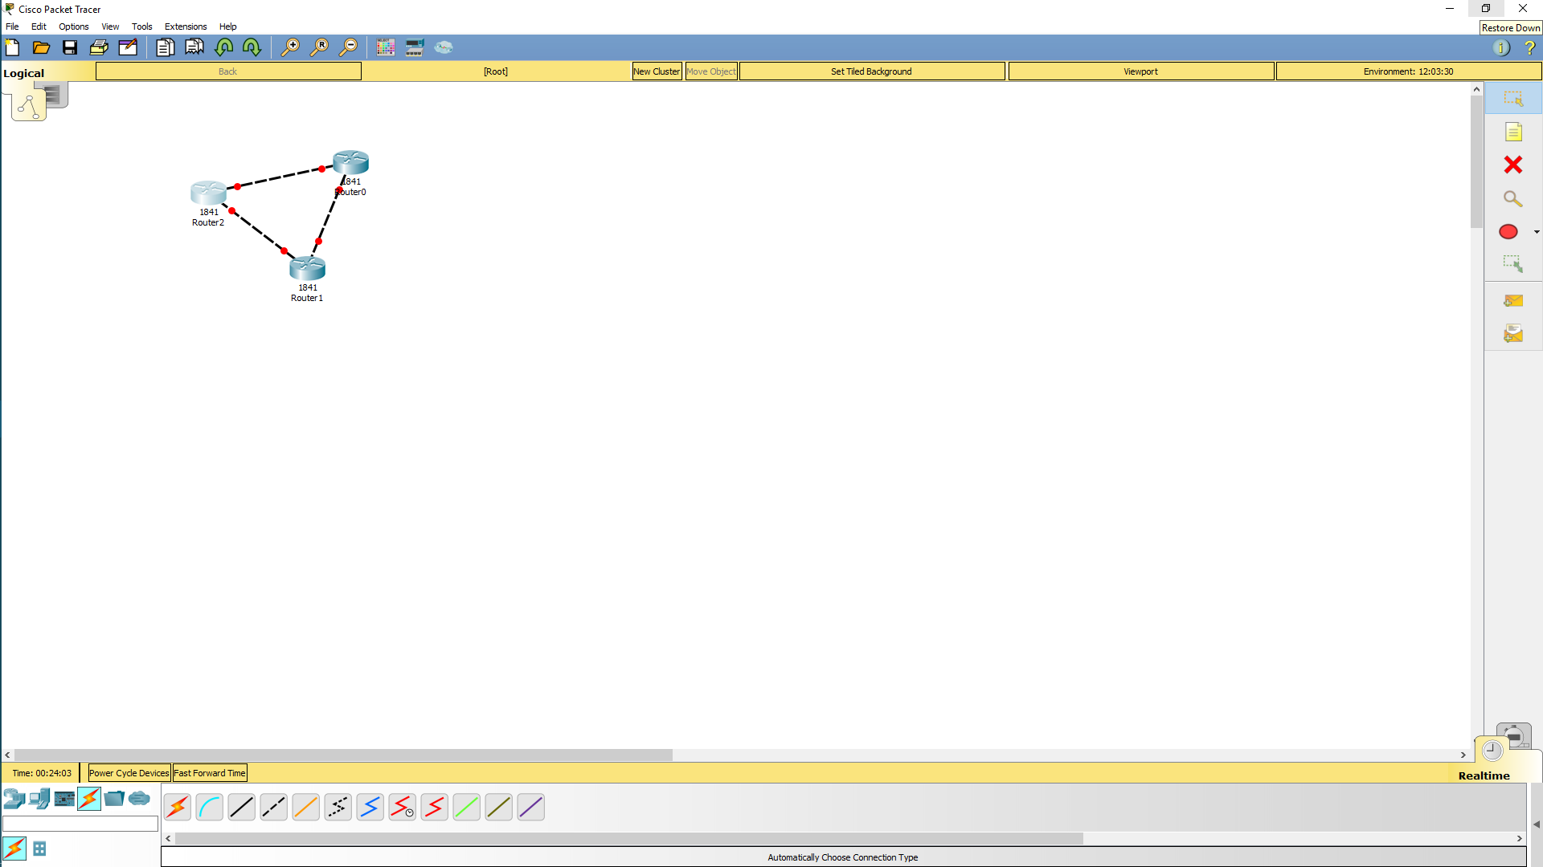

После команды show run

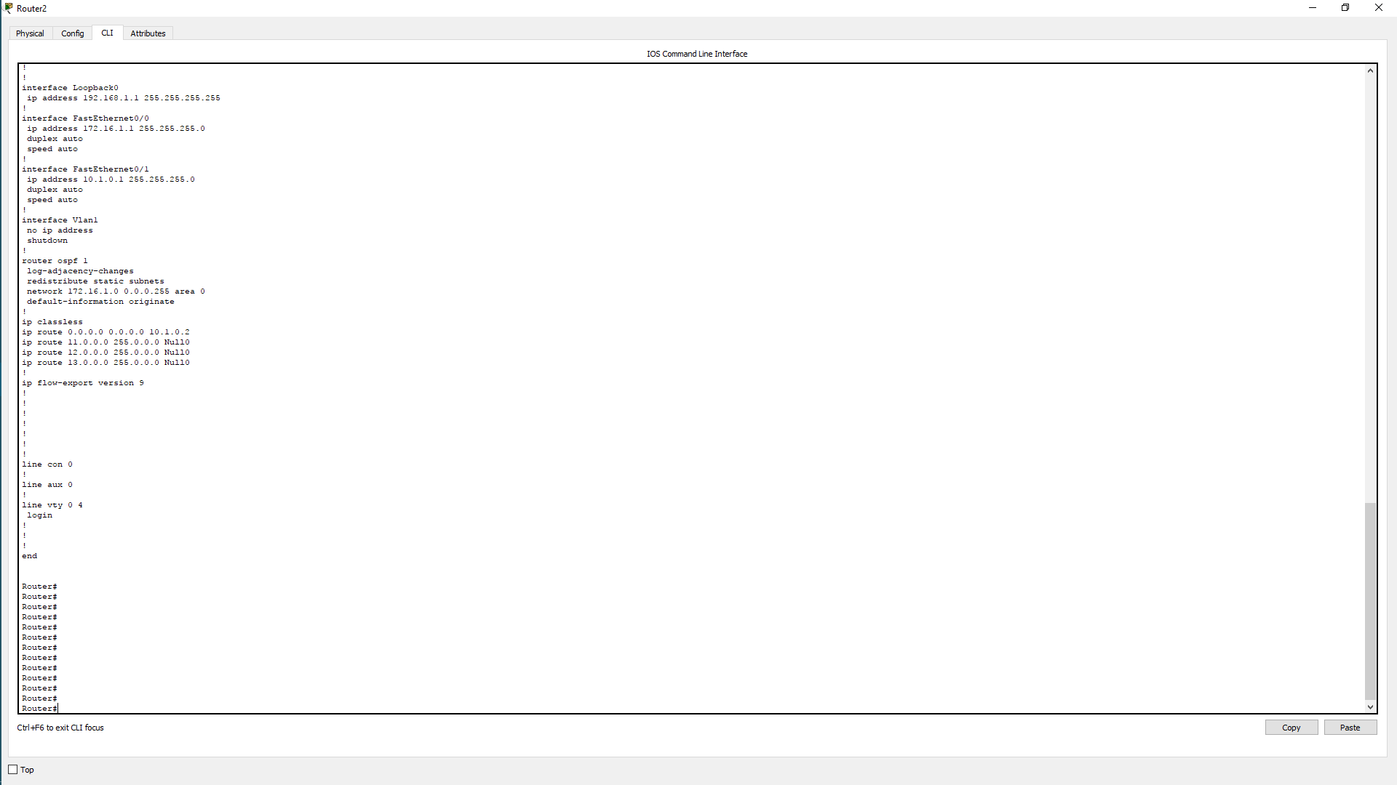

настройка роутера 1

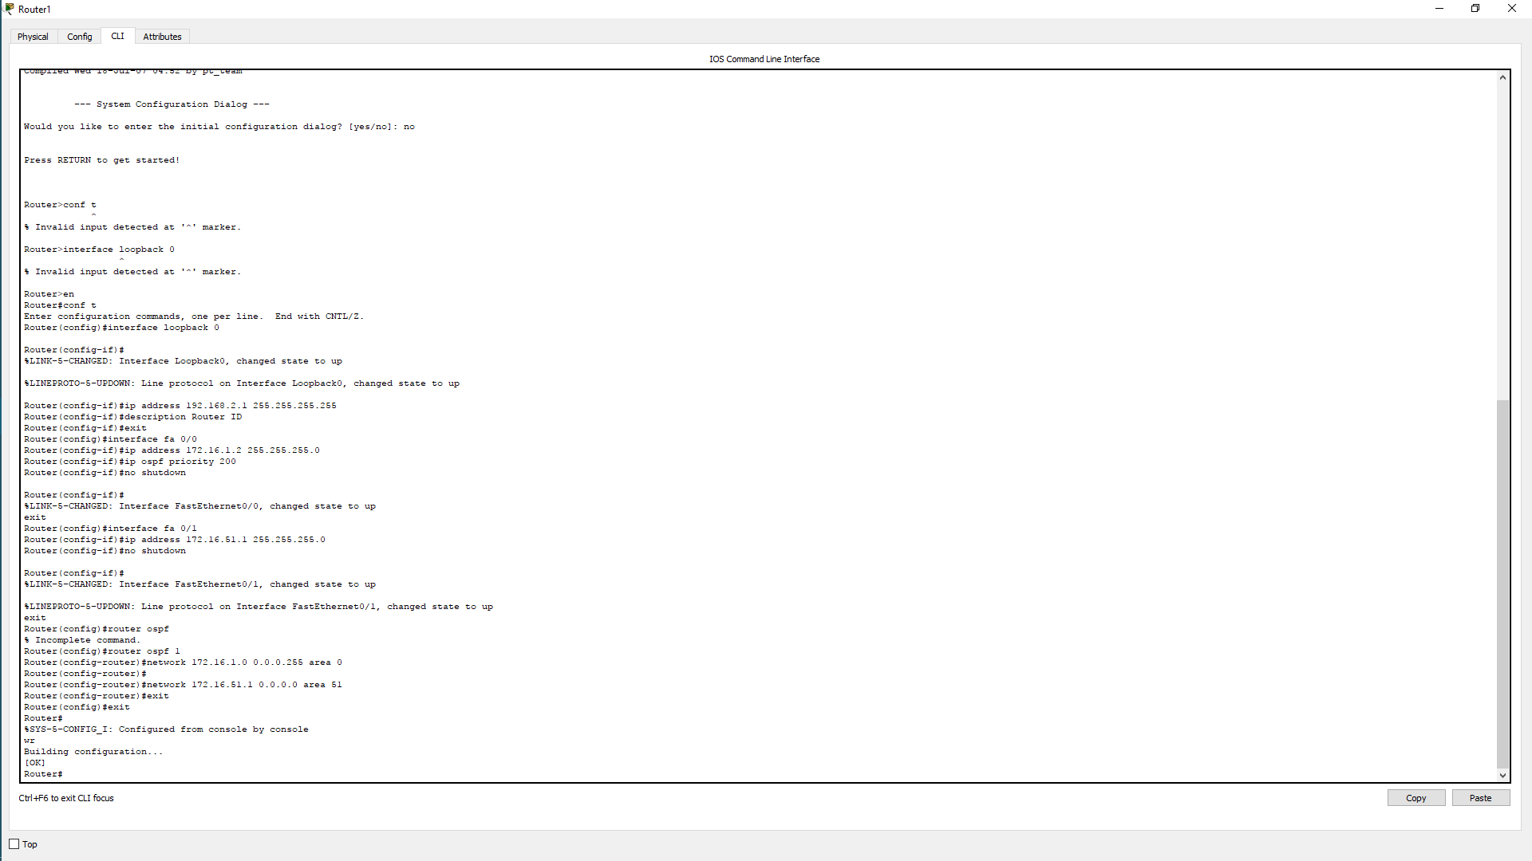

выведем рещультаты

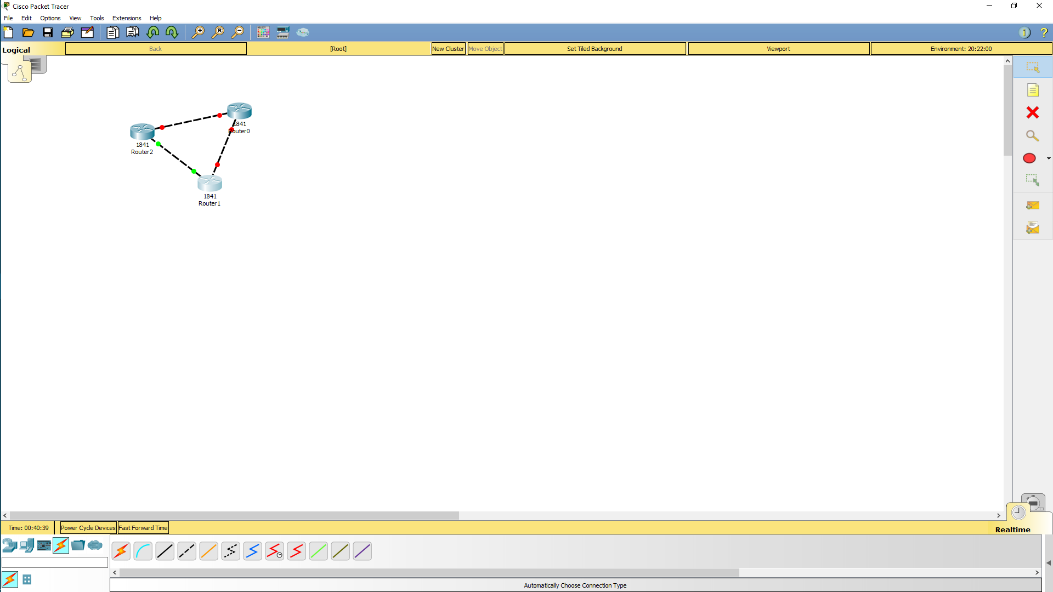

Router(config-if)#interface Serial0/1/1

Router(config-if)#ip address 3.0.0.3 255.255.255.0

Router(config-if)#no shutdown

Построим всю схему

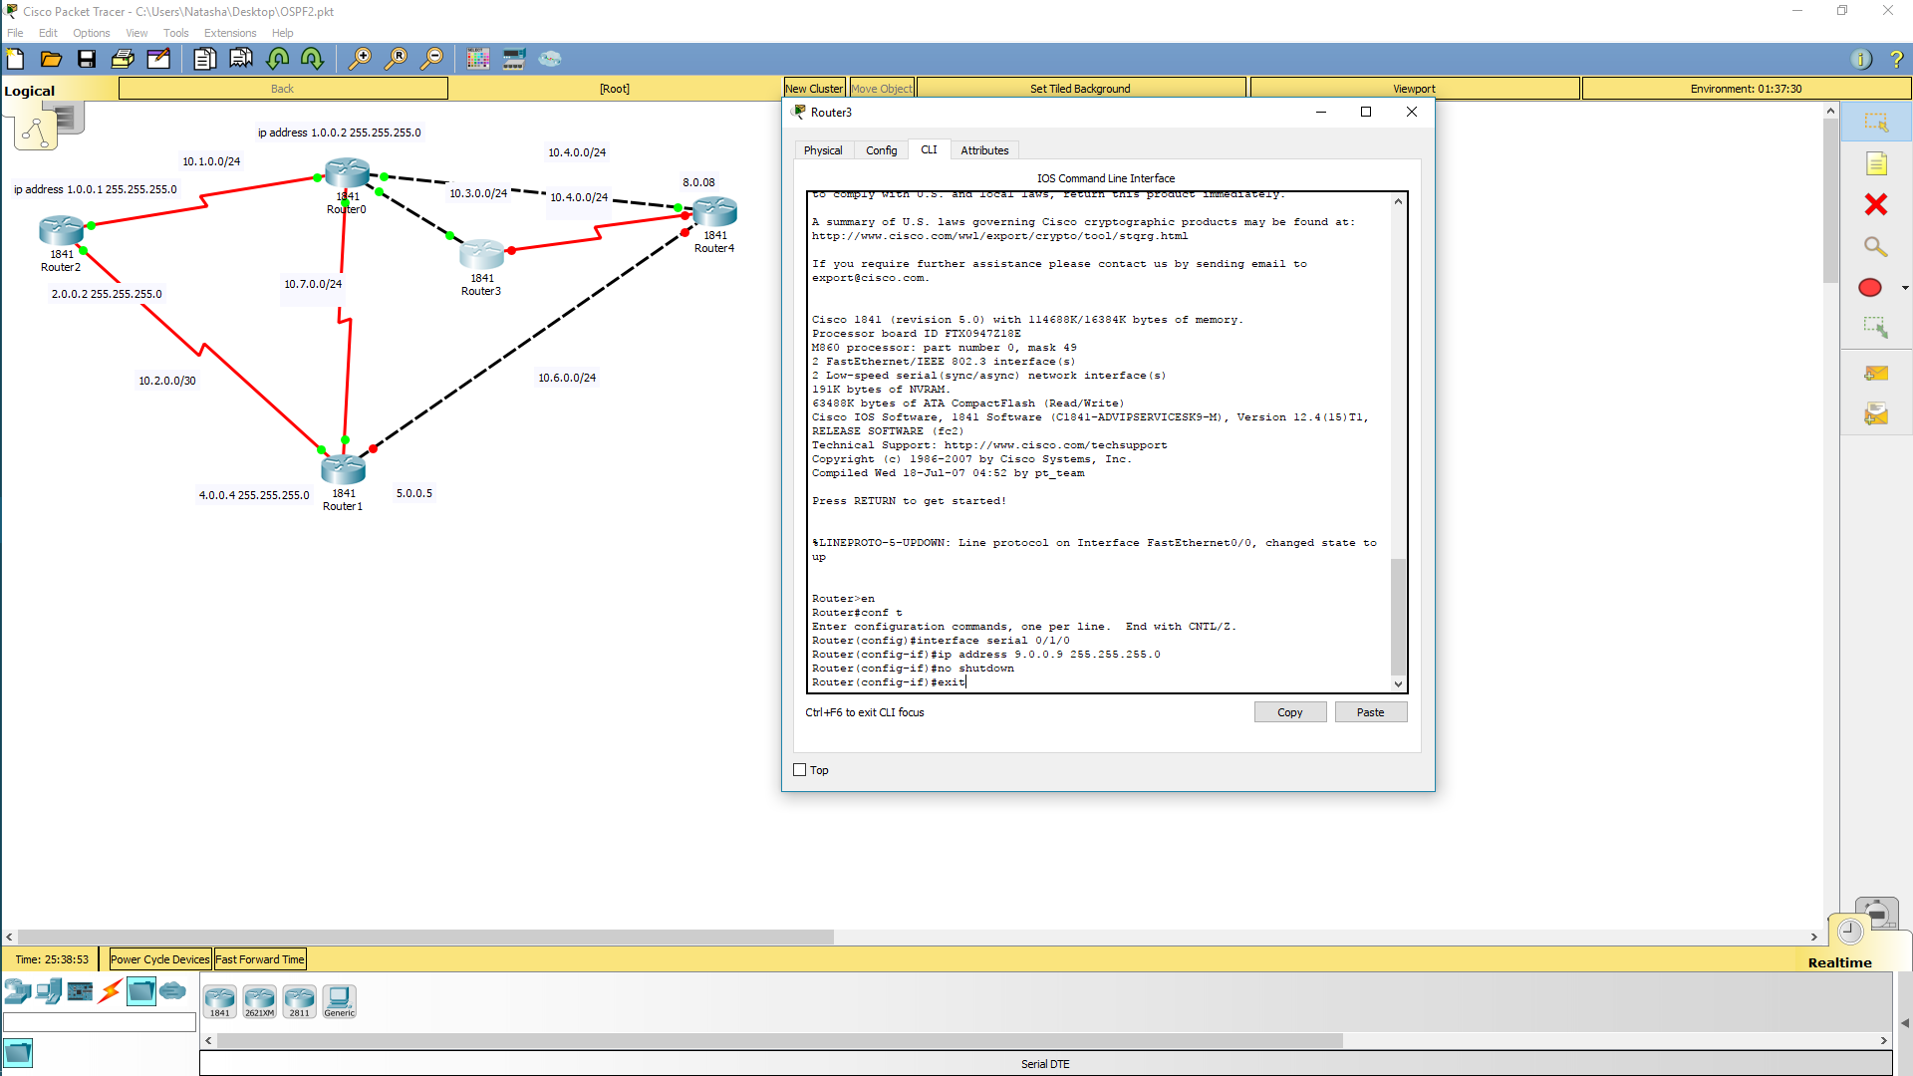

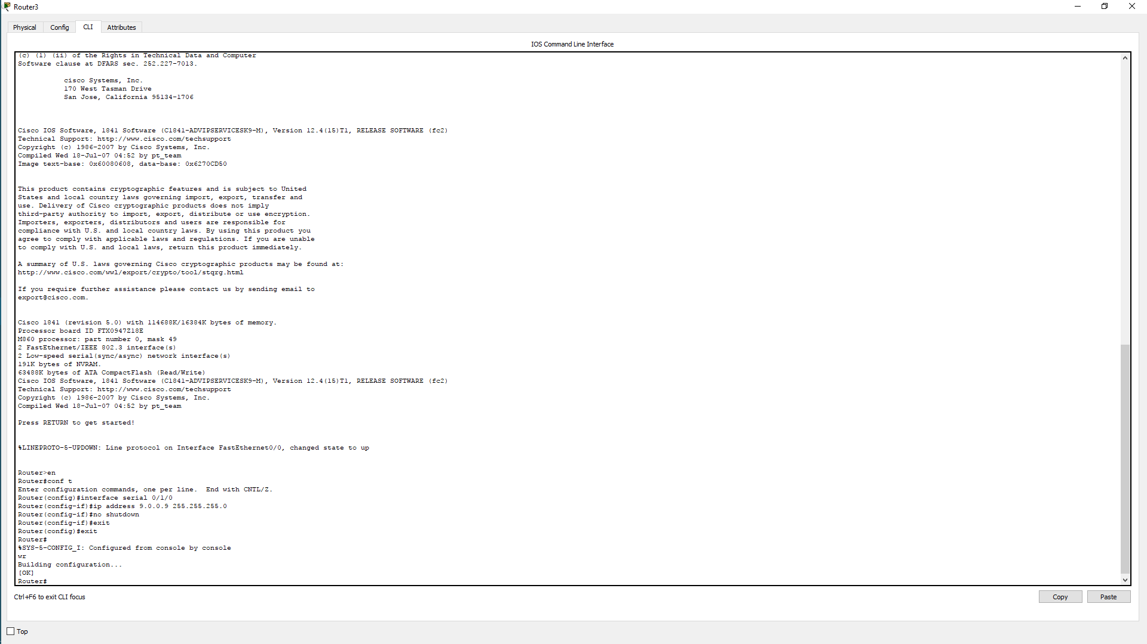

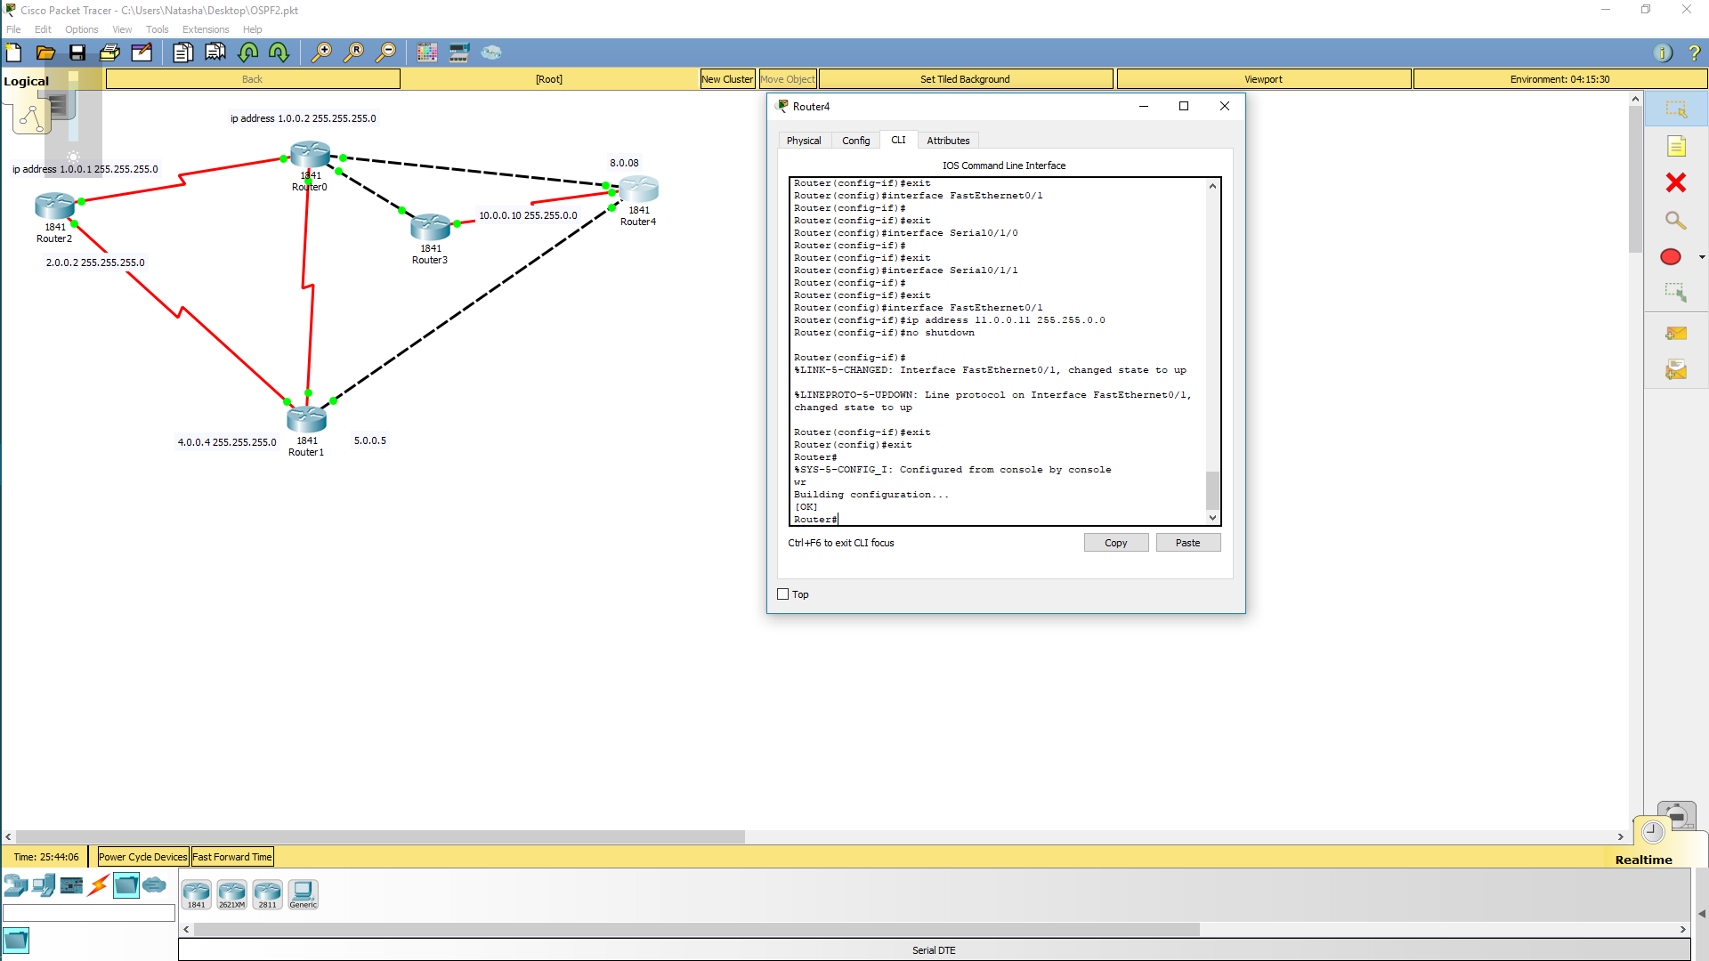

Все интерфейсы прописаны

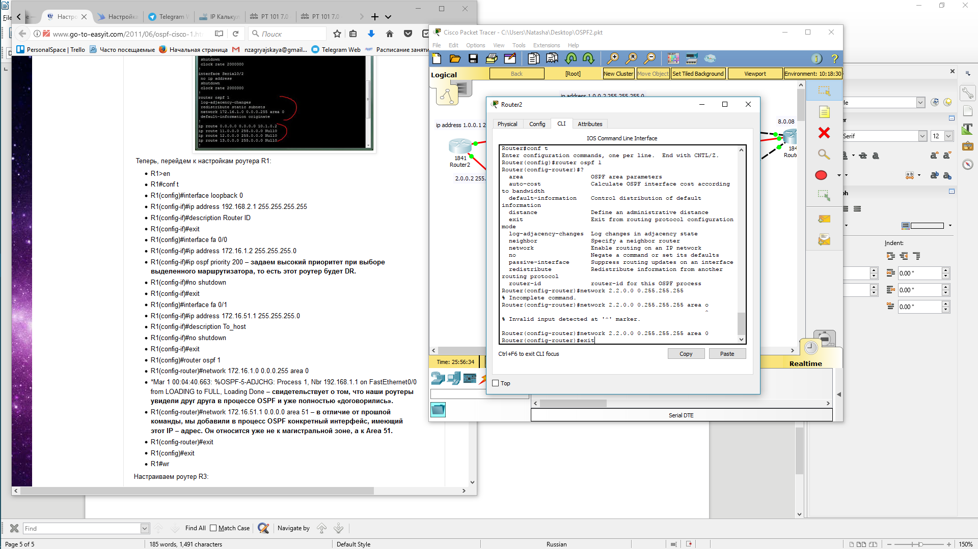Начнем настройку ospf

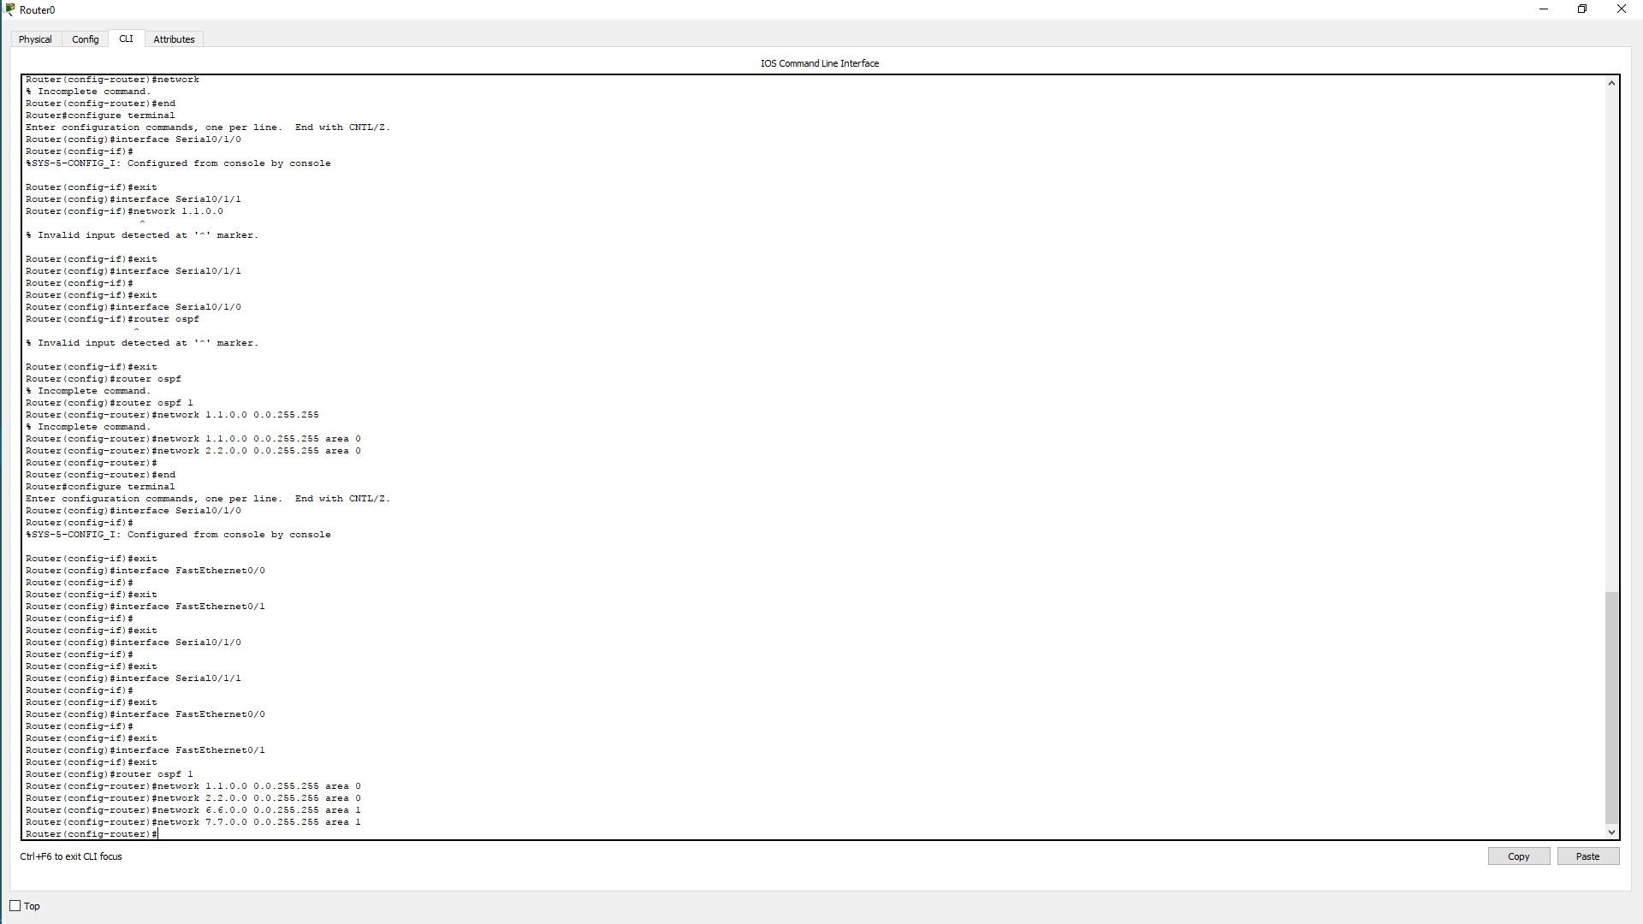

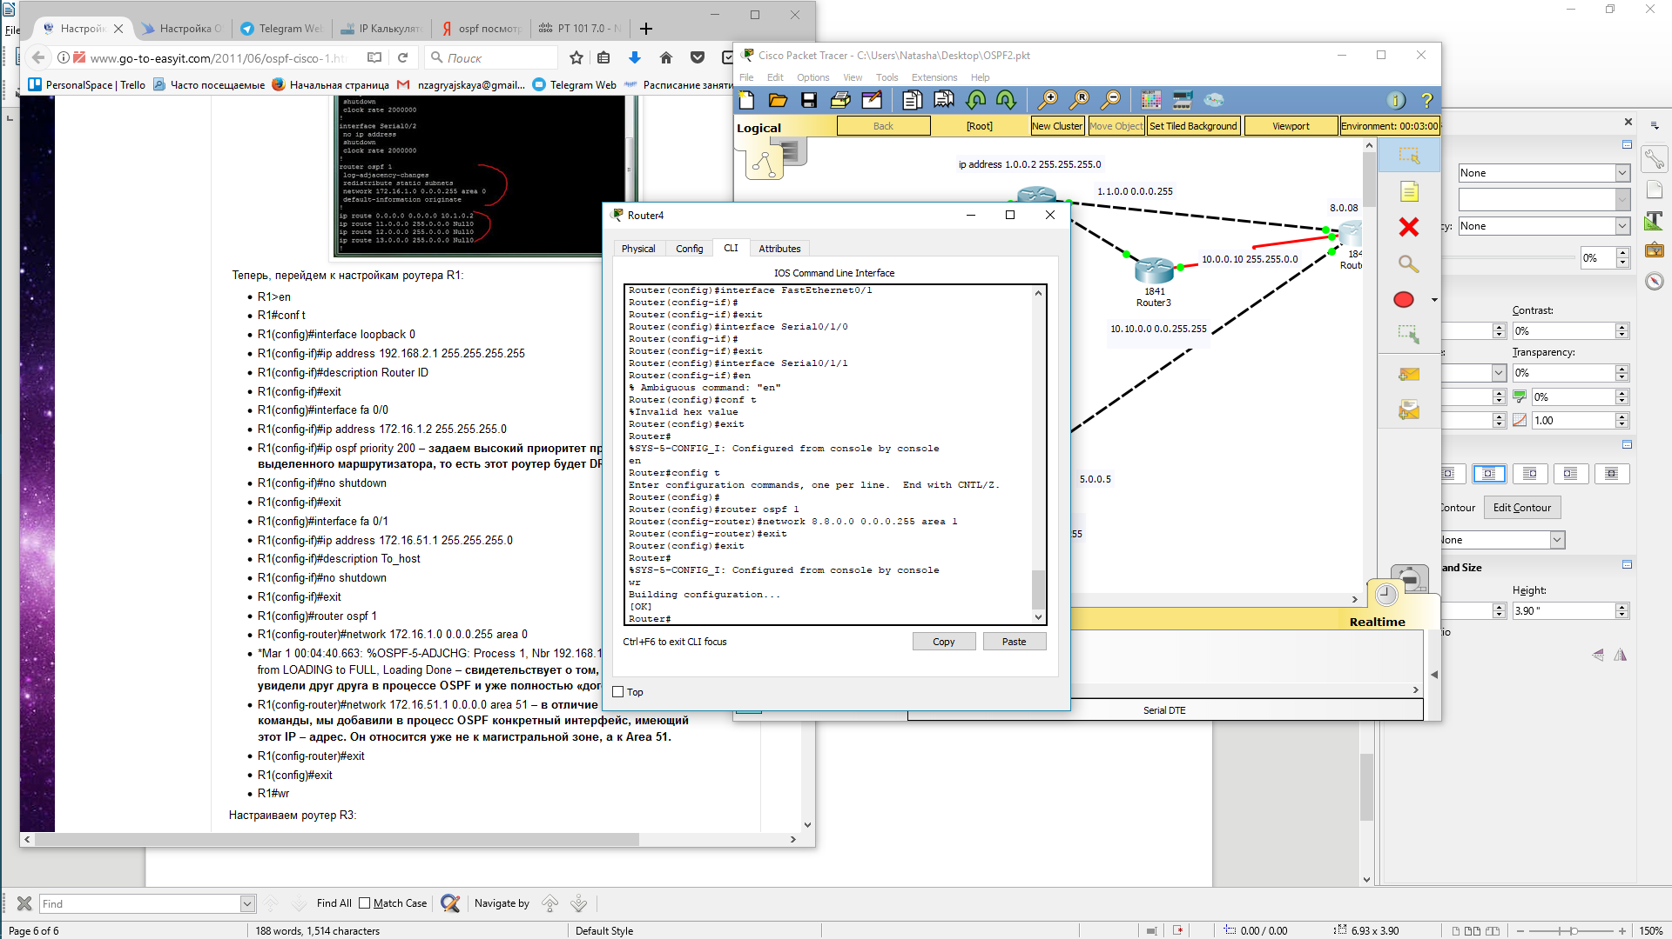

Выполним настройку оспф на первом роутере и убедимся что все верно внесено в зону

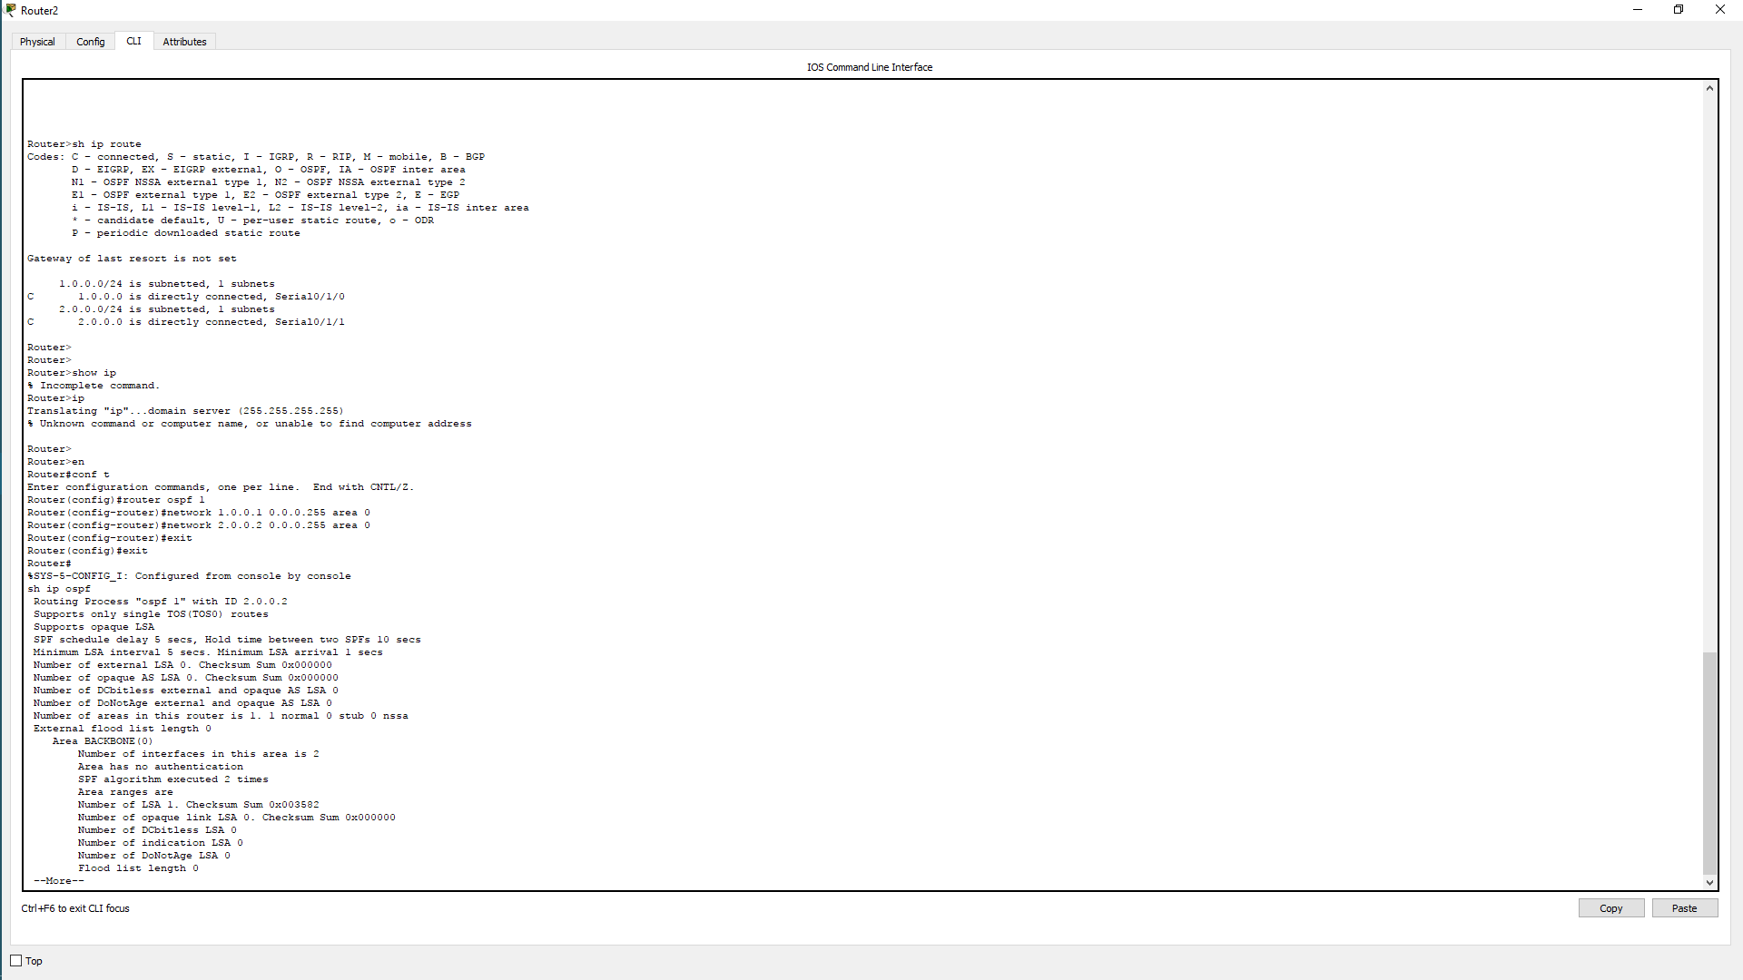

Router(config)#router ospf 1

Router(config-router)#network

% Incomplete command.

Router(config-router)#end

Router#configure terminal

Enter configuration commands, one per line. End with CNTL/Z.

Router(config)#interface Serial0/1/0

Router(config-if)#

%SYS-5-CONFIG_I: Configured from console by network nen

Router(config-if)#exit

Router(config)#

Router(config)#interface Serial0/1/0

Router(config-if)#

Router(config-if)#exit

Router(config)#interface Serial0/1/0

Router(config-if)#

Router(config-if)#exit

Router(config)#interface Serial0/1/1

Router(config-if)#

Router(config-if)#exit

Router(config)#interface FastEthernet0/0

Router(config-if)#

Router(config-if)#exit

Router(config)#interface FastEthernet0/1

Router(config-if)#exit

Router(config)#router ospf 1

Router(config-router)#network 1.0.0.2 0.0.0.255 area 0

Router(config-router)#network 2.2.0.2 0.0.0.255 area 0

Router(config-router)#network 6.0.0.6 0.0.0.255 area 1

Router(config-router)#network 7.0.0.7 0.0.0.255 area 1

Router(config-router)#exit

Router(config)#exit

Router#

%SYS-5-CONFIG_I: Configured from console by console

sh ip route

Codes: C - connected, S - static, I - IGRP, R - RIP, M - mobile, B - BGP

D - EIGRP, EX - EIGRP external, O - OSPF, IA - OSPF inter area

N1 - OSPF NSSA external type 1, N2 - OSPF NSSA external type 2

E1 - OSPF external type 1, E2 - OSPF external type 2, E - EGP

i - IS-IS, L1 - IS-IS level-1, L2 - IS-IS level-2, ia - IS-IS inter area

* - candidate default, U - per-user static route, o - ODR

P - periodic downloaded static route

Gateway of last resort is not set

1.0.0.0/16 is subnetted, 1 subnets

C 1.0.0.0 is directly connected, Serial0/1/0

2.0.0.0/16 is subnetted, 1 subnets

C 2.2.0.0 is directly connected, Serial0/1/1

6.0.0.0/16 is subnetted, 1 subnets

C 6.0.0.0 is directly connected, FastEthernet0/0

7.0.0.0/16 is subnetted, 1 subnets

C 7.0.0.0 is directly connected, FastEthernet0/1

Router#

Router#sh ip ospf

Routing Process "ospf 1" with ID 7.0.0.7

Supports only single TOS(TOS0) routes

Supports opaque LSA

It is an area border router

SPF schedule delay 5 secs, Hold time between two SPFs 10 secs

Minimum LSA interval 5 secs. Minimum LSA arrival 1 secs

Number of external LSA 0. Checksum Sum 0x000000

Number of opaque AS LSA 0. Checksum Sum 0x000000

Number of DCbitless external and opaque AS LSA 0

Number of DoNotAge external and opaque AS LSA 0

Number of areas in this router is 2. 2 normal 0 stub 0 nssa

External flood list length 0

Area BACKBONE(0)

Number of interfaces in this area is 2

Area has no authentication

SPF algorithm executed 6 times

Area ranges are

Number of LSA 3. Checksum Sum 0x023100

Number of opaque link LSA 0. Checksum Sum 0x000000

Number of DCbitless LSA 0

Number of indication LSA 0

Number of DoNotAge LSA 0

Flood list length 0

Area 1

Number of interfaces in this area is 2

Area has no authentication

SPF algorithm executed 4 times

Area ranges are

Number of LSA 3. Checksum Sum 0x012d03

Number of opaque link LSA 0. Checksum Sum 0x000000

Number of DCbitless LSA 0

Number of indication LSA 0

Number of DoNotAge LSA 0

Flood list length 0

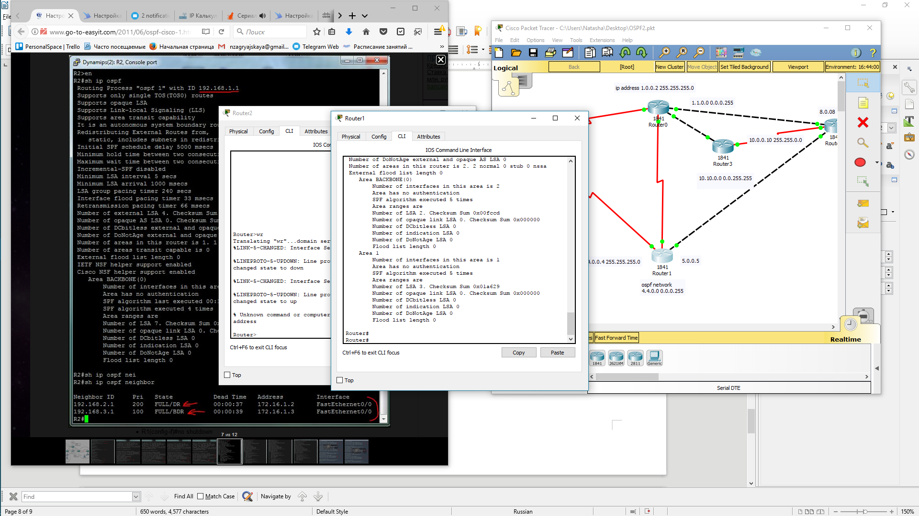Настроим следущий роутер  
  
и последний

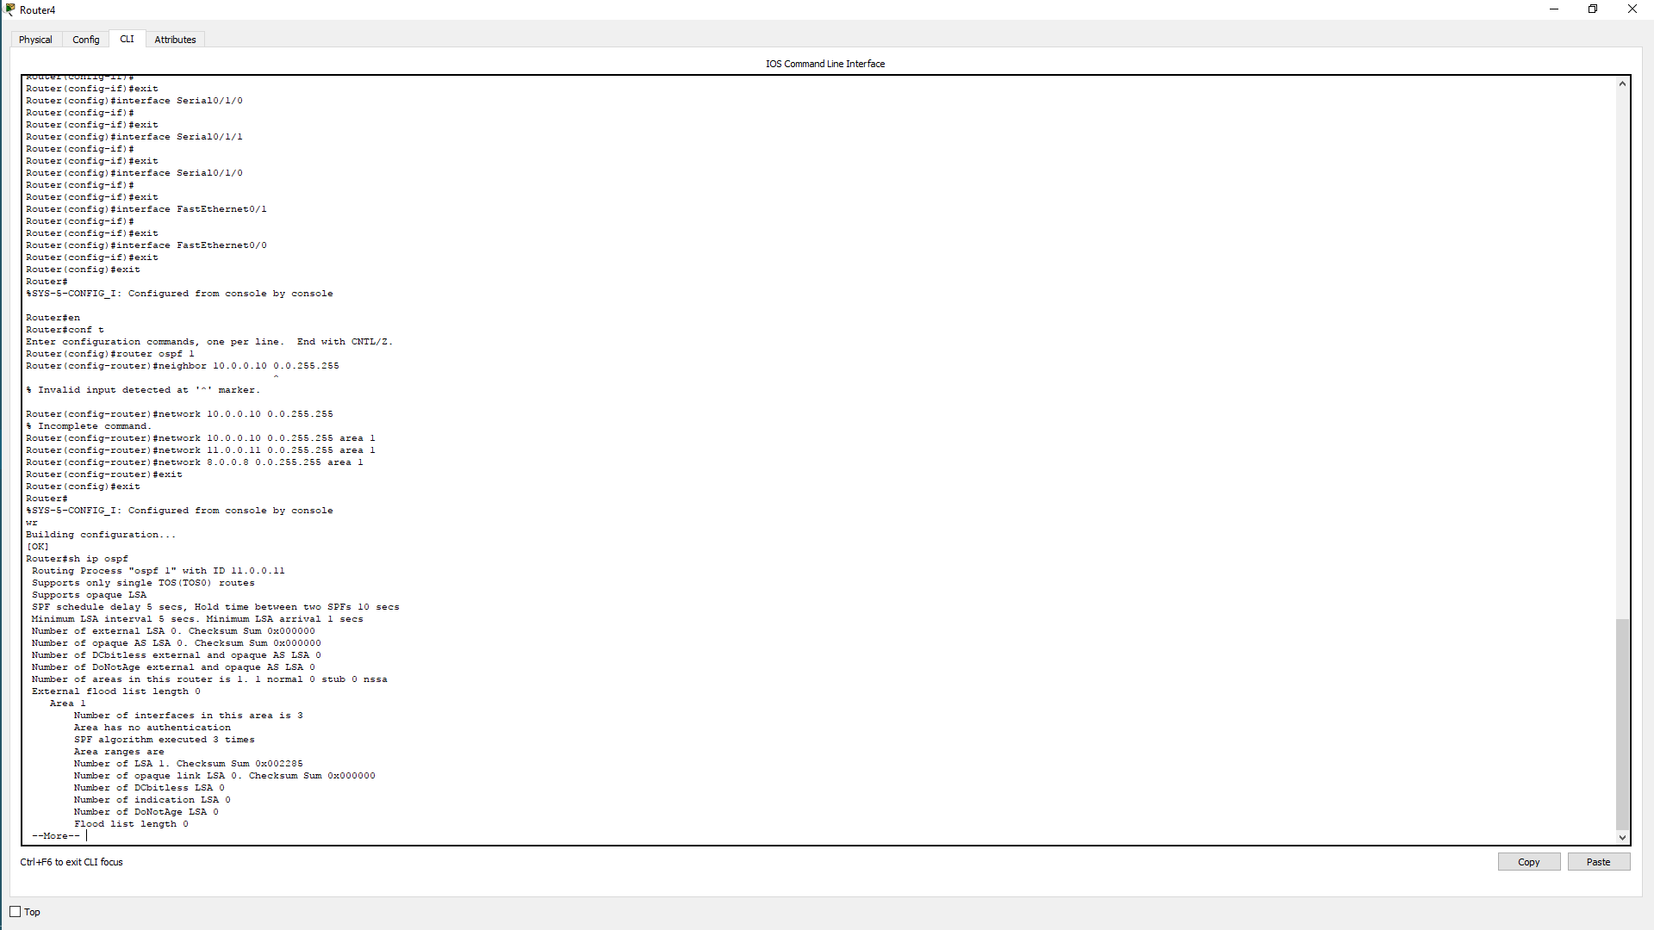

Router>en

Router#conf t

Enter configuration commands, one per line. End with CNTL/Z.

Router(config)#router ospf 1

Router(config-router)#router-id 1.1.1.1

Router(config-router)#Reload or use "clear ip ospf process"

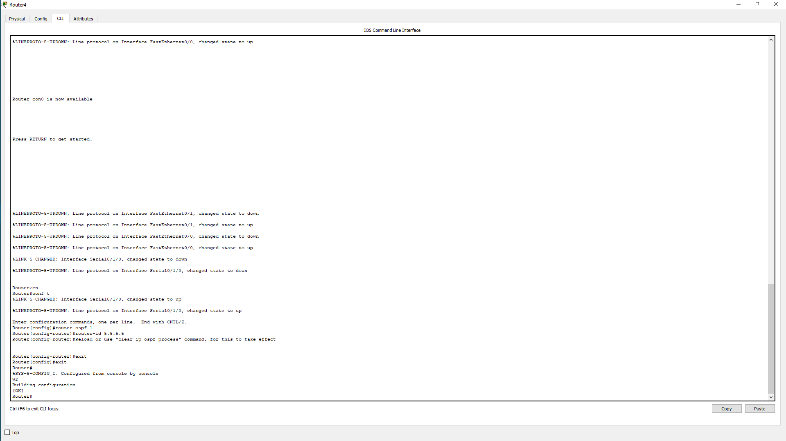

Router>en

Router#conf t

%LINK-5-CHANGED: Interface Serial0/1/0, changed state to up

%LINEPROTO-5-UPDOWN: Line protocol on Interface Serial0/1/0, changed state to up

Enter configuration commands, one per line. End with CNTL/Z.

Router(config)#router ospf 1

Router(config-router)#router-id 5.5.5.5

Router(config-router)#Reload or use "clear ip ospf process" command, for this to take effect

Router(config-router)#exit

Router(config)#exit

Router#

%SYS-5-CONFIG_I: Configured from console by console

wr

Building configuration...

[OK]

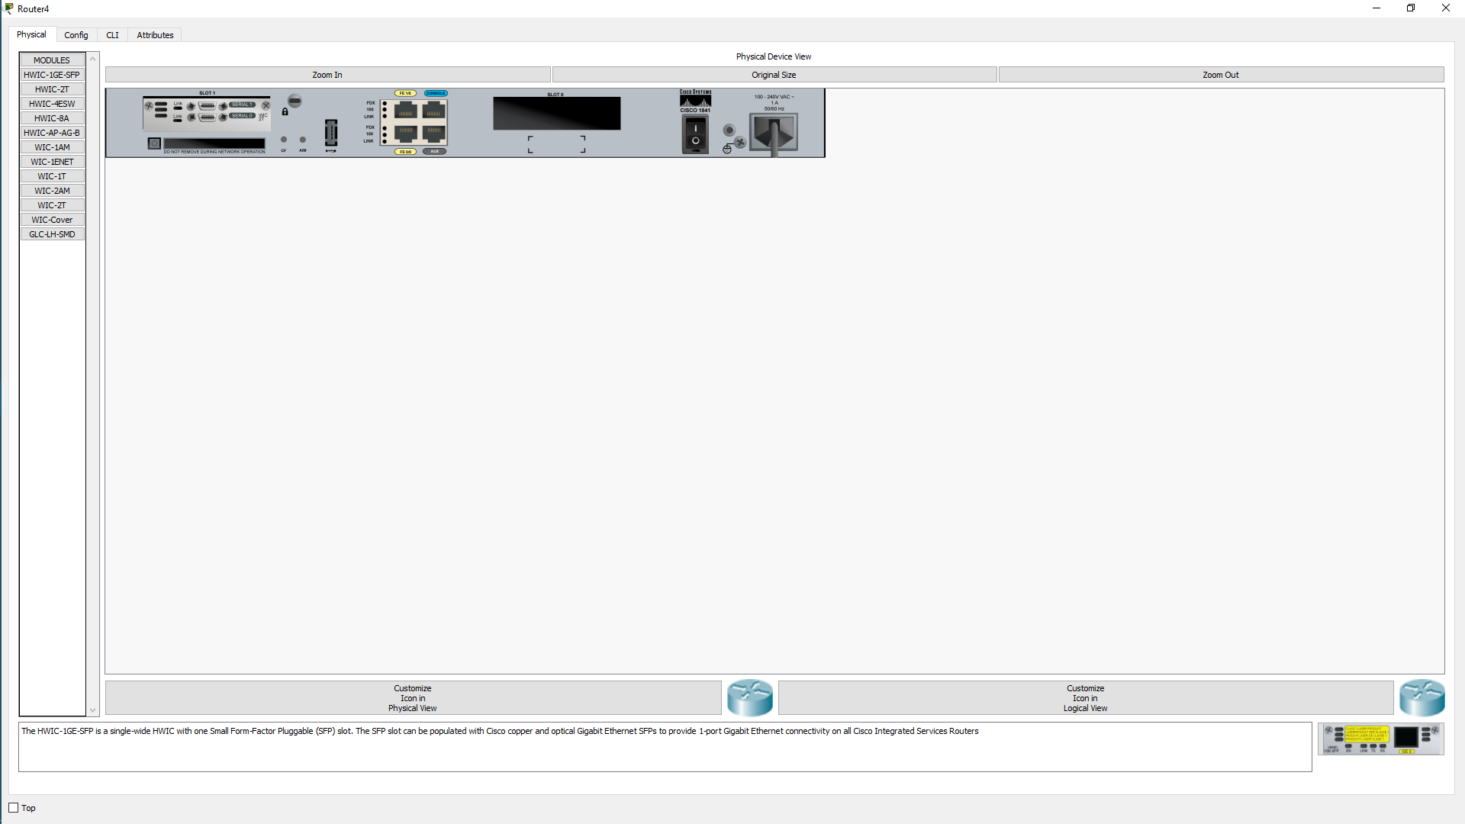Затем