- R2>en
- R2#conf t
- R2(config)#interface loopback 0 – создаем loopback интерфейс
- R2(config-if)#ip address 192.168.1.1 255.255.255.255 – назначаем ему IP - адрес
- R2(config-if)#exit
- R2(config)#interface fa 0/0
- R2(config-if)#ip address 172.16.1.1 255.255.255.0
- R2(config-if)#no sh
- R2(config-if)#exit
- R2(config)#interface fa 0/1
- R2(config-if)#ip address 10.1.0.1 255.255.255.0
- R2(config-if)#no sh
- R2(config-if)#exit
- R2(config)#ip route 0.0.0.0 0.0.0.0 10.1.0.2 – добавляем default route
- R2(config)#ip route 11.0.0.0 255.0.0.0 null 0 – добавляем статический маршрут
- R2(config)#ip route 12.0.0.0 255.0.0.0 null 0
- R2(config)#ip route 13.0.0.0 255.0.0.0 null 0
- R2(config)#router ospf 1 – заходим в настройки OSPF и одновременно запускаем процесс
- R2(config-router)#network 172.16.1.0 0.0.0.255 area 0 – добавляем все интерфейсы из сети 172.16.1.x в Area 0 (магистральная зона)
- R2(config-router)#default-information originate – прописываем, что default route будет объявляться всем участникам OSPF этим роутером
- R2(config-router)#redistribute static subnets – включаем редистрибуцию статических маршрутов в процесс OSPF. Таким образом, об этих маршрутах будут знать все участники процесса OSPF, а не только R2.
- R2(config-router)#exit
- R2(config)#exit
- R2#wr
- R2#
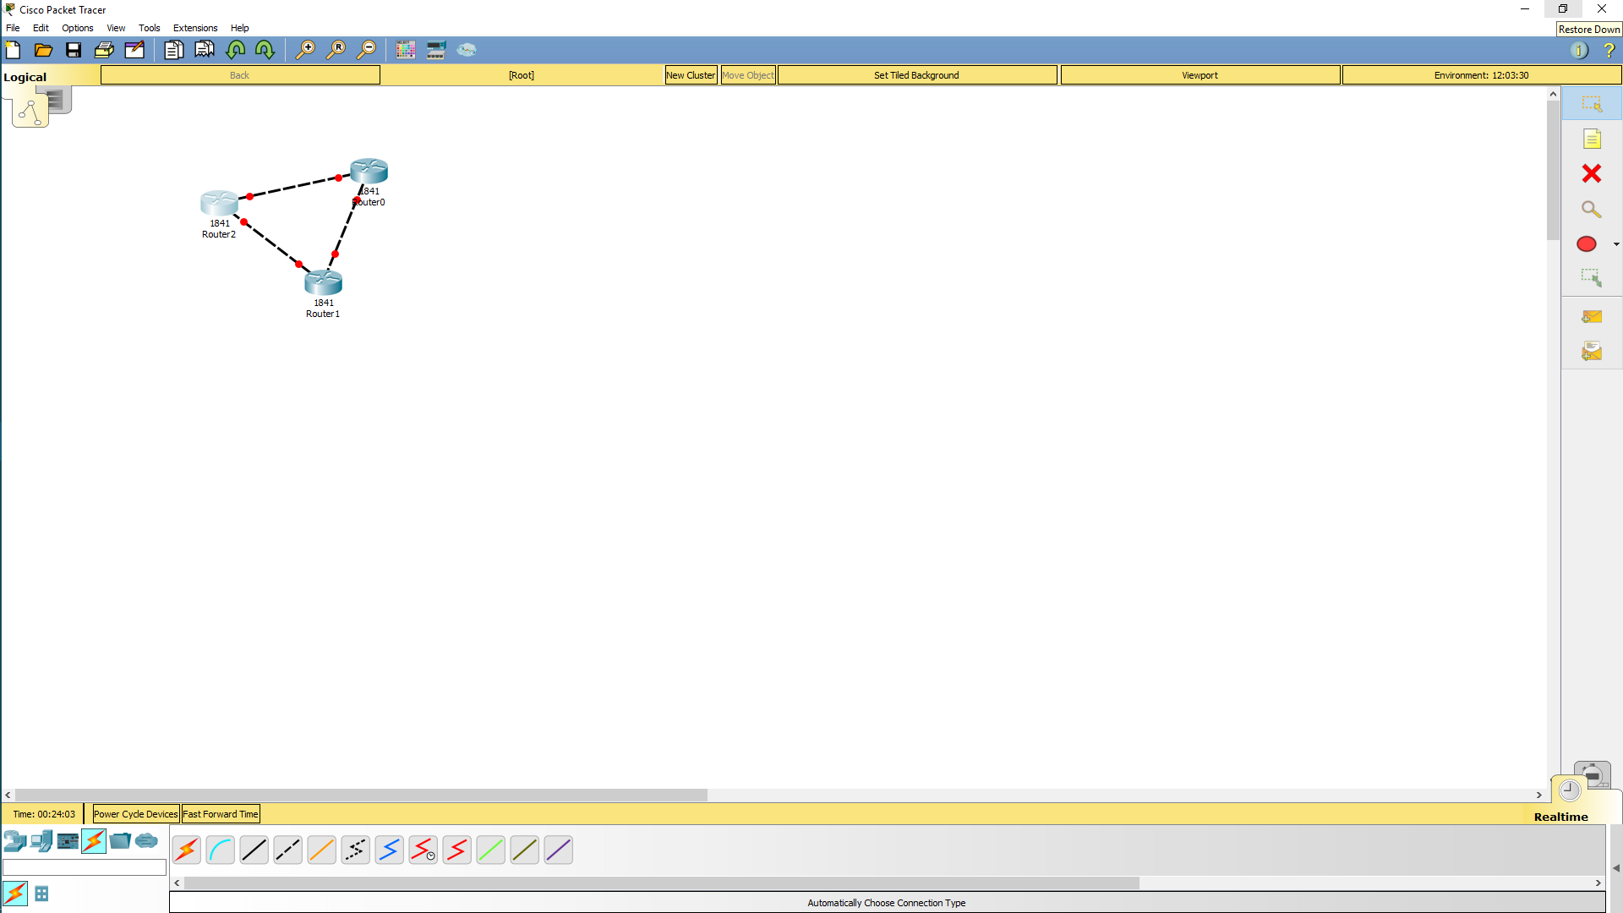
После команды show run
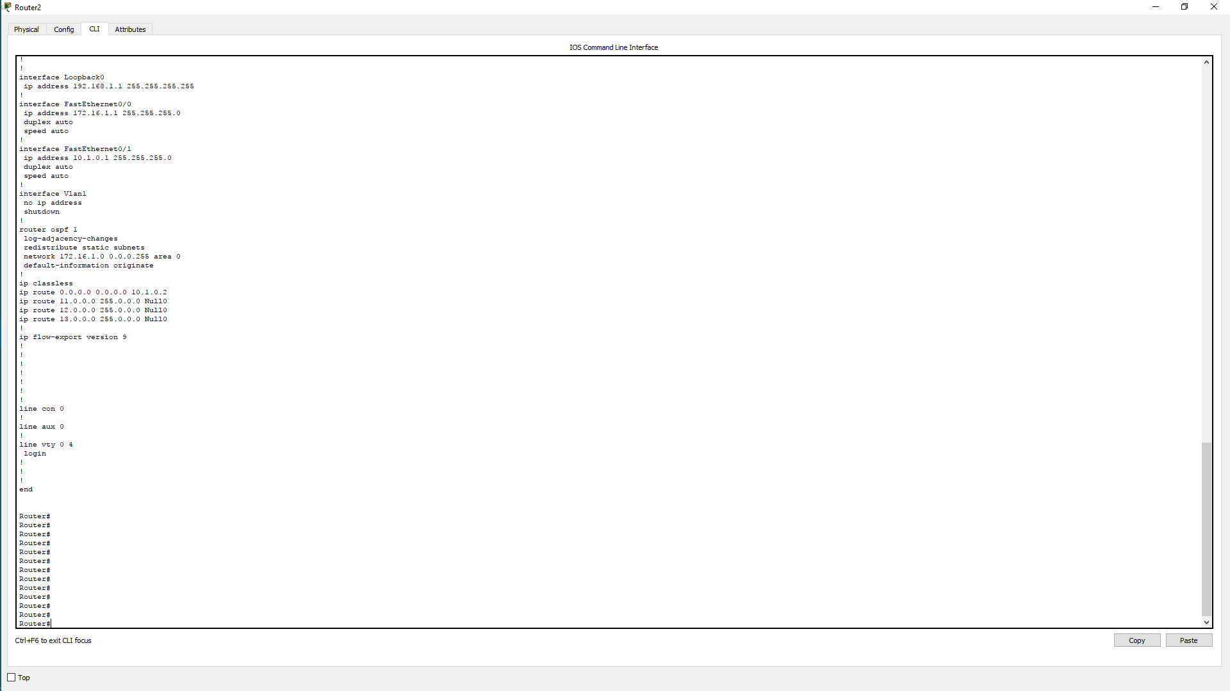

настройка роутера 1

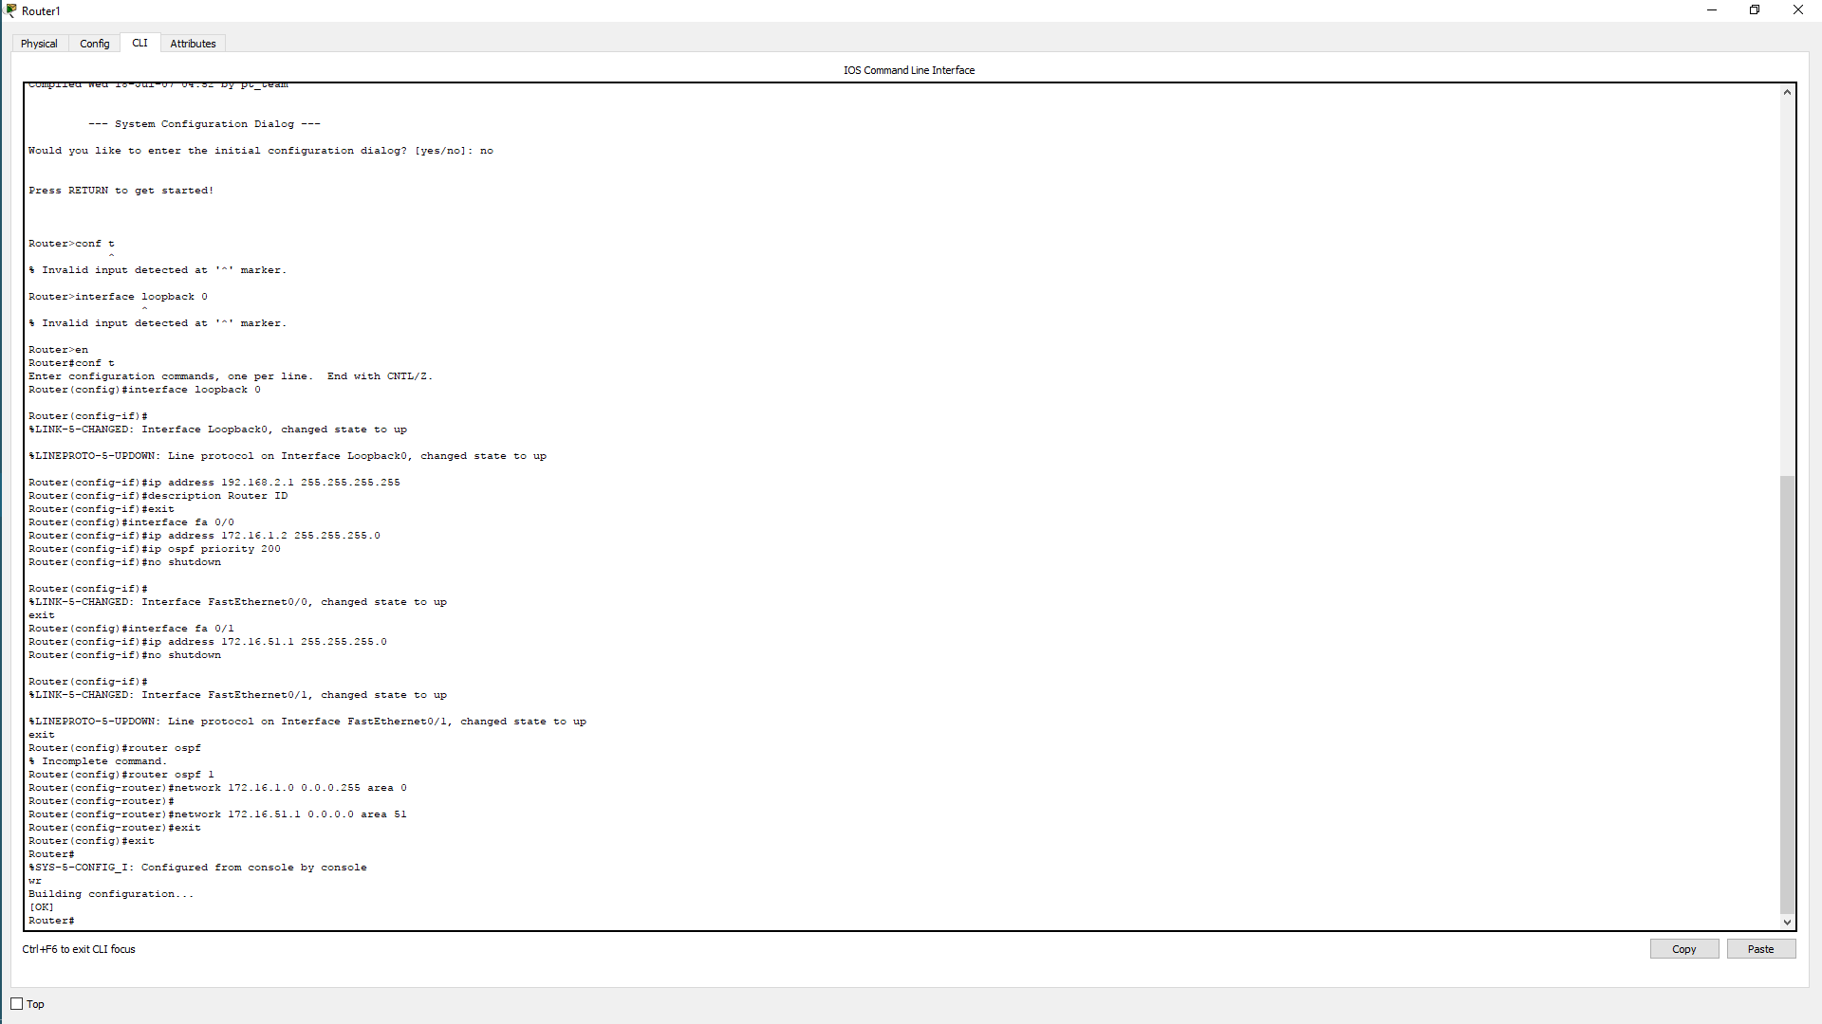

выведем рещультаты

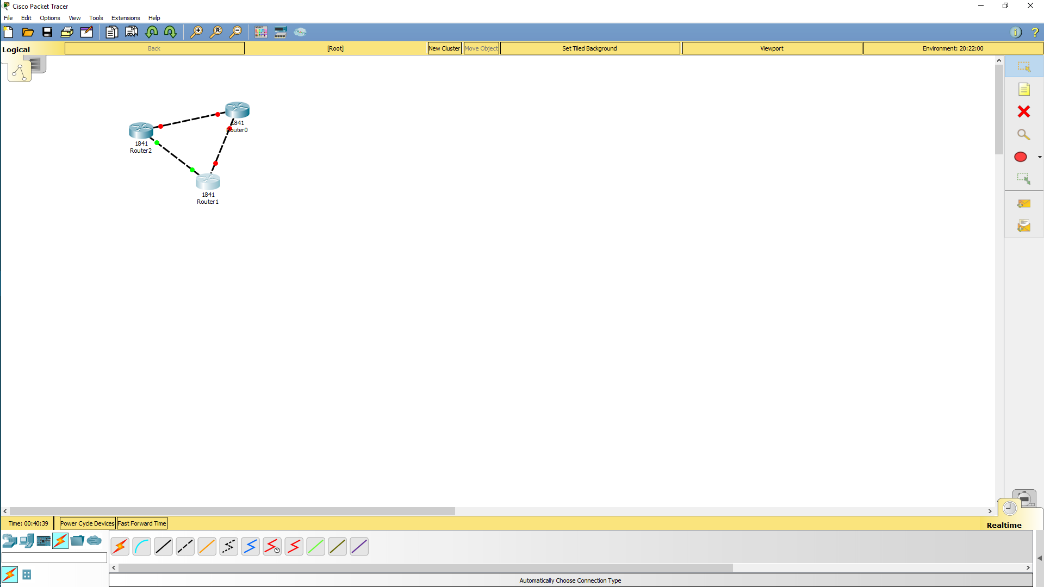

Router(config-if)#interface Serial0/1/1
Router(config-if)#ip address 3.0.0.3 255.255.255.0
Router(config-if)#no shutdown

Построим всю схему
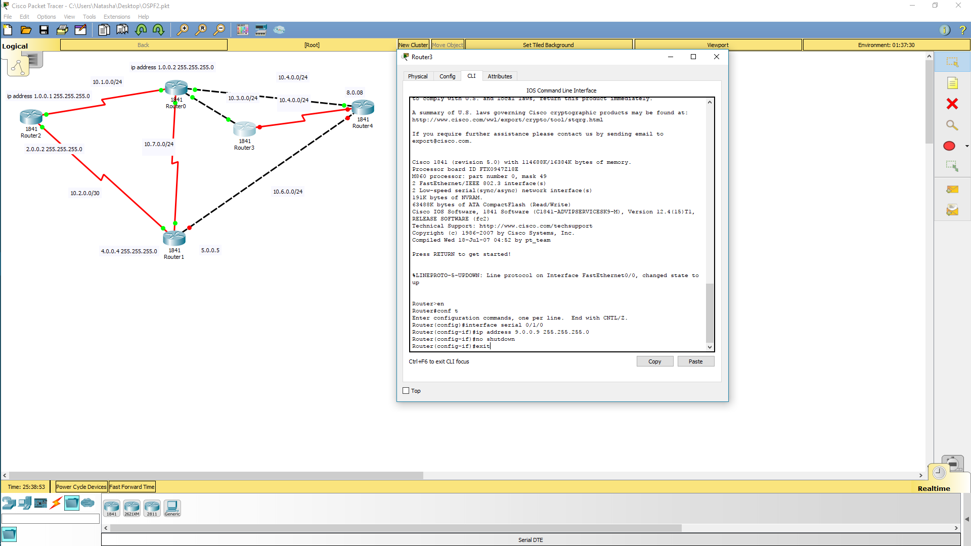

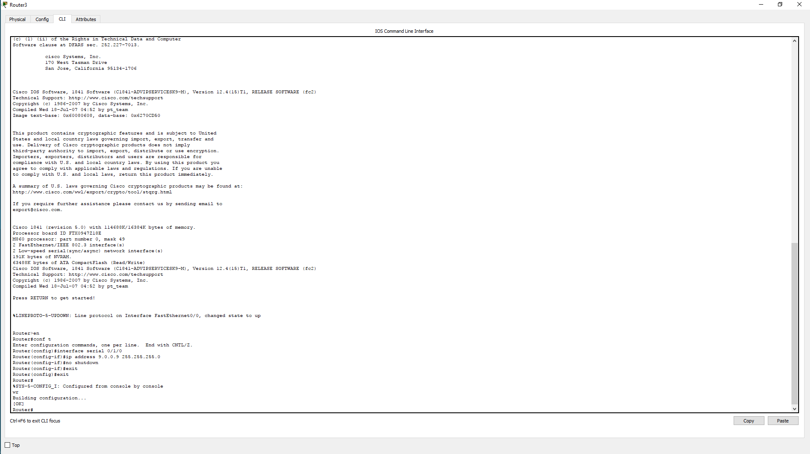

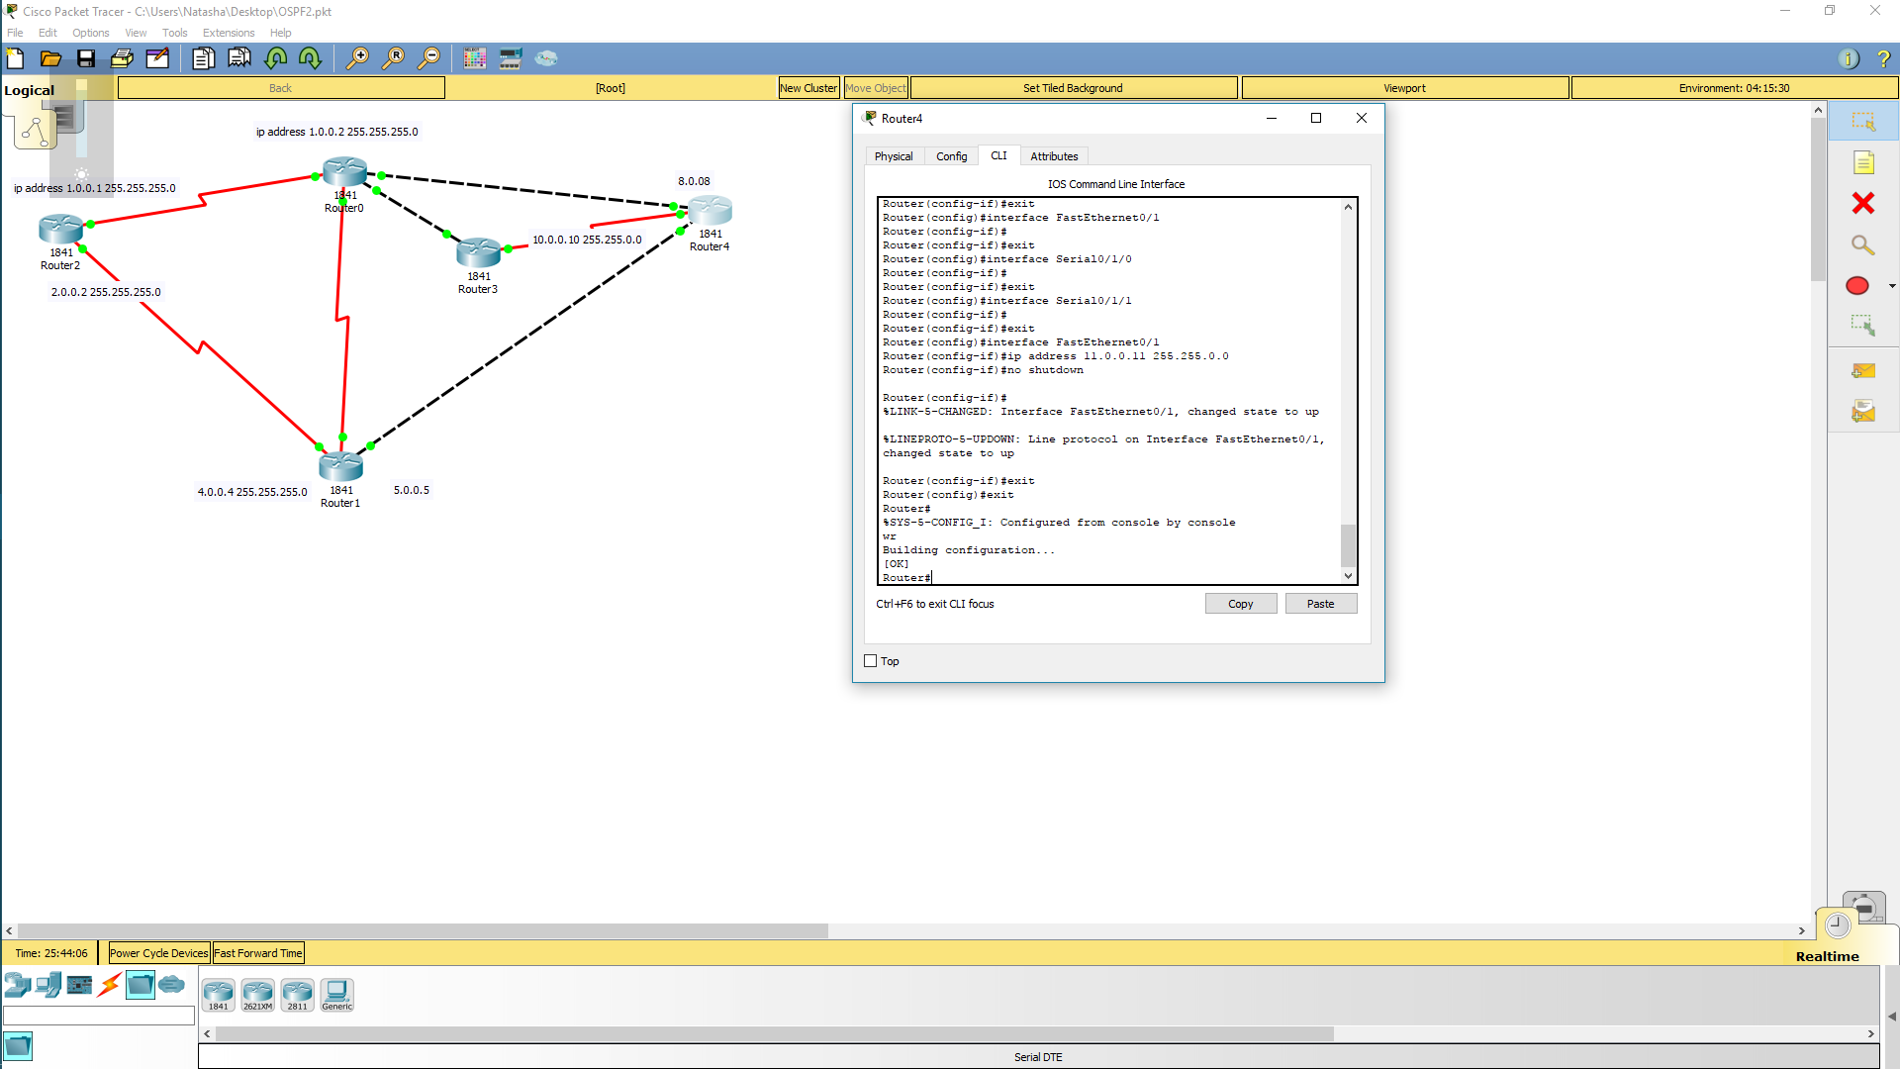

Все интерфейсы прописаны
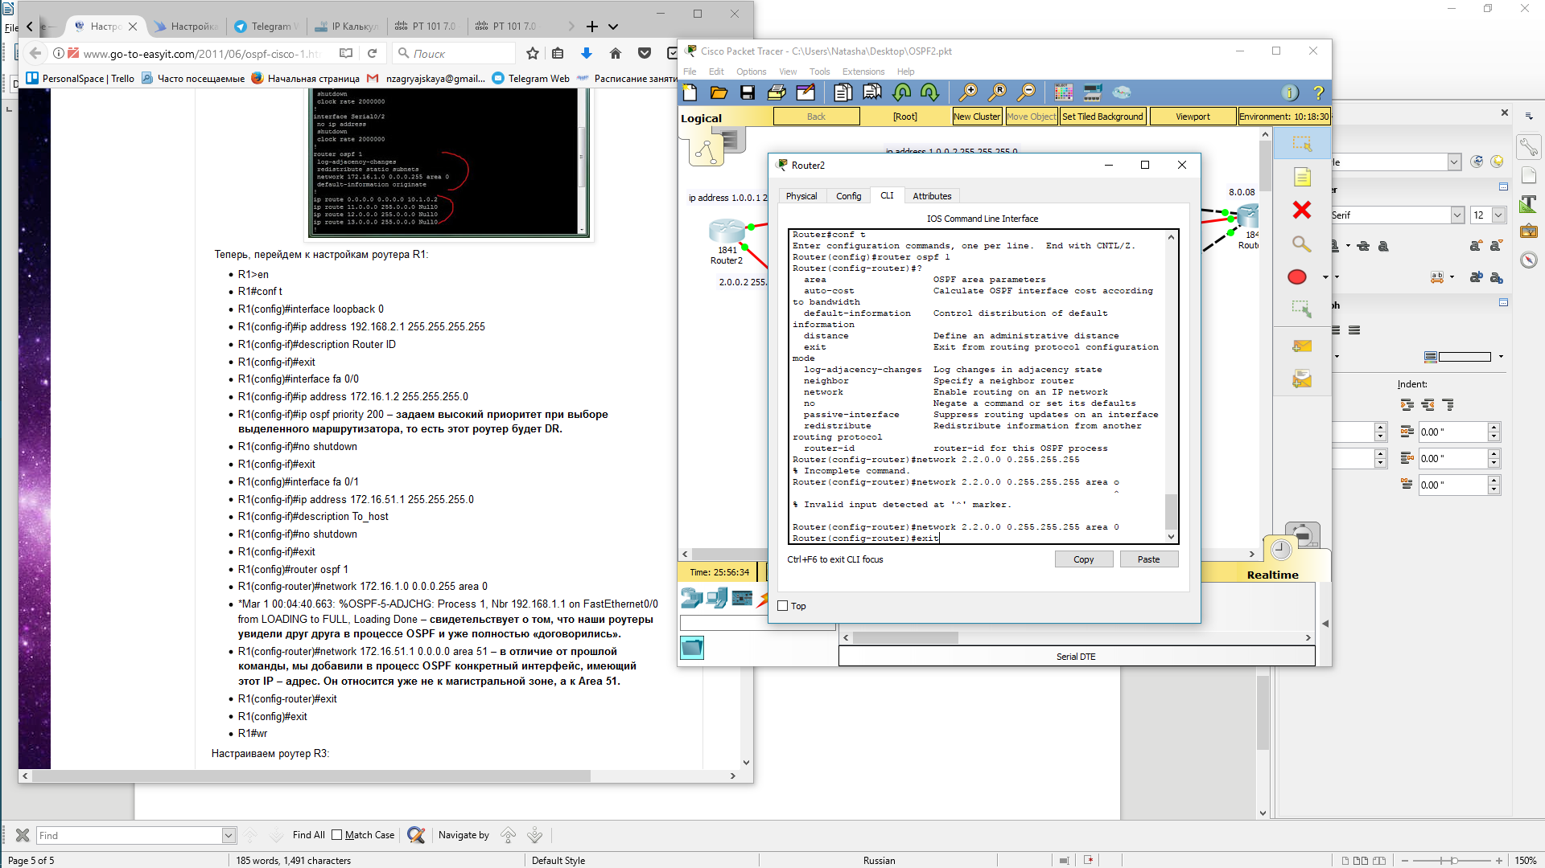
Начнем настройку ospf

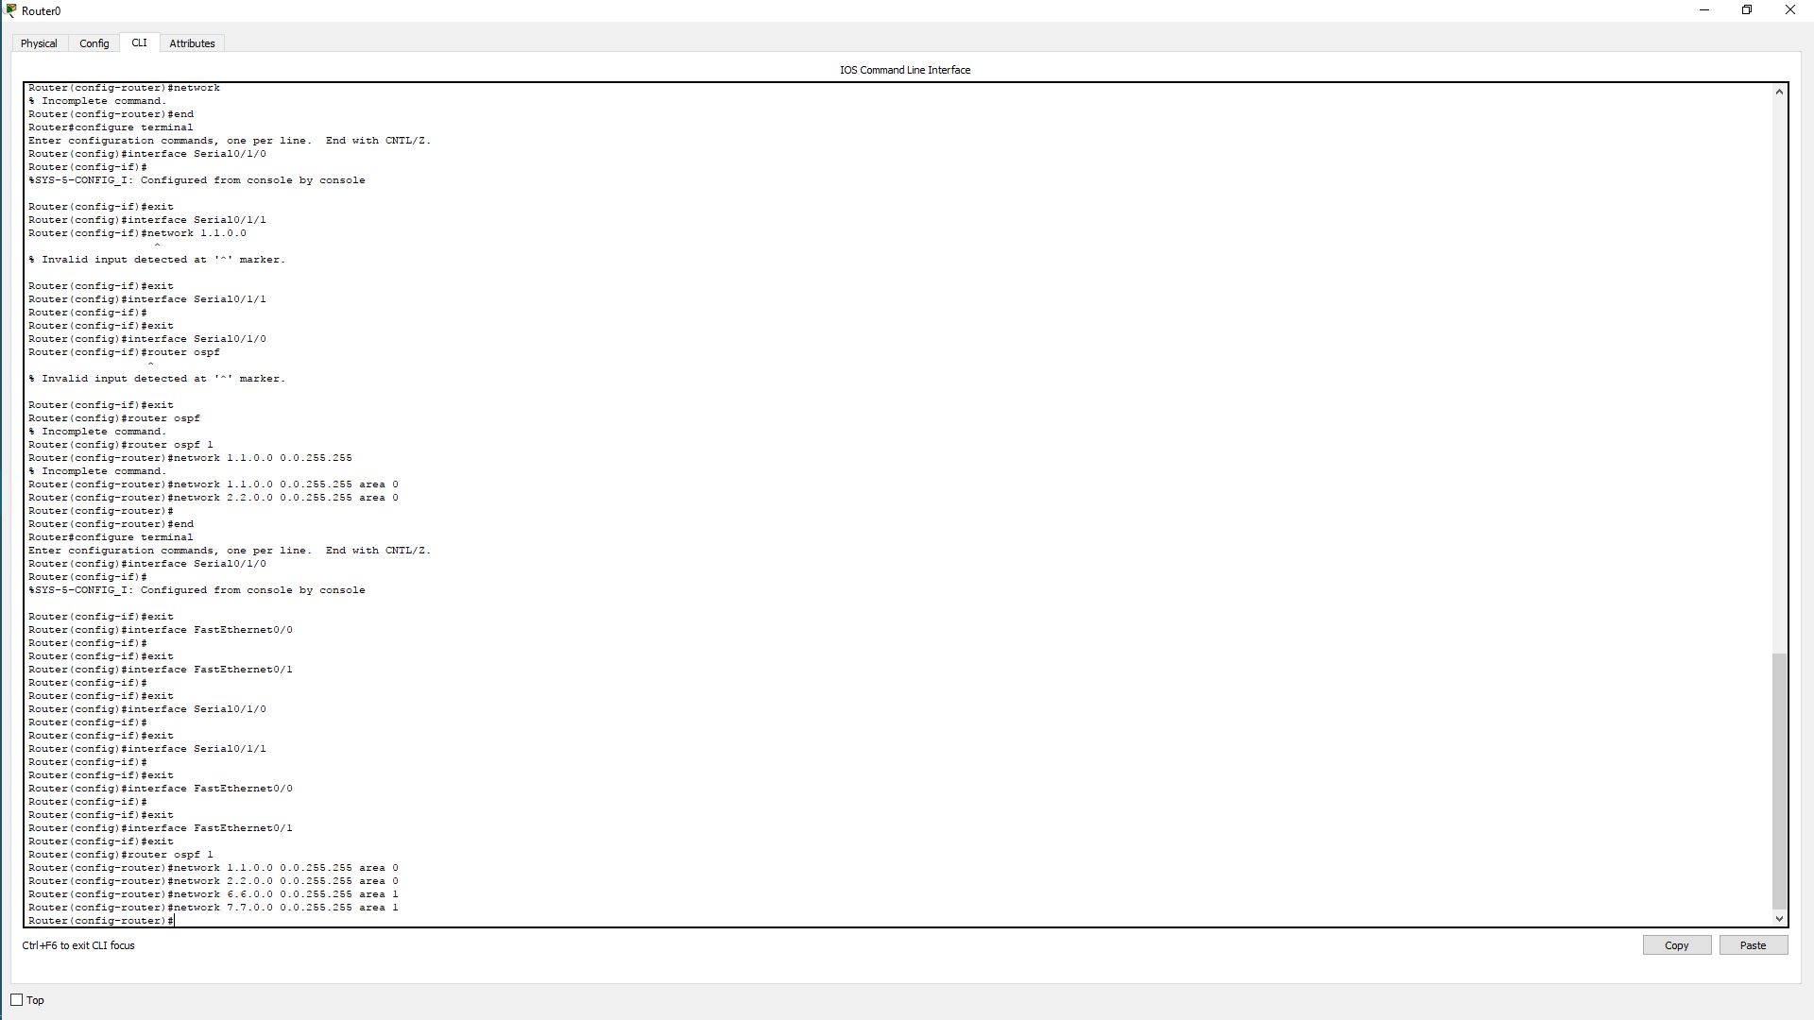

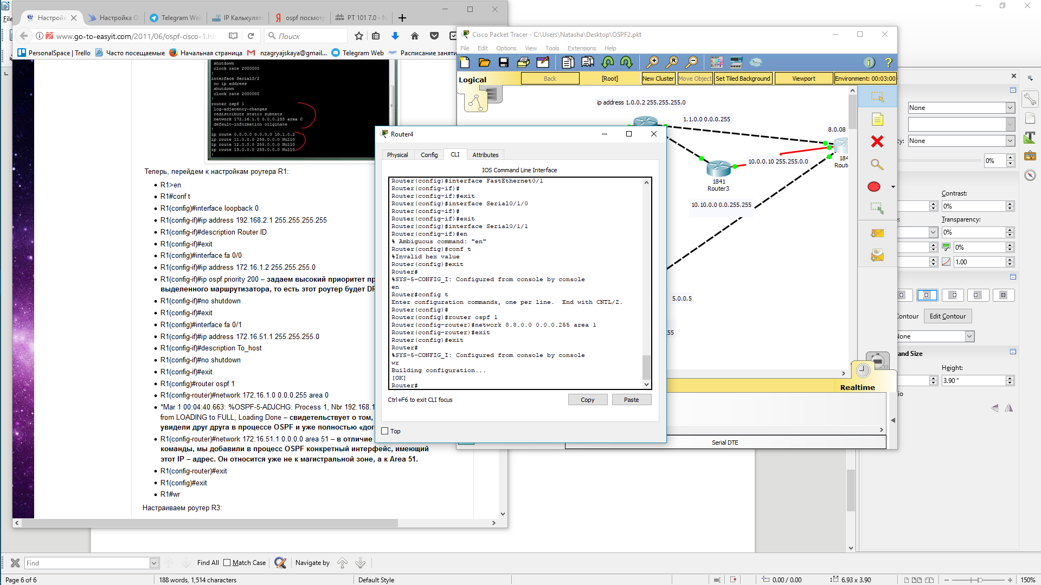

Выполним настройку оспф на первом роутере и убедимся что все верно внесено в зону

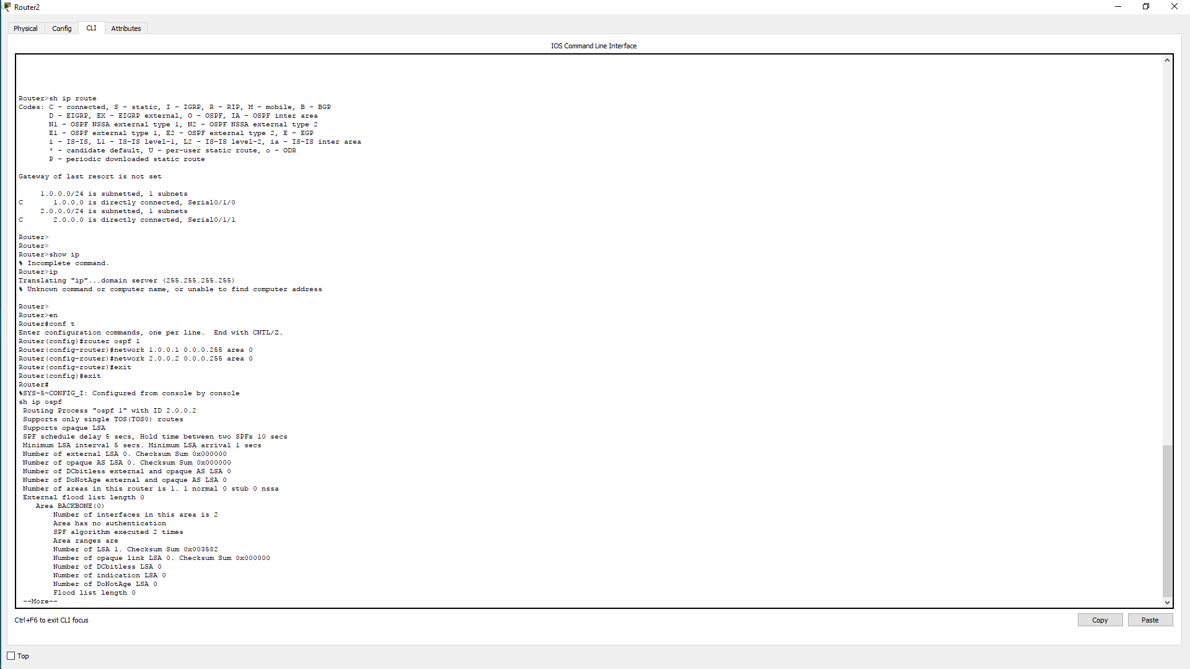

Router(config)#router ospf 1
Router(config-router)#network
% Incomplete command.
Router(config-router)#end
Router#configure terminal
Enter configuration commands, one per line. End with CNTL/Z.
Router(config)#interface Serial0/1/0
Router(config-if)#
%SYS-5-CONFIG_I: Configured from console by network nen
Router(config-if)#exit
Router(config)#
Router(config)#interface Serial0/1/0
Router(config-if)#
Router(config-if)#exit
Router(config)#interface Serial0/1/0
Router(config-if)#
Router(config-if)#exit
Router(config)#interface Serial0/1/1
Router(config-if)#
Router(config-if)#exit
Router(config)#interface FastEthernet0/0
Router(config-if)#
Router(config-if)#exit
Router(config)#interface FastEthernet0/1
Router(config-if)#exit
Router(config)#router ospf 1
Router(config-router)#network 1.0.0.2 0.0.0.255 area 0
Router(config-router)#network 2.2.0.2 0.0.0.255 area 0
Router(config-router)#network 6.0.0.6 0.0.0.255 area 1
Router(config-router)#network 7.0.0.7 0.0.0.255 area 1
Router(config-router)#exit
Router(config)#exit
Router#
%SYS-5-CONFIG_I: Configured from console by console
sh ip route
Codes: C - connected, S - static, I - IGRP, R - RIP, M - mobile, B - BGP
D - EIGRP, EX - EIGRP external, O - OSPF, IA - OSPF inter area
N1 - OSPF NSSA external type 1, N2 - OSPF NSSA external type 2
E1 - OSPF external type 1, E2 - OSPF external type 2, E - EGP
i - IS-IS, L1 - IS-IS level-1, L2 - IS-IS level-2, ia - IS-IS inter area
* - candidate default, U - per-user static route, o - ODR
P - periodic downloaded static route

Gateway of last resort is not set

1.0.0.0/16 is subnetted, 1 subnets
C 1.0.0.0 is directly connected, Serial0/1/0
2.0.0.0/16 is subnetted, 1 subnets
C 2.2.0.0 is directly connected, Serial0/1/1
6.0.0.0/16 is subnetted, 1 subnets
C 6.0.0.0 is directly connected, FastEthernet0/0
7.0.0.0/16 is subnetted, 1 subnets
C 7.0.0.0 is directly connected, FastEthernet0/1

Router#
Router#sh ip ospf
Routing Process "ospf 1" with ID 7.0.0.7
Supports only single TOS(TOS0) routes
Supports opaque LSA
It is an area border router
SPF schedule delay 5 secs, Hold time between two SPFs 10 secs

Minimum LSA interval 5 secs. Minimum LSA arrival 1 secs
Number of external LSA 0. Checksum Sum 0x000000
Number of opaque AS LSA 0. Checksum Sum 0x000000
Number of DCbitless external and opaque AS LSA 0
Number of DoNotAge external and opaque AS LSA 0
Number of areas in this router is 2. 2 normal 0 stub 0 nssa
External flood list length 0
Area BACKBONE(0)
Number of interfaces in this area is 2
Area has no authentication
SPF algorithm executed 6 times
Area ranges are
Number of LSA 3. Checksum Sum 0x023100
Number of opaque link LSA 0. Checksum Sum 0x000000
Number of DCbitless LSA 0
Number of indication LSA 0
Number of DoNotAge LSA 0
Flood list length 0
Area 1
Number of interfaces in this area is 2
Area has no authentication
SPF algorithm executed 4 times
Area ranges are
Number of LSA 3. Checksum Sum 0x012d03
Number of opaque link LSA 0. Checksum Sum 0x000000
Number of DCbitless LSA 0
Number of indication LSA 0
Number of DoNotAge LSA 0
Flood list length 0

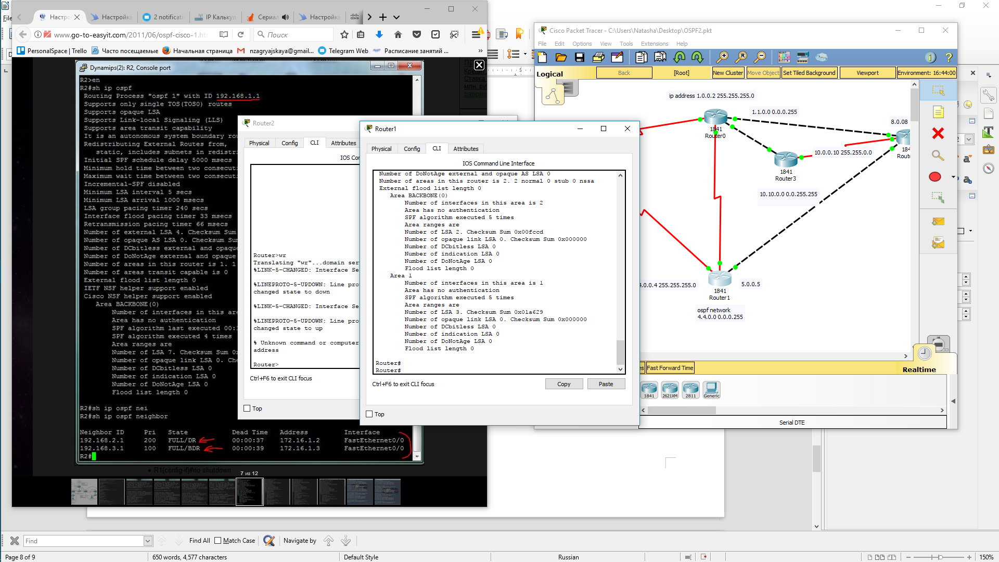
Настроим следущий роутер
и последний

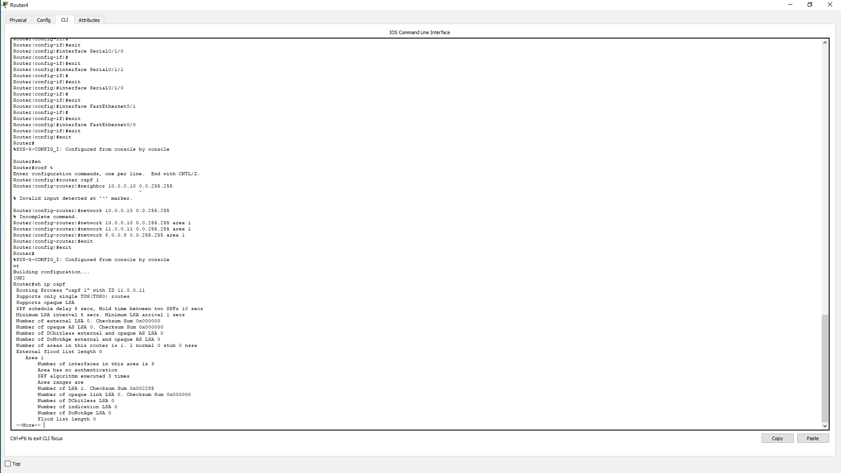

Router>en
Router#conf t
Enter configuration commands, one per line. End with CNTL/Z.
Router(config)#router ospf 1
Router(config-router)#router-id 1.1.1.1
Router(config-router)#Reload or use "clear ip ospf process"

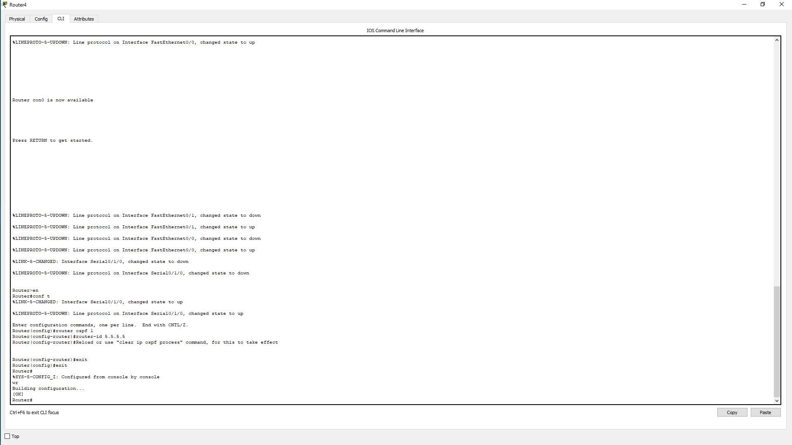

Router>en
Router#conf t
%LINK-5-CHANGED: Interface Serial0/1/0, changed state to up

%LINEPROTO-5-UPDOWN: Line protocol on Interface Serial0/1/0, changed state to up

Enter configuration commands, one per line. End with CNTL/Z.
Router(config)#router ospf 1
Router(config-router)#router-id 5.5.5.5
Router(config-router)#Reload or use "clear ip ospf process" command, for this to take effect

Router(config-router)#exit
Router(config)#exit
Router#
%SYS-5-CONFIG_I: Configured from console by console
wr
Building configuration...
[OK]
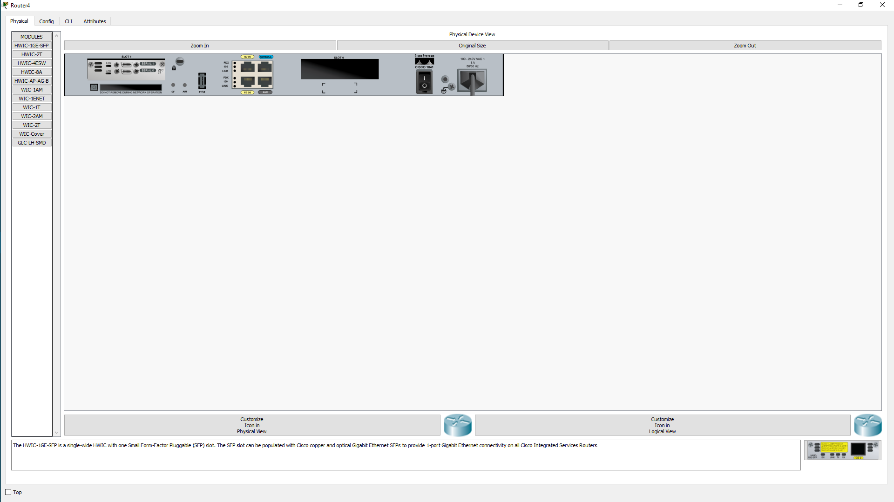
Затем

