Poisson-Nernst-Planck Solver

PNP module's tests

Poisson Solver
Testing of Poisson solver was made for single ion and 1I1B protein, different parameters were applied. The results of calculation were compared with empirical calculation (born energy) and with over solvers: ElectrostMod (based on Delphi), APBS.
Energies and operation time were compared; operation time is tentative, the difference is due to the fact that programs use different criteria for exit from computational circle, different discretization and calculation algorithms, and also none of them were specially optimized for particular system.
For convenience of procedure python script was written, it run the same type of calculation using three different solvers. Here is listening of this script:
from time import *

#common parameters
mset=GetCurMolSet()

GridSize=65
GridScale=1.0
epsi=2.0;
epsout=80.0
epsout2=2.0
rionst=0.0
exrad=2.0
radprb=1.4

print "PNPMod"
StartPNP=time()

pnpmod=mset.GetPNPMod(1)

#Set Size of the Grid
intArray_setitem(pnpmod.InitWorldD.GridSize,0,GridSize)
intArray_setitem(pnpmod.InitWorldD.GridSize,1,GridSize)
intArray_setitem(pnpmod.InitWorldD.GridSize,2,GridSize)
#Set GridScale
pnpmod.InitWorldD.GridScale=GridScale
#Set Periodic Boundary Condition
boolArray_setitem(pnpmod.InitWorldD.PBC,0,0)
boolArray_setitem(pnpmod.InitWorldD.PBC,1,0)
boolArray_setitem(pnpmod.InitWorldD.PBC,2,0)
#where to put molecule PNPMod.DontMove/PNPMod.MoveToCenter/PNPMod.UseOffset
pnpmod.SetMoleculePosition(PNPMod.MoveToCenter)
#set boundary contition
pnpmod.BoundaryCond=1
#set dielectrical constant 0 is for Protein, 1 is for solvent
pnpmod.DielDiffTablesD.Epsilon[0]=epsi
pnpmod.DielDiffTablesD.Epsilon[1]=epsout
#set Ionic Strenrgh
pnpmod.BulkD.Concentration[0]=rionst
#Add Membrane PNPMod.MemT_None/PNPMod.MemT_MembraneZ/PNPMod.MemT_Tube
#pnpmod.SetMembraneType(PNPMod.MemT_MembraneZ,4.0,-4.0,-2.5)
#pnpmod.SetMembraneType(PNPMod.MemT_Tube,4.0,-4.0,-2.5,1.0,0.0,2.0)
pnpmod.RunPoissonBolzmann()
EsolPNP=pnpmod.GeometryWorld.SystemEnergy

pnpmod.DielDiffTablesD.Epsilon[1]=epsout2
pnpmod.BulkD.Concentration[0]=0.0

pnpmod.RunPoissonBolzmann()
EvacPNP=pnpmod.GeometryWorld.SystemEnergy

dEPNP=EsolPNP-EvacPNP
EndPNP=time()
OperTimePNP=EndPNP-StartPNP

print "ElectostMod"
StartElMod=time()
elmod=mset.GetElectrostMod(1)
elmod.nx=GridSize
elmod.ny=GridSize
elmod.nz=GridSize
elmod.perfil=pnpmod.ConvertGridSizeGridScaleToPerFil(GridSize,GridScale)
elmod.rionst=rionst
elmod.exrad=exrad
elmod.radprb=radprb
elmod.epsi=epsi
elmod.epsout=epsout
elmod.boundary=3
elmod.nlit=-1

elmod.run(RUN_FOREGROUND)
EsolElMod=elmod.tot_ene

elmod.epsout=epsout2
elmod.rionst=0.0

elmod.run(RUN_FOREGROUND)
EvacElMod=elmod.tot_ene

dEElMod=EsolElMod-EvacElMod
EndElMod=time()
OperTimeElMod=EndElMod-StartElMod

print "APBS"
StartAPBS=time()
apbsmod=mset.GetAPBSMod(1)
apbsmod.nx=GridSize
apbsmod.ny=GridSize
apbsmod.nz=GridSize
apbsmod.GridScale=GridScale
apbsmod.rionst=rionst
apbsmod.exrad=exrad
apbsmod.radprb=radprb
apbsmod.epsi=epsi
apbsmod.epsout=epsout
apbsmod.chgm="spl0"
apbsmod.bcfl="mdh"
apbsmod.nlev=0
apbsmod.Run()

EsolAPBS=apbsmod.E

apbsmod.epsout=epsout2
apbsmod.rionst=0.0
apbsmod.Run()

EvacAPBS=apbsmod.E

dEAPBS=EsolAPBS-EvacAPBS
EndAPBS=time()
OperTimeAPBS=EndAPBS-StartAPBS

print "Solver Esol \tEvac \tdE \tTime"
#print "Solver Esol_w_Salt \tEsol \tdE"
print "PNPMOD ",EsolPNP,"\t",EvacPNP,"\t",dEPNP,"\t",OperTimePNP
print "ElectrostMod ",EsolElMod,"\t",EvacElMod,"\t",dEElMod,"\t",OperTimeElMod
print "APBS ",EsolAPBS,"\t",EvacAPBS,"\t",dEAPBS,"\t",OperTimeAPBS

Single Ion
Solvation energy was calculated. All solvers got next values: dielectric constant: inside molecules - 2.0, solvent – 80.0, solvent radius - 1.4 A, zero boundary condition, molecule is moved to center.
GridSize=65
GridScale=3.0;
Solver Esol,kT Evac,kT dE,kT Time,s
PNPMOD 1272.98088434 1324.77470959 -51.7938252511 2.17531204224
ElectrostMod 1272.94616699 1324.73510742 -51.7889404297 1.24395394325
APBS 1271.76890759 1323.51265972 -51.7437521297 3.06076598167
GridSize=65
GridScale=2.0
PNPMOD 826.552989666 883.183056348 -56.6300666819 1.78427696228
ElectrostMod 826.530761719 883.156738281 -56.6259765625 1.20015096664
APBS 825.765451278 882.340890806 -56.5754395279 3.13503909111
GridSize=129
GridScale=6.0
PNPMOD 2609.67661489 2661.04404853 -51.367433633 18.0741899014
ElectrostMod 2609.56933594 2660.96850586 -51.3991699219 17.0587890148
APBS 2607.18388906 2658.4994751 -51.3155860352 30.3970332146
With Coulombic boundary condition:
GridSize=65
GridScale=3.0;
Solver Esol,kT Evac,kT dE,kT Time,s
PNPMOD 1273.26811579 1336.26567683 -62.9975610373 2.19902896881
ElectrostMod 1273.23352051 1336.22631836 -62.9927978516 2.85096907616
APBS 1272.05584298 1334.99223044 -62.9363874534 2.86767101288
GridSize=65
GridScale=2.0
PNPMOD 826.744517989 890.843762018 -64.0992440288 1.85637187958
ElectrostMod 826.722290039 890.817382812 -64.0950927734 1.13080906868
APBS 825.956573473 889.993930296 -64.0373568228 2.65773200989
GridSize=129
GridScale=6.0
PNPMOD 2609.96396842 2672.53501577 -62.5710473488 20.0396208763
ElectrostMod 2609.85644531 2672.46166992 -62.6052246094 17.1300909519
APBS 2607.47069106 2669.97766424 -62.5069731789 24.846570015

Well, PNPMod and ElectrostMod shows pretty closed results, difference can be explain by different realization of PDE solvation algorithm and thus computational error. From point of view of the time PNPMod shows reasonable time once even faster then ElectrostMod. APBS results is more different but this is probably due to unit conversion (Tstd: 300K vs 298.15K).

Iterlycin Protein, 1I1B
Same condition as for single ion, with zero boundary condition.
GridSize=65
GridScale=1.0;
Solver Esol,kT Evac,kT dE,kT Time,s
PNPMOD 21587.3071246 23847.7227102 -2260.41558564 2.42379999161
ElectrostMod 21652.140625 23847.0214844 -2194.88085938 1.39233016968
APBS 21238.9054197 23819.4892082 -2580.58378849 9.39401006699
GridSize=129
GridScale=2.0;
PNPMOD 83507.4988818 85702.3973202 -2194.89843839 17.9057979584
ElectrostMod 83384.96875 85699.875 -2314.90625 17.7802278996
APBS 83849.4653397 86135.6710507 -2286.20571102 40.5025370121
GridSize=195
GridScale=3.0;
PNPMOD 145449.162686 147621.975301 -2172.81261508 73.0878109932
ElectrostMod 145368.15625 147617.734375 -2249.578125 80.9364740849
APBS 147427.656191 149639.758289 -2212.10209754 132.723589182
With Coulombic boundary condition:
GridSize=65
GridScale=1.0;
Solver Esol,kT Evac,kT dE,kT Time,s
PNPMOD 21588.4498473 23885.5229017 -2297.07305436 5.42228007317
ElectrostMod 21653.2617188 23884.8007812 -2231.5390625 15.2633519173
APBS 21240.0521279 23857.6870214 -2617.63489352 14.038007021
GridSize=129
GridScale=2.0;
PNPMOD 83508.6310501 85740.1506997 -2231.51964957 30.7595939636
ElectrostMod 83386.1015625 85737.6328125 -2351.53125 72.4121410847
APBS 83850.6045224 86173.8393275 -2323.23480513 59.0469441414
GridSize=195
GridScale=3.0;
PNPMOD 145450.225281 147659.741756 -2209.51647523 106.437078953
ElectrostMod 145369.28125 147655.484375 -2286.203125 208.777123928
APBS 147428.796701 149677.922119 -2249.12541834 169.571993113
At this run the difference in results is sufficiently differ: 15%- 1 Grids/A, 5% - 2, 3% - 3 for zero boundary condition. Thus with increasing of precision the deviation between solvers become smaller. Interesting to mention what on rough grid ElectrostMod shows results which is more close to precise on. The deviation among solver seems to be connected with different molecule discretization algorithms. PNPMod is fastest for big fine grid. With coulombic boundary condition ElectrostMod was the slowest.

Linear Poisson-Bolzmann

Single Ion
Next table shows summery of conducted calculation:
Solver | Esol_salt | Esol | dE | Time,s | GSize | GScale | I,M
PNPMOD | 8.27E+02 | 8.27E+02 | 0.00E+00 | 1.539 | 65 | 2 | 0
ElectrostMod | 8.27E+02 | 8.27E+02 | 0.00E+00 | 0.976 | 65 | 2 | 0
APBS | 8.26E+02 | 8.26E+02 | 0.00E+00 | 2.913 | 65 | 2 | 0
PNPMOD | 8.26E+02 | 8.27E+02 | -1.31E-01 | 1.701 | 65 | 2 | 0.2
ElectrostMod | 8.26E+02 | 8.27E+02 | -1.33E-01 | 0.9676 | 65 | 2 | 0.2
APBS | 8.26E+02 | 8.26E+02 | -1.31E-01 | 2.902 | 65 | 2 | 0.2
PNPMOD | 8.26E+02 | 8.27E+02 | -1.95E-01 | 1.428 | 65 | 2 | 0.4
ElectrostMod | 8.26E+02 | 8.27E+02 | -1.98E-01 | 0.9107 | 65 | 2 | 0.4
APBS | 8.26E+02 | 8.26E+02 | -1.96E-01 | 2.908 | 65 | 2 | 0.4
PNPMOD | 8.26E+02 | 8.27E+02 | -2.37E-01 | 1.645 | 65 | 2 | 0.6
ElectrostMod | 8.26E+02 | 8.27E+02 | -2.39E-01 | 0.8578 | 65 | 2 | 0.6
APBS | 8.26E+02 | 8.26E+02 | -2.37E-01 | 2.902 | 65 | 2 | 0.6
PNPMOD | 8.26E+02 | 8.27E+02 | -2.67E-01 | 1.763 | 65 | 2 | 0.8
ElectrostMod | 8.26E+02 | 8.27E+02 | -2.68E-01 | 0.8318 | 65 | 2 | 0.8
APBS | 8.25E+02 | 8.26E+02 | -2.66E-01 | 2.902 | 65 | 2 | 0.8
PNPMOD | 8.26E+02 | 8.27E+02 | -2.89E-01 | 1.706 | 65 | 2 | 1
ElectrostMod | 8.26E+02 | 8.27E+02 | -2.91E-01 | 0.8119 | 65 | 2 | 1
APBS | 8.25E+02 | 8.26E+02 | -2.89E-01 | 2.9 | 65 | 2 | 1
PNPMOD | 8.26E+02 | 8.27E+02 | -3.07E-01 | 1.661 | 65 | 2 | 1.2
ElectrostMod | 8.26E+02 | 8.27E+02 | -3.09E-01 | 0.7936 | 65 | 2 | 1.2
APBS | 8.25E+02 | 8.26E+02 | -3.07E-01 | 2.903 | 65 | 2 | 1.2
PNPMOD | 8.26E+02 | 8.27E+02 | -3.23E-01 | 1.64 | 65 | 2 | 1.4
ElectrostMod | 8.26E+02 | 8.27E+02 | -3.24E-01 | 0.7689 | 65 | 2 | 1.4
APBS | 8.25E+02 | 8.26E+02 | -3.22E-01 | 2.903 | 65 | 2 | 1.4
PNPMOD | 8.26E+02 | 8.27E+02 | -3.36E-01 | 1.692 | 65 | 2 | 1.6
ElectrostMod | 8.26E+02 | 8.27E+02 | -3.37E-01 | 0.761 | 65 | 2 | 1.6
APBS | 8.25E+02 | 8.26E+02 | -3.35E-01 | 2.906 | 65 | 2 | 1.6
PNPMOD | 8.26E+02 | 8.27E+02 | -3.47E-01 | 1.545 | 65 | 2 | 1.8
ElectrostMod | 8.26E+02 | 8.27E+02 | -3.48E-01 | 0.7452 | 65 | 2 | 1.8
APBS | 8.25E+02 | 8.26E+02 | -3.47E-01 | 2.912 | 65 | 2 | 1.8
PNPMOD | 8.26E+02 | 8.27E+02 | -3.57E-01 | 1.598 | 65 | 2 | 2
ElectrostMod | 8.26E+02 | 8.27E+02 | -3.58E-01 | 0.7384 | 65 | 2 | 2
APBS | 8.25E+02 | 8.26E+02 | -3.56E-01 | 2.905 | 65 | 2 | 2
PNPMOD | 1.27E+03 | 1.27E+03 | 0.00E+00 | 14.28 | 129 | 3 | 0
ElectrostMod | 1.27E+03 | 1.27E+03 | 0.00E+00 | 15.59 | 129 | 3 | 0
APBS | 1.27E+03 | 1.27E+03 | 0.00E+00 | 21.78 | 129 | 3 | 0
PNPMOD | 1.27E+03 | 1.27E+03 | -1.74E-01 | 14.75 | 129 | 3 | 0.2
ElectrostMod | 1.27E+03 | 1.27E+03 | -1.76E-01 | 13.94 | 129 | 3 | 0.2
APBS | 1.27E+03 | 1.27E+03 | -1.74E-01 | 21.76 | 129 | 3 | 0.2
PNPMOD | 1.27E+03 | 1.27E+03 | -2.44E-01 | 15.26 | 129 | 3 | 0.4
ElectrostMod | 1.27E+03 | 1.27E+03 | -2.46E-01 | 12.69 | 129 | 3 | 0.4
APBS | 1.27E+03 | 1.27E+03 | -2.43E-01 | 21.86 | 129 | 3 | 0.4
PNPMOD | 1.27E+03 | 1.27E+03 | -2.86E-01 | 14.33 | 129 | 3 | 0.6
ElectrostMod | 1.27E+03 | 1.27E+03 | -2.88E-01 | 12.08 | 129 | 3 | 0.6
APBS | 1.27E+03 | 1.27E+03 | -2.85E-01 | 21.73 | 129 | 3 | 0.6
PNPMOD | 1.27E+03 | 1.27E+03 | -3.16E-01 | 14.28 | 129 | 3 | 0.8
ElectrostMod | 1.27E+03 | 1.27E+03 | -3.17E-01 | 11.75 | 129 | 3 | 0.8
APBS | 1.27E+03 | 1.27E+03 | -3.15E-01 | 21.74 | 129 | 3 | 0.8
PNPMOD | 1.27E+03 | 1.27E+03 | -3.39E-01 | 15.24 | 129 | 3 | 1
ElectrostMod | 1.27E+03 | 1.27E+03 | -3.40E-01 | 11.38 | 129 | 3 | 1
APBS | 1.27E+03 | 1.27E+03 | -3.38E-01 | 21.77 | 129 | 3 | 1
PNPMOD | 1.27E+03 | 1.27E+03 | -3.57E-01 | 14.39 | 129 | 3 | 1.2
ElectrostMod | 1.27E+03 | 1.27E+03 | -3.59E-01 | 11.18 | 129 | 3 | 1.2
APBS | 1.27E+03 | 1.27E+03 | -3.57E-01 | 21.86 | 129 | 3 | 1.2
PNPMOD | 1.27E+03 | 1.27E+03 | -3.72E-01 | 14.28 | 129 | 3 | 1.4
ElectrostMod | 1.27E+03 | 1.27E+03 | -3.74E-01 | 10.88 | 129 | 3 | 1.4
APBS | 1.27E+03 | 1.27E+03 | -3.72E-01 | 21.82 | 129 | 3 | 1.4
PNPMOD | 1.27E+03 | 1.27E+03 | -3.85E-01 | 14.33 | 129 | 3 | 1.6
ElectrostMod | 1.27E+03 | 1.27E+03 | -3.87E-01 | 10.78 | 129 | 3 | 1.6
APBS | 1.27E+03 | 1.27E+03 | -3.85E-01 | 21.89 | 129 | 3 | 1.6
PNPMOD | 1.27E+03 | 1.27E+03 | -3.96E-01 | 14.76 | 129 | 3 | 1.8
ElectrostMod | 1.27E+03 | 1.27E+03 | -3.98E-01 | 10.68 | 129 | 3 | 1.8
APBS | 1.27E+03 | 1.27E+03 | -3.96E-01 | 21.84 | 129 | 3 | 1.8
PNPMOD | 1.27E+03 | 1.27E+03 | -4.06E-01 | 14.33 | 129 | 3 | 2
ElectrostMod | 1.27E+03 | 1.27E+03 | -4.08E-01 | 10.52 | 129 | 3 | 2
APBS | 1.27E+03 | 1.27E+03 | -4.06E-01 | 21.81 | 129 | 3 | 2
PNPMOD | 1.72E+03 | 1.72E+03 | 0.00E+00 | 14.55 | 129 | 4 | 0
ElectrostMod | 1.72E+03 | 1.72E+03 | 0.00E+00 | 15.79 | 129 | 4 | 0
APBS | 1.72E+03 | 1.72E+03 | 0.00E+00 | 27.01 | 129 | 4 | 0
PNPMOD | 1.72E+03 | 1.72E+03 | -1.32E-01 | 15.06 | 129 | 4 | 0.2
ElectrostMod | 1.72E+03 | 1.72E+03 | -1.33E-01 | 15.13 | 129 | 4 | 0.2
APBS | 1.72E+03 | 1.72E+03 | -1.32E-01 | 26.84 | 129 | 4 | 0.2
PNPMOD | 1.72E+03 | 1.72E+03 | -1.97E-01 | 14.62 | 129 | 4 | 0.4
ElectrostMod | 1.72E+03 | 1.72E+03 | -1.98E-01 | 14.13 | 129 | 4 | 0.4
APBS | 1.72E+03 | 1.72E+03 | -1.97E-01 | 27.05 | 129 | 4 | 0.4
PNPMOD | 1.72E+03 | 1.72E+03 | -2.38E-01 | 14.65 | 129 | 4 | 0.6
ElectrostMod | 1.72E+03 | 1.72E+03 | -2.40E-01 | 13.47 | 129 | 4 | 0.6
APBS | 1.72E+03 | 1.72E+03 | -2.38E-01 | 26.96 | 129 | 4 | 0.6
PNPMOD | 1.72E+03 | 1.72E+03 | -2.68E-01 | 14.62 | 129 | 4 | 0.8
ElectrostMod | 1.72E+03 | 1.72E+03 | -2.70E-01 | 12.97 | 129 | 4 | 0.8
APBS | 1.72E+03 | 1.72E+03 | -2.67E-01 | 27.02 | 129 | 4 | 0.8
PNPMOD | 1.72E+03 | 1.72E+03 | -2.91E-01 | 15.53 | 129 | 4 | 1
ElectrostMod | 1.72E+03 | 1.72E+03 | -2.92E-01 | 12.56 | 129 | 4 | 1
APBS | 1.72E+03 | 1.72E+03 | -2.90E-01 | 26.91 | 129 | 4 | 1
PNPMOD | 1.72E+03 | 1.72E+03 | -3.09E-01 | 14.62 | 129 | 4 | 1.2
ElectrostMod | 1.72E+03 | 1.72E+03 | -3.11E-01 | 12.28 | 129 | 4 | 1.2
APBS | 1.72E+03 | 1.72E+03 | -3.08E-01 | 27 | 129 | 4 | 1.2
PNPMOD | 1.72E+03 | 1.72E+03 | -3.24E-01 | 15.07 | 129 | 4 | 1.4
ElectrostMod | 1.72E+03 | 1.72E+03 | -3.26E-01 | 12.21 | 129 | 4 | 1.4
APBS | 1.72E+03 | 1.72E+03 | -3.24E-01 | 27.04 | 129 | 4 | 1.4
PNPMOD | 1.72E+03 | 1.72E+03 | -3.37E-01 | 14.63 | 129 | 4 | 1.6
ElectrostMod | 1.72E+03 | 1.72E+03 | -3.39E-01 | 11.94 | 129 | 4 | 1.6
APBS | 1.72E+03 | 1.72E+03 | -3.37E-01 | 27.05 | 129 | 4 | 1.6
PNPMOD | 1.72E+03 | 1.72E+03 | -3.49E-01 | 15.52 | 129 | 4 | 1.8
ElectrostMod | 1.72E+03 | 1.72E+03 | -3.50E-01 | 11.73 | 129 | 4 | 1.8
APBS | 1.72E+03 | 1.72E+03 | -3.48E-01 | 26.9 | 129 | 4 | 1.8
PNPMOD | 1.72E+03 | 1.72E+03 | -3.58E-01 | 14.62 | 129 | 4 | 2
ElectrostMod | 1.72E+03 | 1.72E+03 | -3.60E-01 | 11.67 | 129 | 4 | 2
APBS | 1.72E+03 | 1.72E+03 | -3.58E-01 | 27.01 | 129 | 4 | 2
PNPMOD | 2.16E+03 | 2.16E+03 | 0.00E+00 | 14.99 | 129 | 5 | 0
ElectrostMod | 2.16E+03 | 2.16E+03 | 0.00E+00 | 16.13 | 129 | 5 | 0
APBS | 2.16E+03 | 2.16E+03 | 0.00E+00 | 25.89 | 129 | 5 | 0
PNPMOD | 2.16E+03 | 2.16E+03 | -9.67E-02 | 14.69 | 129 | 5 | 0.2
ElectrostMod | 2.16E+03 | 2.16E+03 | -9.79E-02 | 16.08 | 129 | 5 | 0.2
APBS | 2.16E+03 | 2.16E+03 | -9.66E-02 | 25.85 | 129 | 5 | 0.2
PNPMOD | 2.16E+03 | 2.16E+03 | -1.54E-01 | 15.14 | 129 | 5 | 0.4
ElectrostMod | 2.16E+03 | 2.16E+03 | -1.55E-01 | 15.26 | 129 | 5 | 0.4
APBS | 2.16E+03 | 2.16E+03 | -1.53E-01 | 25.76 | 129 | 5 | 0.4
PNPMOD | 2.16E+03 | 2.16E+03 | -1.92E-01 | 14.73 | 129 | 5 | 0.6
ElectrostMod | 2.16E+03 | 2.16E+03 | -1.94E-01 | 14.6 | 129 | 5 | 0.6
APBS | 2.16E+03 | 2.16E+03 | -1.92E-01 | 25.71 | 129 | 5 | 0.6
PNPMOD | 2.16E+03 | 2.16E+03 | -2.21E-01 | 14.62 | 129 | 5 | 0.8
ElectrostMod | 2.16E+03 | 2.16E+03 | -2.23E-01 | 14.21 | 129 | 5 | 0.8
APBS | 2.16E+03 | 2.16E+03 | -2.21E-01 | 25.86 | 129 | 5 | 0.8
PNPMOD | 2.16E+03 | 2.16E+03 | -2.43E-01 | 15.05 | 129 | 5 | 1
ElectrostMod | 2.16E+03 | 2.16E+03 | -2.46E-01 | 13.92 | 129 | 5 | 1
APBS | 2.16E+03 | 2.16E+03 | -2.43E-01 | 25.83 | 129 | 5 | 1
PNPMOD | 2.16E+03 | 2.16E+03 | -2.61E-01 | 14.68 | 129 | 5 | 1.2
ElectrostMod | 2.16E+03 | 2.16E+03 | -2.63E-01 | 13.55 | 129 | 5 | 1.2
APBS | 2.16E+03 | 2.16E+03 | -2.61E-01 | 25.84 | 129 | 5 | 1.2
PNPMOD | 2.16E+03 | 2.16E+03 | -2.76E-01 | 14.66 | 129 | 5 | 1.4
ElectrostMod | 2.16E+03 | 2.16E+03 | -2.78E-01 | 13.4 | 129 | 5 | 1.4
APBS | 2.16E+03 | 2.16E+03 | -2.76E-01 | 25.8 | 129 | 5 | 1.4
PNPMOD | 2.16E+03 | 2.16E+03 | -2.90E-01 | 15.98 | 129 | 5 | 1.6
ElectrostMod | 2.16E+03 | 2.16E+03 | -2.91E-01 | 13.22 | 129 | 5 | 1.6
APBS | 2.16E+03 | 2.16E+03 | -2.89E-01 | 25.82 | 129 | 5 | 1.6
PNPMOD | 2.16E+03 | 2.16E+03 | -3.01E-01 | 15.09 | 129 | 5 | 1.8
ElectrostMod | 2.16E+03 | 2.16E+03 | -3.02E-01 | 13 | 129 | 5 | 1.8
APBS | 2.16E+03 | 2.16E+03 | -3.01E-01 | 25.92 | 129 | 5 | 1.8
PNPMOD | 2.16E+03 | 2.16E+03 | -3.11E-01 | 14.65 | 129 | 5 | 2
ElectrostMod | 2.16E+03 | 2.16E+03 | -3.12E-01 | 12.82 | 129 | 5 | 2
APBS | 2.16E+03 | 2.16E+03 | -3.11E-01 | 25.78 | 129 | 5 | 2
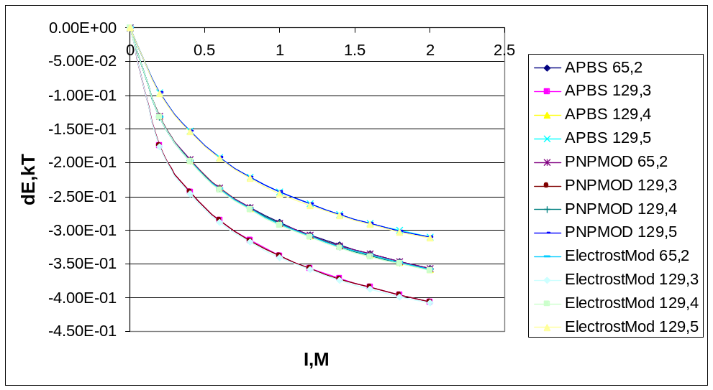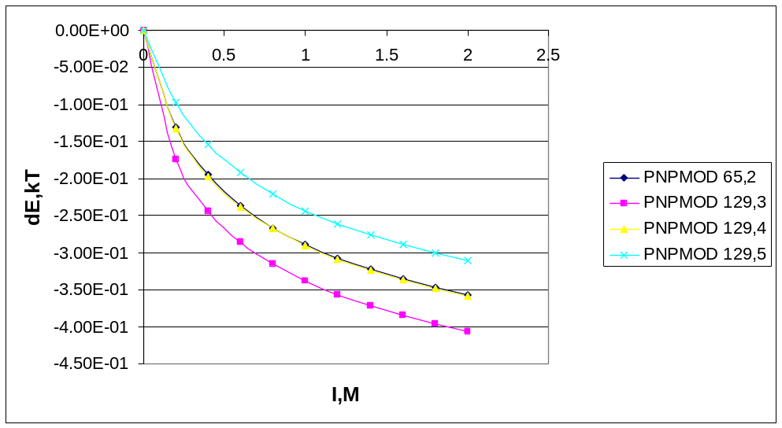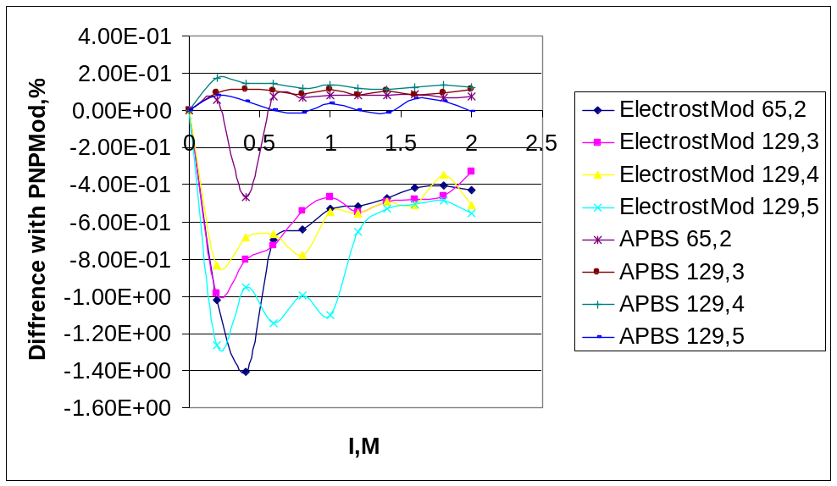
Fig.1 dE by different solvers
Fig.2 dE by PNPMod
Fig.3 diffrence in dE between PNPMod and other solvers
From figure 1 and 3 we see that under similar conditions all solvers showed very similar results, although PNPMod results is located between ElectrostMod and APBS and is more close to APBS.
Under different grid parameters solvents shows different energies, that is due to zero boundary condition, then the physical size of the box is the same solvents show similar results (Fig.2 65,2 and 129,4, grid size and grid scale correspondingly).
PNPMod took about the same time as ElectrostMod, usually little bit slower, sometime faster.

Iterlycin Protein, 1I1B
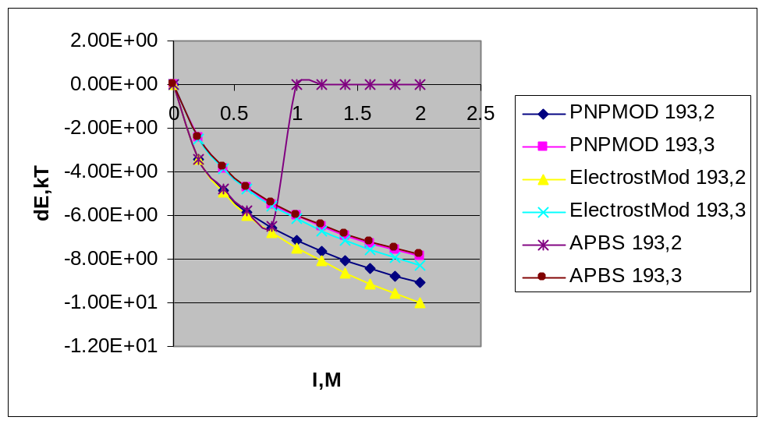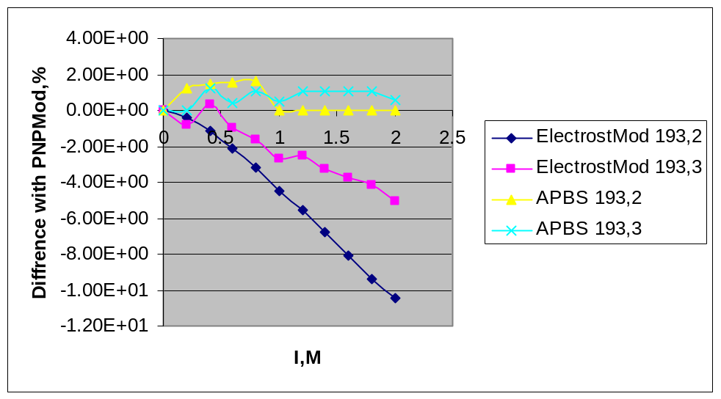
Calculations for 1I1B also indicate similarities of results, although deviation of ElectrostMod from APBS and PNPMod is bigger, especially under rough grid and high ionic strength.
PS have some memory issues in PNPMod (leakage) that’s why APBS didn’t calculate all the points (need more memory)

Nonlinear Poisson-Bolzmann

Single Ion
Still in progress, but about the same as for Linear PB.

Iterlycin Protein, 1I1B

