04_vscode + kivy + raspberry pi 4B (3B+) LCD 480x800

pi@raspberrypi:~ $ "/home/pi/vscode/"

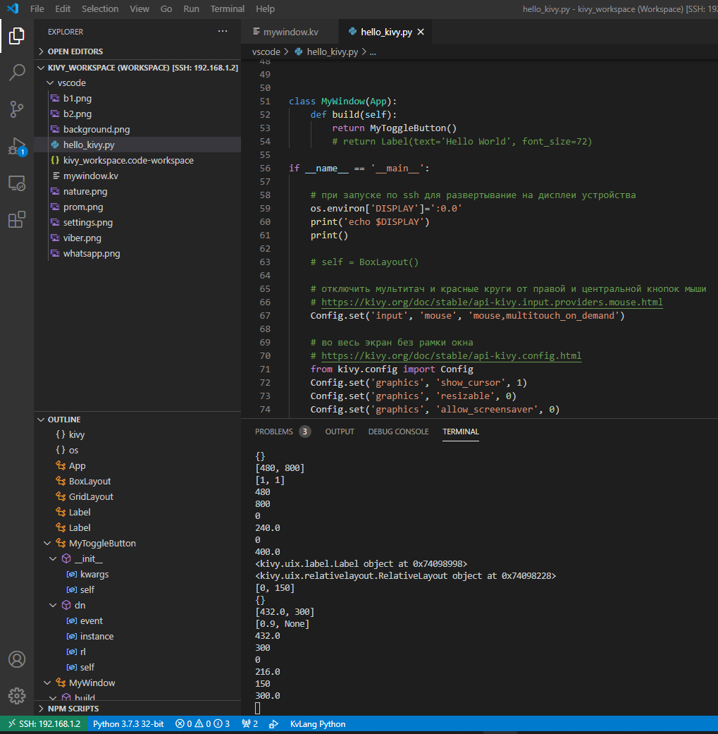

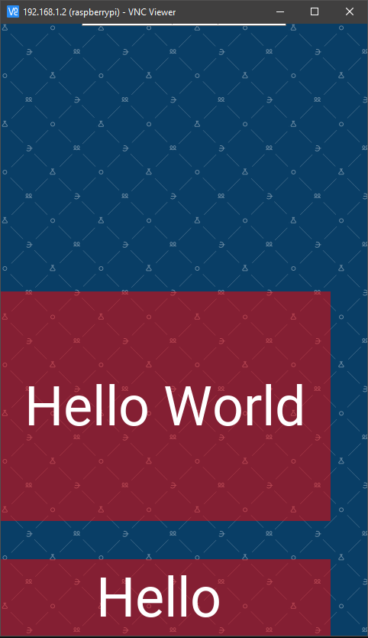

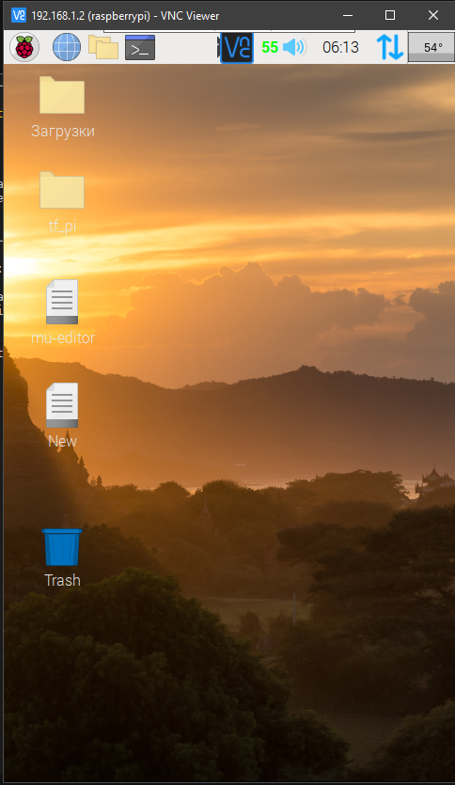

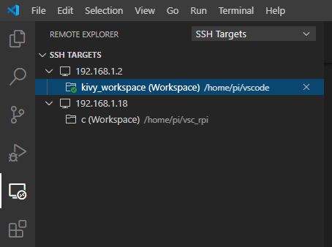

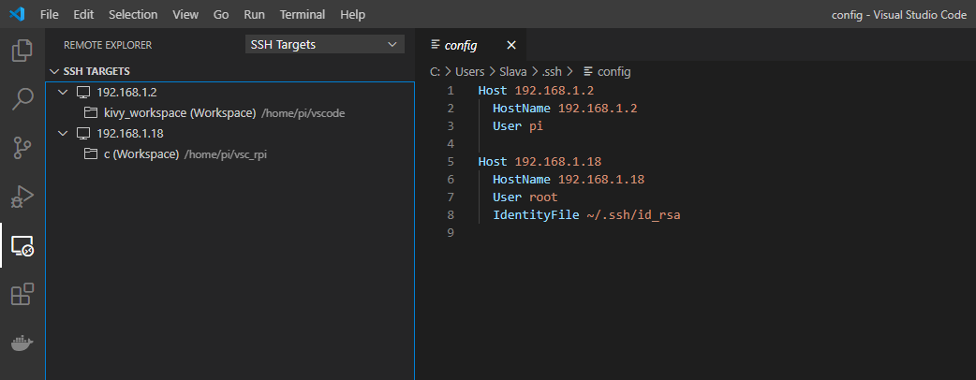

C:\Users\Slava\.ssh\config