Inter-Annotator Agreement (IAA) Report

1. Overview
This report provides an overview of dataset annotation reliability, including Inter-Annotator Agreement (IAA), Cohen’s Kappa coefficient, disagreement counts, and correction statistics.

2. Dataset Summary
• Dataset size: 4800 items
• Balanced dataset: 2400 positive (1), 2400 negative (0)
• Total disagreements: 66 items (1.375%)
- 0→1 disagreements: 1
- 1→0 disagreements: 65

3. Agreement Metrics
• Observed Agreement (IAA): 98.625%
• Expected Agreement (Chance): 50%
• Cohen’s Kappa: 0.9725 (indicating near-perfect reliability)

4. Correction Statistics
• Changed items (non-label errors): 223
• Percentage corrected: 4.65%

5. Confusion Matrix
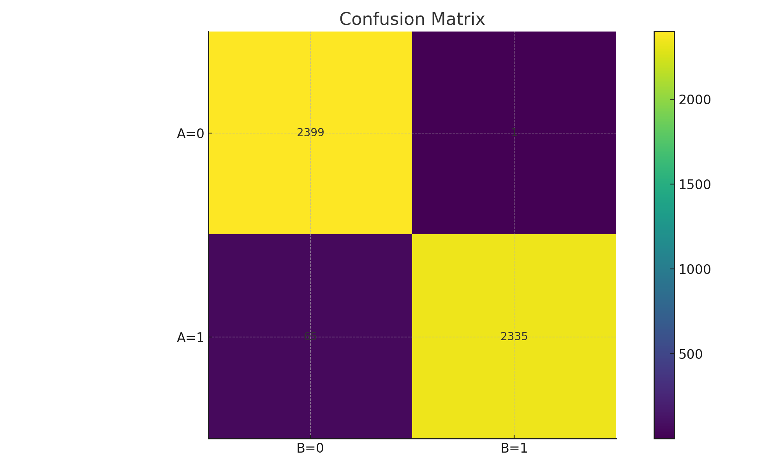

6. Notes and Recommendations
• Very high agreement suggests clear annotation guidelines and strong annotator consistency.
• Review corrected items to identify patterns in non-label errors.
• Consider periodic calibration sessions to maintain consistency.

