DC Voltage Divider
Igor Subbotin
Project 1
Measurements: October 19, 2026

Goal
A voltage divider makes a lower voltage from a power supply. I wanted to learn how to build one, use a multimeter, and check the results in MATLAB.

Parts and setup
I used a breadboard, jumper wires, a DFRobot DFR0140 power module, a 9 V adapter and a Klein MM420 multimeter. I had two 1k resistors and two 10k resistors. Here, 1k means 1,000 ohms.
R1 goes from the positive supply to the output point. R2 goes from the output point to ground (0 V). I measured Vout between the output point and ground. Vin was 4.98 V for all six tests.
With the power off, I measured the resistors. The two 10k parts measured 9.83 kΩ and 9.89 kΩ. The two 1k parts measured 0.979 kΩ and 0.98 kΩ.
$$Vout = \frac{Vin × R2}{R1 + R2}$$
For resistors in series: $R = Ra + Rb$
For resistors in parallel: $R = \frac{Ra × Rb}{Ra + Rb}$

Readings
Test | R1 label | R2 parts | Measured Vout
1 | 10k | 1k | 0.450 V
2 | 10k | 1k + 1k in series | 0.828 V
3 | 10k | 10k | 2.489 V
4 | 1k | 10k and 10k in parallel | 4.15 V
5 | 1k | 10k | 4.53 V
6 | 1k | 10k + 10k in series | 4.74 V

MATLAB check
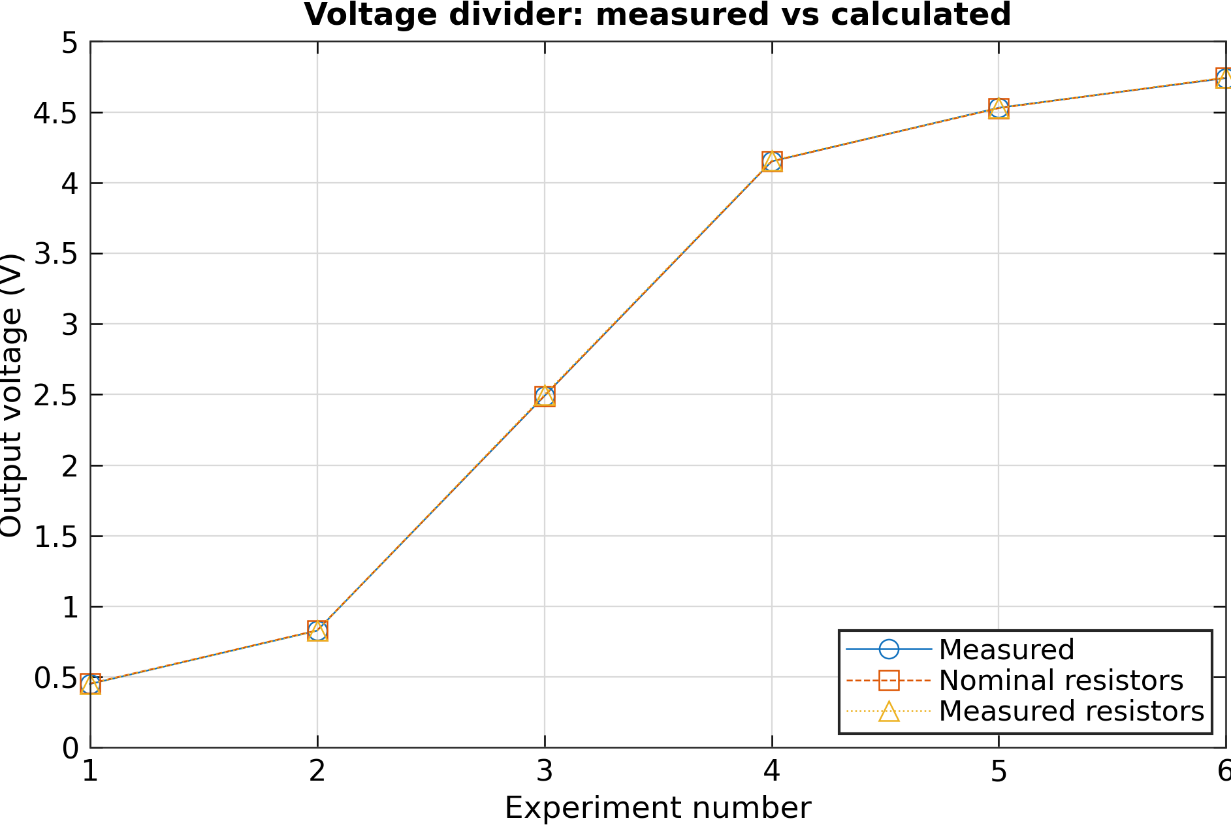
MATLAB calculated Vout using the resistor labels, then using the measured resistances. The graph compares both answers with my readings. Nominal means the label value, such as 1k or 10k.
Test | Measured  Vout | Calculated Vout  (label values) | Calculated Vout  (measured R) | Difference  (label values)
1 | 0.450 V | 0.4527 V | 0.4511 V | 0.60 %
2 | 0.828 V | 0.8300 V | 0.8275 V | 0.24 %
3 | 2.489 V | 2.4900 V | 2.4976 V | 0.04 %
4 | 4.15 V | 4.1500 V | 4.1549 V | 0.00 %
5 | 4.53 V | 4.5273 V | 4.5289 V | 0.06 %
6 | 4.74 V | 4.7429 V | 4.7445 V | 0.06 %

In test 3, both labels were 10k. The output was half the input: 4.98 / 2 = 2.49 V. My reading was 2.489 V. The graph lines are close because the readings and calculations are close.
I calculated current, using this formula I = Vin / (R1 + R2). The current values are in the results CSV. For test 4, this is the total current before it splits between the parallel resistors.

Differences and Meter Limits
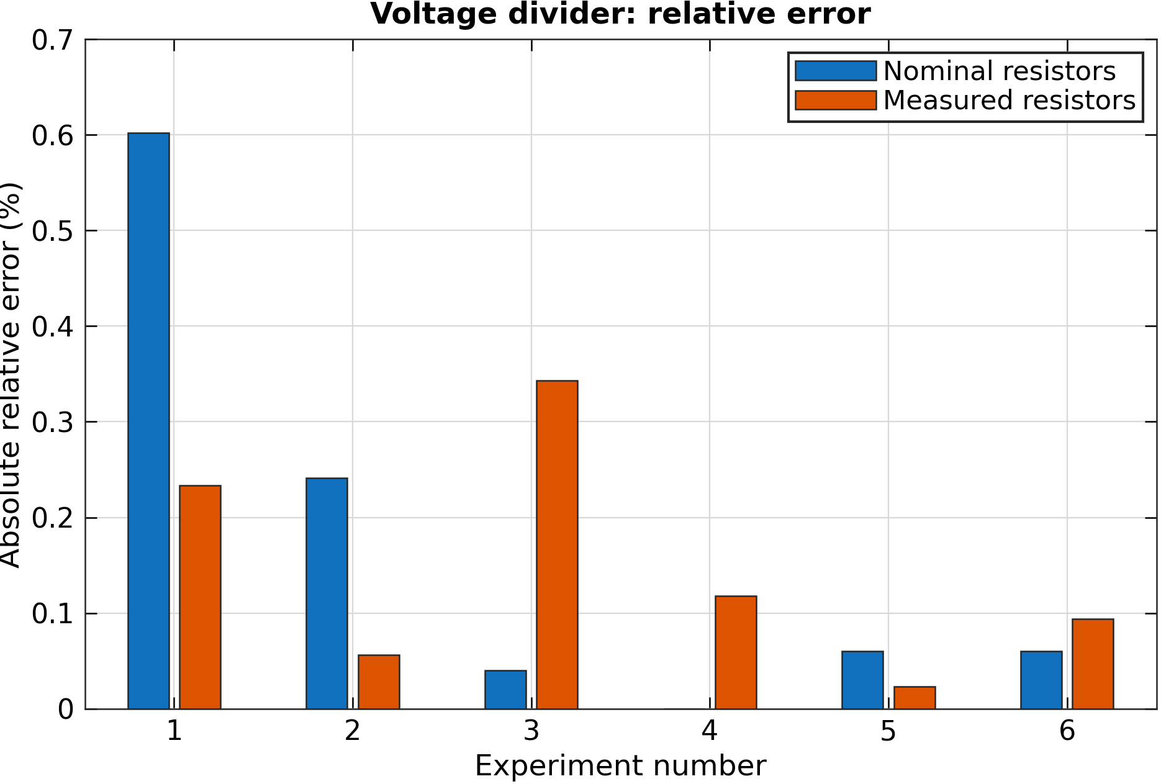
$$Difference (\%) = 100 × \frac{|measured - calculated|}{calculated}$$
Test 4 shows 0.00 % using the label values. Its blue bar is zero in height. The recorded numbers match, but that does not mean the meter is exact.
The largest differences were about 0.60% with label values and 0.34% with measured resistances. Using measured resistances was closer in tests 1, 2 and 5.
The meter has its own limits [1]. A count is one small display step. For example, if the step is 0.001 V, five counts add 0.005 V to the limit.
Reading | Meter ranges | Display steps | Limit (% of reading)
DC voltage | 4.000 / 40.00 V | 0.001 / 0.01 V | ± (0.5% + 5 counts)
Resistance | 4.000 / 40.00 kΩ | 1 / 10 Ω | ± (1.2% + 5 counts)

At 2.489 V, the voltage limit is ± (0.005 × 2.489 + 0.005), or about ± 0.0174 V. For the 4.98 V input, it is ± 0.0749 V. The code also includes the resistor limits. The measured and calculated voltage ranges overlap in all six tests.
Some ranges were not recorded, so the check uses assumed ranges. The manual limits apply from 18-28 °C and within one year of calibration. I did not record those conditions. The code also adds room for rounding in the shorter 0.98 kΩ note.

What I learned
The results were close to the divider formula. I learned how to wire a breadboard, measure voltage and resistance, and compare readings in MATLAB. I also learned that a small difference must be checked against the meter limits.
[1] Klein Tools, MM420 Instructions, English pages 2-3.

Circuit diagram
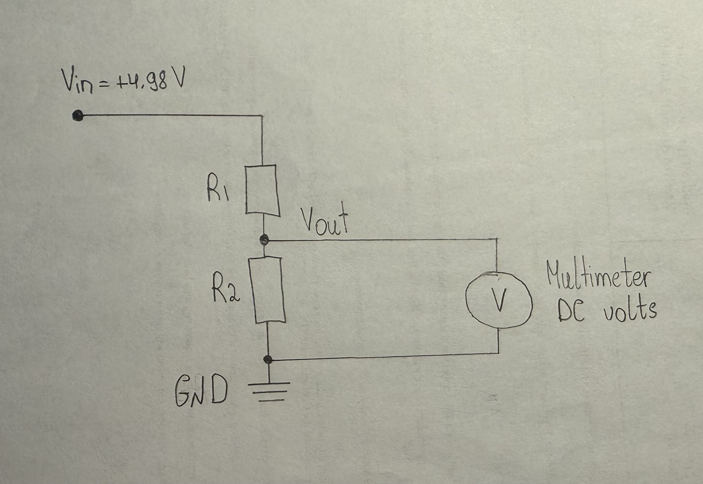
My hand-drawn circuit diagram. R1 and R2 change between tests as shown in the readings table.

