Network Configuration and Implementation Report

This report outlines the design, configuration, and validation of a multi-network infrastructure implemented using Cisco Packet Tracer. The goal of this project was to create a functional and scalable network that supports multiple subnets, centralized services, and proper communication across all network segments.
The network was divided into logical segments to improve organization, performance, and security. Subnet1 (192.168.1.0/24) and Subnet2 (192.168.5.0/24) were configured on Router1, while Network3 (192.168.10.0/24) and the server network (172.16.1.0/24) were configured on Router2. This segmentation reduces broadcast traffic, improves performance, and enhances security by isolating traffic between different departments or functional areas.
A dedicated server network was implemented using the address range 172.16.1.0/24. The server was assigned a static IP address of 172.16.1.100 with a default gateway of 172.16.1.1. The server was configured to provide both DHCP and DNS services to all client networks, allowing centralized management and reducing the need for manual configuration on individual devices.
A point-to-point serial connection between Router1 and Router2 was configured using the subnet 10.0.0.0/30. Router1 was assigned 10.0.0.1 and Router2 was assigned 10.0.0.2. The /30 subnet mask was selected because it efficiently supports point-to-point communication with minimal wasted IP addresses.
DHCP was configured on the server to dynamically assign IP addresses to devices in all subnets. Because DHCP broadcasts cannot cross routers, the ip helper-address command was configured on all router interfaces connected to client networks. This allowed DHCP requests to be forwarded to the centralized server, ensuring that all devices receive correct network configuration automatically.
Network Address Translation (NAT) with Port Address Translation (PAT) was configured on Router1. This allows multiple internal devices to share a single external IP address using unique port numbers. NAT improves security by hiding internal IP addresses and is widely used in real-world networks.
Static routing was implemented on both routers to ensure full communication between all networks. Router1 was configured with routes to the server network and Network3 through Router2, while Router2 was configured with routes to Subnet1 and Subnet2 through Router1. This ensures predictable and controlled traffic flow across the network.
Testing confirmed that all devices were able to obtain IP addresses via DHCP and successfully communicate across networks. Ping tests verified connectivity between subnets and the server, while NAT translation tables confirmed that address translation was functioning correctly.
This network design is scalable and can support additional subnets or devices with minimal changes. Overall, the implementation demonstrates a strong understanding of networking concepts and reflects a realistic enterprise network design.

Screenshots and Explanations

Network Topology
This screenshot shows the complete network topology, including both routers, all subnets, the server network, and the serial connection. It demonstrates how all devices are interconnected and how traffic flows across the network.
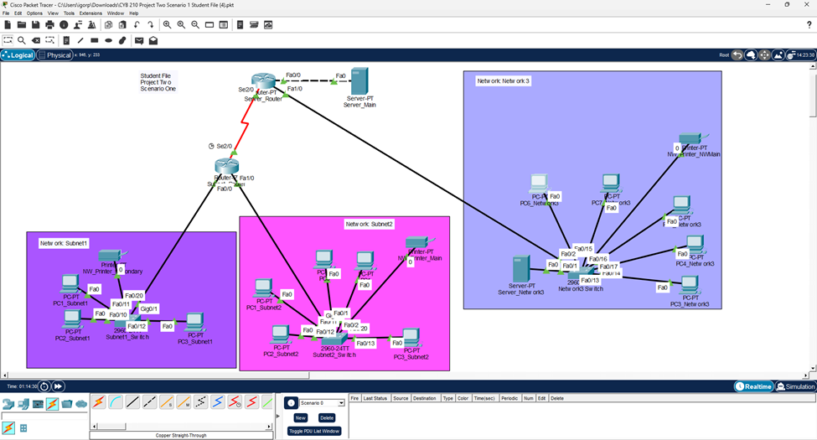

Router1 Interface Configuration
This screenshot verifies that Router1 interfaces are properly configured with correct IP addresses and are in an operational state (up/up), ensuring connectivity for Subnet1 and Subnet2.
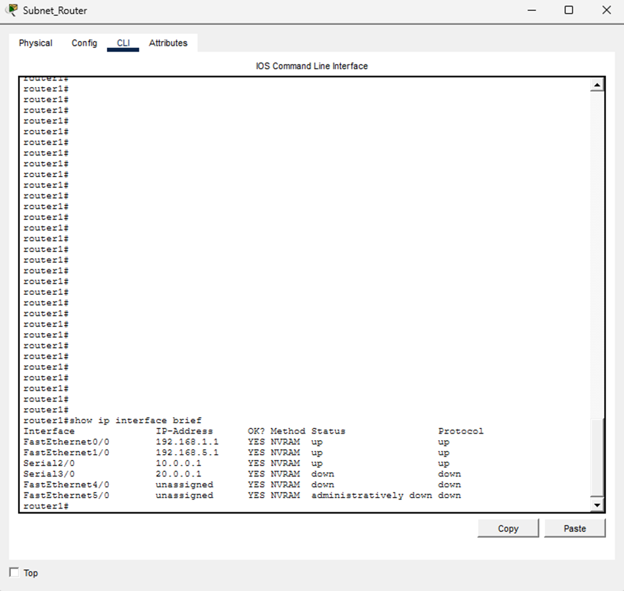

Router2 Interface Configuration
This screenshot confirms that Router2 is correctly configured to support the server network and Network3, with all required interfaces active and properly addressed.
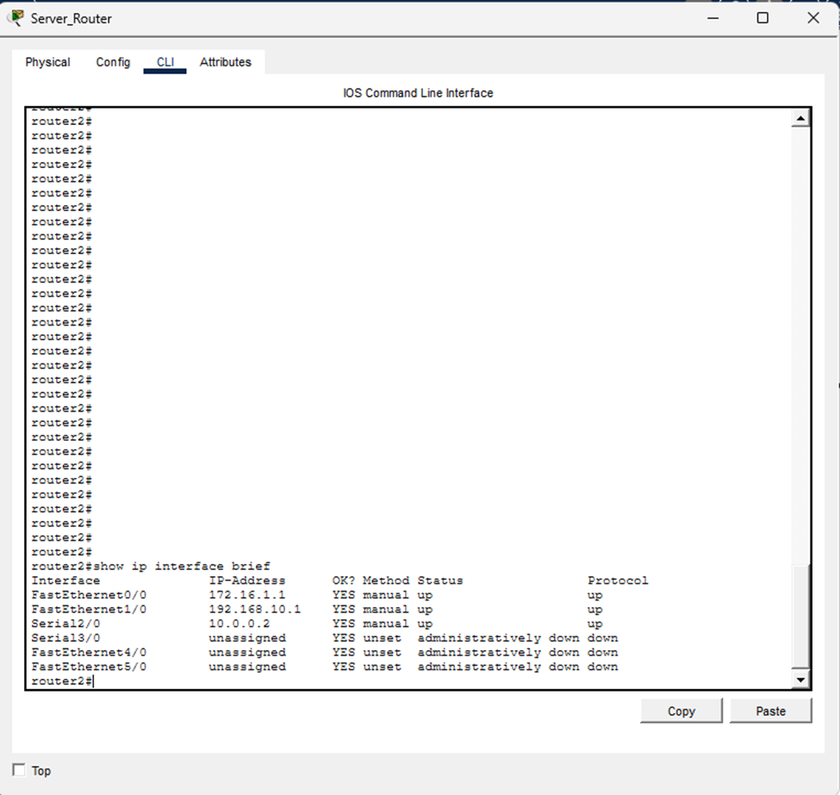

DHCP Configuration
This screenshot demonstrates that a client device successfully received an IP address dynamically from the DHCP server, including subnet mask, default gateway, and DNS server.
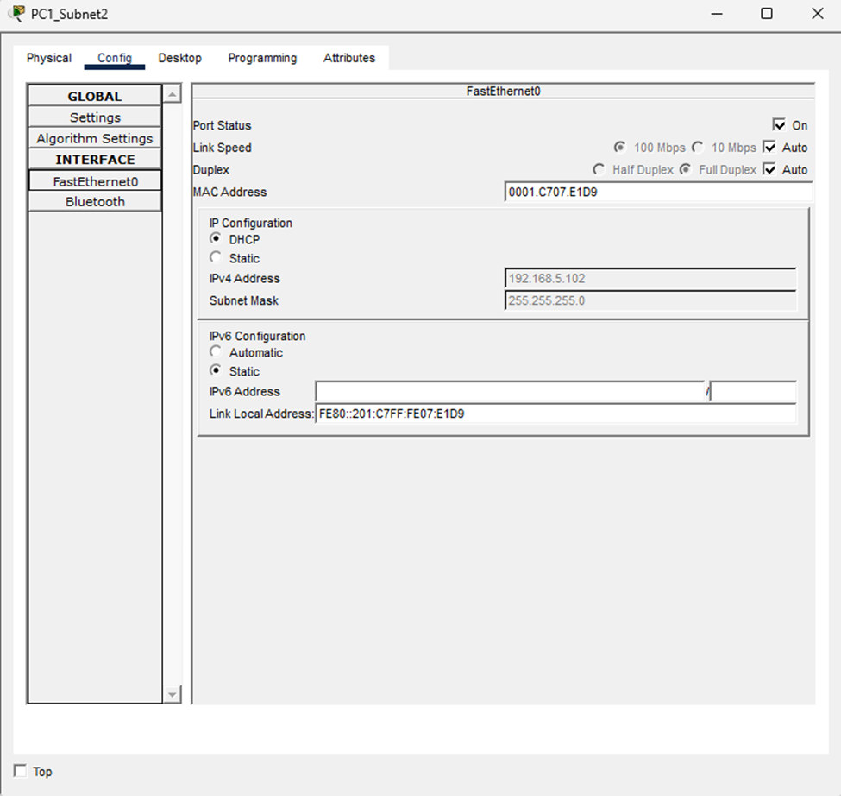

Connectivity Testing
This screenshot shows successful ping results between different networks, proving that routing is functioning correctly and that all devices can communicate.
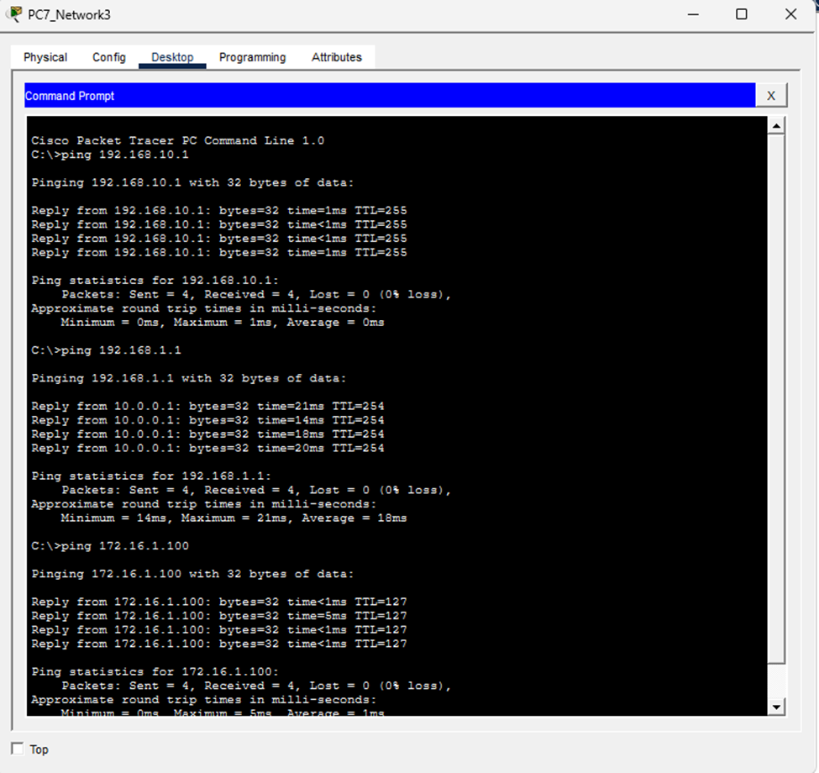

NAT Translation Table
This screenshot verifies that NAT is correctly translating internal IP addresses into external addresses, confirming that PAT is working as expected.
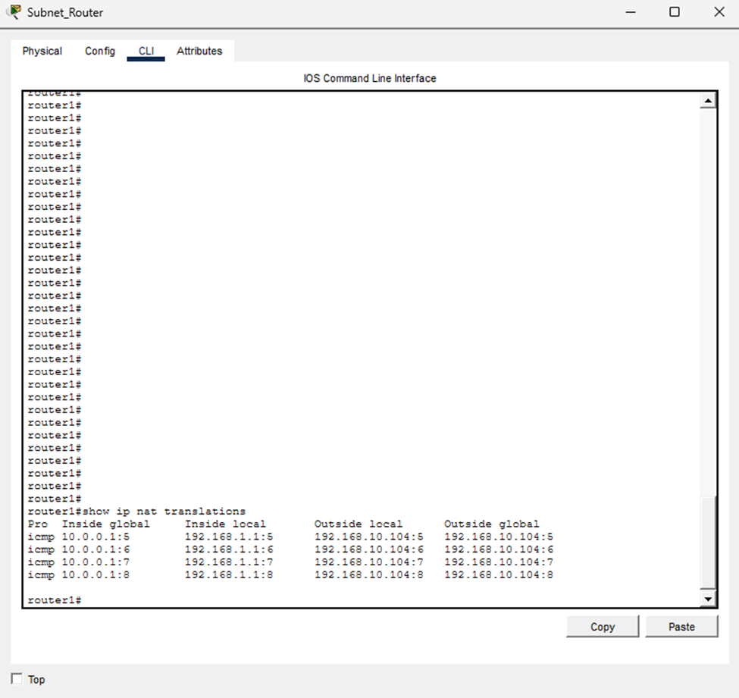

Router1 Routing Table
This screenshot displays the routing table on Router1, showing both directly connected and static routes, ensuring proper path selection.
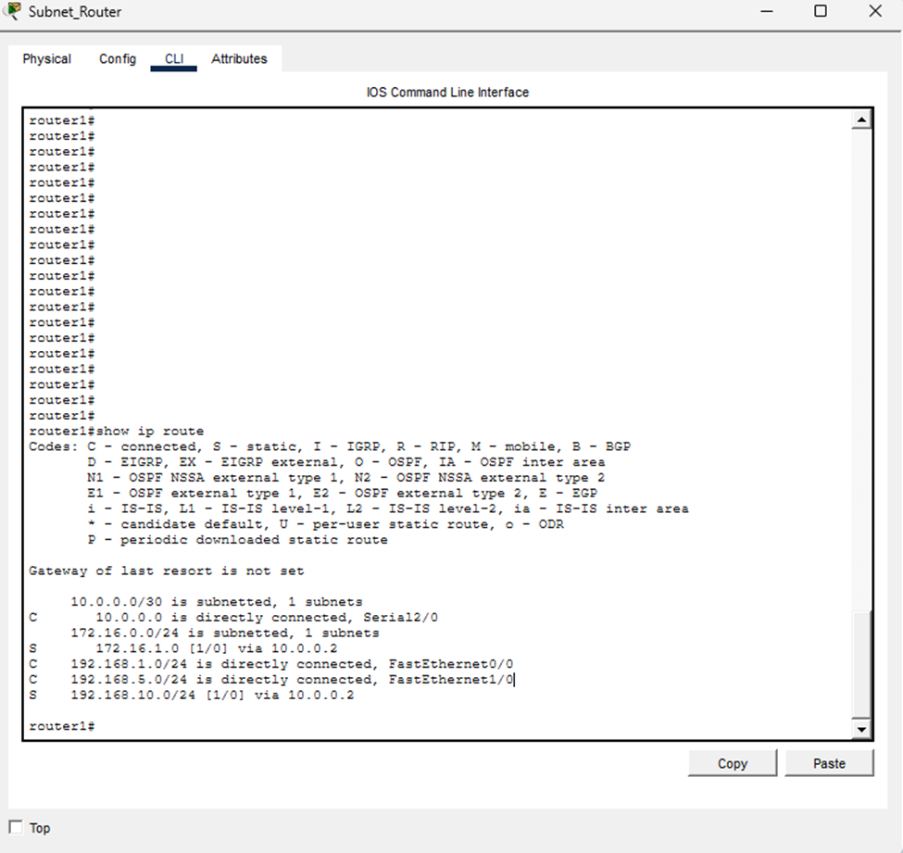

Router2 Routing Table
This screenshot displays the routing table on Router2, confirming that routes to all networks are correctly configured.
