Mathematical modeling of the impact of vehicles on water-saturated soil

Basic concepts of the physical and mechanical properties of soil
By their nature, soils are divided into two main classes: sands are products of mechanical destruction of basic rocks, and clays are products of chemical destruction of basic rocks. Sands and clays differ greatly in their physical and mechanical properties.
In nature, soils of mixed origin are usually found. They exhibit intermediate properties of sand and clay and are called, respectively, sandy loam, loam, etc.
All qualitative differences in soil properties are determined by the size and shape of the particles forming them. Of great importance in the manifestation of these properties is the water in the gaps between the particles. The gas in the soil (air, methane, water vapor) also strongly affects the properties of the soil.
Sands consist of particles having the shape of grains with a diameter of 0.5 - 2 mm (coarse sand) to 0.1 - 0.05 mm (fine sand) [47]. Clay particles are in the form of plates with a thickness of not more than 1 micron.

Let us introduce the notation.

- some volume of soil

- pore volume

- volume of solid particles

- soil porosity

- the volume of solid particles per unit volume of soil

- coefficient of porosity.

Compressibility of soils
Due to the low permeability of solid soil particles, compression deformation occurs mainly due to a change in porosity. The relationship between the coefficient of porosityand compressive stresses is obtained using uniaxial compression devices. The curve is shown in Fig. One.
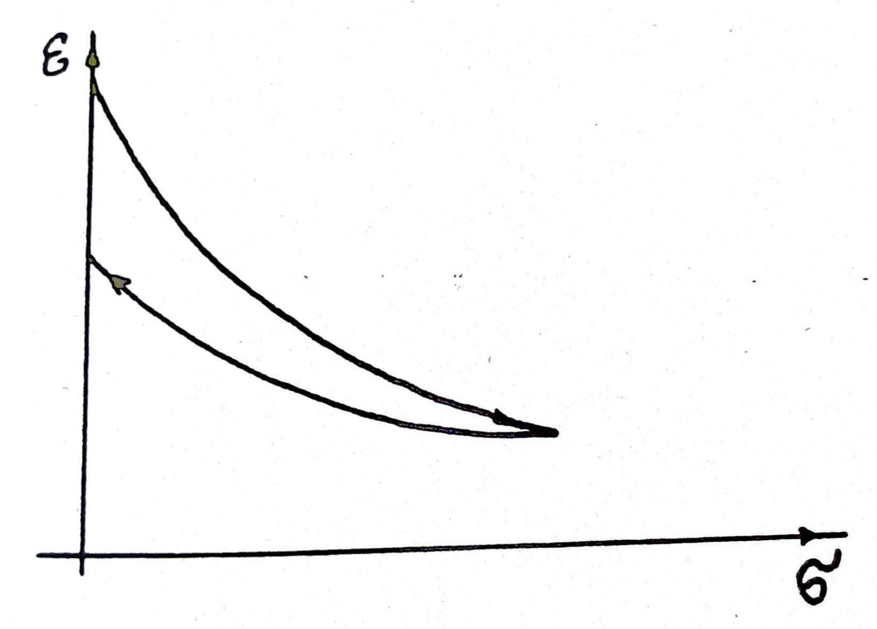Illustration 1: Compression curve

On small intervals of stresses change, it is approximated by a straight line

(1)
With a large number of loading and unloading, the soil becomes practically elastic.

Compaction factors , (according to Florin)

Weakly compacted clays | 0.10 - 0.01
Compacted clays | 0.005 - 0.001

Porosity coefficients (according to Florin)

Sands | 0.54 - 0.82
Compacted clays | 0.67 - 1.2
Silt | 1.00 - 3.00
Loams and clays | 0.67 -1.00

Filtration properties of soils

The filtration rate is defined in soil mechanics as the flow rate of water through a unit of the geometrical area of ​​the soil section. Darcy's law establishes a relationship between the filtration rateand the fluid pressure gradient:

Where is the filtration coefficient [cm / s]
is determined in hydraulics by the formula:

, [cm]

Where is the pressure in the liquid []
- specific gravity of the liquid []
- the height of this point above the zero mark [cm].
The actual speed of water relative to immobile soil grains is determined by the formula:

Where is the porosity of the soil (see above).
In the case of movement of soil grains towards the liquid at a speed, Darcy's law is written in the form:

(2)

Filtration coefficient , cm / s (according to Florin):
Sands
Clays

Understanding stresses in soil
Consider the case of deformation propagation in one plane. Let's select an elementary parallelepiped and call the ratio of the force acting on an elementary area to its area stress. Then, on the sections of the parallelepiped, inclined at different angles, we will get different values ​​of stresses. The stress vector coincides in direction with the force vector and it can be decomposed into normal and tangential components: and(Fig. 2).
Let us introduce a rectangular coordinate system XoZ and denote the stresses acting along the oX and oZ axes, respectively, and .
Let only normal stress act in any section, and there is no tangential stress. This normal stress is called the main one. The largest and the smallest normal stresses acting in a given section are the main ones. They are denoted by andrespectively.
It is convenient to determine the stress distribution in the sections of an elementary parallelepiped using Mohr's circles (Fig. 3). It can be seen from the figure that in the section drawn at an angle , the values ​​of the normal and tangential stresses are determined by the coordinates of the point D on the circle. The maximum shear stress in absolute value is achieved at.

The concept of soil strength
In soil mechanics, the main indicators of strength are considered to be the shear resistance of the soil. The maximum shear stress is determined from the equation:

(3)
where is called adhesion, and is the angle of internal friction. For sands, therefore, for clays, the cohesion and the angle of internal friction depend on the density of moisture. After preliminary compaction of the soil, an increase in adhesion and a decrease in the angle of internal friction are observed, this is associated with an irreversible decrease in the strength factor, as a result of which the molecular forces of interaction between particles increase [48].
From equation (3), you can determine the straight lines, which are called the lines of destruction. For a given value, construct a Mohr circle so that it touches these lines (Fig. 4).
The slope of the fracture planes can now be determined. It makes an angle to the line of action of the lowest principal stress. At this moment, the principal stresses satisfy the equation

(4)

Where, and the soil massif is in a state of so-called plastic limiting equilibrium [49]. The effect of the hydrostatic pressure of water in the pores of the soil should also be taken into account, therefore, the so-called effective stress, which is perceived by the skeleton of the soil, should be substituted in formulas (3) and (4), and their values ​​are less than the actual stresses by the value of the pore pressure of water. The sine of the largest deviation of the total stress vector can be represented as:
.

Deformation modulus and Poisson's ratio
When compressing a soil sample in a compression device, transverse deformations of the soil are impossible. In this case, the lateral pressure coefficient is determined by the formula:. In soil mechanics, it is assumed that porosity depends only on the sum of the principal stresses, and not on their ratios. This assumption is based on the approximation of the real stress-strain curve by a straight line with sufficient accuracy for practical calculations. Because of this, we write formula (1) for the case of a biaxial stress state (plane problem):

(5)
Here is the sum of the principal stresses.
The deformation modulus is determined in soil mechanics from the expression:
,
where and is the increment in stresses, that caused - the strain increment along the oX axis.
Poisson's ratiois defined through the lateral pressure ratio:.
If we take the dependence as linear, for example, in the form (5), we obtain
,
Where .

Lateral pressure coefficient (according to Florin):
Sands 0.40-0.42
Clays 0.70-0.75.
The above expressions for the deformation moduli make it possible, in the case of a nonlinear relationship between stresses and strains, to determine the modulus value for any given stress state. However, in many cases it is more convenient to use the so-called average deformation modulus, where is the initial porosity coefficient.
It was shown (N.M. Gersevanov) the constancy offor plastic soils in a small range of load variation.
In conclusion, let us consider the case of applying a vertical load along the rectilinear boundary of a linearly deformed medium. In this case [51]:

(6)
The stress components are determined by the formulas:

,
where , , , ,
и - displacement components.
,
where .
For a general model of a linearly deformable medium, the stresses in the soil skeleton must satisfy the equations [51]:

(7)

(8)

Where и - components of volumetric forces,
and the equation

(9)

Where- коэффициент Пуассона , - оператор Лапласа.

