# MyBlog

Blogging application

**Documentation**

Igor Šimko

# DESCRIPTION

Blog application where multiple users can create posts, comment on posts, and react to comments.

# Functionality

The application supports following functionality.

## Login/Registration

User can log in or sign up blog application.

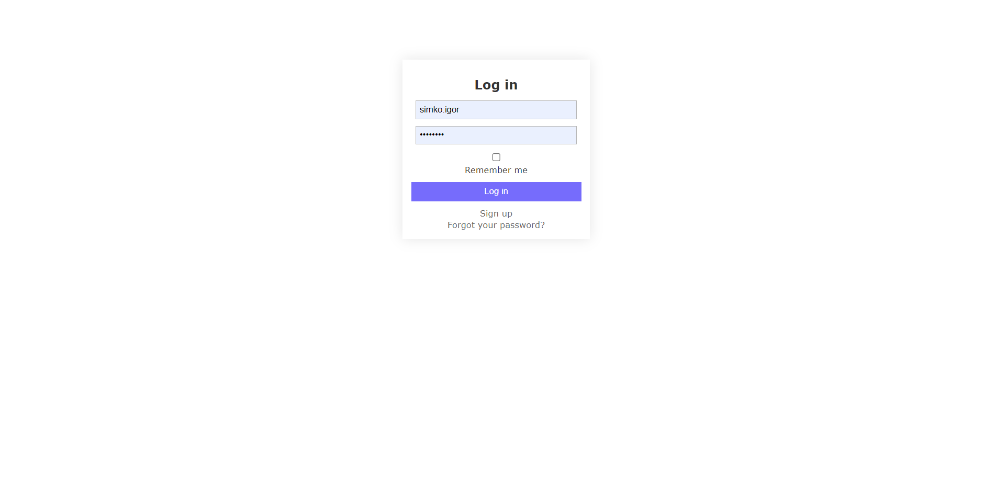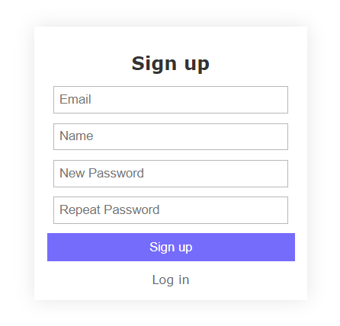

## Display users blogs

List of all users. Selecting a specific user, the list of all user’s posts will be displayed.

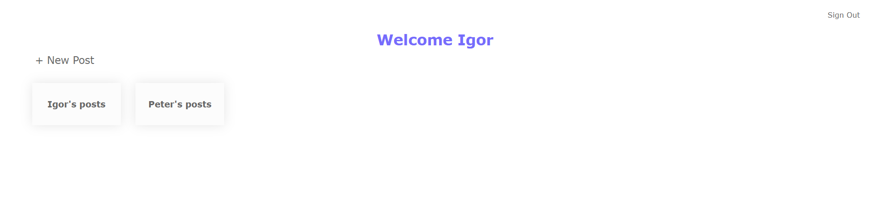

## Create A Post

User can create a new post specifying title and content by selecting .

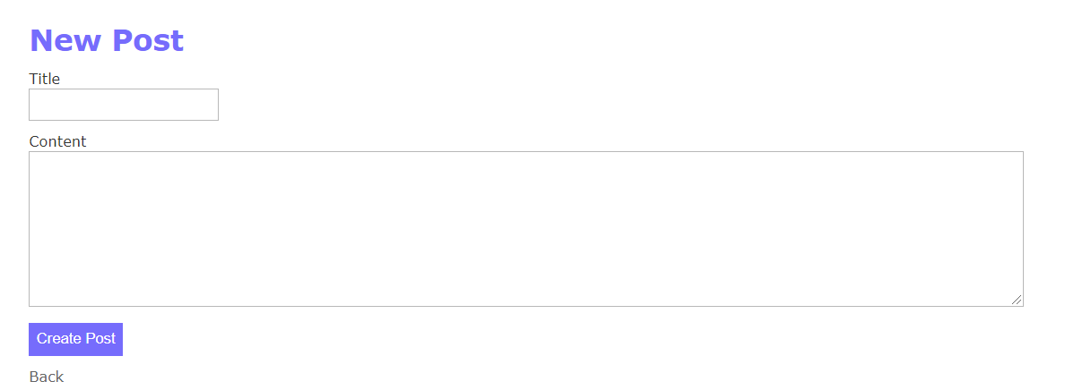

## Edit Post

User can edit the post by selecting Edit option in post detail section.

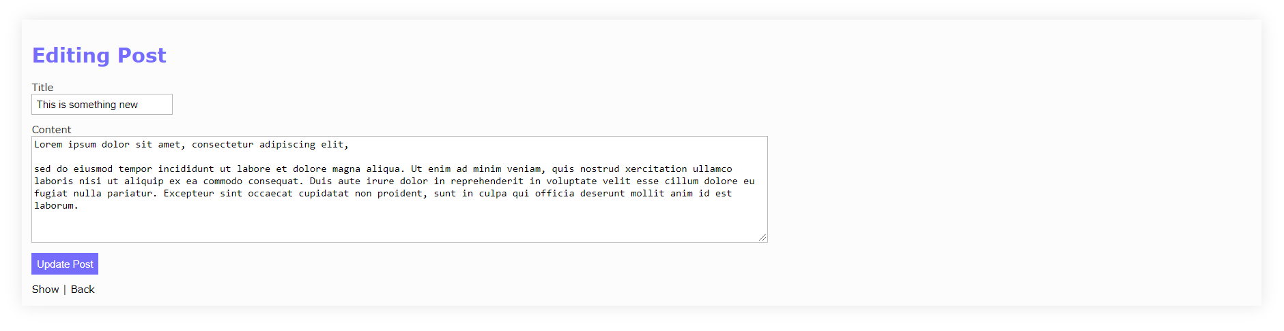

## Destroy post

User can destroy post by selecting Destroy option in post detail section.

## List user’s posts

List the posts of selected user. User can see the content of a post by selecting the post.

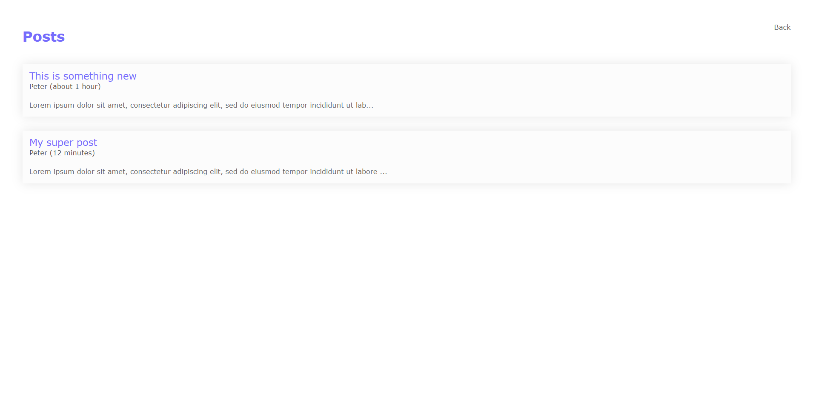

## Show post detail

Display a content of selected post. The list of all comments is visible under the content of the post. User can add new comment by providing a content of comment at the very bottom of page.

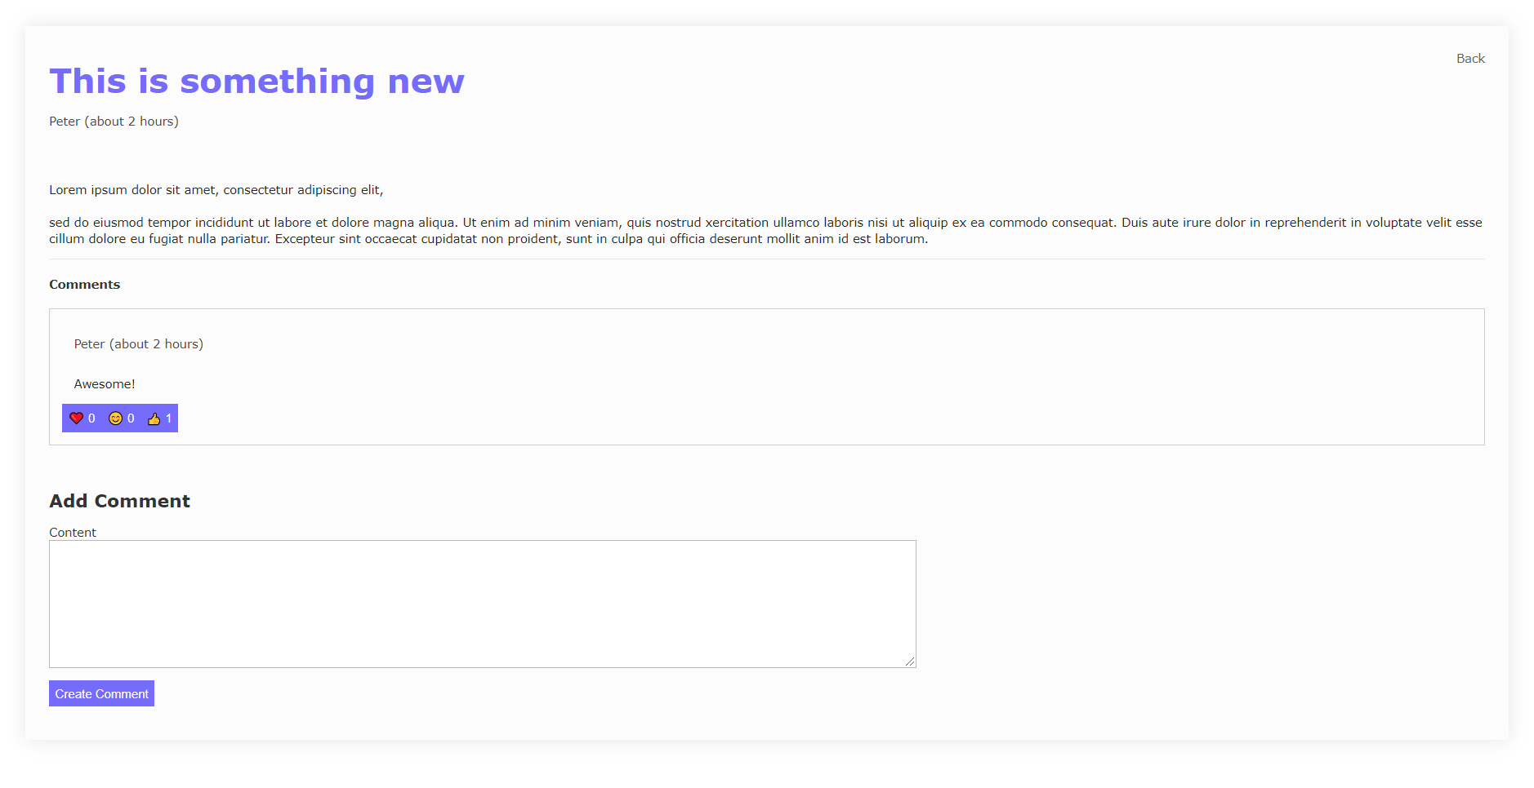

## React to comment

User can react to comment by selecting one of available reactions (like, smile, thumbs up).



## Edit Comment

User can edit a comment by selecting Edit option in comment card.

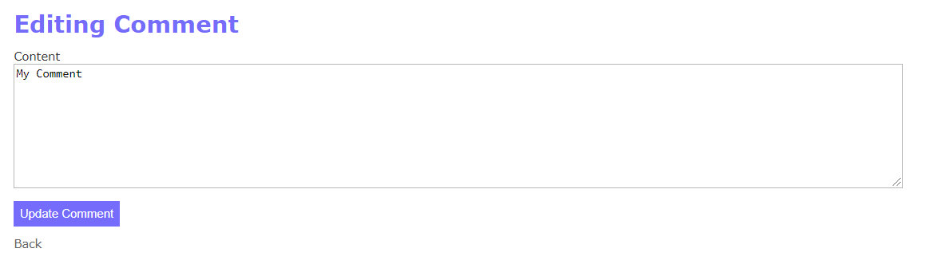

## Delete Comment

User can destroy the comment by selected Destroy option in comment card.

# DATABASE SCHEMA

