Test testxasa

A

Sdfasdfasdfas

Asdfasdfa sdfa

asdfasdfasdfasd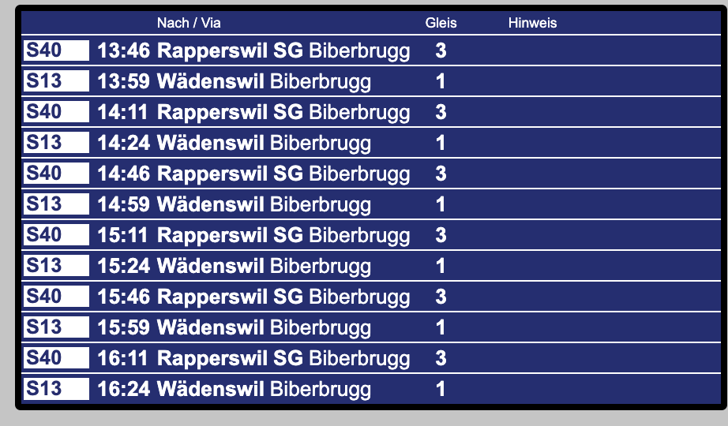

Asdfasdfasdfasdfas

JAJAJAJA se vikam Igor

