MINISTRY OF EDUCATION AND RESEARCH OF THE REPUBLIC OF MOLDOVA
Technical University of Moldova
Faculty of Computers Informatics and Microelectronics
Department of Software Engineering and Automation

Report on laboratory work 3
The command line shell pipes and text filters
Course Operating Systems

Done by: st. gr. FAF-242, Tacu Igor
Checked by: Reițman Patricia

Chișinău, 2026

Purpose and execution record
All twenty-four Lab 3 figures now use native Terminal screenshots supplied by the author from direct execution and source inspection on the Ubuntu server on 9 November 2026. Some screenshots cover two adjacent questions. The initial predictions and their original run are retained in predictions.json; the screenshots document subsequent verification runs. The exact text logs and source are also included in the repository. The submission was prepared with coding assistance, and MIT xv6 is identified as upstream in the source provenance file.

Part 1 Move fast and find help
Cd and echo are Bash builtins. In the interactive capture, ls is an alias for ls --color=auto; which resolves the underlying external executable to /usr/bin/ls. Cd must change the current directory of the persistent shell itself. A child process could change only its own directory. In this run PATH had nine entries and which resolved ls to /usr/bin/ls. A nonexistent command returned 127. The ls option -t sorts by modification time, newest first. Man, man -k, ls --help and help cd supplied local help.
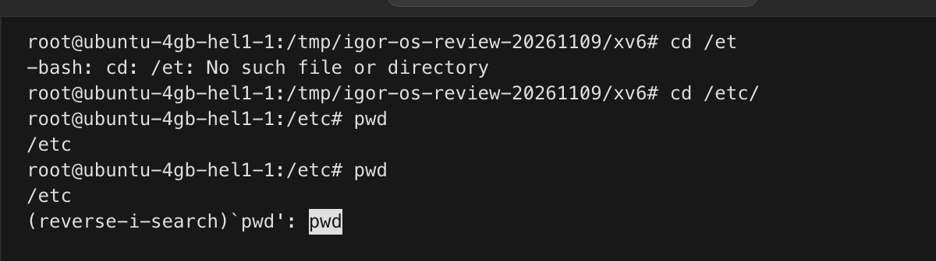
Figure 1.1 – Tab completion and reverse history search
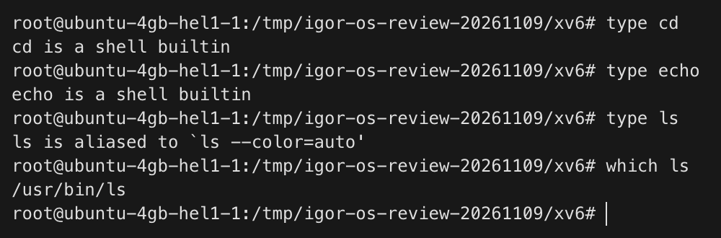
Figure 1.2 – Type and which
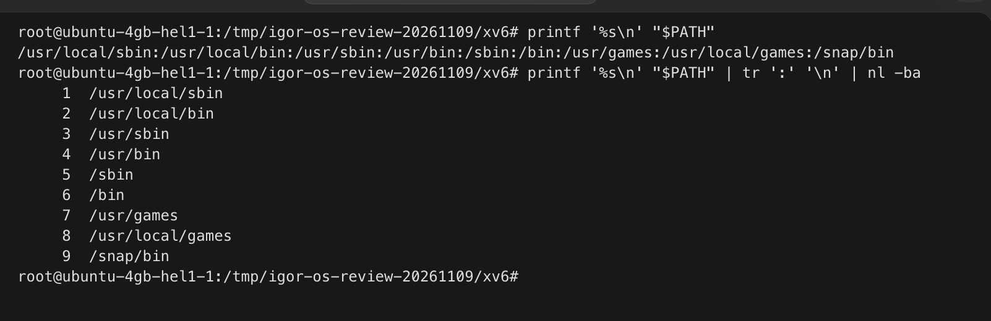
Figure 1.3 – Directories in PATH
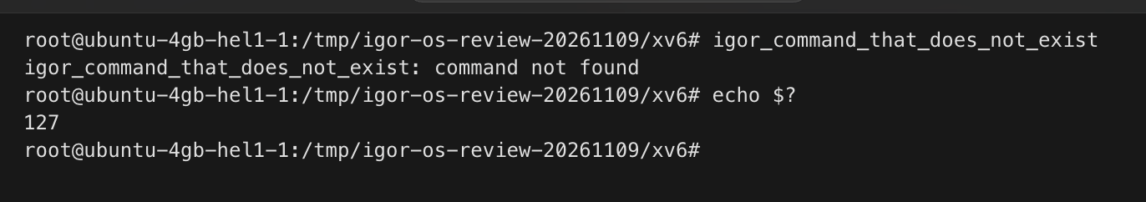
Figure 1.4 – Exit status of a missing command

Part 2 Predictions and shell expansion
The required play directory contained a.c, b.c, file1.txt, file2.txt, notes.txt and alfa beta.txt. Each prediction below was recorded before execution; timestamps and complete stderr are retained in the JSON evidence. Differences in line layout from ls are presentation differences, not additional filenames.

Command | Prediction before run | Observed output and status | Explanation
echo *.c | a.c b.c | a.c b.c  status 0 | Bash expands the pattern before echo starts.
echo file?.txt | file1.txt file2.txt | file1.txt file2.txt  status 0 | Question mark matches one character.
echo [a-b]* | a.c alfa beta.txt b.c | a.c alfa beta.txt b.c  status 0 | The range matches names beginning with a or b.
echo *.xyz | literal *.xyz because no match exists | *.xyz  status 0 | The unmatched pattern remains literal with the default settings.
ls alfa beta.txt | two missing operands and a nonzero status | ls: cannot access 'alfa': No such file or directory  ls: cannot access 'beta.txt': No such file or directory  status 2 | Unquoted whitespace creates two operands.
ls "alfa beta.txt" | one file named alfa beta.txt | alfa beta.txt  status 0 | Quotes preserve one pathname containing a space.
echo '$HOME' "$HOME" \$HOME | $HOME /root $HOME | $HOME /root $HOME  status 0 | Single quotes and backslash protect the dollar sign; double quotes permit expansion.
echo {1..5} ; echo $((7 * 6)) | 1 2 3 4 5 then 42 | 1 2 3 4 5  42  status 0 | Brace expansion lists values; arithmetic expansion computes 42.
echo "today is $(date +%A), I am $(whoami)" | current weekday and current login identity | today is Monday, I am root  status 0 | Command substitution supplies the current weekday and identity.
touch log{1..3}.txt && ls log* | log1.txt, log2.txt, log3.txt | log1.txt  log2.txt  log3.txt  status 0 | Brace expansion creates three filenames.
Echo does not discover files; Bash supplies the expanded arguments. The unquoted space in ls alfa beta.txt produces two failed lookups. Both ls "alfa beta.txt" and ls alfa\ beta.txt address the single file correctly. Single quotes retain literal text; double quotes still allow parameter and command substitution. GNU ls may display quotes for a space-containing filename when its output is a terminal, but those display quotes are not stored in the name.
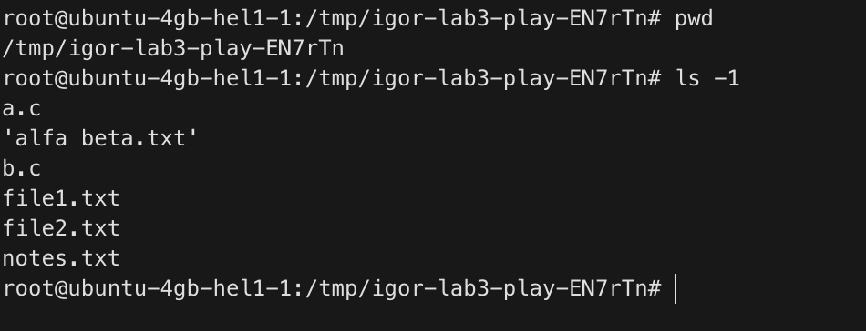
Figure 2.1 – Files in the required play directory
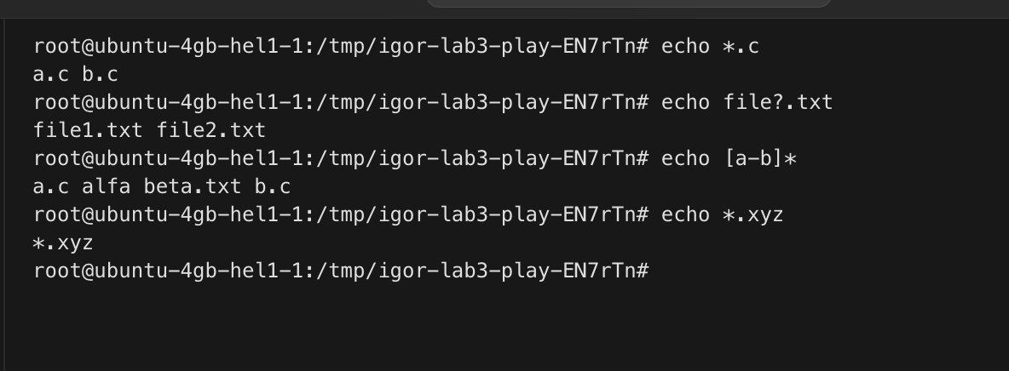
Figure 2.2 – Globbing results
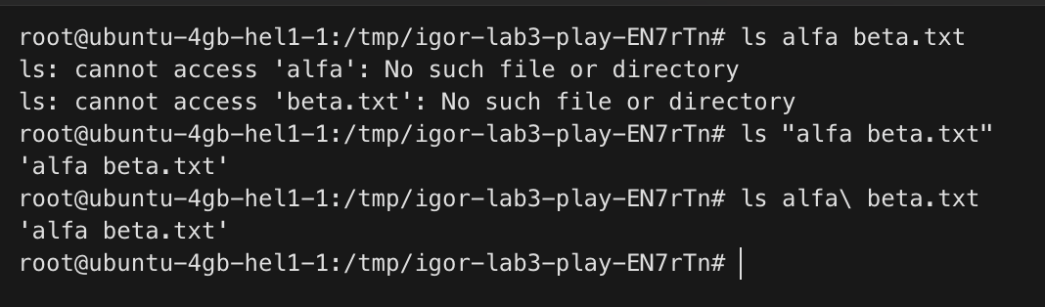
Figure 2.3 – A space containing name and the quoted fix
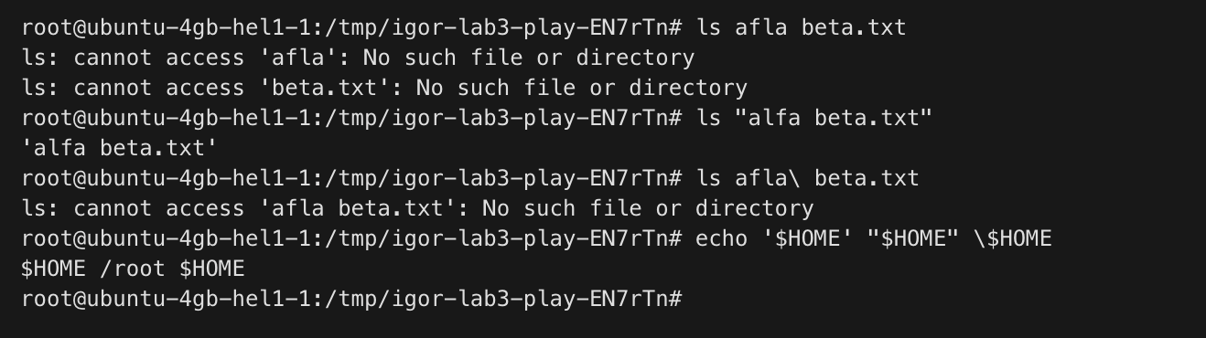
Figure 2.4 – Single double and escaped dollar quoting

Part 3 Redirection chaining and jobs
Out.txt received stdout, while err.txt received the diagnostic for /nope. In > all.txt 2>&1, descriptor 1 is changed first and descriptor 2 duplicates that new target. In 2>&1 > all.txt, stderr keeps the original stdout target while only stdout moves to the file. Wc -l < access.log receives stdin and therefore prints a count only; with access.log as an operand it also knows and prints the filename. A semicolon sequences regardless of the previous status; AND runs the next command only after success; OR runs it only after failure. The background sleep was listed, terminated and reaped with status 143.
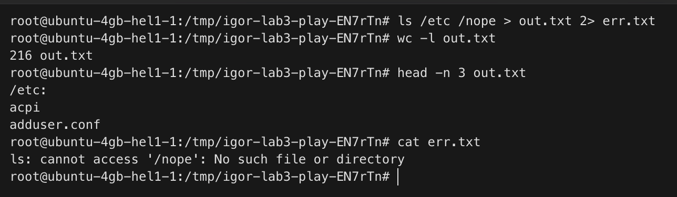
Figure 3.1 – Stdout and stderr in separate files
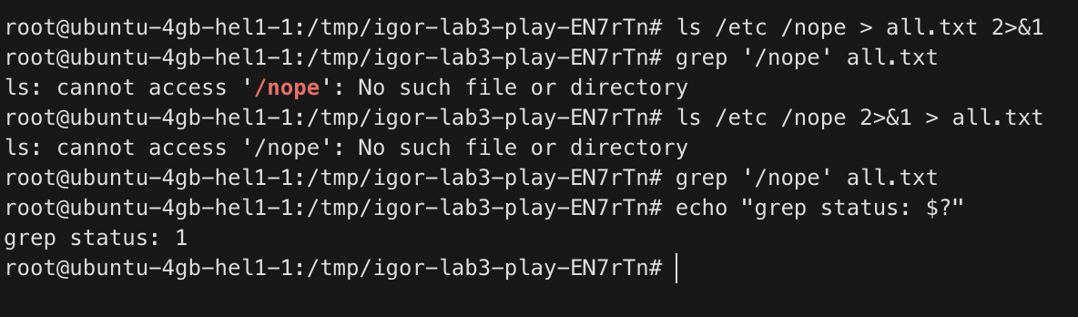
Figure 3.2 – Order of descriptor redirections
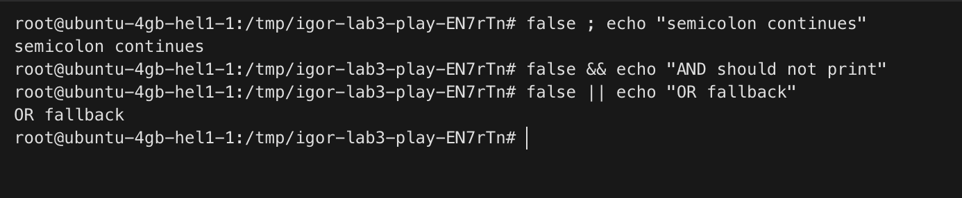
Figure 3.3 – Semicolon AND and OR
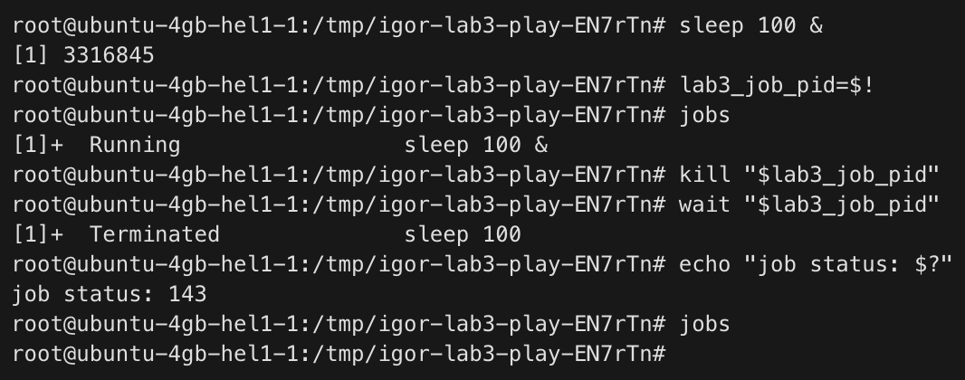
Figure 3.4 – Background job and termination

Part 4 Answers to the eight log questions
The artificial dataset uses the exact 2026-10-05 generator supplied in the handout. It is shared assignment input rather than real web traffic. All 500 lines were regenerated. The pipelines compare the result field, preserve tied maxima and sort their output. The four page counts sum to 500 and the seven user failure counts sum to 100. In Q8 the long listing has one extra total header line; the entries are otherwise the same.
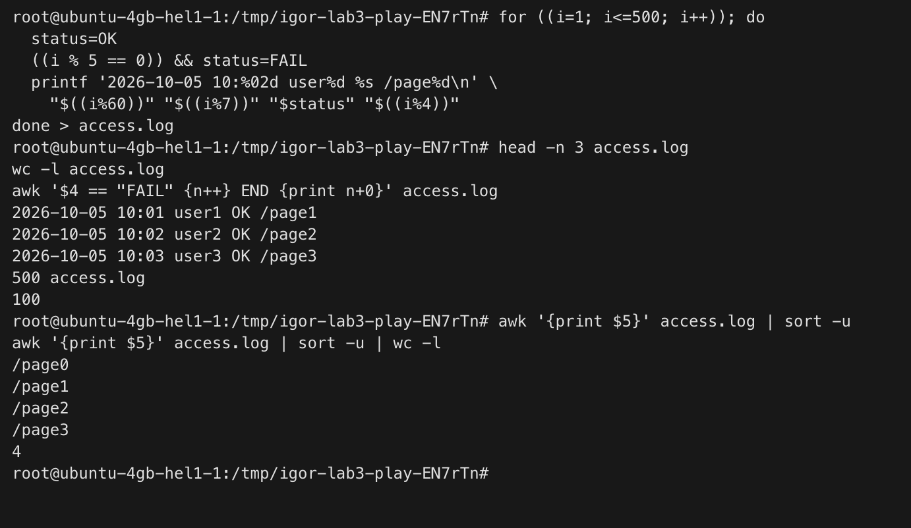
Figure 4.1 – Question 1 result
Figure 4.2 – Question 2 result
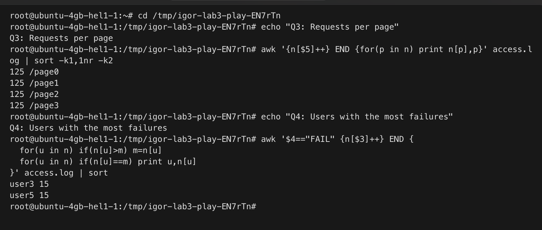
Figure 4.3 – Question 3 result
Figure 4.4 – Question 4 result
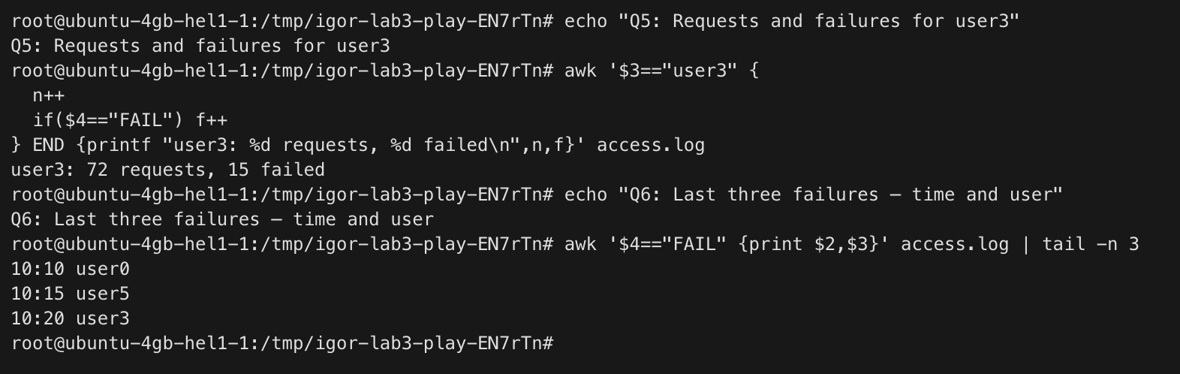
Figure 4.5 – Question 5 result
Figure 4.6 – Question 6 result
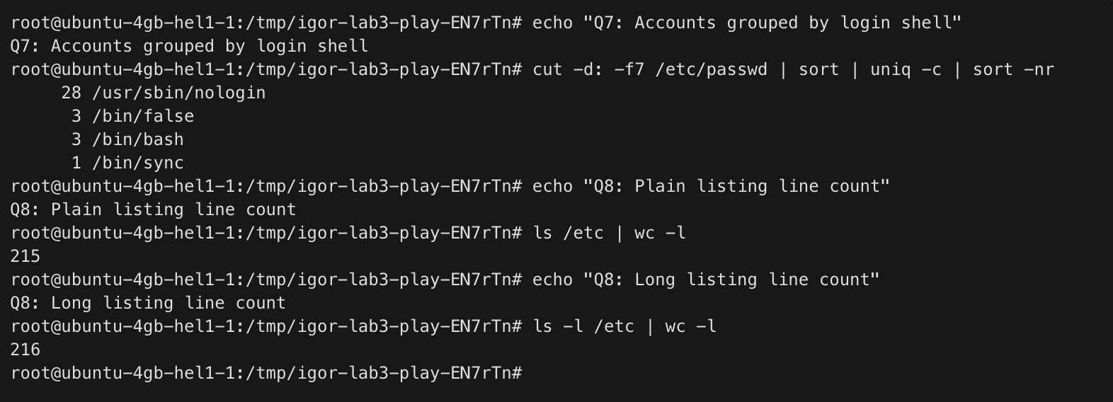
Figure 4.7 – Question 7 result
Figure 4.8 – Question 8 result
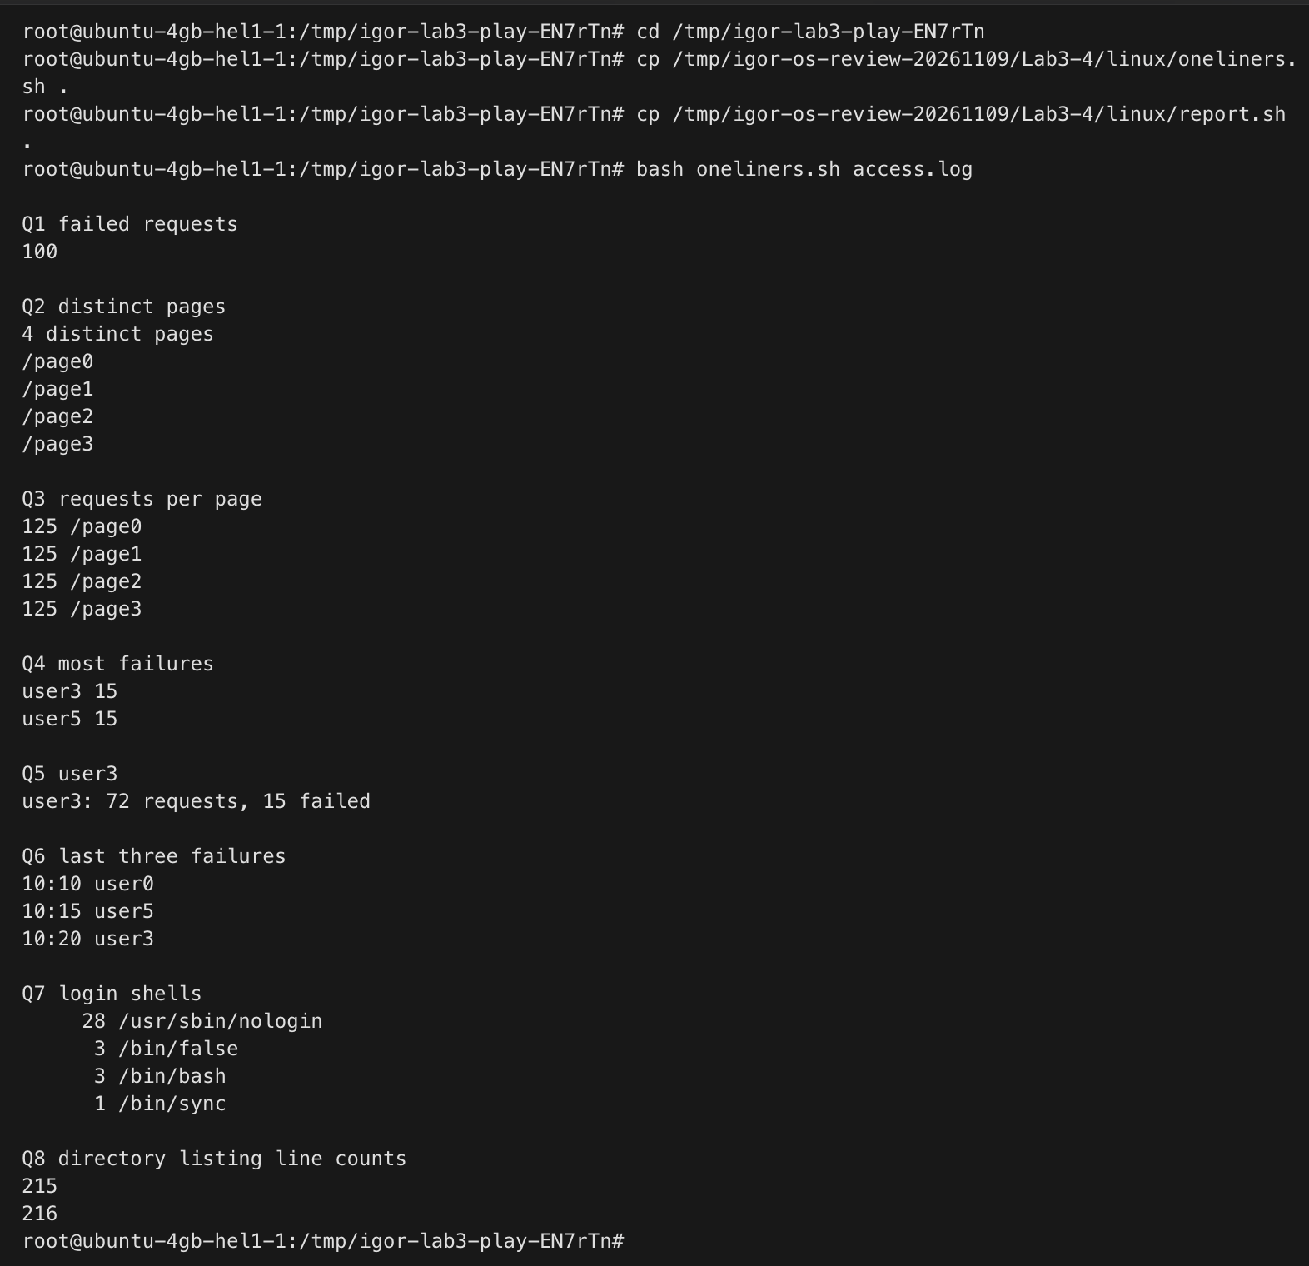
Figure 4.9 – Full run of oneliners.sh

Part 5 The report script and its error path
The shebang #!/bin/bash selects Bash when the executable script is launched directly. Before chmod +x, ./report.sh returned permission denied and status 126. The prefix ./ supplies a pathname because the current directory is not searched through PATH here. The error is written to descriptor 2 so stdout remains usable for normal results; exit 1 lets a caller detect failure. The script prints every user from user0 to user6, including zero counts, using its aggregation loop. Optional cron and bonus tasks are not claimed.
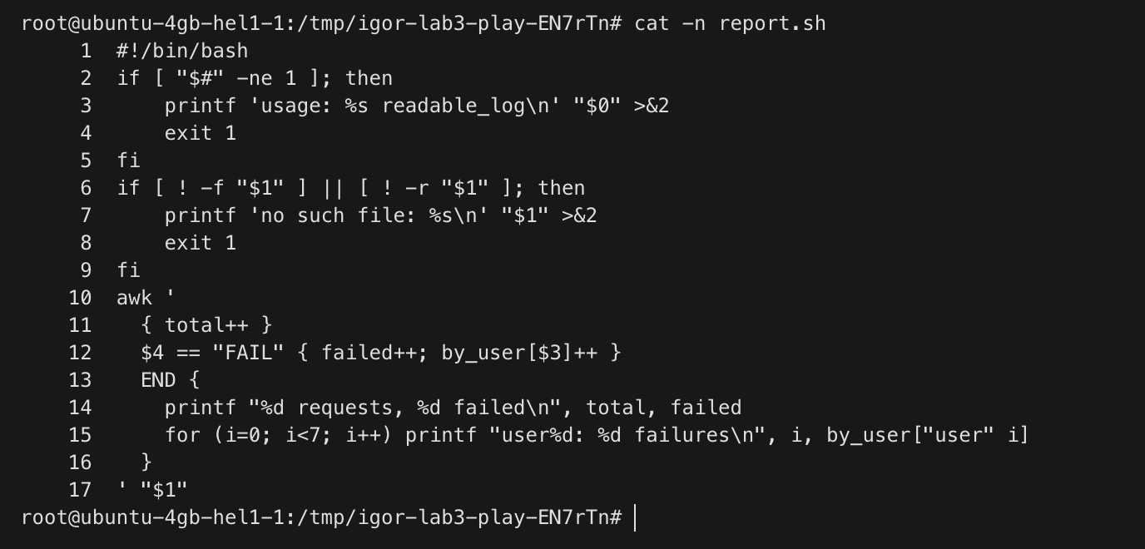
Figure 5.1 – Source of report.sh
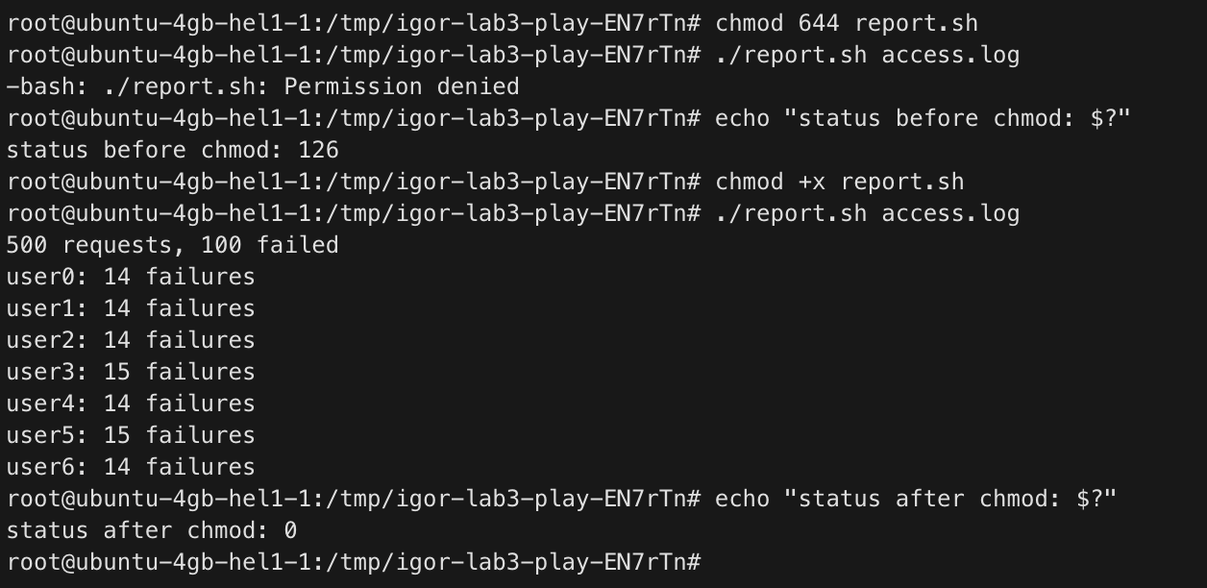
Figure 5.2 – Successful report and execute permission check
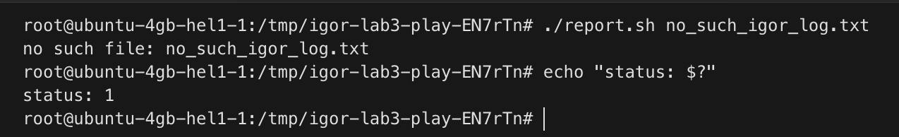
Figure 5.3 – Missing file diagnostic and status

Conclusions
Argument expansion belongs to Bash before program execution. Descriptor duplication explains the order-sensitive redirection result, while status-dependent operators make failure handling explicit. The one-liners were verified against fixed input totals and the reusable script was tested on success and missing input. Source files, predictions and raw recordings accompany this report.

