MINISTRY OF EDUCATION AND RESEARCH OF THE REPUBLIC OF MOLDOVA
Technical University of Moldova
Faculty of Computers Informatics and Microelectronics
Department of Software Engineering and Automation

Report on laboratory work 4
The xv6 shell from the outside
Course Operating Systems

Done by: st. gr. FAF-242, Tacu Igor
Checked by: Reițman Patricia

Chișinău, 2026

Purpose and execution record
All twelve figures are native Terminal screenshots supplied by the author from direct command execution and source inspection on the Ubuntu server on 9 November 2026. The xv6 tests use an isolated source copy and its generated test disk. The directory d already existed during the directory-handling capture; grep READ limits the displayed listing. Bash comparisons use separate temporary directories. Source files and earlier full execution transcripts accompany the screenshots. The submission was prepared with coding assistance; MIT xv6 is identified as upstream in the source provenance file.

Part 1 Sleep and the current interface
The header declares pause rather than sleep. The submitted utility calls pause with validated decimal ticks; sleep 20 returns normally, missing input produces usage, and negative input produces a diagnostic. The Makefile contains the _sleep entry. Forked processes inherit the binary and descriptor context, while pause is the kernel operation that performs the delay.
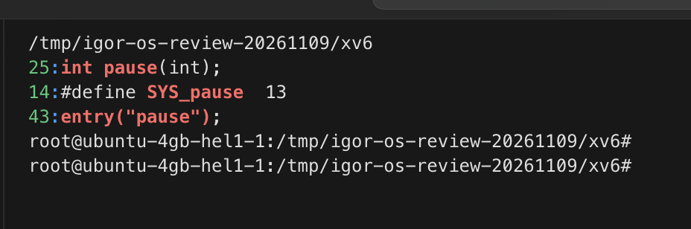
Figure 1.1 – The pause declaration
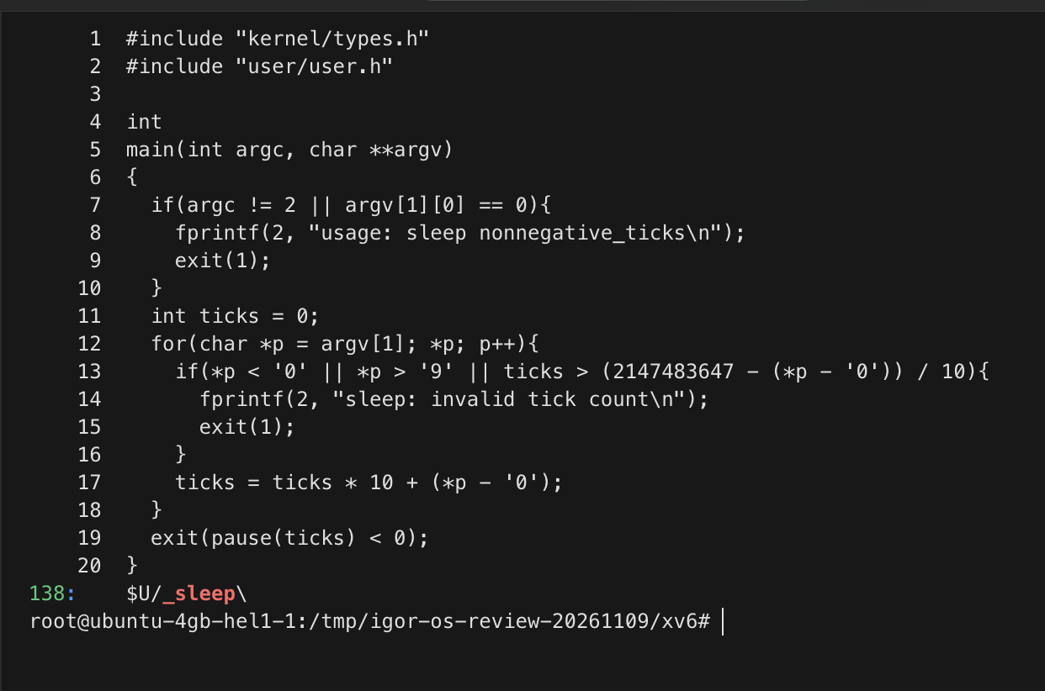
Figure 1.2 – Sleep source and registration
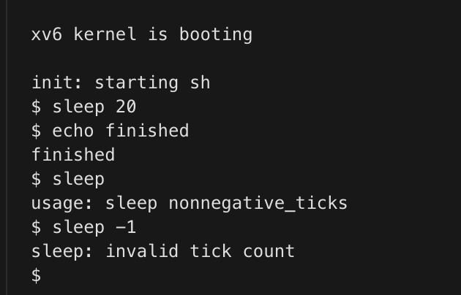
Figure 1.3 – Sleep with valid and invalid arguments

Part 2 Comparing every command in the two shells
The Bash test starts in a fresh directory containing README. Both shells provide execution, descriptor redirection, pipelines, command lists, grouping and background commands. Bash additionally expands wildcards and variables, removes syntactic quotes, and offers readline history and completion. The table records the actual small-shell behavior rather than assuming it implements Bash syntax.
Command | Bash | xv6 | Reason
echo hello > f ; cat < f | hello | hello | descriptor redirection
ls | grep READ | README | README line | pipe
(echo a; echo b) | wc | 2 lines 2 words 4 bytes | 2 2 4 | group and list
echo one ; echo two | one then two | one then two | sequence
echo bg & | bg and prompt | bg and prompt | background
ls * | expands existing names | cannot open * | Bash pathname expansion
echo $HOME | /root | $HOME | Bash variable expansion
echo "a b" | a b | "a b" | Bash quote removal
mkdir d ; cd d ; ls .. | lists parent after changing directory | exec cd failed; lists from original directory | xv6 handles cd only as a whole input line
Up Tab Ctrl+R | history and completion | not implemented as Bash readline features | source and PTY inspection
There is an important distinction in the last directory case. A cd embedded in a semicolon list is passed through the xv6 execution parser and fails as an external command. Issuing cd d as its own input line does change the parent shell. From there a bare ls fails because xv6 has no PATH search, while /ls .. succeeds. For interactive work, history and completion are valuable additions. Basic quote handling would be a localized tokenizer improvement; full pathname expansion would also require directory traversal.
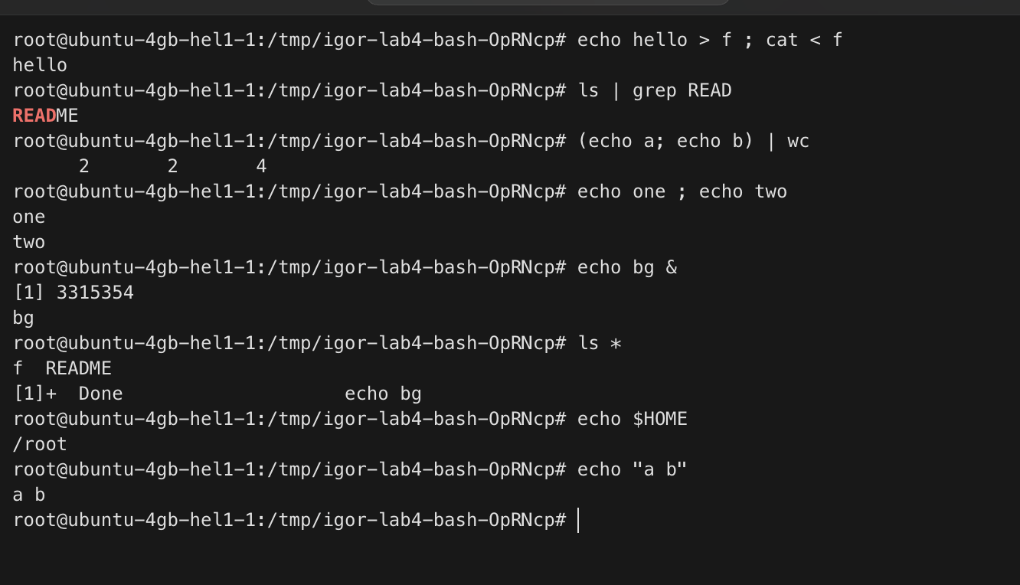
Figure 2.1 – The original comparison commands in Bash
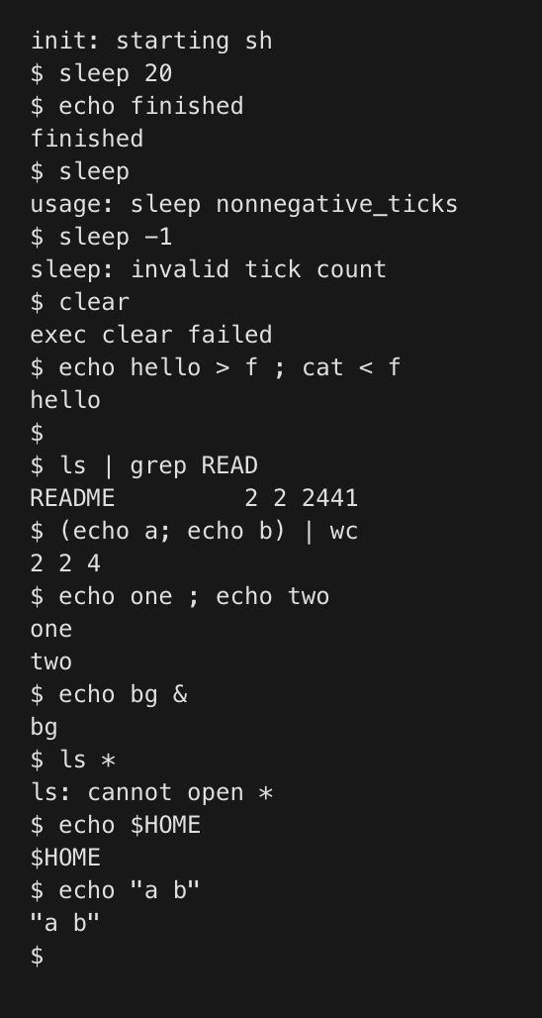
Figure 2.2 – The same comparison commands in xv6
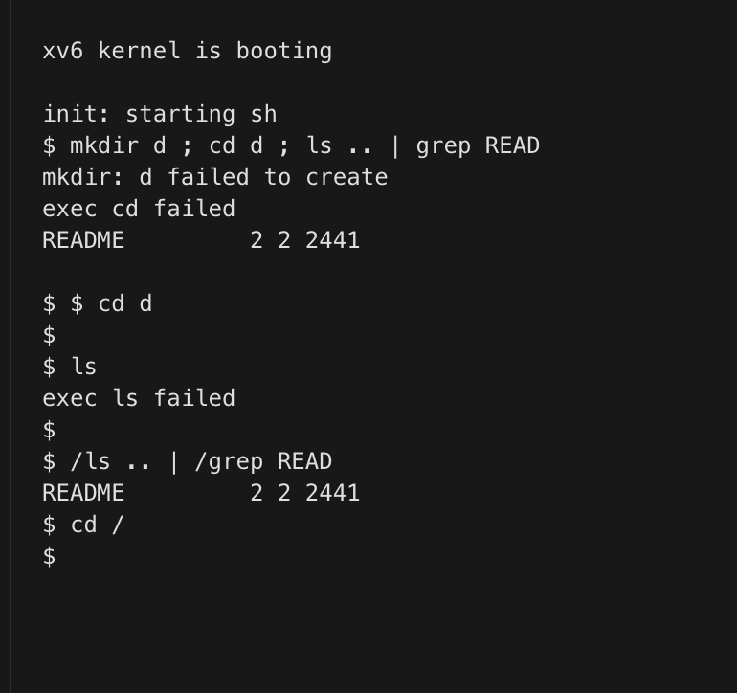
Figure 2.3 – Directory handling and absolute ls (README-filtered listing)

Part 3 Who expands the argument vector
Both inspectors print only argc and argv. The Linux wildcard experiment in this additional test directory had four C files and one quoted x y operand, giving argc 6 including argv zero. Xv6 passed four arguments: args, the literal *.c, and two values containing the double quote marks. The shell, not the inspector or kernel, is responsible for expansion and syntactic quote removal. Repeated unquoted spaces delimit arguments in both shells; they do not become empty arguments.
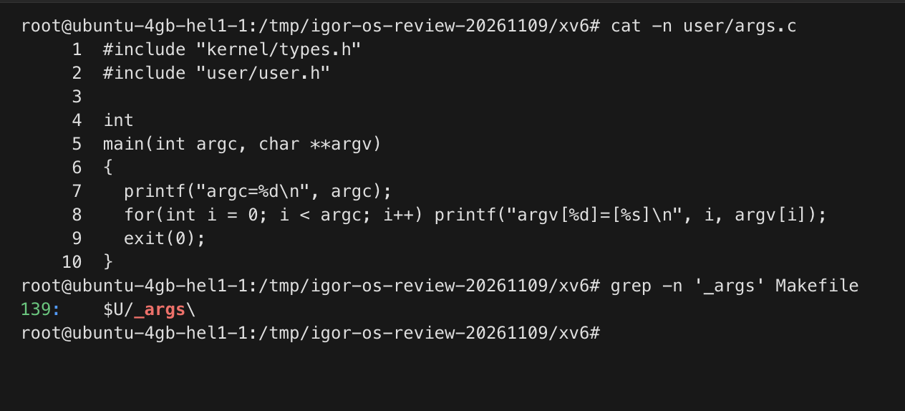
Figure 3.1 – Args source and UPROGS entry
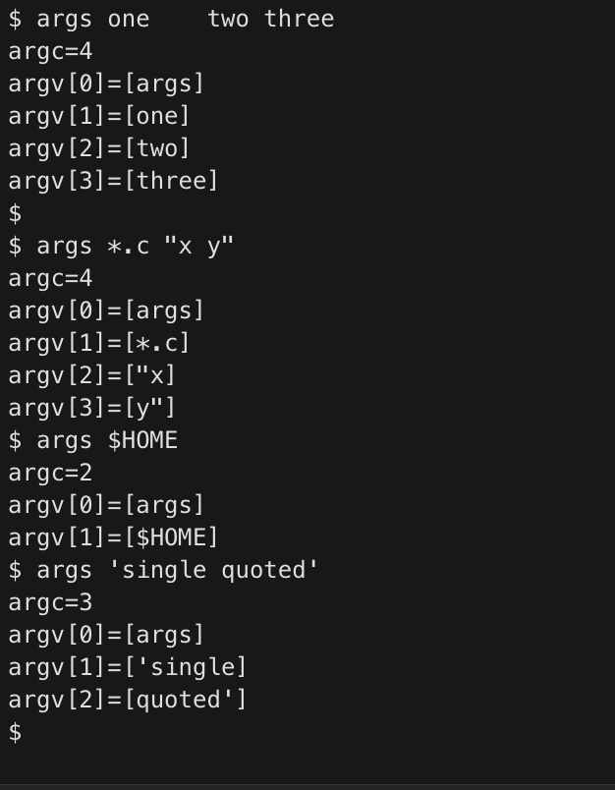
Figure 3.2 – Argument arrays from xv6
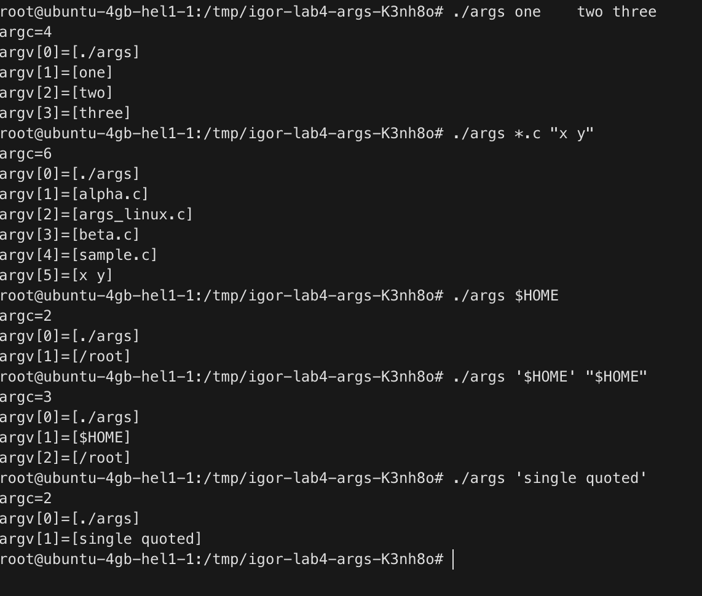
Figure 3.3 – Argument arrays from Linux

Part 4 Reading the shell
This version of user/sh.c has 499 lines. EXEC represents a plain command; REDIR is introduced by < or >; PIPE by |; LIST by a semicolon; and BACK by ampersand. Parentheses group a parsed command tree. Cd is recognized in the parent loop before forking and parsing a general command, so its directory change persists. The parser has no Bash parameter-expansion or globbing stage, explaining the literal * and $HOME results. The five command kinds are visible both in their definitions and in runcmd dispatch.
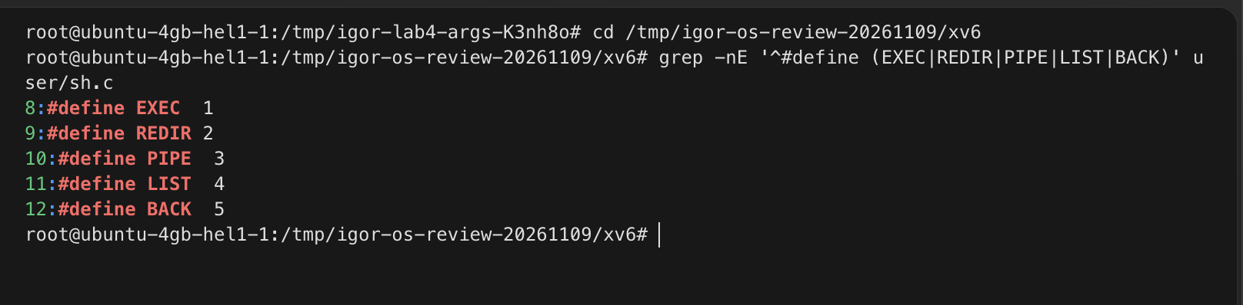
Figure 4.1 – Defined command kinds
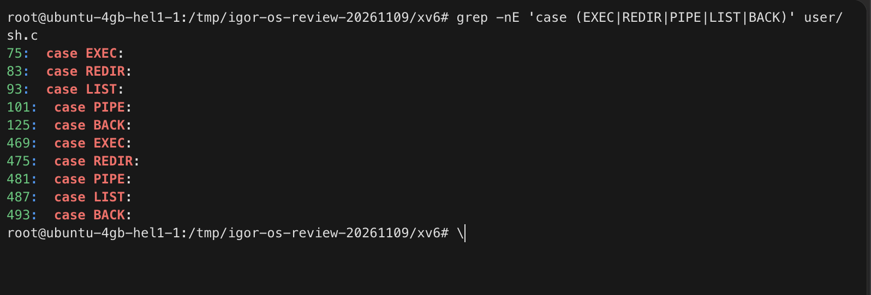
Figure 4.2 – Dispatch cases
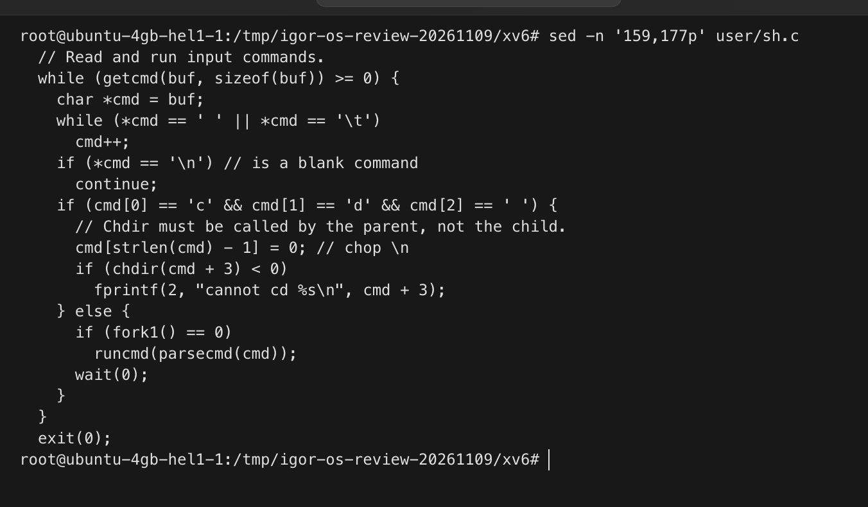
Figure 4.3 – Parent shell implementation of cd

Conclusions
The two shells share process and descriptor mechanisms but differ before exec in parsing and expansion. The argument inspector isolates those differences. The additional cd-list test also shows why a small shell feature cannot be assumed to compose exactly as in Bash. Both requested programs and the integrated Makefile are submitted with the full xv6 source and raw console evidence.

