Webshop iFlow Templates on SAP Integration Suite
Document | Template iFlows for the HYDAC Magento ↔ SAP webshop integration on SAP Integration Suite (Cloud Integration): sync request-reply, async shop → SAP, async SAP → shop
Builds on | AU Webshop iFlow Design – Sync & Async (8 November 2026) · Customer Monitor on SAP BTP – Solution Design (design review 10 November 2026) · read-only review of the tenant fsm-dev-cpi-hydac (8 November 2026)
Customer | HYDAC – Group IT, HYDAC Digital, HYDAC Australia; TechDivision (Magento); DyFlex (S/4HANA Cloud AU)
Prepared by | purplecat AG – Igor Vorobev, SAP BTP solution architecture
Version | 0.1 – first draft for review
Date | 9 November 2026
Classification | Confidential – HYDAC / purplecat project documentation

Conventions. ✅ exists in the tenant · 🟡 designed, not built · 💡 proposal, needs agreement · ❓ open point · My call = a detail settled by purplecat so that the build can start; say so if you disagree. Identifiers: T-n template, R-n rule, TD-n decision needed. Placeholders: <REGION> = EU | US | AU, <region> the same in lower case, <STG> = DEV | TST | PRD, <IF> = interface code (S1, A4, B1, …), <SYSTEM> = SAP system flavour (S4OP on-premise and RISE, S4PC Public Cloud).
Summary. Seven template iFlows and one shared package per region cover every webshop interface HYDAC has planned. A synchronous pair – a shop-facing contract flow plus one backend flow per SAP system – serves request-reply APIs such as prices, order simulation and availability. An asynchronous chain – generic inbound, Event Mesh → JMS bridge, dispatcher, consumer – serves everything that must never be lost: orders and registrations towards SAP and the Customer Monitor, business-partner and stock changes towards the shops. The templates are region-neutral: the AU design of 8 November becomes the first instance set; EU and US are copies with a different backend adapter and different parameter values, not new designs. Registrations (A1–A3) end in the Customer Monitor's IntakeService; the monitor's own calls to SAP and its notifications back to the shop stay outside Integration Suite, as the solution design proposes (D-10, D-09, §6.2).
Contents
1. Purpose, scope and sources
2. Where the templates sit
3. Template catalogue
4. Rules shared by all templates
5. Naming, stages, parameters, context
5.1 Names
5.2 Stages
5.3 Externalised parameters
5.4 Context: properties and headers
6. Error contract
7. Sync template – T-1 contract and T-2 backend
7.1 Steps of T-1 (contract flow)
7.2 Steps of T-2 (backend flow) and the variants per SAP system
7.3 Timeouts
7.4 Copy checklist T-1 / T-2 (what an instance changes, nothing else)
8. Async template – T-3 inbound, T-4 bridge, T-5 dispatcher, T-6 consumer
8.1 Why Event Mesh and JMS
8.2 Steps of T-3 (generic inbound, one per region)
8.3 T-4 bridge and T-5 dispatcher (one per region, direction and stage)
8.4 T-6 consumer – structure and steps
8.5 Reprocessing
8.6 Copy checklist T-6 (what an instance changes, nothing else)
9. Registrations A1–A3 and the Customer Monitor
10. SAP → shop – T-7
11. Shared artefacts and scripts
12. Queues, Event Mesh and security material per region
13. Monitoring and alerting
14. Versioning and delivery
15. Acceptance tests for a template instance
16. Decisions needed and next steps

1. Purpose, scope and sources
This document is the one place that says how every webshop iFlow is built, so that a new interface is a copy with a new mapping and a new backend call – in every region – and so that TechDivision, DyFlex and HYDAC Digital meet the same endpoint style, error codes and monitoring everywhere.
Source | Taken over unchanged | Changed or added here
AU Webshop iFlow Design (sync S1, async A4) | Two-layer sync design; Event Mesh → JMS staging with backoff and explicit dead-letter queue; the three error classes; RFC 9457 error contract; idempotency; MPL custom headers and statuses; JMS queue budget; dispatcher and reprocessing pattern from the US team | Region placeholders instead of AU; backend variants for S/4HANA on-premise (EU), S/4HANA Cloud Private Edition on RISE (US) and S/4HANA Cloud Public Edition (AU); a fixed contract at the ProcessDirect seam (R-9); header-only transport across ProcessDirect; copy checklists per template; the shared Groovy scripts (scripts/)
Customer Monitor Solution Design (§3.2, §6.2, §7.5, §8.9, D-09, D-10) | IntakeService /intake/v1 as the target for registrations; monitor runtime calls and notifications not through Integration Suite; cpi-iflows repository for the iFlows; API Management optional | A1–A3 consumers mapped onto the three intake operations and their error contract (§9); the registration path and the result-notification path per region raised as decisions (TD-01, TD-02)
Tenant review fsm-dev-cpi-hydac (read-only) | Naming <REGION>-<AREA>-<Name> and com.hydac.<REGION>.<AREA>.<name>; JMS retry/dead-letter pattern of US-SLS-GenericIS_Artifacts; JMS budget 30 queues, 12 used; standard Event Mesh through the AMQP adapter | Template package outside the region naming (TD-03); queue budget per region (§12)

Out of scope: the field mappings of the individual interfaces (interface documents, DyFlex IDD), the Magento side (TechDivision), API Management policies (optional, solution design §8.9), bulk synchronisation SAP → shop beyond the consumer skeleton (§10), and the business-partner event enablement in S/4HANA on-premise (separate work package, solution design §8.9).

2. Where the templates sit
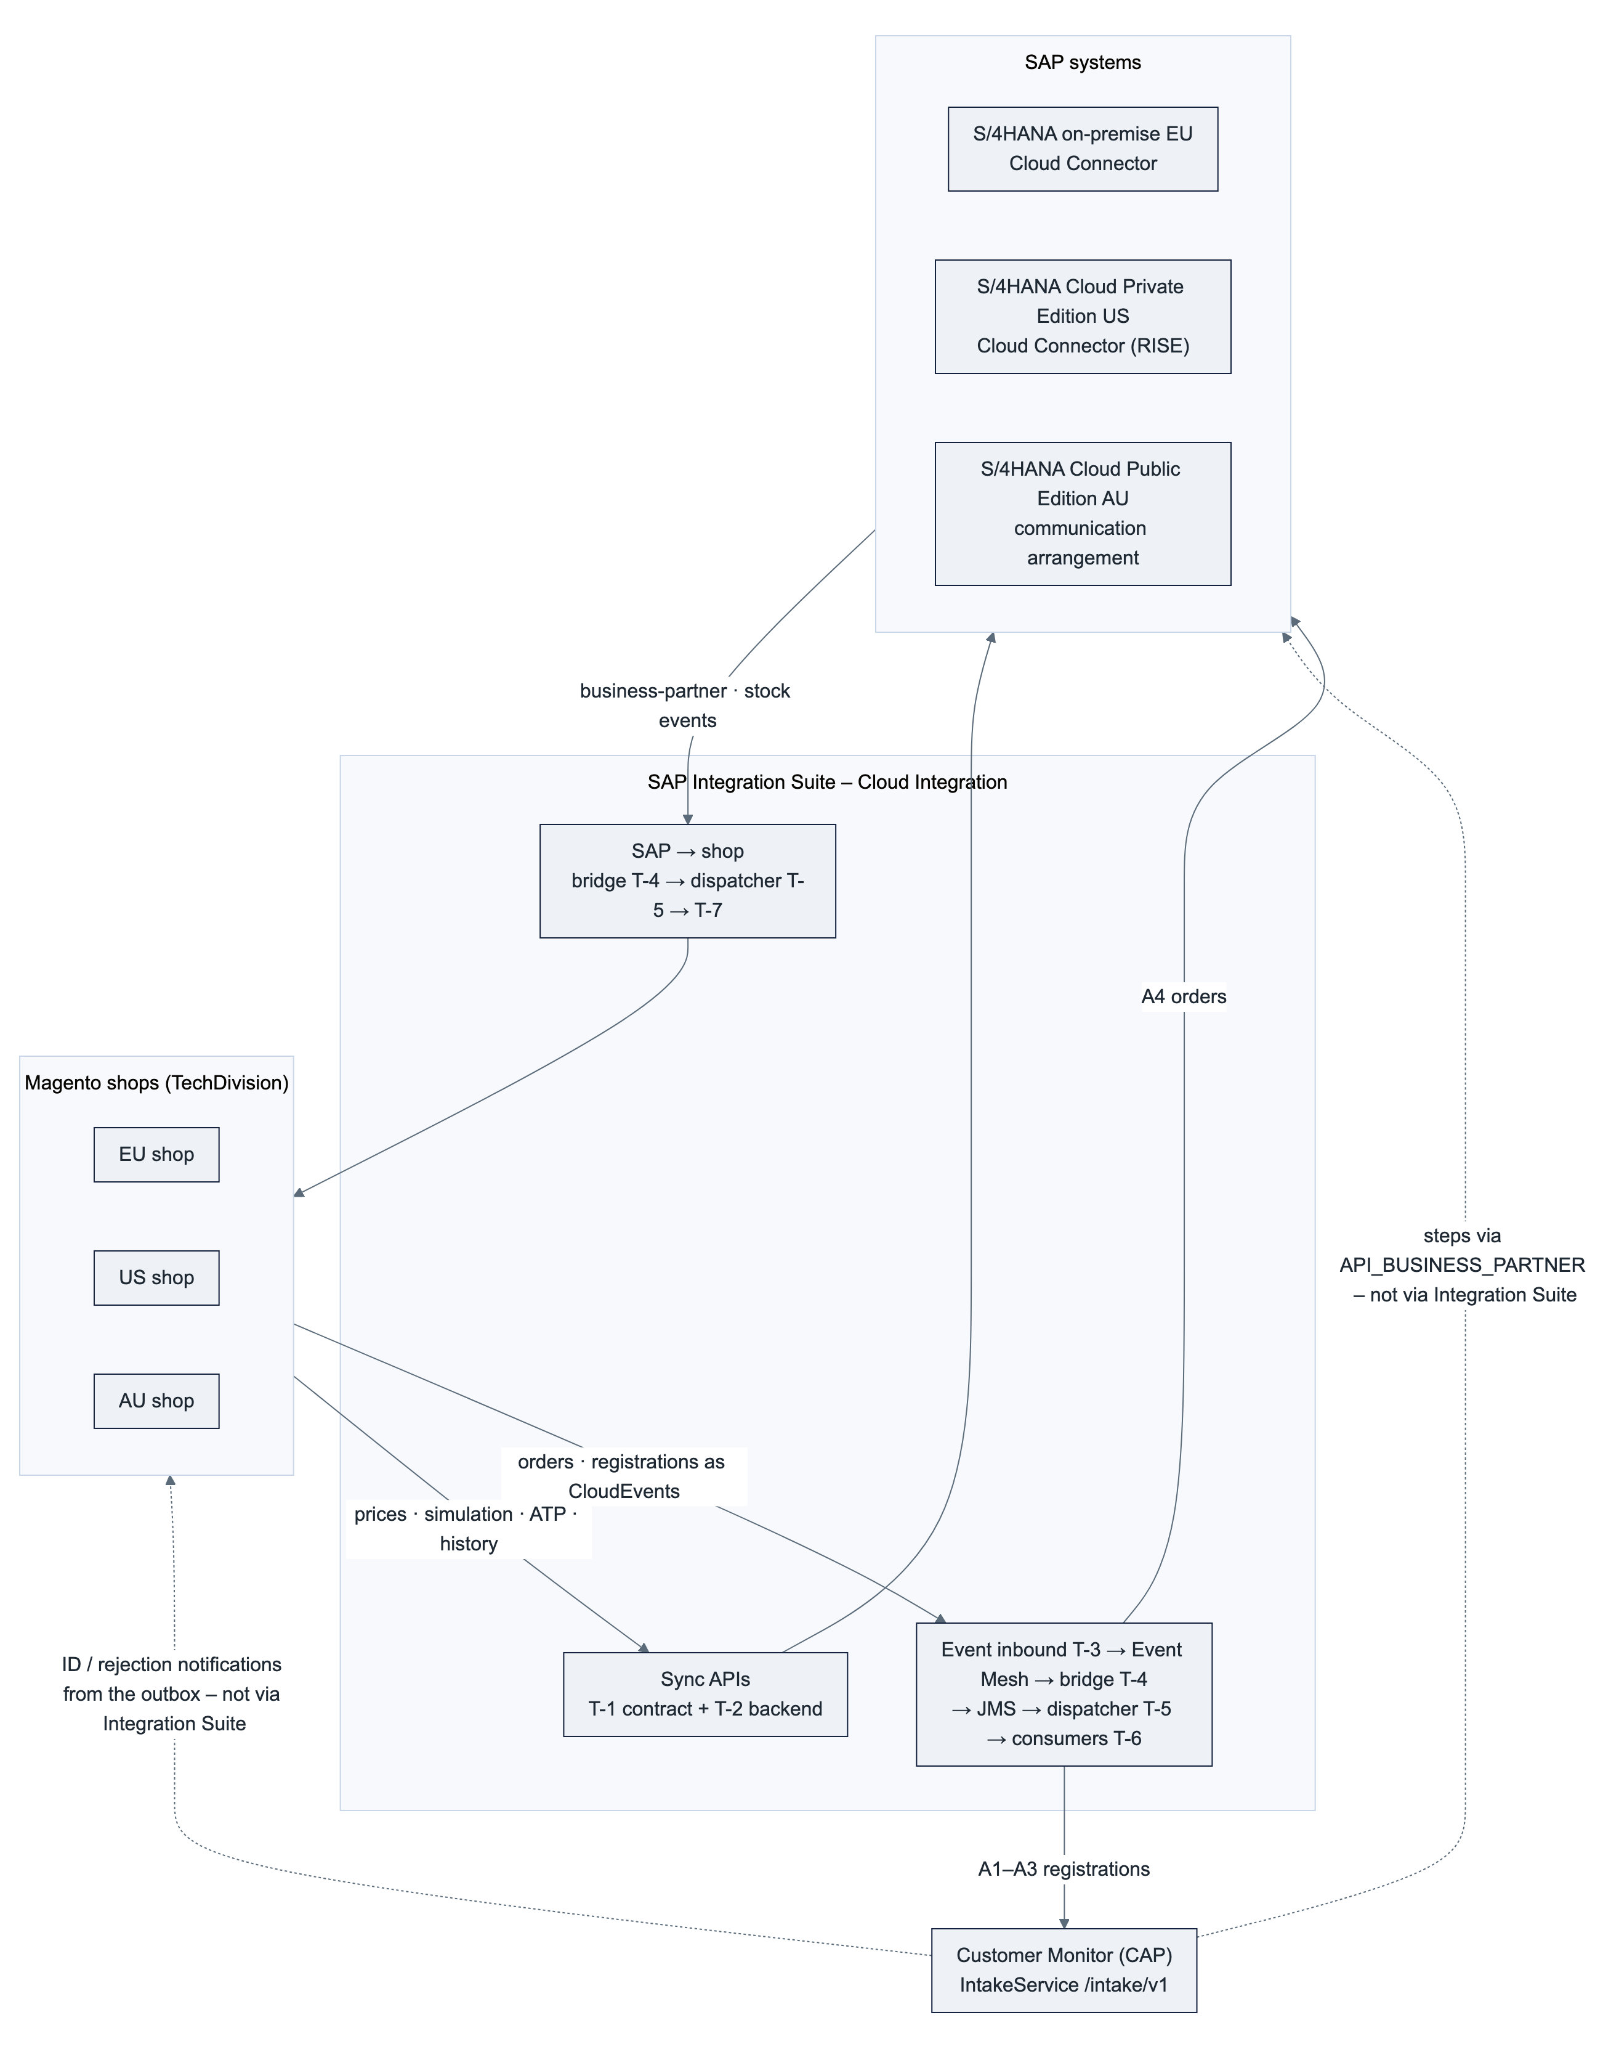
Interface family (AU concept) | Pattern | Templates | Target
S1 customer prices, S2 order simulation, S3 availability, S4 order history, S5 freight | Sync request-reply, shop → SAP | T-1 + T-2 | SAP system of the region
A4 order create | Async, shop → SAP | T-3 + T-4 + T-5 + T-6 | SAP system of the region
A1 company, A2 contact, A3 address registration | Async, shop → BTP | T-3 + T-4 + T-5 + T-6 | Customer Monitor IntakeService
B1 business partner, B2 stock, … | Async, SAP → shop | T-4 + T-5 + T-7 | Magento shop system(s) of the region

Boundary to the Customer Monitor. The monitor calls API_BUSINESS_PARTNER inside its steps with the user's identity (principal propagation) and sends ID and rejection notifications from its outbox to the destination MAGENTO_<REGION> (D-10, D-09). No template sits in these two paths. A shop that can call /intake/v1 directly with OAuth 2.0 client credentials (solution design §3.2, §6.2) does not need A1–A3 at all; the solution design and docs/10 §2 want an iFlow only where a shop cannot adapt its payload. A1–A3 exist for a shop whose concept routes everything through one event inbound (AU, concept D-38) – a deviation from that criterion that TD-01 puts up for decision. Both paths arrive at the same three intake operations, so the monitor does not know which path a region uses.

3. Template catalogue
# | Template (name · ID pattern) | Instances | Copied per interface? | Role
T-1 | <IF>_<Name>_API · com.hydac.<REGION>.SLS.<IF>_<Name>_API | one per sync interface and region | yes | Shop-facing REST contract: HTTPS endpoint, validation, routing by system key, response mapping, error contract
T-2 | <IF>_<Name>_<SYSTEM> · com.hydac.<REGION>.SLS.<IF>_<Name>_<SYSTEM> | one per sync interface and SAP system | yes | Backend layer: SAP calls (parallel where possible), normalisation to the internal XML
T-3 | Webshop_Event_Inbound · com.hydac.<REGION>.SLS.Webshop_Event_Inbound | one per region | no | Generic inbound: validates the CloudEvent, publishes to Event Mesh, answers 202
T-4 | Webshop_Event_EM2JMS / SAP_Event_EM2JMS | one per region, direction and stage | no | Bridge: Event Mesh queue → JMS staging queue; sets interfacename from the event type
T-5 | Webshop_Event_Dispatch / SAP_Event_Dispatch | one per region, direction and stage | no | JMS sender → ProcessDirect /hydac/<region>/<stg>/sls/<interfacename>/v1; owns the JMS transaction and the retry
T-6 | <IF>_<Entity>_Event2<Target> · com.hydac.<REGION>.SLS.<IF>_<Entity>_Event2<Target> | one per async interface and region | yes | Consumer: pull, preconditions, idempotency, target call, confirmation, dead letter
T-7 | <IF>_<Entity>2Webshop · com.hydac.<REGION>.SLS.<IF>_<Entity>2Webshop | one per SAP → shop interface and region | yes | T-6 skeleton with the shop as target; one run per connected shop system
Shared | Package <REGION>-SLS-GenericIS_Artifacts: script collection <REGION>_SLS_Common, value mappings, GenericIS_ReprocessDLQ, GenericIS_QueueWatch, Mock_Backend | one per region | no | Common scripts, replay of dead-lettered messages, queue alerting, test double for the backend layer

Where the templates live. 💡 Package TPL-SLS-WebshopTemplates in the non-production tenant. Its content is never deployed: no endpoints, parameters left at placeholder values, description TEMPLATE – do not deploy. The template iFlows are versioned in cpi-iflows/templates through Integration Suite's Git access (solution design §7.5); script collections and value mappings are outside that feature, so their sources are kept in the same repository as plain files and copied into the package by hand (§14). A new instance means: download the template, add it to the region package under the instance name, work through the copy checklist of the template (§7.4, §8.6). The pseudo-region TPL needs an exception from the tenant naming rule <REGION>-<AREA>-<Name> (TD-03).
Package placement of the instances (the AU design puts the dispatcher with the generic artefacts): T-1 and T-2 instances in <REGION>-SLS-WebshopSyncAPIs; T-3, Webshop_Event_EM2JMS and the T-6 instances in <REGION>-SLS-WebshopToSAP; SAP_Event_EM2JMS and the T-7 instances in <REGION>-SLS-SAPToWebshop; both dispatchers, GenericIS_ReprocessDLQ, GenericIS_QueueWatch, Mock_Backend, the script collection and the value mappings in <REGION>-SLS-GenericIS_Artifacts.

4. Rules shared by all templates
# | Rule | Where it shows
R-1 | Two layers per sync interface. The contract flow owns the shop-facing REST contract (validation, normalisation, RFC 9457 errors, correlation); the backend flow owns the SAP calls and is chosen by system key over ProcessDirect. A new SAP system adds a backend flow, never a new contract. | T-1, T-2
R-2 | Routing is configuration. Region, system key, sales area, shop systems, endpoints, credential aliases, timeouts and retry budgets are externalised parameters; nothing is hard-coded, stage copies differ only in parameter values. | §5.3
R-3 | Error classes drive behaviour, not adapters. classifyError turns every exception into TRANSIENT, PERMANENT_TECH or PERMANENT_BUSINESS. Only TRANSIENT is ever retried, and only in the async chain. Unknown errors are PERMANENT_TECH – dead letter with alert, never a retry storm. | §6, scripts/classifyError.groovy
R-4 | Lean payloads. Only the fields the shop uses; large results paged from SAP and chunked into Magento. | T-2, T-7
R-5 | Correlation end-to-end. X-Correlation-ID from the shop (or the CloudEvent id) becomes SAP_ApplicationID and is returned in every response, comment and alert. | all
R-6 | Observable by non-developers. MPL custom header properties (shopSystem, websiteCode, entity, entityId, incrementId, correlationId, sapDocument, errorClass, errorCode) on every run, a custom status on every outcome, an Alert Notification Service event on every dead-lettered message. | §13
R-7 | No secrets in flows. Credentials only as security material with the aliases of §12; shop → BTP with OAuth 2.0 client credentials and a region-specific user role; BTP → SAP with the technical user of the region; BTP → Magento with TechDivision's integration user per shop system. | §12
R-8 | Idempotent by design. Every write to SAP, Magento or the monitor is safe to repeat: lookup before create, PUT semantics, Idempotent Process Call keyed by the business key where the target has one (orders) and by the CloudEvent id where the target decides on duplicates itself (registrations, §8.4 step 2), duplicate answers (409) treated as success. | T-6, T-7
R-9 | Fixed contract at the ProcessDirect seam (my call). The caller sends the normalised internal XML and the context as headers; the callee answers with <Response> or <Error class code> and always ends normally. Error End events never cross the seam; the caller re-raises an <Error> into its own exception subprocess. Exchange properties stay inside one iFlow – everything that must cross ProcessDirect travels as a header. | T-1 ↔ T-2, T-5 ↔ T-6 (exception: the deliberate Error End for a transient retry, §8.4)
R-10 | Sync never persists and never retries; async persists first and retries only TRANSIENT. A retry inside a sync flow would double the SAP load exactly when SAP is struggling; the shop already degrades and retries on the next request. | T-1, T-6
R-11 | Templates are never deployed and carry no customer-specific values. An instance differs from its template only in the places listed in its copy checklist; everything else is a defect of the template and is fixed there first. | §3, §14

5. Naming, stages, parameters, context

5.1 Names
Object | Pattern | Example (AU, S1)
Package | <REGION>-SLS-WebshopSyncAPIs, <REGION>-SLS-WebshopToSAP, <REGION>-SLS-SAPToWebshop, <REGION>-SLS-GenericIS_Artifacts | AU-SLS-WebshopSyncAPIs
iFlow name · ID | see §3 · com.hydac.<REGION>.SLS.<name> | S1_CustomerPrices_API · com.hydac.AU.SLS.S1_CustomerPrices_API
Shop-facing endpoint | /hydac/<region>/<stg>/sls/<interface>/v<n> (version in the path, not in the iFlow name; a v2 contract is a new contract flow next to the old one) | /hydac/au/tst/sls/prices/v1
Event inbound endpoint | /hydac/<region>/<stg>/sls/events/v1 | /hydac/au/tst/sls/events/v1
ProcessDirect backend | /hydac/<region>/<stg>/sls/<SYSTEMKEY>/<interface>/v1 | /hydac/au/tst/sls/AU/prices/v1
ProcessDirect consumer | /hydac/<region>/<stg>/sls/<interfacename>/v1 and …/v1/reprocess | /hydac/au/tst/sls/A4_Order_Event2SalesOrder/v1
JMS queue | <REGION>_<STG>_WebshopToSAP_IN, <REGION>_<STG>_SAPToWebshop_IN, <REGION>_<STG>_DLQ | AU_TST_WebshopToSAP_IN
Event Mesh topic / queue | hydac/ci/<stg>/<region>/shop/<entity>/v1/<event> · <REGION>_<STG>_WebshopToSAP; hydac/ci/<stg>/<region>/s4/<entity>/v1/<event> · <REGION>_<SHOPSYSTEM>_<Entity>Data (hydac/ci/<stg> is the namespace of the stage's message client, §12) | hydac/ci/tst/au/shop/order/v1/export-requested
Security material | <REGION>_S4_<STG>, <REGION>_Magento_<SHOPSYSTEM>, <REGION>_Monitor_<STG>, EM_<STG>, ANS_<STG>, IS_Monitoring_<STG> (the last three are per tenant and stage, not per region) | AU_Magento_SHL
User role (HTTPS sender) | <REGION>_Webshop_Send | AU_Webshop_Send
MPL custom status | <REGION>_SYNC_OK, <REGION>_SYNC_FAILED_<CLASS>, <REGION>_<IF>_DONE, <REGION>_<IF>_RETRY, <REGION>_<IF>_DEAD_LETTERED, <REGION>_<IF>_SKIPPED_DUPLICATE | AU_A4_DEAD_LETTERED
Error code | upper snake case, stable across regions and systems (§6) | S4_UNAVAILABLE

Renamed against the AU design (my call, so that the names work for every interface): ORDER_PRECONDITION_FAILED → PRECONDITION_FAILED, AU_A4_CREATED → <REGION>_A4_DONE, AU_SYNC_FAILED_PERMANENT → <REGION>_SYNC_FAILED_PERMANENT_TECH and …_PERMANENT_BUSINESS (one status per class, so the two alert routes are visible in the monitor).

5.2 Stages
Two stages share the non-production tenant and one stage has its own tenant, so the suffix rule is: _DEV and _TST copies in name and ID in the non-production tenant (AU concept §8.9), no suffix in the production tenant (my call; the AU design leaves production open). Queues and credentials carry <STG> in all three stages. HTTPS endpoint paths, ProcessDirect addresses and Event Mesh topics must be unique per tenant, so they carry the stage as well – <stg> in every address, the stage's message-client namespace in every topic – otherwise the _DEV and _TST copies could not both be deployed and both stage queues would receive every event. The stage is the externalised parameter stage and appears nowhere else in a flow. Stage copies differ only in parameter values (R-2); a diff of two stage copies must show nothing but the externalised parameters.

5.3 Externalised parameters
Group | Parameters (defaults) | Used by
Region and stage | region (AU), stage (DEV), systemKey (AU), salesOrg, distChannel, division, shopSystems (comma list, e.g. DEV,TST,STG,SHL,PRD) | all
Shop contract | maxBodySizeKb (512), maxItemsPerCall (100), allowedEventTypes (comma list), cacheControl (no-store), retryAfterSeconds (30) | T-1, T-3
Backend | s4.baseUrl, s4.credentialAlias (<REGION>_S4_<STG>), s4.proxyType (Internet or OnPremise), s4.locationId (Cloud Connector, on-premise only), s4.timeoutMs (1200 sync short, 8000 sync long – HTTP receiver), s4.timeoutMin (1 – OData receiver in the async flows, whose timeout is in whole minutes) | T-2, T-6
Monitor | monitor.baseUrl (…/intake/v1), monitor.credentialAlias (<REGION>_Monitor_<STG>), monitor.timeoutMs (10000) | T-6 (A1–A3)
Shop systems | magento.<SHOPSYSTEM>.baseUrl, magento.<SHOPSYSTEM>.credentialAlias, magento.<SHOPSYSTEM>.storeCode – or the value mapping <REGION>_ShopSystems when the list is long | T-6, T-7
Messaging | em.credentialAlias (EM_<STG>), em.namespace (hydac/ci/<stg>), em.maxRedelivery (20, set on the queue), jms.inQueue, jms.dlq, jms.retryIntervalMin (5), jms.maxRetryIntervalMin (240), maxRetries (8), dispatch.maxRetries (10 = maxRetries + 2, the poison-message guard of T-5) | T-3 … T-7
Operations | ans.credentialAlias (ANS_<STG>), ans.baseUrl, monitoring.credentialAlias (IS_Monitoring_<STG>), alert.businessRecipients, alert.technicalRecipients, log.level (INFO in TST, NONE for sync flows in PRD), log.attachPayloadOnPermanent (true) | all

The context step of every flow copies region, stage, maxRetries and retryAfterSeconds into exchange properties of the same name, so that the shared scripts can read them without knowing the parameters.

5.4 Context: properties and headers
Name | Set by | Carried as | Used for
correlationId | T-1 step 2, T-3 step 3, T-6 step 2 | header correlationId inside the chain; X-Correlation-ID only at the shop boundary (request in, response out) | SAP_ApplicationID, response header, problem instance, comments, alerts
systemKey | T-1 (request or parameter), T-6 (event) | header | router to the backend flow, credential alias composition
shopSystem, websiteCode, entity, entityId, incrementId, eventType | T-3 from the CloudEvent (source, type, subject, data) | headers in T-3 (the AMQP receiver forwards message headers as application properties, not exchange properties) → JMS headers → headers; T-6 copies them to properties for local use | credential and endpoint selection, idempotency key, MPL headers
region, stage, maxRetries, retryAfterSeconds | context step, from the parameters of the same name | property | shared scripts (alerts, problem body, retry budget)
originalBody | T-6 step 2 | property | the CloudEvent as received, restored as body before the dead-letter write, so that reprocessing starts from the event and not from the response of the step that failed
validationErrors | validation step of T-1 and T-3 | property (JSON array) | errors[] of the problem body
acceptStatuses | Content Modifier before a Request-Reply with Throw Exception on Failure off | property (e.g. 201,409) | evaluateHttpStatus raises every other status
interfacename | T-4 via value mapping <REGION>_EventTypes | header | ProcessDirect address in T-5, dead-letter owner, reprocessing
retryCount | T-6 step 2 from header SAPJMSRetries (0 on the first attempt) | property | retry budget against maxRetries
idempotencyKey | T-6 step 2 | property | Idempotent Process Call
errorTarget | Content Modifier before every Request-Reply (S4, MONITOR, SHOP, MESSAGING) | property | lets classifyError name the target in the code (<TARGET>_UNAVAILABLE, <TARGET>_BUSINESS_ERROR) and treat a 404 from the shop as technical, from SAP or the monitor as business
errorClass, errorCode, errorText, errorHttpStatus | classifyError, or a script that raises a business error before | property; MPL header errorClass, errorCode | error contract, routing in the exception subprocess, alerts
SAP_ApplicationID | = correlationId | header (as a property it has no effect) | Application Message ID in the monitor
SAP_MessageProcessingLogCustomStatus | last step of every path | property | custom status (§5.1)

6. Error contract
Three classes, one script, one behaviour per class.
Class | Typical causes | Sync behaviour (T-1) | Async behaviour (T-6, T-7)
TRANSIENT | Target answers 5xx, 429 or 408; connection refused or reset; connect or read timeout; Event Mesh or JMS not available | 503 with Retry-After: 30; no retry in the flow (R-10) | Error End → JMS rolls back and redelivers with backoff until maxRetries, then dead letter
PERMANENT_TECH | Schema or contract validation; mapping or script error; the shop, the monitor or the messaging layer answers 400, 401, 403, 404, 405, 415; unknown system key; TLS or certificate problem; any unclassified exception | 400, 404 or 500 | Dead letter at once, alert technical
PERMANENT_BUSINESS | SAP returns a message of type E – SAP Gateway sends it as HTTP 400 with an error body, so a 400 from an SAP target is business, not technical; SAP answers 404 for customer or material; precondition not met; a target answers 422 or 409 where the interface is not idempotent | 404 or 422 | Dead letter at once, alert business, comment to the shop where the interface has one

Stable codes (one code per situation, identical in every region and for every SAP system):
Situation | Class | HTTP (sync) | code | Shop behaviour
Schema or business validation of the request fails | PERMANENT_TECH | 400 | VALIDATION_FAILED (+ errors[]) | Fix the request; no retry
Unknown system key, sales area or shop system | PERMANENT_TECH | 404 | UNKNOWN_SYSTEM | Configuration error; alert purplecat
Customer, material or document not found in the target | PERMANENT_BUSINESS | 404 | NOT_FOUND | Show fallback (list price, message)
SAP returns a business error (E message, HTTP 400 with error body) | PERMANENT_BUSINESS | 422 | S4_BUSINESS_ERROR; SAP message id and text in detail | Message to the user; no retry
Precondition for an async write not met (unpaid order, missing SAP number) | PERMANENT_BUSINESS | – | PRECONDITION_FAILED | Comment on the order; back office acts
Target timeout, 5xx, 429, connection refused (maintenance window) | TRANSIENT | 503 + Retry-After: 30 | S4_UNAVAILABLE / MONITOR_UNAVAILABLE / SHOP_UNAVAILABLE | Sync: degrade, retry next request. Async: automatic
Event Mesh or JMS not reachable at the inbound | TRANSIENT | 503 + Retry-After: 30 | MESSAGING_UNAVAILABLE | Shop pipeline retries (leg 1 belongs to the shop)
Integration error (mapping, script, unclassified) | PERMANENT_TECH | 500 | INTEGRATION_ERROR | Alert purplecat; shop degrades as for 503

Sync error body – always application/problem+json (RFC 9457), never a Cloud Integration HTML error page, therefore the exception subprocess of T-1 and T-3 ends with a normal End:
{
"type": "https://hydac.com/problems/S4_UNAVAILABLE",
"title": "SAP system not reachable",
"status": 503,
"detail": "Read timed out after 1200 ms (S4_AU, prices)",
"instance": "8d3f2c4e-…-correlation-id",
"code": "S4_UNAVAILABLE",
"errors": []
}
The exception-type table that classifyError relies on (HTTP adapter HttpOperationFailedException with statusCode, OData adapter exception text with the status, SocketTimeoutException, ConnectException, JMS and AMQP exceptions, mapping and Groovy exceptions) is written from SAP's documentation and the US flows and has to be verified on the tenant in the first test cycle ❓; the script is built so that an unknown type lands in PERMANENT_TECH, never in a retry.

7. Sync template – T-1 contract and T-2 backend
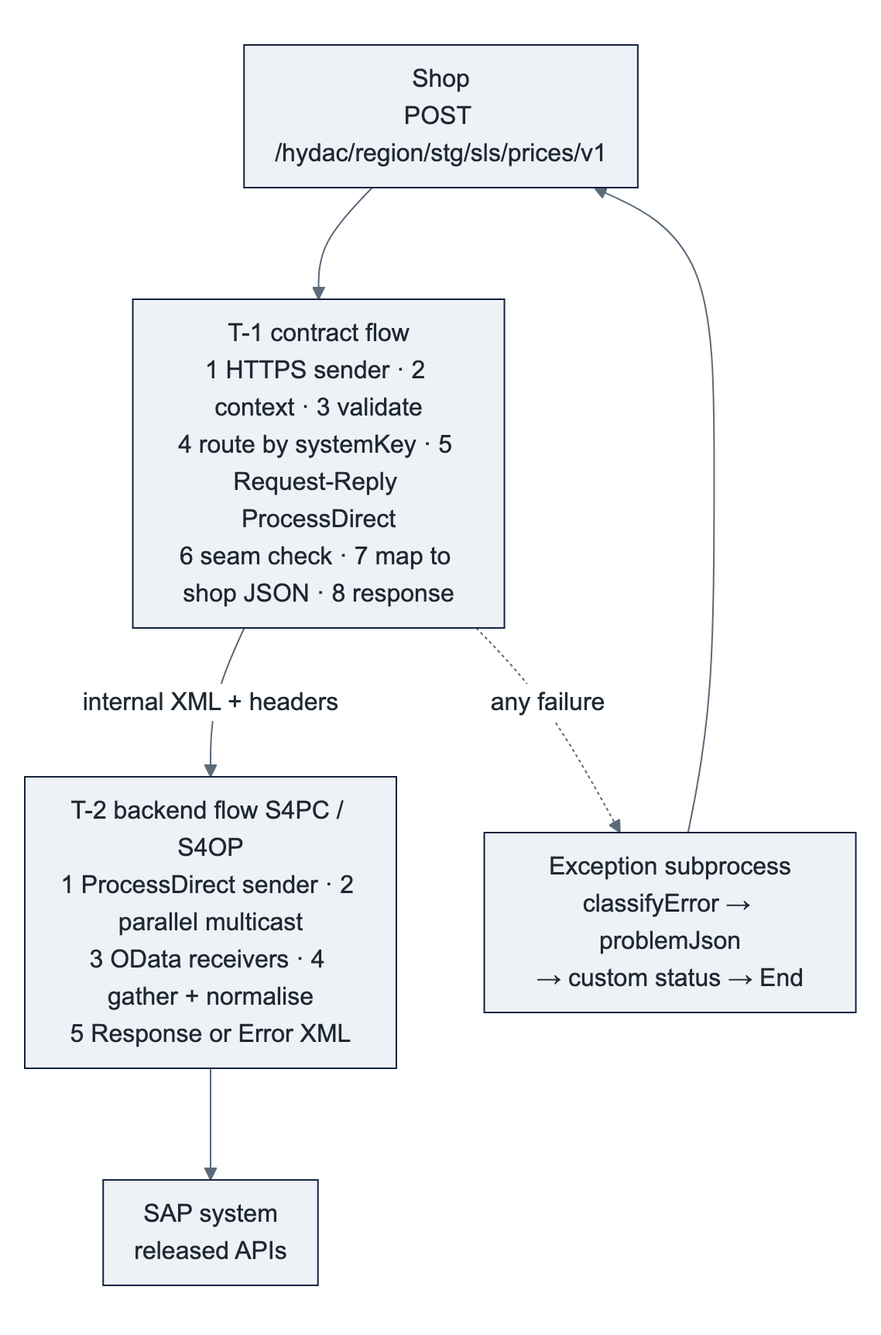

7.1 Steps of T-1 (contract flow)
# | Step | Detail
1 | HTTPS sender | POST /hydac/<region>/<stg>/sls/<interface>/v1; OAuth 2.0 client credentials; user role <REGION>_Webshop_Send (custom role per region, not ESBMessaging.send, so a shop client of one region cannot call another region's endpoints); CSRF off; max body size from maxBodySizeKb; Allowed Header(s) X-Correlation-ID, X-Shop-System – the sender drops every request header that is not listed, so without this the correlation id would silently fall back to the MPL id
2 | Content Modifier Capture context + mplHeaders | Properties correlationId (X-Correlation-ID, fallback the MPL id), systemKey, shopSystem, sales area, customerId, itemCount; header SAP_ApplicationID; MPL custom headers
3 | Validate request | Groovy Validate: parses the JSON (a parse error is classified as VALIDATION_FAILED, because errorTarget is still unset), checks required fields and business limits (maxItemsPerCall) and collects the message list in validationErrors; then JSON → XML and XML Validator with the XSD derived from the OpenAPI contract, Prevent Exception on Failure on, followed by a Groovy step that turns the validator's result (written to a message header when this option is on; the exact header name is taken from the step's help on the tenant) into errorClass PERMANENT_TECH, errorCode VALIDATION_FAILED and validationErrors, and raiseError. Result: HTTP 400 with errors[], never a 500 from a converter exception. ❓ A JSON-schema library is not bundled in the Groovy runtime; the XSD route is the fallback that works everywhere
4 | Router by systemKey | Content Modifier errorTarget = S4 first (from here on a parser or mapping exception is an integration error, not a validation failure); known key → Request-Reply ProcessDirect /hydac/<region>/<stg>/sls/<SYSTEMKEY>/<interface>/v1; unknown key → raiseError UNKNOWN_SYSTEM. A new SAP system is one more branch and one more backend flow
5 | Request-Reply ProcessDirect | No timeout of its own (the ProcessDirect adapter has none); the response time is bounded by the backend's call timeouts (§7.3); context travels as headers (R-9)
6 | Seam check (raiseError) | Body root <Error> → properties errorClass, errorCode, errorText from its attributes → throw, so the exception subprocess runs with the backend's classification
7 | Message mapping to the shop contract | Internal XML → shop JSON (listPrice, netPrice, conditions[], scales[], amounts with currency, quantities with unit); the only interface-specific step besides the backend
8 | Content Modifier Response + responseHeaders | Content-Type: application/json, X-Correlation-ID, Cache-Control from parameter (the shop caches, BTP does not), HTTP 200, custom status <REGION>_SYNC_OK; responseHeaders drops every other header, because the HTTPS sender returns all message headers to the shop and the seam context (hydacResult, systemKey, …) must not leak
E | Exception subprocess | classifyError → problemJson (body, CamelHttpResponseCode, Retry-After for TRANSIENT, internal headers dropped) → log attachment only when PERMANENT and log.attachPayloadOnPermanent → custom status <REGION>_SYNC_FAILED_<CLASS> → End (normal)

7.2 Steps of T-2 (backend flow) and the variants per SAP system
# | Step | Detail
1 | ProcessDirect sender | /hydac/<region>/<stg>/sls/<SYSTEMKEY>/<interface>/v1
2 | Parallel Multicast | One branch per SAP call that does not depend on another (S1: price API and condition-record API); sequential multicast or a single call where the interface has one API (S2 simulation)
3 | HTTP receivers against the OData URLs | $select only the fields used, $filter on customer, materials and sales area, $top paging above maxItemsPerCall; timeout s4.timeoutMs in milliseconds; connection reuse on; credential s4.credentialAlias. The HTTP adapter, not the OData adapter, because the OData receiver's timeout is set in whole minutes and cannot express a 1 200 ms budget (the AU design has the same slip); the OData adapter stays where its features pay off – deep insert and $batch in the async flows
4 | Gather + Groovy Normalise | Join by key (material), keep only the condition types of the value mapping <REGION>_ConditionTypes, sum totals, convert scales to the sales unit → internal XML <Response interface="prices" version="1">
5 | End | Internal XML back to the contract flow, header hydacResult = OK
E | Exception subprocess | classifyError → Content Modifier builds <Error class="…" code="…" httpStatus="…">text</Error>, header hydacResult = ERROR → End (normal; R-9). An unreachable SAP system therefore reaches the contract flow as TRANSIENT / S4_UNAVAILABLE, not as a ProcessDirect exception

 | EU – S/4HANA on-premise | US – S/4HANA Cloud Private Edition (RISE) | AU – S/4HANA Cloud Public Edition
Instance name | <IF>_<Name>_S4OP | <IF>_<Name>_S4OP (copy of EU with other parameter values) | <IF>_<Name>_S4PC
Receiver adapter | HTTP against the OData service (sync); OData V2 (async writes); legacy ZEC_* / ZSD_* services only while still in use ❓ | as EU | HTTP against the released OData V2 / V4 APIs (sync); OData adapter (async writes); released APIs only (DyFlex IDD, Q-01)
Proxy type | On-Premise, Cloud Connector location ID s4.locationId | On-Premise, Cloud Connector of the RISE landscape | Internet
Authentication | Basic with technical user EU_S4_<STG>; client certificate once the Cloud Connector is set up for it | as EU, US_S4_<STG> | Communication arrangement per scenario, technical user AU_S4_<STG> – basic as DyFlex sets it up today, X.509 when supported ❓
Principal propagation | not used – the shop calls are technical calls without a named user; the monitor's steps use principal propagation on their own destination (solution design I-02) | as EU | not applicable
APIs | standard OData APIs of the on-premise release where available; otherwise the interface document names the service | as EU | released APIs per interface document

7.3 Timeouts
Shop client timeout > SAP call timeout (HTTP receiver, milliseconds) plus the mapping time, with the parallel branches counting once; ProcessDirect adds no timeout of its own. Defaults for the short interfaces (S1, S3, S4): shop 2 000 ms, SAP 1 200 ms; for S2: shop 10 000 ms, SAP 8 000 ms. Values are parameters and are adjusted after the latency and load test (AU concept §10.2); the structure stays.

7.4 Copy checklist T-1 / T-2 (what an instance changes, nothing else)
- Name and ID (<IF>_<Name>_API, <IF>_<Name>_<SYSTEM>), description instance of T-1 v1.0 / T-2 v1.0.
- Endpoint path and ProcessDirect address of the interface.
- XSD of the request (from the OpenAPI contract) in step 3; business limits in the Groovy check.
- Message mapping to the shop contract (step 7).
- Backend calls (T-2 steps 2–4): APIs, $select/$filter, normalisation script, value mapping.
- Parameter values: timeouts, maxItemsPerCall, credential aliases, Cloud Connector location.
- Custom status prefix <REGION>_SYNC_* stays; interface-specific codes only if a new business situation needs one (then add it to §6 first).

8. Async template – T-3 inbound, T-4 bridge, T-5 dispatcher, T-6 consumer
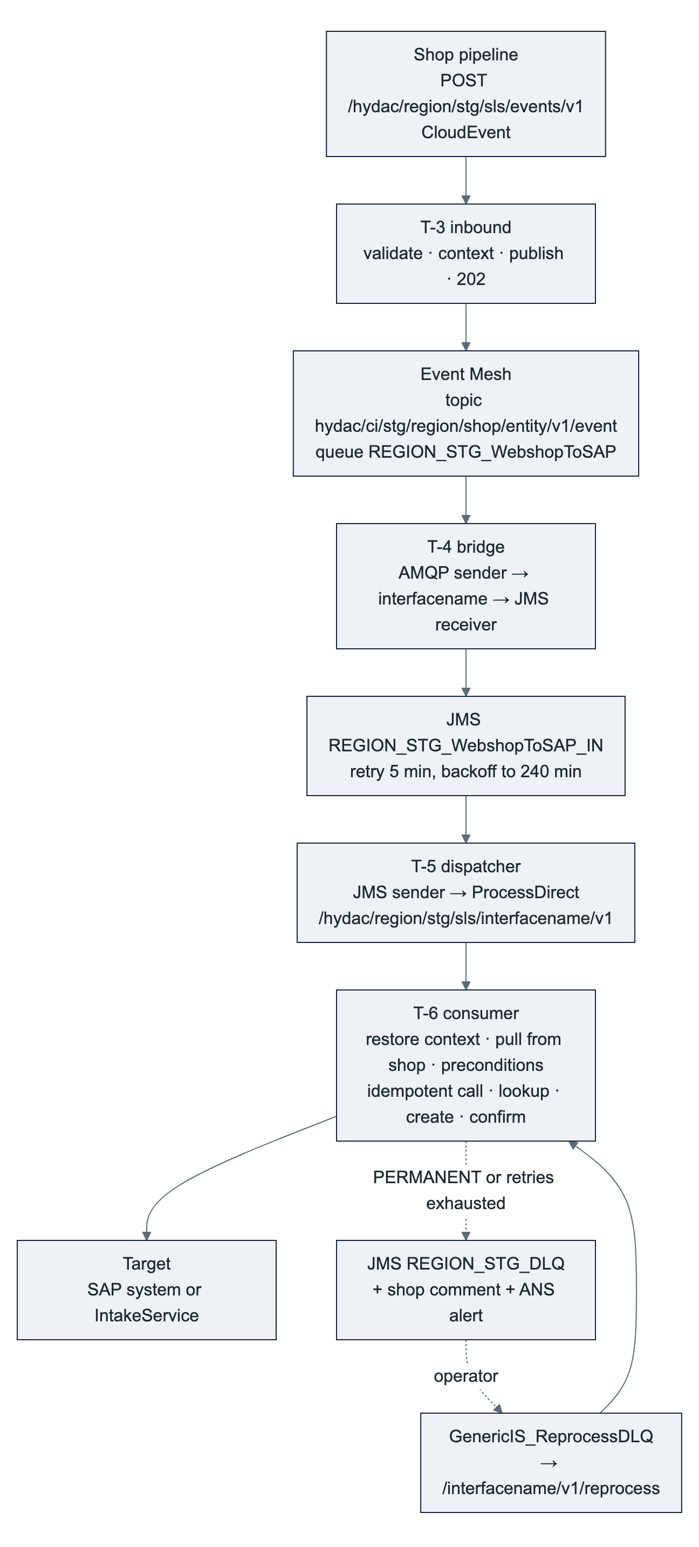

8.1 Why Event Mesh and JMS
Event Mesh gives the multiplex (one copy per subscriber) that the SAP → shop direction needs and decouples the shop from Cloud Integration; its redelivery is immediate and bounded, which a weekend maintenance window would exhaust within seconds. The JMS staging queue adds exponential backoff (the US flows run 10 → 600 minutes; the AU design proposes 5 → 240 for the shop flows, taken over here) and a transaction that acknowledges the message only when the target has accepted it. The cost is one tiny bridge message per event. The JMS adapter's own dead-letter flag only parks a message that crashed a worker node twice; the business dead letter of this design is explicit (§8.4). Event Mesh queues need maxRedeliveryCount (em.maxRedelivery, 20) and a dead-message queue set at creation.

8.2 Steps of T-3 (generic inbound, one per region)
# | Step | Detail
1 | HTTPS sender | POST /hydac/<region>/<stg>/sls/events/v1, OAuth 2.0 client credentials, role <REGION>_Webshop_Send
2 | Groovy Validate CloudEvent | specversion, id, source, type in allowedEventTypes, subject, data present; on failure raiseError VALIDATION_FAILED
3 | Content Modifier Context + mplHeaders | Headers eventType, shopSystem (from source), websiteCode, entity, entityId, incrementId, correlationId = id, SAP_ApplicationID = id – headers, because the AMQP receiver forwards message headers as application properties and exchange properties would not survive the bridge; the same values as properties for the local steps; property topic = {{em.namespace}}/<region>/shop/<entity>/v1/<event> (externalised parameters are referenced in {{…}} syntax) derived from the event type
4 | AMQP receiver (Event Mesh) | errorTarget = MESSAGING before the call; dynamic topic ${property.topic}; message client of the stage (em.credentialAlias); body = the CloudEvent as received
5 | Response 202 | { "id": …, "correlationId": … }, custom status <REGION>_EVT_ACCEPTED
E | Exception subprocess | classifyError → problemJson: Event Mesh unreachable → 503 with Retry-After so that the shop pipeline retries (leg 1 belongs to the shop); validation → 400. No JMS fallback here – the shop is the retry owner for leg 1

8.3 T-4 bridge and T-5 dispatcher (one per region, direction and stage)
Flow | Steps | Settings
T-4 Webshop_Event_EM2JMS | AMQP sender on queue <REGION>_<STG>_WebshopToSAP → Content Modifier (properties region, stage from the parameters) → resolveEventType (value mapping <REGION>_EventTypes → headers interfacename, entity; a Content Modifier cannot read a value mapping) → JMS receiver <REGION>_<STG>_WebshopToSAP_IN → End | Transaction handling Required for JMS. Exception subprocess: classifyError → Router: TRANSIENT (JMS not available) → Error End, so Event Mesh redelivers (em.maxRedelivery 20 on the queue; JMS outages are short, and the Event Mesh dead-message queue remains the residual gap that GenericIS_QueueWatch checks ❓ API) · PERMANENT (unknown event type) → Content Modifier Alert context (headers interfacename, correlationId, parameters region, stage into properties) → JMS receiver <REGION>_<STG>_DLQ with owner Webshop_Event_EM2JMS → Process Call → local process Notify (best effort, own exception subprocess → End, as in T-6) → End, so the Event Mesh message is acknowledged and never redelivered. A second process Reprocess (ProcessDirect sender /hydac/<region>/<stg>/sls/Webshop_Event_EM2JMS/v1/reprocess) runs the same steps, so a dead-lettered unknown event type is replayed through the bridge once the value mapping is fixed
T-5 Webshop_Event_Dispatch | JMS sender <REGION>_<STG>_WebshopToSAP_IN → Request-Reply ProcessDirect /hydac/<region>/<stg>/sls/${header.interfacename}/v1 → End | JMS: retry interval jms.retryIntervalMin, exponential backoff on, max jms.maxRetryIntervalMin, 1 concurrent process per node (raise per flow after the load test), dead-letter flag on. Exception subprocess as poison-message guard: Router on ${header.SAPJMSRetries} < dispatch.maxRetries → **Error End** (rollback, redelivery with backoff – the path a transient failure in T-6 takes on purpose) · otherwise → Content Modifier *Alert context* (headers interfacename, correlationId, parameters region, stage, errorClass PERMANENT_TECH, errorCode DISPATCH_FAILED, errorText = ${exception.message} into properties – T-5 has no context step and no classifyError, so the alert would otherwise be empty) → JMS receiver <REGION>_<STG>_DLQ with owner = interfacename → Process Call → local process Notify (best effort) → End (acknowledged). Without the guard a consumer that is not deployed, an unknown address or a failure inside the consumer's own error handling would retry until the 30-day queue expiry deletes the message – a silent loss

The dispatcher variant saves JMS queues (3 per region and stage instead of 3 + one per consumer). If HYDAC IT grants a larger budget, the consumers get their own queue and their own JMS sender; nothing else changes (TD-04).

8.4 T-6 consumer – structure and steps
A start event takes exactly one sender channel, so T-6 has two small integration processes that share one local integration process Consume: Main (ProcessDirect sender /hydac/<region>/<stg>/sls/<interfacename>/v1, called by T-5) and Reprocess (ProcessDirect sender …/v1/reprocess, called by GenericIS_ReprocessDLQ; a Content Modifier sets the header SAPJMSRetries = 0 and the property reprocess = true first). Each consists of a Process Call to Consume and an End; neither has an exception subprocess, so an Error End of Consume propagates to T-5 (rollback, retry) and a normal end acknowledges. Transaction handling Required for JMS on every process. Slots marked ⚙ are interface-specific; everything else is the template.
# | Step of Consume | Detail
2 | Content Modifier Restore context + mplHeaders | Properties from the headers of the persisted event (shopSystem, entity, entityId, incrementId, correlationId, …) and from the parameters (region, stage, maxRetries); retryCount = ${header.SAPJMSRetries} (0 when absent, 0 from Reprocess); originalBody = the body, i.e. the CloudEvent, so that the dead-letter write and reprocessing see the event and not the response of the step that failed; idempotencyKey ⚙ – A4: <shopSystem>:<incrementId> (an order is exported once, ever); A1–A3: the CloudEvent id (a replay of the same event is skipped; a new registration of the same company after a rejection is a new event and reaches the intake, which answers 409 only while a request is open – keying by company id would silently swallow it); credential alias and base URL of the shop system from the value mapping <REGION>_ShopSystems; custom status <REGION>_<IF>_RETRY when retryCount > 0
3 | Request-Reply HTTP Pull from shop ⚙ | errorTarget = SHOP; GET /rest/<store>/V1/<entity>/<entityId> with the shop system's credential; the event carries IDs, the shop stays the source of the data (lean events); 404 → PERMANENT_TECH
4 | Groovy Preconditions ⚙ | A4: customer has an SAP number and is approved, ship-to has a partner number, card orders are paid. A1–A3: mandatory intake fields present (§9). On failure raiseError PERMANENT_BUSINESS / PRECONDITION_FAILED
5 | Request-Reply Lookup ⚙ | errorTarget = S4; target lookup by business key before any create (A4: A_SalesOrder?$filter=<reference field> eq '<shopSystem>:<incrementId>', field per TD-07; A1–A3: none – the intake answers 409). A hit fills sapDocument. Deliberately outside the idempotent call, so that a retry after a failure in step 8 or 9 finds the number again and the confirmation never goes out without it. This also covers "created, but the response was lost", which no idempotent repository can
6 | Idempotent Process Call → local process Create | Message ID <interfacename>:${property.idempotencyKey}; Skip Process Call for Duplicates off, so the flow sees a duplicate in the property CamelDuplicateMessage and can set a status instead of silently skipping; the retention of the IDs is the step's setting – verify the available options and the maximum on the tenant ❓. Create starts with a Router: CamelDuplicateMessage true or sapDocument already set → custom status <REGION>_<IF>_SKIPPED_DUPLICATE, skip 7–8 · else 7–8
7 | Mapping + Request-Reply Create ⚙ (in Create) | A4: OData V2 deep insert API_SALES_ORDER_SRV, timeout s4.timeoutMin. A1–A3: errorTarget = MONITOR; HTTP POST /intake/v1/register<Kind>, timeout monitor.timeoutMs, Throw Exception on Failure off, so that step 8 can treat 409 as done instead of as an error
8 | evaluateHttpStatus + Groovy Evaluate result ⚙ (in Create) | evaluateHttpStatus with acceptStatuses (201,409 for A1–A3) raises every other status with the class of §6, so a 503 from the intake can never pass as success; A4's OData adapter throws itself (SAP E message = HTTP 400 → S4_BUSINESS_ERROR). Then the interface part: A4 201 → sales order number into sapDocument, A and W messages per agreement (TD-07); A1–A3 201 → requestId into sapDocument, 409 → _SKIPPED_DUPLICATE (R-8)
9 | Request-Reply HTTP Confirm to shop ⚙ | errorTarget = SHOP; A4: POST /V1/orders/<entityId>/comments "SAP order ". A1–A3: none – the monitor notifies the shop itself (TD-02). A failure here is TRANSIENT but must not recreate the document – steps 5–6 guarantee that on retry; a repeated comment is accepted as at-least-once
10 | End | Normal end → Main ends → T-5 completes → JMS message acknowledged; custom status <REGION>_<IF>_DONE
E | Exception subprocess of Consume | classifyError → Router: TRANSIENT and retryCount < maxRetries, or reprocess = true → Error End (propagates through Main to T-5: rollback, redelivery with backoff; custom status <REGION>_<IF>_RETRY. On the reprocess path every failure ends this way, so the entry stays in the DLQ under the reprocess flow's backoff – re-writing it would make the running reprocess flow pick it up again at once, one alert per pass) · otherwise → Process Call → local process DeadLetter → custom status <REGION>_<IF>_DEAD_LETTERED → End (normal → T-5 acknowledges the staging message)
DL | Local process DeadLetter | Content Modifier: body = ${property.originalBody}, headers interfacename, errorClass, errorCode, errorText, retryCount, correlationId → JMS receiver <REGION>_<STG>_DLQ → Process Call → local process Notify → End. If the dead-letter write itself fails (JMS down), the exception propagates: Error End → T-5 rollback → the staging message stays and is retried; nothing is lost
NF | Local process Notify (best effort) | ansEvent → HTTP receiver Alert Notification Service (ans.credentialAlias) → shop comment "Not exported: " ⚙ where the interface has one. Own exception subprocess that ends with End, so an ANS or shop outage never rolls back the dead-letter write – an exception subprocess cannot hold a try/catch of its own, which is why the notification is a separate local process

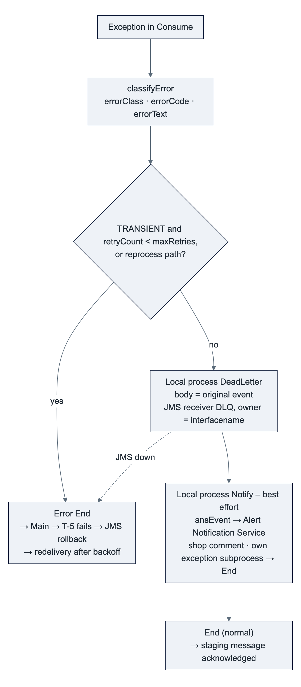
Transaction boundary, to be measured on DEV before the first go-live ❓: the AU design (p. 13) assumes that the dead-letter write and the acknowledgement of the staging message share one JMS transaction. With the dispatcher variant they sit in two iFlows; whether Consume's Required for JMS joins T-5's transaction across ProcessDirect or opens its own is not documented. If it is two transactions, a node crash between them yields a second dead-letter entry with the same correlationId on redelivery, which the operator deletes – at-least-once, never lost. The acceptance test of §15 forces a failure after the dead-letter write to settle it; the document is corrected with the result.

8.5 Reprocessing
An operator with write access (purplecat) fixes the cause – for example the missing SAP number is now maintained through the Customer Monitor – and deploys GenericIS_ReprocessDLQ for the stage: JMS sender on <REGION>_<STG>_DLQ (retry 10 minutes with exponential backoff to 600 minutes, 1 concurrent process, as the US pattern) → Request-Reply ProcessDirect /hydac/<region>/<stg>/sls/${header.interfacename}/v1/reprocess → End. The consumer's Reprocess process resets SAPJMSRetries to 0 and enters Consume at step 2 with the original event as body. Every failure during reprocessing, transient or permanent, ends in Error End (property reprocess): the entry stays in the DLQ with its original headers, the consumer's MPL shows the new error, and the reprocess flow's own JMS sender redelivers it with its backoff until the operator undeploys the flow. GenericIS_ReprocessDLQ itself has an exception subprocess that ends in Error End as well, so an entry whose owner has no /reprocess endpoint – a consumer that is not deployed, a DISPATCH_FAILED entry – also stays and is visible instead of failing silently; the operator deploys the consumer first, then replays. Entries owned by Webshop_Event_EM2JMS (unknown event type) are replayed through the bridge's own /reprocess endpoint once the value mapping is fixed (§8.3). Single entries are deleted in Manage Message Queues when the business decides not to export a document. The pattern is the US process_JMSQueues flow with the AU naming.

8.6 Copy checklist T-6 (what an instance changes, nothing else)
- Name and ID (<IF>_<Entity>_Event2<Target>), description instance of T-6 v1.0; the two ProcessDirect addresses with the instance name.
- Entry in the value mapping <REGION>_EventTypes (event type → instance name, entity) and in allowedEventTypes of T-3.
- idempotencyKey expression (step 2).
- The ⚙ slots: pull (3), preconditions (4), lookup (5), mapping, create and evaluation (7–8 in Create, with acceptStatuses), confirmation (9) and the shop comment in Notify.
- Parameter values: target base URL, credential alias, timeouts, maxRetries.
- Custom status prefix <REGION>_<IF>_*; interface-specific codes only after §6 has them.
T-3, T-4 and T-5 are not copied per interface; a new async interface touches them only through the value mapping and the allowedEventTypes parameter.

9. Registrations A1–A3 and the Customer Monitor
The consumer target for registrations is the monitor's IntakeService (solution design §6.2, docs/10 §2): three operations, OAuth 2.0 client credentials against the monitor's XSUAA with the scope IntakeClient, the region (backendSystem) bound to the client. Integration Suite therefore holds one service key per region and stage as security material <REGION>_Monitor_<STG>, and the monitor sees the region from the token, not from a field.
Event (type) | Instance | Pull from shop (step 3) | Intake call (step 7) | Idempotency key
company registered | A1_Company_Event2Monitor | GET /V1/company/{id} + the admin customer | POST /intake/v1/registerCompany – payload as the shop sends it to ZEC_CUSTOMER_CREATE_SRV today | CloudEvent id
customer (contact) registered | A2_Contact_Event2Monitor | GET /V1/customers/{id} | POST /intake/v1/registerContact | CloudEvent id
address added | A3_Address_Event2Monitor | GET /V1/customers/{id} (address block) | POST /intake/v1/registerShipTo | CloudEvent id

Intake answers (docs/10 §2: 400, 401/403, 409, 503) and what the consumer does with them: 201 → done, requestId into sapDocument and the MPL header; 409 (open request with the same Magento IDs – the intake owns the business duplicate check, which is why the consumer keys only by event id) → done, custom status …_SKIPPED_DUPLICATE (R-8); 400 (message list) → PERMANENT_TECH / VALIDATION_FAILED, dead letter, technical alert – a mapping defect, not a business case; 401 / 403 → PERMANENT_TECH, alert purplecat (service key or role); 503 → TRANSIENT, retry with backoff.
Nothing goes back to the shop from A1–A3: the monitor sends the ID notification or the rejection from its outbox to MAGENTO_<REGION> once the back office has processed the request (D-09).
What the consumer has to assemble from the shop for the intake payload is not written down anywhere yet ❓: the legacy structure carries order volume, currency, credit-card flag, sales data and the admin contact, which GET /V1/company/{id} and GET /V1/customers/{id} do not return as such. The A1–A3 mapping slot needs an interface document from TechDivision (which Magento attributes feed which intake fields) before it can be filled; the template itself does not depend on it. The exact event type names and the CloudEvent data of the AU shop come from the AU concept and TechDivision ❓. Whether a region uses A1–A3 at all, or lets the shop call /intake/v1 directly, is TD-01; where the shop gets the resulting SAP numbers from is TD-02.

10. SAP → shop – T-7
T-7 is the T-6 skeleton with the shop as target, as the AU concept (§6.4) lays it out. Note that docs/10 §4 sketches the replacement of the legacy ZO-partner-role notification as S/4 event → CAP → Magento, without Integration Suite; which of the two carries business-partner changes to the shops is part of TD-02. S/4 publishes a business-partner or stock event to Event Mesh (Public Cloud: standard events; on-premise: event enablement, separate work package); <IF>_<Entity>_Notification2DataEvent reads it once, enriches from SAP and publishes one data event per region to hydac/ci/<stg>/<region>/s4/<entity>/v1/<event>; one Event Mesh queue per connected shop system subscribes; the bridge SAP_Event_EM2JMS and the dispatcher SAP_Event_Dispatch feed <REGION>_<STG>_SAPToWebshop_IN; <IF>_<Entity>2Webshop writes to the shop system named in the header targetShop (PUT semantics, R-8) and, for bulk writes, keeps the changelog and polls /V1/bulk/{uuid}/status (AU concept §6.4). Error classes, dead-letter queue, alerting and reprocessing are identical to T-6.

11. Shared artefacts and scripts
Script collection <REGION>_SLS_Common (package <REGION>-SLS-GenericIS_Artifacts); sources in scripts/ next to this document, one script per step so that they can be referenced from any iFlow:
Script | Step in | What it does
mplHeaders.groovy | context step of T-1, T-3, T-6, T-7 | Copies the context properties to MPL custom header properties and sets the header SAP_ApplicationID
classifyError.groovy | first step of every exception subprocess | Reads CamelExceptionCaught; keeps a classification set deliberately before (raiseError); otherwise derives class, code, HTTP status and text from the exception; writes errorClass, errorCode, errorText, errorHttpStatus and the MPL headers
raiseError.groovy | seam check of T-1, validation and precondition steps, result evaluation | Takes class, code and text from an <Error> body or from properties set by the preceding step and throws, so the exception subprocess runs with that classification
problemJson.groovy | exception subprocess of T-1 and T-3 | Builds the RFC 9457 body, sets CamelHttpResponseCode, Content-Type, X-Correlation-ID and Retry-After for TRANSIENT
ansEvent.groovy | local process Notify of T-6 and T-7, GenericIS_QueueWatch | Builds the Alert Notification Service event: eventType HYDAC.Webshop.<REGION>.<interface>.<errorClass>, severity by class, subject, body with correlation id and error text, tags for routing; alertSubject / alertBody override the wording for the summary alert
evaluateHttpStatus.groovy | after a Request-Reply with Throw Exception on Failure off (T-6 step 8, T-7 writes, shop comment) | Raises every status outside acceptStatuses with errorHttpStatus set, so that classifyError maps it exactly like an adapter exception – one status mapping for both kinds of call; without it a 503 from the intake would pass as success
resolveEventType.groovy | T-4 | Value-mapping lookup event type → headers interfacename, entity (a Content Modifier cannot read a value mapping); unknown type → UNKNOWN_EVENT_TYPE
responseHeaders.groovy | last step of T-1 and T-3 | Drops the internal headers before the HTTPS response, which otherwise returns every message header to the shop

The scripts are written against the documented Cloud Integration Groovy API (Message, messageLogFactory, ValueMappingApi) and have not run on the tenant yet 🟡; the status and seam regular expressions were checked against typical adapter error texts outside the tenant. The first build on stage DEV verifies them together with the exception-type table of §6.
Value mappings and their agencies (a value mapping is addressed by agency and identifier, so these names are part of the contract): <REGION>_EventTypes – source agency <REGION>_CloudEvents, identifier type; target agency HYDAC, identifiers interfacename and entity. <REGION>_ShopSystems – source agency <REGION>_Shop, identifier shopSystem; target agency HYDAC, identifiers credentialAlias, baseUrl, storeCode. <REGION>_ConditionTypes – source agency <REGION>_SAP, identifier conditionType; target agency HYDAC, identifier conditionKind (list, net, discount, surcharge, freight, tax).
Further shared flows: GenericIS_ReprocessDLQ (§8.5); GenericIS_QueueWatch – timer every 15 minutes, reads the message processing logs of the last 20 minutes through the Cloud Integration OData API MessageProcessingLogs ($filter on LogEnd; the API has no wildcard on CustomStatus, so the _DEAD_LETTERED statuses are selected in a script afterwards; the 5-minute overlap replaces a stored last-run timestamp, ANS de-duplicates), credential monitoring.credentialAlias (API-plan service key with the role MonitoringDataRead), and raises one summary alert through ansEvent with alertSubject / alertBody as a safety net behind the per-message alert; it also checks the Event Mesh dead-message queues of the stage through the Event Mesh management API ❓ to be confirmed; Mock_Backend – ProcessDirect /hydac/<region>/<stg>/sls/MOCK/<interface>/v1, answers canned <Response> or <Error> XML by a test customer or material number, so that T-1 and T-6 instances are tested before SAP test systems are reachable.

12. Queues, Event Mesh and security material per region
Each region needs three JMS queues per stage: <REGION>_<STG>_WebshopToSAP_IN, <REGION>_<STG>_SAPToWebshop_IN, <REGION>_<STG>_DLQ. Settings for the _IN queues: expiration 30 days, retry 5 minutes with exponential backoff to 240 minutes, dead-letter flag on, non-exclusive, 1 concurrent process per consumer; for _DLQ: expiration 90 days, no consumer deployed by default.
Tenant | Queues today | AU (DEV + TST / PRD) | EU (DEV + TST / PRD) | US | Remaining of 30
Non-production fsm-dev-cpi-hydac | 12 (AS2, TPM, EDI, US) | 6 | 6 | existing US flows keep their queues; the US shop flows would take 6 more when they move to the templates ❓ | 6 (0 once US moves)
Production | ❓ not reviewed | 3 | 3 | 3 | ❓

The budget is tenant-wide, so the plan has to be approved by HYDAC IT as one (TD-04).
Event Mesh queues are not subject to this limit. One message client per stage with the namespace hydac/ci/<stg> (em.namespace), topic and queue rules ${namespace}/* (SAP Event Mesh default-plan syntax; the > wildcard belongs to Advanced Event Mesh), queue names prefixed with the namespace as Event Mesh does it; the full topic is hydac/ci/<stg>/<region>/shop/<entity>/v1/<event>. The queue <REGION>_<STG>_WebshopToSAP subscribes hydac/ci/<stg>/<region>/shop/*/v1/* with maxRedeliveryCount 20 and a dead-message queue; one queue per connected shop system serves the SAP → shop direction. The stage in the namespace is what keeps DEV and TST events apart in the shared non-production tenant. ❓ The AU concept writes the topics without a namespace (ci/au/shop/…); the namespace prefix is the Event Mesh convention. T-3 is the only publisher of these topics (D-38), so the naming is internal to Integration Suite and only the AU concept text has to follow.
Security material | Type | Used by
<REGION>_S4_<STG> | User credentials or client certificate of the technical user (EU/US: Cloud Connector user; AU: communication user of the arrangement, DyFlex) | T-2, T-6 (A4), T-7 enrichment
<REGION>_Magento_<SHOPSYSTEM> | OAuth 2.0 client credentials or token of TechDivision's integration user per shop system, ACL limited to the entities the flows use | T-6 pulls and comments, T-7 writes
<REGION>_Monitor_<STG> | OAuth 2.0 client credentials: XSUAA service key of the Customer Monitor with scope IntakeClient, region bound to the client | T-6 (A1–A3)
EM_<STG> | OAuth 2.0 client credentials of the stage's Event Mesh message client (one per stage, shared by the regions) | AMQP sender and receiver
ANS_<STG> | OAuth 2.0 client credentials of the Alert Notification Service instance (one per tenant, TD-08) | dead-letter alerts, GenericIS_QueueWatch
IS_Monitoring_<STG> | OAuth 2.0 client credentials of the Cloud Integration API-plan service key with the role MonitoringDataRead | GenericIS_QueueWatch
<REGION>_Webshop_Send | User role on the Process Integration Runtime instance; one service key per shop system with this role | HTTPS senders of all endpoints of the region

13. Monitoring and alerting
Every failure is visible within one minute to the party that can act on it, and every message is findable by its business key without BTP write access.
Concern | Mechanism
Find a message by business key | MPL custom header properties on every run (R-6); SAP_ApplicationID = correlation id, searchable as Application Message ID in Monitor → Integrations and APIs
Status at a glance | Custom statuses of §5.1 on every outcome
Payload for analysis | Log attachments only in the exception subprocess and only on PERMANENT; no customer data in logs on the happy path (GDPR, Australian Privacy Act); log.level INFO in TST, NONE for the sync flows in PRD
Alerting | ansEvent posts to the Alert Notification Service from the dead-letter path; routing by class: business → the region's back office and HYDAC Digital, technical → purplecat; GenericIS_QueueWatch adds a 15-minute summary; one ANS instance per tenant, two subscriptions by severity (TD-08)
Sync SLA | ANS or Cloud ALM threshold on error rate and P95 of the S flows; input to the hosting decision of the AU concept (D-25)
Read access for HYDAC Digital and TechDivision | Access policy AP_<REGION>_Developer on all region packages (AU concept Q-12), or a read-only policy per region on the three shop packages if HYDAC IT keeps the EDI packages separate

14. Versioning and delivery
Topic | Rule
Repository | cpi-iflows in HYDAC's GitHub organization (solution design §7.5), connected through Integration Suite's built-in Git access: templates/ holds T-1 … T-7, <REGION>/<package>/ holds the instances. The Git feature covers iFlows only: the Groovy scripts and the value mappings are committed as plain files (scripts/, valuemappings/) and copied into the script collection and the value-mapping artefact by hand; a change there is a reviewed commit first, a tenant edit second
Template version | In the iFlow description of the template (T-6 v1.0) and of every instance (instance of T-6 v1.0); a change to a template lists the instances to patch in the commit, and the instance description is updated when the patch is applied
Stage promotion | Non-production tenant: _DEV → _TST copy with the TST parameter values; production tenant: transport of the unsuffixed copy with the PRD values through the tenant's transport mechanism (cTMS from ctms-hydac or manual export/import until it is connected ❓)
Who may change what | Templates and shared artefacts: purplecat with review by HYDAC Digital; instances: the integration team of the region; parameter values per stage: the operator of the stage

15. Acceptance tests for a template instance
Template | Test | Expected
T-1 / T-2 | Valid request against Mock_Backend | 200, shop JSON, X-Correlation-ID echoed, custom status <REGION>_SYNC_OK, MPL headers set
T-1 | Invalid body; malformed JSON; unknown system key | 400 VALIDATION_FAILED with errors[] (also for unparsable JSON, not 500); 404 UNKNOWN_SYSTEM – all as problem+json, never an HTML error page
T-1 | Response headers on 200 and on 503 | only Content-Type, X-Correlation-ID, Cache-Control (and Retry-After on 503) reach the shop; no hydacResult, systemKey or other seam header
T-2 | Backend returns <Error class="TRANSIENT">; SAP endpoint switched to an unreachable host | 503 S4_UNAVAILABLE with Retry-After, response time ≤ s4.timeoutMs + 300 ms
T-3 | Valid CloudEvent; unknown type; Event Mesh credentials invalid | 202 with id; 400; 503 with Retry-After and nothing published
T-4 / T-5 / T-6 | Event with the target switched off, maxRetries = 2 | MPL shows _RETRY with growing intervals, then _DEAD_LETTERED, one DLQ entry with the headers of §8.4, one ANS alert
T-6 | Same event sent twice; event whose target document already exists (lookup hit) | second run _SKIPPED_DUPLICATE; no second document, number taken from the lookup
T-6 | Transient failure inside Create (intake answers 503 once), then redelivery | Create runs again and succeeds – proves that the Idempotent Process Call stores the ID only after a successful run; if it does not, the duplicate check moves to a property set at the end of Create
Reprocess | Replay of an entry whose cause is not fixed | the entry stays in the DLQ, the consumer's MPL shows the error, redelivery follows the reprocess flow's backoff; no second DLQ entry, no alert per pass
T-6 | Precondition violated | _DEAD_LETTERED at once, business alert, shop comment where applicable, no retry
T-4 | Event with an unknown type | one DLQ entry with owner Webshop_Event_EM2JMS, Event Mesh message acknowledged, no redelivery
T-5 | Consumer undeployed, dispatch.maxRetries = 3 | retries with backoff, then one DLQ entry DISPATCH_FAILED, staging message acknowledged, alert
T-6 | ANS endpoint invalid while a message dead-letters | DLQ entry exists, staging message acknowledged, _DEAD_LETTERED; the failed alert is visible in the MPL of Notify only
T-6 | Forced failure between the dead-letter write and the end of Main | records whether one or two DLQ entries appear (transaction boundary, §8.4); the document is corrected with the result
Reprocess | Deploy GenericIS_ReprocessDLQ after the cause is fixed | consumer runs with retryCount = 0, _DONE, DLQ entry consumed
Stage copy | Diff _DEV against _TST | only externalised parameter values differ (R-2)

16. Decisions needed and next steps
# | Decision | Owner | Proposal
TD-01 | Registration path per region: A1–A3 consumers through the event inbound (AU concept D-38) or the shop calls /intake/v1 directly (solution design §6.2; docs/10 §2 and solution design §8.9 want an iFlow only where a shop cannot adapt its payload) | HYDAC Digital, TechDivision, purplecat | AU through A1–A3, deviating from that criterion because its concept routes every shop event through one inbound; EU and US directly. If HYDAC Digital holds to the criterion, AU calls /intake/v1 directly as well and A1–A3 are not built. The intake contract is the same in both cases
TD-02 | Where a shop learns the SAP numbers of a registration: the monitor's outbox notification to MAGENTO_<REGION> (today's contract, D-09) or the business-partner event through T-7 (AU concept §6.3); and, for later master-data changes, T-7 (AU concept) or S/4 event → CAP → Magento (docs/10 §4) | HYDAC Digital, TechDivision, purplecat | Outbox notification for every region – it carries the request context (rejection reasons, address-level results) that a business-partner event does not. For later master-data changes, T-7 where a region's shops already consume data events (AU), otherwise the CAP path of docs/10 §4
TD-03 | Template package TPL-SLS-WebshopTemplates outside the <REGION>-<AREA>-<Name> rule | HYDAC IT | Allow TPL as pseudo-region for never-deployed content; alternative: templates only in cpi-iflows
TD-04 | JMS queue budget: 3 per region and stage with the dispatcher variant; tenant-wide approval | HYDAC IT | Approve §12; revisit one queue per consumer only if the budget grows
TD-05 | Seam contract (R-9): <Response> / <Error> with normal End across ProcessDirect, headers only | purplecat (my call) | Confirm with HYDAC Digital's integration team so that the US flows can adopt it when they are reworked
TD-06 | Shop → BTP authentication: OAuth 2.0 client credentials, one service key per shop system, role <REGION>_Webshop_Send | purplecat, TechDivision | As proposed; the US endpoints keep their own role
TD-07 | Reference field for the shop order number on the SAP sales order (idempotency of A4) and handling of A / W messages | DyFlex (AU), HYDAC SAP team (EU, US), purplecat | Custom field YY1_ShopOrderRef on the header in Public Cloud, the equivalent customer field on-premise; value <shopSystem>:<incrementId>; W logged, A treated as error
TD-08 | Alert routing and the ANS instance per tenant | HYDAC Digital, regional back offices, purplecat | One instance per tenant, two subscriptions by severity, recipients per region as parameters

Next steps: review this document with HYDAC Digital, TechDivision and DyFlex (purplecat) · create TPL-SLS-WebshopTemplates and AU-SLS-GenericIS_Artifacts on stage DEV with the scripts, value mappings, dispatcher, reprocessing flow and Mock_Backend, and verify the exception-type table (purplecat) · build S1_CustomerPrices_API + _S4PC and Webshop_Event_Inbound, _EM2JMS, _Dispatch, A4_Order_Event2SalesOrder as the first instances, run the acceptance tests of §15 with the target switched off (purplecat) · request the JMS queues, Event Mesh queues, user role and access policy from HYDAC IT (purplecat / HYDAC IT) · once TD-01 and TD-02 are decided, instantiate A1–A3 against the monitor's IntakeService on DEV and copy the sync template to S2–S5 when the interface documents are frozen.

