一、实验目的

1.掌握深度学习在图像分类和时序预测中的基本建模方法；
2.学会使用多种深度学习模型 (如CNN、MLP、LSTM、GRU等) ;
3.理解模型结构、超参数 (学习率、batch大小、优化器等)对训练和测试效果的影响；
4.掌握多步时序预测的原理与实践；
5.掌握实验对比与可视化分析方法。

二、实验过程

修改示例代码，训练模型，测试模型。

三、实验内容

·深度学习框架: PyTorch 2. x
·数据可视化: Matplotlib/ Seaborn

实验任务一：图像分类
1.使用的数据集
·数据集名称: CIFAR-10

2.模型选择

模型编号 | 模型名称
Model A | VGG
Model B | ResNet模型
3.参数配置

参数 | 值 (Model A) | 值 (Model B)
学习率 | 0.001 | /
批大小 | 512 | 512
优化器 | Adam | SGD, momentum=0.9
Epoch数量 | 3 | 3

实验任务二：时序数据预测
1.使用的数据集
·数据集名称: UCR ECG1 10000 11800 12100. txt)

2.预测任务设置
·多步预测目标：预测未来五步

3.模型对比
模型编号 | 模型名称 | 网络结构简述
Model A | LSTM | LSTM(64,2层)→FC(5)
Model B | GRU | GRU(64,2层)→FC(5)
4.超参数配置

参数 | 值 (Model A) | 值 (Model B)
学习率 | 0.001 | 0.0005
批大小 | 32 | 32
优化器 | Adam | Adam
Epoch数量 | 5 | 5
预测步长 | 5 | 5
滑动窗口大小 | 30 | 20
四、实验结果

任务一实验结果
Accuracy
参数 | 值 (VGG) | 值 (ResNet模型)
Accuracy | 64.64% | 57.52%
图为VGG的学习率为0.001, batch为512,训练三轮的混淆矩阵
Confusion Matrix
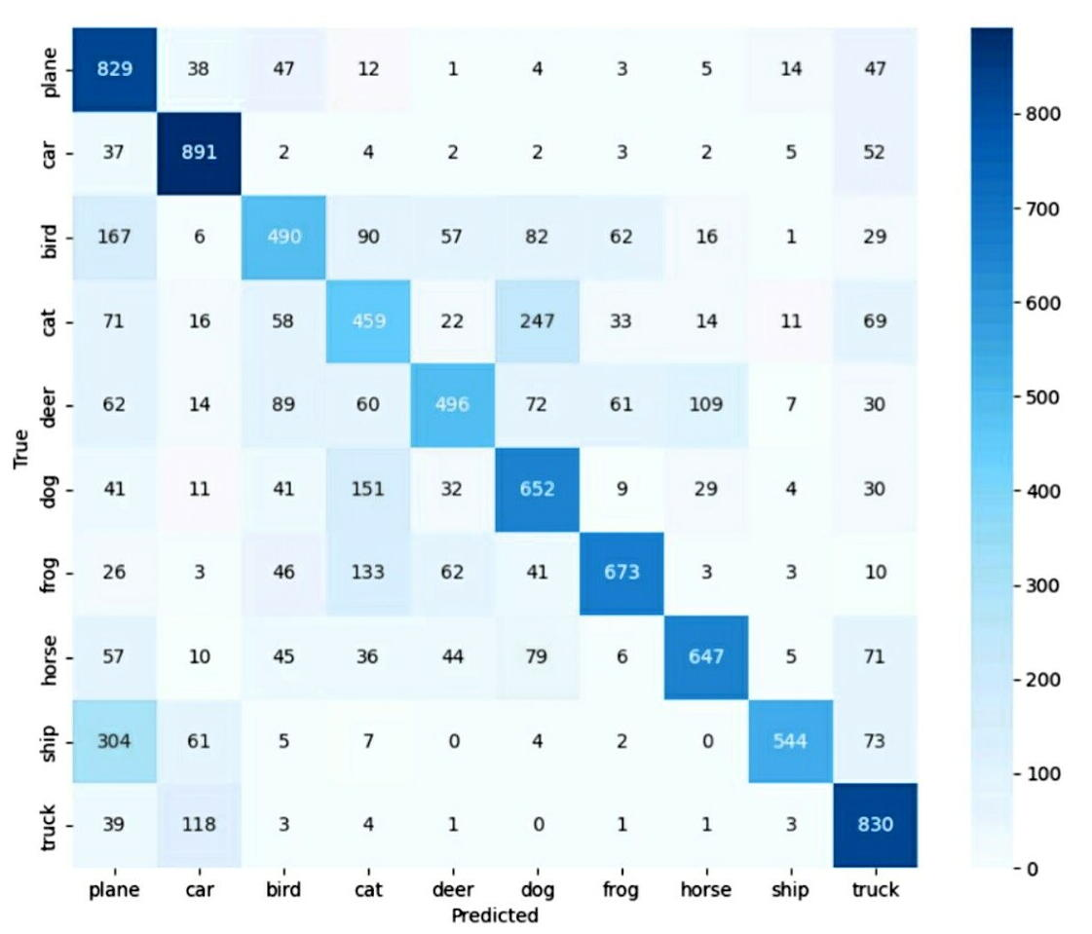

更改参数
保持 Epoch数量和批大小不变，改变vggClassifier的学习率，测试结果为

学习率 | Accuracy
0.001 | 64.64%
0.0005 | 66.67%
0.0001 | 58.85%

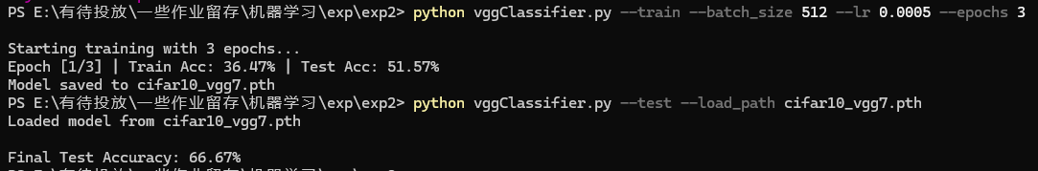
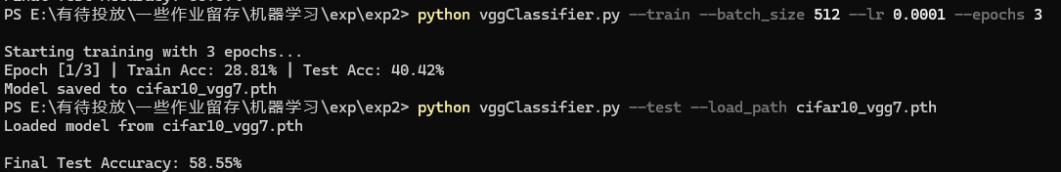
保持 Epoch数量和学习率不变，改变vggClassifier的批大小，测试结果为

batch _ size | Accuracy
512 | 64.64%
256 | 62.86%
128 | 66.96%
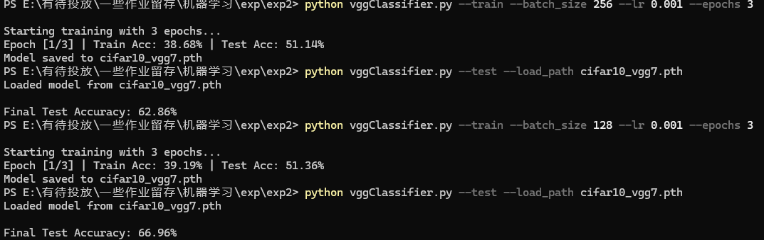

保持 Epoch数量不变, 改变ResNet的批大小, 测试结果为

batch _ size | Accuracy
512 | 57.52%
256 | 65.12%
128 | 65.64%
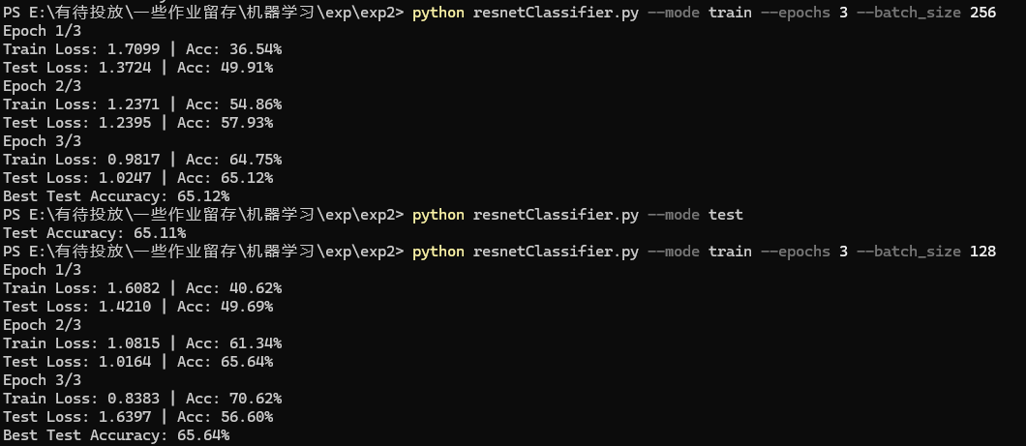
任务二实验结果
多步预测图示

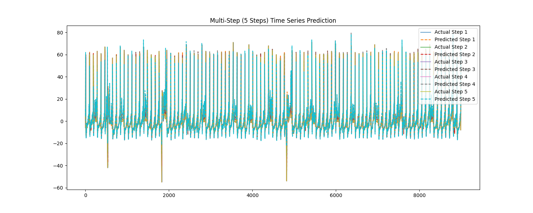

。

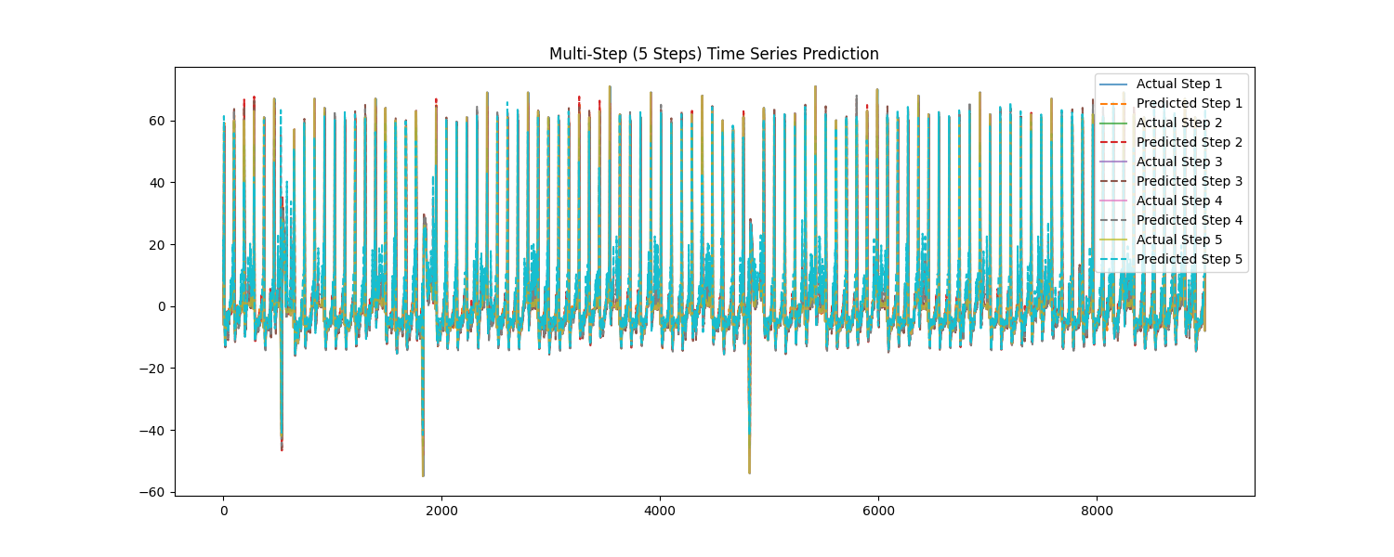

测试 MSE (均方误差)
模型名称 | Test MSE
LSTM | 10.6880
GRU | 15.1801
更改参数
保持其他参数不变，修改LSTM的滑动窗口大小

滑动窗口大小 | MSE
30 | 10.6880
20 | 15.8873
10 | 17.5447
保持其他参数不变，修改GRU的滑动窗口大小

滑动窗口大小 | MSE
30 | 26.8271
20 | 15.8873
10 | 21.3722
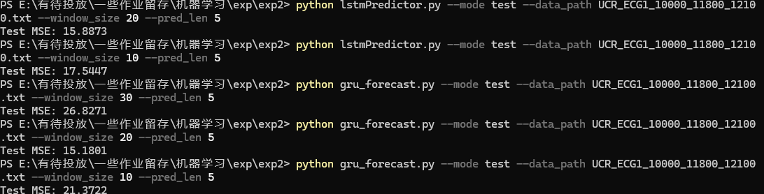
五、总结
VGG部分
1. Epoch数少导致模型尚未充分收敛
·训练轮次少 (Epoch=3)，模型还在初步学习阶段，很多参数还没调整到最优，训练曲线可能都没稳定。
2.学习率的影响有限是因为模型还没学到多少
· 从结果看, 学习率为0.0005时效果最好 (66.67%) , 0.001略低, 0.0001更低。
·这说明：
。学习率太大会导致模型更新不稳定 (如0.001稍逊)；
。学习率太小，模型几乎学不到东西 (0.0001训练太慢)；
。但因为 Epoch太少，即便调整学习率，也没有足够轮次让它展现出更显著差异。
3.批大小 (batch size) 的影响
·最好的是 batch size=128 (66.96%) , 这说明:
。小批次 (比如128)能提供更频繁的参数更新，有助于模型快速适应数据，提升早期准确率；
。批次太大 (如512)，更新频率低，可能难以在短时间内收敛；
·但整体来看差距也不是特别大 (差异小于5%)，依旧和 Epoch太少有关。
总结：
Epoch太少，训练还未收敛，因此无论调整学习率还是批大小，对最终准确率的影响都比较有限，模型整体还处于“没学明白”的阶段。

ResNet部分
批大小 (batch size) 的影响
·最好的是 batch size=128 (65.64%) , 这说明:
。小批次 (比如128)能提供更频繁的参数更新，有助于模型快速适应数据，提升早期准确率；
·但整体来看差距也不是特别大 (差异小于5%)，依旧和 Epoch太少有关。
LSTM结果分析
观察：
·MSE随着窗口增大明显下降，窗口=30时误差最小。
·说明LSTM更擅长利用较长时间依赖，给它更多的历史信息 (窗口大)，就能更好地建模未来趋势。

窗口太小 (如10)时，信息不足，预测不准。
GRU结果分析
观察：
·不像LSTM那样线性改善，GRU在窗口=20时效果最好。
·窗口=30反而效果最差 (MSE最大)。
·说明：GRU可能在较短窗口时就能很好地捕捉关键信息，窗口过大可能引入噪声或冗余信息，反而拉高误差。
为什么不同模型对窗口大小反应不同?
模型 | 特点 | 对窗口的反应
LSTM | 有专门的“记忆单元”(cell state)擅长捕捉长期依赖 | 喜欢长窗口，越长信息越全
GRU | 结构更简单，更新门和重置门合并，响应更快 | 喜欢中等长度窗口，太长可能引入噪声
Epoch太少的影响
·当前结果是训练不充分下的初步趋势；
·如果 Epoch多一点，模型会更稳定，可能：
。LSTM继续提升;
。GRU在窗口=20时更稳定，但窗口=30时的MSE可能略微下降；

附录
001  002  003  004  005  006  007  008  009  010  011  012  013  014  015  016  017  018  019  020  021  022  023  024  025  026  027  028  029  030  031  032  033  034  035  036  037  038  039  040  041  042  043  044  045  046  047  048  049  050  051  052  053  054  055  056  057  058  059  060  061  062  063  064  065  066  067  068  069  070  071  072  073  074  075  076  077  078  079  080  081  082  083  084  085  086  087  088  089  090  091  092  093  094  095  096  097  098  099  100  101  102  103  104  105  106  107  108  109  110  111  112  113  114  115  116  117  118  119  120  121  122  123  124  125  126  127  128  129  130  131  132  133  134  135  136  137  138  139  140  141  142  143  144  145  146  147  148  149  150  151  152  153  154  155  156  157  158  159  160  161  162  163  164  165  166  167  168  169  170  171  172  173  174  175  176  177  178  179  180  181  182  183  184  185  186  187  188  189  190  191  192  193  194  195  196  197  198  199  200  201  202  203  204  205  206  207  208  209  210  211  212  213  214  215  216  217  218  219  220  221  222  223  224  225  226  227  228  229  230  231  232  233  234  235  236  237  238  239  240  241  242  243  244  245  246  247  248  249  250  251  252  253  254  255  256  257  258  259  260  261  262  263  264  265  266  267  268  269  270  271  272  273  274  275  276  277  278  279  280  281  282  283  284  285  286  287  288  289  290  291  292  293  294  295  296  297  298  299  300  301  302  303  304  305  306  307  308  309  310  311  312  313  314  315  316  317  318  319  320  321  322  323  324  325  326  327  328  329  330  331  332  333  334  335  336  337  338  339  340  341  342  343  344  345  346  347  348  349  350  351  352  353  354  355  356  357  358  359  360  361  362  363  364  365  366  367  368  369  370  371  372  373  374  375  376  377  378  379  380  381  382  383  384  385  386  387  388  389  390  391  392  393  394  395  396  397  398  399  400  401  402  403  404  405  406  407  408  409  410  411  412  413  414  415  416  417  418 | ```vggClassifier.py  import torch  import torch.nn as nn  import torch.optim as optim  import torchvision  import torchvision.transforms as transforms  from torch.utils.data import DataLoader  import numpy as np  import matplotlib.pyplot as plt  import seaborn as sns  from sklearn.metrics import confusion_matrix  import argparse  class VGG7(nn.Module):  def __init__(self):  super(VGG7, self).__init__()  self.features = nn.Sequential(  nn.Conv2d(3, 64, kernel_size=3, padding=1),  nn.BatchNorm2d(64),  nn.ReLU(inplace=True),  nn.MaxPool2d(kernel_size=2, stride=2),  nn.Conv2d(64, 128, kernel_size=3, padding=1),  nn.BatchNorm2d(128),  nn.ReLU(inplace=True),  nn.MaxPool2d(kernel_size=2, stride=2),  nn.Conv2d(128, 256, kernel_size=3, padding=1),  nn.BatchNorm2d(256),  nn.ReLU(inplace=True),  nn.Conv2d(256, 256, kernel_size=3, padding=1),  nn.ReLU(inplace=True),  nn.MaxPool2d(kernel_size=2, stride=2),  )  self.classifier = nn.Sequential(  nn.Linear(256*4*4, 512),  nn.ReLU(inplace=True),  nn.Dropout(0.5),  nn.Linear(512, 256),  nn.ReLU(inplace=True),  nn.Dropout(0.5),  nn.Linear(256, 10),  )  def forward(self, x):  x = self.features(x)  x = x.view(x.size(0), -1)  x = self.classifier(x)  return x  class CIFAR10Classifier:  def __init__(self, args):  self.args = args  self.device = torch.device("cuda" if torch.cuda.is_available() else "cpu")  self.classes = ('plane', 'car', 'bird', 'cat', 'deer',  'dog', 'frog', 'horse', 'ship', 'truck')  # 初始化模型  self.model = VGG7().to(self.device)  self.criterion = nn.CrossEntropyLoss()  self.optimizer = optim.Adam(self.model.parameters(),  lr=args.lr,  weight_decay=args.weight_decay)  # 数据加载  self._load_data()  def _load_data(self):  transform_train = transforms.Compose([  transforms.RandomHorizontalFlip(),  transforms.RandomCrop(32, padding=4),  transforms.ToTensor(),  transforms.Normalize((0.4914, 0.4822, 0.4465), (0.2023, 0.1994, 0.2010)),  ])  transform_test = transforms.Compose([  transforms.ToTensor(),  transforms.Normalize((0.4914, 0.4822, 0.4465), (0.2023, 0.1994, 0.2010)),  ])  trainset = torchvision.datasets.CIFAR10(  root='./data', train=True, download=True, transform=transform_train)  self.trainloader = DataLoader(trainset, batch_size=self.args.batch_size,  shuffle=True, num_workers=2)  testset = torchvision.datasets.CIFAR10(  root='./data', train=False, download=True, transform=transform_test)  self.testloader = DataLoader(testset, batch_size=self.args.batch_size,  shuffle=False, num_workers=2)  def train(self):  print(f"\nStarting training with {self.args.epochs} epochs...")  for epoch in range(self.args.epochs):  self.model.train()  total = 0  correct = 0  for inputs, targets in self.trainloader:  inputs, targets = inputs.to(self.device), targets.to(self.device)  self.optimizer.zero_grad()  outputs = self.model(inputs)  loss = self.criterion(outputs, targets)  loss.backward()  self.optimizer.step()  _, predicted = outputs.max(1)  total += targets.size(0)  correct += predicted.eq(targets).sum().item()  train_acc = 100 * correct / total  if (epoch+1) % 5 == 0 or epoch == 0:  test_acc = self.test()  print(f"Epoch [{epoch+1}/{self.args.epochs}] | "  f"Train Acc: {train_acc:.2f}% | "  f"Test Acc: {test_acc:.2f}%")  torch.save(self.model.state_dict(), self.args.save_path)  print(f"Model saved to {self.args.save_path}")  def test(self):  self.model.eval()  all_targets = []  all_preds = []  with torch.no_grad():  for inputs, targets in self.testloader:  inputs, targets = inputs.to(self.device), targets.to(self.device)  outputs = self.model(inputs)  _, predicted = outputs.max(1)  all_targets.extend(targets.cpu().numpy())  all_preds.extend(predicted.cpu().numpy())  accuracy = 100 * np.sum(np.array(all_preds) == np.array(all_targets)) / len(all_targets)  return accuracy  def plot_confusion_matrix(self):  self.model.eval()  all_targets = []  all_preds = []  with torch.no_grad():  for inputs, targets in self.testloader:  inputs, targets = inputs.to(self.device), targets.to(self.device)  outputs = self.model(inputs)  _, predicted = outputs.max(1)  all_targets.extend(targets.cpu().numpy())  all_preds.extend(predicted.cpu().numpy())  cm = confusion_matrix(all_targets, all_preds)  plt.figure(figsize=(12, 10))  sns.heatmap(cm, annot=True, fmt='d', cmap='Blues',  xticklabels=self.classes,  yticklabels=self.classes)  plt.title('Confusion Matrix')  plt.xlabel('Predicted')  plt.ylabel('True')  plt.savefig('confusion_matrix.png')  print("Confusion matrix saved to confusion_matrix.png")  if __name__ == "__main__":  parser = argparse.ArgumentParser(description='CIFAR10 Classification with VGG7')  parser.add_argument('--train', action='store_true', help='Train the model')  parser.add_argument('--test', action='store_true', help='Test the model')  parser.add_argument('--plot', action='store_true', help='Plot confusion matrix')  parser.add_argument('--epochs', type=int, default=20, help='Number of epochs')  parser.add_argument('--batch_size', type=int, default=128, help='Batch size')  parser.add_argument('--lr', type=float, default=0.0005, help='Learning rate')  parser.add_argument('--weight_decay', type=float, default=5e-4, help='Weight decay')  parser.add_argument('--save_path', type=str, default='cifar10_vgg7.pth', help='Model save path')  parser.add_argument('--load_path', type=str, help='Model load path')  args = parser.parse_args()  classifier = CIFAR10Classifier(args)  if args.load_path:  classifier.model.load_state_dict(torch.load(args.load_path))  print(f"Loaded model from {args.load_path}")  if args.train:  classifier.train()  if args.test:  if not args.load_path and not args.train:  raise ValueError("For testing, either train first or provide --load_path")  accuracy = classifier.test()  print(f"\nFinal Test Accuracy: {accuracy:.2f}%")  if args.plot:  classifier.plot_confusion_matrix()  ```  ```lstmPredictor.py  import torch  import torch.nn as nn  import torch.optim as optim  from torch.utils.data import Dataset, DataLoader  import pandas as pd  import numpy as np  import argparse  import matplotlib.pyplot as plt  class TimeSeriesDataset(Dataset):  def __init__(self, X, y):  self.X = X  self.y = y  def __len__(self):  return len(self.X)  def __getitem__(self, idx):  return self.X[idx], self.y[idx]  class LSTMForecaster:  def __init__(self, data_path, window_size, pred_len, hidden_size, num_layers, epochs, batch_size, lr):  self.data_path = data_path  self.window_size = window_size  self.pred_len = pred_len  self.hidden_size = hidden_size  self.num_layers = num_layers  self.epochs = epochs  self.batch_size = batch_size  self.lr = lr  self.device = torch.device('cuda' if torch.cuda.is_available() else 'cpu')  self.mean = 0  self.std = 1  self.X_train = None  self.y_train = None  self.X_test = None  self.y_test = None  self.model = None  self.criterion = nn.MSELoss()  self.optimizer = None  class LSTMModel(nn.Module):  def __init__(self, input_size, hidden_size, num_layers, output_size):  super().__init__()  self.lstm = nn.LSTM(input_size, hidden_size, num_layers, batch_first=True)  self.fc = nn.Linear(hidden_size, output_size)  def forward(self, x):  out, _ = self.lstm(x)  out = out[:, -1, :]  out = self.fc(out)  return out  def prepare_data(self):  data = pd.read_csv(self.data_path, header=None).values.astype(np.float32)  train_size = int(len(data) * 0.7)  train_data = data[:train_size]  test_data = data[train_size - self.window_size:]  self.mean = train_data.mean()  self.std = train_data.std()  train_data = (train_data - self.mean) / self.std  test_data = (test_data - self.mean) / self.std  def create_samples(dataset):  X, y = [], []  for i in range(len(dataset) - self.window_size - self.pred_len + 1):  X.append(dataset[i:i+self.window_size])  y.append(dataset[i+self.window_size:i+self.window_size+self.pred_len].flatten())  return np.array(X), np.array(y)  X_train, y_train = create_samples(train_data)  X_test, y_test = create_samples(test_data)  self.X_train = torch.from_numpy(X_train).float().view(-1, self.window_size, 1)  self.y_train = torch.from_numpy(y_train).float()  self.X_test = torch.from_numpy(X_test).float().view(-1, self.window_size, 1)  self.y_test = torch.from_numpy(y_test).float()  def build_model(self):  self.model = self.LSTMModel(1, self.hidden_size, self.num_layers, self.pred_len).to(self.device)  self.optimizer = optim.Adam(self.model.parameters(), lr=self.lr)  def train(self):  train_dataset = TimeSeriesDataset(self.X_train, self.y_train)  train_loader = DataLoader(train_dataset, batch_size=self.batch_size, shuffle=True)  self.model.train()  for epoch in range(self.epochs):  total_loss = 0  for X_batch, y_batch in train_loader:  X_batch, y_batch = X_batch.to(self.device), y_batch.to(self.device)  self.optimizer.zero_grad()  outputs = self.model(X_batch)  loss = self.criterion(outputs, y_batch)  loss.backward()  self.optimizer.step()  total_loss += loss.item()  print(f'Epoch [{epoch+1}/{self.epochs}], Loss: {total_loss/len(train_loader):.4f}')  torch.save(self.model.state_dict(), 'lstm_model.pth')  def test(self):  test_dataset = TimeSeriesDataset(self.X_test, self.y_test)  test_loader = DataLoader(test_dataset, batch_size=self.batch_size, shuffle=False)  self.model.load_state_dict(torch.load('lstm_model.pth'))  self.model.eval()  predictions = []  actuals = []  with torch.no_grad():  for X_batch, y_batch in test_loader:  X_batch = X_batch.to(self.device)  pred = self.model(X_batch).cpu().numpy()  predictions.extend(pred)  actuals.extend(y_batch.numpy())  predictions = np.array(predictions) * self.std + self.mean  actuals = np.array(actuals) * self.std + self.mean  mse = np.mean((predictions - actuals) ** 2)  print(f'Test MSE: {mse:.4f}')  return actuals, predictions  def plot_results(self, actuals, predictions):  plt.figure(figsize=(15, 6))  # 绘制每个预测步的结果  for step in range(self.pred_len):  plt.plot(actuals[:, step], label=f'Actual Step {step+1}', alpha=0.7)  plt.plot(predictions[:, step], label=f'Predicted Step {step+1}', linestyle='--')  plt.legend()  plt.title(f'Multi-Step ({self.pred_len} Steps) Time Series Prediction')  plt.savefig('multi_step_prediction_Istm.png')  plt.close()  if __name__ == '__main__':  parser = argparse.ArgumentParser()  parser.add_argument('--mode', type=str, required=True, choices=['train', 'test'])  parser.add_argument('--data_path', type=str, required=True)  parser.add_argument('--window_size', type=int, default=20)  parser.add_argument('--pred_len', type=int, default=5)  parser.add_argument('--hidden_size', type=int, default=64)  parser.add_argument('--num_layers', type=int, default=2)  parser.add_argument('--epochs', type=int, default=30)  parser.add_argument('--batch_size', type=int, default=32)  parser.add_argument('--lr', type=float, default=0.001)  args = parser.parse_args()  forecaster = LSTMForecaster(  data_path=args.data_path,  window_size=args.window_size,  pred_len=args.pred_len,  hidden_size=args.hidden_size,  num_layers=args.num_layers,  epochs=args.epochs,  batch_size=args.batch_size,  lr=args.lr  )  forecaster.prepare_data()  forecaster.build_model()  if args.mode == 'train':  forecaster.train()  elif args.mode == 'test':  actuals, predictions = forecaster.test()  forecaster.plot_results(actuals, predictions)  ```  ```resnetClassifier.py  import argparse  import torch  import torch.nn as nn  import torch.nn.functional as F  import torch.optim as optim  import torchvision  import torchvision.transforms as transforms  from torch.utils.data import DataLoader  import matplotlib.pyplot as plt  import numpy as np  from sklearn.metrics import confusion_matrix, accuracy_score  import seaborn as sns  # 定义基础残差块  class BasicBlock(nn.Module):  def __init__(self, in_channels, out_channels, stride=1):  super().__init__()  self.conv1 = nn.Conv2d(  in_channels, out_channels, kernel_size=3, stride=stride, padding=1, bias=False)  self.bn1 = nn.BatchNorm2d(out_channels)  self.conv2 = nn.Conv2d(  out_channels, out_channels, kernel_size=3, stride=1, padding=1, bias=False)  self.bn2 = nn.BatchNorm2d(out_channels)  self.shortcut = nn.Sequential()  if stride != 1 or in_channels != out_channels:  self.shortcut = nn.Sequential(  nn.Conv2d(in_channels, out_channels, kernel_size=1,  stride=stride, bias=False),  nn.BatchNorm2d(out_channels)  )  def forward(self, x):  out = F.relu(self.bn1(self.conv1(x)))  out = self.bn2(self.conv2(out))  out += self.shortcut(x)  out = F.relu(out)  return out  # 定义ResNet模型  class ResNet(nn.Module):  def __init__(self, num_classes=10):  super().__init__()  self.in_channels = 64  self.conv1 = nn.Conv2d(3, 64, kernel_size=3,  stride=1, padding=1, bias=False)  self.bn1 = nn.BatchNorm2d(64)  # 定义残差块序列  self.layer1 = self._make_layer(64, 2, stride=1)  self.layer2 = self._make_layer(128, 2, stride=2)  self.layer3 = self._make_layer(256, 2, stride=2)  self.avgpool = nn.AdaptiveAvgPool2d((1, 1))  self.fc = nn.Linear(256, num_classes)  def _make_layer(self, out_channels, num_blocks, stride):  layers = []  layers.append(BasicBlock(self.in_channels, out_channels, stride))  self.in_channels = out_channels  for _ in range(1, num_blocks):  layers.append(BasicBlock(out_channels, out_channels, stride=1))  return nn.Sequential(*layers)  def forward(self, x):  x = F.relu(self.bn1(self.conv1(x)))  x = self.layer1(x)  x = self.layer2(x)  x = self.layer3(x)  x = self.avgpool(x)  x = x.view(x.size(0), -1)  x = self.fc(x)  return x  # 数据处理类  class CIFAR10DataLoader:  def __init__(self, batch_size=128):  self.batch_size = batch_size  self.transform_train = transforms.Compose([  transforms.RandomCrop(32, padding=4),  transforms.RandomHorizontalFlip(),  transforms.ToTensor(),  transforms.Normalize((0.4914, 0.4822, 0.4465), (0.2023, 0.1994, 0.2010)),  ])  self.transform_test = transforms.Compose([  transforms.ToTensor(),  transforms.Normalize((0.4914, 0.4822, 0.4465), (0.2023, 0.1994, 0.2010)),  ])  def get_loaders(self):  trainset = torchvision.datasets.CIFAR10(  root='./data', train=True, download=True, transform=self.transform_train)  testset = torchvision.datasets.CIFAR10(  root='./data', train=False, download=True, transform=self.transform_test)  trainloader = DataLoader(  trainset, batch_size=self.batch_size, shuffle=True, num_workers=2)  testloader = DataLoader(  testset, batch_size=self.batch_size, shuffle=False, num_workers=2)  return trainloader, testloader  # 训练类  class Trainer:  def __init__(self, model, train_loader, test_loader, device, epochs=100, lr=0.1):  self.model = model.to(device)  self.train_loader = train_loader  self.test_loader = test_loader  self.device = device  self.epochs = epochs  self.criterion = nn.CrossEntropyLoss()  self.optimizer = optim.SGD(  model.parameters(), lr=lr, momentum=0.9, weight_decay=5e-4)  self.scheduler = optim.lr_scheduler.StepLR(  self.optimizer, step_size=30, gamma=0.1)  self.best_acc = 0.0  def train_epoch(self):  self.model.train()  total_loss = 0.0  correct = 0  total = 0  for inputs, labels in self.train_loader:  inputs, labels = inputs.to(self.device), labels.to(self.device)  self.optimizer.zero_grad()  outputs = self.model(inputs)  loss = self.criterion(outputs, labels)  loss.backward()  self.optimizer.step()  total_loss += loss.item()  _, predicted = outputs.max(1)  total += labels.size(0)  correct += predicted.eq(labels).sum().item()  return total_loss/len(self.train_loader), 100.*correct/total  def evaluate(self):  self.model.eval()  total_loss = 0.0  correct = 0  total = 0  with torch.no_grad():  for inputs, labels in self.test_loader:  inputs, labels = inputs.to(self.device), labels.to(self.device)  outputs = self.model(inputs)  loss = self.criterion(outputs, labels)  total_loss += loss.item()  _, predicted = outputs.max(1)  total += labels.size(0)  correct += predicted.eq(labels).sum().item()  return total_loss/len(self.test_loader), 100.*correct/total  def train(self):  for epoch in range(self.epochs):  train_loss, train_acc = self.train_epoch()  test_loss, test_acc = self.evaluate()  self.scheduler.step()  print(f"Epoch {epoch+1}/{self.epochs}")  print(f"Train Loss: {train_loss:.4f} | Acc: {train_acc:.2f}%")  print(f"Test Loss: {test_loss:.4f} | Acc: {test_acc:.2f}%")  if test_acc > self.best_acc:  self.best_acc = test_acc  torch.save(self.model.state_dict(), "best_model.pth")  print(f"Best Test Accuracy: {self.best_acc:.2f}%")  # 测试和可视化类  class Tester:  def __init__(self, model, test_loader, device, model_path):  self.model = model.to(device)  self.test_loader = test_loader  self.device = device  self.model.load_state_dict(torch.load(model_path))  self.model.eval()  self.classes = ('plane', 'car', 'bird', 'cat', 'deer',  'dog', 'frog', 'horse', 'ship', 'truck')  def evaluate(self):  all_labels = []  all_preds = []  with torch.no_grad():  for inputs, labels in self.test_loader:  inputs = inputs.to(self.device)  outputs = self.model(inputs)  _, preds = torch.max(outputs, 1)  all_labels.extend(labels.cpu().numpy())  all_preds.extend(preds.cpu().numpy())  accuracy = accuracy_score(all_labels, all_preds)  print(f"Test Accuracy: {accuracy*100:.2f}%")  return all_labels, all_preds  def plot_confusion_matrix(self, labels, preds):  cm = confusion_matrix(labels, preds)  plt.figure(figsize=(10, 8))  sns.heatmap(cm, annot=True, fmt="d", cmap="Blues",  xticklabels=self.classes, yticklabels=self.classes)  plt.xlabel("Predicted")  plt.ylabel("True")  plt.title("Confusion Matrix")  plt.savefig("confusion_matrix.png")  plt.close()  if __name__ == "__main__":  parser = argparse.ArgumentParser()  parser.add_argument("--mode", type=str, required=True,  choices=["train", "test"])  parser.add_argument("--epochs", type=int, default=100)  parser.add_argument("--batch_size", type=int, default=128)  args = parser.parse_args()  device = torch.device("cuda" if torch.cuda.is_available() else "cpu")  # 初始化数据加载器  data_loader = CIFAR10DataLoader(args.batch_size)  train_loader, test_loader = data_loader.get_loaders()  # 初始化模型  model = ResNet()  if args.mode == "train":  trainer = Trainer(model, train_loader, test_loader, device, args.epochs)  trainer.train()  elif args.mode == "test":  tester = Tester(model, test_loader, device, "best_model.pth")  labels, preds = tester.evaluate()  tester.plot_confusion_matrix(labels, preds)  ```  ```gru_forecast.py  import torch  import torch.nn as nn  import torch.optim as optim  from torch.utils.data import Dataset, DataLoader  import pandas as pd  import numpy as np  import argparse  import matplotlib.pyplot as plt  class TimeSeriesDataset(Dataset):  def __init__(self, X, y):  self.X = X  self.y = y  def __len__(self):  return len(self.X)  def __getitem__(self, idx):  return self.X[idx], self.y[idx]  class GRUForecaster:  def __init__(self, data_path, window_size, pred_len, hidden_size, num_layers, epochs, batch_size, lr):  self.data_path = data_path  self.window_size = window_size  self.pred_len = pred_len  self.hidden_size = hidden_size  self.num_layers = num_layers  self.epochs = epochs  self.batch_size = batch_size  self.lr = lr  self.device = torch.device('cuda' if torch.cuda.is_available() else 'cpu')  self.mean = 0  self.std = 1  self.X_train = None  self.y_train = None  self.X_test = None  self.y_test = None  self.model = None  self.criterion = nn.MSELoss()  self.optimizer = None  class GRUModel(nn.Module):  def __init__(self, input_size, hidden_size, num_layers, output_size):  super().__init__()  self.gru = nn.GRU(input_size, hidden_size, num_layers, batch_first=True)  self.fc = nn.Linear(hidden_size, output_size)  def forward(self, x):  out, _ = self.gru(x)  out = out[:, -1, :]  out = self.fc(out)  return out  def prepare_data(self):  data = pd.read_csv(self.data_path).values.astype(np.float32)  train_size = int(len(data) * 0.7)  train_data = data[:train_size]  test_data = data[train_size - self.window_size:]  self.mean = train_data.mean()  self.std = train_data.std()  train_data = (train_data - self.mean) / self.std  test_data = (test_data - self.mean) / self.std  def create_samples(dataset):  X, y = [], []  for i in range(len(dataset) - self.window_size - self.pred_len):  X.append(dataset[i:i+self.window_size])  y.append(dataset[i+self.window_size:i+self.window_size+self.pred_len])  return np.array(X), np.array(y)  X_train, y_train = create_samples(train_data)  X_test, y_test = create_samples(test_data)  self.X_train = torch.from_numpy(X_train).float().view(-1, self.window_size, 1)  self.y_train = torch.from_numpy(y_train).float().view(-1, self.pred_len)  self.X_test = torch.from_numpy(X_test).float().view(-1, self.window_size, 1)  self.y_test = torch.from_numpy(y_test).float().view(-1, self.pred_len)  def build_model(self):  self.model = self.GRUModel(1, self.hidden_size, self.num_layers, self.pred_len).to(self.device)  self.optimizer = optim.Adam(self.model.parameters(), lr=self.lr)  def train(self):  train_dataset = TimeSeriesDataset(self.X_train, self.y_train)  train_loader = DataLoader(train_dataset, batch_size=self.batch_size, shuffle=True)  self.model.train()  for epoch in range(self.epochs):  total_loss = 0  for X_batch, y_batch in train_loader:  X_batch, y_batch = X_batch.to(self.device), y_batch.to(self.device)  self.optimizer.zero_grad()  outputs = self.model(X_batch)  loss = self.criterion(outputs, y_batch)  loss.backward()  self.optimizer.step()  total_loss += loss.item()  print(f'[Epoch {epoch+1}/{self.epochs}] Loss: {total_loss/len(train_loader):.4f}')  torch.save(self.model.state_dict(), 'gru_model.pth')  def test(self):  test_dataset = TimeSeriesDataset(self.X_test, self.y_test)  test_loader = DataLoader(test_dataset, batch_size=self.batch_size, shuffle=False)  self.model.load_state_dict(torch.load('gru_model.pth'))  self.model.eval()  predictions = []  actuals = []  with torch.no_grad():  for X_batch, y_batch in test_loader:  X_batch = X_batch.to(self.device)  pred = self.model(X_batch).cpu().numpy()  predictions.extend(pred)  actuals.extend(y_batch.numpy())  predictions = np.array(predictions) * self.std + self.mean  actuals = np.array(actuals) * self.std + self.mean  mse = np.mean((predictions - actuals) ** 2)  print(f'Test MSE: {mse:.4f}')  return actuals, predictions  def plot_results(self, actuals, predictions):  plt.figure(figsize=(15, 6))  # 绘制每个预测步的结果  for step in range(self.pred_len):  plt.plot(actuals[:, step], label=f'Actual Step {step+1}', alpha=0.7)  plt.plot(predictions[:, step], label=f'Predicted Step {step+1}', linestyle='--')  plt.legend()  plt.title(f'Multi-Step ({self.pred_len} Steps) Time Series Prediction')  plt.savefig('multi_step_prediction_gru.png')  plt.close()  if __name__ == '__main__':  parser = argparse.ArgumentParser()  parser.add_argument('--mode', type=str, required=True, choices=['train', 'test'])  parser.add_argument('--data_path', type=str, required=True)  parser.add_argument('--window_size', type=int, default=10)  parser.add_argument('--pred_len', type=int, default=5)  parser.add_argument('--hidden_size', type=int, default=64)  parser.add_argument('--num_layers', type=int, default=2)  parser.add_argument('--epochs', type=int, default=30)  parser.add_argument('--batch_size', type=int, default=32)  parser.add_argument('--lr', type=float, default=0.001)  args = parser.parse_args()  forecaster = GRUForecaster(  data_path=args.data_path,  window_size=args.window_size,  pred_len=args.pred_len,  hidden_size=args.hidden_size,  num_layers=args.num_layers,  epochs=args.epochs,  batch_size=args.batch_size,  lr=args.lr  )  forecaster.prepare_data()  forecaster.build_model()  if args.mode == 'train':  forecaster.train()  elif args.mode == 'test':  actuals, predictions = forecaster.test()  forecaster.plot_results(actuals, predictions)  ```  # 过程中有使用大模型辅助编程

