How to update the Fiscal Future GitHub Data
- Download R & Rstudio (or Positron) onto your computer.
- Download Git so your computer can talk to GitHub.
- Have a GitHub Account (if you are going to be editing the website or in charge of the IGPA page).
- Go to Fiscal-Futures project and click the green “< > Code” button and get the project link to join your computer and GitHub.
  - HTTPS link is fine and easiest if you are only pulling the data. If you want to push updates and modify the website, you will most likely need the SSH password connected key and connection method. There are steps to this online that can be followed (that’s how I learned how to do it and have to re-google it every time I’ve had to set it up).
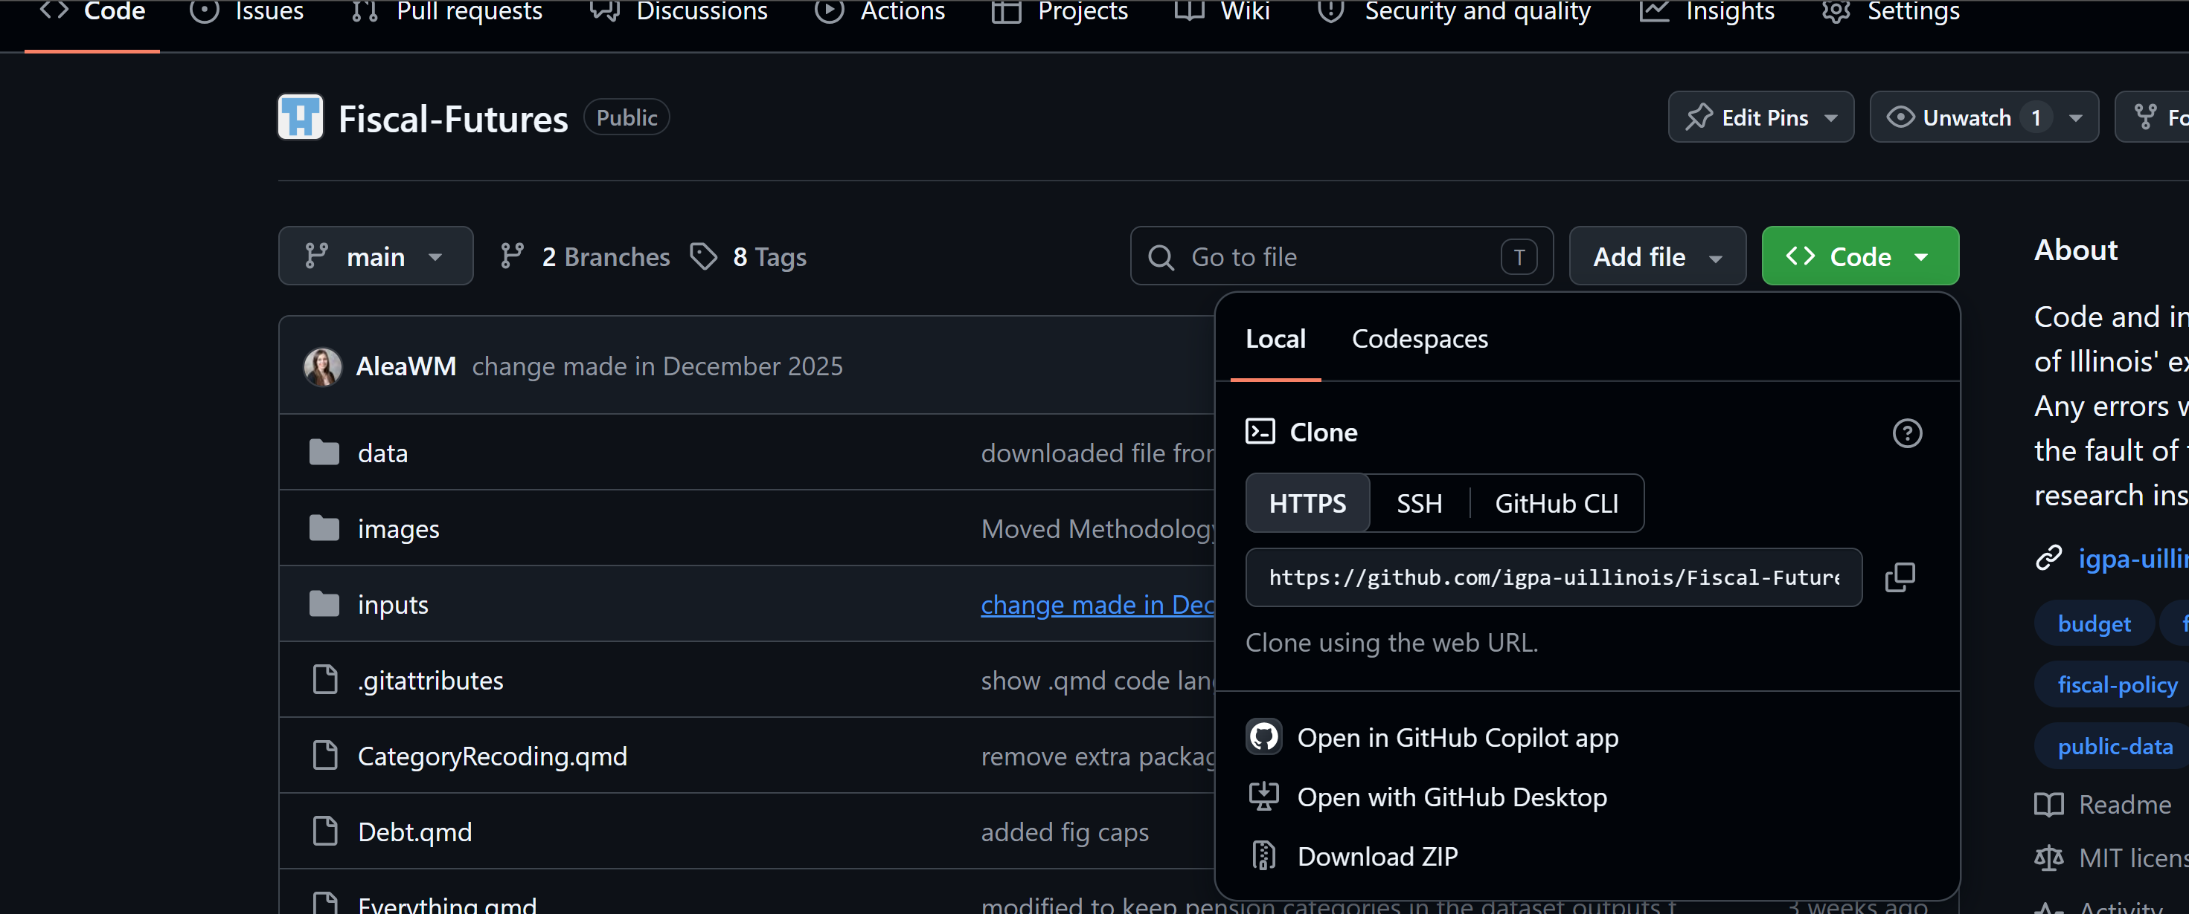
- Open RStudio. File > New Project > Version Control > Git > Choose folder location for the project. paste in the link from GitHub.
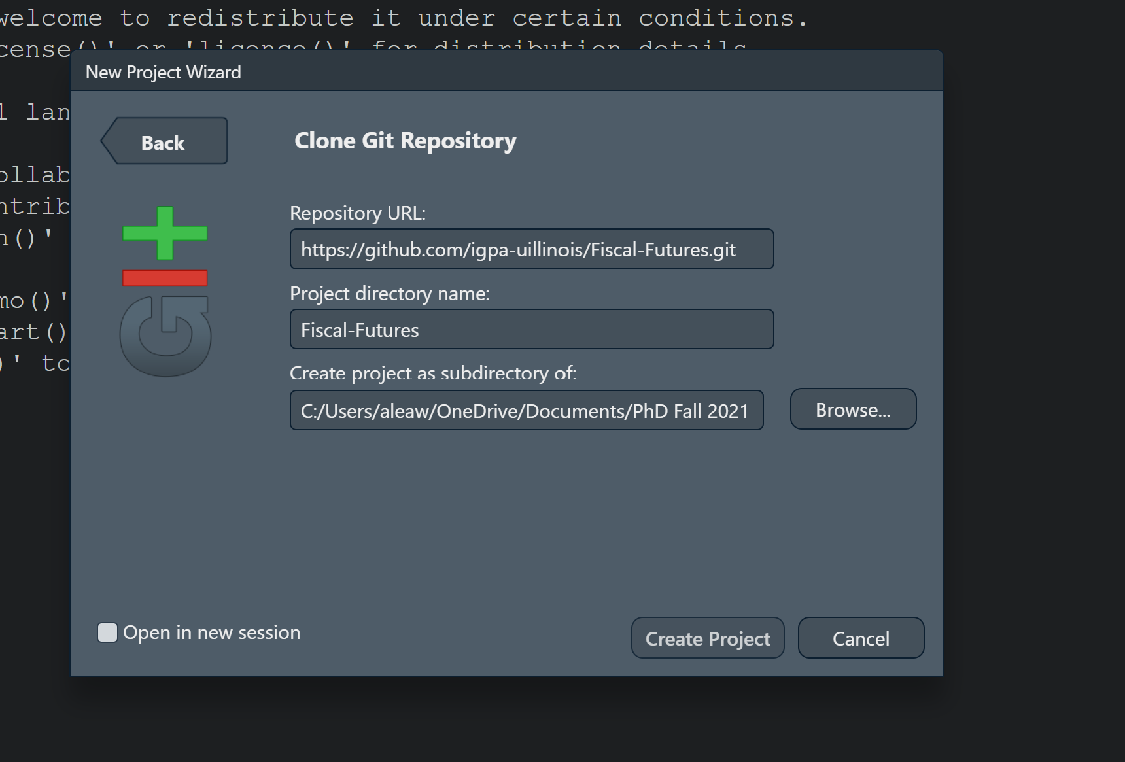

How to update the Fiscal Future GitHub Data
- Refresh files on your computer by Using Git > Pull.
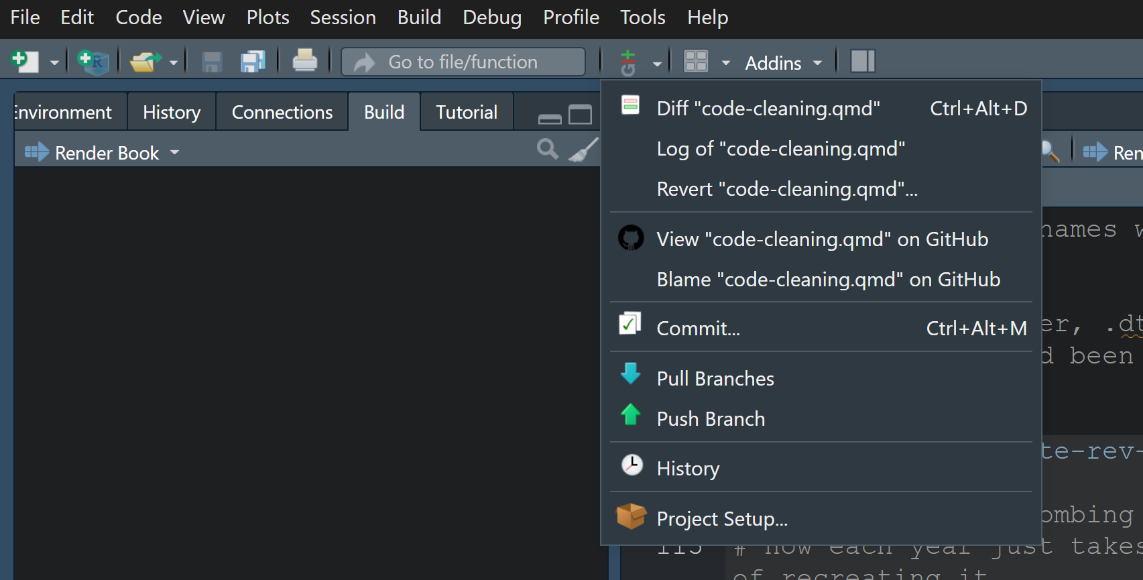
- Move raw FOIA-ed files from GOMB into Fiscal-Futures/inputs/ioc_data_received/ expenditures or the revenues folder.
- Create folder in Fiscal Futures IGPA/Fiscal-Futures/data/NEW FOLDER
  - Folder name should be “FY2025 Files” so that file paths in code can find the correct folder in code files and rev_temp and exp_temp files that will be created for the new fiscal year.
- Open code-cleaning.qmd in Fiscal-Futures R project. NOTE you need to manually run the chunks. They are set to EVAL == FALSE. There is one chunk called “historic-create-rev-csv-dtafiles” that you do not need to run. It is for historic documentation only.
  - Update current year variable
  - Run chunk named “add-newest-years-data”
    - Creates allrevfiles_FY___.csv and allexpfiles_FY____.csv in the newly created folder from step 2.
  - Find new and reused funds, agencies, organizations, etc. anything that has changed from previous fiscal years.
    - Make a document or show the research team somehow the new funds or revenue sources so that decisions can be made on if they should be included in the fiscal gap or not.
    - Usually a table of the output from code-cleaning.qmd is screenshotted or shown somehow to the group and the RA searches what the funds are supposed to be used for. Add column for if it is a name change, not new, new. Etc. Identify what rev source group it should be included as. See past examples if confused!
    - Search each fund to see if name is changed or if the fund has a completely new name

- After new and reused funds are discussed with research group, update input files. Determine if included or excluded in fiscal gap calculation.
  - Update “fund_ab_in.xlsx” file with any changes
  - Update ioc_rev_source.xlsx
- Update current_year in Everything_changepensions.qmd file

