Detection Transients using PBO cGPS Network

- Data
The raw GPS observation data (RINEX) were acquired from the SOPAC website (http://sopac.ucsd.edu/). More information can be found in the WNAM CGPS position time series dataset directory (ftp://garner.ucsd.edu/pub/timeseries/measures/ats/WesternNorthAmerica/). In this test, we only use data from 60 station (Fig 1).
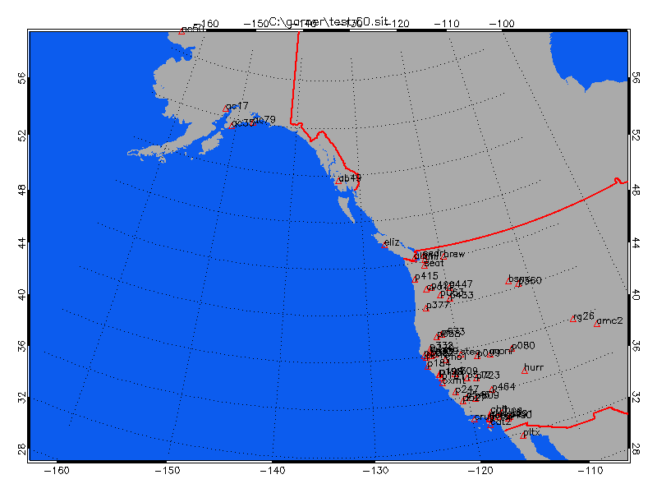
Fig 1. cGPS stations used in the example.

- Perform Transient Signal Detection
Start iGPS as described in the tutorial document. Select the example\cmc\PBO\WNAM_Clean_ResidNeuTimeSeries_comb_20150318.test directory as the input path and the example\cmc\PBO\WNAM_Clean_ResidNeuTimeSeries_comb_20150318.test.cmc directory as the output path.
Change the Input Type droplist from “SIO NEU” to “SIO NEU [ATS]”. The ATS format use millimeter as the position unit; and the old SIO NEU format use meter.
From the “tools” button menu, select the “Extract CMC (CWSF)” submenu (Fig 2), the parameter setting panel for CMC extraction will show in the lower-left corner (Fig 3).
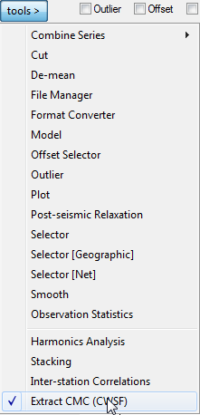  Fig 2. CMC menu. | 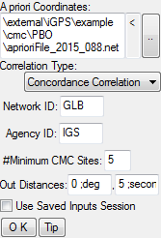  Fig 3. Parameter setting for “Extract CMC (CWSF)” module.
Change the “A priori coordinates” file to example\cmc\PBO\aprioriFile_2015_088.net Keep all the other settings as the default. Click the “A” button below the site list to select all sites. Click the “OK” button to star the test run. If everything is OK, the task will finish within five minutes. And a hierarchical clustering window will show with the results (Fig 4). Click the “Show Tree” button to perform clustering and form the hierarchical tree. Once the tree is shown, you can click a site name to show its position time series. However, the time series should be loaded first (using the Load buttons above the plot area).
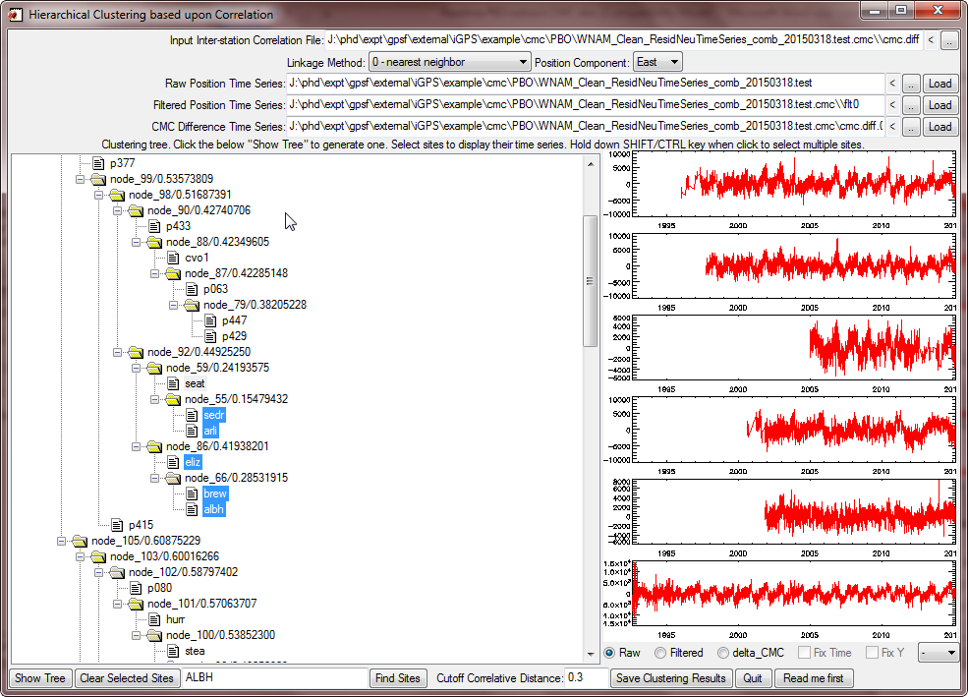
Fig 4. Clustering window.
You can switch among the position components (north, east, and vertical). To save the clustering results as a text file, click the “Save Clustering Results” button and choose an output filename. Fig 5 shows an example of the output clusters file for the east component. The aseismic slow slip group (ARLI, SEAT, and SEDR) has the second highest correlations among all groups.
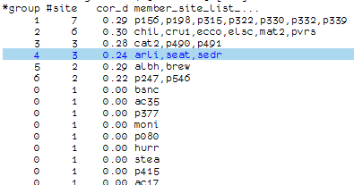
Fig 5. Sample output classes file.
If you want to do a second run, select the “Overwrite Existing” checkbox to force remove old output files.

