Detection Earthquake Transient using cGPS Network: a Case for 25 April 2015 M7.8 Nepal Earthquake

- Data
The raw GPS observation data (RINEX) were acquired from the UNAVCO website. More information can be found at the post “GPS data available at the UNAVCO archive” in the response forum of UNAVCO community (http://www.unavco.org/voce/viewtopic.php?f=59&t=1399&sid=7dddebfb1c9f40c2df519512c09532cf). The data collected from 1 January 2015 to 10 May 2015 are used in this example.
The daily observation data for Nepal and nearby IGS continuous GPS stations (Fig 1) were processed with GAMIT/GLOBK software v10.5. The final positions (*.neu files in pos.neu directory) are in the ITRF08 reference frame. Outliers are removed with the criterion that the formal errors are larger than 10 mm and 20 mm for the horizontal and vertical components, respectively.
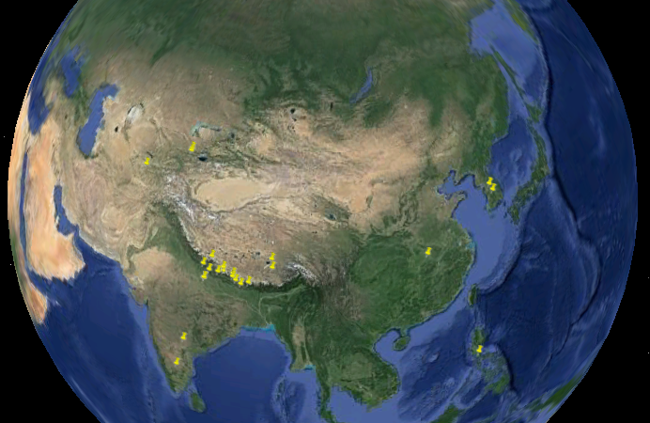
Fig 1. cGPS stations used in the example (Google Earth view).
- Perform Transient Signal Detection
Start iGPS as described in the tutorial document. The default input (example\eq.nepal20150425\pos.neu) and output (example\eq.nepal20150425\pos.neu.cmc) paths are already set for CMC detection example. You can examine individual time series by click the site name in the left panel.
From the “tools” button menu, select the “Extract CMC (CWSF)” submenu (Fig 2), the parameter setting panel for CMC extraction will show in the lower-left corner (Fig 3).
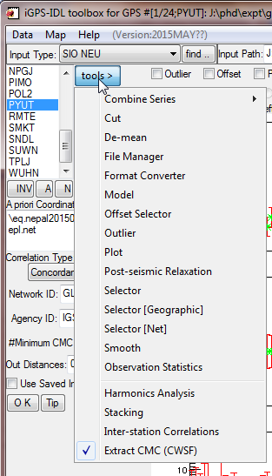  Fig 2. CMC menu. | 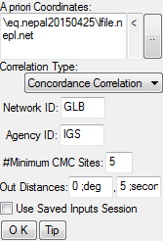  Fig 3. Parameter setting for “Extract CMC (CWSF)” module.
Keep all the setting as the default. Click the “A” button below the site list to select all sites. Click the “OK” button to star the test run. If everything is OK, the task will finish in about one minute. And a hierarchical clustering window will show with the results (Fig 4). Click the “Show Tree” button to perform clustering and form the hierarchical tree. Once the tree is shown, you can click a site name to show its position time series. However, the time series should be loaded first (using the Load buttons above the plot area).
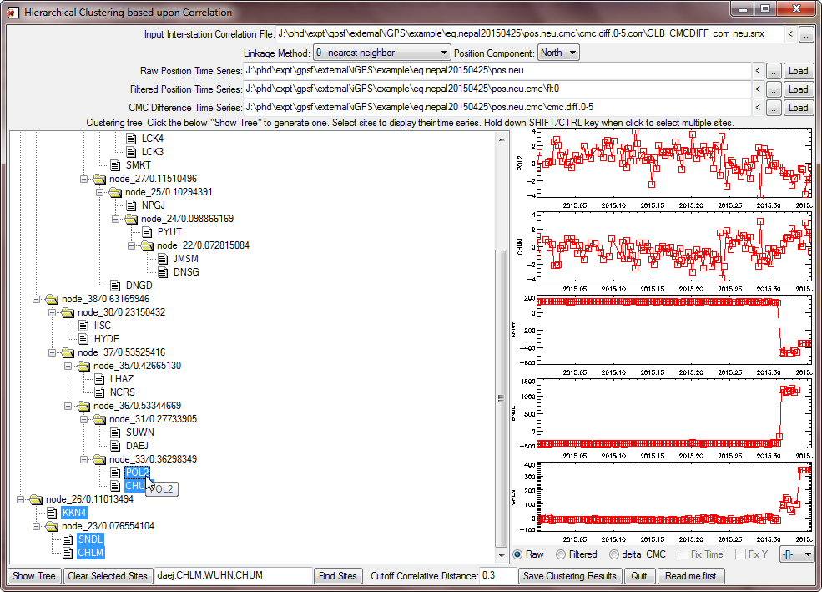
Fig 4. Clustering window.
To save the clustering results as a text file, click the “Save Clustering Results” button and choose an output filename. Fig 5 shown an example of the output classes file. It shows that the highest correlated cluster is the second group (CHLM, KKN4, and SNDL) which represent the coseismic displacements caused by the 25 April 2015 M_{w}7.8 Nepal earthquake. The clusters are currently ordered by the number of member sites.
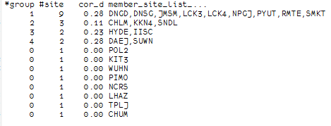
Fig 5. Sample output classes file.
If you want to do a second run, select the “Overwrite Existing” checkbox to force remove old output files.

