**How to use iGPS to generate velocity profiles?**

Step1). For InSAR LOS rate map ($iGPS\example\sar\xyz_profiles\xyz\meanvel_01.txt) in XYZ format (Fig. 1):

|  |
| --- |
| 91.474576 31.035791 0.505565  91.482076 31.030791 -1.081916  … |

Each line of the XYZ file contains:

*longitude latitude velocity* [*velocity_uncertainty*]

The last column (velocity uncertainty) is optional.

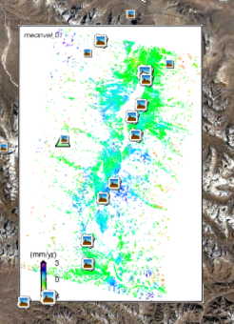

*Fig. 1 InSAR LOS rate map for Gulu Graben, Dangxiong, Lhasa, Tibet, China. Viewed with Google Earth.*

If the LOS rate map is in other formats (e.g. binary grid), one should first convert it to XYZ format. Currently, iGPS does not support other file formats.

2) Create a fault trace polyline for Yadong-Gulu rift and save it as GMT psxy format ($iGPS\example\sar\xyz_profiles\fault_trace\fault_ydgl2.psxy).

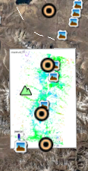 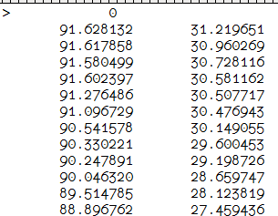

*Fig. 2 Fault trace polyline for Yadong-Gulu fault zone.*

3) Use iGPS program “SAR_LOS_PROFILES_AUTO_XYZ” to generate velocity profiles.

The iGPS main program should be first launched. If not, open the iGPS starter ($iGPS\main\start_igps.pro) and run it (e.g. by pressing the F8 key), which will set the iGPS environment paths automatically. Then, open $iGPS\sar\sar_los_profiles_auto_xyz.pro file with IDL Workbench (IDLDE) and set your parameters. Currently, iGPS does not provide a GUI for this program.

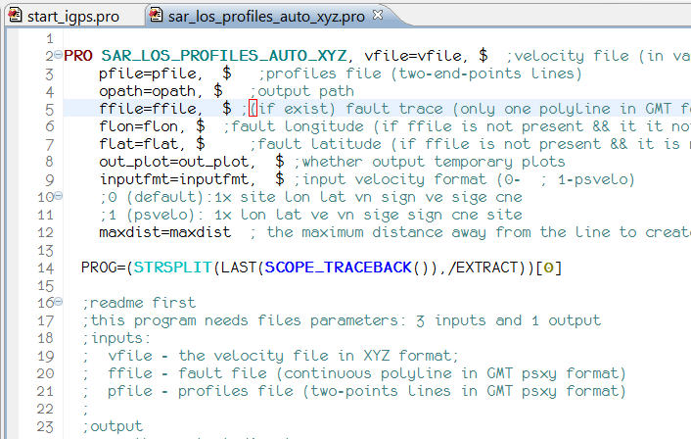

*Fig. 3 Open SAR_LOS_PROFILES_AUTO_XYZ source code in IDL Workbench.*

With the default settings, SAR_LOS_PROFILES_AUTO_XYZ program will run with the supplied example located at $iGPS\example\sar\xyz_profiles\ directory. If the output path does not exist, iGPS will create it.

iGPS will create a preview plot for each profile (e.g. Fig. 4).

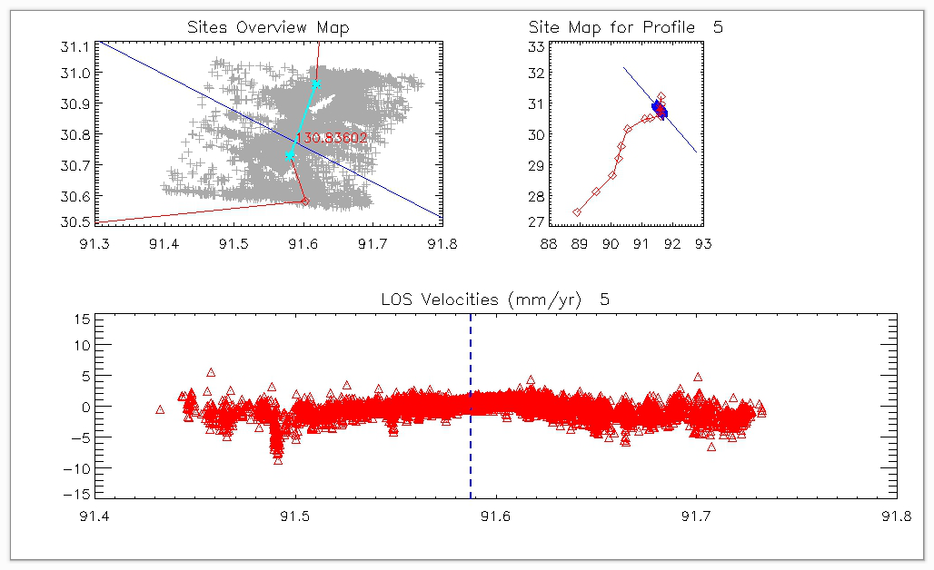

*Fig. 4 Plot for velocity profile.*

Content of the output velocity profile file looks like:

|  |
| --- |
| # PSXY_PROFILE 90.440 32.500  # PSXY_PROFILE 92.809 29.758 *These two lines are profile line.*  # PSXY_FAULT_PROFILE_INTERSECT 91.625 31.129 *This is the intersection point between the profile and fault.*  # PSXY_FAULT_TRACE 91.628 31.220 *The below points represent the fault trace.*  # PSXY_FAULT_TRACE 91.618 30.960  # PSXY_FAULT_TRACE 91.580 30.728  # PSXY_FAULT_TRACE 91.602 30.581  # PSXY_FAULT_TRACE 91.276 30.508  # PSXY_FAULT_TRACE 91.097 30.477  # PSXY_FAULT_TRACE 90.542 30.149  # PSXY_FAULT_TRACE 90.330 29.600  # PSXY_FAULT_TRACE 90.248 29.199  # PSXY_FAULT_TRACE 90.046 28.660  # PSXY_FAULT_TRACE 89.515 28.124  # PSXY_FAULT_TRACE 88.897 27.459  * site p_long p_lati p_dist v_along ve_along v_tang ve_tang long lati dist_to_fault v_los ve_los  1165 91.709 31.031 -4.99 0.00 0.00 0.00 0.00 91.673 30.999 13.603498 -0.47 0.00  1151 91.710 31.031 -4.92 0.00 0.00 0.00 0.00 91.673 30.999 13.619490 -0.51 0.00  1166 91.710 31.030 -4.92 0.00 0.00 0.00 0.00 91.673 30.999 13.660586 -0.89 0.00  1171 91.710 31.030 -4.94 0.00 0.00 0.00 0.00 91.673 30.999 13.682630 -0.43 0.00 |

The data section of the profile file is velocity along the profile. The columns are

* site: site name (each point in LOS map);
* p_long: longitude of the point by projecting the site (LOS point) to the profile;
* p_lati: latitude of the above point;
* p_dist: distance from the LOS point to the profile;
* v_along: velocity along the profile (not valid for InSAR LOS velocity);
* ve_along: uncertainty for the above;
* v_tang: velocity perpendicular to the profile (strike-slip component);
* ve_tang: uncertainty for the above;
* long: longitude of the LOS point;
* lati: latitude of the LOS point;
* dist_to_fault: distance from the LOS point to the fault trace (vary between negative and positive from the left to the right)
* v_los: LOS velocity
* ve_los: LOS velocity uncertainty